**GIL MICHAEL E. REGALADO BS ECE IV EE 272**

**LABORATORY #6 LEVEL SHIFTER**

**SHIFT UP**

SCHEMATIC

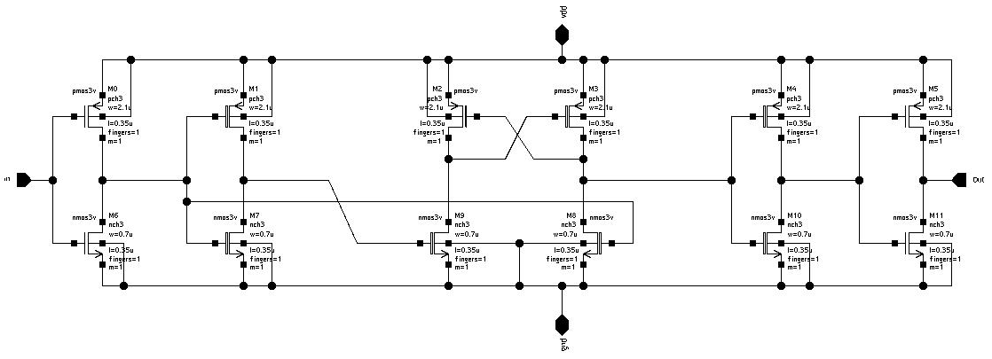

TEST BENCH

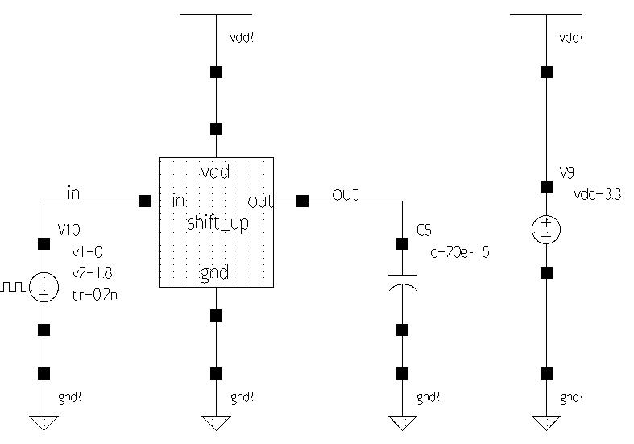

SIMULATION

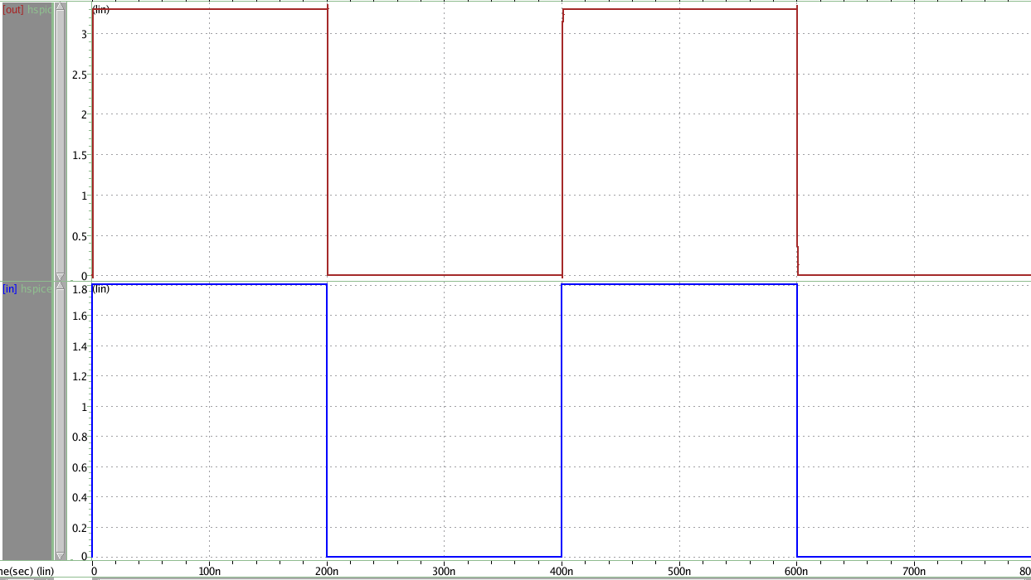

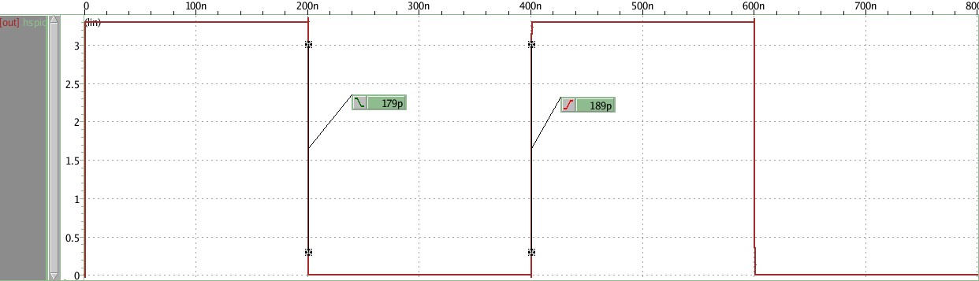

**SHIFT DOWN**

SCHEMATIC

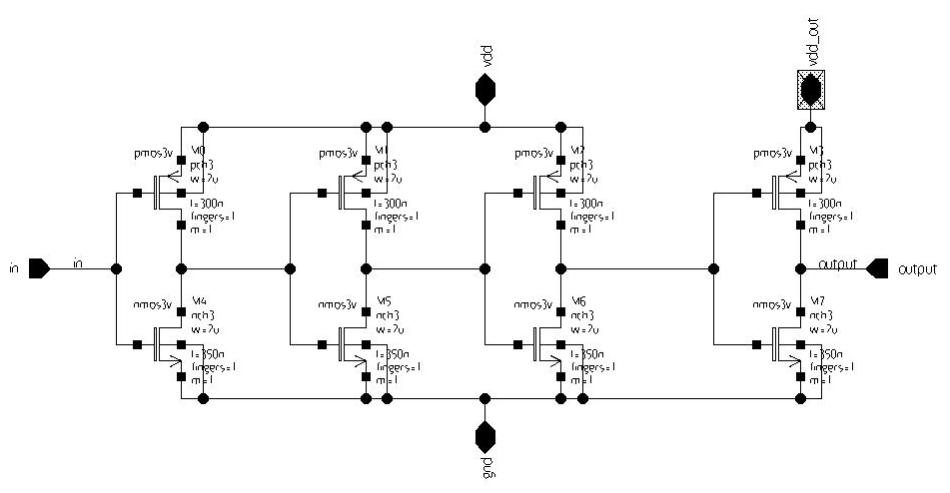

TEST BENCH

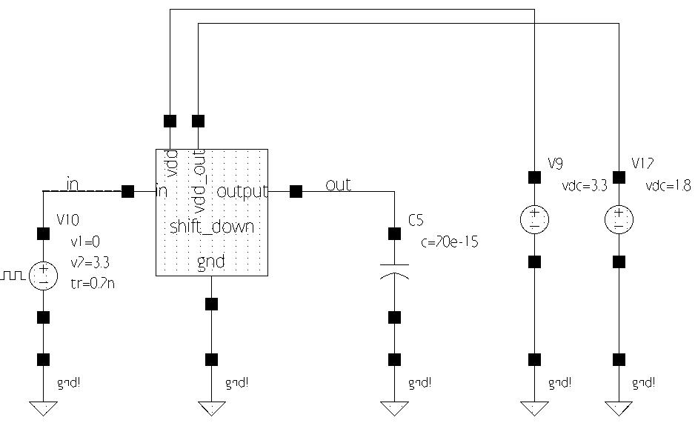

SIMULATION

