**GIL MICHAEL E. REGALADO BS-ECE IV**

**SRAM**

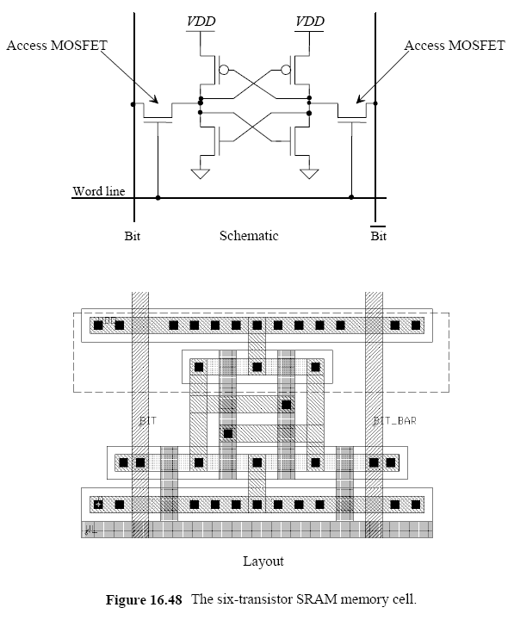

IN_BB

IN_BN

OUT_BN

OUT_BB

MP1

MN1

MN2

MN4

MN3

MP2

1. Simulate the operation of the SRAM cell seen in figure above. Use the 0.18 um process.
2. Simulate a 1x2-bit memory composed of 2 cells (refer to the figure above). The block diagram is shown below.



SINGLE SRAM CELL

|  |
| --- |
| SRAM SINGLE CELL SIMULATION  ****** PARAMETER DEFINITION  .PARAM LMIN=0.18u  .PARAM PVDD=1.8  .PARAM RFTIME=0.1n  ****** ANALYSIS PARAMTERS  .option post  .op  .tran 1e-12 '16n'  ****** STIMULI  Vdd ndd 0 PVDD  Vin_bb nbb 0 pulse (PVDD 0 0 RFTIME RFTIME 8n 16n)  Vin_ww nww 0 pulse (0 PVDD 0 RFTIME RFTIME 2n 04n)  Co_bb n_obb 0 1f  Co_bn n_obn 0 1f  ****** MAIN CIRCUIT : SINGLE SRAM CELL SIMULATION  X_sram_cell ndd 0 nww nbb n_obb n_obn sram_cell  ****** SRAM CELL  .subckt sram_cell dd ss ww bb obb obn  x_inverter dd ss bb bn inverter  MP1 obb obn dd dd pch l=LMIN w='6*LMIN'  MP2 obn obb dd dd pch l=LMIN w='6*LMIN'  MN1 obb obn ss ss nch l=LMIN w='2*LMIN'  MN2 obn obb ss ss nch l=LMIN w='2*LMIN'  MN4 bb ww obb ss nch l=LMIN w='3*LMIN'  MN3 bn ww obn ss nch l=LMIN w='3*LMIN'  .ends  ****** INVERTER CELL  .subckt inverter ndd nss in out  MN1 out in nss nss nch l='1*LMIN' w='2*LMIN'  MP2 out in ndd ndd pch l='1*LMIN' w='6*LMIN'  .ends  ****** LIBRARY  .prot  .lib "C:\synopsys\rf018.l" TT  .unprot  .end |

SRAM SINGLE CELL SIMULATION RESULT

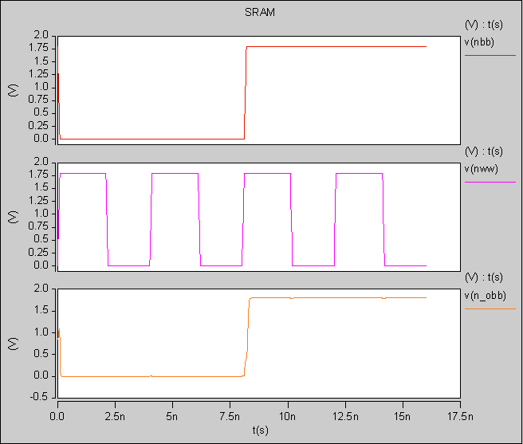

Synchronised with the World Line clock, the output follows the input for the respective pins.

SRAM WITH 2 CELLS SIMULATION

|  |
| --- |
| SRAM 2 CELL SIMULATION  ****** PARAMETER DEFINITION  .PARAM LMIN=0.18u  .PARAM PVDD=1.8  .PARAM RFTIME=0.1n  ****** ANALYSIS PARAMTERS  .option post  .op  .tran 1e-12 '35n'  ****** STIMULI  Vdd ndd 0 PVDD  ** INPUTS FOR SRAM_CELL_0  Vin_bb_0 nbb_0 0 pulse (PVDD 0 0 RFTIME RFTIME 08n 16n)  ** INPUTS FOR SRAM_CELL_1  Vin_bb_1 nbb_1 0 pulse (PVDD 0 0 RFTIME RFTIME 16n 32n)  Vin_ww nww 0 pulse (0 PVDD 0 RFTIME RFTIME 02n 04n)  ** CAPS FOR SRAM_CELL_0 OUTPUT  Co_bb_0 n_obb_0 0 1f  Co_bn_0 n_obn_0 0 1f  ** CAPS FOR SRAM_CELL_1 OUTPUT  Co_bb_1 n_obb_1 0 1f  Co_bn_1 n_obn_1 0 1f  ****** MAIN CIRCUIT : SINGLE SRAM CELL SIMULATION  X_sram_cell_0 ndd 0 nww nbb_0 n_obb_0 n_obn_0 sram_cell  X_sram_cell_1 ndd 0 nww nbb_1 n_obb_1 n_obn_1 sram_cell  ****** SRAM CELL  .subckt sram_cell dd ss ww bb obb obn  x_inverter dd ss bb bn inverter  MP1 obb obn dd dd pch l=LMIN w='6*LMIN'  MP2 obn obb dd dd pch l=LMIN w='6*LMIN'  MN1 obb obn ss ss nch l=LMIN w='2*LMIN'  MN2 obn obb ss ss nch l=LMIN w='2*LMIN'  MN4 bb ww obb ss nch l=LMIN w='3*LMIN'  MN3 bn ww obn ss nch l=LMIN w='3*LMIN'  .ends  ****** INVERTER CELL  .subckt inverter ndd nss in out  MN1 out in nss nss nch l='1*LMIN' w='2*LMIN'  MP2 out in ndd ndd pch l='1*LMIN' w='6*LMIN'  .ends  ****** LIBRARY  .prot  .lib "C:\synopsys\rf018.l" TT  .unprot  .end |

SIMULATION RESULTS

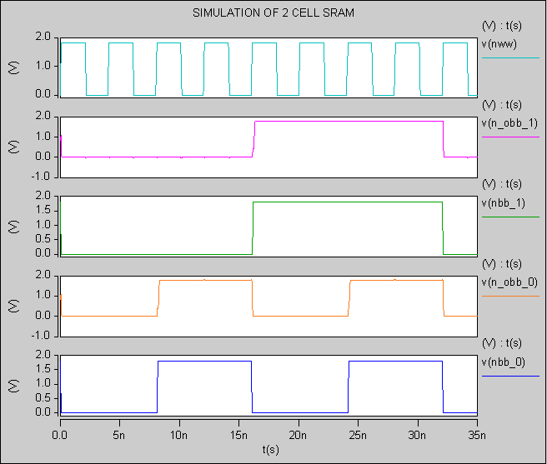

For the SRAM_CELL_0

Input: nbb_0

Output: n_obb_0

For the SRAM_CELL_1

Input: nbb_1

Output: n_obb_1

SUMMARY

The output of the SRAM cell follows the input synchronized by the Word Line posedge. If the World Line is low the value in the input bit is kept in memory on the main SRAM cell.