Upload sharepoint package:

1. Take the latest build from the source code and build the package, which will create the file with the name Sharepoint-Client-Side-Controls.sppkg
2. Upload this file to APP catalog site

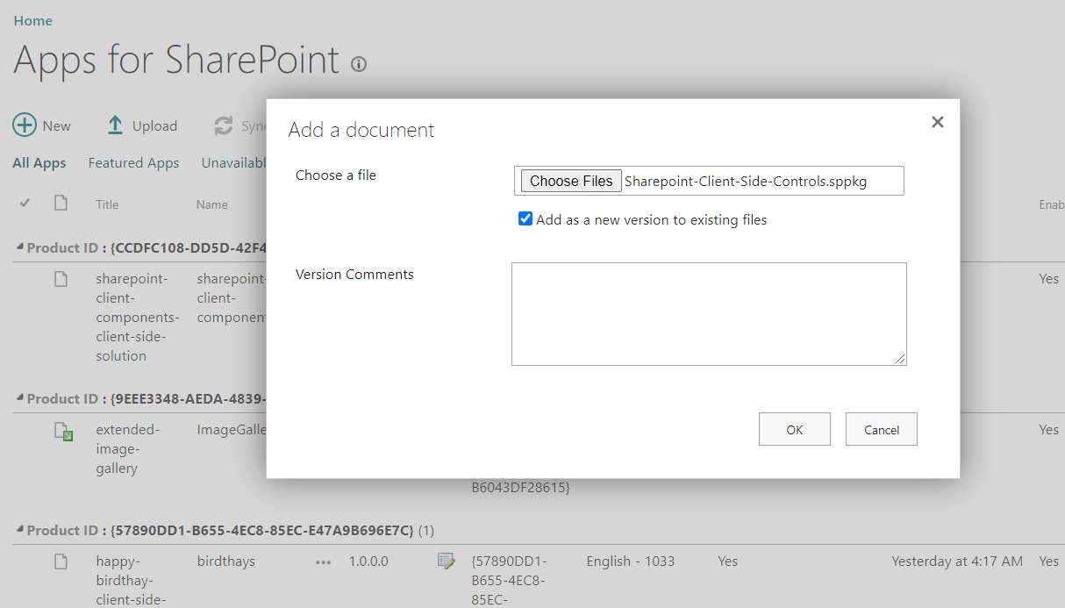

1. Click Deploy the solution

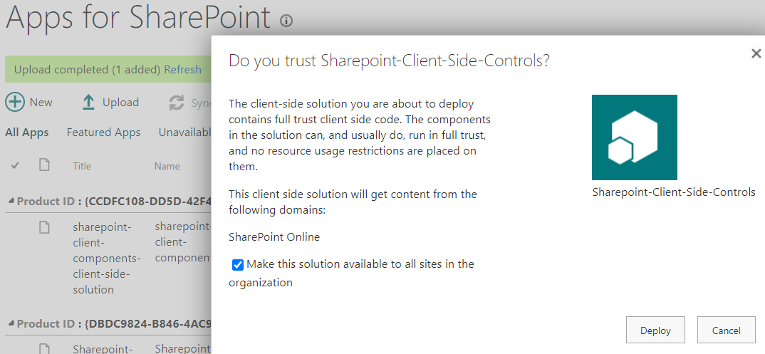

1. Once its uploaded we can see the solution as below

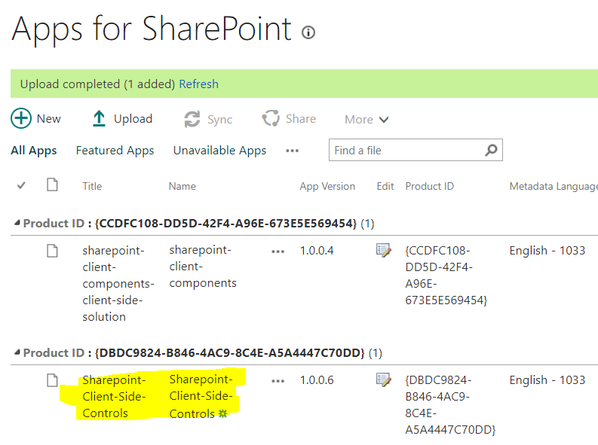

Configuration of Webpart:

1. Make sure we have list with below columns is available in the site

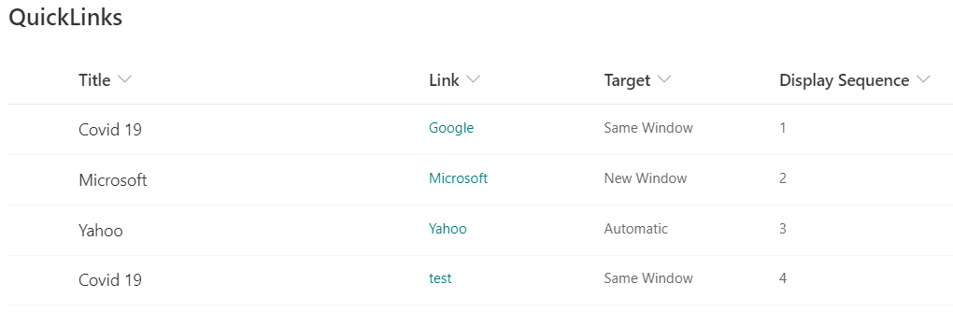

1. Add QuickLinks web parts in the page

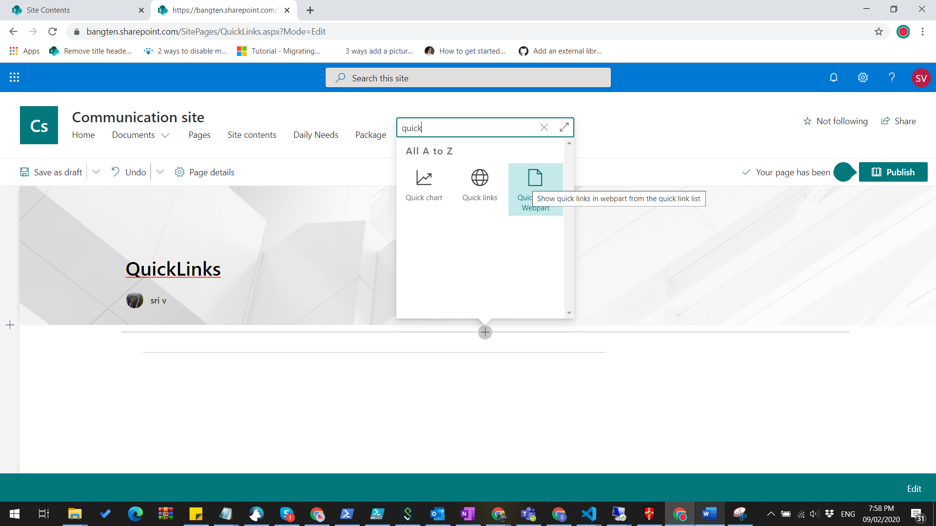

1. Edit the webpart property to configure the webpart properties

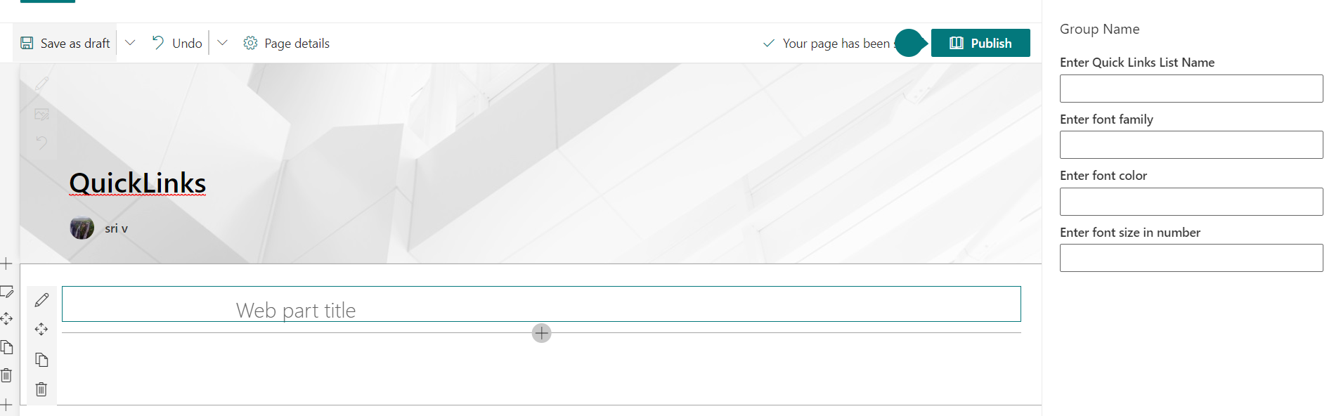

1. Update the properties with the corresponding list and type

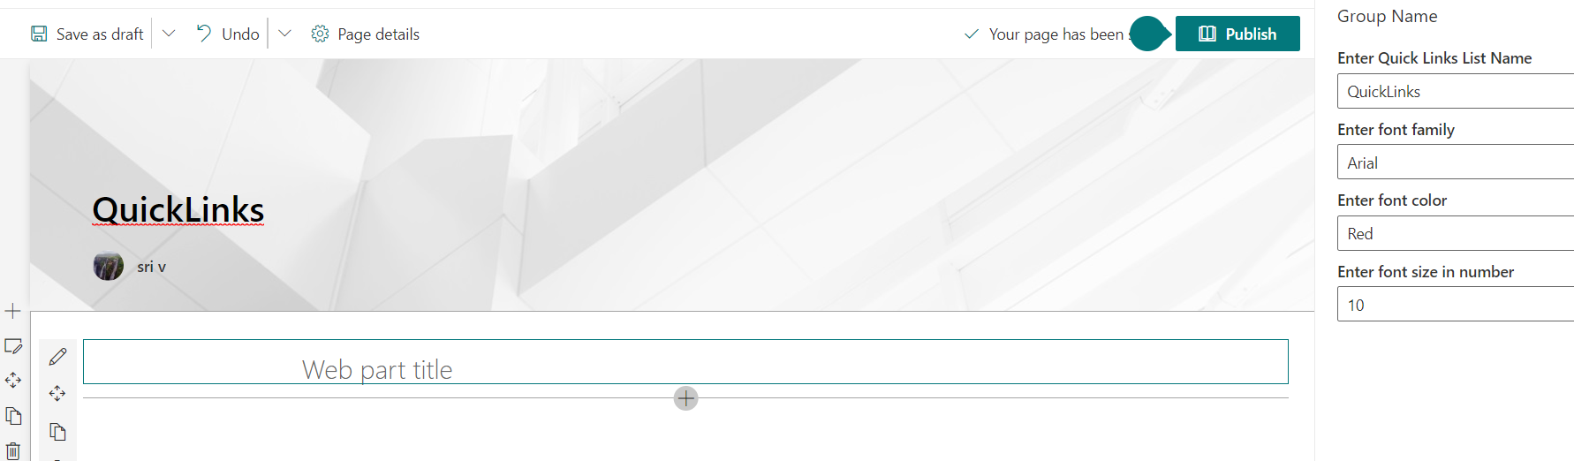

1. Close the property pane and publish the page (We can refresh the page also)



Note: Here we can set the web part title also

Configuration of Daily Needs

1. Create list with below columns

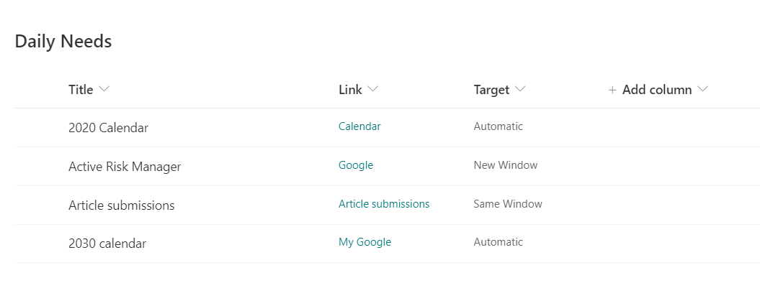

1. Add the TypeAheadControl webpart to the page where this needs to be displayed

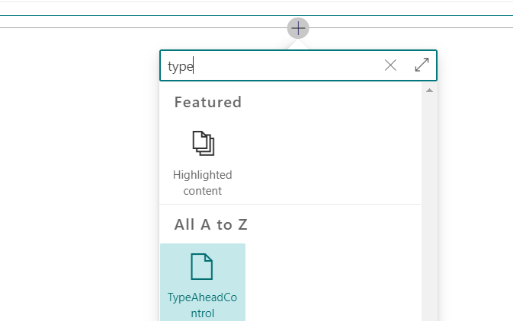

1. Open the webpart properties and configure the data

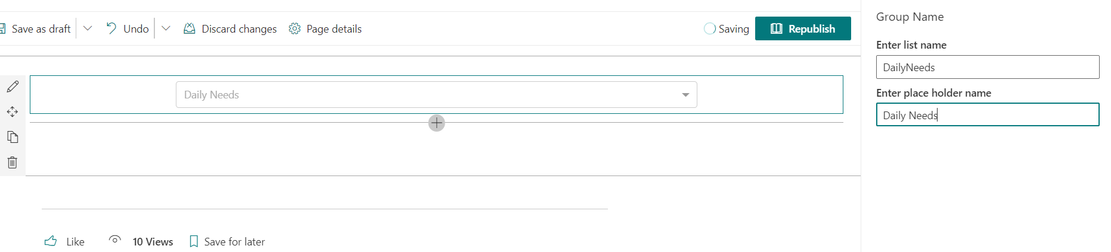

1. Publish the page and refresh the page to see the records

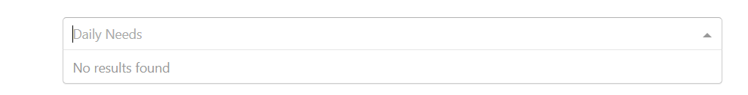

Source code of the project:

<https://github.com/bangten/2019>