Employee Management System Project Plan
  - Prepared for Meítǐ Shāngchéng
Prepared by: Employee Management System Development Team
Version 2.2 Issued 27 October 2026 Software release 2.1.0-flask Final delivery 1 November 2026

Document Change Record
Date | Version | Prepared by | Change
13 Oct 2026 | 1.0 | Liang Bangyu and team | Initial delivery baseline.
13 Oct 2026 | 1.1 | Development team | Client edition covering scope, acceptance and responsibilities.
15 Oct 2026 | 1.2 | Development team | Revised review sequence, named schedule, departure deletion, permission boundaries and proposed priorities.
26 Oct 2026 | 2.0 | Development team | Local Flask baseline and separately packaged 2.0 history.
27 Oct 2026 | 2.1 | Development team | User-authorized E01-E10 enhancement iteration.
27 Oct 2026 | 2.2 | Development team | Full planning baseline restored (WBS, dependencies, critical path, Gantt); phased and dependency figures added; aligned to URS 2.1 and release 2.1.0-flask.

Definitions Acronyms and Abbreviations
Term | Meaning
HR | Human Resources staff responsible for employee administration.
URS | User Requirements Specification defining functions, business rules and acceptance conditions.
WBS | Work Breakdown Structure grouping delivery work and responsibilities.
CPM | Critical Path Method identifying dependencies that control the completion date.

Introduction
We will deliver an independent employee management web application for Meítǐ Shāngchéng’s Zhengzhou store by 1 November 2026. It will support employee records, a basic workforce overview, manual team scheduling, personal schedule access and on-site check-in.
This plan defines the delivery scope, responsibilities, schedule and acceptance checks. It is paired with the URS version 2.1. Planning and design documents must be reviewed for correctness before implementation starts in the week beginning 19 October. The review dates below are proposed arrangements; approval is recorded separately.
Handover includes the runnable application, installation materials, user and installation guides, and acceptance evidence. Post-delivery maintenance is excluded.

1 Client
Meítǐ Shāngchéng is a hardware retail business preparing to open its first store in Zhengzhou, China. Its parent company, Jupiter, provides funding. This project serves the Zhengzhou store independently and does not replace or connect to Jupiter’s administration system.
Henriette, a manager identified in the initial client interview, represents the business needs in the brief. HR needs current employee information and a clear workforce overview. Supervisors need practical schedules for their own teams, and employees need access to their own work arrangements. Earlier stores in the parent-company context use calendars or spreadsheets that the client describes as overly detailed and unreliable.
The planning scale is 500 employee records. HR staffing starts with one person and may increase to two or three as the workforce grows. Employee-record volume, login accounts and simultaneous users are separate measures.

1 1 Client communication
Liang Bangyu will coordinate client communication and consolidate questions, comments and review decisions in writing. The client is requested to nominate the representative responsible for reviews and final acceptance. The four review points in Section 9 will provide the planned decision opportunities; separate periodic progress reports are not included.

2 Team
The named leads coordinate their areas. The four team members share implementation, review and integration work.
Member | Project role | Responsibilities
Liang Bangyu | Project coordinator and requirements lead | Client communication, planning, URS, user stories, decisions, manuals and handover.
Li Yuanxiang | Data and backend lead | Employee data, class and data design, business rules, permissions and attendance logic.
Liu Yixuan | Interface and scheduling lead | Interface design, manual scheduling, personal views and frontend integration.
Liu Shuai | Verification and release lead | Test planning, synthetic data, acceptance scenarios, regression and installation checks.

The team will control application and document versions, review changes before integration and identify the release used for client review and handover.

3 Current situation
The new store has no existing employee management application. The project starts with a new single-store system, without legacy migration or parent-company integration. Employee information covers name, age, position, department, address, wage or salary information and an emergency contact.
HR maintains employee records and permanently deletes the employee record when a person leaves. The departure action must remove the record from searches, direct record retrieval, workforce totals and new schedule selection, and deny all application accounts and active sessions linked to the deleted employee identity. Historical schedules, check-in records and backup treatment will be recorded at design review before implementation.
Supervisors view and arrange work only for their own team members. Ordinary employees access only their own account and its personal schedule and check-in functions. HR retains the employee-administration functions in the URS. A department field does not establish a separate department-management module.
The fixed shifts are morning 08:00-12:00, afternoon 12:00-16:00 and evening 16:00-20:00. A baseline week has five working days per employee and two different shifts per working day. Supervisors assign shifts manually. Employees may view their own schedules remotely, while check-in requires the designated workplace arrangement.

4 Problem description
The client needs to keep employee details current, find records and communicate dependable work arrangements as the store grows. HR requires a consistent employee total; supervisors need a clear team schedule; employees need a readable personal view. Personal and pay information must stay within the authorised role boundaries, and website access from home must not permit remote attendance confirmation.

5 Project goal
By 1 November 2026, the delivered release will meet the following outcomes on an identified release, using synthetic employee data for verification.
Outcome | Measure for the delivered release
Current records | HR record workflows pass; confirmed departure records stay deleted after restart (AT1).
Basic workforce overview | Basic search and current total match 500 records and subsequent changes (AT2).
Controlled access | Permitted actions pass; cross-team and cross-account access is rejected (AT3).
Clear work arrangements | Manual team schedules follow the fixed shift and weekly rules (AT4).
On-site attendance | Personal schedule viewing works remotely; remote check-in creates no record (AT5).
Usable and verified handover | Installation, guide-based tasks and mandatory release checks pass (AT6-AT8).

The 500-record check measures data volume, not 500 simultaneous users. The test record will identify the actual environment, accounts and usage profile.

6 Deliverables
The application and materials below form the single-store handover. The URS version 2.1 defines detailed requirements and interactions.
Deliverable | Included handover item
Employee management web application | Employee records and deletion, basic search and total, authentication and role boundaries, manual team scheduling, personal schedule views and on-site check-in.
Installation and configuration package | Release files, data initialisation and configuration materials required to install and start the application.
User manual | Task instructions for HR personnel, supervisors and ordinary employees.
Installation guide | Supported environment, components, configuration, start-up and verification steps for IT personnel.
Acceptance package | Release identification, acceptance checklist, test results and installation verification record.

6 1 Requirement priorities
The proposed priority classification retains the ten core functional requirements FR-01 to FR-10 and all nine non-functional requirements NFR-01 to NFR-09 as Must. These must be implemented and verified before acceptance. Basic employee search and the current employee total remain core functions.
Grouped department and position statistics are proposed as Should under FR-11. They are expected unless the schedule is insufficient and may then be removed. Combined department and position filters are proposed as Could under FR-12 and may be added only after Must and retained Should work are complete ahead of schedule. This reclassification requires scope review; it is not a recorded approval. The release record will state the agreed outcome for both optional items.

6 2 User-authorized enhancements
On 26 October 2026 the client authorized E01-E10 as an enhancement of the existing release, not as new mandatory requirements. They add role workspaces, directory filters and full-match export, a read-only team week, clearer invalid-schedule feedback, manual previous-week drafts, personal-schedule navigation, check-in history filters and export, authorized print views and an office-style responsive layout. The original FR-01-FR-12 and AT1-AT8 identifiers are unchanged; the enhancements are traceable in URS 2.1 and are included in release 2.1.0-flask. They do not change the delivery date, the Must set or the acceptance checks.

7 Non deliverables
Item | Release boundary
Group and organisation expansion | Jupiter integration, multi-store administration, product or stock management, and advanced department workflows are excluded.
Automatic scheduling and added services | Automatic allocation, sick-leave notifications and flexible working-day extensions are excluded.
Advanced payroll | Store pay information only; tax, bonuses, deductions and salary payment are excluded.
Additional platforms and migration | No separate native mobile app, separate employee website or legacy-system migration. Personal access uses the web application.
Services after handover | No post-delivery maintenance, continuing support, managed hosting or operational service.

Testing, corrections and regression before handover remain included. Any additional feature or service requires a separate written scope agreement. Planning, requirements, user stories, class diagram and test records support the reviews; the final handover contains the application and materials listed above.

8 Constraints

8 1 Delivery period
The delivery baseline is 13 October to 1 November 2026 inclusive, a period of 20 calendar days. The week of 12-18 October is reserved for planning and design documentation. Formal implementation starts no earlier than 19 October and only after the project plan, URS, user stories and class diagram have been reviewed and confirmed correct. A planned date alone does not authorise implementation.
The proposed review discussion on 16 October and final documentation and design review on 18 October are included in the schedule. Any unresolved decision that blocks an activity must be closed before that dependent activity begins. Changes to scope, dates or responsibilities require a recorded decision and an updated schedule.

8 2 Fees and expenditure
Cost category | Commercial boundary
Development fees | Development fees and payment terms require a written agreement between the client and the development team.
Third-party purchases | Written approval must identify the item, price and paying party before a purchase is made on the client’s behalf.
Operating costs | Responsibility for hosting, domain, network and recurring charges must be recorded before a paid service is commissioned.

The installation package and guides are included. Scope approval does not authorise additional expenditure.

8 3 Operation and data
The application will run on one execution host and be accessed through a current desktop browser. It will maintain the Zhengzhou store’s own accounts and employee data. Authorised remote access supports personal schedule viewing; on-site check-in uses a separate workplace restriction.
Design review must record the host and deployment arrangement, the on-site check-in procedure, account and team configuration responsibilities, and the treatment of historical schedules, check-ins and backups after employee deletion. These decisions must be reflected consistently in the URS, class diagram, test plan and installation guide before the affected implementation begins.
The installation guide will identify the supported environment, components, configuration and start-up checks. Verification will use separate role accounts and 500 synthetic employee records. Performance evidence will state the tested usage profile without equating record volume to concurrent sessions.

8 4 Quality and cooperation
We will verify the mandatory workflows, role boundaries, deletion, persistence, schedule rules, remote-access separation and installation on the release presented for acceptance. The client is requested to provide review decisions, representative business scenarios and access to the installation and on-site acceptance environment. We will supply review versions, guides and verification evidence.

9 Phasing

9 1 Phases and client reviews
The following dates are the proposed delivery arrangements. Each review records the reviewed versions, findings, decision and outstanding actions. No completed review or approval is asserted by this plan.
Phase | Dates | Stage result and proposed review
Requirements | 13-16 Oct | Project plan, URS and user stories. Review discussion on 16 Oct: scope, priorities, roles, business rules and acceptance checks.
Design | 17-18 Oct | Class diagram, data design, interface views and deployment decisions. Review on 18 Oct: confirm all required planning and design documents are correct before implementation.
Implementation | 19-26 Oct | After confirmation, build the core routes in parallel and complete attendance integration on 26 Oct.
Verification | 27-30 Oct | Workflow, permission, deletion, scheduling, attendance and installation evidence. Release-readiness review on 30 Oct.
Handover | 31 Oct-1 Nov | Package the verified release and guides. Final demonstration, acceptance record and transfer on 1 Nov.

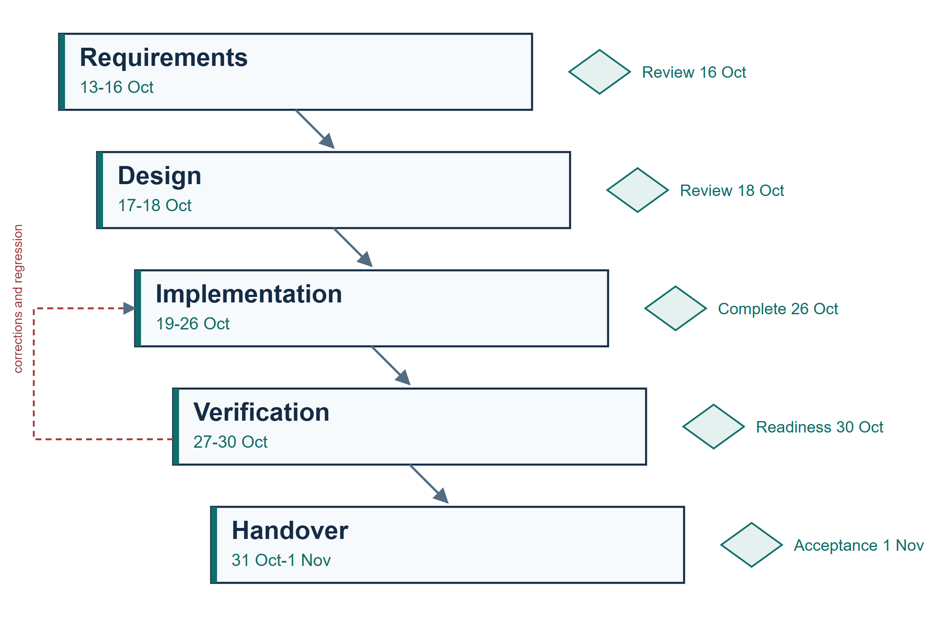
Figure 1 Phased delivery model with client review gates; diamonds mark reviews and the dashed arrow is the verification feedback loop
The classroom review on 28 October is a readiness checkpoint inside the verification phase; it is not the final acceptance described in Section 9.8.

9 2 Work breakdown structure
The WBS groups work by purpose: business analysis and requirements; solution design; application implementation and integration; user and installation documentation; and verification, release and handover. Section 2 assigns the coordinating leads. The named packages on the next page show the task dependencies directly.
Business analysis leads to the project plan, URS and user stories, followed by class diagram and interface design. The final preimplementation review must confirm all four required documents before any implementation route begins. Employee records, authentication and scheduling then run in parallel. All three must finish before attendance integration and the final guides begin.
Verification follows attendance integration. Packaging requires both verification and the completed guides. Final acceptance follows packaging. Coordination, document control and review work are included in these packages; they do not add hidden task durations.

9 3 Review decisions and changes
At the requirements review, the client and team will record the priority decision for grouped statistics and combined filters. At design review, they will settle the deletion-related history policy and the operational arrangements listed in Section 8 3. Open decisions are tracked against the affected work package.
A proposed change will state its business purpose and effects on requirements, deliverables, acceptance, dates and fees. Changes affecting client scope or responsibilities require a written decision by both parties before implementation. The URS, schedule and acceptance checklist will be updated together.

9 4 Work packages and dependencies
Durations are elapsed calendar days. Links are finish-to-start with zero lag; every named predecessor must finish before its successor begins. Planning and design review activities are included in the first three packages. Implementation also requires the confirmation in Section 8 1.
Work package | Days | Predecessors | Planned dates
Business analysis and scope | 2 | None | 13-14 Oct
Project plan URS and user stories | 2 | Business analysis and scope | 15-16 Oct
Class diagram and interface design | 2 | Project plan URS and user stories | 17-18 Oct
Employee records and overview | 5 | Class diagram and interface design | 19-23 Oct
Authentication and permissions | 3 | Class diagram and interface design | 19-21 Oct
Manual scheduling and employee views | 5 | Class diagram and interface design | 19-23 Oct
On-site attendance and integration | 3 | Employee records and overview; Authentication and permissions; Manual scheduling and employee views | 24-26 Oct
User manual and installation guide | 4 | Employee records and overview; Authentication and permissions; Manual scheduling and employee views | 24-27 Oct
Verification and regression checks | 4 | On-site attendance and integration | 27-30 Oct
Release packaging and installation checks | 1 | Verification and regression checks; User manual and installation guide | 31 Oct
Final acceptance and handover | 1 | Release packaging and installation checks | 1 Nov

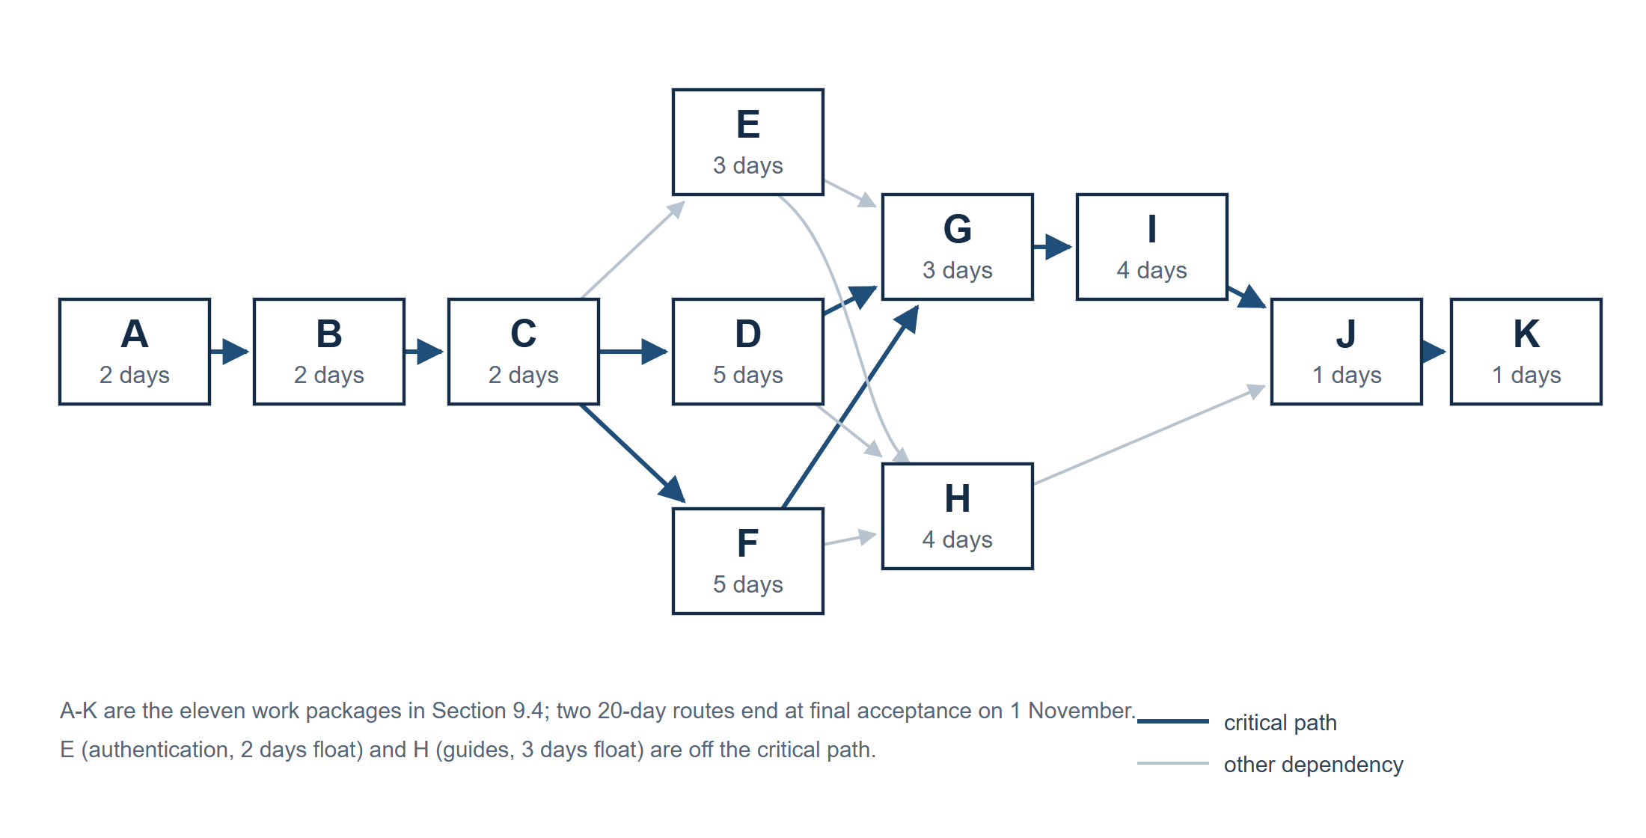
Figure 2 Dependency network for the eleven work packages; blue links are the two critical routes

9 5 Critical path calculation
Day 0 is the start of 13 October. Day 20 is the end of 1 November. Earliest finish equals earliest start plus duration; earliest start is the greatest predecessor finish. The backward pass uses the smallest successor latest start. Total float is latest start minus earliest start.
The following page gives the calculated boundaries using the same package names. Zero-float work controls the final date; the two core implementation routes have equal duration. Any revised dependency or duration requires recalculation before a new milestone commitment.

9 5 Critical path calculation continued
Work package | ES | EF | LS | LF | Float
Business analysis and scope | 0 | 2 | 0 | 2 | 0
Project plan URS and user stories | 2 | 4 | 2 | 4 | 0
Class diagram and interface design | 4 | 6 | 4 | 6 | 0
Employee records and overview | 6 | 11 | 6 | 11 | 0
Authentication and permissions | 6 | 9 | 8 | 11 | 2
Manual scheduling and employee views | 6 | 11 | 6 | 11 | 0
On-site attendance and integration | 11 | 14 | 11 | 14 | 0
User manual and installation guide | 11 | 15 | 14 | 18 | 3
Verification and regression checks | 14 | 18 | 14 | 18 | 0
Release packaging and installation checks | 18 | 19 | 18 | 19 | 0
Final acceptance and handover | 19 | 20 | 19 | 20 | 0

ES and EF are earliest start and finish boundaries; LS and LF are latest boundaries preserving Day 20. A finish boundary is the end of the preceding calendar day. The authentication route has two days of float; the guide work has three. Other packages have zero float.
Critical employee route: Business analysis and scope → Project plan URS and user stories → Class diagram and interface design → Employee records and overview → On-site attendance and integration → Verification and regression checks → Release packaging and installation checks → Final acceptance and handover.
Critical scheduling route: Business analysis and scope → Project plan URS and user stories → Class diagram and interface design → Manual scheduling and employee views → On-site attendance and integration → Verification and regression checks → Release packaging and installation checks → Final acceptance and handover.
Each route totals 2 + 2 + 2 + 5 + 3 + 4 + 1 + 1 = 20 calendar days, ending on 1 November.

9 6 Gantt schedule
Activity | 13-16  Oct | 17-18  Oct | 19-23  Oct | 24-26  Oct | 27-30  Oct | 31 Oct  1 Nov
Analysis and requirements | 13-16
Class diagram and interface design |  | 17-18
Employee records and scheduling |  |  | 19-23
Authentication and permissions |  |  | 19-21
Attendance and integration |  |  |  | 24-26
User manual and installation guide |  |  |  | 24-26 | 27
Verification and regression |  |  |  |  | 27-30
Packaging and acceptance |  |  |  |  |  | 31 / 1

9 7 Quality assurance and project coordination
The team will check that the application, URS, guides and acceptance checks describe the same release. Permission and deletion checks include direct requests as well as normal screens. Relevant corrections require regression checks. Installation will be tested from the delivered guide in a clean supported environment.
Evidence will identify the release, environment, scenario, expected result and observed result. A planned scenario, document review or successful build alone does not establish user acceptance. Synthetic data and representative participant roles will be identified in the record.

9 8 Acceptance requirements and handover
These named checks retain AT1-AT8 for traceability with the URS. The client will review the acceptance baseline during requirements review and the release evidence during readiness review and final acceptance.
Check | Acceptance requirement and evidence
AT1 Employee records | HR can add, find, view and update the specified fields, and confirm permanent deletion on departure. Invalid input is rejected. A deleted record cannot be retrieved directly or after restart. All application accounts and active sessions linked to the deleted employee identity are denied.
AT2 Overview and volume | Basic search and current employee totals match 500 synthetic records. Add, update and delete actions give the expected results, including removal from new schedule selection. Optional statistics and filters follow the recorded priority decision.
AT3 Permissions | HR, supervisor and employee accounts pass their authorised workflows. Supervisors cannot operate outside their own teams; ordinary employees cannot access another account’s data. Direct cross-team and cross-account requests are rejected without unauthorised changes. Pay-data access follows the reviewed matrix.
AT4 Manual scheduling | Supervisors assign and adjust only their own teams’ schedules. Fixed shifts are 08:00-12:00, 12:00-16:00 and 16:00-20:00. A baseline week has five workdays and two different shifts per workday per employee. Invalid assignments are identified.
AT5 Schedule and check-in | Employees view only their own schedules, including remotely. A dedicated on-site action records employee identity and check-in time. Remote check-in is rejected without creating an attendance record.
AT6 Installation | A tester installs the identified release in a clean supported environment using the package and guide, starts it and verifies login, saved data and the documented check-in restriction.
AT7 Documentation | Representative HR, supervisor and employee tasks can be completed with the user manual. The installation guide matches the delivered configuration, start-up and verification steps.
AT8 Release and transfer | All Must functional and non-functional scenarios pass on the identified release. The record states whether FR-11 Should and FR-12 Could were included, deferred or excluded, with the agreed decision and test result for included items. The application, guides, configuration and verification evidence are identified at transfer.

On 1 November 2026, we will demonstrate the release, complete the acceptance record and transfer the deliverables in Section 6. Required testing, corrections and regression before acceptance are included. Final handover closes the project; post-delivery maintenance and continuing support are excluded.

