Employee Management System User Requirements Specification
  - Group 2 | Meiti Shangcheng | 28 October 2026
Version 2.1 | Prepared 27 October 2026 for the Group 2 client review | Release 2.1.0-flask
Members: 梁邦羽 / Liang Bangyu; 李远向 / Li Yuanxiang; 柳懿轩 / Liu Yixuan; 刘帅 / Liu Shuai.
Location: to be confirmed. Tutor and client reviewer: course teacher; name to be confirmed.
Date and version | Change
15 October 2026 | URS 1.1 | Earlier document baseline retained separately.
26 October 2026 | URS 2.0 | Original FR and local Flask baseline preserved.
27 October 2026 | URS 2.1 | Document revision for E01–E10 authorized on 26 October; original identifiers retained.

Introduction and background
This specification defines the user-visible behavior of the standalone Meiti Shangcheng employee-management web application. It aligns the previous URS v1.1 with the confirmed Python/Flask stack, no-JavaScript constraint and local 28 October demonstration. It defines a review baseline rather than asserting client approval.

Contents
Scope and roles; employee information; functional requirements; non-functional requirements; use case models and descriptions; interface design; acceptance and traceability.

Scope and objectives
Maintain current employee information, correct workforce views and clear manual work arrangements within authorized roles. Employee records and sign-in accounts are distinct identities; multiple accounts can refer to one employee. This release retains FR-01–FR-12 and adds the separately identified, user-authorized E01–E10 iteration. FR-11 remains Should and FR-12 remains Could for priority traceability; these labels do not imply teacher approval.
Exclusions are automatic scheduling, product/stock management, payroll processing, department administration, employee editing of personal data, sickness/leave workflows, Jupiter integration, multiple stores, managed hosting and post-handover maintenance.

Stakeholders and users
Capability | HR | Supervisor | Employee
Employee creation / update / deletion | Store | No | No
Full personal, pay and emergency details | Store | No | No
Directory and headcount | Store | Own team | No
Create / adjust team week | No | Own team | No
Employee CSV export | All matching records | No | No
Saved team week / prior-week draft | No | Own team | No
Personal history / CSV / print | Employee role required | Employee role required | Own identity
Own personal shifts and check-in | Employee role required | Employee role required | Own identity
Sign in and out | Yes | Yes | Yes

Employee information
Group | Rule
Name | Required. Same-name people are separate records.
Age | Optional non-negative whole number; blank is allowed.
Position / Department | Two separate optional text groups. A field does not create a management module.
Address | Optional text, visible only in HR full records.
Pay information | Optional free text; no calculation or payment.
Emergency contact | Optional text, visible only in HR full records.

Functional requirements
The Must behaviors below form the review baseline for 28 October 2026. FR-11 and FR-12 are implemented enhancements whose Should/Could labels remain proposed for client review. Each requirement is verified through its linked use case, the named acceptance checks and the GUI scenarios in the Test Plan. A passing developer check does not pre-fill an independent result.

FR-01 Authentication and scoped access
Must | UC-01, UC-11 | AT3, AT6. Assigned accounts sign in and out; every protected request checks role, employee ownership and team scope.

FR-02 Create employee
Must | UC-02 | AT1, AT2, AT3. HR saves the seven information groups. Name is required, age is optional and non-negative; same-name employees remain distinct.

FR-03 Search and view employee
Must | UC-03 | AT1, AT3. HR searches full or partial names, clears filters and opens the selected full record. Full personal records are HR only.

FR-04 Update employee
Must | UC-04 | AT1, AT2. HR saves valid edits. Invalid, cancelled or stale edits preserve the saved record and do not change the total.

FR-05 Delete departing employee
Must | UC-05 | AT1, AT2, AT3. HR confirms the exact employee name. Delete the record and linked accounts, sessions, assignments and check-ins in one transaction.

FR-06 Workforce lists and totals
Must | UC-06 | AT2, AT3. HR sees the store list and total. Supervisors see their own team and permitted identification fields. Each employee is counted once.

FR-07 Create manual team schedule
Must | UC-07 | AT3, AT4. A supervisor manually selects five working days and two distinct fixed shifts per day for every current own-team member. Save only a complete valid week.

FR-08 Revise manual team schedule
Must | UC-08 | AT3, AT4. A supervisor changes a saved own-team week under the same rules. Rejected, cancelled or stale submissions preserve the previous week.

FR-09 View personal schedule
Must | UC-09 | AT3, AT4, AT5. Employees view only their own dates, shifts and times. The view is read-only and shows a clear empty-week state.

FR-10 On-site check-in
Must | UC-10 | AT3, AT5. Check the signed-in employee identity and configured source network; save identity and China Standard Time. Reject remote or unverified sources. Retry the same operation without duplication.

FR-11 Grouped workforce counts
Should | UC-06 | AT2, AT3. Show department and position counts within the permitted scope; each grouping reconciles with the employee total. Included in this demonstration release.

FR-12 Combined HR filters
Could | UC-03 | AT1, AT2, AT3. HR combines name, exact department and exact position. Criteria apply together; clearing filters restores the directory. Included in this demonstration release.

Business rules and local operating choices
Fixed shifts: Morning 08:00–12:00; Afternoon 12:00–16:00; Evening 16:00–20:00. The week is Monday–Sunday. Each current team employee has five working days with two different shifts on each working day. Complete-week saving is atomic and manual; no shifts are automatically allocated by the application.
Deletion removes the live employee record and its linked users, sessions, assignments and check-ins through SQLite foreign keys. It does not remove separately stored backup files. An empty saved week may remain after its final employee is deleted; the employee must no longer be retrievable or eligible for scheduling.
The demonstration server binds to 127.0.0.1. The default workplace allow-list is 127.0.0.1/32 and ::1/128. The server evaluates the direct connection address and ignores forwarded headers. This supports a local demonstration and source-policy simulations; real remote viewing, TLS and actual workplace distinction require a suitable environment and separate verification. Account and team initialization are local installation tasks. HR accounts have no employee/team link; supervisor accounts link to one team; employee accounts link to one employee. Personal access uses an employee-role account.

Non functional requirements
All nine quality requirements remain Must. Verification references distinguish achieved local checks from acceptance that still requires an external environment or an independent user.

NFR-01 Authorization
Enforce role, own-team and own-employee boundaries on the server, including direct requests and revoked sessions. Verification: TC11–13, TC17, TC22, TC29–33, TC39–40.

NFR-02 Personal-data protection
Use password hashes, CSRF tokens, escaped templates and restricted fields. Configure HTTPS before non-loopback use. Verification: TC03, TC12, TC25–26; external HTTPS pending.

NFR-03 Persistence
Saved creation, update, deletion, schedules and check-ins remain effective when the application reopens the same database. Unsaved forms are not reported as saved. Verification: TC23 and TC35 reopen the application instance; independent process stop/start is an installation check.

NFR-04 Validation and completion
Reject invalid or stale inputs; write complete transactions; prevent duplicate check-in retries; show errors without false success. Verification: TC05, TC08–10, TC15–18, TC20, TC27, TC34, TC38.

NFR-05 Usability
Use consistent names, explicit actions, selected identity/week and clear success, empty and error states. Verification: Current-release browser evidence; independent user acceptance pending.

NFR-06 Standalone installation
Run on one local Windows host with Python, Flask and SQLite. Include source, offline dependencies, initialization and startup instructions. Verification: Clean virtual-environment installation check.

NFR-07 Record volume
Use 500 fictional employee records for retrieval and correct totals. This is not a 500-account or concurrent-user claim. Verification: TC04, TC07, TC12, TC24.

NFR-08 Viewing versus check-in
Personal viewing is allowed from an authorized connection; check-in requires a configured workplace network and ignores forwarded source headers. Verification: TC19, TC21; real-network acceptance pending.

NFR-09 Release and handover
Identify version 2.1.0-flask consistently in application, guides and evidence. Keep local verification separate from teacher and peer acceptance. Verification: Release manifest and evidence ledger.

Capacity and input boundaries
Use 500 fictional employee records. Record count is distinct from account count and simultaneous users. Name is limited to 120 characters and each other text group to 1000 characters. Age is a non-negative ASCII whole number of at most nine digits. These are input-storage limits, not employment-policy decisions. Data is stored after successful validation and transaction completion.

Use case models
The following diagrams retain the original business and shared-access use case structure. UC-01–UC-11 keep their identifiers. The separately described UC-E cases cover new workspace, export, preview, draft, history and print actions in this user-authorized iteration.
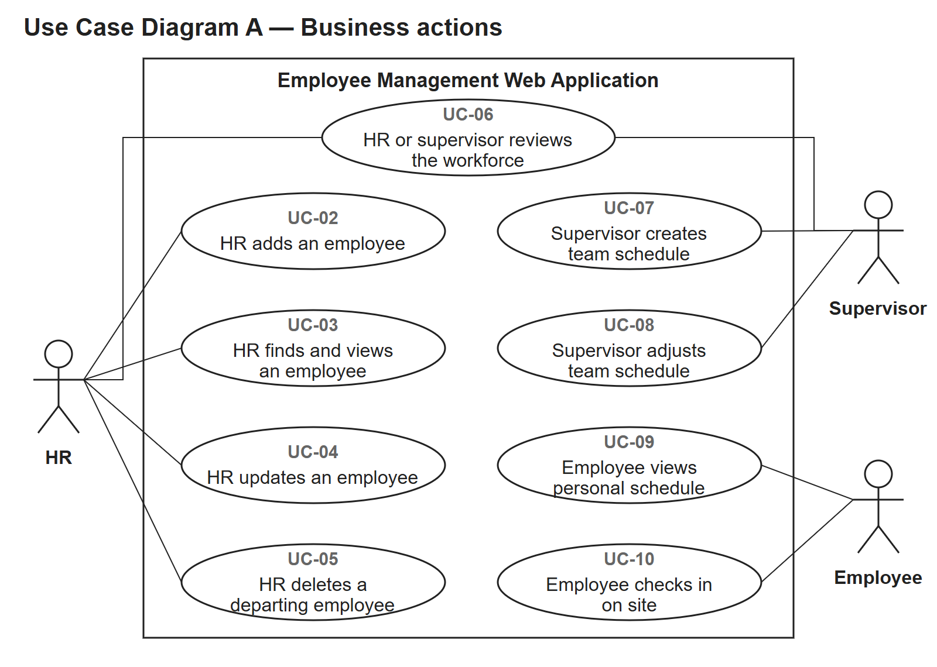
Figure 1 Business use cases and role boundaries
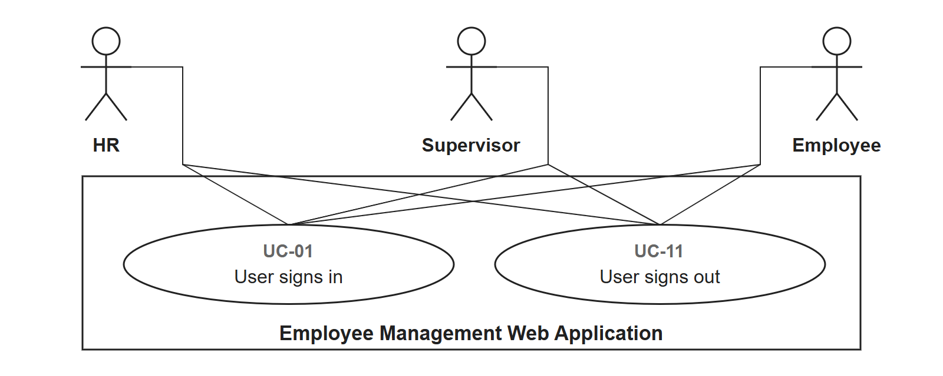
Figure 2 Shared sign-in and sign-out use cases

Use case descriptions

UC-01 Sign in
Actor: All users. Related requirements: FR-01. Preconditions: The application is running and the sign-in page is available.
Trigger: A user requests protected access. Main success scenario: Open Sign in, enter assigned credentials, submit. The system creates a server-side session and opens the permitted workspace.
Extensions and exceptions: Invalid credentials show a generic error and create no session; excessive failures are temporarily limited.
Postconditions: Only the assigned workspace opens; unsuccessful sign-in creates no session.

UC-02 Create employee
Actor: HR. Related requirements: FR-02. Preconditions: The actor is signed in with the required role.
Trigger: A person joins the workforce. Main success scenario: Open Workforce, choose Add employee, enter values and Save employee. Reopen the new record.
Extensions and exceptions: Blank name or invalid age is rejected; input is retained; Cancel returns without saving.
Postconditions: One valid employee is saved, or no record is added on rejection/cancellation.

UC-03 Search and view
Actor: HR. Related requirements: FR-03, FR-12. Preconditions: The actor is signed in with the required role.
Trigger: HR needs to locate an employee. Main success scenario: Enter a name, Search, identify the record number and View details. Clear restores the list.
Extensions and exceptions: No match shows an empty result; same-name people have distinct record numbers; non-HR full-record requests are denied.
Postconditions: The selected record or an empty result is shown; stored values are unchanged.

UC-04 Update employee
Actor: HR. Related requirements: FR-04. Preconditions: The actor is signed in with the required role. The selected employee exists.
Trigger: An employee’s recorded information changes. Main success scenario: Open a record, Edit employee, change values and Save changes. Reopen to compare.
Extensions and exceptions: Invalid or stale values are rejected; Cancel leaves saved data unchanged.
Postconditions: Valid revisions persist; rejected, stale or cancelled edits retain the prior record.

UC-05 Delete employee
Actor: HR. Related requirements: FR-05. Preconditions: The actor is signed in with the required role. The selected employee exists.
Trigger: An employee leaves the workforce. Main success scenario: Open Delete employee, review consequences, type the exact name and confirm permanent deletion.
Extensions and exceptions: Wrong confirmation or Cancel preserves data; deleted records return unavailable; all linked access is revoked.
Postconditions: The employee and linked live records are deleted and access is revoked; cancellation or failure preserves them.

UC-06 View workforce
Actor: HR / supervisor. Related requirements: FR-06, FR-11. Preconditions: The actor is signed in with the required role.
Trigger: An authorized user needs a workforce overview. Main success scenario: Open Workforce. HR sees the store; the supervisor sees their assigned team, counts and permitted fields.
Extensions and exceptions: No records show zero and an empty directory. Employees cannot open workforce lists.
Postconditions: Only the permitted store/team information is displayed; viewing changes no records.

UC-07 Create team week
Actor: Supervisor. Related requirements: FR-07. Preconditions: The actor is signed in with the required role. The team has current members and the selected week has no saved schedule.
Trigger: The supervisor needs an unsaved team week. Main success scenario: Open a week without a schedule, manually select two shifts on five days per team member, then Save complete week.
Extensions and exceptions: Reject missing employees, invalid day counts, invalid shifts and out-of-team entries; no partial valid week is saved.
Postconditions: A complete valid own-team week is saved, or no completed week is created.

UC-08 Revise team week
Actor: Supervisor. Related requirements: FR-08. Preconditions: The actor is signed in with the required role. The own-team week is already saved.
Trigger: The supervisor needs to revise a saved week. Main success scenario: Open a saved week, change assignments, Save complete week and reopen the week.
Extensions and exceptions: Invalid or stale revision preserves the saved week; Discard unsaved changes reloads it.
Postconditions: A valid revision is saved; invalid, stale or discarded revisions preserve the previous week.

UC-09 View own schedule
Actor: Employee. Related requirements: FR-09. Preconditions: The actor is signed in with the required role. The employee-role account links to an existing employee.
Trigger: The employee needs personal working dates. Main success scenario: Open My schedule, choose a week and select Open week. Read dates and fixed shift times.
Extensions and exceptions: An empty week has a clear message; another employee identity and edit requests are denied.
Postconditions: The employee sees only the personal week or an empty state; no assignments change.

UC-10 Check in
Actor: Employee. Related requirements: FR-10. Preconditions: The actor is signed in with the required role. The employee-role account links to an existing employee.
Trigger: The employee requests a check-in. Main success scenario: Open Check in from an allowed network, submit Check in now and read the saved timestamp/history.
Extensions and exceptions: Remote, unverified, forged or other-identity submissions fail; retrying the same signed operation does not duplicate it.
Postconditions: One identity-bound check-in is saved for an accepted operation; rejection creates none and retry returns the existing record.

UC-11 Sign out
Actor: All users. Related requirements: FR-01. Preconditions: The actor is signed in with the required role.
Trigger: The user finishes the session. Main success scenario: Choose Sign out. The system removes the current server session and returns to Sign in.
Extensions and exceptions: Protected pages require a new sign-in after sign-out or employee deletion.
Postconditions: The current session is removed; protected pages require sign-in again.

Interface design and navigation
All pages are rendered by Jinja templates and use ordinary HTML forms. GET opens or searches information; POST submits mutations with a CSRF token. Successful mutations redirect to a GET page. The response policy forbids JavaScript execution.
Page | Purpose and actions
Sign in | Assigned username/password form; clear generic failure message.
Workforce | Role-scoped totals and directory; HR name/department/position filtering; record-number identification.
Employee record | Seven information groups with HR-only edit and separate departure action.
Employee form | Name required; optional values; server validation and Cancel navigation.
Delete employee | Explicit affected identity and consequences; exact-name confirmation.
Team schedule | Week selection; own-team seven-day checkbox grid; complete-week save or discard.
My schedule | Read-only shifts, week navigation, planned hours and separate today/next-shift summaries.
Check in | Connection availability, own identity, signed submission and recent records; full dated history is separate.

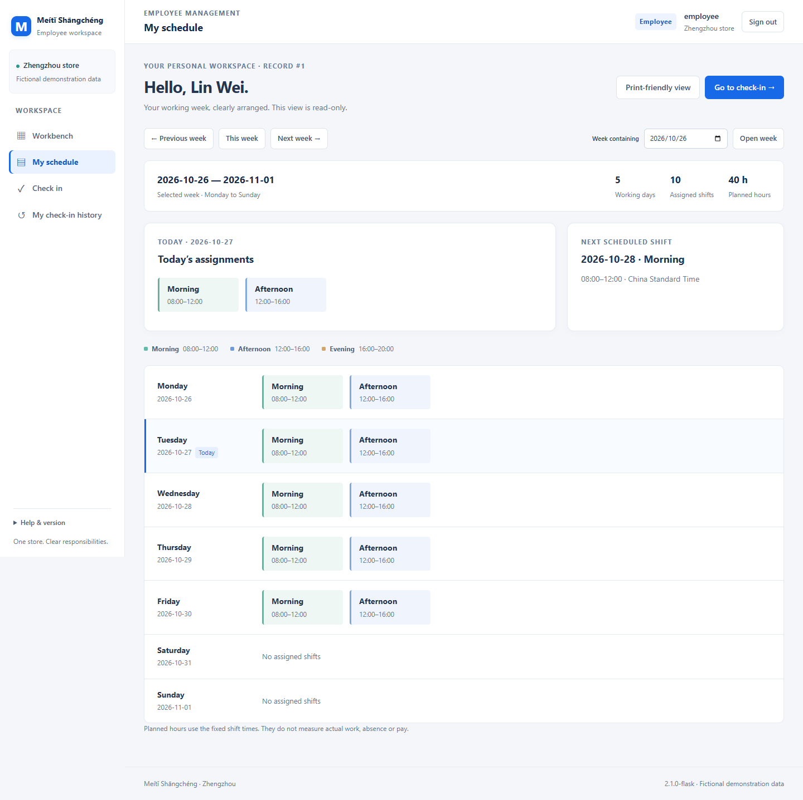
Figure 3 Personal schedule from the isolated browser check of the frozen release

Acceptance and traceability
Requirements | Use cases | Acceptance checks | Supporting local checks
FR-01 | UC-01, UC-11 | AT3, AT6 | TC01–03, TC11–13, TC29–33, TC39–40
FR-02 | UC-02 | AT1, AT2, AT3 | TC04–06
FR-03 | UC-03 | AT1, AT3 | TC07, TC12
FR-04 | UC-04 | AT1, AT2 | TC08–09, TC35
FR-05 | UC-05 | AT1, AT2, AT3 | TC10–11, TC23, TC37
FR-06 | UC-06 | AT2, AT3 | TC12, TC24
FR-07 | UC-07 | AT3, AT4 | TC14–18, TC34, TC38
FR-08 | UC-08 | AT3, AT4 | TC14–18, TC34–35, TC38
FR-09 | UC-09 | AT3, AT4, AT5 | TC13, TC19
FR-10 | UC-10 | AT3, AT5 | TC20–22
FR-11 | UC-06 | AT2, AT3 | TC24
FR-12 | UC-03 | AT1, AT2, AT3 | TC24

AT1 covers employee records; AT2 counts; AT3 permissions; AT4 schedules; AT5 personal access and check-in; AT6 installation; AT7 usability; AT8 release and transfer. The formal GUI Test Plan maps observable scenarios to the use cases. The automated evidence is supplementary and is not an independent peer test report.

Open acceptance items
Record the teacher’s findings on 28 October, independent peer GUI execution, representative-user usability, any required physical-device testing and any real network/TLS arrangement. Do not mark these accepted solely because a developer test or local demonstration passes. Final acceptance is recorded against the reviewed release and actual decisions.

User authorized enhancement requirements
E01–E10 identify the user-authorized iteration of 26 October 2026. They supplement the retained FR-01–FR-12, all nine NFRs and AT1–AT8. Their inclusion does not change the historical Should/Could classification or assert teacher approval. The following actions retain server-side role and identity checks on direct requests.

E01 Role workspaces
Provide a workspace selected by the signed-in role. HR sees actual workforce totals, group summaries and record actions. A supervisor sees only the assigned team, whether the current week is saved and its assignment count. An employee sees personal arrangements for today and the selected week. Do not present invented approval, absence or attendance indicators.
Traceability: FR-01, FR-06, FR-09, FR-10; UC-01, UC-06, UC-09, UC-10, UC-E01; AT2, AT3, AT5, AT7. GET /dashboard for all signed-in roles; GET / redirects a signed-in user to the role workspace.

E02 HR filters, sorting and return context
HR combines name, exact department and exact position filters using choices from stored values. Separate department_empty=1 and position_empty=1 flags represent blank fields without reserving a real text value. Allow only id_asc, name_asc, name_desc, department_asc and position_asc sorting, with record ID as a stable tie-breaker. Preserve the filter, sorting and page context through record details, editing and return navigation. Supervisors retain the restricted team directory.
Traceability: FR-01, FR-03, FR-06, FR-12; UC-03, UC-04, UC-05, UC-06; AT1, AT2, AT3, AT7. GET /employees; HR has store scope and supervisors have only their assigned team scope.

E03 Export all matching employee records
Only HR may export all matching records in the selected order, rather than only the current 20-row page. The CSV fields are Record ID, Name, Age, Position, Department, Address, Pay information and Emergency contact. State the match count and fields before export and report X-Total-Records. Use UTF-8 with BOM and standard CSV quoting. Protect text that can become a spreadsheet formula, including formula symbols after leading whitespace or control characters. Exclude passwords, session values and tokens.
Traceability: FR-01, FR-03, FR-12; UC-03, UC-E03; AT1, AT2, AT3, AT8. GET /employees/export.csv; HR only.

E04 Read the saved team week
A supervisor reads the assigned team's saved Monday-to-Sunday week without editing it. Show each member's working days, shift count and planned duration at four hours per fixed shift. Display the number of assigned employees for each day and fixed shift. A person assigned to two shifts can appear once in each shift count. Daily people count distinct employees once per date; daily assignments count all scheduled shifts and are labelled separately. Planned duration is not actual attendance or pay.
Traceability: FR-01, FR-06, FR-07, FR-08; UC-06, UC-07, UC-08, UC-E04; AT2, AT3, AT4, AT7. GET /team-week; supervisors, assigned team only.

E05 Explain invalid and unsaved schedule changes
Group validation errors by affected team member. Retain invalid selections and their submitted version so the supervisor can correct them, and show an explicit Unsaved changes state. Keep current-member rereading, complete-week validation, the write transaction and version-conflict protection. Only a valid complete week replaces the saved week; rejected, stale or discarded forms do not replace it.
Traceability: FR-01, FR-07, FR-08; UC-07, UC-08; AT2, AT3, AT4, AT7. GET and POST /team-schedule; supervisors, assigned team only.

E06 Manually load the previous week as a draft
On the supervisor's request, map the previous saved week by weekday to an unsaved draft for the selected target week. Include only employees who remain in the current team; leave new members blank and explain a missing source week. Loading the draft is a read-only GET: it writes no database rows and does not overwrite the target's saved week. Carry the target week's current version, explain that loading replaces unsaved form choices, and require the supervisor's review confirmation before Save complete week. Apply the original full-week rules, transaction and optimistic lock. This is manual reuse, not automatic shift allocation.
Traceability: FR-01, FR-07, FR-08; UC-07, UC-08, UC-E06; AT3, AT4. GET /team-schedule?week=…&draft=previous; subsequent POST /team-schedule saves only after review confirmation; supervisors, assigned team only.

E07 Navigate and understand the personal schedule
An employee navigates the previous, current and next week and sees personal working days, shift count and planned hours. Determine today independently using the Zhengzhou date, even when the selected week is historical. Find the next shift only among saved entries from the current time through the following 90 days. State that search range when no entry exists. Viewing and summaries do not allocate shifts or establish attendance.
Traceability: FR-01, FR-09; UC-09; AT3, AT4, AT5, AT7. GET /my-schedule; employee role, own linked identity only.

E08 Filter and export personal check-in history
An employee filters only personal check-ins by optional from and to ISO dates. Include both endpoint dates using Zhengzhou local dates; reject invalid dates and a start after the end. Show 20 records per page and a clear-filter action. Export all matching records, not just the displayed page, as UTF-8 CSV with BOM and spreadsheet-formula protection. Bind every query and export to the session employee and reject attempts to switch employee_id. Preserve the existing signed-operation retry and direct-source check-in rules. History does not add sign-out, a once-per-day rule or attendance conclusions.
Traceability: FR-01, FR-10; UC-10, UC-E08; AT3, AT5, AT8. GET /my-checkins and GET /my-checkins/export.csv; employee role, own linked identity only.

E09 Print authorized schedules and history
Provide read-only HTML print views with the same server-side identity and role checks as their source pages. A supervisor prints only the assigned team week; an employee prints only the personal week or all matching personal check-in history. Use print CSS to remove navigation and preserve legible tables. Tell the user to use the browser's Ctrl+P command; no JavaScript print action is required. A print GET changes no business data.
Traceability: FR-01, FR-07, FR-08, FR-09, FR-10; UC-07, UC-08, UC-09, UC-10, UC-E09; AT3, AT4, AT5, AT7. GET /team-week/print for the assigned supervisor; GET /my-schedule/print and GET /my-checkins/print for the linked employee.

E10 Clear office interface and responsive navigation
Use the user's DingTalk reference for an office layout: a fixed or sticky desktop left navigation, current page and role/team context, a light-gray workspace, white cards, bright-blue primary actions and a clear current-page state. Retain the Meiti brand without DingTalk marks, invented modules or notification badges. At 390 pixels, provide visible navigation or native details controls and confine wide-week-table scrolling to its own region. Include skip navigation, visible focus, semantic labels, readable contrast and reduced-motion support. Restrained short transitions are a design choice, not a numerical acceptance promise. Use real links and forms without application JavaScript or a CDN.
Traceability: FR-01 and the existing role-specific functions; NFR-01, NFR-05; UC-01–UC-11 and the applicable extension use cases; AT3, AT7. all business pages, with the permission checks of their individual routes.

Additional use case descriptions

UC-E01 Open the role workspace
Actor: HR, supervisor or employee. Related: E01; FR-01, FR-06, FR-09, FR-10; AT2, AT3, AT5, AT7.
Preconditions: The application is running and the actor has a valid assigned session and role. Trigger: The actor opens the application home or chooses the workspace navigation item.
Main success scenario: Open the role workspace. Read the current identity and role context. HR reviews workforce counts and record actions; a supervisor reviews only the assigned team and saved-week status; an employee reviews personal arrangements for today and the selected week. Follow an authorized action to its corresponding page.
Exceptions: An unauthenticated request requires sign-in. Missing data has an explicit empty state. A different role or forged team/employee parameter must not expose another scope. Summary cards must not invent approvals, absences or attendance results.
Postconditions: The permitted workspace or an explanatory empty/error state is displayed; opening the workspace changes no business data.

UC-E03 Export the matching employee directory
Actor: HR. Related: E03; FR-01, FR-03, FR-12; AT1, AT2, AT3, AT8.
Preconditions: HR is signed in and the directory filter and allowed sort order are selected. Trigger: HR chooses the employee CSV export action after reviewing its fields and match count.
Main success scenario: Recheck the HR role on the export request. Apply the same matching filters and stable allowed sort order as the directory. Export all matching records using the eight contracted fields, standard CSV quoting, a UTF-8 BOM and spreadsheet-formula protection. Report the total in X-Total-Records.
Exceptions: Reject access by supervisors, employees and unauthenticated users. An invalid sort value must not become SQL. Protect formula-like text even after leading whitespace or controls. A zero-match result must be explicit. Never include passwords, session values or tokens, and never silently limit the export to the current directory page.
Postconditions: The authorized matching CSV is returned, or a clear refusal/error is shown. Employee data is unchanged.

UC-E04 Preview the saved team week
Actor: Supervisor. Related: E04; FR-01, FR-06, FR-07, FR-08; AT2, AT3, AT4, AT7.
Preconditions: The actor is signed in as a supervisor linked to an existing team; a week is selected. Trigger: The supervisor chooses the read-only team-week view.
Main success scenario: Read only the assigned team's saved Monday-to-Sunday entries. Display each member's working-day count, shift count and planned duration using four hours per fixed shift. Read each day/shift employee count, the daily distinct-employee count and the separately labelled daily assignment count.
Exceptions: Show an explicit state for no saved week or no team members. Reject another-team access. Do not use an unsaved draft as the saved preview. Do not present planned hours as actual attendance or pay; daily headcount and daily assignments must not share an ambiguous label.
Postconditions: Only the authorized saved week and clearly defined summaries are shown. No assignments or versions are changed.

UC-E06 Review and save a previous-week draft
Actor: Supervisor. Related: E06; FR-01, FR-07, FR-08; AT3, AT4.
Preconditions: The actor is signed in for the assigned team and has selected a target week. The target week's current saved version is available for conflict protection. Trigger: The supervisor explicitly chooses to load the previous week as a draft.
Main success scenario: Use a GET request to read the previous saved week and map its weekdays to the target form for current team members. Explain that this replaces unsaved form choices. Keep the target saved week unchanged and carry its version. The supervisor reviews and adjusts every member's choices, marks the review confirmation, and submits Save complete week. Recheck team scope, current membership, the target version and the original five-days/two-distinct-shifts rules, then save the whole valid week atomically.
Exceptions: Loading the draft writes zero database rows. Missing source data has an explicit empty state; new members remain blank and departed members are excluded. Reject a missing review confirmation, invalid or incomplete week, unauthorized team or stale target version. A rejected save preserves the previously saved target week; loading alone never commits a schedule.
Postconditions: After loading only, the draft exists only in the returned form and the database is unchanged. After a valid confirmed save, one complete target week persists. Rejection leaves saved data intact. No shifts are automatically allocated.

UC-E08 Read and export personal check-in history
Actor: Employee. Related: E08; FR-01, FR-10; AT3, AT5, AT8.
Preconditions: The actor is signed in with an employee-role account linked to an existing employee. Trigger: The employee opens personal check-in history, changes its date filter or chooses its CSV export.
Main success scenario: Read the optional from and to dates, validate ISO dates and their order, and match the linked employee's records using inclusive Zhengzhou local-date boundaries. Display 20 records per page, preserve the dates through pagination, and allow the filter to be cleared. For export, return all matching personal records as UTF-8 CSV with BOM, normal CSV quoting and spreadsheet-formula protection.
Exceptions: Reject invalid dates, a start after the end and attempts to switch employee identity. Require sign-in and deny other roles. Show an explicit zero-result state. Do not limit export to the visible page or describe history as sign-out, a once-per-day check-in rule or proof of attendance.
Postconditions: Only the linked employee's matching history or CSV is returned. Reading, filtering and exporting create no check-ins and alter no existing records.

UC-E09 Open an authorized print view
Actor: Supervisor for the assigned team week; employee for the personal week or history. Related: E09; FR-01, FR-07, FR-08, FR-09, FR-10; AT3, AT4, AT5, AT7.
Preconditions: The actor has a valid session for the requested source view, and a week or personal-history date filter is selected. Trigger: The actor chooses the corresponding print-view link.
Main success scenario: Recheck the source view's role, team or linked employee on the print route. Render the authorized saved week or all matching personal check-in history in read-only HTML. Apply print styles that hide application navigation and keep the data legible. Explain how to use the browser's Ctrl+P command.
Exceptions: Reject unauthenticated, wrong-role, other-team and other-employee requests even when a print URL is entered directly. Preserve explicit empty and invalid-date states. Personal-history printing includes all matches rather than only one page. Do not require JavaScript or change any business data on the GET request.
Postconditions: An authorized print view or a clear refusal/error is displayed. The browser controls actual printing; opening the view does not save or change business records.

Role navigation and workspace views
Role | Navigation and view purpose
HR | Workbench → Workforce → employee detail / edit / delete. Filtering, sorting and page context return with the record flow. CSV exports all matches using the same authorized conditions.
Supervisor | Workbench → Week overview → Team schedule editor. The editor loads a previous-week draft on request; review and complete save return to the saved preview. The print route shows the authorized saved week.
Employee | Workbench → My schedule with week navigation; Check in records an accepted operation. My check-in history filters the full history and provides matching CSV / print views. Personal prints use the same bound identity.
Shared frame | Current page, role/team identity, Help and Sign out remain accessible through ordinary links or forms. Mobile navigation and scrolling do not change data scope.

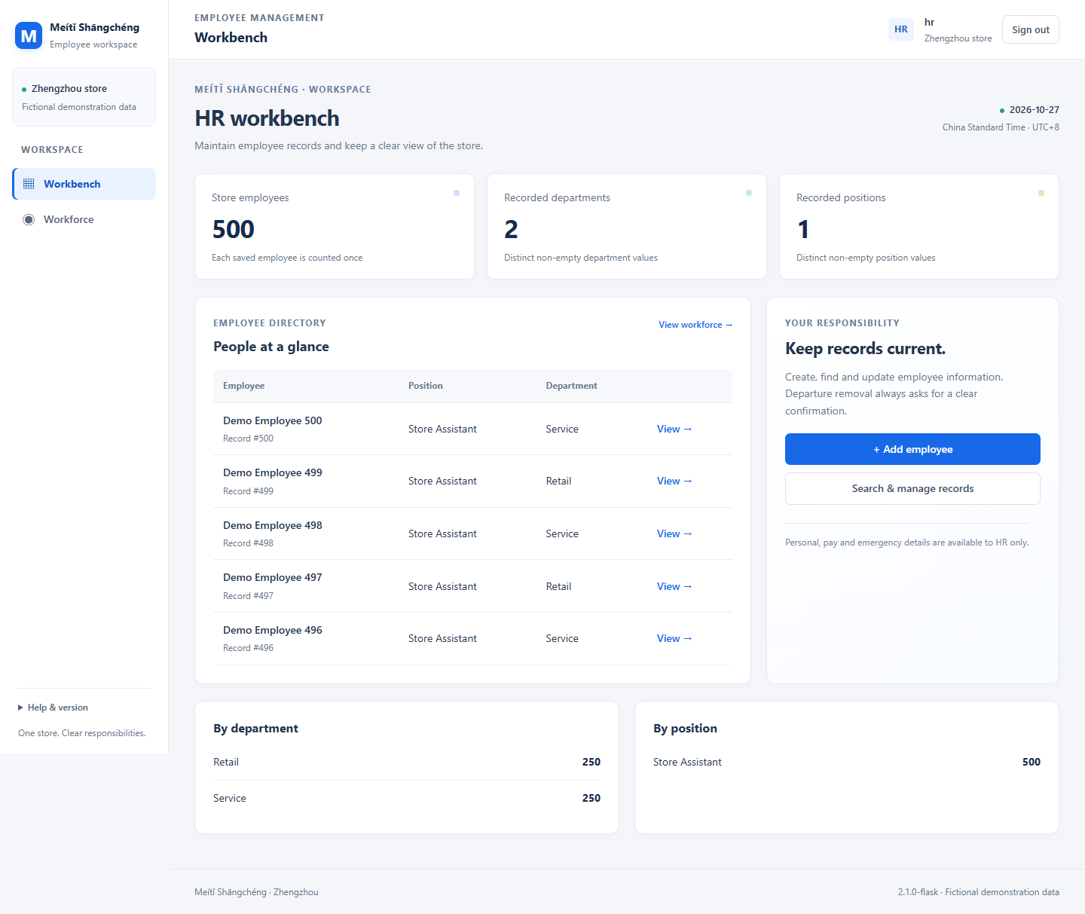
Figure 4 HR workbench, fictional isolated browser fixture
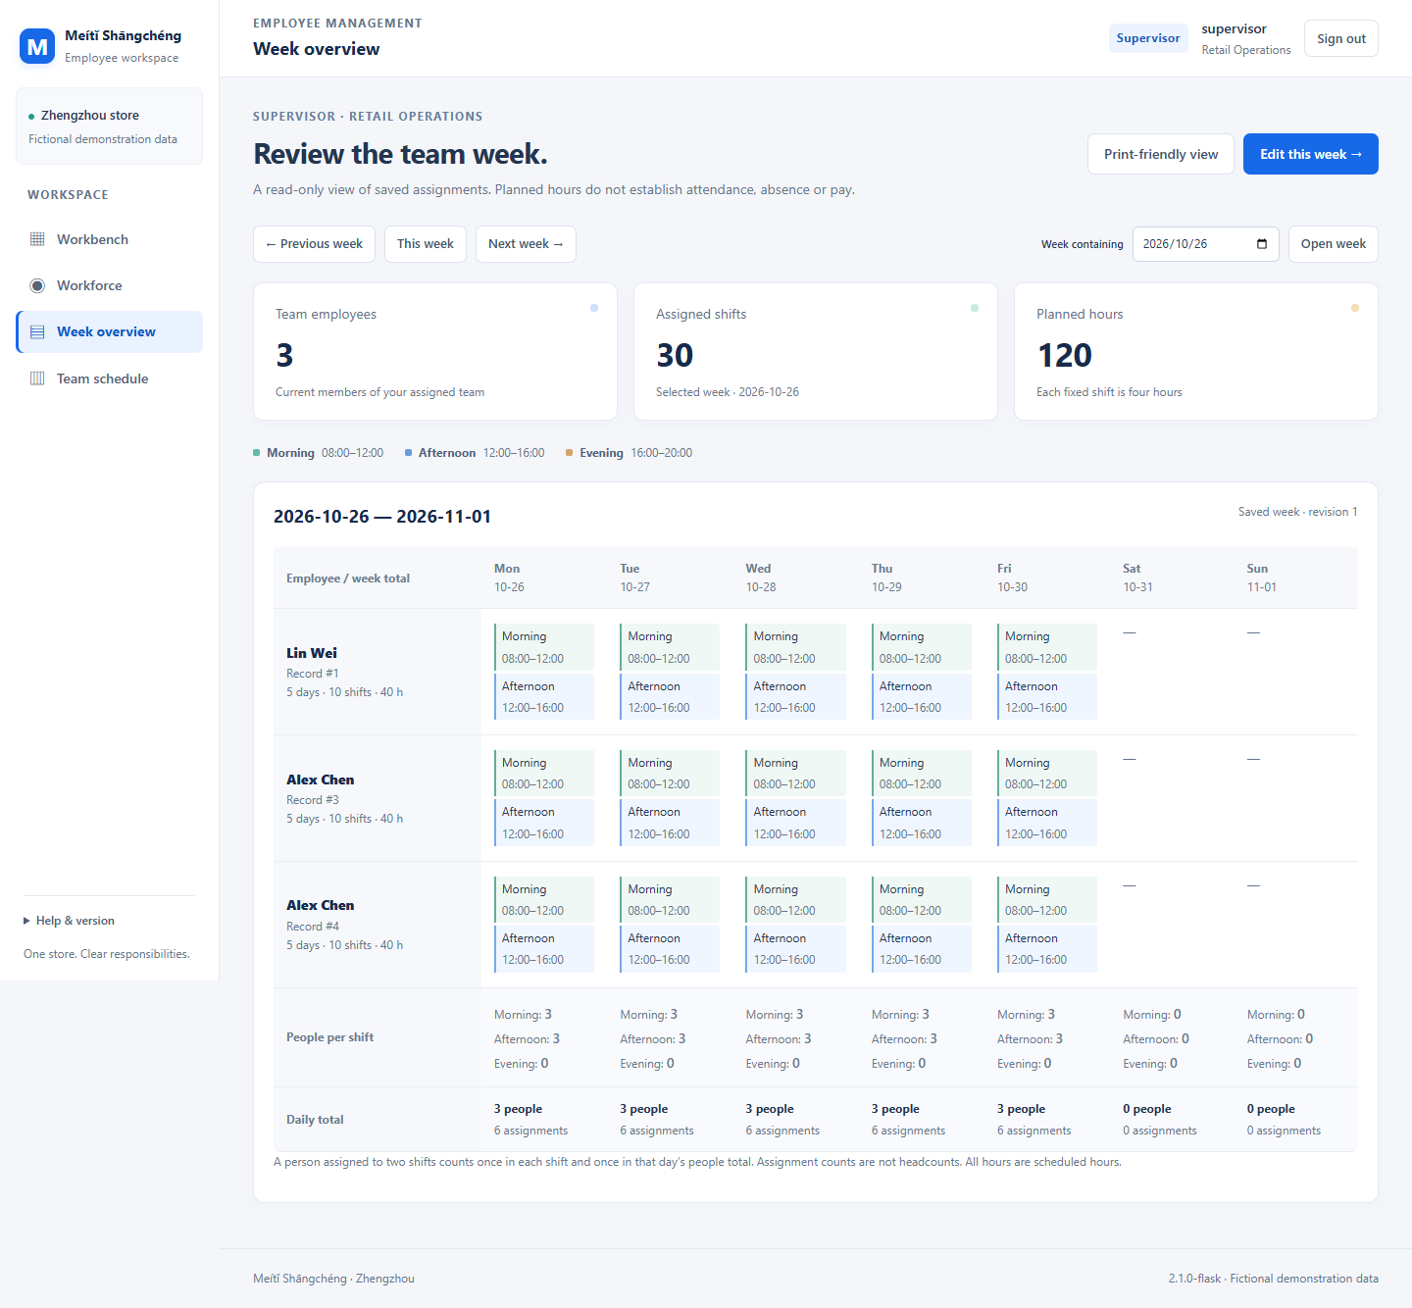
Figure 5 Supervisor saved week, fictional isolated browser fixture

Enhancement verification links
Enhancement | Independent scenarios
E01 | GE01
E02 | GE02, GE03, GE04
E03 | GE05, GE06, GE07
E04 | GE08, GE09
E05 | GE10, GE14
E06 | GE11, GE12, GE13, GE14
E07 | GE15, GE16, GE17
E08 | GE18, GE19, GE20, GE21
E09 | GE22, GE23
E10 | GE24

The 24 enhancement scenarios supplement the original 24 GUI cases. Some require prepared data, CSV byte inspection or read-only database snapshots; those supporting methods are named explicitly. All independent execution and teacher decisions remain unrecorded. Developer evidence is listed separately in the Test Plan.

