Employee Management System Class Diagram
  - Group 2 | Meiti Shangcheng | 28 October 2026
Structural model for release 2.1.0-flask. The five model classes below are implemented in website/models.py.
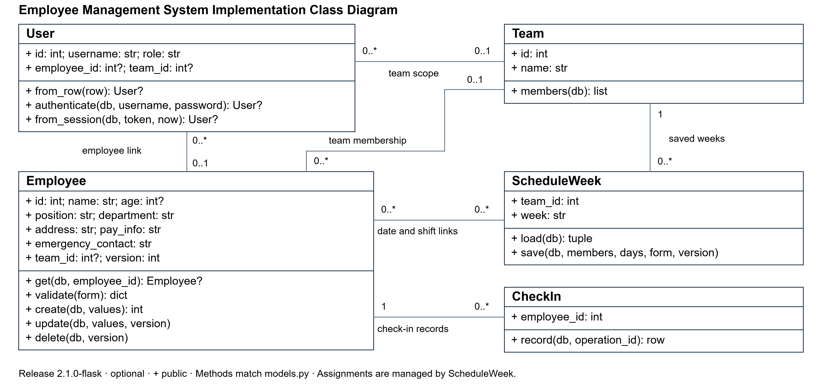
Figure 1 Implementation class model; editable source is assets/class_diagram.svg

Purpose and interpretation
This model explains the structure used for the employee-management release. It separates the person whose information is stored from the account used to sign in. User carries account identity, role and optional links to an employee and a team. HR and supervisor accounts can exist without a personal employee link. More than one User can refer to the same Employee. Removing the Employee removes all linked accounts and their server-side sessions, preventing a second account from retaining access.
Employee carries the seven business information groups, plus internal record identity, team membership and an edit version. The name is required but not unique. Team defines the supervisor’s permitted membership scope. Its members method deliberately returns only identification fields needed for directory and scheduling tasks, rather than full address, pay or emergency-contact data.
ScheduleWeek represents one team and Monday date. Its load method retrieves a saved week and selected shifts. Its save method starts an atomic write transaction, rereads current team members and validates the complete week before replacing assignments. A version rejects stale edits; a failure rolls the transaction back. Employees and schedule weeks have a many-to-many link through date-and-shift assignments. The assignments table is a persistence detail managed by ScheduleWeek, rather than an additional Python model class.
CheckIn represents the current employee identity and stores a validated operation nonce. The route checks the source network, signed envelope and employee identity before invoking this model. The database uniqueness rule makes retries return the existing result. Flask route functions orchestrate these classes and render Jinja pages; routes and HTML files are not additional domain classes.
Association multiplicities describe the links: one Team may contain zero or more Employees and ScheduleWeeks; an Employee may be unassigned or belong to one Team; each CheckIn belongs to one Employee. The actual database deletion policy removes dependent accounts, sessions, assignments and check-ins. Separately stored backups are outside that live transaction. The SVG diagram is retained for editing and should change whenever these class responsibilities or links change.

Class to storage and requirement mapping
Class | Storage | Key methods | Requirements
User | users, sessions | authenticate; from_session | FR-01 / NFR-01
Employee | employees | get; validate; create; update; delete | FR-02–06
Team | teams; employees.team_id | members | FR-06–08
ScheduleWeek | schedule_weeks, assignments | load; save | FR-07–09
CheckIn | checkins | record | FR-10

Workspace module and unchanged model boundary
The role-workspace iteration retains the five business models shown in the class diagram. The workspace module supplies parameterized read queries, allowed sorting, date/shift summaries and CSV formatting. Module functions are not additional entity classes, and summary or export pages do not introduce new database entities. Read-only previews, prior-week loading and printing must not mutate saved assignments.
ScheduleWeek continues to own complete-week validation and atomic saving. The route obtains the current target version and confirmation before calling the model. Loading a previous week is a user-requested draft and is separate from saving. The Chinese code guide locates actual functions and their responsibilities against the same frozen source snapshot. Update that snapshot and this model explanation after any further code change.
Enhancement area | Design boundary
E01–E04, E07–E09 | Authorized route → workspace read/format helpers → existing model tables.
E05–E06 | Route retains draft/form state; ScheduleWeek validates and commits the whole week.
E10 | Jinja templates and CSS present role actions; server checks remain authoritative.

