Part 1: SMTP

Deliverables

1. List the information in the SMTP header (to, from, date, subject, message ID)

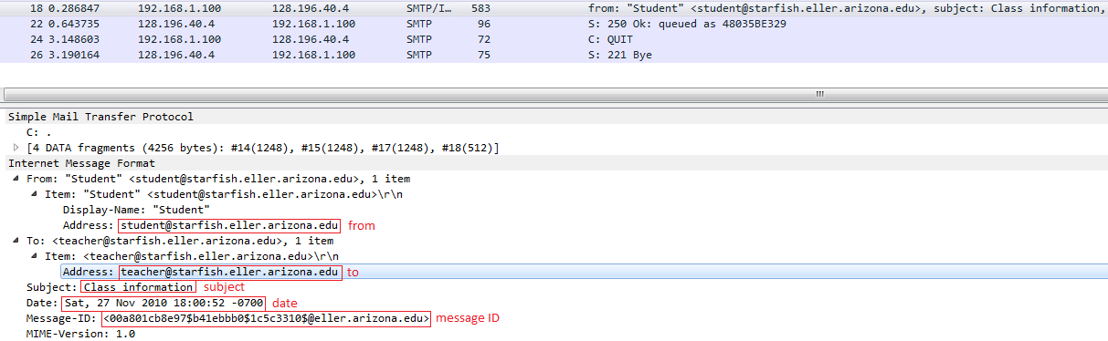

From: [student@starfish.eller.arizona.edu](mailto:student@starfish.eller.arizona.edu)  
To: [teacher@starfish.eller.arizona.edu](mailto:teacher@starfish.eller.arizona.edu)  
Date: Sat, 27 Nov 2010 18:00:52 -0700  
Subject: Class information  
Message-ID: [00a801cb8e97$b41ebbb0$1c5c3310$@eller.arizona.edu](mailto:00a801cb8e97$b41ebbb0$1c5c3310$@eller.arizona.edu)

2. Look through the packets to read the user’s message. List the user’s actual name (not his or her email address), his or her birth date, and his or her SSN.

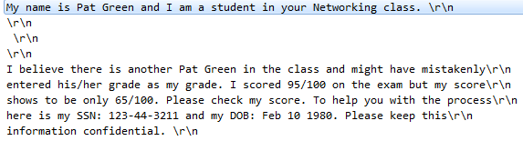

Name: Pat Green  
DOB: Feb 10 1980  
SSN: 123-44-3211

3. Some experts believe that sending an email message is like sending a postcard. Why? How secure is SMTP email? How could security be improved?

When we send a postcard, it needs receiver, sender, address, postal worker can read it if they want, we can know when receiver receive message. The email is the same, also needs receiver, sender address to send email, hacker can also read it, we can also know whether sending email failed or successful.

How secure is SMTP email?  
The SMTP standard sends email without any encryption or authentication.

How could security be improved?  
We can use Secure Sockets Layer (SSL) for SMTP connections on port 465 (standard is port 25) or encrypt the message by third party software.

Part 2: POP

Deliverables

1. Packets 5 through 11 are the log-in process. Can you read the user ID and passwords? Why or why not?

User ID and passwords can be read because the server is using port 110 (unencrypted port) to receive and send packets. Message are not encrypted by any software in advance.

2. Look through the packets to read the user’s message. List the user’s actual name, his or her date of birth, and his or her SSN.

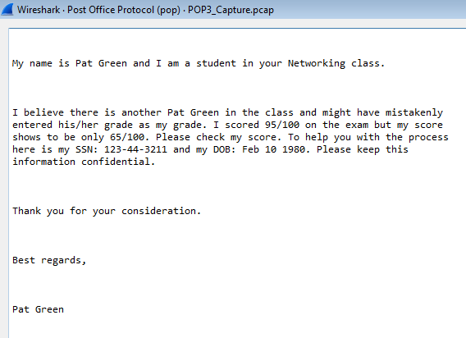

Name: Pat Green  
DOB: Feb 10 1980  
SSN: 123-44-3211