1.

a.

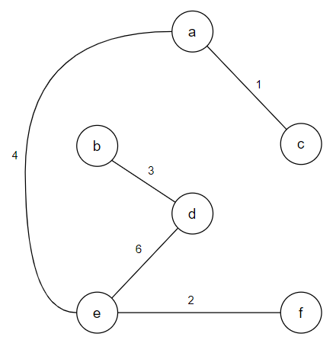

b.

|  |  |  |  |  |  |
| --- | --- | --- | --- | --- | --- |
|  | 1 | 2 | 3 | 4 | 5 |
| Kruskal’s | (a, c) | (e, f) | (b, d) | (a, e) | (d, e) |
| Prim’s | (d, b) | (a, c) | (e, d) | (a, e) | (e, f) |

c.

Suppose there are two distinct MSTs A=(V, E1) and B=(V, E2).

Since A and B are distinct, the sets E1 - E2 and E2 - E1 are not empty.

let e1 be the one with least weight; this choice is unique because the edge weights are all distinct. Without loss of generality, assume e1 is in A. (e1 ∈ E1 - E2)

As B is an MST, {e1} {\displaystyle \cup }∪  B must contain a cycle C.

As a tree, A contains no cycles, therefore C must have an edge e2 that is not in A.

If e2 = e1 then e2 ∈ E1  (because e1 ∈ E1 - E2)  
If e2 ≠ e1 then e2 ∈ E2

So, e2 is not in any MST. This contradicts the assumption that B is an MST.

2.

a.

|  |  |  |  |  |  |  |  |
| --- | --- | --- | --- | --- | --- | --- | --- |
| iter | d[ ] | | | | | | Selected node |
| s | a | b | c | d | e |
| 0 | 0 | 3 | 2 | 6 |  |  | s |
| 1 | 0 | 3 | 2 | 4 | 10 |  | a |
| 2 | 0 | 3 | 2 | 4 | 10 | 11 | b |
| 3 | 0 | 3 | 2 | 4 | 7 | 11 | c |
| 4 | 0 | 3 | 2 | 4 | 7 | 8 | d |
| 5 | 0 | 3 | 2 | 4 | 7 | 8 | e |
| 6 | 0 | 3 | 2 | 4 | 7 | 8 |  |

b.

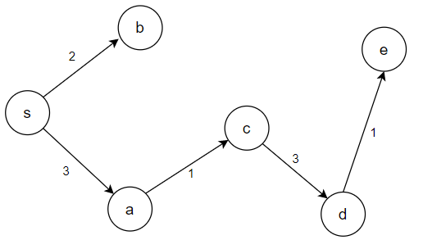

c.

Suppose there is Vz≠Vk, the shortest path distance from s->k-closest is (Vz, k-closest).

not belong to the shortest path from s->v (z ∉ V)

So, there is another shortest path