**Introduction to C**

**Objective**

This lab assignment is intended to get you "warmed up" with the C programming language.  C is a lower-level programming language and is often the language used to write operating system programs and services.  You will also get some practice with C's libraries for opening files, struct data types, processing command line arguments, parsing data, and string manipulation with C's string.h library.

**Instructions**

Using C (not C++), write a "mail merge" program which can replace designated lables in a text file with string values.

For example:

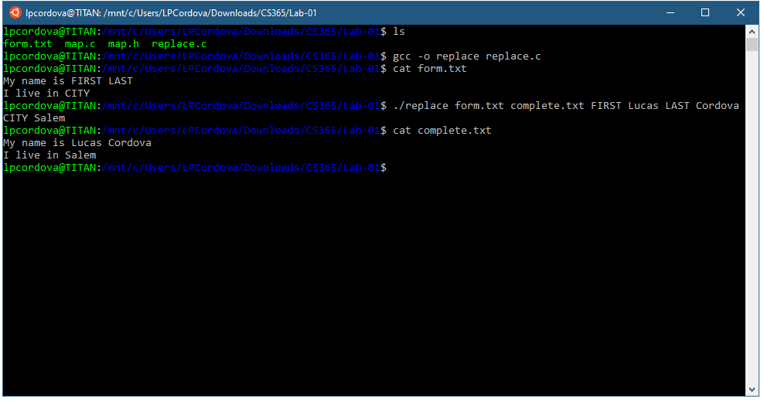

The usage is:

$ replace input_file output_file key1 value1 [key 2 value2 ...]

In order to implement the replace program you will need implement a simple map implementation in C that will allow you to look up a value with a given key, like a dictionary in Python or hash map in C++. However you will implement a very simple version.

Here are the data types and functions for the map implementation to should use and implement:

### map.h

#ifndef _MAP_H  
#define _MAP_H

#define MAP_KEY_LEN 64  
#define MAP_VALUE_LEN 64  
#define MAP_TABLE_LEN 128

struct map_pair_st   
{  
    char key[MAP_KEY_LEN];  
    char value[MAP_VALUE_LEN];  
};

struct map_st   
{  
    struct map_pair_st table[MAP_TABLE_LEN];  
    int count;

};

void map_init(struct map_st *map);  
void map_add(struct map_st *map, char *key, char *value);  
char * map_lookup(struct map_st *map, char *key);

#endif

Here is an unfinished starter program to test the  map implementation.

### replace.c

#include <stdio.h>  
#include <stdlib.h>  
#include <string.h>

#include "map.h"

int main(int argc, char **argv)   
{  
    struct map_st map;  
    char *value;  
    char *key;

    map_init(&map);

    map_add(&map, "course", "cs365");  
    map_add(&map, "year", "2020");  
    map_add(&map, "term", "Fall");

    key = "year";  
    value = map_lookup(&map, key);

    if (value)  
    {  
        printf("key = %s, value = %s\n", key, value);  
    }   
    else   
    {  
        printf("key = %s not found\n", key);  
    }

    key = "section";  
    value = map_lookup(&map, key);

    if (value)   
    {  
        printf("key = %s, value = %s\n", key, value);  
    }   
    else   
    {  
        printf("key = %s not found\n", key);  
    }

    return 0;  
}

### Requirements / Stipulations

1. Use C libraries only for strings (strings.h) and file input and output (e.g. fopen, fclose, strlen, strcpy), and structs (no classes).
2. Adhere to the usage instructions - that is, accept any number of replacements into main.
3. You need not handle replacement words with spaces.  If you do, you will get extra credit.
4. You must replace all instances of the key with the value throughout the file.

### Submission

1. Use the class provided Github [repository](https://classroom.github.com/a/Z2JCl4cZ).
2. Place your solution in the Lab-01 directory.
3. Provide a screen shot demonstrating the required functionality (similar to the example). Store in the Lab-01 directory.
4. Create a tag/release on Github.com and submit the tag/release URL to Canvas by the date specified in Canvas.