Problem 1.

a)

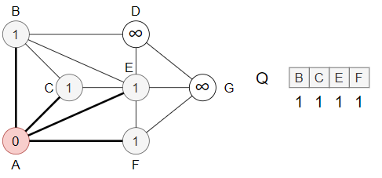

(a) (b)

(c) (d)

(e) (f)

(g) (h)

b)

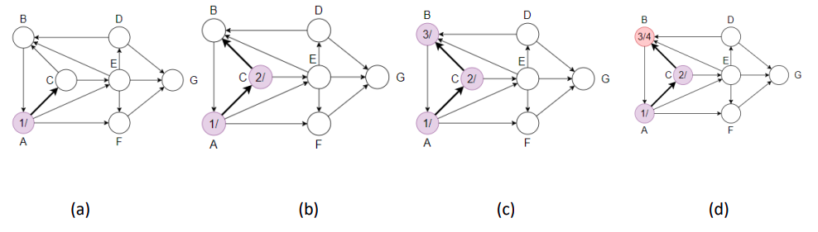

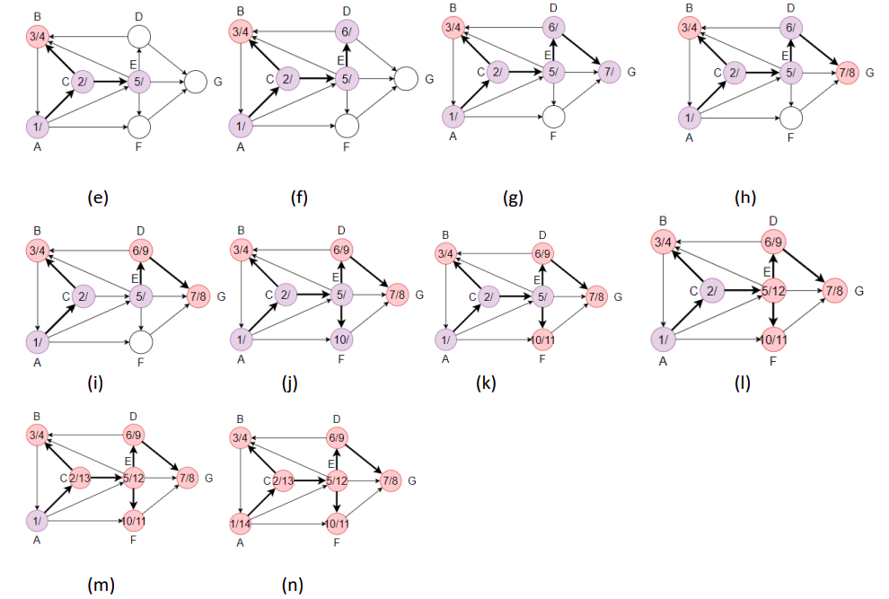

c)

|  |  |  |
| --- | --- | --- |
| Vertex | Discovery time | Finish time |
| A | 1 | 13 |
| B | 2 | 14 |
| C | 3 | 8 |
| D | 4 | 7 |
| E | 5 | 6 |
| F | 9 | 10 |
| G | 11 | 12 |

Problem 2.

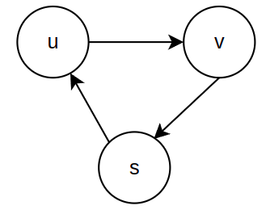

In Grapth G, consider the Adjacent list below. Performing DFS starting at s, we have:

|  | d | f |  |
| --- | --- | --- | --- |
| s | 1 | 4 |  |
| v | 2 | 3 |  |
| u | 5 | 6 |  |

So v.d < u.f, but v is not a descendant of u in the depth-first forest.

Problem 3.

Suppose there is a MST called T that does not contain the minimum weight edge e from u->v. Since T is a connected tree, therefore adding the edge e (u, v) to T will form a cycle. Following this cycle, there must be at least one other edge in the cycle crossing the edge e. By removing this edge, and leaving (u, v), we have a tree with a lower total weight than the original T. But T was assumed to be an MST, this is a contradiction. So, minimum weight edge e form u->v must be part of every MSTs of graph G.

Problem 4.

Assume exist the graph has two distinct MST T1 and T2 . Let (u,v) be an edge in T1 but not in T2. Removing edge (u,v) will split the tree T into two components. Call T1[u] and T1[v] are those 2 components. Let (x,y) be the unique light edge crossing the cut (T1[u],T1[v]).

If (x,y) different from (u,v) then w(x,y) < w(u,v) and the spanning tree T1 − {(u,v)} ∪ {(x,y)} has a better cost than T1. This is a contradiction.

Assume that (x,y) = (u,v), the unique light edge (u,v) crossing the cut (T1[u],T1[v]) doesn’t belong to T2 . Consider the path p from u to v in T2, path p starts in T1[u] and ends in T1[v], therefore there have to be an edge e on it crossing the cut (T1[u], T1[v]). Because edge (u,v) is the unique light edge crossing this cut => w(u,v) < w(e). If we add edge (u,v) to T2 then will form a cycle composed of (u,v) and p. Removing edges from the cycle we get again a spanning tree. Hence T2 ∪ {(u,v)} − {e} is a spanning tree and the cost is better than T2 , a contradiction.

Counterexample for the converse., consider a graph with 3 a,b,c vertexes and weights

w(b,c) = w(b,a) = 3 and w(a,c) = 4 .

The MST is a – b – c . But the cut (b, (a,c)) doesn’t have a unique light edge crossing the cut

Problem 5.

|  |  |  |  |  |  |  |  |
| --- | --- | --- | --- | --- | --- | --- | --- |
| Vertex  Steps | A | B | C | D | E | F | G |
|  | 0 | (∞,─) | (∞,─) | (∞,─) | (∞,─) | (∞,─) | (∞,─) |
| 1 | ─ | (∞,─) | **(2,A)** | (∞,─) | (3,A) | (4,A) | (∞,─) |
| 2 | ─ | (8,C) | ─ | (∞,─) | **(3,A)** | (4,A) | (∞,─) |
| 3 | ─ | (8,C) | ─ | (10,E) | ─ | **(4,A)** | (4,E) |
| 4 | ─ | (8,C) | ─ | (10,E) | ─ | ─ | **(4,E)** |
| 5 | ─ | **(8,C)** | ─ | (10,E) | ─ | ─ | ─ |
| 6 | ─ | ─ | ─ | **(10,E)** | ─ | ─ | ─ |
| 7 | ─ | ─ | ─ | ─ | ─ | ─ | ─ |

Shortest paths between vertex A and all others

A -> A = 0

A -> C -> B = 8

A -> C = 2

A -> E -> D = 10

A -> E = 3

A -> F = 4

A -> E -> G = 4