1.

flow: s→v1, v2→v1, v4→v3, v4→t

v3→v2

capacity: 11+1+4+7-4=19

2.

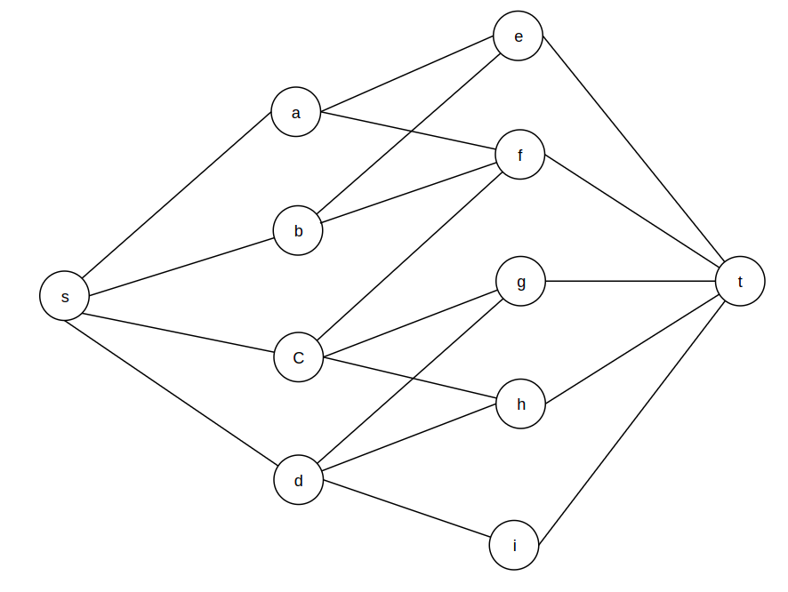

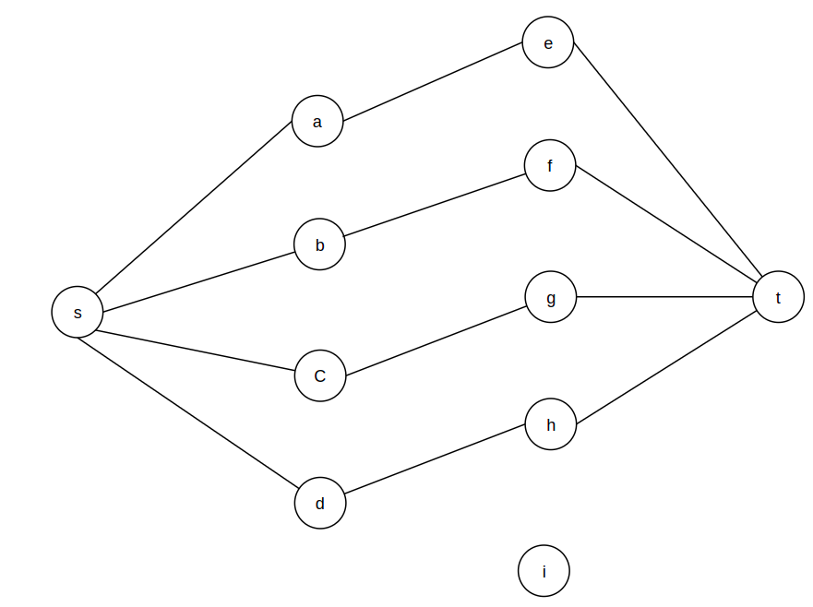

3.

There is no edges between any two vertices of *L*, *R in G’* either because *G* is a bipartite graph.

In G’, The augmenting path (follow FORD-FULKERSON algorithm) has starting edge *s* and any one vertex in *L*. Similarly, the augmenting path has a last edge that connects any one vertex in *R* and the sink *t*. The remaining edges are the edges of *G* from *L* to *R*.

Because a bipartite graph may have a path of maximum length of 2\*min(|L|, |R|)-1, the remaining edges in the augmenting path are 2\*min(|L|, |R|)-1.

Therefore, the total length of an augment path = 2\*min(|L|, |R|)-1+2 = 2\*min(|L|, |R|)+1

=> The upper bound on the length of an augmenting path is 2\*min(|L|, |R|)+1

4.

I think we can reduce 3sat from clique and reduce clique from independent-set

Reduce clique from Independent-set:

It takes polynomial time to verify a set is a clique or not,

Just iterate all vertexes in set to check no vertex has an out-degree.

O(n^2) with n is number of vertices. So it belongs to NP. (1)

Clique: For Graph G=(V,E) and integer k

Independent-set: G'=(V,E') and integer k'

We have same vertices, Construct a graph G and G'.

If there is an independent set size k in G', it implies no

2 vertices share an edge in G' which implies all vertices share an edge with all others in G forming a clique.

That is exist a clique size k in G.

If there is a clique size k in G, it implies all vertices share an edge with all others in G. which

implies no 2 vertices share an edge in G' forming a independent-set.

That is exist a clique size k in G'

So, clique can be reduced to independent-set. it belongs to NP-hard.(2)

(1) (2) -> it's NP-complete

Reduce 3sat from clique:

Construct graph G of k clusters with a maximum of 3 nodes in each cluster.

Each node in cluster is label with a literal.

5.

For checking the result of 3SAT, it needs to iterate all literals and formulas then compute the result true/false. It will take O(mn^8) to compute, it’s in polynomial time, so it is in NP.