**REAL-TIME DATA COLLECTION CAR**

My ideal is the system that can collect necessary data in car such as speed, user behavior, gps,… then send to cloud. Such data can be used for training neutron network or tracking vehicles. I say it is real-time system but actually vehicle could only send real-time data to cloud when vehicles have wifi or LTE, so in case vehicles cannot connect to cloud, the application in vehicle must sort and compress data to reduce size then store in an external storage inside vehicle. When the connection between cloud&vehicle is up, vehicle will send those compressed data to cloud right away. In addition, since the storage amount in vehicle is limited, so in case the storage capacity reach to limitation, vehicle needs to delete the oldest data and just keep the newest data.

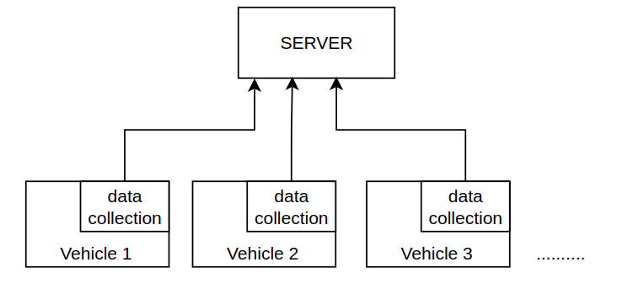

Beside that, since a car company has many car generation, so the hardware is different each others, that means the data can be collected also is different. Server should have a way to request the minimum data from a specific car.

Since car has many modules, so there need to be a common way for other modules can send their log to data collection module. In this case, I think IPC(include socket, message queue, pipe…) is a good method.

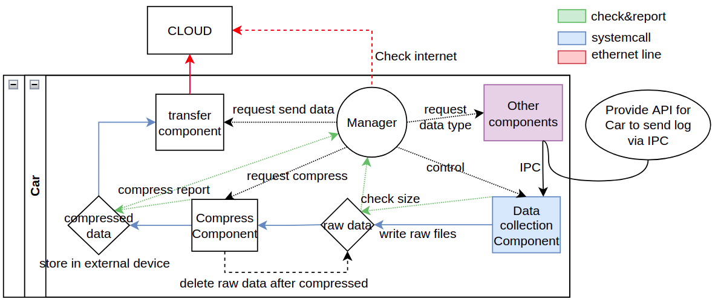

The server responsibility is to receive collection data from clients(vehicles), use those data for training and watch out for the worst case scenario.

Finally, the security is also a concern, how to protect ethernet connection with cloud and protect from malicious application in cloud?

Limitations: In my scope for this design, I do not mention to the method to training data model or the way for server to distribute autopilot update to car based on the collected data because maybe it is complicated.