**FirstName: Rashed**

**Last Name: Alyammahi**

**Problem 1 (7 points):** Answer the following questions using the given code.

1. Compute the successor relation using line numbers. (2 points)

19 successor relations

(2,3)

(3,4)

(4,5)

(4,7)

(7,21)

(5,9)

(9,10)

(9,12)

(10,14)

(14,15)

(14,17)

(17,18)

(18,19)

(19,20)

(15,23)

(23,24)

(12,21)

(21,22)

(22,24)

1. Give the control flow graph (CFG) using the successor relation. (2 points)

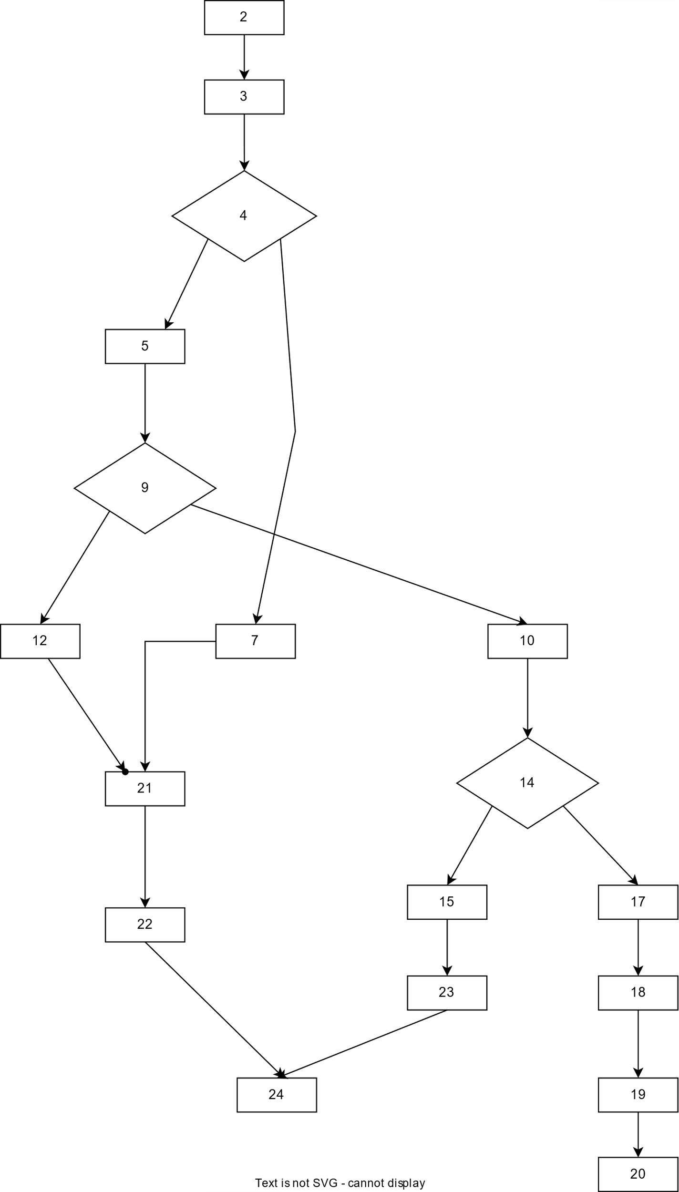

1. Give the number of branch nodes in the CFG. (1 point)

3

1. Is there a memory leak vulnerability ( [CWE-401](https://cwe.mitre.org/data/definitions/401.html) ) in the above program, if yes, write the execution sequences using line numbers which leads to the memory leak. (2 points)

Memory leak: 1,2,3,4,5,9,10,14,15,17,18

**Problem 2 (4 points):** Index XINU in Atlas. Answer the following two questions for the functions *dskqopt* and *ethinter*

1. Create and save the CFG using Atlas and include them as your answer. (2 point)

***dskqopt function***

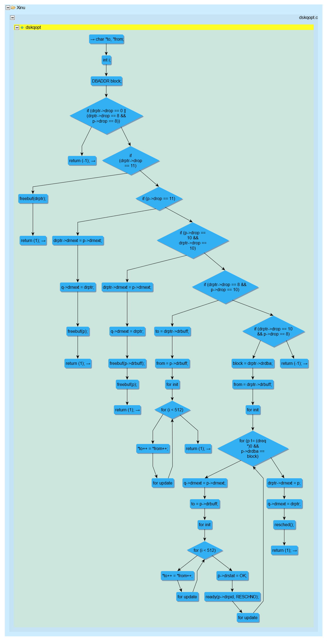

***Ethinter function***

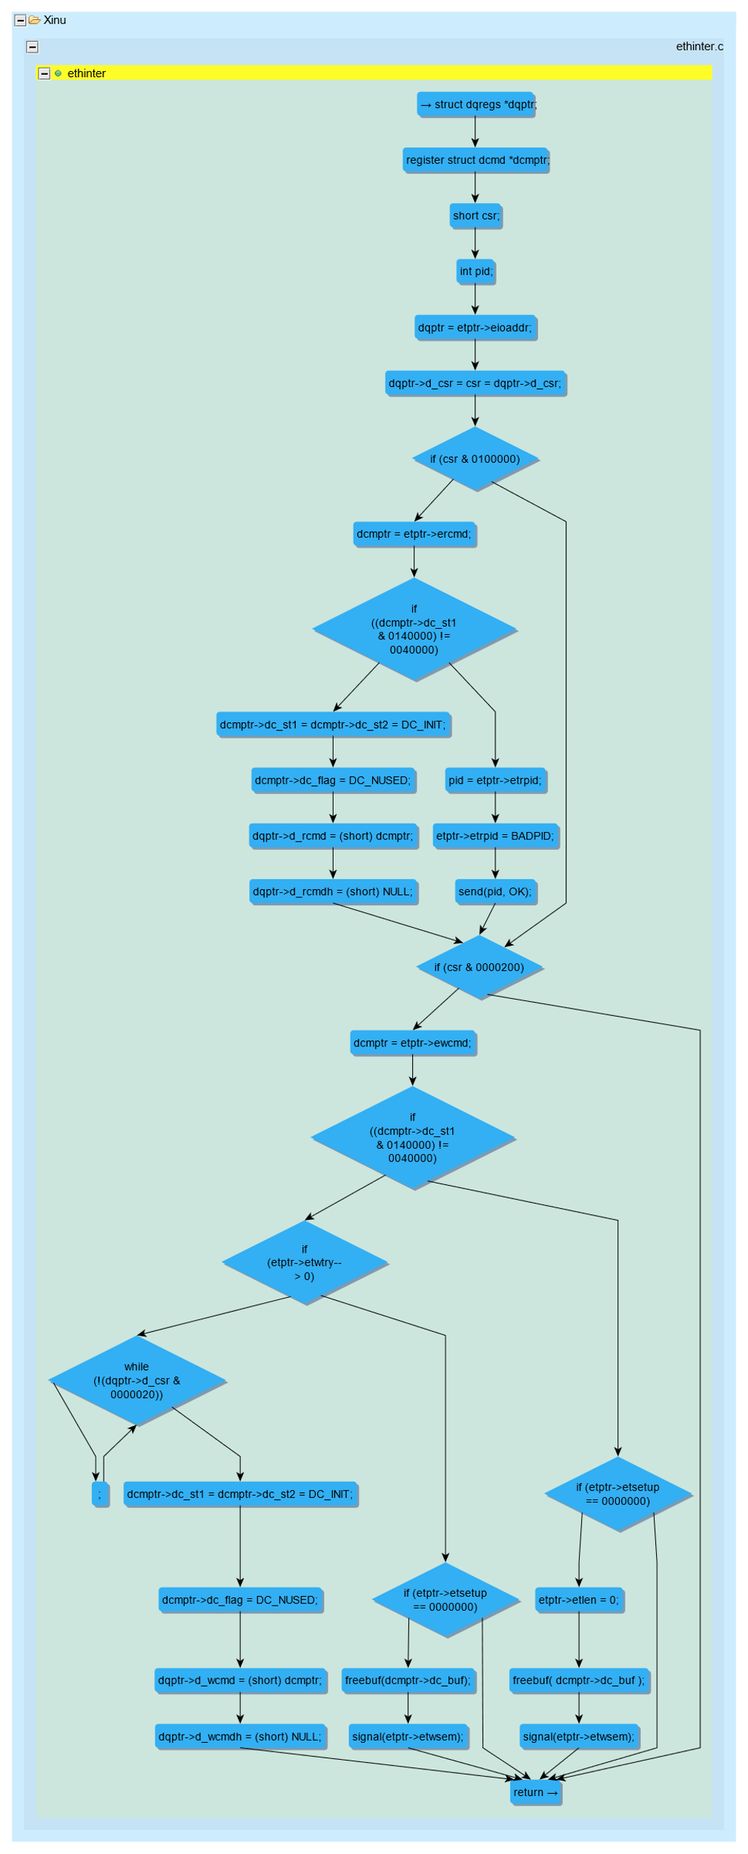

1. Give the following stats for both the functions: #nodes, #edges, #branch nodes, #loops (2 points)

Note: compute manually.

|  |  |  |
| --- | --- | --- |
|  | ***dskqopt*** | ***ethinter*** |
| **#nodes** | 46 | 34 |
| **#edges** | 48 | 41 |
| **#branch nodes** | 9 | 8 |
| **#loops** | 3 | 1 |

**Problem 3 (4 points):** Answer the following questions for the C program given in the problem 1.

1. Create and save the control flow graph (CFG) of the program using Atlas and include it as your answer. You need to create a C project for the program in Eclipse and index it to get the CFG. (2 point)

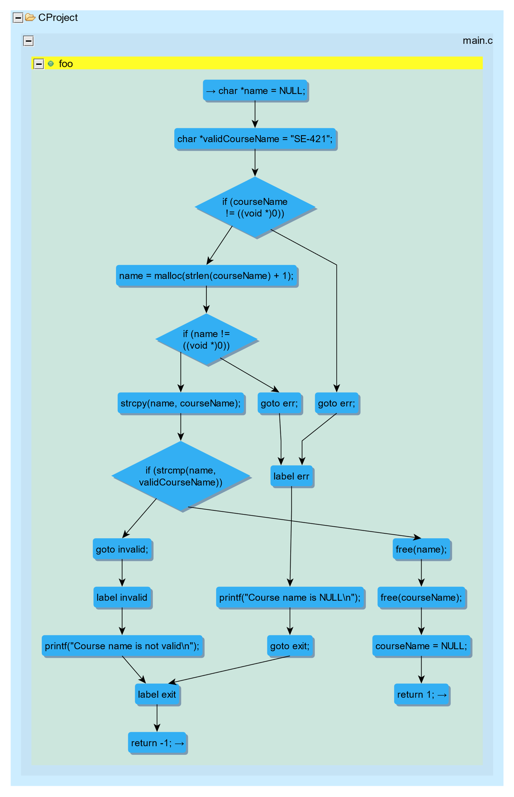

1. Give the following stats for the function foo using Atlas Queries: #nodes, #edges, #branch nodes, #loops. Include the screenshot of the Atlas Shell which shows the stats. Please follow the Atlas Demo slides provided with this homework. (2 points)

**#nodes**

**#edges**

**#branch nodes**

**#loops**

