

**EnglishVocabApp**

**Software Design Document**

– Hanoi, Sept 2022 –

**Table of Contents**

**I. Overview** **5**

1. Code Packages/Namespaces 5

2. Database Design 6

**II. Code Designs** **8**

0. Home Screen 8

a. Screen Design 8

b. Class Diagram 9

c. Class Specifications 9

MainActivity Class 9

d. Sequence Diagram(s) 10

1. Note List 11

a. Screen Design 11

b. Class Diagram 12

c. Class Specifications 12

NoteListActivity Class 12

AppDatabase Class 12

NoteDao Class 13

NoteRecyclerAdapter Class 13

Note Class 13

d. Sequence Diagram(s) 13

e. Database queries 13

2. Note Details 14

a. Screen Design 14

b. Class Diagram 15

c. Class Specifications 15

NoteDetailActivity Class 15

d. Sequence Diagram(s) 16

3. Edit/Add Note 17

a. Screen Design 17

b. Class Diagram 18

c. Class Specifications 18

NoteEditActivity Class 18

d. Sequence Diagram(s) 19

e. Database queries 19

4. Search Notes 20

a. Screen Design 20

b. Class Diagram 20

c. Class Specifications 20

d. Sequence Diagram(s) 20

e. Database queries 20

5. Delete Note 21

a. Screen Design 21

b. Class Diagram 21

c. Class Specifications 21

d. Sequence Diagram(s) 21

e. Database queries 21

6. Play Quiz 22

a. Screen Design 22

b. Class Diagram 25

c. Class Specifications 25

QuizSettingActivity Class 25

QuizQuestionActivity Class 25

AfterQuizActivity Class 26

Quiz Class 26

Question Class 26

QuizWithQuestions Class 26

QuizResult Class 26

d. Sequence Diagram(s) 27

e. Database queries 28

7. Export Quiz Result To Note 29

a. Screen Design 29

b. Class Diagram 29

c. Class Specifications 29

d. Sequence Diagram(s) 29

e. Database queries 29

8. Review Quiz 30

a. Screen Design 30

b. Class Diagram 31

c. Class Specifications 31

QuizQuestionActivity Class 31

d. Sequence Diagram(s) 32

e. Database queries 32

9. View Statistics 33

a. Screen Design 33

b. Class Diagram 34

c. Class Specifications 34

StatisticsActivity Class 34

d. Sequence Diagram(s) 35

e. Database queries 35

10. Search Dictionary 36

a. Screen Design 36

b. Class Diagram 37

c. Class Specifications 37

DictionaryActivity Class 37

DefinitionRecyclerAdapter Class 37

MeaningRecyclerAdapter Class 38

PhoneticRecyclerAdapter Class 38

RequestManager Class 38

d. Sequence Diagram(s) 38

# I. Overview

## 1. Code Packages/Namespaces

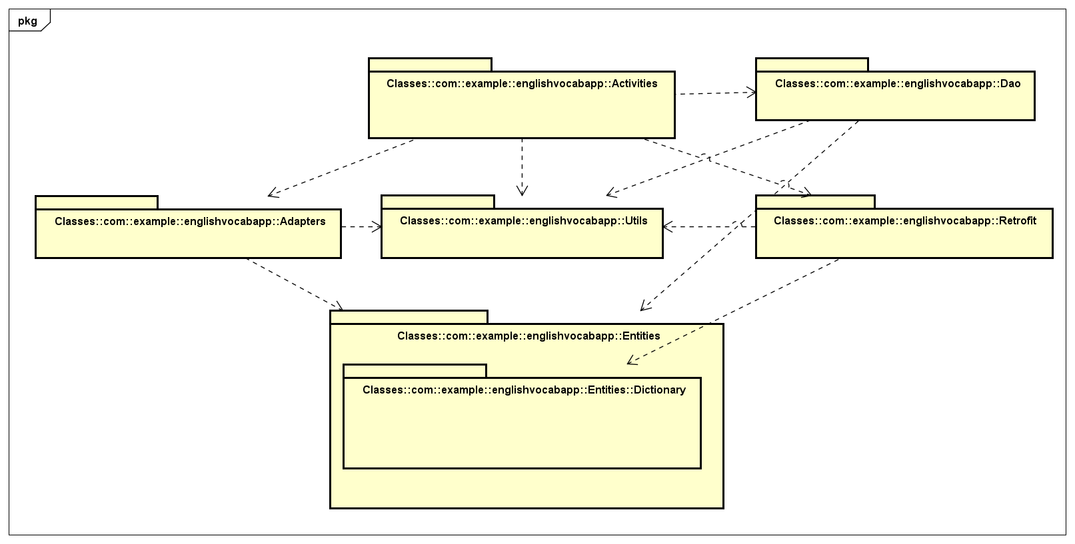

***Package descriptions & package class naming conventions***

| **No** | **Package** | **Description** |
| --- | --- | --- |
| 1 | com.example.  learnenglishapp.Activities | Contains Activity classes |
| 2 | com.example.  learnenglishapp.Adapters | Contains Adapter classes |
| 3 | com.example.  learnenglishapp.Entities | Contains Entity classes |
| 4 | com.example.  learnenglishapp.Dao | Contains DAO classes |
| 5 | com.example.  learnenglishapp.Entities.Dictionary | Contains Model classes for Dictionary |
| 6 | com.example.  learnenglishapp.Utils | Contains Utility classes |
| 7 | com.example.  learnenglishapp.Retrofit | Contains Retrofit classes |

## 2. Database Design

**2.1 Database Schema**

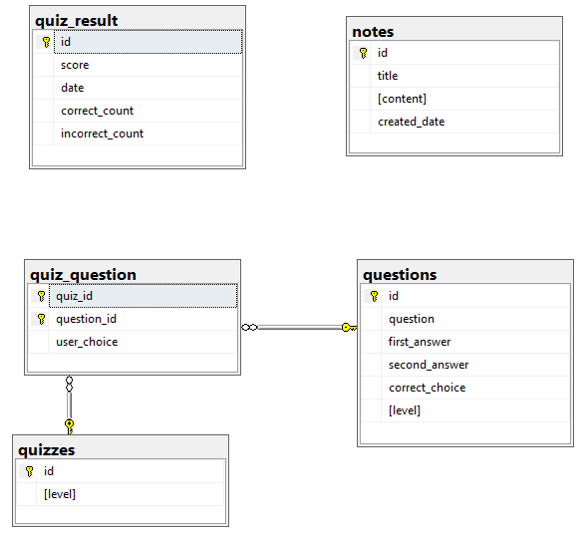

***Table descriptions & package class naming conventions are as below***

| **No** | **Table** | **Description** |
| --- | --- | --- |
| 01 | notes | Store Notes’ Data |
| 02 | quizzes | Store saved Quiz |
| 03 | questions | Store Questions’ Data |
| 04 | quiz_question | Quizzes & Questions Relational Table |
| 05 | quiz_result | Store Quizzes’ Results after finishing Quiz |

**2.2 Database table**

**Notes**

| **#** | **Field name** | **Type** | **Size** | **Unique** | **Not Null** | **PK/FK** | **Notes** |
| --- | --- | --- | --- | --- | --- | --- | --- |
| 1 | id | int |  |  |  | PK |  |
| 2 | title | text | MAX |  | Y |  |  |
| 3 | content | text | MAX |  |  |  |  |

**Quizzes**

| **#** | **Field name** | **Type** | **Size** | **Unique** | **Not Null** | **PK/FK** | **Notes** |
| --- | --- | --- | --- | --- | --- | --- | --- |
| 1 | id | int |  |  |  | PK |  |
| 2 | level | int |  |  | Y |  |  |

## 

**Questions**

| **#** | **Field name** | **Type** | **Size** | **Unique** | **Not Null** | **PK/FK** | **Notes** |
| --- | --- | --- | --- | --- | --- | --- | --- |
| 1 | id | int |  |  |  | PK |  |
| 2 | question | text | MAX |  | Y |  |  |
| 3 | first_answer | text | MAX |  | Y |  |  |
| 4 | second_answer | text | MAX |  | Y |  |  |
| 5 | correct_choice | int |  |  | Y |  |  |
| 6 | level | int |  |  | Y |  |  |

## 

**Quiz_Question**

| **#** | **Field name** | **Type** | **Size** | **Unique** | **Not Null** | **PK/FK** | **Notes** |
| --- | --- | --- | --- | --- | --- | --- | --- |
| 1 | quiz_id | int |  |  |  | PK/FK |  |
| 2 | question_id | int |  |  |  | PK/FK |  |
| 3 | user_Choice | int |  |  | Y |  |  |

## 

**Quiz_Result**

| **#** | **Field name** | **Type** | **Size** | **Unique** | **Not Null** | **PK/FK** | **Notes** |
| --- | --- | --- | --- | --- | --- | --- | --- |
| 1 | id | int |  |  |  | PK |  |
| 2 | score | real |  |  | Y |  |  |
| 3 | date | long | MAX |  | Y |  |  |
| 4 | correct_count | int |  |  |  |  |  |
| 5 | incorrect_count | int |  |  |  |  |  |

# II. Code Designs

## 0. Home Screen

### a. Screen Design

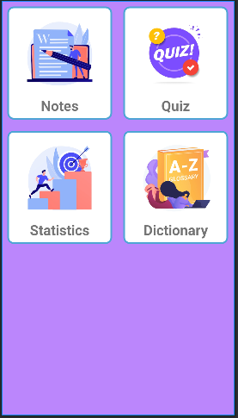

| **No** | **Object/Control Name** | **Type** | **Required** | **Length** | **Description** |
| --- | --- | --- | --- | --- | --- |
| 1 | btnNotes | LinearLayout |  |  | Button to Notes |
| 2 | btnQuiz | LinearLayout |  |  | Button to Quiz |
| 3 | btnStatistics | LinearLayout |  |  | Button to Statistics |
| 4 | btnDictionary | LinearLayout |  |  | Button to Dictionary |

### b. Class Diagram

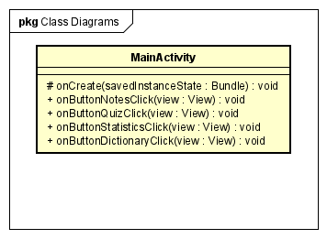

### c. Class Specifications

#### MainActivity Class

| **No** | **Method** | **Description** |
| --- | --- | --- |
| 01 | onCreate | executed when activity is created |
| 02 | onButtonNoteClick | move to Note List Screen |
| 03 | onButtonQuizClick | move to Quiz Setting Screen |
| 04 | onButtonStatisticsClick | move to Statistics Screen |
| 05 | onButtonDictionaryClick | move to Dictionary screen |

### d. Sequence Diagram(s)

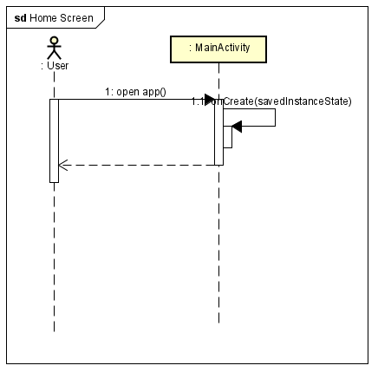

## 1. Note List

### a. Screen Design

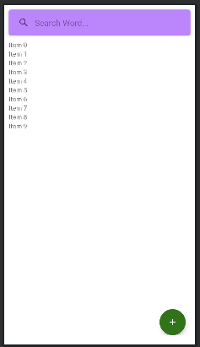

| **No** | **Object/Control Name** | **Type** | **Required** | **Length** | **Description** |
| --- | --- | --- | --- | --- | --- |
| 1 | Search note | SearchView |  |  | Input notes which user want to find |
| 2 | Title | TextView |  |  | note’s title |
| 3 | Date | TextView |  |  | note’s date |
| 4 | Home | Button |  |  | Exit back to Home Screen |
| 5 | Add | Button |  |  | Add new Note |

### b. Class Diagram

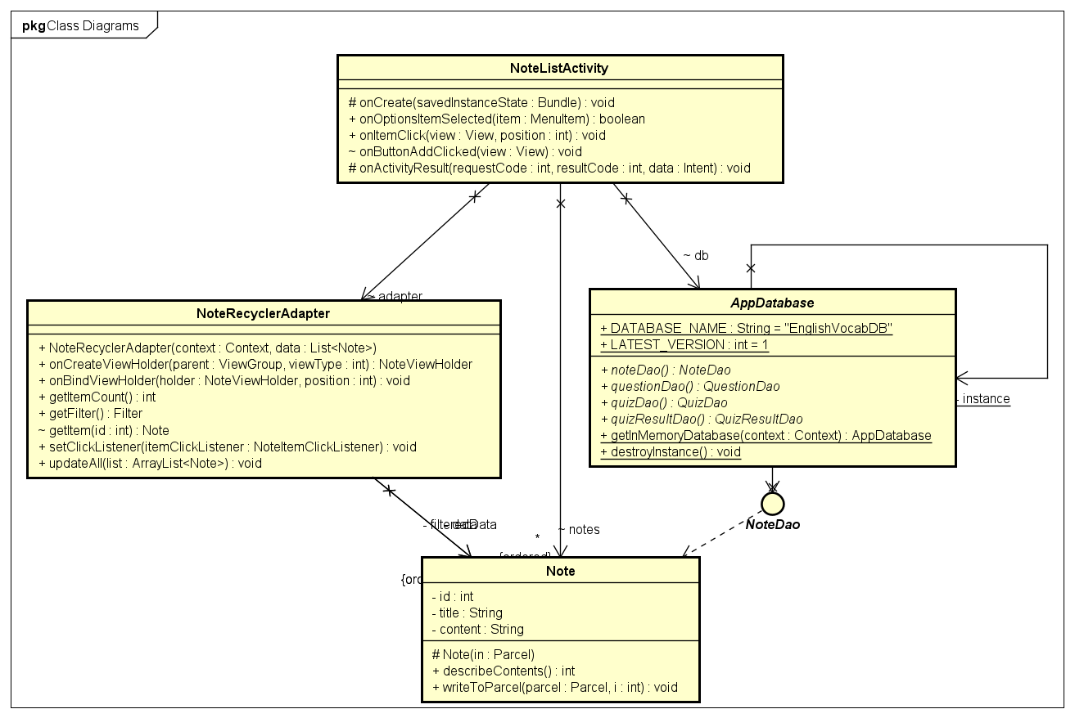

### c. Class Specifications

#### NoteListActivity Class

| **No** | **Method** | **Description** |
| --- | --- | --- |
| 01 | onCreate | executed when activity is created |
| 02 | onOptionsItemSelected | execute when menu items are selected |
| 03 | onItemClick | executed when a Note item is clicked |
| 04 | onButtonAddClicked | move to Note Add Screen |
| 05 | onActivityResult | execute after returning from Note Detail or Note Add Screen |

#### AppDatabase Class

| **No** | **Method** | **Description** |
| --- | --- | --- |
| 01 | noteDao | get NoteDao |
| 02 | questionDao | get QuestionDao |
| 03 | quizDao | get QuizDao |
| 04 | quizResultDao | get QuizResultDao |
| 05 | getInMemoryDatabase | get DB instance |
| 06 | destroyInstance | destroy database instance |

#### NoteDao Class

| **No** | **Method** | **Description** |
| --- | --- | --- |
| 01 |  | contains necessary data fetch methods |

#### NoteRecyclerAdapter Class

| **No** | **Method** | **Description** |
| --- | --- | --- |
| 01 | NoteRecyclerAdapter | RecyclerViewAdapter base methods |
| 02 | onCreateViewHolder |
| 03 | onBindViewHolder |
| 04 | getItemCount |
| 05 | getFilter |
| 06 | getItem |
| 07 | setClickListener |
| 08 | updateAll |

#### Note Class

| **No** | **Method** | **Description** |
| --- | --- | --- |
| 01 |  | implements Parcelable base methods |

### d. Sequence Diagram(s)

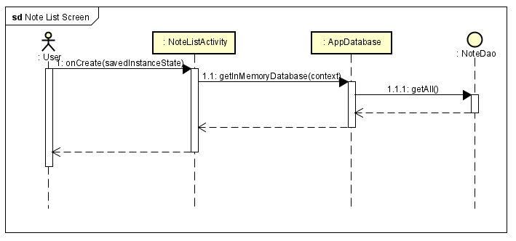

### e. Database queries

SELECT * FROM notes ORDER BY created_date DESC

## 2. Note Details

### a. Screen Design

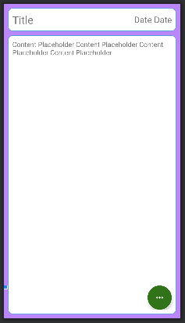

| **No** | **Object/Control Name** | **Type** | **Required** | **Length** | **Description** |
| --- | --- | --- | --- | --- | --- |
| 1 | Title | TextView |  |  | note’s title |
| 2 | Date | TextView |  |  | note’s date |
| 3 | content | TextView |  |  | note’s content |
| 4 | Edit Button | Button |  |  | Edit Note |
| 5 | Delete Button | Button |  |  | Delete Note |
| 6 |  |  |  |  |  |

### b. Class Diagram

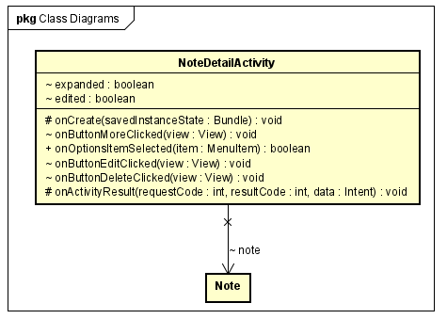

### c. Class Specifications

#### NoteDetailActivity Class

| **No** | **Method** | **Description** |
| --- | --- | --- |
| 01 | onCreate | executed when activity is created |
| 02 | onOptionsItemSelected | execute when menu items are selected |
| 03 | onButtonMoreClick | make Edit/Delete button visible/invisible |
| 04 | onButtonEditClicked | move to Note Edit Screen |
| 05 | onActivityResult | execute after returning fromNote Edit Screen |
| 06 | onButtonDeleteClicked | delete Note then return to Note List Screen |

#### 

### d. Sequence Diagram(s)

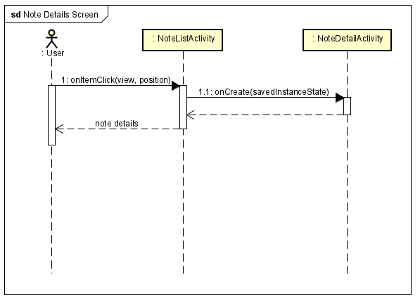

## 3. Edit/Add Note

### a. Screen Design

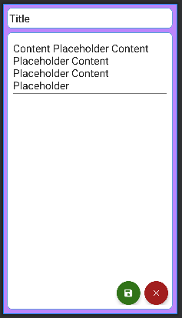

| **No** | **Object/Control Name** | **Type** | **Required** | **Length** | **Description** |
| --- | --- | --- | --- | --- | --- |
| 1 | Note Title | EditText | Yes |  | Input title of note |
| 2 | Note Content | EditText |  |  | Input content of note |
| 3 | Save | Button |  |  | Save Edit/Add Note |
| 4 | Cancel | Button |  |  | Cancel Save/Edit |

### b. Class Diagram

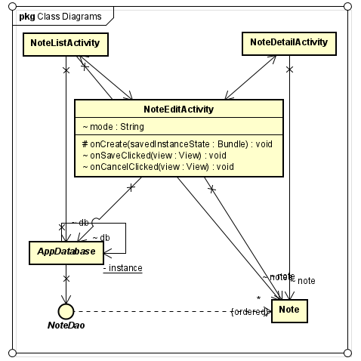

### c. Class Specifications

#### NoteEditActivity Class

| **No** | **Method** | **Description** |
| --- | --- | --- |
| 01 | onCreate | executed when activity is created |
| 02 | onSaveClicked | execute when [Save] is clicked |
| 03 | onCancelClicked | executed when a [Cancel] is clicked |

### d. Sequence Diagram(s)

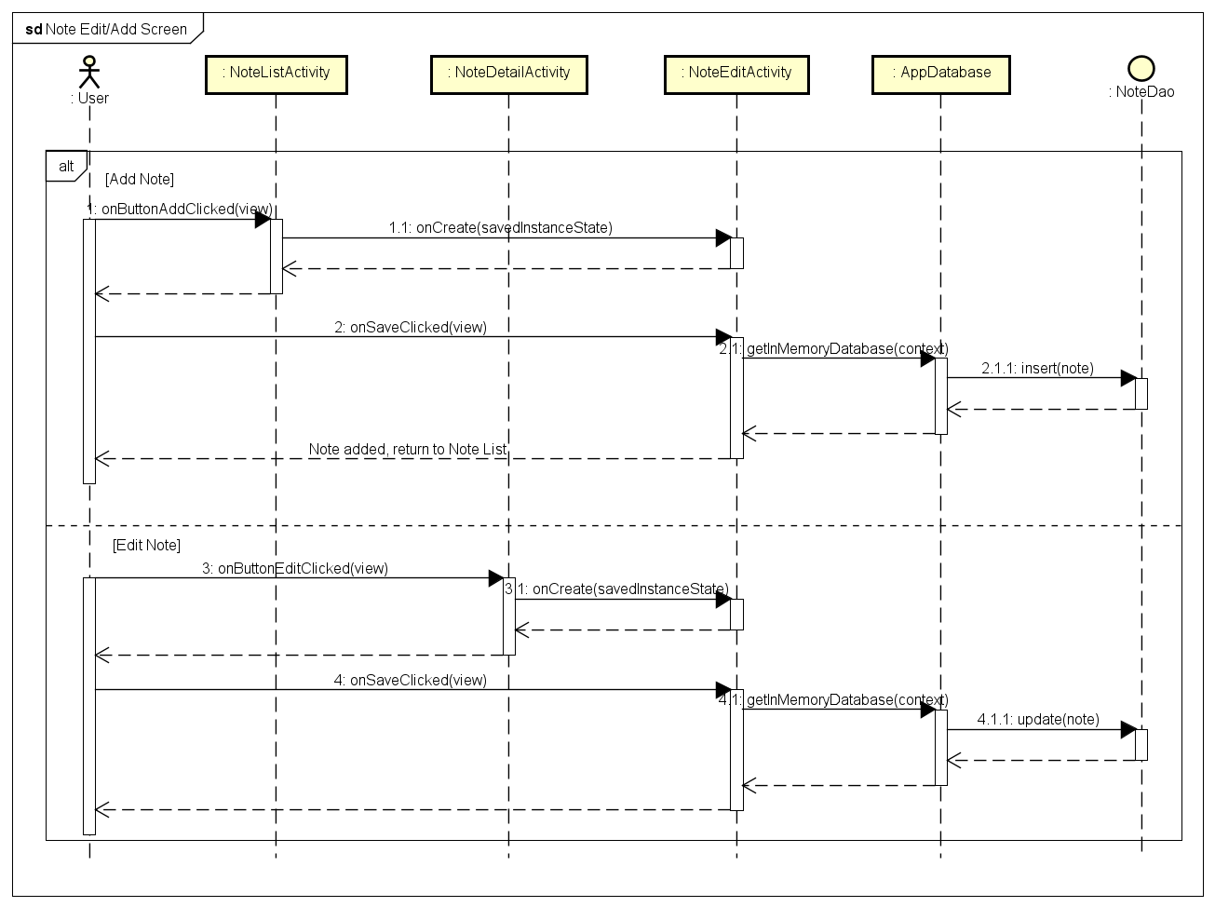

### e. Database queries

* INSERT INTO notes VALUES (...)
* UPDATE notes WHERE id = :id SET […]

## 4. Search Notes

### a. Screen Design

Refer to Note List

### b. Class Diagram

Refer to Note List

### c. Class Specifications

Refer to Note List

### d. Sequence Diagram(s)

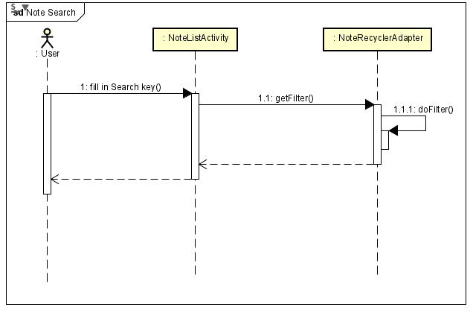

### e. Database queries

Refer to Note List

## 5. Delete Note

### a. Screen Design

Refer to Note Details

### b. Class Diagram

Refer to Note Details

### c. Class Specifications

Refer to Note Details

### d. Sequence Diagram(s)

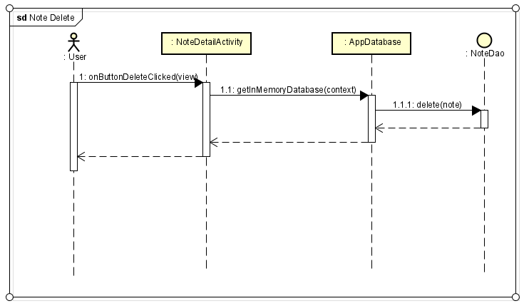

### e. Database queries

* DELETE FROM notes WHERE id = :id

## 6. Play Quiz

### a. Screen Design

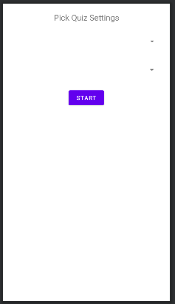

| **No** | **Object/Control Name** | **Type** | **Required** | **Length** | **Description** |
| --- | --- | --- | --- | --- | --- |
| 1 | spinner_level | Spinner | Yes | 20 | Pick Quiz Level, defaultValue = ‘Pick Quiz Level’ |
| 2 | spinner_length | Spinner |  |  | Pick Quiz Length, defaultValue = ‘Pick Quiz Length’ |
| 3 | Start | Button |  |  | Start Quiz |

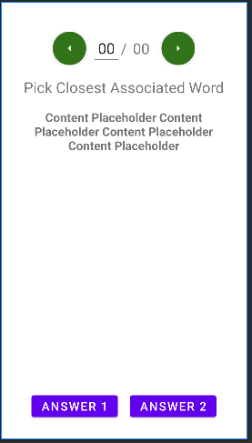

| **No** | **Object/Control Name** | **Type** | **Required** | **Length** | **Description** |
| --- | --- | --- | --- | --- | --- |
| 1 | Exit | Menu option |  |  | show pop-up whether to Save Quiz progress when exiting |
| 2 | fab_prev | FloatingActionButton |  |  | Move to previous question |
| 3 | fab_next | FloatingActionButton |  |  | Move to next question |
| 4 | txt_questionNo | EditText |  | 2 | show current question number & move to new question on change |
| 5 | txt_questionTotal | TextView |  | 2 | show total number of questions |
| 6 | Finish | Menu option |  |  | Finish Quiz |
| 7 | txt_questionContent | TextView |  |  | Show Question content |
| 8 | btn_answer1 | Button |  |  | Show answer choice |
| 9 | btn_answer2 | Button |  |  | Show answer choice |

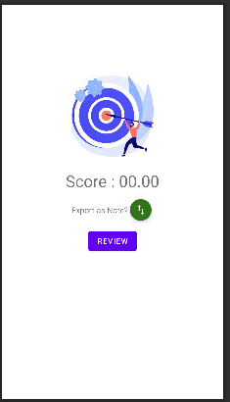

| **No** | **Object/Control Name** | **Type** | **Required** | **Length** | **Description** |
| --- | --- | --- | --- | --- | --- |
| 1 | txt_score | TextView |  |  | show quiz score |
| 2 | btn_review | Button |  |  | Move to Quiz Review Screen |
| 3 | btn_return | Button |  |  | Return to Home |
| 4 | fab_export | FloatingActionButton |  |  | Export quiz questions & answers to Note |

### b. Class Diagram

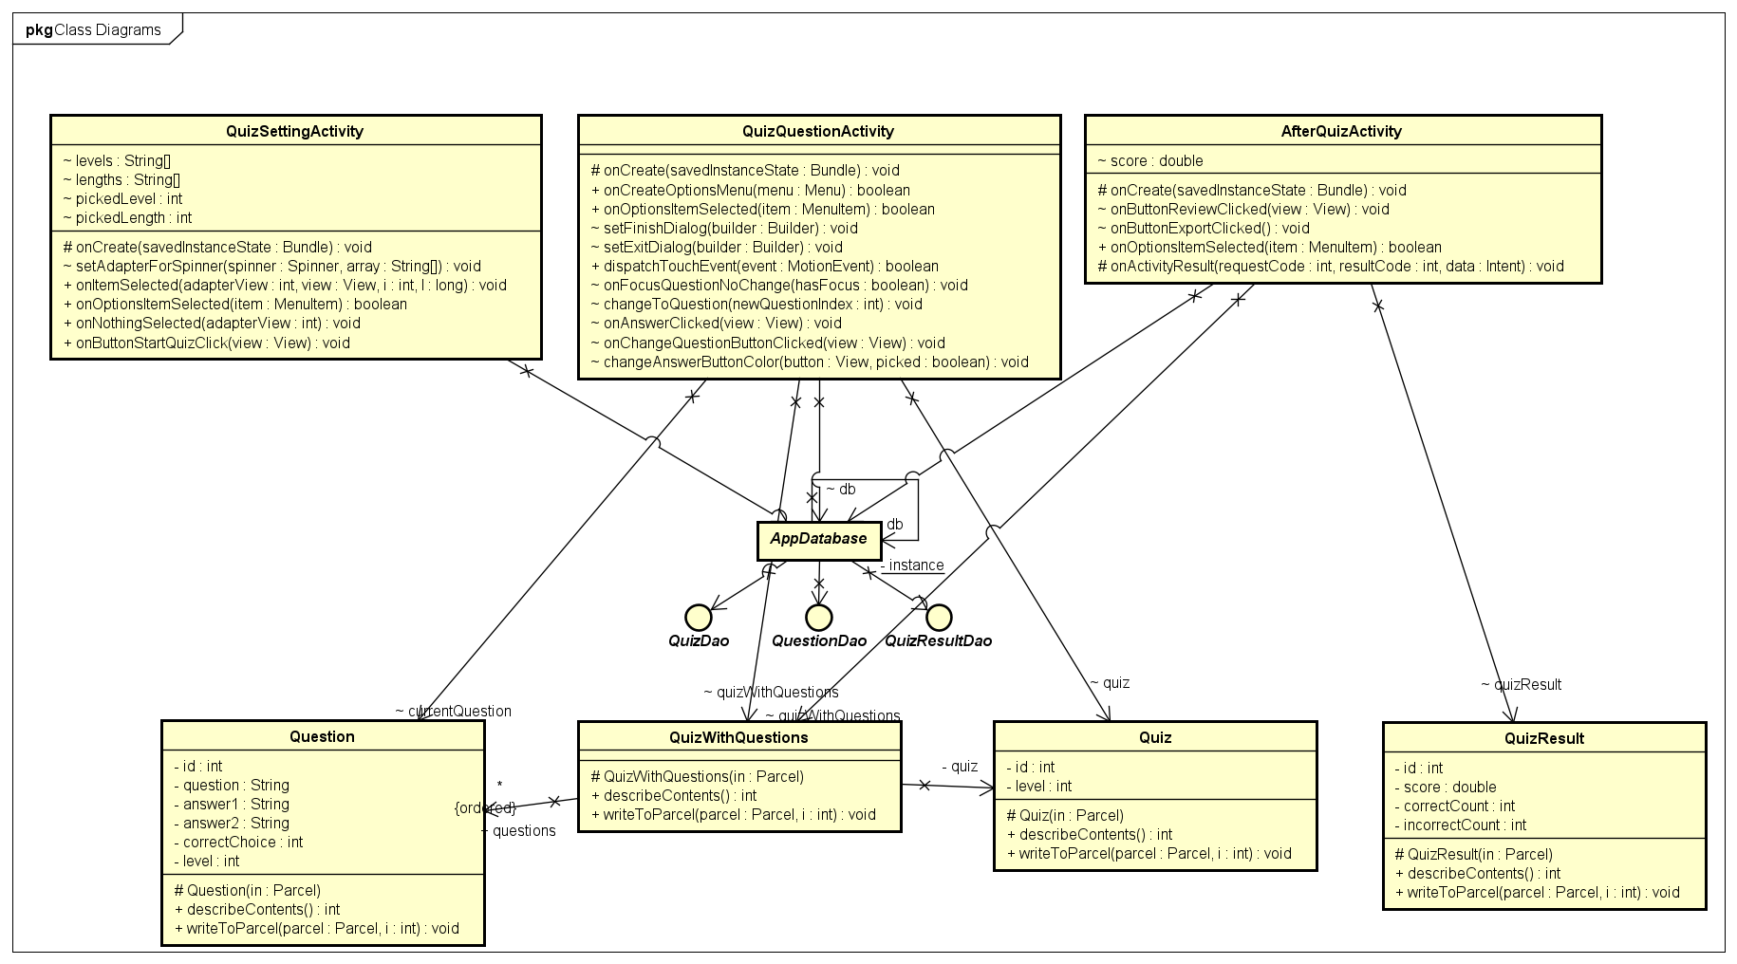

### c. Class Specifications

#### QuizSettingActivity Class

| **No** | **Method** | **Description** |
| --- | --- | --- |
| 01 | onCreate | executed when activity is created |
| 02 | onOptionsItemSelected | execute when menu items are selected |
| 03 | setAdapterForSpinner | setup adapter for spinners |
| 04 | onItemSelected | executed when a spinner item is clicked |
| 06 | onNothingSelected | base methods of adapter |
| 07 | onButtonStartQuizClick | move to Quiz Question Screen |
|  |  |  |

#### QuizQuestionActivity Class

| **No** | **Method** | **Description** |
| --- | --- | --- |
| 01 | onCreate | executed when activity is created |
| 02 | onCreateOptionsMenu | create option menu containing [Finish] & [Exit] buttons |
| 03 | onOptionsItemSelected | execute when menu items are selected |
| 04 | setFinishDialog | setup finish dialog |
| 05 | setExitDialog | setup exit dialog |
| 06 | changeToQuestion | change question displayed on the screen |
| 07 | onAnswerClicked | executed when an answer is picked |
| 08 | onChangeQuestionButtonClicked | executed when prev or next button is clicked |
| 09 | changeAnswerButtonColor | change button color when displayed question is changed or when user picks an answer |
|  |  |  |

#### AfterQuizActivity Class

| **No** | **Method** | **Description** |
| --- | --- | --- |
| 01 | onCreate | executed when activity is created |
| 02 | onOptionsItemSelected | execute when menu items are selected |
| 03 | onButtonReviewClicked | move to review Screen |
| 04 | onButtonExportClicked | move to Note Edit Screen |
| 05 | onActivityResult | executed when user finishes Exporting Quiz Result to Note |
|  |  |  |

#### 

#### Quiz Class

| **No** | **Method** | **Description** |
| --- | --- | --- |
| 01 |  | implements Parcelable base methods |

#### Question Class

| **No** | **Method** | **Description** |
| --- | --- | --- |
| 01 |  | implements Parcelable base methods |

#### 

#### QuizWithQuestions Class

| **No** | **Method** | **Description** |
| --- | --- | --- |
| 01 |  | implements Parcelable base methods |

#### 

#### QuizResult Class

| **No** | **Method** | **Description** |
| --- | --- | --- |
| 01 |  | implements Parcelable base methods |

### d. Sequence Diagram(s)

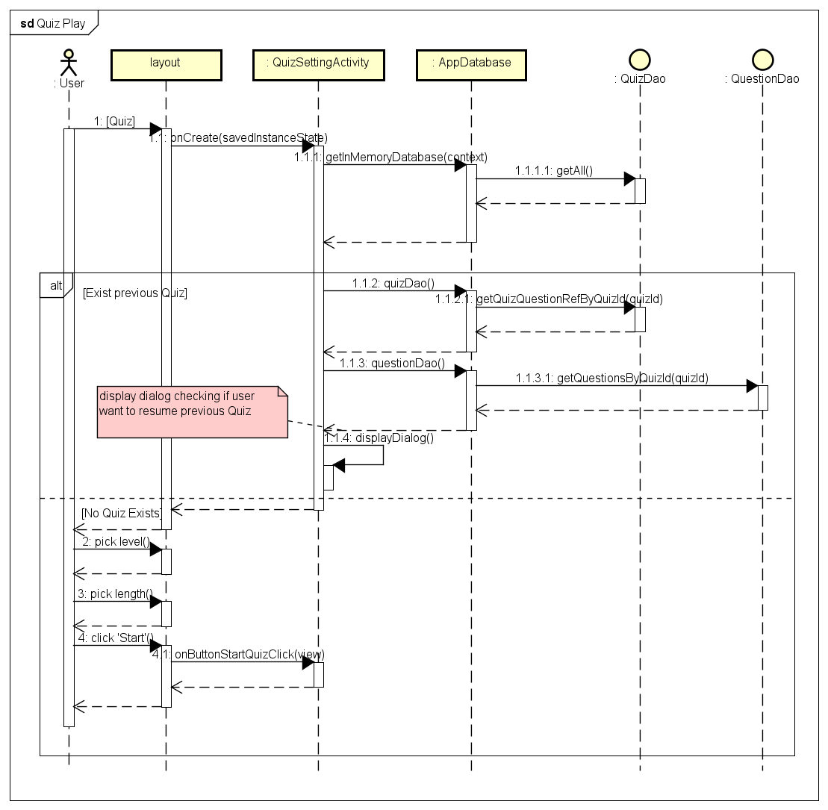

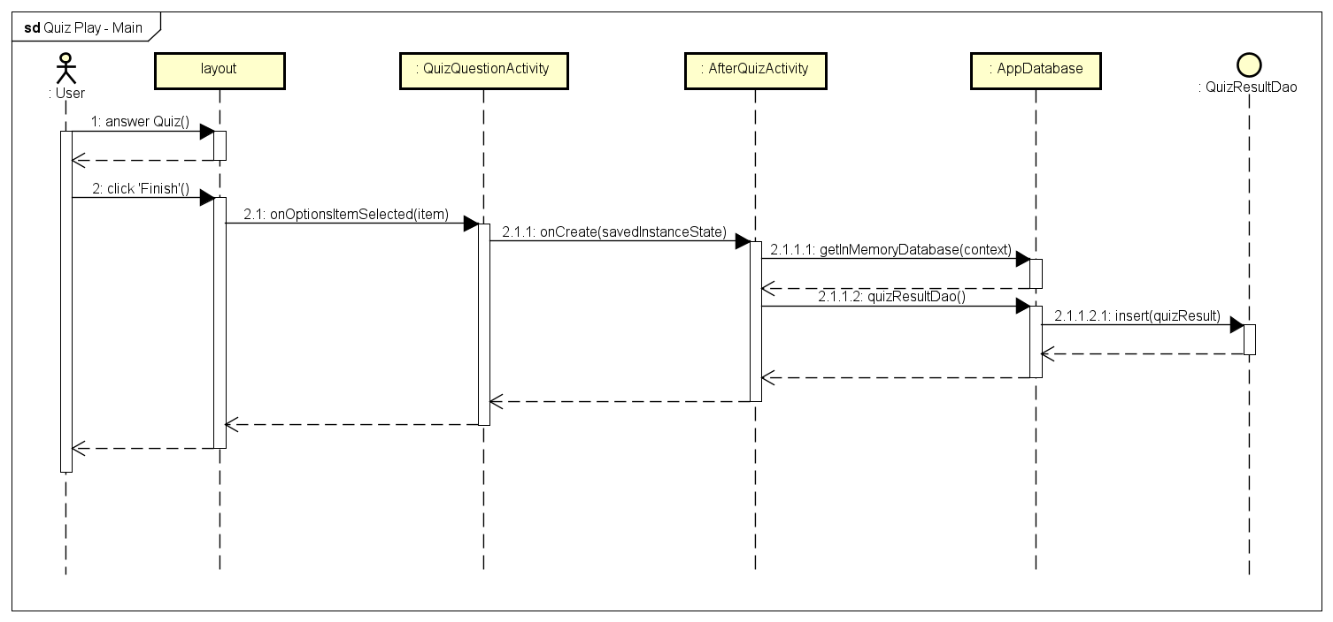

### e. Database queries

* SELECT * FROM quizzes
* SELECT * FROM quiz_question WHERE quiz_id = :quizID
* SELECT id FROM questions WHERE level = :level
* SELECT * FROM questions WHERE id = :id
* INSERT INTO quizzes VALUES (...)
* INSERT INTO quiz_question VALUES (...)
* DELETE * FROM quizzes
* DELETE * FROM quiz_question
* INSERT INTO quiz_result VALUES (...)

## 7. Export Quiz Result To Note

### a. Screen Design

Refer to Play Quiz’s After Quiz Screen & Note Edit Screen

### b. Class Diagram

Refer to previous sections in Note & Quiz

### c. Class Specifications

Refer to previous sections in Note & Quiz

### d. Sequence Diagram(s)

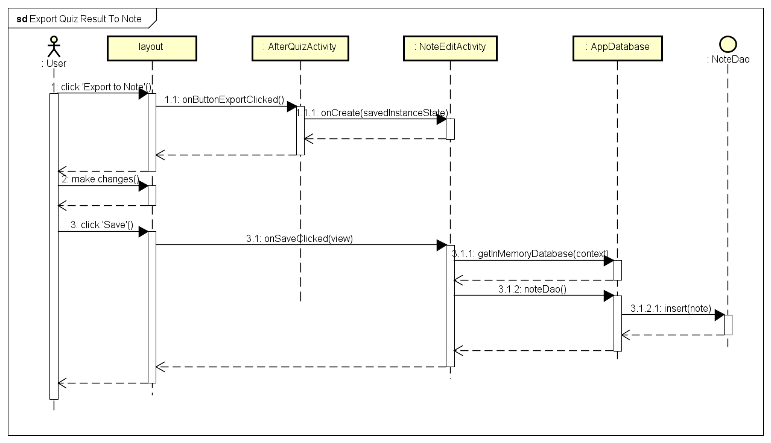

### e. Database queries

* INSERT INTO notes VALUES (...)

## 8. Review Quiz

### a. Screen Design

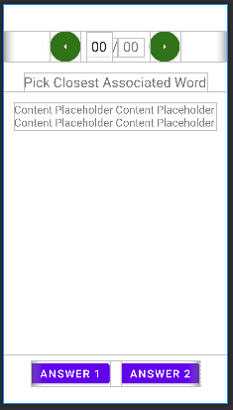

| **No** | **Object/Control Name** | **Type** | **Required** | **Length** | **Description** |
| --- | --- | --- | --- | --- | --- |
| 1 | fab_prev | FloatingActionButton |  |  | Move to previous question |
| 2 | fab_next | FloatingActionButton |  |  | Move to next question |
| 3 | txt_questionNo | EditText |  | 2 | show current question number & move to new question on change |
| 4 | txt_questionTotal | TextView |  | 2 | show total number of questions |
| 5 | txt_questionContent | TextView |  |  | Show Question content |
| 6 | btn_answer1 | Button |  |  | Show answer choice |
| 7 | btn_answer2 | Button |  |  | Show answer choice |

### b. Class Diagram

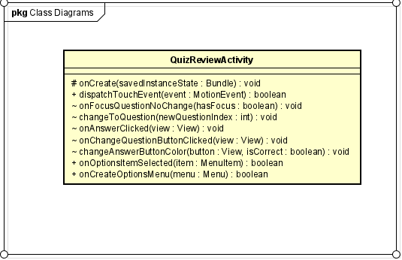

### c. Class Specifications

#### QuizQuestionActivity Class

| **No** | **Method** | **Description** |
| --- | --- | --- |
| 01 | onCreate | executed when activity is created |
| 02 | onCreateOptionsMenu | create option menu containing [Finish] & [Exit] buttons |
| 03 | onOptionsItemSelected | execute when menu items are selected |
| 04 | changeToQuestion | change question displayed on the screen |
| 05 | onAnswerClicked | executed when an answer is clicked, move to Dictionary Screen |
| 06 | onChangeQuestionButtonClicked | executed when prev or next button is clicked |
| 07 | changeAnswerButtonColor | change button color when displayed question is changed |

### d. Sequence Diagram(s)



### e. Database queries

* DELETE FROM notes WHERE id = :id

## 9. View Statistics

### a. Screen Design

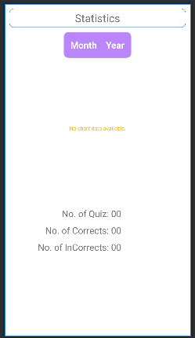

| **No** | **Object/Control Name** | **Type** | **Required** | **Length** | **Description** |
| --- | --- | --- | --- | --- | --- |
| 1 | Month - Year | DatePickDialog |  |  | Allow user to choose a month to display on bar chart |
| 2 | Bar Chart | MPAndroidChart.BarChart |  |  | Show A Month’s Quiz results |
| 3 | txt_NoOfQuiz | TextView |  |  | Total number of Quizzes done in cohen Month |
| 4 | txt_correct | TextView |  |  | Total number of correct answers |
| 5 | txt_incorrect | TextView |  |  | Total number of incorrect answers |

### b. Class Diagram

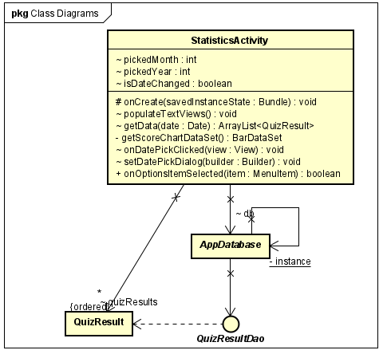

### c. Class Specifications

#### StatisticsActivity Class

| **No** | **Method** | **Description** |
| --- | --- | --- |
| 01 | onCreate | executed when activity is created |
| 02 | getData | fetch Quiz Result data |
| 03 | onOptionsItemSelected | execute when menu items are selected |
| 04 | getScoreChartDataSet | set up bar chart dataset |
| 05 | populateTextViews | populate statistics text views |
| 06 | onDatePickedClicked | show date picker dialog |
| 07 | setDatePickDialog | setup date pick dialog |

### d. Sequence Diagram(s)

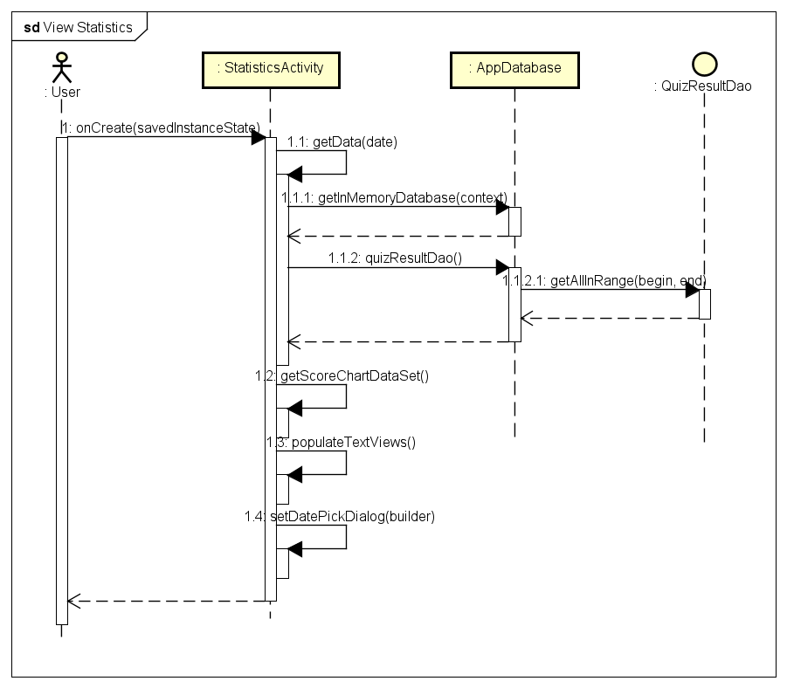

### e. Database queries

* SELECT * FROM quiz_result WHERE date BETWEEN :begin AND :end ORDER BY date ASC

## 10. Search Dictionary

### a. Screen Design

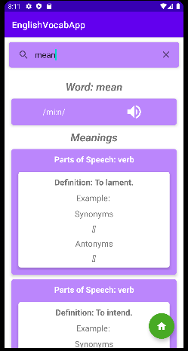

| **No** | **Object/Control Name** | **Type** | **Required** | **Length** | **Description** |
| --- | --- | --- | --- | --- | --- |
| 1 | search_view | SearchView | Yes | 30 | Search input |
| 2 | txt_word | TextView |  |  | Display searched Word |
| 3 | txt_phonetics | TextView |  |  | Display word’s phonetics |
| 4 | btn_play | ImageButton |  |  | Play phonetics via MediaPlayer |
| 5 | txt_definition | TextView |  |  | Show word’s definitions |
| 6 | txt_partOfSpeech | TextView |  |  | Show word’s part of speech |
| 7 | txt_example | TextView |  |  | Show word’s use example |
| 8 | txt_synonyms | TextView |  |  | Show synonyms |
| 9 | txt_antonyms | TextView |  |  | Show antonyms |

### b. Class Diagram

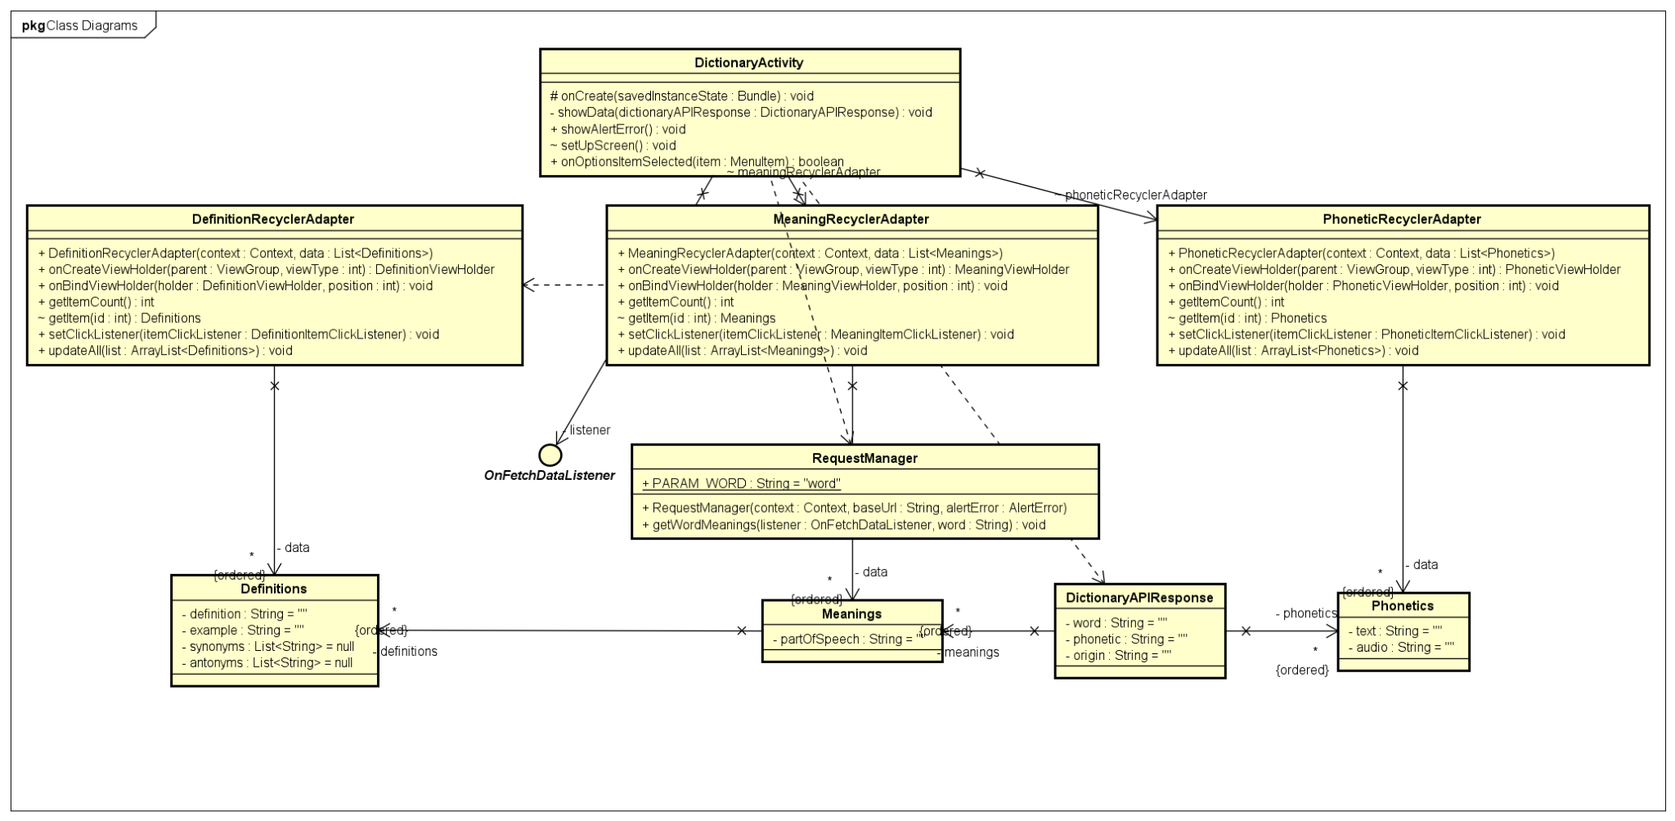

### c. Class Specifications

#### DictionaryActivity Class

| **No** | **Method** | **Description** |
| --- | --- | --- |
| 01 | onCreate | executed when activity is created |
| 02 | showAlertError | show error message when task fail |
| 03 | onOptionsItemSelected | execute when menu items are selected |
| 04 | setUpScreen | setup Screen |
| 05 | showData | show search result data |

#### 

#### DefinitionRecyclerAdapter Class

| **No** | **Method** | **Description** |
| --- | --- | --- |
| 01 | DefinitionRecyclerAdapter | RecyclerViewAdapter base methods |
| 02 | onCreateViewHolder |
| 03 | onBindViewHolder |
| 04 | getItemCount |
| 05 | getItem |
| 06 | setClickListener |
| 07 | updateAll |

#### MeaningRecyclerAdapter Class

| **No** | **Method** | **Description** |
| --- | --- | --- |
| 01 | MeaningRecyclerAdapter | RecyclerViewAdapter base methods |
| 02 | onCreateViewHolder |
| 03 | onBindViewHolder |
| 04 | getItemCount |
| 05 | getItem |
| 06 | setClickListener |
| 07 | updateAll |

#### PhoneticRecyclerAdapter Class

| **No** | **Method** | **Description** |
| --- | --- | --- |
| 01 | PhoneticRecyclerAdapter | RecyclerViewAdapter base methods |
| 02 | onCreateViewHolder |
| 03 | onBindViewHolder |
| 04 | getItemCount |
| 05 | getItem |
| 06 | setClickListener |
| 07 | updateAll |

#### RequestManager Class

| **No** | **Method** | **Description** |
| --- | --- | --- |
| 01 | RequestManager | constructor |
| 02 | getWordMeanings | fetch searched word’s meanings through API |

#### 

### d. Sequence Diagram(s)

### 