

**EnglishVocabApp**

**Software Requirement Specification**

Lưu Bảo Anh - SE05203

– Hanoi, Sept 2022 –

**Table of Contents**

**1 Overall Description** **4**

1.1 Introduction 4

1.2 Feature Descriptions 5

1.2.1 Screen Functions 5

1.2.2 Non-Screen Functions 5

1.2.3 Common Requirements 5

1.3 Screen Description 6

1.3.1 Screen Flow 6

1.3.2 Screen Details 6

1.3.3 User Authorization 6

**2 System Features** **7**

2.0 Home Screen 7

2.1 Note List 8

2.1.1 Screen Design 8

2.1.2 Use case Specification 8

2.2 Note Details 9

2.2.1 Screen Design 9

2.2.2. Use case Specification 10

2.3 Edit/Add Note 11

2.3.1 Screen Design 11

2.3.2 Use case Specification 11

2.4 Search Note 12

2.4.1 Screen Design 12

2.4.2 Use case Specification 12

2.5 Delete Note 12

2.5.1 Screen Design 12

2.5.2 Use case Specification 12

2.6 Play Quiz 13

2.6.1 Screen Design 13

2.6.2 Use case Specification 16

2.7 Export Quiz Result To Note 18

2.7.1 Screen Design 18

2.7.2 Use case Specification 18

2.8 Review Quiz 19

2.8.1 Screen Design 19

2.8.2 Use case Specification 20

2.9 View Statistics 21

2.9.1 Screen Design 21

2.9.2 Use case Specification 21

2.10 Search Dictionary 23

2.10.1 Screen Design 23

2.10.2 Use case Specification 24

# **1 Overall Description**

## **1.1 Introduction**

The LearnEnglishApp provides Users with different tools to help them learn and test their English vocabulary, including notes, dictionary, English vocabulary quizzes & graph visualising Users’ performance over time.

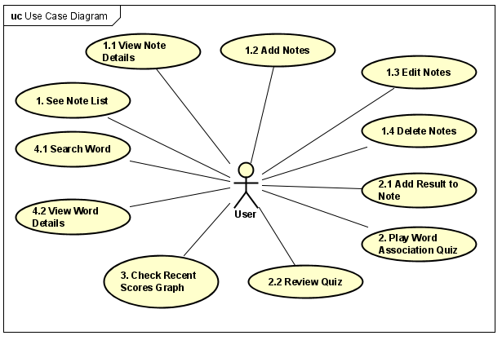

## **1.2 Feature Descriptions**

### **1.2.1 Screen Functions**

| **#** | **Feature** | **System Function** | **Description** |
| --- | --- | --- | --- |
| 1 | Note | Add New Note | Allow User to add Note |
| 2 |  | Edit Note | Allow User to edit Note |
| 3 |  | Delete Note | Allow User to delete Note |
| 4 |  | Show Note List | Show created Notes |
| 5 |  | Show Note Details | Show clicked-on Note’s details |
| 6 | Quiz | Quiz Setting | Allow User to choose the settings of Quiz |
| 7 |  | Show Quiz Questions | Allow User to play picked Quiz |
| 8 |  | After Quiz Result | Show Quiz Result |
| 9 |  | Export Quiz to Note | Show Add Note Screen with Quizzes' contents |
| 10 | Statistics | Show Quiz Statistics | Show User’s past Quiz performance |
| 11 | Dictionary | Search Word | Search for Word |

### **1.2.2 Non-Screen Functions**

| **#** | **Feature** | **System Function** | **Description** |
| --- | --- | --- | --- |
| 1 | Quiz | Save Result to SQLite | Save Quiz Result to SQLite as Graph’s data |

### 

### **1.2.3 Common Requirements**

EnglishVocabApp shall be implemented with:

* Android Studio 2022.3.1 with plugin Lombok 3.4.1
* Android API 33 (minimum 30).
* Java SE 11
* ButterKnife library 10.0.0
* Lombok library 1.18.12
* Retrofit2 library 2.9.0
* Room library 2.4.3

## **1.3 Screen Description**

### **1.3.1 Screen Flow**

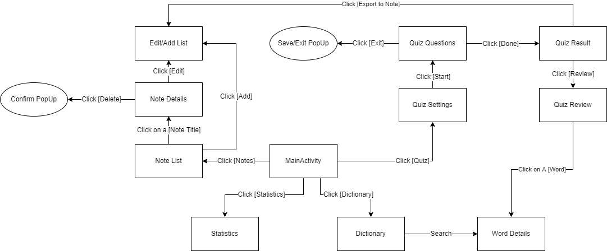

### **1.3.2 Screen Details**

| **#** | **Feature** | **Screen** | **Description** |
| --- | --- | --- | --- |
| 0 | Menu | Main Screen | -Has 4 Button (Note, Quiz, Statistics, Dictionary) |
| 1 | Note | Edit/Add Note | -Has 2 EditText (Title, Content), 2 Button (Cancel, Save) |
| 2 |  | Note List | -Has RecyclerView contains Notes’ Titles, 2 Button (Return, Add) |
| 3 |  | Delete Confirm PopUp | -Yes/No Dialog |
| 4 |  | Note Details | -Has 2 TextView (Title, Content), 3 Button (Return, Delete, Edit) |
| 5 | Quiz | Quiz Settings | -Has 2 Spinner (Level, Length), 2 Button (Start + Return) |
| 6 |  | Quiz Questions | -Has 1 EditText (QuestionNo), 3 TextView (Question, QuestionContent, QuestionTotal), 6 Button (PrevQues, NextQues, Answer1, Answer2, Done, Exit) |
| 7 |  | Save/Exit PopUp | -Yes/No/Cancel Dialog |
| 8 |  | Quiz Result | -Has 1 TextView (Score), 3 Button (Return, Review, Export to Note) |
| 9 |  | Quiz Review | -Has 1 EditText (QuestionNo), 3 TextView (Question, QuestionContent, QuestionTotal), 5 Button (PrevQues, NextQues, Answer1, Answer2, Exit) |
| 10 | Statistics | Statistics | -Has Graphs |
| 11 | Dictionary | Dictionary | -Has 1 EditText (Search), 3 RecyclerView (Results) |

### 

### **1.3.3 User Authorization**

The application is for a single user, as such, there’s no authentication & authorization required.

# **2 System Features**

## **2.0 Home Screen**

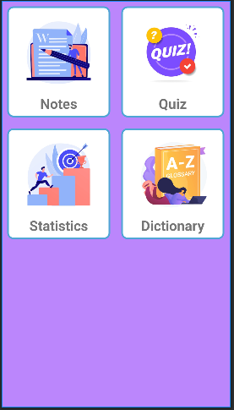

## **2.1 Note List**

### **2.1.1 Screen Design**

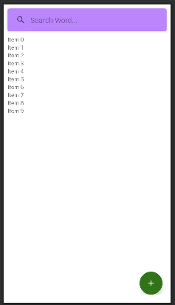

| **#** | **Field Name** | **Type** | **Mandatory** | **Max Length** | **Description** |
| --- | --- | --- | --- | --- | --- |
| 1 | Search note | SearchView |  |  | Input notes which user want to find |
| 2 | Title | TextView |  |  | note’s title |
| 3 | Date | TextView |  |  | note’s date |
| 4 | Home | Button |  |  | Exit back to Home Screen |
| 5 | Add | Button |  |  | Add new Note |

### **2.1.2 Use case Specification**

| **Use Case ID** | | **UC01** | **Use Case Name** | | **Note List** | |
| --- | --- | --- | --- | --- | --- | --- |
| **Author** | | **AnhLB** | **Version** | **1.0** | **Date** | **28/09/2022** |
| **Actor** | | User | | | | |
| **Description** | | The function allows a user to view created Notes | | | | |
| **Precondition** | | PRE-01:  PRE-02: | | | | |
| **Trigger** | | TRG-01: User clicks on [Note] in Home screen | | | | |
| **Post-Condition** | | POS-01: | | | | |
| **Main flows** | | | | | | |
| ***Step*** | ***Actor*** | ***Action*** | | | | |
| *1* | App | Fetch Notes from DB then display in RecyclerView with:  -Note title  -Note created date | | | | |
|  |  |  | | | | |

## **2.2 Note Details**

### **2.2.1 Screen Design**

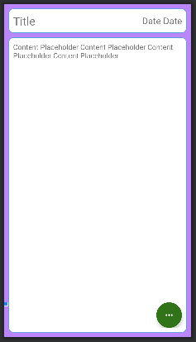

| **#** | **Field Name** | **Type** | **Mandatory** | **Max Length** | **Description** |
| --- | --- | --- | --- | --- | --- |
| 1 | Title | TextView |  |  | note’s title |
| 2 | Date | TextView |  |  | note’s date |
| 3 | content | TextView |  |  | note’s content |
| 4 | Edit Button | Button |  |  | Edit Note |
| 5 | Delete Button | Button |  |  | Delete Note |
| 6 |  |  |  |  |  |

### **2.2.2. Use case Specification**

| **Use Case ID** | | **UC02** | **Use Case Name** | | **Note Details** | |
| --- | --- | --- | --- | --- | --- | --- |
| **Author** | | **AnhLB** | **Version** | **1.0** | **Date** | **28/09/2022** |
| **Actor** | | User | | | | |
| **Description** | | The function allows a user to view created Note’s details | | | | |
| **Precondition** | | PRE-01:  PRE-02: | | | | |
| **Trigger** | | TRG-01: User clicks on a [Note] in Note List screen | | | | |
| **Post-Condition** | | POS-01: | | | | |
| **Main flows** | | | | | | |
| ***Step*** | ***Actor*** | ***Action*** | | | | |
| *1* | App | Fetch Note from DB then display:  -Note title  -Note created date  -Note contents | | | | |
|  |  |  | | | | |

## **2.3 Edit/Add Note**

### **2.3.1 Screen Design**

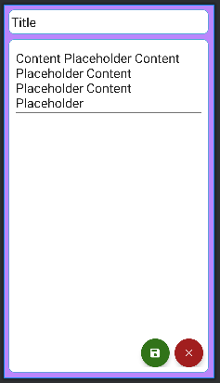

| **#** | **Field Name** | **Type** | **Mandatory** | **Max Length** | **Description** |
| --- | --- | --- | --- | --- | --- |
| 1 | Note Title | EditText | Yes |  | Input title of note |
| 2 | Note Content | EditText |  |  | Input content of note |
| 3 | Save | Button |  |  | Save Edit/Add Note |
| 4 | Cancel | Button |  |  | Cancel Save/Edit |
| 5 |  |  |  |  |  |

### **2.3.2 Use case Specification**

| **Use Case ID** | | **UC03** | **Use Case Name** | | **Add/Edit Note** | |
| --- | --- | --- | --- | --- | --- | --- |
| **Author** | | **AnhLB** | **Version** | **1.0** | **Date** | **27/09/2022** |
| **Actor** | | User | | | | |
| **Description** | | The function allows a user to be able to add/edit notes in the software when the user has selected the option [Add] or [Edit] in other Note screens | | | | |
| **Precondition** | | PRE-01: | | | | |
| **Trigger** | | TRG-01: | | | | |
| **Post-Condition** | | POS-01: | | | | |
| **Main flows** | | | | | | |
| ***Step*** | ***Actor*** | ***Action*** | | | | |
| *1* | User | Click [Add] in Note List, [Edit] in Note Details or [Export to Note] in Quiz Screen | | | | |
| *2* | App | Display Login screen with the following fields:  - Note Title  - Note Contents . . | | | | |
| *3* | User | Enter information about Note, then click [Save] | | | | |
| *4* | App | App save changes into the DB | | | | |
|  |  |  | | | | |

**Alternative flows**

## **2.4 Search Note**

### **2.4.1 Screen Design**

Refer to Note List UseCase

### **2.4.2 Use case Specification**

| **Use Case ID** | | **UC04** | **Use Case Name** | | **Search Notes** | |
| --- | --- | --- | --- | --- | --- | --- |
| **Author** | | **AnhLB** | **Version** | **1.0** | **Date** | **27/09/2022** |
| **Actor** | | User | | | | |
| **Description** | | The function allows a user to search notes in the software | | | | |
| **Precondition** | | PRE-01: | | | | |
| **Trigger** | | TRG-01: | | | | |
| **Post-Condition** | | POS-01: | | | | |
| **Main flows** | | | | | | |
| ***Step*** | ***Actor*** | ***Action*** | | | | |
| *1* | User | Type key User want to find and then press Enter | | | | |
| *2* | EVA | Filter out Notes that doesn’t match the search key | | | | |

## **2.5 Delete Note**

### **2.5.1 Screen Design**

Refer to Note Detail UseCase

### **2.5.2 Use case Specification**

| **Use Case ID** | | **UC05** | **Use Case Name** | | **Delete Note** | |
| --- | --- | --- | --- | --- | --- | --- |
| **Author** | | **AnhLB** | **Version** | **1.0** | **Date** | **27/09/2022** |
| **Actor** | | User | | | | |
| **Description** | | The function allows a user to delete Notes | | | | |
| **Precondition** | | PRE-01: | | | | |
| **Trigger** | | TRG-01: | | | | |
| **Post-Condition** | | POS-01: | | | | |
| **Main flows** | | | | | | |
| ***Step*** | ***Actor*** | ***Action*** | | | | |
| *1* | User | Click [Delete] in Note Detail Screen | | | | |
| *2* | EVA | Show Confirm Dialog | | | | |
| *3* | User | Click [Yes] | | | | |
| *4* | EVA | Note is deleted from DB & move user back to Note List Screen | | | | |

## **2.6 Play Quiz**

### **2.6.1 Screen Design**

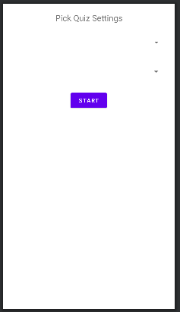

| **#** | **Field Name** | **Type** | **Mandatory** | **Max Length** | **Description** |
| --- | --- | --- | --- | --- | --- |
| 1 | spinner_level | Spinner | Yes | 20 | Pick Quiz Level, defaultValue = ‘Pick Quiz Level’ |
| 2 | spinner_length | Spinner |  |  | Pick Quiz Length, defaultValue = ‘Pick Quiz Length’ |
| 3 | Start | Button |  |  | Start Quiz |
|  |  |  |  |  |  |

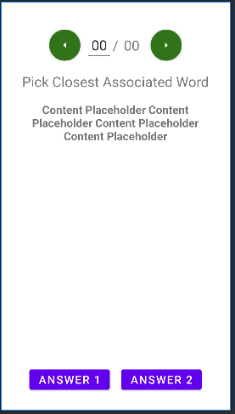

| **#** | **Field Name** | **Type** | **Mandatory** | **Max Length** | **Description** |
| --- | --- | --- | --- | --- | --- |
| 1 | Exit | Menu option |  |  | show pop-up whether to Save Quiz progress when exiting |
| 2 | fab_prev | FloatingActionButton |  |  | Move to previous question |
| 3 | fab_next | FloatingActionButton |  |  | Move to next question |
| 4 | txt_questionNo | EditText |  | 2 | show current question number & move to new question on change |
| 5 | txt_questionTotal | TextView |  | 2 | show total number of questions |
| 6 | Finish | Menu option |  |  | Finish Quiz |
| 7 | txt_questionContent | TextView |  |  | Show Question content |
| 8 | btn_answer1 | Button |  |  | Show answer choice |
| 9 | btn_answer2 | Button |  |  | Show answer choice |

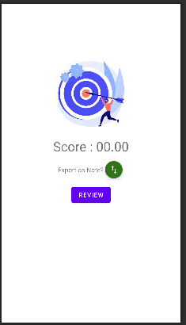

| **#** | **Field Name** | **Type** | **Mandatory** | **Max Length** | **Description** |
| --- | --- | --- | --- | --- | --- |
| 1 | txt_score | TextView |  |  | show quiz score |
| 2 | btn_review | Button |  |  | Move to Quiz Review Screen |
| 3 | btn_return | Button |  |  | Return to Home |
| 4 | fab_export | FloatingActionButton |  |  | Export quiz questions & answers to Note |

### **2.6.2 Use case Specification**

| **Use Case ID** | | **UC06** | **Use Case Name** | | **Play Quiz** | |
| --- | --- | --- | --- | --- | --- | --- |
| **Author** | | **AnhLB** | **Version** | **1.0** | **Date** | **27/09/2022** |
| **Actor** | | User | | | | |
| **Description** | | User pick settings for Quiz and proceed to answer generated questions | | | | |
| **Precondition** | | PRE-01:  PRE-02: | | | | |
| **Trigger** | | TRG-01: User click on [Quiz] in Main Screen | | | | |
| **Post-Condition** | | POS-01: | | | | |
| **Main flows** | | | | | | |
| ***Step*** | ***Actor*** | ***Action*** | | | | |
| 1 | App | Display spinners for Quiz type, level & length | | | | |
| 2 | User | Pick Quiz type, level & length | | | | |
| 3 | User | Click [Start] | | | | |
| 4 | App | Generate Quiz with chosen settings via API | | | | |
| 5 | App | Display Questions | | | | |
| 6 | User | Answer Questions | | | | |
| 7 | User | Click [Done] | | | | |
| 8 | App | Show Result Screen | | | | |

**Alternative flows**

| **AT1** | At step 2 in the main flows**,** if there is a saved quiz, user shall be asked whether to continue previous quiz or start a new quiz | |
| --- | --- | --- |
| **Sub step** | **Actor** | **Action** |
| 2.1 | App | Display Dialog asking user whether to start new quiz or continue saved quiz |
|  |  |  |

| **AT2** | At step 6 in the main flows**,** user choose to exit by clicking [Exit] | |
| --- | --- | --- |
| **Sub step** | **Actor** | **Action** |
| 6.1 | App | Display Dialog asking user whether to save quiz or not |
|  |  |  |

## **2.7 Export Quiz Result To Note**

### **2.7.1 Screen Design**

Refer to Note Add Screen

### **2.7.2 Use case Specification**

| **Use Case ID** | | **UC07** | **Use Case Name** | | Export Quiz Result To Note | |
| --- | --- | --- | --- | --- | --- | --- |
| **Author** | | **AnhLB** | **Version** | **1.0** | **Date** | **27/09/2022** |
| **Actor** | | User | | | | |
| **Description** | | The function allows a user to export quiz questions & answers to Note for studying purpose | | | | |
| **Precondition** | | PRE-01: User finished Quiz  PRE-02: | | | | |
| **Trigger** | | TRG-01: User clicks on [Export] button | | | | |
| **Post-Condition** | | POS-01: | | | | |
| **Main flows** | | | | | | |
| ***Step*** | ***Actor*** | ***Action*** | | | | |
| *1* | User | Click on [Export to Note] button on After Quiz Screen | | | | |
| *2* | App | Open Add Note screen with Quizzes’ contents | | | | |
| *3* | User | [Proceed to make change & save Note like UC03] | | | | |

## **2.8 Review Quiz**

### **2.8.1 Screen Design**

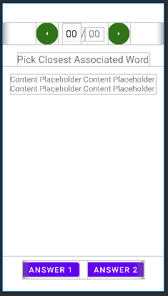

| **#** | **Field Name** | **Type** | **Mandatory** | **Max Length** | **Description** |
| --- | --- | --- | --- | --- | --- |
| 1 | fab_prev | FloatingActionButton |  |  | Move to previous question |
| 2 | fab_next | FloatingActionButton |  |  | Move to next question |
| 3 | txt_questionNo | EditText |  | 2 | show current question number & move to new question on change |
| 4 | txt_questionTotal | TextView |  | 2 | show total number of questions |
| 5 | txt_questionContent | TextView |  |  | Show Question content |
| 6 | btn_answer1 | Button |  |  | Show answer choice |
| 7 | btn_answer2 | Button |  |  | Show answer choice |
| 8 |  |  |  |  |  |

### **2.8.2 Use case Specification**

| **Use Case ID** | | **UC08** | **Use Case Name** | | **Review Quiz** | |
| --- | --- | --- | --- | --- | --- | --- |
| **Author** | | **AnhLB** | **Version** | **1.0** | **Date** | **27/09/2022** |
| **Actor** | | User | | | | |
| **Description** | | The function allows a user to review quiz after finishing Quiz | | | | |
| **Precondition** | | PRE-01: User finished Quiz  PRE-02: | | | | |
| **Trigger** | | TRG-01: User clicks on [Review] in After Quiz Screen | | | | |
| **Post-Condition** | | POS-01: | | | | |
| **Main flows** | | | | | | |
| ***Step*** | ***Actor*** | ***Action*** | | | | |
| *1* | App | Show Questions & Answers, with correct Answers on Green | | | | |

**Alternative flows**

| **AT1** | User clicks on an Answer | |
| --- | --- | --- |
| **Sub step** | **Actor** | **Action** |
| 2.1 | App | Display Dictionary with the Answer’s definition [UC09] |
|  |  |  |

## **2.9 View Statistics**

### **2.9.1 Screen Design**

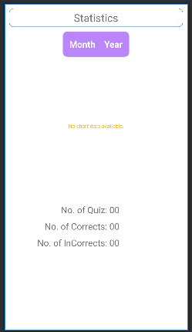

| **#** | **Field Name** | **Type** | **Mandatory** | **Max Length** | **Description** |
| --- | --- | --- | --- | --- | --- |
| 1 | Month - Year | DatePickDialog |  |  | Allow user to choose a month to display on bar chart |
| 2 | Bar Chart | MPAndroidChart.BarChart |  |  | Show A Month’s Quiz results |
| 3 | txt_NoOfQuiz | TextView |  |  | Total number of Quizzes done in cohen Month |
| 4 | txt_correct | TextView |  |  | Total number of correct answers |
| 5 | txt_incorrect | TextView |  |  | Total number of incorrect answers |

### **2.9.2 Use case Specification**

| **Use Case ID** | | **UC09** | **Use Case Name** | | **View Quiz Statistics** | |
| --- | --- | --- | --- | --- | --- | --- |
| **Author** | | **AnhLB** | **Version** | **1.0** | **Date** | **28/09/2022** |
| **Actor** | | ser | | | | |
| **Description** | | The function allows a user to view their past Quiz performance via graphs & other statistics. | | | | |
| **Precondition** | | PRE-01:  PRE-02: | | | | |
| **Trigger** | | TRG-01:User clicks on [Statistics] Button on Home Screen | | | | |
| **Post-Condition** | | POS-01: | | | | |
| **Main flows** | | | | | | |
| ***Step*** | ***Actor*** | ***Action*** | | | | |
| *1* | App | Fetch data for current month from DB & visualise into graphs & text views | | | | |
|  |  |  | | | | |

**Alternative flows**

| **AT1** | User pick new Month range | |
| --- | --- | --- |
| **Sub step** | **Actor** | **Action** |
| 1.1 | App | Fetch data for chosen month from DB & visualise into graphs & text views |
|  |  |  |

## **2.10 Search Dictionary**

### **2.10.1 Screen Design**

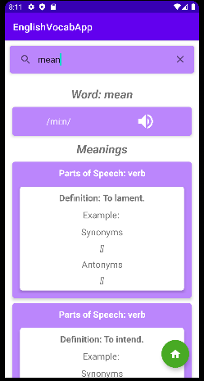

| **#** | **Field Name** | **Type** | **Mandatory** | **Max Length** | **Description** |
| --- | --- | --- | --- | --- | --- |
| 1 | search_view | SearchView | Yes | 30 | Search input |
| 2 | txt_word | TextView |  |  | Display searched Word |
| 3 | txt_phonetics | TextView |  |  | Display word’s phonetics |
| 4 | btn_play | ImageButton |  |  | Play phonetics via MediaPlayer |
| 5 | txt_definition | TextView |  |  | Show word’s definitions |
| 6 | txt_partOfSpeech | TextView |  |  | Show word’s part of speech |
| 7 | txt_example | TextView |  |  | Show word’s use example |
| 8 | txt_synonyms | TextView |  |  | Show synonyms |
| 9 | txt_antonyms | TextView |  |  | Show antonyms |

### **2.10.2 Use case Specification**

| **Use Case ID** | | **UC09** | **Use Case Name** | | **Search/View Word** | |
| --- | --- | --- | --- | --- | --- | --- |
| **Author** | | **AnhLB** | **Version** | **1.0** | **Date** | **28/09/2022** |
| **Actor** | | User | | | | |
| **Description** | | The function allows a user to search for a Word’s definitions | | | | |
| **Precondition** | | PRE-01:  PRE-02: | | | | |
| **Trigger** | | TRG-01: | | | | |
| **Post-Condition** | | POS-01: | | | | |
| **Main flows** | | | | | | |
| ***Step*** | ***Actor*** | ***Action*** | | | | |
| *1* | User | Type in Word and click [Search] button | | | | |
| *2* | App | Display Word’s definitions | | | | |

**Alternative flows**

| **AT1** | At step 2 in the main flows**,** if there is an error, | |
| --- | --- | --- |
| **Sub step** | **Actor** | **Action** |
| 2.1 | App | Display Toast message announcing there’s a problem occurred |