Project Report

IoT-Based Real-Time Weather Monitoring and Machine Learning Prediction System with Power BI Visualization
(A dissertation submitted in partial fulfillment of the requirements of Bachelor of Technology in Computer Science and Engineering of the Maulana Abul Kalam Azad University of Technology, West Bengal)



Submitted by

Nayan Saha Roll No:- 11200122068
Sunayani Mondal Roll No:- 11200121039
Banibrata Manna Roll No:- 11200121005
Mrinmayee Maiti Roll No:- 11200121056
Atul Pandey Roll No:- 11200221027
Susmita Sarkar Roll No:- 11200121036

Under the guidance of
Prof. Chhotan Mal

Professor/Asst. Prof./Lecturer,
Dept. of Computer Science & Engineering

Government College of Engineering and Leather Technology

(Affiliated to MAKAUT, West Bengal)

Kolkata - 700106, WB
2024-2025

Certificate of Approval

This is to certify that the project report on “IoT-Based Real-Time Weather Monitoring and Machine Learning Prediction System with Power BI Visualization” is a record of bonafide work, carried out by Nayan Saha, Sunayani Mondal, Banibrata Manna, Mrinmayee Maiti, Atul Pandey, Susmita Sarkar under my guidance and supervision.

In our opinion, the report in its present form is in conformity as specified by Government College of Engineering and Leather Technology and as per regulations of the Maulana Abul Kalam Azad University of Technology, West Bengal. To the best of my knowledge the results presented here are original in nature and worthy of incorporation in project report for the B.Tech. Program in Computer Science & Engineering.

Signature of Supervisor/ Guide

Signature of HOD, Dept. of CSE

Acknowledgement

With great pleasure, we would like to express our profound gratitude and indebtedness to Prof. Chhotan Mal, Computer Science and Engineering, Government College of Engineering and Leather Technology, W.B. for his continuous guidance, valuable advice and constant encouragement throughout the project work. His valuable and constructive suggestions at many difficult situations are immensely acknowledged. We are in short of words to express his contribution to this thesis through criticism, suggestions and discussions.
We would like to take this opportunity to thank Prof. Chhotan Mal, Project Coordinator and Prof. Santanu Halder, HOD, Department of Computer Science & Engineering and Information Technology, Government College of Engineering and Leather Technology.

Nayan Saha Roll No:- 11200122068

Banibrata Manna Roll No:- 11200121005

Sunayani Mondal Roll No:- 11200121039

Mrinmayee Maiti Roll No:- 11200121056

Atul Pandey Roll No:- 11200221027

Susmita Sarkar Roll No:- 11200121036

Project Abstract

This project explains the implementation of an Internet of Things (IoT)-based weather station with Ardiuno Uno R4 Wifi, Rain Sensor, MQ135 Sensor, LDR Sensor ,DHT11 & BMP280 sensor. This weather station is intended to capture real-time temperature, humidity, and light intensity, air quality, atmospheric pressure and temperature and altitude and send them to an online portal for further processing.
Ardiuno Uno R4 Wifi acts as the principal micro-controller with the responsibility to regulate and get readings from the two sensors. A DHT11 sensor detects air humidity and temperature. The data obtained is transmitted through Wi-Fi connectivity to the Thing Speak IoT server to be stored and analyzed. This weather station offers the capacity for real-time observation of weather conditions and undertaking relevant actions as required based on data obtained using the IoT technology. Integration into an online platform ensures remote access to data, making it possible for users to track weather conditions from anywhere.
Therefore, apart from demonstrating the use of IoT technology in monitoring weather, this research also brings into perspective future applications in monitoring the environment and management of resources. Machine learning models process historic data pattern to offer precise forecasts of weather.
The inclusion of Ardiuno Uno R4 Wifi micro-controllers provides wireless connectivity, with sensors such as DHT, LDR and MQ135 used to measure critical environmental parameters. Practical applications in weather forecasting, agriculture and urban planning are provided by the system, with enhanced-decision-making through predictive analytics.
Smart Weather Forecast System is an integrated solution utilizing IoT and Machine Learning to present actual and timely weather forecasts. It employs sensors including DHT, LDR, MQ135, and other environmental sensors in order to gauge environmental information including temperature, humidity, light, rainfall, air quality, atmospheric pressure and temperature and altitude .
The data is processed by the Ardiuno Uno R4 Wifi micro controller and sent to the ThingSpeak IoT platform for analysis and visualization. Machine learning algorithms are utilized to forecast weather conditions using real-time and past data. Local data visualization is also supported through an OLED display.
It collects real-time atmospheric information and helps deliver useful insight into weather phenomena. With sensors of different kinds, temperature, humidity, air quality, lightness, and precipitation can be monitored. Web-based visualization can be made by IoT-based weather stations using collected data, from which users are able to track remote changes in weather.
In addition, the integration of a notification system can notify users of important weather occurrences, like heavy rain or air pollution, so that they can prepare and respond in a timely manner. Potential future enhancements include adding additional sensors for wind direction and speed to further enhance the capabilities of the station and conduct even more advanced environmental monitoring.
This project tries to offer a cost-effective, scalable, and efficient method for weather forecasting, applicable to both personal and industrial purposes.
Weather data is essential to society as most activities are dependent on it. Weather may change rapidly and dramatically, surprising individuals. Meteorologists utilize such factors as temperature, humidity, rainfall, wind speed, wind direction, and light to forecast future weather.
Today, it is simple to find weather updates on the internet, and as a result, everyone can keep themselves informed in real-time. The web not only distributes information but is even capable of controlling objects through the Internet of Things (IoT). IoT further pushes the frontiers of being internet-connected by enabling everyday devices to talk to one another. A great example of this is a weather station with IoT technology.

Project Keyword

IoT:- Internet of Things
DHT11 Sensor:- Digital Humidity and Temperature Sensor

ESP32:- Espressif Systems' Integrated Circuit (IC) Wi-Fi module.
BMP280 :- Barometric Pressure and Altitude Sensor
LDR Sensor :- Light Dependent Resistor
Rain Drop Sensor
MQ135 Sensor :- Metal Oxide Semiconductor
ThingSpeak IoT Server

Table of Contents
Topic Name | Page Number
Project Abstract | 4
Project Keyword | 5
Chapter 1:- Introduction | 11-12
1.1 Overview | 12
1.2 Literature Review | 12-14
1.3 Objective | 14
1.4 Project Summary | 15
Chapter 2:- Theory of IoT | 15-19
2.1 IoT (Internet of Things) | 15-16
2.2 IoT− Key Features | 16
2.3 IoT– Advantages | 16
2.4 IoT–Disadvantages | 16-17
2.5 IoT Software | 17
2.6 Internet of Things - Technology and Protocols | 17-18
2.7 Internet of Things - Common Use | 18-19
Chapter 3:- Theory of Machine Learning | 19-21
3.1 Machine Learning | 19
3.2 The Goal of Machine Learning | 19
3.3 Advancements in Data Collection and Processing. | 19
3.4 Extracting Patterns and Making Predictions | 19
3.5 Applications of Machine Learning | 20
3.6 Core Concepts in Machine Learning | 20
3.7 Types of Models | 20
3.7.1 Predictive Models | 20
3.7.2 Descriptive Models | 20
3.7.3 Combined Predictive and Descriptive Models | 20
3.8 Theory of Statistics and Inference | 21
3.8.1 Key aspects of statistical inference | 21
3.8.2 Statistical inference types: | 21
3.9 Efficiency and Complexity of Learning Algorithms | 21
3.10 Future Prospects of Machine Learning | 21
Chapter 4 :- Block diagram of the system | 22
Chapter 5 :- Advantages of proposed system | 22-23
Chapter 6 Components and Materials | 23-67
6.1 Hardware Components | 23-63
6.1.1 Arduino Uno R4 WiFi An In-Depth Technical Analysis | 23-24
6.1.2 Arduino UNO R4 WiFi Block Diagram | 24
6.1.3 Pinout for Arduino R4 UNO R4 WiFi. | 24
6.1.4 Delving into the Core: Key Features and Functionalities | 25-26
6.1.5 Technical Specifications of Arduino UNO R4 WiFi | 26-27
6.1.6 The Evolution: Arduino UNO R4 WiFi Compared to its Predecessors | 27-29
6.1.7 Wireless Freedom: Exploring WiFi and Bluetooth Capabilities | 29
6.1.8 Illuminating Ideas: Working with the Onboard LED Matrix | 29
6.1.9 Unleashing Potential: Applications and Project Ideas | 29-30
6.1.10 Embarking on Your Journey: Getting Started with Arduino UNO R4 WiFi | 30
6.1.11 Expert Insights: Reviews and Performance Analysis | 30-31
6.1.12 Conclusion: Embracing the Power of Arduino UNO R4 WiFi | 31
6.2 DHT Sensor | 31
6.2.1 DHT11 Pinout | 31
6.2.2 Working Principle of DHT11 Sensor | 31-32
6.2.3 DHT-11 Pin Description: | 32
6.2.4 Specification of the DHT11 sensor | 32
6.2.5 DHT-11 Communication with Microcontroller | 32-34
6.2.6 DHT11 Communication Protocol | 34
6.2.7 DHT-11 Applications | 34
6.3 MQ135 Sensor | 34
6.3.1 MQ135 Pin Configuration: | 35
6.3.2 MQ135 General specifications of this sensor | 35-37
6.3.3 MQ135 Calculate Value Process | 37-38
6.3.4 MQ135 Air Quality Sensor Working Principle | 39
6.3.5 MQ135 Air Quality Sensor Physical Dimensions | 39
6.3.6 MQ135 Air Quality Sensor Application | 39-40
6.4 LDR Sensor | 40
6.4.1 LDR Symbol | 40
6.4.2 Construction of an LDR | 40-41
6.4.3 Working Principle of Light dependent Resistor | 41
6.4.4 Light Dependent Resistor Circuit | 41
6.4.5 LDR Frequency Dependences | 41
6.4.6 Light Dependent Resistor Latency | 42
6.4.7 Light Dependent Resistor Specification | 42
6.4.8 Characteristics of LDR | 42
6.4.9 Types of LDR | 43
6.4.10 LDR Advantages | 43
6.4.11 LDR Disadvantages | 43
6.4.12 Applications of LDR | 43
6.4.13 Power Conserving of Intensity Controlled Street Lights using LDR | 43-44
6.5 Rain Sensor | 44
6.5.1 Rain Sensor Module | 44
6.5.2 Pin Configuration | 44-45
6.5.3 Specifications | 45-47
6.5.4 Types of Rain Sensor | 45
6.5.4.1 Capacitive Rain Sensors | 45
6.5.4.2 Resistive Rain Sensors | 46
6.5.4.3 Optical Rain Sensors | 46
6.5.4.4 Mechanical Rain Sensors | 46
6.5.4.5 Ultrasonic Rain Sensors | 46
6.5.4.6 Integrated Rain Sensors | 46
6.5.4.7 Water collection basin | 46
6.5.4.8 Conductive sensors | 46
6.5.4.9 Freeze sensors | 47
6.5.5 Rain Sensor: Working Principle | 47
6.5.6 Rain Sensor Circuit | 47-48
6.5.7 Applications of Rain Sensor | 48
6.5.8. Conclusion of Rain Sensor | 48
6.6 BMP 280 Sensor | 49
6.6.1 Technical specifications of BMP 280 Sensor | 49
6.6.2 Block diagram of BMP280 | 50
6.6.3 Sensor Architecture of BMP 280 | 50
6.6.4 Working Principle of BMP 280 Sensor | 50-51
6.6.5 BMP280 Pin Details | 51
6.6.6 Example of Pin Configuration in a Circuit | 51-52
6.6.7 Calibration and Algorithms of BMP 280 Sensor | 52
6.6.8 Applications of BMP 280 Sensor | 52
6.6.9 Conclusion of BMP 280 Sensor | 52
6.7 OLED Display | 53
6.7.1 Overview 0.96 OLED Display | 53
6.7.2 Technical Specifications 0.96 OLED Display | 53
6.7.3 Structure of the 0.96 inch OLED Display | 53
6.7.4 Schematic diagram of the 0.96 inch OLED Display | 54
6.7.5 Working Mechanism 0.96 Inch OLED Display | 54
6.7.6 Control and Pixel Addressing 0.96 Inch OLED Display | 54-55
6.7.7 Advantages of 0.96 OLED Display | 55
6.7.8 Disadvantages of 0.96 OLED Display | 55
6.7.9 Applications of 0.96 OLED Display | 55
6.7.10 Conclusion of 0.96 OLED Display | 56
6.8 LM296 DC-DC Converter: Details and Analysis | 56
6.8.1 The Role of DC-DC Buck Converters | 56
6.8.2 Introducing the LM2596 Series | 56
6.8.3 Core Features and Benefits | 57-58
6.8.3.1 Adjustable Output Voltage | 57
6.8.3.2 Fixed Output Voltage Options | 57
6.8.3.3 High Output Load Current | 57
6.8.3.4 Wide Input Voltage Range | 57
6.8.3.5 Minimal External Components | 57
6.8.3.6 Excellent Regulation | 57
6.8.3.7 Fixed Switching Frequency | 58
6.8.3.8 TTL Shutdown Capability | 58
6.8.3.9 High Efficiency | 58
6.8.3.10 Standard Inductors | 58
6.8.3.11 Protection Features | 58
6.8.4 Comprehensive Electrical Characteristics | 58-60
6.8.4.1 Absolute Maximum Ratings | 58-59
6.8.4.2 Recommended Operating Conditions | 59
6.8.4.3 Electrical Characteristics for Fixed Output Versions (3.3V, 5V, 12V) | 59
6.8.4.4 Electrical Characteristics for Adjustable Output Version | 59
6.8.4.5 Oscillator Frequency | 59
6.8.4.6 Saturation Voltage | 59-60
6.8.4.7 Quiescent Current | 60
6.8.4.8 Thermal Resistance | 60
6.8.5 Understanding the Operating Modes | 60-61
6.8.5.1 Continuous Conduction Mode (CCM) | 60
6.8.5.2 Discontinuous Conduction Mode (DCM) | 60
6.8.5.3 Mode Transition | 60-61
6.8.6 Design and Application of Typical Circuits | 61
6.8.6.1 Fixed Output Voltage Application | 61
6.8.6.2 Adjustable Output Voltage Application | 61
6.8.6.3 Component Selection Considerations | 61
6.8.6.4 Layout Considerations | 62
6.8.7 Addressing Common Issues and Troubleshooting | 62-64
6.8.7.1 Excessive Output Ripple | 62
6.8.7.2 Failure to Start Up | 62
6.8.7.3 Bad Regulation | 62
6.8.7 4 Slow Transient Response | 63
6.8.7.5 Random Shutdowns | 63
6.8.7.6 Overheating | 63
6.8.7.7 Voltage Drops Under Load | 63
6.8.7.8 Counterfeit Chips | 64
6.8.8 Conclusion | 63-64
6.8.8.1 Summary of Key Features and Benefits | 64
6.8.8.2 Suitability and Limitations | 64
6.9 Software Component | 64-68
6.9.1 Arduino IDE | 64
6.9.2 ThingSpeak IoT Platform | 64
6.9.3 Python | 65-67
6.9.4 MATLAB | 67
6.9.5 Getting Started with MATLAB | 67
6.9.6 Microsoft Power Bi | 68
Chapter 7:- System Architecture | 68
Chapter 8:- Working Principle | 68-70
Chapter 9:- Flow Chart &Implementation Steps | 70
Chapter 10:- Sensor Integration and Data Acquisition | 71
Chapter 11:-Hardware Setup | 71
Chapter12:- Coding & Implementation for Arduino IDE | 72-75
Chapter 13:- IoT Platform: ThingSpeak | 75-78
13.1:- MATLAB Visualizations | 78-81
Chapter 14:- Machine Learning for Weather Prediction | 81-126
Chapter 15:- Power BI Visualization Implementation | 127-128
Chapter 16:-Web Server & Coding Implementation | 129-135
Chapter 17:- Additional Features | 135-137
Chapter 18:- Applications | 137
Chapter 19:- Future Scope | 137
Chapter 20:- Conclusion | 138
References | 139-141

List Of Figure
Figure Name | Page Number
Fig.4:-. Block Diagram of the Complete IoT System | 22
Fig 6.1.2:- Arduino UNO R4 WiFi Block Diagram | 24
Fig 6.1.3:- Pinout for Arduino R4 UNO R4 WiFi. | 24
Fig 6.2.1:- DHT11 Pinout: | 31
Fig 6.2.2:- DHT11 Sensor | 32
Fig 6.3:- MQ135 Sensor | 35
Fig 6.3.1:-MQ135 Pin Configuration | 35
Fig 6.3.2:- Internal circuit diagram of MQ135 | 36
Fig 6.3.3:- MQ135 Datasheet-Change in Resistance vs change in PPM | 37
Fig 6.3.4:- MQ135 Air Quality Sensor | 39
Fig 6.4:- Light Dependent Resistor | 40
Fig 6.4.1:- LDR Symbol | 40
Fig 6.4.2:- Light Dependent Resistor Construction | 40
Fig 6.4.4:- LDR Circuit Diagram | 41
Fig 6.4.8:- LDR Characteristics | 42
Fig 6.5.1:- Rain Sensor Module | 44
Fig 6.5.2:- Rain Sensor Pin | 44
Fig 6.5.3:- Rain Sensor | 45
Fig 6.5.4.8:- Conductive Sensor | 46
Fig 6.5.4.9:- Freeze Sensors | 47
Fig 6.5.6:- Rain Sensor Circuit Diagram | 49
Fig 6.6:- BMP 280 Sensor | 50
Fig 6.6.2:-Block Diagram of BMP 280 | 50
Fig 6.6.5:- BMP 280 Sensor Pin | 51
Fig 6.7.1:- OLED Display | 53
Fig 6.7.4:- Schematic diagram of the 0.96 inch OLED Display | 54
Fig 6.8.1:- LM2596 DC-DC Step-down Buck Module with Display | 56
Figure 7.1:- System Architecture for Arduino UNO R4 WiFi | 68
Figure 9.1:- Flow Chart in Arduino Uno R4 WiFi | 70
Figure 11.2:-Arduino UNO R4 WiFi of Hardware Setup | 71
Fig 12:- Serial Monitor of Output | 75
Fig 13.1: Temperature in Month Jun | 75
Fig 13.2: Humidity in Month Jun | 75
Fig 13.3: Rain Value in Month Jun | 75
Fig 13.4:- LED in Month Jun | 75
Fig 13.5: Air Quality in Month Jun | 76
Fig 13.6: Max Temperature in Month Jun | 76
Fig 13.8:Temperatue in Month May 2025 | 76
Fig 13.7: Min Temperature in Month Jun | 76
Fig 13.9-:DHT Humidity in Month May 2025 | 76
Fig 13.10:- Max Temperature in Month May 2025 | 76
Fig 13.11:-Air Quality in Month May 2025 | 76
Fig 13.12:-LED in Month May 2025 | 76
Fig 13.13:-Rain Status in Month May 2025 | 77
Fig 13.14:-Rain Value in Month May 2025 | 77
Fig 13.15:- Min Temperature in Month May 2025 | 77
Fig 13.16:- BMP Temperature in Month May 2025 | 77
Fig 13.19:- BMP Only Value Show for Pressure & Altitude | 77
Fig 13.20:- BMP Only Value Show for Temperature | 78
Fig 13.1.1:- MATLAB Code Visualize correlation between temperature and humidity 1 | 78
Fig 13.1.2:- MATLAB Plot Output Visualize correlation between temperature and humidity 1 | 79
Fig 13.1.3:- MATLAB Code Compare temperature data from three different days | 79
Fig 13.1.4 :- MATLAB Plot Output for 1 day temperature Compassion | 80
Fig 13.1.5:- MATLAB Code Visualize directional data with compass plot 6 | 80
Fig 13.1.6:- MATLAB Plot Output Visualize directional data with compass plot 6 | 81
Fig 14.1:- Temperature Over Time | 81
Fig 14.2:-Line Chart Of Humidity | 82
Fig 14.3:-Line Chart of Pressure in millibars | 82
Fig 14.4:-Random Forest Time Series Forecasting | 84
Fig 14.5:- Maximum Temperature Forecast(Random Forecast) | 85
Fig 14.6:- Weather Forecast for Max Temperature | 86
Fig 14.7:- Weather Forecast, Trend, Weekly, Yearly, Extra Regressors additive Max Temperature | 86
Fig 14.8:- Weather Forecast for Min Temperature | 87
Fig 14.9:- Weather Forecast, Trend, Weekly, Yearly, Extra Regressors additive For Min Temperature | 88
Fig 14.10:- Weather Forecast for Relative Humidity | 89
Fig 14.11:- Weather Forecast, Trend, Weekly, Yearly, Extra Regressors additive For Relative Humidity | 90
Fig 14.12:- Weather Forecast for Sea Level Pressure | 91
Fig 14.13:-Maximum Temperature: Actual vs. Predicted | 93
Fig 14.14:-Minimum Temperature: Actual vs. Predicted | 93
Fig 14.15:-Relative Humidity: Actual vs. Predicted | 93
Fig 14.16:-'Sea Level Pressure: Actual vs. Predicted | 93
Fig 14.17:-Actual vs Predicted AQI using Linear Regression | 94
Fig 14.18:- Decision Tree Regressor - Actual vs Predicted AQI | 95
Fig 14.19:-Random Forest Regressor - Actual vs Predicted AQI | 96
Fig 14.20:- Feature Importance (Random Forest) | 97
Fig 14.21:- XGBoost Regressor - Actual vs Predicted AQI | 98
Fig 14.22:- Feature Importance(XGBoost Regression) | 98
Fig 14.23:-SVR - Actual vs Predicted AQ | 100
Fig 14.24:-Model R² Score Comparison & R2 Score | 102
Fig 14.25:-('Feature Importance - XGBoost (by Gain) | 119
Fig 14.26:- Compare Rain Prediction Model for Using Weather Intelligence Dashboard | 125
Fig 14.27:- AQI Category Prediction Model for Using Weather Intelligence Dashboard | 125
Fig 14.28:- Rain Model Performance Table for Using Weather Intelligence Dashboard | 126
Fig 15.1:- Power BI Visualization Photo-1 | 127
Fig 15.2:- Power BI Visualization Photo-2 | 127
Fig 15.3:- Power BI Visualization Photo-3 | 128
Fig 15.4:- Power BI Visualization Photo-4 | 128
Fig 16.1:- Web server Welcome Page | 130
Fig 16.2:- Web Page Real Time BMP 280 Data | 132
Fig 16.3:-Web Server Page Smart Weather Forecast System using IoT & ML | 135

Chapter 1:- Introduction
With the introduction of high-speed Internet linking more and more people across the globe as become possible. The Internet of Things (IoT) is a step ahead, connecting not just people but also all electronic devices together. With WiFi enabled devices reducing costs this trend will only gather more thrust. The main concept behind the Internet of Things (IoT) is to connect variable electronic devices via a network and then retrieve the data from these devices (sensors)that can be distributed in any fashion, upload them to any cloud service where the collected information can be analyzed and processed. Develop a wireless temperature and humidity ,air quality, rain, atmospheric pressure, and altitude Monitoring System using mobile app. IOT Device for measuring & monitoring of temperature & Humidity It is a portable unit for temperature and humidity, air quality, rain, atmospheric pressure, and altitude Monitoring, It’s a Continuous measurement. Digital OLED with back light displaying. Battery Indication Wireless Indication Programmable distinct Alarms for Deviations in Temperature & Humidity Display Readings in Temperature, Humidity, air quality, rain, atmospheric pressure, and altitude , LED Status(Power -Up, low battery, charging, network ), switch for power On Monitoring is considered to be an essential aspect of environmental changing conditions. It is basically employed to assess and mapping of biodiversity over vast.
These data may be used to inform people by different means, such as using an informative website containing the values of different parameters and also using Machine Learning Techniques. Future technology is to bind the whole world in one place. It is possible to link all objects, items and sensors to transfer the information obtained at different places & process / analysis data to organize applications such as traffic signaling, mobile health tracking in medical use and methods of industrial protection, etc.
IOT provides a vast range of interface communication with different protocols and different application properties to achieve the highest user interaction. Climate monitoring is needed to achieve good crop growth, to ensure safe industrial working conditions etc. Ongoing development made the scanning stage of environmental parameters much simpler compared to the past. These sensors are Electronic instrument commonly used to measure different natural, physical and environmental parameters.
These supply the information which can be fed into cloud afterward. The output would be credible by employing sensors to examine climatic conditions and the whole system will consume fewer resources, and there will be quicker response. Wireless technology is included in this system, and it also possesses Wi-Fi connectivity. In this case, the weather conditions are regulated and the information is put on the website. A weather monitoring system may be defined as a system which provides us with weather forecasts in our surroundings which makes it smart and interactive by wireless communication with objects.
For example, it can give us atmospheric temperature, humidity, and pressure, air Quality etc. information. Forecasting weather has traditionally been reliant on centralized meteorological institutions that employ complex models and extensive observation station networks. While the systems provide excellent insights, the predictions tend to be generalized and may not necessarily reflect the variations of the local weather situation.
Further, the methods employed sometimes are cumbersome in regards to data collection and dissemination 1. The arrival of the Internet of Things (IoT) has brought about a new era of environmental monitoring, where it is possible to deploy dispersed arrays of smart, internet-enabled sensors that can deliver real-time data from a location of interest.
This evolution enables more subtle and real-time understanding of weather conditions, from relying on weather forecasting authorities alone to giving users direct access to local weather. Underlying this technological revolution is the increased exposure of machine learning (ML) in a wide range of scientific applications, including weather forecasting.
Machine learning techniques possess the strong potential of handling high-dimensional, sophisticated data such as that generated by weather observation networks and identifying latent patterns and relations that would otherwise go undetected by traditional analytical methods. Having the ability to draw from enormous pools of historical and live weather data, machine learning approaches such as deep learning algorithms are capable of isolating sophisticated, non-linear patterns, and stand to provide more accurate and earlier weather forecasts. In this article, we put forward an intelligent weather forecasting system for localized observation and prediction relying on the complementary potential of the internet of things and machine learning.
Leveraging easily sourced and affordable hardware, this system offers a complete set of environmental information. Central to this is the Arduino UNO R4 Wi-Fi microcontroller, controlling data acquisition, processing, and streamlined communication. Attached to the core unit are a set of dedicated sensors each responsible for the measurement of certain atmospheric parameters: there is a DHT sensor that religiously records ambient temperature and humidity, an LDR sensor that measures ambient light intensity, an MQ135 sensor that measures surrounding air quality, a rain drop sensor that senses the arrival of precipitation, and a BMP280 sensor that accurately records atmospheric pressure along with temperature and altitude.
For instant, local feedback, a 1.3-inch OLED module visually displays real-time sensor values. At the same time, the gathered sensor data are also sent to the ThingSpeak IoT platform, a cloud-based solution with solid data storage, insightful visualization, and potential for sophisticated integration with machine learning routines. The system thus efficiently monitors temperature, humidity, rain, and pressure for the target location. The prototype ingeniously employs these five interlinked sensors – DHT11 (humidity and temperature), YL83 (rain), LDR (light), MQ135 (air), and BMP280 (altitude, pressure, temperature) – to calculate these vital environmental parameters.
This system effectively keeps track of and monitors ecological conditions, including temperature and relative humidity, using its set of sensors. It subsequently sends this collected data to a special web page, further refining the raw sensor data into graphically intuitive graphical insights. This up-to-date environmental information, as recorded by the system, becomes publicly accessible through the web.
The gathered information receives its display on an interactive HTML webpage, fetching the recent sensor readings directly from ThingSpeak in real time, offering an interface for real-time monitoring. Utilizing the capabilities of machine learning algorithms, the system goes through past data to make forecasts regarding future weather patterns, building a strong solution for predictive weather analysis.
The ThingSpeak integration provides remote access to critical weather parameters worldwide, allowing users to monitor trends and draw valuable insights through an easy-to-use web-based interface. The project fully demonstrates end-to-end integration of cloud computing, Internet of Things (IoT), and predictive analytics in environmental monitoring.

Overview
In order to set up real-time weather observation, the system is mounted as per the circuit diagram, and the Arduino UNO R4 WiFi, a programmable controller with a built-in Wi-Fi module, is programmed with the help of the Arduino IDE. Once the programming is successful, a message will be shown on your screen.

In this configuration, several sensors are attached to one Arduino UNO R4 WiFi board to accumulate in-depth weather information. To be specific, we incorporate the LDR sensor for light intensity, the DHT11 sensor for temperature and humidity levels, the MQ135 sensor for air quality measurement, the rain sensor for precipitation detection, and the BMP280 sensor for pressure and approximate height measurement.

The data gathered by the sensors – including temperature, humidity, air quality, rain, atmospheric pressure, and altitude – are sent over the internet and displayed in an easy-to-read Graphical User Interface (GUI). The Arduino UNO R4 WiFi is then programmed once it is successfully connected to the network and is allocated an IP address. This IP address may be accessed using any standard web browser, e.g., Chrome, Firefox, or Internet Explorer, and the users may see the live weather parameters.

To provide better convenience in accessing and managing the gathered data, the system is also integrated with the ThingSpeak IoT server. The integration provides real-time visualization of the data, safe storage, and remote monitoring. The weather data is publicly hosted so that people can view the surroundings from anywhere there is an internet connection.

In addition, an Android app has also been created to offer easy and seamless access to the weather monitoring system so that users can monitor live weather parameters at any given time directly from their mobile phones. The particular weather parameters being monitored and available through the web interface and the Android app are temperature, humidity, light intensity, air quality (through the MQ135 sensor), detection of rainfall, atmospheric pressure, and approximate elevation. This public hosting of information guarantees universal access to the environmental data that is recorded by the system.

1.2 Literature Review
Jitcha Shivang et al. developed a simulated system to predict weather condition of Indian subcontinent using Machine Learning. Data for training was collected from data.gov.in, ncdc.noaa.gov and UCI machine learning data repository. The system utilizes a linear regression algorithm for data training [1]. Zaheer Ullah Khan et al. utilized different information digging methods for expectation of climate determining including diverse groupings like K-Nearest Neighbor, Decision Trees.

Among the order algorithms, decision tree has accomplished promising outcomes contrasted with different calculations. In this paper they have achieved an accuracy of 82% [2]. Siddharth S. et al. have utilized information mining strategy and Decision tree calculation to group climate parameters like least temperature and most extreme temperature as far as day, month and year [3]. Radhika et al. presented a paper on the use of Support Vector Machines for climate forecast.

Time arrangement information of every day greatest temperature at an area was dissected to anticipate the most extreme temperature of the following day at that area dependent on the day by day most extreme temperatures for a range of past n days alluded to as request of the info.. Non straight relapse technique was utilized to prepare the SVM for this application [4]. Divya Chauhan et al. utilized information mining, an instrument that predicts practices and future patterns, enabling organizations to settle on proactive choices.

This paper introduces the survey of data mining techniques for weather prediction and concentrates the advantage of utilizing it. The paper can be utilized to foresee meteorological information that is climate expectation. The paper gives a review of accessible writings of a few calculations utilized by various specialists to use different information mining methods for weather prediction [5].

After studying all the papers, it has been concluded that the training data is taken from some external source. But in this paper, all the data is measured in different conditions using a set of sensors. In this paper, two sensors viz. LDR and DHT11 have been used that measures temperature, humidity and light density. In this paper, the author elaborates how the weather prediction system is becoming a crucial challenge in every Weather extreme event that causes an adverse effect of the system on lives and property as well. Hence the accuracy of weather data is being one of the critical challenges to enhance the weather prediction skills and build up the resilience to effect of detrimental weather report condition.

The author describes that Uganda and various other developing countries have looked challenges in developing timely & accurate weather data due to scarce weathers observation. The scarce weather monitoring is a part of the high cost of developing automatic weather situations. The restricted funding is available to national meteorological services of the respective countries.

In this proposed system the author firstly takes care of the problems and then applies them. The author proposed an Automatic weather monitoring Station based on a wireless sensor network. The planning of the author is to develop three generations of Automatic weather stations or AWS prototypes. In this research, the author evaluates the 1st-generation AWS prototype to improve the 2nd generation depending upon the need and generation. The author provides a suggestion to improve the nonfunctional requirement such a power consumption, data accuracy, reliability, and data transmission in order to have an Automatic Weather Station.

The non-functional requirement collapsed with cost reduction in order to produce a robust and affordable Automatic Weather Station (AWS) Therefore the proposed work, like developing countries like Uganda will be able to acquire the AWS in suitable quantities. So that it can improve the weather forecasting The author in [2], presents an IoT-based weather monitoring system. In this research, the environmental parameter can be retrieved through sensors.

The author uses a different sensor to scale the various parameter like humidity, temperature, pressure, rain value & the LDR sensor is used.
The system also calculates the dew point value from the temperature prototype. The temperature sensor can be used to measure the value of the particular area, room, or any place. With the help of the LDR sensor, the light intensity can be used as described by the author.

The author in this used an additional functionality of the weather monitoring as SMS alert system based on the exceed the value of the sensing parameters as temperature, humidity, pressure, light intensity, and rain value. The author also adds an email and tweet post alerting system. The author in this system uses Arduino UNO R4 WiFi, and various sensors. In this paper [3], the author represents a low-cost live weather monitoring system using OLED display, in which the author displays the various fields where the IoT has produced innovative things in the system.

The author described A new revolutionary system. Which measures the real-time Weather's condition. The monitoring weather situation is very much helpful for everyone either for farmer or industry or daily working people or for school as well. So, the author by developing a live weather monitoring system reduced the difficulty level for farmers and industry as well. In this paper, the author uses an OLED display that will display the weather conditions and In the proposed model, the author uses an Arduino UNO R4 WiFi microelectronic-based WeMos D1 board executed on Arduino, that retrieved the data from the cloud. WeMos D1 is a wifi module that is developed on Arduino UNO R4 WiFi micro-controller. It has a 4MB flash memory.

It one of the Excellent which is programmed with node MCU and Arduino ide. In this paper Author uses only two gadgets to measure the weather conditions i.e., Wemos and OLED, After the connection, it will store the data on the cloud for storing data a thing speak website is used to display the data regarding weather.

The system displays the data on OLED and thing speak cloud. The author's aim is to obtain live information on weather conditions on OLED display. The author in [4], proposed a system that monitors and predicts the weather condition by which anyone can plan for our day-to-day life. This activity became helpful in every field either in agriculture or industry.

So as to achieve monitoring and predicting weather info, the author uses 2 stages of the weather management system. In which they amalgamated the information from the sensors, bus mobility, and deep learning technology is used to allow a weather reporting system in stations and buses in real-time. Forecasting of weather is achieved through the friction model. Depending upon the sensing measurement from vehicles like buses, the work incorporates the strength of local information processing. The author talks about in stage-I, sensing of weather’s condition, multi-layer perception model and long-term memory are trained and then it will verify using temperature data, humidity, air pressure of test environment.

In Stage-II, the training is applied to learn the time series of weather information. To get accurate data or not, to check the system performance, the author comparing the predicted weather data and actually obtained data from the environment Protection Administrator and central Bureau of Taichung observation system that calculate the prediction of accuracy. The author finally talks about the proposed system has reliable-performance on monitoring of weather. And this model also proposed a one-day weather forecast or prediction via the training model.

So finally, the author demonstrates that this system presents a real-time weather monitoring and prediction system using bus information management. The author represents 4 basic components 1- Information management. 2- Interactive bus stop Machine learning predictive model 4- weather information platform. In this, information shown via dynamic chart. The author [5],implement an IoT-based weather monitoring system, in this research paper, the author describes that how with the help of IoT technology, the weather can be monitored.

And which provide the info of climate-changing conditions. With the help of this project, people can be aware of the climate condition changes. It gives an accurate and efficient output and the algorithm as the swarm is used to implement for further improving the accuracy.
So, in this project, the author aims to make a weather monitoring with the help of IoT. In this project, the hardware and software are used which makes it easy to implement. In the project, the author uses a different sensor to collect the information of the climate and stored it in the cloud.

For this storage, the website www.thingspeak.com is commonly used for Internet of things projects. And from the cloud storage space, it extracts the whole weather data and uploads it to the android mobile application using an API key. Tools which detect the rain drops, is called rain sensor. Once the plague reveals the raindrops on the strips and the voltage is considered from that.

1.3 Objective

To develop, design, and test an intelligent weather forecasting IoT-based system using an Arduino Uno R4 WiFi and a set of environmental sensors to gather real-time data, send it to the cloud for storage and processing, use machine learning algorithms to forecast the weather, and display the data through easy-to-use interfaces.

Specific Objectives:

Comprehensive Environmental Data Acquisition: Interface and integrate a variety of sensors – DHT (humidity and temperature), LDR (light), rain drop sensor (rain), MQ135 (air), and BMP280 (pressure, altitude, temperature) – with the Arduino Uno R4 WiFi to obtain a complete picture of the local environment weather. Calibrate these sensors so that they provide accurate and consistent real-time data readings.

Seamless Internet Connectivity and Data Transfer: Create a strong Wi-Fi link for the Arduino Uno R4 WiFi to enable efficient transmission of data over the internet. Use either HTTP or MQTT protocols to securely transfer the captured sensor data in real-time to the ThingSpeak IoT platform for long-term storage and later analysis.

Intuitive Local Real-Time Display: Program a 1.3-inch OLED module to provide immediate, on-site visualization of the current readings from all connected environmental sensors, offering users instant feedback on the present weather parameters.

Precise Weather Forecasting using Machine Learning: Utilize historical weather data being kept on the ThingSpeak platform to analyze, choose, and deploy suitable machine learning algorithms (e.g., Linear Regression, Decision Trees, Random Forest, or Neural Networks). Train them to make precise short-term predictions for major weather metrics (temperature, humidity, pressure, and likelihood of rain) specific to the region being tracked. Improve the predictability constantly with the integration of new data collected.

Dynamic and Thoughtful Data Visualization using Power BI: Create an interactive and dynamic Power BI dashboard to display both real-time and historical weather data, including the forecasts developed by machine learning. Display trends, forecasts, and analytical results in different graphical formats (charts, graphs, and tables) to enable decision-making based on solid facts. Have the dashboard update in real-time to mirror the current sensor readings and forecasts.

User-Friendly Real-Time Web Interface: Design a responsive web interface with HTML, CSS, and JavaScript to give the user real-time access to the actual weather conditions and forecasts generated. Use AJAX to fetch and display data dynamically from ThingSpeak in an easily readable format on various devices.

Proactive Alert and Notification System: Implement an alert system that sends out notifications to users if there is a drastic or significant change in weather conditions. Provide the options of receiving alerts through SMS, mail, or push notices based on pre-specified thresholds for different weather variables.

Effective System Operation and Power Control: Use power-saving methods by employing sleep modes on the Arduino Uno R4 WiFi to maximize energy efficiency, especially important for possible future long-term use in different locations.

Strong Data Security and Integrity: Utilize suitable encryption techniques and secure communication protocols to ensure the confidentiality and integrity of the harvested sensor data while in transit to and stored on the cloud platform. Use error handling techniques to maintain data consistency and reliability.

Detailed System Documentation: Create detailed technical documentation explaining the overall system design, sequential implementation processes for all components, and a clear description of the working principles of the individual sensors, the microcontroller, the interaction with the cloud platform, the machine learning algorithms, and the visualization interfaces.

1.4 Project Summary

This project describes creating a smart, localized weather predicting system using the potential of the Internet of Things (IoT) and machine learning (ML). The centerpiece of the system is the Arduino Uno R4 WiFi microcontroller, which is connected to an array of environmental sensors to read actual weather readings. Some of these sensors are:

DHT sensor: Reads ambient temperature and relative humidity.
LDR sensor: Reads the level of ambient light.
MQ135 sensor: Senses the quality of ambient air.
BMP280 sensor: Sensor’s temperature, barometric pressure, and altitude.
Rain drop sensor: Senses the amount and intensity of rain.
The information collected through these sensors is sent wirelessly using Wi-Fi to the ThingSpeak IoT cloud platform. ThingSpeak is a cloud-based centralized platform for safe data storage, real-time visualization using configurable graphs and charts, and remote monitoring from any internet-connected device.

For instant, on-board feedback, there is a 1.3-inch OLED display connected in direct communication with the Arduino Uno R4 WiFi. A local display, it gives real-time output of all the connected sensors in a useful way of instant checking of prevailing weather without going on the ThingSpeak platform.

One of the innovations of this project is the use of machine learning to forecast the weather. The data gathered and saved on ThingSpeak is a useful dataset for training different ML models. Selection of particular algorithms will rely on the duration of desired forecasts and the simplicity or complexity of local weather patterns. Some possible ML methods are:

ARIMA: For time series analysis and prediction of single weather parameters.
Regression methods (e.g., Linear Regression, Random Forests): For predicting continuous values such as temperature, humidity, pressure, and light intensity.
Advanced Deep Learning models: For capturing more complex relationships and possibly improving forecast accuracy.
The machine learning computation can be done through MATLAB integration with ThingSpeak or by simply accessing the data using Python and pertinent ML libraries. The generated weather forecasts can be displayed on the ThingSpeak dashboard and possibly shown on the local OLED module for real-time user alertness.

The system has been planned keeping power efficiency in mind, using low-power modes and optimized data transfer protocols to prolong operation.

In addition, the project also examines future possible upgrades by using the Arduino ESP32 microcontroller as an upgrade possibility. The upgraded processing power and increased memory capacity of the ESP32 would allow for more sophisticated ML algorithms to be run on the device directly, resulting in quicker and more responsive forecasting. Its increased analog input pins would also make possible the incorporation of more sensors, like those for wind speed and direction measurement, to produce a more complete weather observation solution. The onboard Bluetooth features of the ESP32 could also be used for local data logging or for communication between devices.

In short, this project hopes to develop an intelligent and localized smart weather forecasting system that optimally integrates the real-time data gathering capabilities of IoT via the Arduino Uno R4 WiFi and environmental sensors with the analytical capabilities of machine learning for smart weather prediction and monitoring. The system offers both remote access to detailed weather information and forecasts through ThingSpeak, and real-time on-location readings through a local OLED screen. The possibility of using more advanced microcontrollers such as the ESP32 further underlines the scalability and future growth of the project for greater functionality and accuracy.

Chapter 2:- Theory of IoT
2.1 IoT (Internet of Things)

IoT (Internet of Things) is an advanced automation and analytics system which exploits networking, sensing, big data, and artificial intelligence technology to deliver complete systems for a product or service. These systems allow greater transparency, control, and performance when applied to any industry or system.

IoT systems have applications across industries through their unique flexibility and ability to be suitable in any environment. They enhance data collection, automation, operations, and much more through smart devices and powerful enabling technology.

The world is experiencing a strong rush towards modern technology, while specialized companies are living a terrible rush in the information technology towards the so-called Internet of things IoT or Internet of objects, which is the integration of things with the world of Internet, by adding hardware or/and software to be smart and so be able to communicate with each other and participate effectively in all aspects of daily life, so enabling new forms of communication between people and things, and between things themselves, that’s will change the traditional life into a high style of living.

But it won’t be easy, because there are still many challenges and issues that need to be addressed and have to be viewed from various aspects to realize their full potential. The main objective of this review paper will provide the reader with a detailed discussion from a technological and social perspective. The various IoT challenges and issues, definition and architecture were discussed. Furthermore, a description of several sensors and actuators and their smart communication.

Also, the most important application areas of IoT were presented. This work will help readers and researchers understand the IoT and its potential application in the real world. The term “Internet of Things” (IoT) was coined by Kevin Ashton at a presentation to Proctor & Gamble in 1999.

He is one of the founders of the Massachusetts Institute of Technology’s Automatic Recognition Lab. He pioneered RFID (used in barcode detector) technology in the field of supply chain management. He also founded Zensi, a company that manufactures energy sensing and monitoring technologies. The Internet of Things is an emerging topic of technical, social and economic importance.

Consumer products, durable goods, cars and trucks, industrial components and facilities, sensors, and other everyday objects are combined with internet connectivity and powerful data analysis capabilities that promise to transform the way we live and work. A major shift in our daily routines can be observed along with the widespread implementation of IoT devices and technologies.

IoT is everywhere, although we do not always see it or know that a device is part of it. For consumers, new IoT products like Internet-enabled devices, home automation components and power management devices drives us toward seeing “Smart home”, which provides more safety and energy efficiency. Other IoT personal devices such as wearable fitness and health monitors that support the network-enabled medical devices are transforming the way healthcare services are delivered.

The Internet of Things transforms physical objects into an information ecosystem shared between wearable, portable, and even implantable devices, making our life technology and data rich.

2.2 IoT− Key Features

The most important features of IoT include artificial intelligence, connectivity, sensors, active engagement, and small device use. A brief review of these features is given below

AI − IoT essentially makes virtually anything “smart”, meaning it enhances every aspect of life with the power of data collection, artificial intelligence algorithms, and networks. This can mean something as simple as enhancing your refrigerator and cabinets to detect when milk and your favorite cereal run low, and to then place an order with your preferred grocer.

Connectivity − New enabling technologies for networking and specifically IoT networking, mean networks are no longer exclusively tied to major providers. Networks can exist on a much smaller and cheaper scale while still being practical. IoT creates these small networks between its system devices.

Sensors − IoT loses its distinction without sensors. They act as defining instruments that transform IoT from a standard passive network of devices into an active system capable of real world integration.

Active Engagement − Much of today's interaction with connected technology happens through passive engagement. IoT introduces a new paradigm for active content, product, or service engagement.

Small Devices − Devices, as predicted, have become smaller, cheaper, and more powerful over time. IoT exploits purpose-built small devices to deliver its precision, scalability, and versatility.

2.3 IoT– Advantages

The advantages of IoT span across every area of lifestyle and business. Here is a list of some of the advantages that IoT has to offer.

Improved Customer Engagement − Current analytics suffer from blind spots and significant flaws in accuracy; and as noted, engagement remains passive. IoT completely transforms this to achieve richer and more effective engagement with audiences.

Technology Optimization − The same technologies and data which improve the customer experience also improve device use, and aid in more potent improvements to technology. IoT unlocks a world of critical functional and field data.

Reduced Waste − IoT makes areas of improvement clear. Current analytics give us superficial insight, but IoT provides real-world information leading to more effective management of resources.

Enhanced Data Collection − Modern data collection suffers from its limitations and its design for passive use. IoT breaks it out of those spaces and places it exactly where humans really want to go to analyze our world. It allows an accurate picture of everything.

2.4 IoT–Disadvantages

Though IoT delivers an impressive set of benefits, it also presents a significant set of challenges. Here is a list of some its major issues.

Security − IoT creates an ecosystem of constantly connected devices communicating over networks. The system offers little control despite any security measures. This leaves users exposed to various kinds of attackers.

Privacy − The sophistication of IoT provides substantial personal data in extreme detail without the user's active participation.

Complexity − Some find IoT systems complicated in terms of design, deployment, and maintenance given their use of multiple technologies and a large set of new enabling technologies.

Flexibility − Many are concerned about the flexibility of an IoT system to integrate easily with another. They worry about finding themselves with several conflicting or locked systems.

Compliance − IoT, like any other technology in the realm of business, must comply with regulations. Its complexity makes the issue of compliance seem incredibly challenging when many consider standard software compliance a battle.

2.5 IoT Software

IoT software addresses its key areas of networking and action through platforms, embedded systems, partner systems, and middleware. These individual and master applications are responsible for data collection, device integration, real-time analytics, and application and process extension within the IoT network. They exploit integration with critical business systems (e.g., ordering systems, robotics, scheduling, and more) in the execution of related tasks.

Data Collection

This software manages sensing, measurements, light data filtering, light data security, and aggregation of data. It uses certain protocols to aid sensors in connecting with real-time, machine-to-machine networks. Then it collects data from multiple devices and distributes it in accordance with settings. It also works in reverse by distributing data over devices. The system eventually transmits all collected data to a central server.

Device Integration

Software supporting integration binds (dependent relationships) all system devices to create the body of the IoT system. It ensures the necessary cooperation and stable networking between devices. These applications are the defining software technology of the IoT network because without them, it is not an IoT system. They manage the various applications, protocols, and limitations of each device to allow communication.

Real-Time Analytics
 
These applications take data or input from various devices and convert it into viable actions or clear patterns for human analysis. They analyze information based on various settings and designs in order to perform automation-related tasks or provide the data required by industry.

Application and Process Extension 

These applications extend the reach of existing systems and software to allow a wider, more effective system. They integrate predefined devices for specific purposes such as allowing certain mobile devices or engineering instruments access. It supports improved productivity and more accurate data collection.

2.6 Internet of Things - Technology and Protocols

IoT primarily exploits standard protocols and networking technologies. However, the major enabling technologies and protocols of IoT are RFID, NFC, low-energy Bluetooth, low-energy wireless, low-energy radio protocols, LTE-A, and WiFi-Direct. These technologies support the specific networking functionality needed in an IoT system in contrast to a standard uniform network of common systems.

NFC and RFID :-RFID (radio-frequency identification) and NFC (near-field communication) provide simple, low energy, and versatile options for identity and access tokens, connection bootstrapping, and payments. RFID technology employs 2-way radio transmitter-receivers to identify and track tags associated with objects. NFC consists of communication protocols for electronic devices, typically a mobile device-and a standard device.

Low-Energy Bluetooth :-This technology supports the low-power, long-use need of IoT function while exploiting a standard technology with native support across systems.

Low-Energy Wireless :-This technology replaces the most power hungry aspect of an IoT system. Though sensors and other elements can power down over long periods, communication links (i.e., wireless) must remain in listening mode. Low-energy wireless not only reduces consumption, but also extends the life of the device through less use.

Radio Protocols :-ZigBee, Z-Wave, and Thread are radio protocols for creating low-rate private area networks. These technologies are low-power, but offer high throughput unlike many similar options. This increases the power of small local device networks without the typical costs.

LTE-A :-LTE-A, or LTE Advanced, delivers an important upgrade to LTE technology by increasing not only its coverage, but also reducing its latency and raising its throughput. It gives IoT a tremendous power through expanding its range, with its most significant applications being vehicle, UAV, and similar communication.

WiFi-Direct :-WiFi-Direct eliminates the need for an access point. It allows P2P (peer-to-peer) connections with the speed of WiFi, but with lower latency. WiFi-Direct eliminates an element of a network that-often bogs it down, and it does not compromise on speed or throughput.

2.7 Internet of Things - Common Uses
IoT has applications across all industries and markets. It spans user groups from those who want to reduce energy use in their home to large organizations who want to streamline their operations. It proves not just useful, but nearly critical in many industries as technology advances and we move towards the advanced automation imagined in the distant future.
The Internet of Things (IoT) is transforming industries by seamlessly connecting devices, systems, and processes. Its applications span various sectors, ranging from enhancing everyday life at home to optimizing large-scale industrial operations. As technological advancements continue, IoT is proving to be not just useful but increasingly essential, driving us toward a future of intelligent automation and efficiency.
Engineering, Industry, and Infrastructure :-Applications of IoT in these areas include improving production, marketing, service delivery, and safety. IoT provides a strong means of monitoring various processes; and real transparency creates greater visibility for improvement opportunities.

The deep level of control afforded by IoT allows rapid and more action on those opportunities, which include events like obvious customer needs, nonconforming product, malfunctions in equipment, problems in the distribution network, and more. IoT applications in engineering, industry, and infrastructure enhance production, marketing, service delivery, and safety. By providing real-time monitoring of processes, IoT offers transparency and visibility, enabling organizations to identify and act on improvement opportunities quickly. This includes detecting customer demands, identifying nonconforming products, diagnosing equipment malfunctions, and addressing distribution network inefficiencies. The deep level of control enabled by IoT allows industries to respond rapidly to these events, ensuring optimized operations and increased efficiency.

Government and Safety :-IoT applied to government and safety allows improved law enforcement, defense, city planning, and economic management. The technology fills in the current gaps, corrects many current flaws, and expands the reach of these efforts. For example, IoT can help city planners have a clearer view of the-impact of their design, and governments have a better idea of the local economy.

IoT plays a pivotal role in enhancing law enforcement, defense, urban planning, and economic management. By filling critical gaps and addressing existing inefficiencies, IoT enables governments to gain better insights and make informed decisions. For instance: City planners can assess the impact of their designs by analyzing real-time data on traffic patterns and environmental conditions. Law enforcement agencies can improve public safety by using smart surveillance systems and predictive analytics. Local governments can better understand economic trends and respond proactively to community needs.
Home and Office :-In our daily lives, IoT provides a personalized experience from the home to the office to the organizations we frequently do business with. This improves our overall satisfaction, enhances productivity, and improves our health and safety.
For example, IoT can help us customize our office space to optimize our work. In our daily lives, IoT offers a personalized and enhanced experience at home, in the office, and within the organizations we interact with. Smart home devices optimize energy usage, improve security, and enhance convenience, while IoT-enabled offices boost productivity by customizing work environments based on user preferences. For example: Smart thermostats and lighting systems adjust automatically for energy efficiency and comfort. IoT-enabled office spaces optimize layouts and environmental conditions to maximize productivity and employee satisfaction.
Health and Medicine :-IoT pushes us towards our imagined future of medicine which exploits a highly integrated network-of sophisticated medical devices. Today, IoT can dramatically enhance medical research, devices, care, and emergency care. The integration of all elements provides more accuracy, more attention to detail, faster reactions to events, and constant improvement while reducing the typical overhead of medical research and organization. IoT is revolutionizing the healthcare and medical industry by facilitating seamless communication between advanced medical devices, healthcare professionals, and patients.
IoT-driven systems improve medical research, patient care, and emergency response by ensuring faster reactions to critical events and enhancing accuracy. Key benefits include: Real-time patient monitoring: Wearable devices track vital signs and alert medical staff of anomalies. Smart medical devices: IoT-connected equipment optimizes hospital operations and reduces human error. Improved research and development: IoT streamlines data collection and analysis, accelerating medical discoveries.
Chapter 3:- Theory of Machine Learning
3.1 Machine Learning
Normally, programming a computer to do a particular task would need the implementation and development of an explicit algorithm for the definition of the precise series of operations that should be implemented. In modern computer systems, however, the capacity for learning from prior occurrences and automatic correction of earlier errors is non-existent.

Consequently, instructing a computer to perform intricate tasks requires careful work from highly skilled professionals who need to define and code the algorithms manually. In the opinion of Jaime G. Carbonell (1983), existing computer systems cannot learn to accomplish tasks based on examples or by solving similar tasks solved before. They cannot improve their performance by learning from past errors or gaining new skills by watching experts. To meet these challenges, machine learning (ML) research seeks to transform the instruction of computers so that they can minimize the effort of writing complicated algorithms as well as manage increasingly large amounts of information.

3.2 The Goal of Machine Learning

Machine learning seeks to create systems that can learn and adapt without being programmed. These systems can interact with humans, learn from experience, and become better over time.

Thus, learning machines or programs can learn to fulfill users' needs and adjust to various situations. But for the systems to function in a positive manner with human users, what they learn—the knowledge and skills—need not be made explicitly present at the machinery's internal processes, but humans need to understand and decipher.

3.3 Advancements in Data Collection and Processing.

Ethem Alpaydin (2004) noted that with the development of computer hardware, we can store enormous amounts of data and process them, and even retrieve them from geographically distant places through computer networks. Most modern data acquisition devices record stable and accurate digital data. For instance, a supermarket chain with hundreds of stores scattered all over the country produces gigabytes of data daily, recording information such as:

Date and time of transactions
Customer identification
Things bought and their amounts Total amount spent

This data, however, is not valuable until such data is processed to provide meaningful insights and predictions. Since actual customer behavior or decision trends are unknown, raw data cannot be converted into useful insights directly. Trends and patterns can be approximated through data analysis and machine learning, and decisions can be made accordingly by organizations.

3.4 Extracting Patterns and Making Predictions

Machine learning is particularly good in cases where there are patterns and consistencies in the data. Without even knowing the whole underlying process, machine learning algorithms can detect these patterns and use them to make accurate predictions. By assuming similar future conditions to those under which the sample data was collected, future event predictions can be fairly accurate.

For instance: Forecasting which customers are likely to buy a specific item. Recommending a movie or a novel to a user based on his previous choice. This capacity to identify patterns and forecast the future positions machine learning at the forefront of artificial intelligence (AI). The smart system of a changing world has to have the capability to learn and adapt. Machine learning makes it unnecessary for system designers to forecast every possible situation and prepare for it, and the system can learn and become intelligent on its own with the passage of time.

3.5 Applications of Machine Learning

Machine learning has advanced incredibly in several domains, such as:

Computer Vision: Detection of objects and faces in images and videos.

Speech Recognition: Converting spoken words into text.

Robotics: Facilitating self-navigation and intelligent decision-making.

Take the case of face recognition, something we do so easily by identifying known faces even under changes in lighting, pose, and hair style. Although human beings cannot tell us exactly how they recognize faces, machine learning programs can learn the task through learning from huge volumes of face pictures. By identifying unique facial features and patterns, the programs are able to tell individuals from new pictures with high accuracy. That is pattern recognition, whereby the system learns the intrinsic information structure and uses the same to recognize patterns in the future

3.6 Core Concepts in Machine Learning

Machine learning basically deals with the process of training computers to improve a performance criterion using past data or earlier experiences. The major concepts coming under machine learning are:

Model Definition and Parameter Optimization A model is characterized by specific parameters to be optimized. Learning is to execute algorithms to tune these parameters from training data.

3.7 Types of Models:

3.7.1 Predictive Models:

Predictive models apply historical data to predict future results, whereas descriptive models uncover patterns and information in current data. Certain models can be applied for both, blending prediction with an understanding of the underlying data.

Objective: To make predictions regarding future occurrences or results based on past data.
Purpose: To predict trends, detect risks, and aid decision-making.
Techniques: Apply statistical techniques, machine learning models, and data mining methods.
Examples: Customer churn prediction, sales forecasting, fraud detection.

3.7.2 Descriptive Models:

Focus: Summarizing and analyzing data to gain insight into patterns, trends, and relationships.
Purpose: To provide insights into past and current data, form a basis for decision-making, and facilitate business reporting.
Techniques: Use statistical analysis, data aggregation, and data mining.
Examples: Building dashboards, report generation, determining key performance indicators (KPIs).

3.7.3 Combined Predictive and Descriptive Models:

Purpose: To provide a complete picture of data, to facilitate both prediction and exploration.
Techniques: Integrate predictive and descriptive techniques into the same model or analysis.
Examples: A model that predicts customer behavior as well as determining the most important factors affecting that behavior.

3.8 Theory of Statistics and Inference

Machine learning relies heavily on statistical theory to build mathematical models. The objective is to make inferences from sample data and generalize patterns to unseen data. Statistical inference is one of the key concepts in statistics that enables the making of conclusions regarding a population from information available from a sample, resolving uncertainty and making generalizations. It involves techniques such as estimation and hypothesis testing to learn about unknown population parameters. Statistical inference is based on theory in probability theory and mathematical models to determine the probability of varying outcomes and make informed choices.

3.8.1 Key aspects of statistical inference

Estimation: Estimating the most probable value of an unseen population parameter using sample information. This may include point estimation (one value) or interval estimation (a collection of values at a given confidence level).

Hypothesis Testing:-Assessing evidence against a null hypothesis (a statement about the population) based on sample data. It includes comparison of the sample evidence with the null hypothesis to see if there is sufficient evidence to reject it.

Confidence Intervals:-Giving a range of possible values for an unknown population parameter with a given level of confidence.

Probability and Randomness: Statistical inference depends on probability theory to describe randomness in data and make conclusions about the population underlying
.
Model Building: Constructing statistical models to describe relationships among variables and the data. The models are subsequently utilized to draw conclusions about the population.

3.8.2 Statistical inference types:

Parametric Inference: Assumes that the population has a particular probability distribution (e.g., normal) and estimates the parameters.

Non-parametric Inference: Does not rely on a special distribution and may be employed whenever distributional assumptions are not valid.

Bayesian Inference: Merges prior opinions along with the available data to find the new probability distribution of parameters.

3.9 Efficiency and Complexity of Learning Algorithms

Efficiency of algorithms, in machine learning, is equal to their precision in prediction, particularly in terms of big data. Learning systems need to be calibrated to address:
Training Efficiency: Optimization algorithms have to process gigantic datasets effectively and quickly.
Inference Efficiency: After training the model, its capability to provide real-time predictions ought to reflect computational efficiency.
Space and Time Complexity: Storage and processing must be managed to enable efficient execution.

3.10 Future Prospects of Machine Learning

The future of machine learning lies in developing systems capable of handling increasingly complex tasks with minimal human intervention. As ML algorithms become more sophisticated and datasets grow in size, machine learning will continue to revolutionize industries by:
Enabling more personalized services.
Improving automation in healthcare, finance, and retail.
Enhancing the capabilities of intelligent systems such as self-driving cars and smart cities.

Machine learning empowers computers to go beyond traditional algorithms by learning from data and improving performance over time. It is a cornerstone of artificial intelligence, enabling systems to adapt to changing environments and tackle challenges that are difficult or impossible to solve through conventional programming. As machine learning continues to advance, its applications will extend into new domains, further transforming the way we interact with technology and unlocking new possibilities in the digital age

Chapter 4:- Block diagram of the system

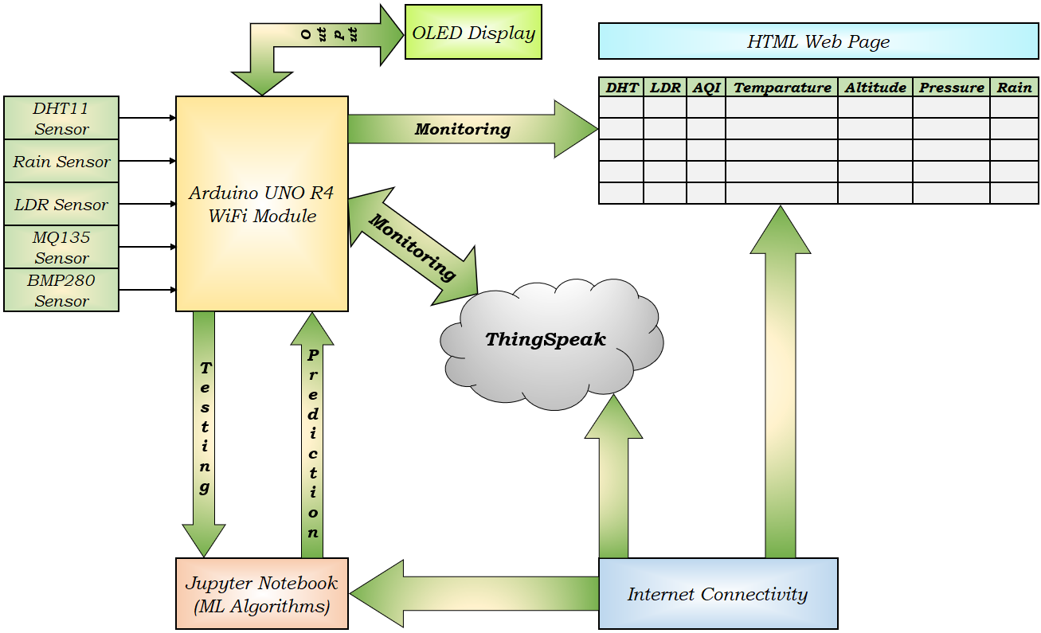

Fig.4:-. Block Diagram of the Complete IoT System

Chapter 5: Advantages of proposed system

Reduced field damaging conditions

Explanation: IoT environmental monitoring systems assist in minimizing field damage through real-time information, which facilitates timely intervention against damage from severe weather.

Example: In farming use, IoT devices with soil moisture sensors and weather prediction capabilities can identify water stress or oversaturation. This information prevents crop damage by turning on irrigation or drainage systems remotely.

Impact: Reduced crop loss and increased yield. Improved efficiency in the management of natural resources.

Improved Safety and Security:

Explanation: IoT systems can detect environmental anomalies, unauthorized access, or potential hazards and send alerts to users or authorities for corrective action.

Example: In industrial environments, IoT-enabled gas leak detectors and fire sensors continuously monitor the surrounding environment and alert security teams in case of hazardous conditions.

Impact: Prevention of accidents and safety hazards. Real-time alerts to mitigate emergencies. Enhanced security of assets and resources.

High-Quality Receiving Data:

Explanation: IoT sensors used in environmental monitoring are capable of capturing accurate and real-time data with minimal interference. Advanced communication protocols (such as MQTT, HTTP, or LoRaWAN) ensure efficient data transmission with minimal loss.

Example: A weather monitoring system with BMP280 sensors for temperature and pressure, and DHT11 for humidity, transmits high-quality data to a centralized server, which can be visualized and analyzed for insights.

Impact: Accurate data ensures reliable decision-making. Minimizes errors in data processing and forecasting.

Less Power Consumption:

Explanation: Modern IoT systems are designed to be energy-efficient by utilizing low-power micro-controllers (such as Arduino Uno R4 Wifi) and power-saving techniques like sleep modes and duty cycling.

Example: An Arduino Uno R4 Wifi-based weather monitoring system uses deep sleep mode between sensor readings, reducing power consumption to microampere levels and extending the battery life significantly.

Impact: Prolonged battery life for remote monitoring devices. Reduced maintenance efforts and cost.

Accuracy is High:

Explanation: IoT-based systems use calibrated sensors and advanced data processing techniques that ensure high accuracy in environmental measurements. Machine learning models can further improve the predictive accuracy of these systems.

Example: A smart weather forecasting system integrating ThingSpeak and machine learning models analyzes real-time sensor data (temperature, humidity, and air quality) to make accurate predictions.

Impact: Higher precision in environmental data collection. Better predictions, reducing the likelihood of false alarms or errors.

Smart Way to Monitor Environment:

Explanation: IoT-based solutions automate the process of monitoring environmental conditions, reducing the need for manual labor and improving efficiency. These systems can analyze and process data in real time, ensuring proactive management.

Example: A smart irrigation system uses soil moisture sensors and weather data to optimize water usage, ensuring plants receive adequate water while preventing wastage.

Impact: Remote access and control from mobile devices. Reduced environmental impact through efficient resource management.

Low Cost and Efforts are Less in This System:

Explanation: IoT systems reduce operational costs by minimizing manual intervention, automating processes, and using affordable hardware like Arduino, Arduino UNO R4 WiFi. Open-source platforms and cloud services further lower development and maintenance costs.

Example: Implementing a weather monitoring system with Arduino Uno R4 Wifi, DHT11, and ThingSpeak costs a fraction of traditional monitoring setups while providing real-time data and insights.

Impact: Cost-effective monitoring and decision-making. Less human effort, reducing operational complexity. Scalability at a low cost.

Chapter 6:- Components and Material

6.1 Hardware Components

6.1.1 Arduino Uno R4 WiFi An In-Depth Technical Analysis
The Arduino UNO platform has long served as a cornerstone for makers, educators, and engineers seeking a user-friendly yet versatile foundation for their electronic projects. Continuing this legacy, the Arduino UNO R4 WiFi represents a significant evolution, introducing a host of advancements in processing power, memory capacity, connectivity, and integrated peripherals that propel the platform into a new dimension of making. This latest iteration marks a substantial leap forward by incorporating a dual-core architecture, featuring the robust Renesas RA4M1 microcontroller alongside the Espressif ESP32-S3 module. This report provides a comprehensive technical analysis of the Arduino UNO R4 WiFi, detailing its key features, functionalities, technical specifications, improvements over previous models, potential applications, and guidance for getting started. It is intended for makers, hobbyists, and engineers who possess a technical inclination and are eager to explore the enhanced capabilities offered by this innovative board.
6.1.2 Arduino UNO R4 WiFi Block Diagram
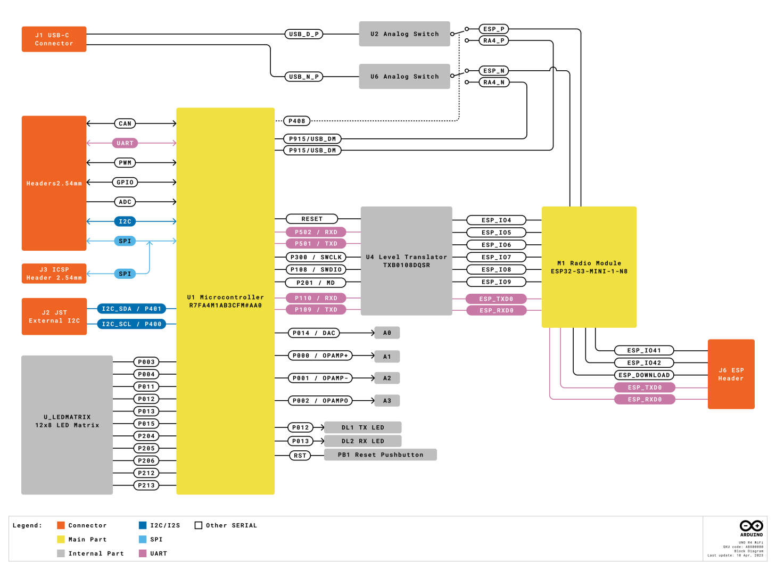
Fig 6.1.2:- Arduino UNO R4 WiFi Block Diagram
6.1.3 Pinout for Arduino R4 UNO R4 WiFi.
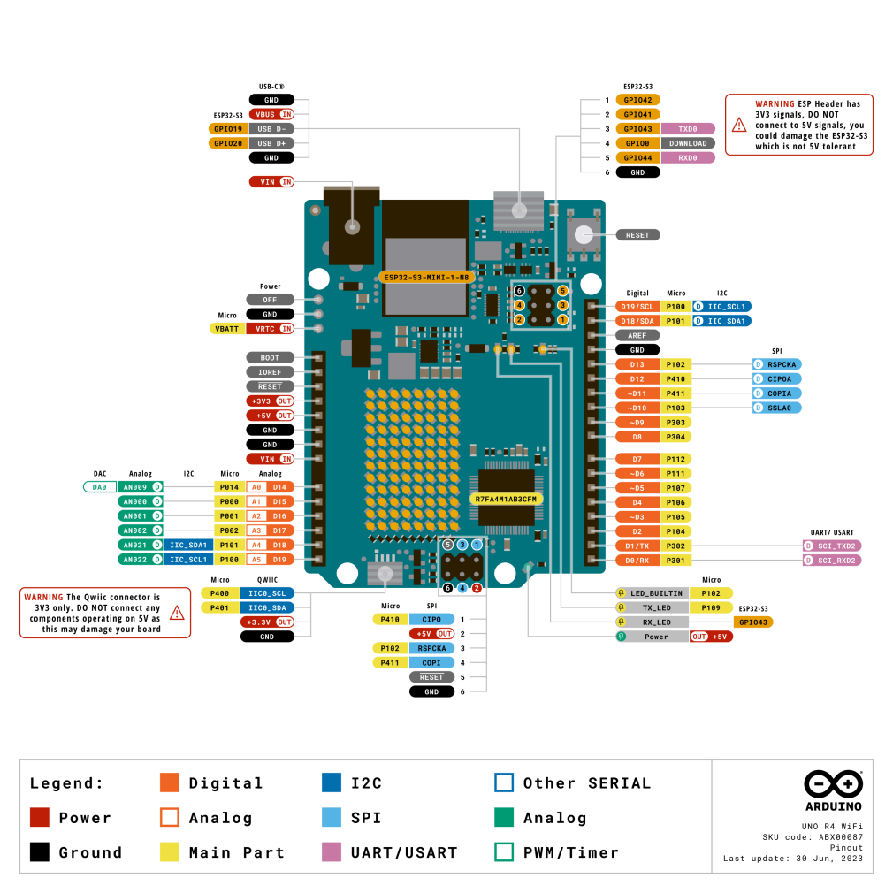
Fig 6.1.3:- Pinout for Arduino UNO R4 WiFi.

6.1.4 Delving into the Core: Key Features and Functionalities
At the heart of the Arduino UNO R4 WiFi lies the powerful Renesas RA4M1 microcontroller, built upon a 32-bit Arm® Cortex®-M4 architecture.⁴ This core operates at a clock speed of 48 MHz and incorporates a floating-point unit (FPU), enabling significantly more precise and efficient handling of complex calculations compared to the 8-bit AVR architecture found in earlier UNO boards.⁶ The inclusion of an FPU is particularly beneficial for applications involving signal processing, advanced control algorithms, and other computationally intensive tasks.⁸ Complementing its processing prowess is an expanded memory configuration, featuring 256 kB of Flash memory for program storage, 32 kB of SRAM for dynamic data manipulation, and 8 kB of EEPROM for persistent, non-volatile data storage.⁶ This substantial increase in memory compared to the UNO R3 allows for the development of larger and more intricate projects with greater data handling capabilities.⁶
Beyond its core processing and memory enhancements, the RA4M1 microcontroller integrates a suite of on-chip peripherals that significantly expand the board's native functionality.⁴ These include a Real-Time Clock (RTC) for accurate timekeeping, a 12-bit Digital-to-Analog Converter (DAC) for generating true analog output signals, a Controller Area Network (CAN) bus for robust communication in industrial and automotive applications, an operational amplifier (OP AMP) for signal conditioning, and support for Human Interface Device (HID) emulation over USB.⁴ These integrated peripherals reduce the reliance on external components for many common applications, streamlining project design and development.⁷
The Arduino UNO R4 WiFi further distinguishes itself through the inclusion of an Espressif ESP32-S3 micro controller.⁴ This dual-core 32-bit LX7 microprocessor boasts a clock speed of up to 240 MHz, providing considerable processing power dedicated to managing the board's wireless connectivity.⁴ The ESP32-S3 is equipped with 384 kB of ROM and 512 kB of SRAM, ensuring efficient handling of WiFi (802.11 b/g/n) and Bluetooth® 5 Low Energy (LE) protocols.⁴ This integrated wireless capability enables a wide spectrum of Internet of Things (IoT) applications and seamless communication with other devices and networks.⁴ The dual-core architecture of the ESP32-S3 allows for concurrent management of both WiFi and Bluetooth functionalities, ensuring reliable wireless communication without placing a significant burden on the main RA4M1 micro controller.
A notable addition to the Arduino UNO R4 WiFi is its onboard 12x8 LED matrix.¹ Comprising 96 individually addressable red LEDs controlled via Charlieplexing, this integrated display offers a convenient platform for visualizing data, creating animations, and implementing simple user interfaces directly on the board.⁷ Charlieplexing is an efficient technique that allows a large number of LEDs to be controlled using a relatively small number of micro controller pins. This feature enhances the board's interactivity and provides immediate visual feedback for various projects, eliminating the need for external displays in many basic applications.¹¹
The inclusion of a 12-bit DAC on the Arduino UNO R4 WiFi provides a significant upgrade in analog output capabilities.¹ Unlike the pulse-width modulation (PWM) techniques used in previous UNO versions to simulate analog output, the 12-bit DAC offers a true analog voltage output with a resolution of up to 4096 discrete levels.⁵ This enables applications requiring precise analog control, such as high-quality audio generation, control of analog sensors and actuators, and the creation of arbitrary waveforms.⁵
For applications requiring robust communication with multiple peripherals, the Arduino UNO R4 WiFi incorporates a CAN bus interface.¹ This protocol is widely used in automotive and industrial environments due to its reliability in noisy conditions.¹ While the RA4M1 micro controller features an integrated CAN controller, an external transceiver is necessary to implement the physical layer of the CAN bus for communication with other CAN-enabled devices.¹⁵
The integrated operational amplifier (OP AMP) on the Arduino UNO R4 WiFi serves as a versatile analog component for signal amplification and conditioning.¹ It can be used to amplify weak signals from sensors, buffer analog outputs, or implement various analog signal processing functions.¹ The OP AMP features a rail-to-rail output swing, meaning its output voltage can go very close to the positive and negative supply voltages (0V to 5V), maximizing the dynamic range of the amplified signal.¹³
The HID support integrated into the Arduino UNO R4 WiFi allows the board to emulate a mouse or keyboard when connected to a computer via USB.⁵ This feature opens up possibilities for creating custom input devices, game controllers, or automated interfaces for software applications.¹⁴
For time-sensitive applications, the Arduino UNO R4 WiFi includes a Real-Time Clock (RTC).¹ This dedicated hardware clock can keep track of the current time and date, even when the main power to the board is disconnected, provided an optional battery backup is connected to the designated pins on the WiFi version.⁵ This is crucial for projects requiring time-stamping of data, scheduling events, or maintaining time-based functionality independently of the main power supply.
Simplifying the integration of external sensors and actuators is the Qwiic connector featured on the Arduino UNO R4 WiFi.¹ This connector provides a convenient plug-and-play I2C interface, allowing for easy connection to a wide ecosystem of Qwiic-compatible modules without the need for soldering or complex wiring.⁵
Finally, the Arduino UNO R4 WiFi incorporates a helpful error diagnostics feature.¹ This mechanism detects runtime crashes, such as division by zero errors or out-of-memory conditions, and provides informative hints about the specific line of code that caused the issue.⁴ This is a valuable tool for both novice and experienced programmers, streamlining the debugging process and making it easier to identify and resolve errors in their code.

6.1.5 Technical Specifications of Arduino UNO R4 WiFi
The Arduino UNO R4 WiFi boasts a robust set of technical specifications that underscore its enhanced capabilities. A summary of these specifications is provided in the table below:
Feature | Specification
Board Name | Arduino® UNO R4 WiFi
SKU | ABX00087
Microcontroller | Renesas RA4M1 (Arm® Cortex®-M4)
Secondary Microcontroller | ESP32-S3 (Dual-core 32-bit LX7)
USB Connector | USB-C® (Programming Port)
Digital I/O Pins | 14
Analog Input Pins | 6
DAC | 1 (12-bit resolution)
PWM Pins | 6
Communication | UART (1x), I2C (1x + Qwiic), SPI (1x), CAN (1x)
Operating Voltage | 5 V (RA4M1), 3.3 V (ESP32-S3)
Input Voltage (VIN) | 6-24 V
DC Current per I/O Pin | 8 mA
Clock Speed (Main Core) | 48 MHz
Clock Speed (ESP32-S3) | Up to 240 MHz
Memory (RA4M1) | 256 kB Flash, 32 kB SRAM, 8 kB EEPROM
Memory (ESP32-S3) | 384 kB ROM, 512 kB SRAM
Dimensions (Width x Length) | 68.85 mm x 53.34 mm
Wireless Connectivity | Wi-Fi® (802.11 b/g/n), Bluetooth® 5 LE
On-board Peripherals | 12x8 red LED matrix, Qwiic I2C connector, RTC, OP AMP
Other Features | HID support, Error diagnostics, VRTC, OFF pin
The primary microcontroller, the Renesas RA4M1, features an Arm Cortex-M4 core with an FPU, operating at 48 MHz.¹⁶ It is equipped with 256 kB of Flash memory, 32 kB of SRAM, and 8 kB of EEPROM.¹⁶ The RA4M1 supports a 5V operating voltage and integrates a 14-bit ADC, a DAC with up to 12-bit resolution, and various communication interfaces including UART, SPI, I2C, and CAN.¹⁶ In contrast, the ESP32-S3, acting as the secondary microcontroller, utilizes a dual-core 32-bit LX7 processor with a clock speed reaching up to 240 MHz.¹⁶ It operates at 3.3V and includes 384 kB of ROM and 512 kB of SRAM.¹⁶ Its primary function is to manage wireless communication, supporting WiFi 4 (802.11 b/g/n) in the 2.4 GHz band with data rates up to 150 Mbps, and Bluetooth 5 LE.¹⁶ The difference in operating voltages between these two microcontrollers necessitates the use of a logic-level translator to ensure proper and safe communication between them.⁶
The pinout of the Arduino UNO R4 WiFi largely maintains compatibility with the classic UNO R3, featuring 14 digital input/output pins, 6 analog input pins, and 6 PWM pins.³ Dedicated pins are provided for UART (D0, D1), I2C (A4, A5), and SPI (D10-D13) communication.³ Additionally, pins D4 and D5 are designated for the CAN bus interface.³ The analog pin A0 also serves as the output for the 12-bit DAC.³ The inclusion of the Qwiic connector provides an additional I2C interface. Furthermore, the board features dedicated pins for VRTC (battery backup for the RTC) and an OFF pin for controlling the board's power state.³ This preservation of the UNO form factor and pinout ensures a high degree of compatibility with existing Arduino UNO shields.⁴
The Arduino UNO R4 WiFi can be powered through the USB-C connector at 5V or via the VIN pin or barrel jack with an input voltage ranging from 6 to 24V.¹⁵ The wider input voltage tolerance offers greater flexibility in power supply options, allowing for easier integration with various power sources, including batteries and higher voltage supplies commonly used for motors and LED strips.¹¹ The operating voltage for the RA4M1 microcontroller is 5V, while the ESP32-S3 operates at 3.3V.¹⁵
In terms of communication interfaces, the Arduino UNO R4 WiFi provides one UART interface, two I2C interfaces (one via the standard A4/A5 pins and another through the Qwiic connector), one SPI interface, and one CAN bus interface.¹⁵ The presence of dual I2C buses expands connectivity options for I2C peripherals, potentially mitigating address conflicts when working with multiple I2C devices.¹² The physical dimensions of the board (68.85 mm width and 53.34 mm length) adhere to the standard UNO form factor, ensuring compatibility with a vast ecosystem of shields and enclosures designed for the Arduino UNO.⁴

6.1.6 The Evolution: Arduino UNO R4 WiFi Compared to its Predecessors
The Arduino UNO R4 WiFi represents a significant step forward when compared to its predecessors, most notably the widely popular Arduino UNO R3. The following table highlights the key differences across several critical specifications:
Feature | Arduino UNO R3 | Arduino UNO R4 Minima | Arduino UNO R4 WiFi
Microcontroller | ATmega328P (8-bit AVR) | Renesas RA4M1 (32-bit Arm Cortex-M4) | Renesas RA4M1 (32-bit Arm Cortex-M4)
Clock Speed | 16 MHz | 48 MHz | 48 MHz
Flash Memory | 32 KB | 256 KB | 256 KB
SRAM | 2 KB | 32 KB | 32 KB
EEPROM | 1 KB | 8 KB | 8 KB
Wireless Connectivity | None | None | Wi-Fi & Bluetooth LE
USB Connector | USB-B | USB-C | USB-C
DAC | None | 1 (12-bit) | 1 (12-bit)
CAN Bus | None | 1 | 1
LED Matrix | None | None | 12x8 Red LED Matrix
Qwiic Connector | None | None | 1
HID Support | No | Yes | Yes
RTC | No | Yes | Yes
Input Voltage (VIN) | 7-12 V (Recommended), 6-20 V (Limit) | 6-24 V | 6-24 V
DC Current per I/O Pin | 20 mA | 8 mA | 8 mA
As evident from the comparison, the Arduino UNO R4 WiFi boasts substantial improvements in several key areas.¹ Its 32-bit Arm Cortex-M4 processor offers a clock speed three times faster than the UNO R3's 8-bit AVR microcontroller.⁶ This, coupled with an eightfold increase in Flash memory and a 16-fold increase in SRAM, allows the R4 WiFi to handle significantly more complex tasks and larger datasets.⁶ The integration of WiFi and Bluetooth Low Energy provides native wireless connectivity, a feature entirely absent in the UNO R3.⁶ Furthermore, the inclusion of a 12-bit DAC, a CAN bus interface, and an onboard LED matrix significantly expands the range of potential applications for the UNO R4 WiFi.⁶ The transition to a USB-C connector offers a more modern and robust interface for power and programming.⁶
The move to a 32-bit architecture offers several advantages over the 8-bit architecture of the UNO R3.¹ A 32-bit processor can handle larger data types and execute more complex algorithms with greater efficiency, leading to improved performance in applications involving significant data processing or mathematical operations.⁸ While the Arduino UNO R4 WiFi brings numerous advancements, it maintains a crucial aspect of its heritage: compatibility with existing hardware.⁴ The board retains the same form factor and pinout as the UNO R3, ensuring that the vast majority of shields designed for the older board can be readily used with the new R4 WiFi.⁴ This protects users' investments in existing hardware and facilitates a smoother transition to the new platform. In terms of software compatibility, sketches developed using the Arduino API are generally compatible with the UNO R4 WiFi. However, code that relies on specific instructions or low-level register access unique to the AVR architecture of the UNO R3 may require modifications to ensure proper functionality on the Renesas RA4M1 microcontroller.²

6.1.7 Wireless Freedom: Exploring WiFi and Bluetooth Capabilities
The Espressif ESP32-S3 module integrated into the Arduino UNO R4 WiFi provides robust wireless connectivity through both WiFi and Bluetooth Low Energy.⁵ The module supports the 802.11 b/g/n (WiFi 4) standard on the 2.4 GHz frequency band, with data rates reaching up to 150 Mbps.⁶ For short-range communication, it features Bluetooth 5 LE, enabling low-power wireless connections suitable for various applications.⁶
Getting started with WiFi on the Arduino UNO R4 WiFi is facilitated by the WiFiS3 library, which is included as part of the Arduino UNO R4 Boards package.²¹ Users can easily connect the board to their local WiFi networks by providing the network's SSID and password. It is recommended to store these credentials securely in a separate header file, as demonstrated in the Arduino documentation.²¹ Basic examples provided in the documentation illustrate how to establish a WiFi connection and perform network operations, such as creating a simple web server that can control onboard peripherals like the built-in LED.²¹
The Bluetooth Low Energy functionality of the ESP32-S3 opens up further possibilities for wireless communication.¹⁴ Bluetooth LE is particularly well-suited for applications requiring low power consumption, such as wearable devices, remote controls, and sensor networks.⁶ While the initial documentation for Bluetooth functionality on the R4 WiFi was limited ¹³, the underlying ESP32-S3 module is a well-documented platform, and libraries for Bluetooth LE communication are available within the Arduino ecosystem.
The Arduino UNO R4 WiFi is designed for seamless integration with the Arduino Cloud platform, simplifying the development of IoT projects.⁴ Through the Arduino Cloud, users can configure, program, monitor, and control their boards remotely without needing to write complex networking code.⁵ The board can also be integrated with other IoT platforms and services using standard protocols like MQTT, providing flexibility for users with different preferences and requirements.²⁴

6.1.8 Illuminating Ideas: Working with the Onboard LED Matrix
The 12x8 LED matrix on the Arduino UNO R4 WiFi offers a versatile platform for visual output.⁵ This grid of 96 red LEDs is controlled using a technique called Charlieplexing, which allows each LED to be individually addressed using a limited number of microcontroller pins.⁷ To program the LED matrix, users can utilize the Arduino_LED_Matrix library, which is included with the Arduino UNO R4 Boards package.³
Basic programming involves initializing the matrix using matrix.begin() and then defining "frames" that represent the on/off state of each LED.²⁶ These frames are typically created as arrays of 32-bit integers, where each bit corresponds to the state of a specific LED in the 12x8 grid.²⁶ The matrix.loadFrame() function is used to load a frame into the matrix's buffer, and functions like matrix.play() can be used to display a sequence of frames as an animation.²⁶
The onboard LED matrix lends itself to a wide range of creative and practical applications.¹ It can be used to display scrolling text messages, create simple animations, visualize data from sensors, or even implement basic games.⁶ Examples provided in the Arduino documentation and community projects showcase the matrix's capabilities, including displaying network status indicators and running animations like Tetris.¹² This integrated visual output capability enhances the interactivity of projects and provides immediate feedback without requiring external display hardware.

6.1.9 Unleashing Potential: Applications and Project Ideas
The Arduino UNO R4 WiFi's enhanced processing power, memory, wireless connectivity, and integrated peripherals open up a vast landscape of potential applications and project ideas, catering to makers of all skill levels.²⁴
For beginners, the board can be used for foundational projects like creating a WiFi-enabled weather dashboard that displays temperature and humidity data on a web interface, building remote-controlled LEDs that can be toggled on or off via a smartphone app, or setting up a wireless sensor hub to collect data from multiple sensors and transmit it wirelessly.²⁴
Intermediate users can leverage the board's capabilities for more complex projects such as an IoT-based smart lock controlled by RFID or fingerprint sensors, a real-time data logger that records sensor readings to an SD card and simultaneously sends them to a cloud platform, or a smart water level monitor that provides alerts when water levels drop to a critical point.²⁴
Advanced makers can explore cutting-edge applications like implementing AI-based motion detection systems using platforms like Edge Impulse, building comprehensive web-based dashboards to control and monitor multiple IoT devices in real-time, or developing sophisticated robotics projects that utilize the CAN bus for inter-device communication.²⁴
Specific project ideas highlighted in the research material include controlling home appliances via WiFi, monitoring air quality and sending data to the cloud, creating automated irrigation systems, building WiFi-controlled robots, and developing smart doorbells.²⁴ The onboard LED matrix can be used for interactive art installations, displaying sensor data graphically, or creating simple games.²⁸ The DAC can be utilized for audio synthesis projects, while the CAN bus enables communication with automotive or industrial systems. The HID support allows for the creation of custom input devices for various applications.¹ The Arduino Cloud compatibility further facilitates the development of connected projects with remote monitoring and control capabilities.²³

6.1.10 Embarking on Your Journey: Getting Started with Arduino UNO R4 WiFi
To begin working with the Arduino UNO R4 WiFi, the first step is to install the Arduino IDE (Integrated Development Environment) on your computer.²⁷ The latest version of the IDE can be downloaded from the official Arduino website.¹² Once the IDE is installed, you will need to install the board package for the Arduino UNO R4 WiFi. This can be done through the IDE's Board Manager, which can be accessed from the Tools menu.¹⁰ Search for "UNO R4 WiFi" and install the latest version of the "Arduino UNO R4 Boards" package.²⁷
Next, connect the Arduino UNO R4 WiFi board to your computer using a USB-C cable.²⁷ In the Arduino IDE, select the "Arduino UNO R4 WiFi" board from the Tools > Board menu.¹² You may also need to select the correct port to which your board is connected, which can usually be found under the Tools > Port menu.³⁰
To verify that your setup is working correctly, you can try uploading a basic example sketch, such as the "Blink" sketch that blinks the onboard LED.²⁷ This sketch can be found under File > Examples > 01.Basics > Blink in the Arduino IDE. Alternatively, the Arduino UNO R4 WiFi comes preloaded with a Tetris animation on its LED matrix, which will run upon powering the board.²⁷
To start programming the specific features of the Arduino UNO R4 WiFi, you will need to explore the relevant libraries. For WiFi functionality, use the WiFiS3 library; for Bluetooth, the BluetoothLE library; and for the LED matrix, the Arduino_LED_Matrix library.³ The Arduino documentation provides numerous examples and tutorials for using these libraries and the various peripherals, such as the DAC and RTC.³
Users encountering issues may find helpful resources in the Arduino forums and community websites.³¹ Common problems can include the board not being recognized by the computer, errors during code upload, or unexpected behavior with specific features. Ensuring that the correct board package is installed and the correct port is selected in the IDE are crucial first steps in troubleshooting.

6.1.11 Expert Insights: Reviews and Performance Analysis
Reviews and evaluations of the Arduino UNO R4 WiFi generally highlight its significant performance improvements and the addition of valuable new features.¹³ The increased processing power and memory are consistently praised, enabling more complex projects and faster execution of code.³³ The integrated WiFi and Bluetooth connectivity are seen as major advantages, making the board well-suited for IoT applications.³³ The onboard LED matrix and Qwiic connector are also frequently mentioned as convenient and useful additions.³³
However, some reviews have noted a higher power consumption compared to the Arduino UNO R3, particularly due to the inclusion of the ESP32 chip.¹³ This may be a consideration for battery-powered projects.¹³ Initial reports also indicated some software and library compatibility issues, although the Arduino community is actively working on addressing these.³² Additionally, the current output per GPIO pin on the R4 WiFi is lower than on the R3 (8mA vs 20mA), which may necessitate the use of external drivers for certain components.³²
Performance benchmarks reveal a substantial increase in the speed of mathematical operations on the Arduino UNO R4 WiFi compared to the UNO R3, especially in floating-point calculations.¹³ This is attributed to the 32-bit architecture and the inclusion of a floating-point unit in the Renesas RA4M1 microcontroller.¹³ This performance boost makes the R4 WiFi a more capable platform for applications involving complex computations, such as signal processing and advanced control algorithms.
User experiences reported in online forums and reviews indicate overall satisfaction with the Arduino UNO R4 WiFi, with many appreciating the enhanced capabilities and ease of use.³² The convenience of the USB-C connector and the plug-and-play nature of the Qwiic connector are also frequently cited as positive aspects.³³ However, some users have reported initial challenges with specific features, such as Bluetooth functionality and library compatibility, suggesting that the ecosystem is still maturing.¹³ Concerns have also been raised regarding the placement of the WiFi antenna and potential signal strength.³⁶ Despite these minor limitations, the general consensus is that the Arduino UNO R4 WiFi is a powerful and versatile board that offers a significant upgrade over its predecessors.

6.1.12 Conclusion: Embracing the Power of Arduino UNO R4 WiFi
The Arduino UNO R4 WiFi represents a significant advancement in the Arduino UNO family, offering a compelling upgrade for makers of all levels.¹ Its enhanced processing power, increased memory, integrated wireless connectivity, and a suite of useful onboard peripherals like the LED matrix, DAC, and CAN bus, position it as a versatile platform for a wide range of projects.¹ While maintaining the familiar UNO form factor and pinout for hardware compatibility, the R4 WiFi empowers users to tackle more complex and connected applications.¹ Whether you are a beginner looking to explore the world of IoT or an experienced engineer working on advanced prototypes, the Arduino UNO R4 WiFi provides the tools and capabilities to bring your innovative ideas to life.⁴
6.2 DHT Sensor
Humidity is the measure of water vapor present in the air. The level of humidity in air affects various physical, chemical and biological processes. In industrial applications, humidity can affect the business cost of the products, health and safety of the employees. So, in semiconductor industries and control system industries measurement of humidity is very important. Humidity measurement determines the amount of moisture present in the gas that can be a mixture of water vapor, nitrogen, argon or pure gas etc.… Humidity sensors are of two types based on their measurement units. They are a relative humidity sensor and Absolute humidity sensor. DHT11 is a digital temperature and humidity sensor.

DHT11 is a low-cost digital sensor for sensing temperature and humidity. This sensor can be easily interfaced with any micro-controller such as Arduino, Raspberry Pi etc.… to measure humidity and temperature instantaneously.
DHT11 humidity and temperature sensor is available as a sensor and as a module. The difference between this sensor and module is the pull-up resistor and a power-on LED. DHT11 is a relative humidity sensor. To measure the surrounding air this sensor uses a thermistor and a capacitive humidity sensor.

6.2.1 DHT11 Pinout:

DHT11 is a 4-pin sensor, these pins are VCC, DATA, GND and one pin is not in use shown in fig below.
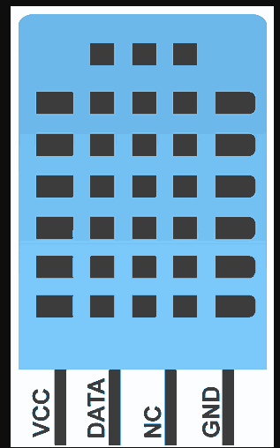
Fig 6.2.1:- DHT11 Pinout:
6.2.2 Working Principle of DHT11 Sensor

DHT11 sensor consists of a capacitive humidity sensing element and a thermistor for sensing temperature. The humidity sensing capacitor has two electrodes with a moisture holding substrate as a dielectric between them. Change in the capacitance value occurs with the change in humidity levels. The IC measure, process this changed resistance values and change them into digital form.
For measuring temperature this sensor uses a Negative Temperature coefficient thermistor, which causes a decrease in its resistance value with increase in temperature. To get larger resistance value even for the smallest change in temperature, this sensor is usually made up of semiconductor ceramics or polymers.
The temperature range of DHT11 is from 0 to 50 degree Celsius with a 2-degree accuracy. Humidity range of this sensor is from 20 to 80% with 5% accuracy. The sampling rate of this sensor is 1Hz .i.e. it gives one reading for every second. DHT11 is small in size with operating voltage from 3 to 5 volts. The maximum current used while measuring is 2.5mA.

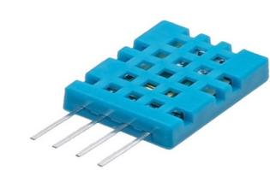
Fig 6.2.2:- DHT11 Sensor
DHT11 sensor has four pins- VCC, GND, Data Pin and a not connected pin. A pull-up resistor of 5k to 10k ohms is provided for communication between sensor and micro-controller.

6.2.3 DHT-11 Pin Description:

Pin No. | Pin Name | Pin Description
1 | VCC | Power supply 3.3 to 5.5 Volt DC
2 | DATA | Digital output pin
3 | NC | Not in use
4 | GND | Ground

6.2.4 Specification of the DHT11 sensor

Power supply: 3.3 to 5V DC
Current consumption: max 2.5mA
Operating range: 20-80% RH, 0-50°C
Humidity measurement range: 20-90% RH
Humidity measurement accuracy: ±5% RH
Temperature measurement range: 0-50°C
Temperature measurement accuracy: ±2°C
Response time: 1s
Sampling rate: 1Hz (1 sample per second)
Data output format: single-bus digital signal
Data transmission distance: 20-30m (at open air)
Dimensions: 15mm x 12mm x 5.5mm
Weight: 2.5g
Digital signal transmission protocol: 1 start signal + 40bit data + 1 checksum

6.2.5 DHT-11 Communication with Microcontroller

DHT11 uses only one wire for communication. The voltage levels with certain time value defines the logic one or logic zero on this pin.
The communication process is divided in three steps, first is to send request to DHT11 sensor then sensor will send response pulse and then it starts sending data of total 40 bits to the microcontroller.

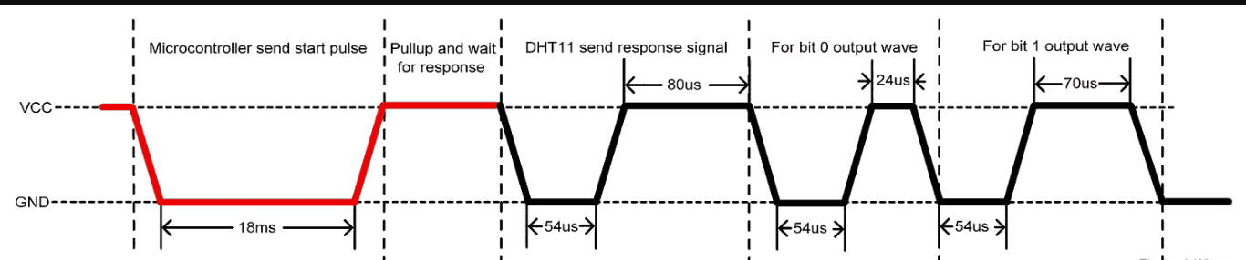
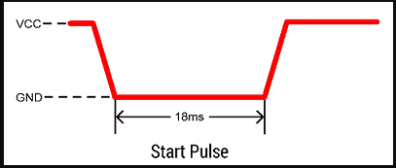
To start communication with DHT11, first we should send the start pulse to the DHT11 sensor.
To provide start pulse, pull down (low) the data pin minimum 18ms and then pull up, as shown in diagram.

Response
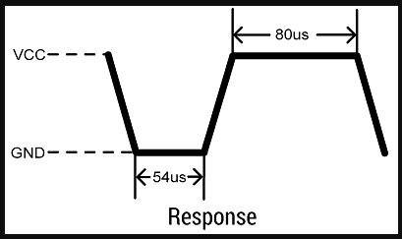
After getting start pulse from, DHT11 sensor sends the response pulse which indicates that DHT11 received start pulse.
The response pulse is low for 54us and then goes high for 80us.

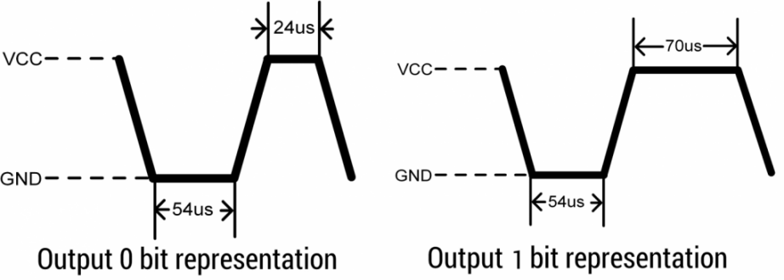
After sending the response pulse, DHT11 sensor sends the data, which contains humidity and temperature value along with checksum.

The data frame is of total 40 bits long, it contains 5 segments (byte) and each segment is 8-bit long.

In these 5 segments, first two segments contain humidity value in decimal integer form. This value gives us Relative Percentage Humidity. 1st 8-bits are integer part and next 8 bits are fractional part.

Next two segments contain temperature value in decimal integer form. This value gives us temperature in Celsius form.
Last segment is the checksum which holds checksum of first four segments.

Here checksum byte is direct addition of humidity and temperature value. And we can verify it, whether it is same as checksum value or not. If it is not equal, then there is some error in the received data.

Once data received, DHT11 pin goes in low power consumption mode till next start pulse
.
End of frame

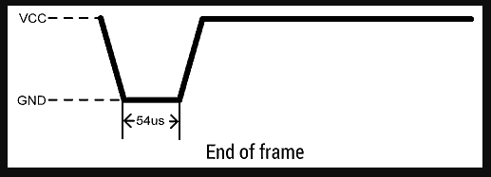
End of Frame
After sending 40-bit data, DHT11 sensor sends 54us low level and then goes high. After this DHT11 goes in sleep mode.

6.2.6 DHT11 Communication Protocol

DHT11 sensor uses a single-wire, two-way Serial Protocol for communicating with third-party peripherals normally microcontrollers.
We call it single-wire because the communication is performed through a single pin.
It is two-way because DHT11 receives commands from the microcontroller and then responds required data.
Data sent by the DHT11 sensor is 40 bits and it sends Higher Data Bits first.
Data contains both Integral and decimal values of temperature and relative humidity along with a checksum value.
DHT11 Data Format
DHT11 sends the 40Bit serial data in the below format:
8-Bit Humidity(Integral)
8-Bit Humidity(Decimal)
8-Bit Temperature(Integral)
8-Bit Temperature(Decimal)
8-Bit Checksum
If DHT11 is sending the correct data, then it must send an 8-bit Checksum data at the end.

6.2.7 DHT-11 Applications

This sensor is used in various applications such as measuring humidity and temperature values in heating, ventilation and air conditioning systems. Weather stations also use these sensors to predict weather conditions. The humidity sensor is used as a preventive measure in homes where people are affected by humidity. Offices, cars, museums, greenhouses and industries use this sensor for measuring humidity values and as a safety measure.
It is compact size and sampling rate made this sensor popular among hobbyists. Some of the sensors which can be used as an alternative to DHT11 sensor are DHT22, AM2302, SHT71. Which of the specification of the DHT11 sensor was helpful for your application.

6.3 MQ135 Sensor

The MQ135 sensor is the chemical sensor type which is sensitive to NH3, NOx, alcohol, benzene, smoke (CO), CO2 and others. This sensor is operated by receiving changes in the resistance value (analog) when explosive gas releases. This sensor has the advantage of good resistance to the use of a hazard signal because it is convenient and does not consume or require a lot of power. The sensitivity setting of the sensor is determined by the resistance value of the MQ135, which is different for different gas concentrations. Therefore, sensitivity adjustment is required when using this component. In addition, the calibration detects CO2 concentrations of 400 ppm or 50 ppm CO2 in the air.[5] The physical form of MQ135 can be seen in Figure 2 and the Characters from MQ135. The MQ135 sensor has characteristics such as its graphical scale, which is log_log on a linear scale where the behavior of gas concentrations is relatively relative to exponential resistance, then the distance between gas concentrations is only between 0 ppm to above 1000 ppm, and the relationship between gas concentration and resistance ratio looks linear can be seen in Figure
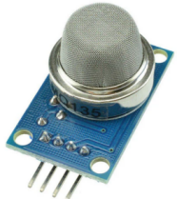
Fig 6.3:- MQ135 Sensor
6.3.1 MQ135 Pin Configuration:
The MQ135 air quality sensor is a 4-pin sensor module that has both analog and digital output from the respective pins. The pin configuration of the MQ135 air quality sensor is given below.
For MQ135 Air Quality Sensor Module:

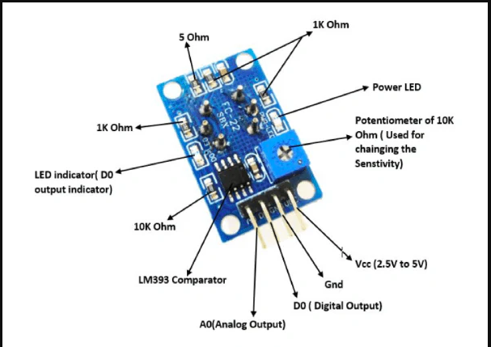
Fig 6.3.1:-MQ135 Pin Configuration
The MQ135 air quality sensor module is given below.
Pin 1: VCC: This pin represents a positive power supply of 5V that supply power to the MQ135 sensor module.
Pin 2: GND (Ground): This is a reference potential pin, which grounds the MQ135 sensor module.
Pin 3: Digital Out (Do): This pin is called the digital output pin that provides the digital output by varying the threshold value with the assistance of a potentiometer. This pin is utilized to sense and measure any one specific gas and brings the MQ135 sensor into operation without a microcontroller.
6.3.2 MQ135 General specifications of this sensor

Property | Value
Model | MQ135Sensor
Type | SemiconductorStandard
Encapsulation | Bakelite, Metal cap
Target Gas | ammonia gas, sulfide, benzene series steam
Detection range | 10～1000ppm( ammonia gas, toluene, hydrogen, smoke)
Standard Circuit Conditions | Loop VoltageVc5.0V±0.1V DC  Heater VoltageVH5.0V±0.1V AC or DC  Load resistanceRLAdjustable
Sensor character under standard test conditions | Heater ResistanceRH30Ω±3Ω (room temp.)  Heater consumptionPH≤950mW  SensitivitySRs(in air)/Rs(in 400ppm H2)≥5  Output VoltageVs2.0V～4.0V（in 400ppm H2）  Concentration Slopeα≤0.6(R400ppm/R100ppmH2)
Standard test conditions | Tem. Humidity20℃±2℃；55%±5%RH
Standard test circuit | Vc:5.0V±0.1V； VH: 5.0V±0.1V
Preheat time | Over 48 hours
Oxygen content | 21% (not less than 18%), O2 concentration affects initial value, sensitivity, and repeatability.

Pin 4: Analog Out (Ao): This pin produces the analog output signal of 0V to 5V and is based on the gas intensity. This analog output signal is in proportion to the gas vapor concentration, which is sensed by the MQ135 sensor module. This pin is employed to sense the gases in PPM. It is TTL logic driven, runs on 5V, and is primarily interfaced with microcontrollers.
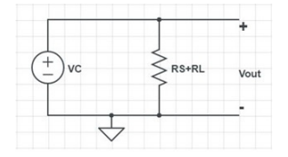
Fig 6.3.2:- Internal circuit diagram of MQ135

Got it! You're talking about a configuration where you are employing MQ135 gas sensors with an ESP-01 (ESP8266), and taking great care to manage power needs using a 9V battery with an LM7805 voltage regulator to provide 5V to the . Here's a concise and polished version of your write-up, followed by a potential continuation on the mathematical calculations for sensor output to PPM conversion:

Sensor Power Configuration and Calibration
MQ135 gas sensor is connected to ESP8266's (ESP-01) Vdd pin directly. The ESP8266 can only source current in small quantities, and it is not possible to directly power another sensor like MQ135 with it. So, MQ7 is being powered with a 9V battery with an LM7805 voltage regulator. It is very important because MQ135 sensor needs 5V to run, and giving it a direct 9V supply could burn the sensor. The LM7805 regulator safely stops the voltage from 9V to 5V, allowing the correct functioning of sensors 7,9,17.

The ESP-01 module communicates with a nearby Wi-Fi hotspot through the SSID and password set, allowing wireless data transfer between an IoT server or cloud platform.

6.3.3 MQ135 Calculate Value Process

The most important step is to calibrate the sensor in fresh air and then draws an equation that converts the sensor output voltage value into our convenient units PPM. Here are the mathematical calculations derived from

From Ohm’s Law, at constant temperature, we can derive I as follows:
(3.1) I=$\frac{V}{R}$
Equation 3.1 is equivalent according to [12] with

(3.2) $I=\frac{v_{c}}{R_{s}+R_{f}}$
From Figure , we can obtain the output voltage at the load resistor using the value obtained for I and Ohm’s Law at constant temperature (V = I · R)

(3.3) $V_{R_{l}}=\left[\frac{V_{c}}{R_{s}+R_{l}}\right]*R_{L}$

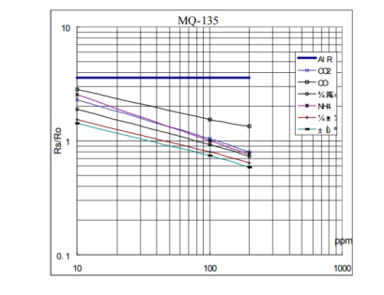
Fig 6.3.3:- MQ135 Datasheet-Change in Resistance vs change in PPM

(3.4) $V_{R_{l}}=\left[\frac{V_{c}*R_{L}}{R_{s}+R_{l}}\right]$
So now we solve for $R_{s}$ :
(3.5) $V_{R_{l}}*R_{s}+R_{l}=V_{c}*R_{L}$

(3.6) ${(V}_{R_{l}}*R_{s})+{(V}_{R_{l}}*R_{l})=V_{c}*R_{L}$

(3.7) ${(V}_{R_{l}}*R_{s})=(V_{c}*R_{L})-{(V}_{R_{l}}*R_{l})$

(3.8) $\left[R_{s}=\frac{(V_{c}*R_{L})-{(V}_{R_{l}}*R_{l})}{V_{R_{l}}}\right]$

(3.9) $\left[R_{s}=\frac{(V_{c}*R_{L})}{V_{R_{l}}}-R_{l})\right]$

Equation 3.9 help us to find the internal sensor resistance for fresh air [14]. From the graph shown in Figure 3.3, we can see that the resistance ratio in fresh air is a constant. Figure 3.3 is taken from the MQ135 datasheet where X axis represents the PPM and Y axis represents ${R_{s}}/{R_{0}}$ ratio. Now, the sensor is subjected to the respective gases alone and on increasing the PPMs of the gas say methane or Carbon Dioxide, then the corresponding resistance ratio is plotted. If we are interested to calculate the Carbon Monoxide, we have to consider the respective line in the graph and calculate the resistance ratio:

(3.10) $\frac{R_{s}}{R_{0}}=3.6$

Value 3.6 which is mentioned in Equation 3.10 is derived from the datasheet mentioned in Figure 3.3. To calculate $R_{0}$ we will need to find the value of the $R_{s}$in fresh air. This will be done by taking the analog average readings from the sensor and converting it to voltage [12]. Then we will use the $R_{s}$formula to find $R_{0}$First of all, we will treat the lines as if they were linear. This way we can use one formula that linearly relates the ratio and the concentration [19, 20]. By doing so, we can find the concentration of a gas at any ratio value even outside of the graph’s boundaries. The formula we will be using is the equation for a line, but for a log-log scale. The formula for a line is [21]:

(3.11) $y=mx+b$

From Figure 3.3, we try to derive the following calculations. For a log-log scale, the formula looks like this:

(3.12) $logy=mlogx+b$

Let’s find the slope. To do so, we need to choose 2 points from the graph. In our case, we chose the points (200,2.6) and (10000,0.75) from the LPG (Liquified Petroleum Gas) line and we can choose any line shown in Figure 3.3. The formula to calculate m is the following:

(3.13) $m=\left[\frac{logy -\log_{y_{0}}}{log x - \log_{x_{0}}}\right]$

If we apply the logarithmic quotient rule we get the following

(3.14) $m=\left[\frac{log(y/{y_{0}})}{log(x/{x_{0})}}\right]$

Now we substitute the values for $x, x_{0} , y and y_{0}$

(3.15) $m=\left[\frac{log({0.75}/{2.6})}{log({10000}/{200)}}\right]$

(3.16) $m= -0.318$

Now that we have m, we can calculate the y intercept. To do so, we need to choose one point from the graph (once again from the CO2 line). In our case, we chose (5000,0.9),

(3.17) log(y) = m log(x) + b

(3.18) b = log(0.9) − (−0.318) ∗ log(5000)

(3.19) b = 1.13

Now that we have m and b, we can find the gas concentration for any ratio with the following formula:

(3.20) $log(x)=\frac{log(y) - b}{m}$

(3.21) $x= {10}^{\frac{log(y) - b}{m}}$

Using equations 3.9 and 3.21, we will be able to convert the sensor output values into PPM [12]. We developed the code and flashed it into the ESP 8266 giving proper connections as mentioned in Figure

6.3.4 MQ135 Air Quality Sensor Working Principle

The MQ135 has a simple design behind its simple use and excellent performance. The principle of working of the sensor can be explained with the following steps:

MQ135 Air Quality Sensor Pre-heating:-The moment the sensor is powered on, it must be preheated. This is achieved through the heating circuit of the sensor. It takes 20-30 seconds to achieve a temperature of 300°C. After achieving this temperature, it operates on keeping this temperature as long as it has power.

MQ135 Air Quality Sensor Sensitivity Layer:-The heating mechanism heats up the sensing element to absorb the oxygen in the surrounding air. The sensing element is constructed with tin dioxide which, upon absorption of the oxygen, possesses a sensing layer on its surface. This occurs to a limit only since the stacking of atoms on the surface results in the formation of a layer around it. This is because tin oxide boasts high electrical resistance in pure air. At such a level, the sensing layer experiences minimal presence of free electrons to interact with the external pure air.
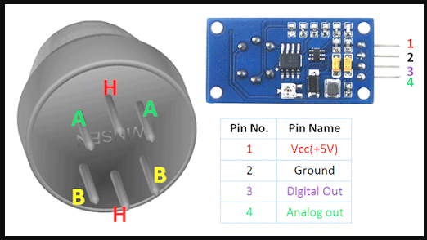

Fig 6.3.4:- MQ135 Air Quality Sensor

MQ135 Air Quality Sensor Gas Interaction:-Whenever the target gas (smoke or ammonia) exists in the atmosphere, the gas molecules are picked up by the sensing element atoms, and through this reaction, absorption of this layer occurs. Consequently, electrical conductance increases in the sensing element, and these measurements are shown via analogue data on the analogue pin.

MQ135 Air Quality Sensor Output:- The higher the concentration of the target gas in the ambient region, the higher the analogue values. The entire circuit is made in a manner that the analogue pins provide the information to the output device for the indication of this variation.

Some MQ135 models feature a digital pin which indicates the presence of gas only when values cross the pre-set threshold limit. The digital pin then sends the message to the output device.

6.3.5 MQ135 Air Quality Sensor Physical Dimensions
The physical size of this sensor can differ from package to package but I have made a table for you which broadly describes it:

Package Type | Diameter (mm) | Height (mm)
Standard TO-18 | 20-22 | 18-22
Board-mounted | Varies (typically larger) | Varies (typically taller due to additional components)

6.3.6 MQ135 Air Quality Sensor Application

Because of its versatility in gas detection, this sensor can be used in a wide range of projects. A general list of some of the major and most commonly used terms is given below:

Home gas leak detection

Indoor air quality monitoring

Industrial air quality monitoring

Intelligent home appliances (ventilation systems, air purifiers)

Mobile air quality monitors

Vehicle applications (emissions, in-car air quality).

6.4 LDR Sensor

An electronic component like LDR or light-dependent resistor is responsive to light. Once light rays drop on it, then immediately the resistance will be changed. The resistance values of an LDR may change over several orders of magnitude. The resistance value will be dropped when the light level increases.

The resistance values of LDR in darkness are several megaohms whereas in bright light it will be dropped to hundred ohms. So due to this change in resistance, these resistors are extremely used in different applications. The LDR sensitivity also changes through the incident light’s wavelength.
The designing of LDRs can be done by using semiconductor materials to allow their light-sensitive properties. The famous material used in this resistor is CdS (cadmium sulfide), even though the utilization of this material is currently restricted in European countries due to some environmental issues while using this material. Likewise, CdSe (cadmium selenide) is also restricted and additional materials that can be employed mainly include PbS (lead sulfide), InSb (indium antimonide).
Even though for these resistors, a semiconductor material is used, because they are simply passive devices and they do not have a PN-junction. This detaches them from other LDRs such as phototransistors & photodiodes.

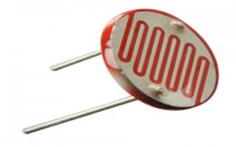
Fig 6.4:- Light Dependent Resistor

6.4.1 LDR Symbol
In electronic circuits, the LDR symbol is used that mainly depends on the resistor symbol; however, it illustrates the light rays in the arrows form. In this way, it follows the same principle which is used for phototransistor & photodiode circuit symbols wherever arrows are utilized to demonstrate the light dropping on these types of components. The LDR circuit symbols are shown below.
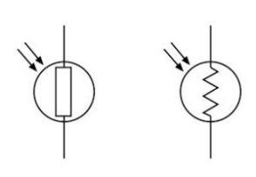
Fig 6.4.1:- LDR Symbol

6.4.2 Construction of an LDR
The construction of an LDR includes a light-sensitive material that is placed on an insulating substrate like ceramic. The material is placed in a zigzag shape in order to get the required power rating and resistance. The area of zigzag separates the metal-placed areas into two regions.
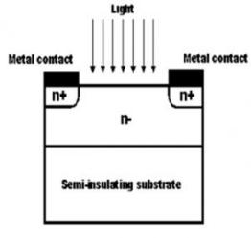
Fig 6.4.2:- Light Dependent Resistor Construction

Where the Ohmic contacts are made either on the sides of the area. The resistances of the contacts must be as less as possible to make sure that the resistance, mainly varies due to the light effect only. The use of lead & cadmium materials is avoided as they are injurious to the environment.

6.4.3 Working Principle of Light Dependent Resistor
The working principle of an LDR is photoconductivity, which is nothing but an optical phenomenon. When the light is absorbed by the material then the conductivity of the material enhances. When the light falls on the LDR, then the electrons in the valence band of the material are eager to the conduction band.

But, the photons in the incident light must have energy superior to the bandgap of the material to make the electrons jump from one band to another band (valance to conduction).Hence, when light having ample energy, more electrons are excited to the conduction band which grades in a large number of charge carriers. When the effect of this process and the flow of the current starts flowing more, the resistance of the device decreases.

6.4.4 Light Dependent Resistor Circuit
The circuit of LDR is an electronic circuit built with LDR, relay, Darlington pair, diode, & resistors shown in the below circuit diagram. A voltage supply is given to the load The required DC voltage of the LDR circuit is supplied from a bridge rectifier circuit or a battery. This circuit changes the AC supply into a DC.

The bridge rectifier circuit uses a step-down transformer to step-down the voltage from 230v into 12v. The diodes are connected in the form of a bridge used to alter the AC voltage into DC. The voltage regulator is used to change the 12v DC-6v DC, and then, this DC voltage is supplied to the entire circuit. A 230v AC supply for both the bridge rectifier and the load is to be kept continuously for continuous operation of the light sensor circuit.

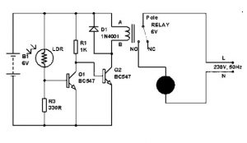
Fig 6.4.4:- LDR Circuit Diagram

In the morning time, this sensor has a low resistance of around 100Ω. Thus, the power supply flows through the LDR & ground through the variable resistor and resistor as shown in the above light sensor circuit. This is due to the resistance offered by the light-dependent resistor in the daytime or when the light falls on the LDR, then it is less compared to the resistance of the remaining part of the sensor circuit. We are alert of the principle of current, that the flow of current always flows in the path of low resistance.

Therefore, the relay coil does not get sufficient supplies to get strengthened. Hence, the light is switched off in the daylight. In the same way, during the night time, the resistance of the LDR increases to a high value (20MΩ). Thus, due to the high resistance of the resistor, the flow of current is low or almost zero. Now, the flow of current through the low-resistance lane such that it increases the base voltage of the Darlington pair to reach more than 1.4v. As the Darlington pair transistor is triggered, the relay coil acquires enough supply to get energized, and hence, the light switches in the nighttime.

6.4.5 LDR Frequency Dependence
The sensitivity of LDR varies based on the light’s wavelength that is affecting the responsive region of the device. This effect is noticeable & found when the wavelength of light is outside of a specified range then a noticeable effect will not be there. Devices that are made with different materials will respond in a different way to the wavelengths of light, which means that the various components can be employed for a variety of applications.

It is also found that extrinsic type resistors tend to be more responsive to lights wavelength & can be utilized for infrared. But once working with IR, we should take care to evade heat build-up caused due to the heating effect of the radiation.

6.4.6 Light Dependent Resistor Latency
Latency is the main aspect associated with an LDR which means the time taken to respond to the components for any changes. So, this feature is particularly significant for designing a circuit. It takes a visible amount of time from any changes within a light level before the LDR attains its last value for the new level of light. So for this reason, the light-dependent resistor is not a better choice wherever there is a reasonably quick changing of light values. Once the light changes occur over a certain time period then they are above sufficient.

The recovery rate of resistance is nothing but the rate at which point the resistance changes. Usually, The LDR responds in a few tens of milli secs once the light is given after complete darkness, however, once the light is removed, then it can take up to a second. In the component’s datasheet, LDR specifications are normally quoted as the dark resistance after a specified time like in seconds. The frequently quoted values are one value is for 1 sec & another one is for 5 sec. These values give an indication of the resistor’s latency.

6.4.7 Light Dependent Resistor Specifications
The LDR specifications mainly include maximum power dissipation, maximum operating voltage, peak wavelength, dark resistance, etc. The values of these specifications mentioned below.
Maximum power dissipation is 200mW
The maximum voltage at 0 lux is 200V
The peak wavelength is 600nm
Minimum resistance at 10lux is 1.8kΩ
Maximum resistance at 10lux is 4.5kΩ
Typical resistance at100lux is 0.7kΩ
Dark resistance after 1 sec is 0.03MΩ
Dark resistance after 5 sec is 0.25MΩ

6.4.8 Characteristics of LDR
The light-dependent resistor is very responsive to light. When the light is stronger, then the resistance is lower which means, when the light intensity increases then the value of resistance for the LDR will be decreased drastically to below 1K.
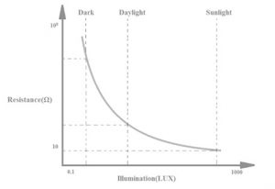
Fig 6.4.8:- LDR Characteristics

When the light drops on LDR, the resistance will be decreased and when the resistor is placed in the dark then the resistance will be increased which is called dark resistance. If any device absorbs light then its resistance will be reduced radically. If a stable voltage is given to it, the light intensity will be increased & the flow of current starts increasing. So, the following diagram represents the characteristics between resistance & illumination for a specific LDR.

LDRs are not linear devices and their sensitivity changes through the light’s wavelength which drops on them. Some kinds of photocells are not at all sensitive to a specific range of wavelengths because it depends on the used material.
Once light rays fall on a photocell, the resistance will be changed in 8 ms to 12, while it uses few more seconds to rise the resistance back again to its early value once the light is removed. So this is known as a recovery rate of resistance. In audio compressors, this property is applicable.

In addition, these resistors are low responsive to phototransistors & photodiodes. A photo-diode is a PN-junction semiconductor device, used to change the light to electricity, while a photocell is a passive device and it doesn’t include a PN junction but is used to convert light to electricity but it is not.

6.4.9 Types of LDR
The classification of LDR can be done based on linearity or photosensitive materials. The most frequently used materials while designing LDR mainly include cadmium sulfide, thallium sulfide, cadmium selenide & lead sulfide.
The LDRs generated with this cadmium sulfide chemical are very responsive to all kinds of light radiation that are noticeable within the spectrum of human beings.

The LDRs made with lead sulfate chemicals are particularly responsive to IR radiation.
The most frequent classification of LDR is linear as well as nonlinear

Liner type LDRs are called as photodiodes however in some applications areas it is used as photoresistors because of the linear performance they present & their operation.

Non-linear LDRs are commonly used but their behavior does not depend on the polarity through which it unites.

6.4.10 LDR Advantages
The advantages of LDR include the following.
Sensitivity is High
Simple & Small devices
Easily used
Inexpensive
There is no union potential.
The light-dark resistance ratio is high.
Its connection is simple

6.4.11 LDR Disadvantages
The disadvantages of LDR include the following.
Spectral response is narrow
Hysteresis effect
Temperature stability is low for the best materials
In stable materials, it responses very slowly
The use of LDR is limited where the light signal changes very quickly
It is not so much a responsive device.
It provides incorrect result once working temperature alters

6.4.12 Applications of LDR
Light-dependent resistors are simple and low-cost devices. These devices are used where there is a need to sense the presence and absence of light is necessary. These resistors are used as light sensors and the applications of LDR mainly include alarm clocks, street lights, light intensity meters, burglar alarm circuits. For a better understanding of this concept, here we have explained one project namely; power conserving of intensity controlled street lights using LDR.

6.4.13 Power Conserving of Intensity Controlled Street Lights using LDR
Nowadays, the lightening-up of highways is done through HID lamps but, the energy consumption of these lights is high as well as there is no particular mechanism to turn on/off the lights from sunrise to sunset. To overcome this problem, here is an alternative method using LEDs i.e. power conserving of intensity controlled street lights using LDR.

The proposed system is built to overcome the drawback of the present-day HID lamps. The proposed system determines the usage of light-emitting diodes as a light source and its adjustable intensity control according to the requirement. These lights consume less power, as well as the life span of these lights, which is more compared to conventional HID lamps.
The most important feature of this project is, the light intensity can be controlled according to necessity during nighttime, which is not possible in HID lamps. An LDR is used to detect the light and the resistance of the LDR drastically reduces according to the light in the daytime, which forms as an i/p signal to the controller.

A bunch of LEDs is used to make a street light and the microcontroller using in the project is preprogrammed with instructions that control the light intensity based on the Pulse width modulation signals generated.
The light intensity is kept high during the nighttime, and as the traffic on the roads tends to fall in peak hours; the intensity also falls gradually till morning. Finally, the LED lights get turned off in the morning at 6 am and continues again at 6 pm in the evening. This process will continue.

Furthermore, this project can be developed by mixing it with a solar panel, which changes the intensity of the solar to the equivalent voltage and solar energy is used to feed the lights on highways. Thus, this is all about the working principle of the light-dependent resistor, circuit diagram, and its applications and it is one kind of photoresistor.

We hope that you have got a better concept through this article. Furthermore, any queries regarding this article or electrical and electronics projects, please give your feedback in the comment section below. Here is a question for you, what is the function of an LDR?

6.5 Rain Sensor

A rain sensor is an electronic device that detects the presence of rainfall or moisture in the environment . It is primarily designed to sense raindrops and provide an output signal to control connected systems . Such sensors are commonly used in automotive applications for automatically activating windshield wipers , in irrigation systems to prevent unnecessary watering during rainy conditions , and in various home automation setups to enhance environmental control . The integration of rain sensors in these applications promotes efficiency and safety

6.5.1 Rain Sensor Module
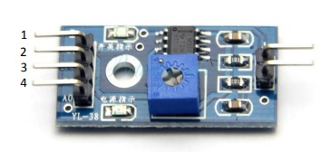
Fig 6.5.1:- Rain Sensor Module

The rain sensor module typically consists of the following components:

Sensing Element : This is often a pair of conductive traces arranged in a grid or pattern .When raindrops bridge the conductive paths , the module detects the presence of moisture .
Electronic Circuitry : The module includes additional circuitry for signal processing and may contain a microcontroller or comparator circuit to interpret the data from the sensing element .
Output Interface : The module provides an output in the form of digital or analog signals that can be interfaced with microcontrollers and control systems .

6.5.2 Pin Configuration
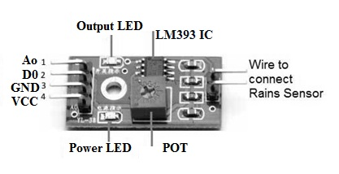
Fig 6.5.2:- Rain Sensor Pin
The typical rain sensor module comes with a few pins that allow it to interface with other electronic components, such as microcontrollers. The most common pin configuration is as follows :

Pin Pin
Description
Number Name
1 | VCC | Power supply pin ( typically 5V) . This pin provides power to the sensor module .
2 | GND | Ground pin . This pin must be connected to the common ground of the circuit .
3 | AO | Analog output pin . This pin provides an analog voltage output that corresponds to the amount of moisture detected .
4 | DO | Digital output pin . This pin outputs a high or low digital signal based on the presence of rain ( active low in many cases ) .

6.5.3 Specifications
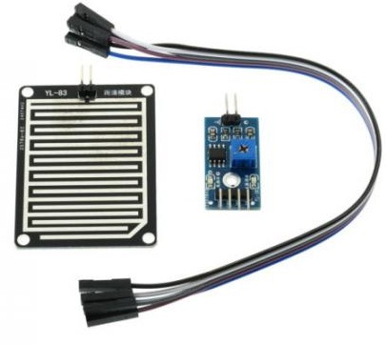
Fig 6.5.3:- Rain Sensor

The specifications of a rain sensor module can vary depending on the design and application, but some common specifications include :

Operating Voltage : Typically 3.3V to 5V, allowing compatibility with various microcontrollers.
Sensing Distance : The distance at which rain can be detected ; it varies but is usually in the range of a few millimeters.
Response Time : The time taken to react to rain detection , often in milliseconds.
Output Types : Both digital ( on / off signal ) and analog voltage ( depending on the sensor design ) .
Durability : Suitable for outdoor conditions , often rated with environmental considerations for humidity and temperature.
Size: Compact modules typically measuring a few centimeters , allowing easy integration into devices and systems.

6.5.4 Types of Rain Sensors

Rain sensors can be categorized based on their operating principles , construction, and application Here are the primary types of rain sensors :

6.5.4.1 Capacitive Rain Sensors

Principle : Capacitive rain sensors work on the principle of capacitance changes caused by the presence of water. The sensing element consists of two conductive plates that create an electric field . When water droplets are present, they change the dielectric constant between the plates, which is detected as a change in capacitance.
.
Application : These sensors are often used in automated irrigation systems and meteorological stations due to their sensitivity to small amounts of moisture.

6.5.4.2 Resistive Rain Sensors

Principle : Resistive rain sensors function based on the conductivity of water . They usually contain a grid or pattern of conductive material . When raindrops bridge the conductive paths , they create a short circuit that alters the resistance of the circuit , signaling the presence of rain .

Application : Commonly found in automotive applications( e.g. ., windshield wipers ) , home automation systems , and smart irrigation systems .

6.5.4.3 Optical Rain Sensors:-

Principle: Optical rain sensors use light beams to detect rain . They typically consist of a light - emitting diode ( LED) and a photodetector. When rain droplets fall onto the sensor they interrupt the light beam , causing a change in the detected light intensity , which signals the presence of rain .

Application : Mostly utilized in advanced weather stations and some automotive applications where precision and rapid response are required .

6.5.4.4 Mechanical Rain Sensors:-

Principle : Mechanical rain sensors rely on physical movement to detect rain . These sensors may use a tipping bucket mechanism, where drops of rain fill a small container until it tips , triggering a switch to record rainfall .

Application : Predominantly used in meteorological applications to measure rainfall amounts accurately.

6.5.4.5 Ultrasonic Rain Sensors:-

Principle : Ultrasonic rain sensors utilize ultrasonic waves to detect rain . By emitting ultrasonic signals and measuring the time it takes for the signals to return , the sensor can determine the presence and intensity of raindrops based on the changes in sound wave propagation .

Application : These sensors are relatively new and are being explored for use in advanced weather forecasting systems and smart agriculture .

6.5.4.6 Integrated Rain Sensors:-

Principle : These are multifunctional sensors that integrate rain detection with other environmental monitoring capabilities , such as detecting temperature, humidity and UV radiation . They typically use various technologies( e.g .,capacitive, resistive ) in a single device .

Application : Used in smart home devices , weather stations , and agricultural applications to provide comprehensive environmental data .

6.5.4.7 Water collection basin

This is one of the oldest forms of rain sensors and can still be found. The sensor has a cup or basin attached to it that serves as a rain gauge as the water accumulates in it. This aids the sensor in deciding whether to trigger the sprinklers or not. Its biggest limitation is that it cannot tell the difference between rainwater and debris that causes an unjustified disruption of the watering process. Also, when your sensors possess a smaller basin, wind will be able to blow the water out of your container which results in the same problems. They are also referred to as rain collection cups and also tend to work with wireless systems.

6.5.4.8 Conductive sensors
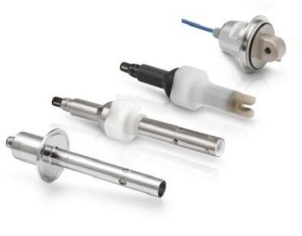
Fig 6.5.4.8:- Conductive Sensor

These sensors operate on a more sophisticated technology and are based on the concept of conductivity. There are two electrodes at the bottom of the basin in this design. As the water level rises to these electrodes, a circuit is completed and a switch is turned on. This mechanism is able to sense difference between debris and water, but if the debris causes the water level to rise after a short shower, the sprinklers can be turned off too early. Thus, the open container is a disadvantage in both water collection and conductive type of sensors.

Hygroscopic disk (or expansion disk)

This sensor is one that has become super popular over the years and is ranked among the most precise. It contains a cork disk that swells by soaking up rainwater. This activates a switch once a predetermined quantity is accumulated. The timing of the watering will not begin until the disk has dried out and retracted to its usual size; therefore, the more it stays wet and expanded, the longer the sprinklers will continue to be shut down. The system is effective and accurate which has contributed to its popularity.

6.5.4.9 Freeze sensors
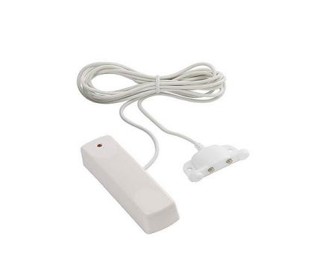
Fig 6.5.4.9:- Freeze Sensors

6.5.5 Rain Sensor : Working Principle

A rain sensor (or rain detector) is a device designed to sense the presence of rain and initiate an appropriate response or action in connected systems. The working principle of most rain sensors is based on the detection of water droplets and can be understood through the following key components and processes:

Sensing Element:-The core of a rain sensor typically consists of a conductive material arranged in a grid or a set of parallel wires. The basic operating principle leverages the conductivity of water.
When raindrops fall on the sensing element, they bridge the gap between the conductive pathways. This creates a change in electrical resistance or a short circuit, which can be detected by an electronic circuit.

Signal Processing:-The change in resistance or continuity in the circuit caused by the raindrops is interpreted by a microcontroller or an integrated circuit in the rain sensor.
The sensor is designed to output a digital or analog signal based on the presence or absence of rain. Typically, if rain is detected, the output signal changes state – for example, switching from high to low.

Sensitivity Adjustment:-Some advanced rain sensors come equipped with sensitivity adjustment settings, allowing users to configure how much water is necessary to trigger a response. This is achieved through threshold settings in the electronic circuit.

Control and Response Mechanism:-The output from the sensor can be used to control various devices mechanisms, such as wipers in a vehicle, irrigation systems, or alarms. The sensor may integrate with relays, microcontrollers, or other smart devices to automate actions based on rainfall detection.

6.5.6 Rain Sensor Circuit

The rain sensor alarm circuit is shown below. This circuit can be designed with different components like rain sensor module, 9V supply, buzzer, variable resistor -300K, BC547B transistor, etc.
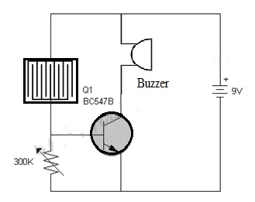
Fig 6.5.6:- Rain Sensor Circuit Diagram

In the following circuit, the BC547B transistor is an essential component that works like a switch in this circuit. The rain sensor is very responsive to water drops or rainfalls. The circuit sensitivity can be adjusted through a variable resistor. Once the rain falls onto the sensor strips then the circuit will be activated because water is a great electricity conductor.
The voltage is supplied to the transistor to turn ON the transistor then it activates the buzzer which is connected to it. Here, the buzzer in this circuit works like an alarm to alert the user. For better performance, the sensor strip must be connected very close to the circuit. This sensor can be designed through different methods based on your choice & convenience.

6.5.7 Applications of Rain Sensor

Rain sensors have a broad range of applications across various domains, including but not limited to:

Automotive Systems:-Rain sensors are widely used in automobiles to control automatic windshield wipers. When the sensor detects rain, it sends a signal to activate the wipers, improving visibility and enhancing safety.

Smart Irrigation Systems:-In agriculture, rain sensors can be used alongside irrigation systems to prevent unnecessary watering when it is raining. This contributes to efficient water management, reducing waste and promoting sustainability.

Weather Stations:- Rain sensors are vital components in meteorological stations that monitor local weather conditions. They provide real-time data regarding precipitation, which can be analyzed for weather predictions and climate studies.

Building Automation:-In building management systems, rain sensors can activate drainage systems, protect HVAC equipment, or trigger alerts when moisture levels rise beyond a specified threshold. This helps in managing maintenance and preventing water damage.

Home Automation:-Rain sensors are integrated into smart home systems to control awnings, shades, or exterior lighting. For instance, if rain is detected, an awning can automatically retract to avoid damage.

Flood Monitoring and Alerts:-Rain sensors can be deployed in flood-prone areas to monitor rainfall levels and trigger alarms when rain exceeds predefined amounts. This can aid in early warning systems for potential flooding events.

Robotics and Drones:-In automated outdoor robots and drones, rain sensors can help pause operations during inclement weather, protecting sensitive components from moisture damage.

6.5.8 Conclusion of Rain Sensor

Rain sensors are essential components in numerous applications , providing valuable functionality by detecting moisture and rain .Understanding the rain sensor module's pin configuration and specifications is critical for integrating these devices into systems ranging from basic home automation to advanced vehicular safety features. Their ability to enhance the efficiency of operations and contribute to user convenience makes them an indispensable element in modern electronic designs.
The diverse range of rain sensors, categorized by their working principles and applications, highlights the adaptability of sensor technology to different environmental monitoring needs . From simple resistive sensors to sophisticated optical and ultrasonic sensors , each type offers specific advantages for various applications, ultimately enhancing automated systems and improving environmental management. The selection of a rain sensor should depend on the intended application desired sensitivity, and environmental conditions in which the sensor will operate

6.6 BMP 280 Sensor
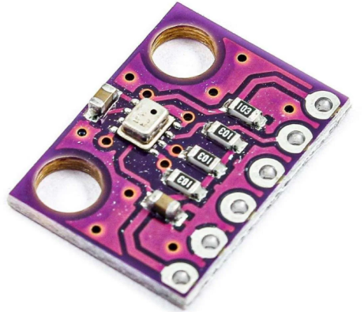
Fig 6.6:- BMP 280 Sensor
The BMP280 sensor is a high-precision digital barometer and temperature sensor designed for various applications in environmental monitoring, weather stations, and altitude tracking. Developed by Bosch Sensortec, the BMP280 integrates both pressure and temperature measuring capabilities in a compact, energy-efficient package, making it suitable for mobile and IoT devices. The working principle of the BMP280 sensor is rooted in the fundamental physics of pressure and temperature measurement. BMP280 employs a barometric pressure based on a piezo-resistive measurement, combined with a high-accuracy temperature sensor. Below, we outline the key components and the overall operation of the sensor.

6.6.1 Technical Specifications of BMP 280 Sensor

Measurement Range:

Pressure: The BMP280 can measure atmospheric pressure in the range of 300 to 1100 hPa (hectopascals), corresponding to altitudes approximately between -500 to 9000 meters. This broad range allows for versatile application in differing altitudinal environments.

Temperature: The sensor has a temperature measurement range of -40 to 85 degrees Celsius, making it effective for use in various climatic conditions.

Resolution and Accuracy:-

The BMP280 offers a pressure resolution of 1 Pa, which is equivalent to a sensitivity of 0.01 hPa. Furthermore, it boasts a temperature measurement accuracy of ±1°C and a pressure accuracy of ±1 hPa at sea level, ensuring reliable data under standard atmospheric conditions.

Communication Interfaces:-

The BMP280 supports both I²C and SPI communication protocols, enabling compatibility with a wide range of microcontrollers and development platforms. The programmable modes of operation (Standard, Low Power, and Sleep) enhance its flexibility for various energy consumption needs.

Low Power Consumption:-

One of the BMP280's key features is its low power consumption, making it ideal for battery-operated and portable devices. In low-power mode, the device can operate effectively while consuming minimal energy, thus prolonging battery life.

Low-Power Mode: In standby or low-power mode, the BMP280 can significantly reduce its current consumption, operating with as little as 0.1 µA (typical) in sleep mode and 2.7 µA during low-frequency pressure and temperature measurements at 1 Hz.

6.6.2 Block diagram of BMP280
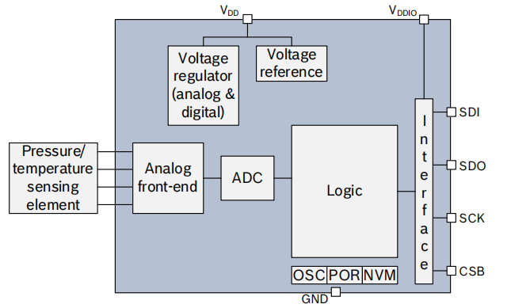
Fig 6.6.2:- Block Diagram of BMP 280

6.6.3 Sensor Architecture of BMP 280

Pressure Sensor:

The BMP280 contains a micro-machined silicon pressure sensor. This element is based on piezoresistive technology, where the physical deformation of silicon structure under pressure leads to changes in resistance. The sensor consists of a membrane and a reference cavity. When atmospheric pressure is applied to membrane, it deforms, and this deformation is converted into an electrical signal.

Temperature Sensor:

The BMP280 integrates a thermistor for temperature measurements. The thermistor's resistance varies with temperature changes, enabling the sensor to detect ambient temperature accurately. Both the pressure and temperature readings are necessary for precise altitude and weather calculations.

Analog-to-Digital Converter (ADC):-

The sensor features an integrated ADC that converts the analog signals generated from the pressure and temperature measurements into digital data. This allows for straightforward interfacing with microcontrollers and other digital systems via I²C SPI communication protocols.

6.6.4 Working Principle of BMP 280 Sensor

Pressure Measurement:-

The sensor performs pressure measurement by monitoring the force exerted by the atmosphere on the diaphragm. This force causes a deflection in the silicon membrane, which is proportional to the pressure. The change in resistance due to the deformation of the membrane is captured and amplified by internal circuitry. The sensor calibrates the raw pressure readings using built-in algorithms that correct for temperature influences and sensor-specific biases.

Temperature Measurement:-

The thermistor detects temperature changes by measuring variations in its resistance, which behaves according to the principle of thermos-resistivity. The resistance data is processed and converted into a temperature reading, enabling temperature compensation for the pressure measurements.

Data Processing and Output:-

The BMP280 combines the pressure and temperature data to output compensated measurements, further enhancing the accuracy of both values. This is essential, especially in barometric altitude calculations, where atmospheric pressure decreases with altitude.
The digital output (temperature and pressure readings) can be accessed either via the I²C or SPI bus, allowing for easy integration into different devices and systems
.
6.6.5 BMP280 Pin Details:-

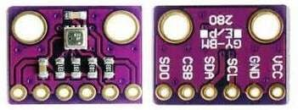
Fig 6.6.5:- BMP 280 Sensor Pin

The BMP280 typically in a 6-pin LGALand Grid Array) package and its pinout is as follows1. VINPin 1)
Function: pin is where the voltage is connected.
Range The voltage for the BMP typically ranges from 1.71 3.6. It is crucial to ensure that the supply voltage is within this range to prevent damage to sensor.

GND (Pin 2):

Function: This is the ground pin of the sensor.
Significance: provides a common return path for the power supply. Proper grounding is essential for the functioning of the sensor and helps in minimizing noise in the measured signals.

SDA (Pin3) / SDI (Pin 3):

Function: This pin is used for data input/output when using the I²C communication protocol. In the SPI mode, this pin functions as Serial Data In (SDI).
Purpose: SDA pin carries the data signals between the BMP280 sensor and the micro. It is utilized to read the measurement data and to send configuration.

SCL (Pin 4) / SD (Pin 4):

Function: This pin serves as the clock signal for I²C communication (SCL) or as the Serial Data Out (SDO) in SPI mode.
Purpose: The SCL pin synchronizes the data transfer over the I²C bus. In SPI mode, it enables the microcontroller to read data from the sensor.

CSB (Pin 5):

Function: This pin is the Chip Select pin for SPI communication.
Purpose: In SPI mode, the CSB pin determines whether the sensor is activated. The pin should be pulled low for the microcontroller to communicate with the BMP280 through SPI. In I²C mode, this pin is typically pulled high.

NC (Pin 6):

Function: This pin is typically left unconnected or "not connected."
Significance: The NC pin does not have a function in the standard operation of the BMP280 and can be ignored during circuit design.

6.6.6 Example of Pin Configuration in a Circuit

For integration into a microcontroller project, a typical connection scheme could be:
Connect VIN to a 3.3V power source.
Connect GND to the common ground.

For I²C communication:
Connect SDA to the corresponding I²C data line of the microcontroller.
Connect SCL to the corresponding I²C clock line.
Connect CSB to high or leave it unconnected.

For SPI communication:
Connect SDI to MOSI (Master Out Slave In) on the microcontroller.
Connect SDO to MISO (Master In Slave Out).
Connect CSB to a GPIO pin on the microcontroller configured as an output.

6.6.7 Calibration and Algorithms of BMP 280 Sensor

The BMP280 incorporates advanced calibration algorithms that account for variations due to manufacturing differences, environmental influences, and electronic offsets. Calibrated coefficients stored in the sensor help in accurately converting the raw measurements into meaningful outputs. The part’s firmware processes these coefficients to yield pressure readings accurate to ±1 hPa and temperature readings accurate to ±1°C.

6.6.8 Applications of BMP 280 Sensor

The broad operational capabilities of the BMP280 make it suitable for a variety of applications, such as:

Weather Stations: The sensor can be utilized in personal and professional weather stations to track and report atmospheric conditions, including the determination of local barometric pressure and temperature.

Altitude Measurement: In navigation applications such as drones and smartphones, the BMP280 can provide accurate altitude readings, which is crucial for tasks that require precise position tracking.

Environmental Monitoring: The sensor can aid in environmental studies by providing meteorological data, which can be used in analyzing climate patterns and changes over time.

Consumer Electronics: The integration of the BMP280 in smart devices enhances functionalities such as weather forecasts, health monitoring, and environmental awareness applications.

6.6.9 Conclusion of BMP 280 Sensor

In summary, the BMP280 sensor exemplifies a powerful tool featuring an impressive array of specifications that make it well-suited for diverse applications in both consumer and industrial markets. Its ability to measure temperature and pressure with high accuracy while maintaining low power consumption highlights its significance in advancing smart technology environments.

As research and development in sensor technology continue to evolve, the BMP280 stands as a foundational component in the ongoing quest for precision in environmental monitoring and data collection. In summary, the BMP280 sensor operates on the principles of piezoresistive technology for pressure measurement and thermos-resistivity for temperature sensing.

The combination of these mechanisms, along with sophisticated calibration techniques and digital communication capabilities, allows the BMP280 to provide reliable and efficient atmospheric data suitable for a wide range of applications in environmental monitoring, navigation, and consumer electronic devices.

Through its robust design and operational efficiency, the BMP280 exemplifies a significant advancement in modern sensor technology. The BMP280’s pin configuration is designed for straightforward integration and ease of use, whether for I²C or SPI communication protocols.

Understanding the function of each pin allows engineers and developers to effectively implement this sensor into various applications, such as environmental monitoring systems, drones, and meteorological equipment. Proper wiring according to the pinout is essential to ensure accurate sensor operation and reliable performance in the intended applications

6.7 OLED Display

6.7.1 Overview 0.96 OLED Display
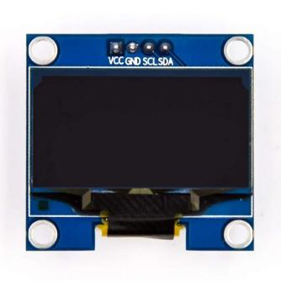
Fig 6.7.1:- OLED Display

The 0.96-inch OLED (Organic Light Emitting Diode) display is a compact size display module widely used in a variety of electronic applications, ranging from hobbyist projects to industrial devices. Often featuring a resolution of 128x64 pixels, this display enables the visualization of text, graphics, and icons in a small form factor. The OLED technology allows for vivid colors, high contrast, and low power consumption, making it suitable for battery-operated devices.

The 1.3-inch OLED (Organic Light Emitting Diode) display is a compact, high-quality display used in various applications, including portable devices, wearables, and smart appliances. Typical resolutions include 128x64 pixels or 240x240 pixels, providing clear images and text. OLED technology is favored in applications where low power consumption and excellent visibility are essential.

6.7.2 Technical Specifications 0.96 OLED Display

Size: 0.96 inches diagonally
Resolution: 128 x 64 pixels
Interface: Commonly supports I2C and SPI interfaces for communication
Color: Typically, monochrome (usually white or blue), but some variants offer color displays
Operating Voltage: Generally operates on 3.3V to 5V
Viewing Angle: Wide viewing angles (usually up to 160 degrees)
Response Time: Fast response times due to the nature of OLED technology

6.7.3 Structure of the 0.96 inch OLED Display

OLED displays consist of several layers, each serving a specific function:
Substrate: The display starts with a substrate, often made of glass, plastic, or metal, which supports the entire structure.
Anode: A transparent conductive layer typically made of Indium Tin Oxide (ITO) acts as the anode, allowing light produced in the organic layers to pass through.
Organic Layers:
Conductive Layer: This layer consists of organic compounds that transport positive charges (holes) towards the emission layer.
Emissive Layer: This layer contains organic molecules that emit light when excited by electric current. Depending on the organic materials used, different colors can be produced.
Cathode: The cathode layer is a thin metallic layer that injects electrons into the organic layers. It is usually made of materials like aluminum.

6.7.4 Schematic diagram of the 0.96 inch OLED Display
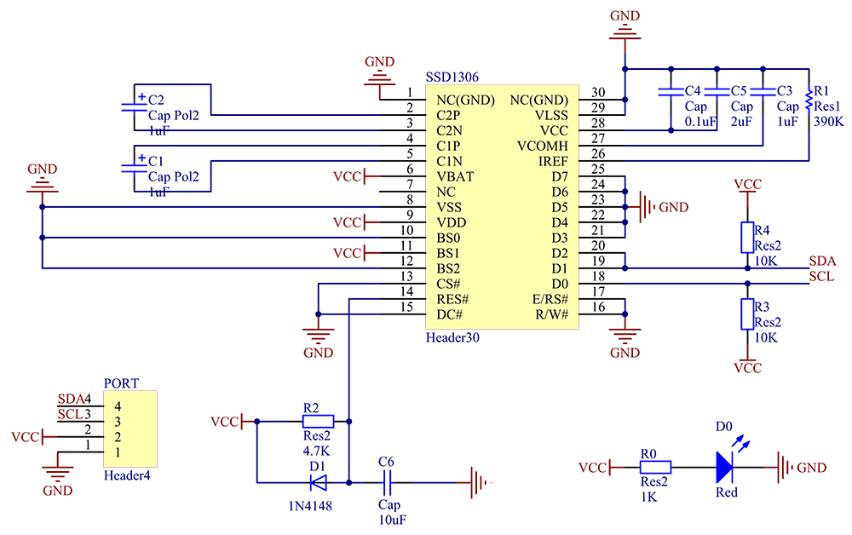
Fig 6.7.4:- Schematic diagram of the 0.96 inch OLED Display

6.7.5 Working Mechanism 0.96 Inch OLED Display

The operation of an OLED display involves several steps:

Electrical Activation: When voltage is applied to the OLED display, the anode receives positive charge carriers (holes) and the cathode provides negative charge carriers (electrons).

Charge Injection: Holes migrate through the conductive layer towards the emissive layer, while electrons move from the cathode into the emissive layer. When both charges meet in this layer, they recombine.

Excitement of Organic Molecules: Upon recombination, energy is released in the form of photons (light) as the organic molecules transition from an excited state back to a ground state. This is the fundamental mechanism that generates visible light in an OLED display.

Light Emission: The emitted light passes through the transparent anode and is visible to the user. Varying the current flowing through the components alters the intensity and color of the light emitted, allowing for the display of images, text, and graphics.

6.7.6 Control and Pixel Addressing 0.96 Inch OLED Display

For the 0.96-inch OLED module with a resolution of 128x64 pixels, the following methods are commonly used to control what is displayed:

Pixel Matrix: Each pixel in an OLED display is controllable, allowing for individual pixel management. Pixels are arranged in a grid, and manipulation of these pixels enables the display of different characters and images.

Multiplexing: To reduce power consumption, OLED displays often employ a technique called multiplexing where only a fraction of the pixels are energized at any one time, refreshing the display quickly to maintain the appearance of a fully active display.

Driver IC: Control of the OLED display is typically managed by a dedicated driver IC (Integrated Circuit), such as the SSD1306, which communicates with microcontrollers via I2C or SPI protocols. Commands sent to the driver determine which pixels are turned on or off, effectively creating the visual output seen on the screen.

6.7.7 Advantages of 0.96 OLED Display

High Contrast Ratio: The OLED technology provides superior contrast as individual pixels emit their light, resulting in deep blacks and vibrant colors even in bright ambient light.

Wide Viewing Angles: The display maintains image clarity from various angles, making it ideal for applications where the viewing position may vary.

Low Power Consumption: OLED displays consume less power than traditional LCDs, particularly when displaying dark images or text, as black pixels are turned off completely.

Thin and Lightweight: The compact form factor and flat profile of OLED displays make them suitable for space-constrained designs.

Fast Refresh Rate: The response time of OLED displays is superior, allowing for fluid motion and quick changes in displayed content without ghosting.

Readability in Low Light Conditions: OLEDs are more visible in low-light environments compared to LCD displays, providing better usability in diverse lighting scenarios.

6.7.8 Disadvantages of 0.96 OLED Display

Limited Lifespan: OLED displays can experience a phenomenon known as “burn-in,” where static images can persist on the screen over time due to uneven wear of organic materials.

Higher Cost: Generally, OLED displays tend to be more expensive than traditional LCDs, which may be a consideration for mass-produced devices in cost-sensitive applications.

Viewability in Direct Light: While they have good viewing angles, under direct sunlight, the visibility may be less than that of high-end LCDs, primarily due to glare.

Color Variability: The color output can vary between different OLED displays based on the manufacturing process, which may affect consistency across multiple devices.

Temperature Sensitivity: OLEDs can be sensitive to temperature extremes, which may affect performance and longevity.

6.7.9 Applications of 0.96 OLED Display

The 1.3-inch OLED display is used in various applications across different industries, including:

Wearable Devices: Commonly found in smartwatches and fitness bands, where compact displays are essential for providing user interfaces and notifications.

Portable Electronics: Used in handheld devices like portable game consoles, e-readers, and smartphones due to their small size and low power consumption.

Home Automation: Integrated into smart home systems for displaying information related to temperature, humidity, and device status.

Industrial Applications: Employed in control panels and industrial automation equipment where quick readability and robustness are essential.

Consumer Electronics: Utilized in devices like remote controls, MP3 players, and digital cameras to provide user feedback and status information.

6.7.10 Conclusion of 0.96 OLED Display

The 1.3-inch OLED display encapsulates numerous advantages for a wide range of applications. Its working principle relies on the electroluminescence of organic materials to produce light, resulting in high contrast, vivid colors, and low power consumption. However, potential drawbacks such as limited lifespan due to burn-in effects and higher costs compared to LCDs must be addressed. Despite these concerns, the OLED display remains a preferred choice for portable and smart devices, contributing to its growing popularity in both consumer and industrial markets.

6.8 LM2596 DC-DC Converter: Details and Analysis

6.8.1 The Role of DC-DC Buck Converters
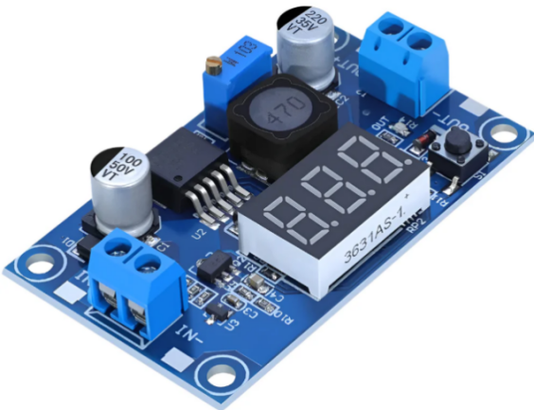
Fig 6.8.1:- LM2596 DC-DC Step-down Buck Module with Display

A DC-DC buck converter is a type of switched-mode power supply that efficiently reduces a higher DC voltage to a lower DC voltage. This step-down regulation is fundamental in modern electronics, where various components often require different voltage levels to operate correctly. From portable devices powered by batteries to complex industrial machinery, buck converters play a crucial role in ensuring that each part of the system receives the appropriate voltage from a common power source. Their efficiency, often significantly higher than linear regulators, makes them particularly valuable in applications where power conservation and thermal management are critical
6.8.2. Introducing the LM2596 Series

The LM2596 series is a family of monolithic integrated circuits that are intended to be employed as step-down (buck) switching regulators.1 These regulators were originally developed by Texas Instruments but are also produced by other firms, such as ON Semiconductor. Perhaps one of the most notable features of the LM2596 is that it can source a load current of up to 3 amperes and provide very good regulation of both the output voltage when the input voltage is varying (line regulation) and when the load is varying (load regulation).1
The LM2596 series is characterized by its versatility, as it comes in a number of fixed output voltage configurations, i.e., 3.3 V, 5 V, and 12 V, as well as an adjustable output version.1 The adjustable version enables the output voltage to be adjusted over a range of 1.2 V to 37 V, with a stated maximum tolerance of ±4% over a variety of line and load conditions.1 This combination of both fixed and adjustable voltage versions enables the LM2596 to find application in a wide variety of applications, from supplying standard voltage levels to digital circuits to delivering customized voltages to specialized equipment. This versatility has been the key to the widespread use of the LM2596 in many electronic designs.
In addition, the LM2596 has a fixed internal switching frequency of 150 kHz.1 This comparatively high switching frequency makes it possible to use smaller external filter components, for example, inductors and capacitors, as opposed to switching regulators with lower switching frequencies. This miniaturization of components is beneficial in applications where board space is restricted. The 150 kHz selection is a compromise between passive component size and switching loss in the regulator. Higher frequencies would allow further component miniaturization but may also cause lower efficiency due to increased switching loss per cycle. Lower frequencies, on the other hand, would result in higher efficiency but would also require larger and heavier inductors and capacitors.

6.8.3 Core Features and Benefits

6.8.3.1 Adjustable Output Voltage
The adjustable version of the LM2596 provides a flexible output voltage range, spanning from a minimum of 1.2 V to a maximum of 37 V. This adjustable output can be configured with a maximum tolerance of ±4% across the specified input voltage and output load conditions. The output voltage is typically set using an external voltage divider network consisting of two resistors connected to the feedback pin. The ability to fine-tune the output voltage to meet specific requirements enhances the versatility of the LM2596, making it suitable for powering a wide array of loads with diverse voltage demands in various electronic systems

6.8.3.2 Fixed Output Voltage Options
In addition to the adjustable version, the LM2596 series is available in common fixed output voltage configurations, including 3.3 V, 5 V, and 12 V. These fixed voltage options streamline the design process by eliminating the need for external components to set the output voltage.² For applications requiring standard power rails, such as those commonly used in digital and analog circuits, the fixed voltage versions of the LM2596 offer a straightforward and reliable power solution, reducing both component count and overall design complexity.

6.8.3.3 High Output Load Current
The LM2596 is capable of delivering a continuous output load current of up to 3 A.¹ This current handling capacity positions the LM2596 as a mid-power DC-DC converter, suitable for a wide range of applications that demand more current than typical linear regulators can efficiently provide, yet do not necessitate the very high current levels offered by more specialized switching regulators. Many microcontrollers, sensors, and small motors operate within a current range of hundreds of milliamperes to a few amperes, making the 3 A rating of the LM2596 well-suited for these types of loads.

6.8.3.4 Wide Input Voltage Range
The LM2596 can operate with an input voltage range extending up to 40 V.¹ Some datasheets may also specify an absolute maximum supply voltage of 45 V.⁶ This wide input voltage capability provides significant flexibility in power source selection, allowing the LM2596 to be powered from various sources, including batteries, unregulated DC power supplies, and rectified AC mains. This ability to handle a broad range of input voltages is particularly advantageous in systems where the input voltage may fluctuate, such as in automotive or industrial environments, ensuring that the regulator can maintain a stable output despite these variations.

6.8.3.5 Minimal External Components
A key benefit of the LM2596 is its requirement for only a minimal number of external components for basic operation. For fixed output voltage versions, only four external components are typically needed: an inductor, an input capacitor, an output capacitor, and a catch diode.¹ The adjustable output version requires an additional two resistors to set the output voltage. Furthermore, the LM2596 includes internal frequency compensation ², which simplifies the design process by eliminating the need for external components typically required for loop stability in other switching regulators. This low external component count not only simplifies circuit design and PCB layout but also contributes to a reduced overall bill of materials (BOM) cost, making the LM2596 a cost-effective solution for many applications.

6.8.3.6. Excellent Regulation
The LM2596 boasts excellent line and load regulation specifications , ensuring a stable output voltage even when the input voltage or the load current changes. The load regulation is typically within a maximum of ±4% over the specified line and load conditions. This tight regulation is crucial for sensitive electronic devices that require a stable and accurate power supply to function reliably. Microcontrollers, analog sensors, and communication modules, for example, often have strict voltage requirements, and the good regulation provided by the LM2596 helps prevent voltage drops or surges that could lead to malfunction or damage.

6.8.3.7.Fixed Switching Frequency
The LM2596 incorporates a 150-kHz fixed-frequency internal oscillator. This fixed switching frequency simplifies the design of the external filter components needed to minimize output ripple and noise. Moreover, a consistent switching frequency can aid in managing electromagnetic interference (EMI) by concentrating the noise energy at a predictable frequency, making it easier to design appropriate filtering to mitigate potential interference with other electronic circuits.

6.8.3.8. TTL Shutdown Capability
The LM2596 features a TTL-compatible shutdown capability, accessible through the ON/OFF pin (pin 5). Applying a high-level TTL signal (typically above 1.6 V ) to this pin disables the regulator, significantly reducing the total input supply current to a low standby level, typically around 80 µA. Conversely, leaving the ON/OFF pin open or pulling it to a low logic level enables the regulator.¹⁵ This shutdown feature is particularly valuable in battery-operated devices or systems where it is necessary to disable the power supply to conserve energy when the load is not active. The very low standby current in shutdown mode helps to maximize battery life by minimizing power drain.

6.8.3.9. High Efficiency
The LM2596 offers high efficiency in converting the input voltage to the desired output voltage.¹ The exact efficiency achieved depends on the difference between the input and output voltages and the magnitude of the output load current, as detailed in Section 3. High efficiency is crucial for minimizing power loss and the generation of heat. This can lead to cooler operation of the device, potentially allowing for the use of smaller or even no heat sinks in some applications. Furthermore, higher efficiency contributes to the overall energy efficiency of the system, which is increasingly important in modern electronic designs.

6.8.3.10 Standard Inductors
The LM2596 is designed to operate effectively with readily available standard inductors.¹ Several manufacturers offer standard series of inductors specifically optimized for use with the LM2596 series.⁴
This compatibility with standard components simplifies the process of sourcing parts and can often lead to more cost-effective designs compared to regulators that require specialized or custom magnetic components. The wide availability of standard inductors also reduces the risk of component obsolescence and simplifies supply chain management.

6.8.3.11. Protection Features
To enhance reliability and prevent damage under fault conditions, the LM2596 incorporates several protection features, including thermal shutdown and current-limit protection.¹ The thermal shutdown feature automatically disables the regulator if its internal temperature exceeds a safe limit, preventing damage due to overheating.
The current-limit protection feature restricts the output current to a safe maximum value, protecting the regulator and the load from overcurrent conditions, such as those that might occur during a short circuit. Some datasheets also mention a two-stage frequency reducing current limit ⁴, which further helps to limit power dissipation during severe overcurrent or short circuit events by reducing the switching frequency. These built-in protection mechanisms significantly improve the robustness of the LM2596, making it a reliable choice for various applications.

6.8.4 Comprehensive Electrical Characteristics

6.8.4.1. Absolute Maximum Ratings
The absolute maximum ratings define the limits beyond which the device may be permanently damaged. For the LM2596 series, these ratings typically include:
- Supply Voltage (VIN): Up to 45 V.
- ON/OFF Pin Input Voltage: -0.3 V to +VIN, with some datasheets specifying a maximum of +25V.
- Output Voltage to Ground (Steady-State): -1.0 V.
- Maximum Junction Temperature (TJ): 150 °C.
- Storage Temperature Range: -65 °C to +150 °C.
- ESD Susceptibility: Typically greater than 2 kV, as tested by the Human Body Model.
Operating the LM2596 at or beyond these absolute maximum ratings, even for brief periods, can lead to irreversible damage and device failure.¹⁶ Therefore, designers must ensure that the operational conditions of their application remain well within these limits under all foreseeable circumstances to guarantee the long-term reliability of the system.

6.8.4.2. Recommended Operating Conditions
The recommended operating conditions specify the range of parameters under which the device is intended to function optimally and according to its datasheet specifications. For the LM2596, these conditions generally include:
- Supply Voltage (VIN): 4.5 V to 40 V.
- Operating Junction Temperature Range (TJ): -40 °C to +125 °C.
- Output Voltage Range (Adjustable Version): 1.23 V to 37 V, with some datasheets citing 1.2 V to 37 V.
- Output Current: A guaranteed maximum of 3 A.
Operating the LM2596 within these recommended conditions ensures that the device will perform as expected in terms of voltage accuracy, efficiency, and stability. Deviating from these conditions may result in degraded performance or even instability of the regulator.

6.8.4.3. Electrical Characteristics for Fixed Output Versions (3.3V, 5V, 12V) ²
The electrical characteristics for the fixed output versions of the LM2596 provide detailed specifications under specific test conditions. For instance, the 5V version typically has an output voltage of 5V with a tolerance of ±4% over an input voltage range of 7V to 40V and a load current range of 0.2A to 3A. Specifically, at a junction temperature of 25°C, the output voltage is typically 5V, with a minimum of 4.8V and a maximum of 5.2V.
Over the full operating temperature range of -40°C to 125°C, the output voltage range is 4.75V to 5.25V. The efficiency for the 5V version is typically 80% when the input voltage is 12V and the load current is 3A. Similar detailed specifications are available for the 3.3V and 12V fixed output versions, including their respective output voltage tolerances and efficiency figures at various operating points. These characteristics are crucial for designers to verify if a particular fixed voltage variant meets the specific requirements of their application.

6.8.4.4. Electrical Characteristics for Adjustable Output Version
For the adjustable output version of the LM2596, key electrical characteristics include the feedback voltage, which is typically 1.23 V. This internal reference voltage is used in conjunction with the external resistor divider to set the desired output voltage. The feedback bias current is another important parameter, typically around 10 nA at 25°C.
For example, the feedback voltage is typically 1.23V, with a minimum of 1.193V and a maximum of 1.267V at 25°C, and a range of 1.18V to 1.28V over the -40°C to 125°C temperature range, under input voltages from 4.5V to 40V and load currents from 0.2A to 3A. The efficiency for the adjustable version, when configured for a 3V output with a 12V input and a 3A load, is typically 73%. Understanding these characteristics, particularly the feedback voltage, is essential for accurately calculating the values of the external resistors needed to achieve the desired output voltage.

6.8.4.5. Oscillator Frequency
The LM2596 operates with a fixed internal oscillator frequency that is typically 150 kHz. This frequency has a tolerance of ±15% over the operating temperature range, meaning it can vary from a minimum of 127 kHz to a maximum of 173 kHz at 25°C, and from 110 kHz to 173 kHz over the full temperature range of -40°C to 125°C.²
As a self-protection mechanism, the oscillator frequency may decrease significantly, down to approximately 30 kHz in some cases, under conditions of output short circuit or overload.⁹ The switching frequency is a critical parameter as it influences the selection of external inductor and capacitor values.
A higher frequency generally allows for smaller components but may also affect the overall efficiency of the regulator. The tolerance in the switching frequency should be considered when designing the input and output filters to ensure proper operation across the expected frequency range.

6.8.4.6. Saturation Voltage
The saturation voltage (Vsat) of the internal switching transistor in the LM2596 is an important factor affecting the efficiency of the regulator, especially at higher output currents. Typically, at a load current of 3 A and a junction temperature of 25°C, the saturation voltage ranges from 1.16 V to 1.4 V, with a maximum of 1.5 V over the full operating temperature range of -40°C to 125°C.² Some datasheets might specify a maximum saturation voltage of up to 2.0V.⁹ A lower saturation voltage indicates less power is dissipated within the switching transistor as heat, leading to higher overall efficiency. This is particularly significant at higher output currents, where the power loss due to saturation voltage becomes more substantial.

6.8.4.7. Quiescent Current
The quiescent current of the LM2596 refers to the current consumed by the regulator's internal circuitry to operate. There are two main types of quiescent current specified: the operating quiescent current and the standby quiescent current. The operating quiescent current, when the regulator is actively switching and regulating the output, is typically around 5 mA to 10 mA. The standby quiescent current, which is the current drawn when the regulator is in shutdown mode (via the ON/OFF pin), is significantly lower, typically around 80 µA, with a maximum ranging from 200 µA to 250 µA over the operating temperature range. A low standby quiescent current is particularly important for battery-powered applications as it directly impacts the battery life of the device when the regulator is disabled. The operating quiescent current contributes to the overall power consumption of the system even when no load is connected to the output.

6.8.4.8. Thermal Resistance
Thermal resistance is a measure of how effectively a component can dissipate heat to its surroundings. It is typically expressed in °C/W (degrees Celsius per Watt). For the LM2596, the junction-to-ambient thermal resistance (RθJA) varies depending on the package type. For the TO-220 package (often designated as NDZ), the RθJA is typically around 50 °C/W. For the TO-263 surface mount package (often designated as KTW), the RθJA is also around 50 °C/W, although this can vary slightly depending on the specific datasheet and mounting conditions. The junction-to-case thermal resistance (RθJC), which measures the thermal resistance from the semiconductor junction to the external surface of the package, is typically around 2 °C/W. These thermal resistance values are crucial for calculating the expected temperature rise of the LM2596 under different power dissipation levels and ambient temperatures. This information is essential for designing an appropriate thermal management solution, such as a heat sink, to ensure that the junction temperature of the IC remains below its maximum rating of 150 °C, thereby preventing thermal damage and ensuring reliable operation.

6.8.5 Understanding the Operating Modes

6.8.5.1. Continuous Conduction Mode (CCM)
In Continuous Conduction Mode (CCM), the current flowing through the inductor of the buck converter remains above zero throughout the entire switching cycle. This mode of operation is generally preferred for applications requiring higher output power and tends to result in a lower peak current through the switching transistor, as well as lower ripple currents in both the inductor and the output diode. CCM can also lead to a lower output ripple voltage compared to other modes. However, to ensure continuous current flow, especially at light output loads or high input voltages, a larger inductor value is typically required.

6.8.5.2. Discontinuous Conduction Mode (DCM)
Discontinuous Conduction Mode (DCM) is characterized by the inductor current falling to zero for a portion of each switching cycle. This mode can be advantageous in applications with low output current requirements or when dealing with high input voltages.
One of the benefits of DCM is that it allows for the use of a physically smaller inductor with a lower inductance value, often about one-half to one-third of that required for CCM under similar conditions. However, DCM typically results in higher peak currents through the switching transistor and the inductor. Additionally, the output waveform in DCM may exhibit some damped sinusoidal ringing on the switch node, which is a normal characteristic of this mode due to energy circulating between the inductor and parasitic capacitances during the period when neither the switch nor the diode is conducting.

6.8.5.3. Mode Transition
It is common for buck converter designs, including those intended for CCM operation at higher loads, to automatically transition into DCM when the output load current is significantly reduced. This occurs because at light loads, the amount of energy required to be transferred to the output per switching cycle is smaller, and the inductor current may naturally fall to zero before the next switching cycle begins.
This transition to DCM at light loads is generally considered an acceptable mode of operation and can even improve efficiency under these conditions by reducing switching losses, although it might come at the cost of increased output voltage ripple.

6.8.6 Design and Application of Typical Circuits

6.8.6.1. Fixed Output Voltage Application
Designing a fixed output voltage power supply using the LM2596 is relatively straightforward, requiring a minimal number of external components. The basic circuit includes an input capacitor (CIN) to filter the input voltage and provide a stable source of energy, an output capacitor (COUT) to filter the output voltage and ensure loop stability, an inductor (L1) to store and transfer energy, and a catch diode (D1) to provide a path for the inductor current when the internal switch is off. The selection of these components is primarily determined by the desired output voltage and the maximum output load current. For example, a typical application for a 5V output might use an input capacitor of 470 μF (50 V), an output capacitor of 220 μF (25 V), a 5 A, 40 V Schottky catch diode, and a 68 μH inductor. These values serve as a good starting point, and specific application requirements may necessitate adjustments.

6.8.6.2. Adjustable Output Voltage Application
The adjustable output voltage version of the LM2596 allows for setting the output voltage to any value between 1.2 V and 37 V by using two external resistors (R1 and R2) in a voltage divider configuration. The circuit is similar to the fixed output version, including the input capacitor (CIN), output capacitor (COUT), inductor (L1), and catch diode (D1).
The output voltage is determined by the formula VOUT = VREF * (1 + R2/R1), where VREF is the internal reference voltage, typically 1.23 V. A feedforward capacitor (CFF) is often recommended to be placed in parallel with R2, especially when the desired output voltage is greater than 10 V or when using output capacitors with very low ESR, to improve the stability of the feedback loop.
Typical component values for an adjustable output application might include an input capacitor of 470 μF (50 V), an output capacitor of 220 μF (35 V), a 5 A, 40 V Schottky diode, a 68 μH inductor, and a resistor R1 typically around 1 kΩ. The value of R2 is then calculated based on the desired output voltage.

6.8.6.3. Component Selection Considerations
Proper selection of the external components is paramount for achieving the desired performance from the LM2596 regulator. The inductor value affects the ripple current and the mode of operation (CCM or DCM). Its current rating must be sufficient to handle the peak inductor current without saturating. Several manufacturers offer standard series of inductors specifically optimized for use with the LM2596, simplifying the selection process.
For capacitors, both the input and output capacitors, the voltage rating should be at least 1.5 times the maximum voltage they will be subjected to, to provide a safety margin. The input capacitor must be able to handle the RMS ripple current generated by the switching action. The output capacitor's value and ESR significantly affect the output voltage ripple and the transient response of the regulator.
Low ESR capacitors, such as ceramic or solid electrolytic types, are often preferred for minimizing output ripple. The catch diode should be a fast recovery diode; a Schottky diode is highly recommended due to its low forward voltage drop and fast switching speed, which contribute to higher efficiency. The diode's forward current rating should be at least the maximum output current, and its reverse voltage rating should be greater than the maximum input voltage.

6.8.6.4. Layout Considerations
A well-executed PCB layout is crucial for the stable and reliable operation of any switching regulator, including the LM2596. Traces carrying high switching currents, such as the loop formed by the input capacitor, the internal switch, the catch diode, and the inductor, should be kept as short and wide as possible to minimize parasitic inductance and resistance. The input and output capacitors should be placed as close as possible to the LM2596 IC to minimize the loop area and reduce noise. If the system includes both power and sensitive analog circuitry, it may be beneficial to separate the power ground and signal ground planes. Special attention should be paid to the routing of the feedback pin trace in adjustable output configurations. This trace should be kept short and should avoid running near noisy switching nodes to prevent noise pickup, which can lead to output voltage instability. Poor PCB layout can result in increased electromagnetic interference (EMI), voltage regulation issues, and overall system instability.¹⁵

6.8.7 Addressing Common Issues and Troubleshooting

6.8.7.1. Excessive Output Ripple
Excessive ripple on the output voltage of an LM2596-based power supply can be detrimental to the performance of connected electronic circuits. Several factors can contribute to this issue. If the inductance of the inductor used in the circuit is too low, it may not effectively smooth out the current waveform, leading to increased ripple. Conversely, a higher inductance value generally results in lower ripple but can also slow down the transient response of the regulator. Another common cause is an insufficient output capacitance. The output capacitor acts as a reservoir of charge and helps to filter out the AC components of the output voltage. If its capacitance is too low, it may not provide enough charge storage to effectively reduce the ripple. Additionally, the Equivalent Series Resistance (ESR) of the output capacitor plays a significant role. A higher ESR will cause a larger voltage drop across the capacitor as the ripple current flows through it, thus increasing the output ripple. Finally, a low switching frequency can also contribute to higher ripple, as there are fewer switching cycles per second to filter. Addressing excessive output ripple often involves carefully selecting the values and types of the inductor and output capacitor, ensuring that the output capacitor has a sufficiently low ESR, and verifying that the operating conditions are within the expected range for the designed switching frequency.

6.8.7.2 Failure to Start Up
An LM2596 circuit that fails to start up can be due to several reasons. One of the first things to check is the enable pin (ON/OFF pin). If this pin is not correctly driven to the appropriate logic level (low or left open for operation), the regulator will remain in shutdown mode. Another potential cause is excessive load capacitance. At startup, a large capacitive load can draw a high inrush current, which might trigger the current limit protection of the LM2596, preventing it from starting. Some versions of the LM2596 and associated modules have features like blanking and soft-start to mitigate this issue. It's also important to ensure that the input voltage is sufficient and stable. If the input voltage sags below the undervoltage lockout threshold of the LM2596, the device will not start or may shut down shortly after starting. Verifying the input voltage level and stability is crucial in troubleshooting startup failures.

6.8.7.3. Bad Regulation
Poor voltage regulation in an LM2596 circuit indicates that the output voltage is not being maintained at the desired level under varying operating conditions. In configurations where remote voltage sensing is used, a significant ohmic voltage drop in the power path between the regulator and the load can lead to bad regulation at the load. This is particularly problematic if the output current is distributed to multiple loads across a board.
Another potential issue is a noisy voltage sense pin. If the layout around the feedback pin is not clean, or if any resistors associated with the sense signal are not placed close to the controller, noise pickup can cause instability in the feedback loop, resulting in poor regulation.
An unstable or under-filtered reference voltage within the LM2596 or in external circuitry (for adjustable versions) can also contribute to regulation problems. Furthermore, if the output voltage drops significantly even under moderate load conditions ¹⁷, it could indicate an issue with the regulator's ability to provide sufficient power, possibly due to incorrect component selection or a faulty IC

6.8.7 4. Slow Transient Response
A slow transient response in an LM2596 power supply means that the output voltage takes an extended period to recover after a sudden change in the load current. This can be problematic in applications where the load current varies dynamically. One common cause of slow transient response is excessive bulk output capacitance. While a larger output capacitor can reduce voltage ripple, it can also slow down the regulator's ability to quickly respond to load changes.
Similarly, using an inductor with too large an inductance can also hinder the transient response. Another significant factor is inadequate loop compensation. The compensation network is designed to ensure the stability and optimize the transient response of the feedback loop. If this network is not properly designed, it can lead to a slow recovery after a load transient. It's also important to consider whether the test conditions during development accurately reflect the actual operating conditions. For example, testing with a factory evaluation module at a load significantly different from its designed load can result in misleading transient response characteristics.

6.8.7.5. Random Shutdowns
Random and unexpected shutdowns of an LM2596-based power supply can be a significant reliability concern. One potential cause, especially in custom PCB designs, is layout issues that might introduce noise onto the ON/OFF pin (pin 5) of the LM2596.¹⁵ This noise can inadvertently trigger the shutdown functionality.
Transient issues on the input supply, such as voltage spikes or dips, can also cause the regulator to shut down as a protective measure. While less likely if the IC remains cool, thermal overload due to intermittent high power dissipation could also lead to shutdowns. In some cases, particularly with cheap modules, the LM2596 might require a minimum load to maintain stable operation ²³, and operating without this minimum load could result in random shutdowns. Troubleshooting random shutdowns often involves careful examination of the PCB layout, monitoring the input supply for transients, and ensuring that the operating conditions, including the load, are within the specified limits.

6.8.7.6. Overheating
Overheating of the LM2596 IC is a common issue that can lead to premature failure. One primary cause is exceeding the maximum output current rating of the IC (3 A). Drawing more current than the device is designed for will result in increased power dissipation and heat generation. Insufficient heat sinking is another frequent reason for overheating. If the LM2596 is not adequately cooled, the junction temperature will rise above its maximum rating. This is particularly relevant when operating with a large difference between the input and output voltages or at high output currents.
An excessively high input voltage can also lead to increased power dissipation within the regulator, even if the output current is within limits. Finally, the use of counterfeit or sub-standard components ²³ can also result in overheating, as these components may not meet the thermal performance specifications of genuine LM2596 ICs. Ensuring that the output current is within the rated limit, providing adequate heat sinking based on the expected power dissipation, keeping the input voltage within the recommended range, and using genuine components from reputable sources are crucial for preventing overheating.

6.8.7.7. Voltage Drops Under Load
A significant drop in the output voltage of an LM2596 power supply when a load is applied can indicate several potential problems. If the voltage drop is substantial even at moderate load currents, it might suggest an issue with the regulator IC itself, such as internal damage or degradation. Incorrect component selection, particularly of the inductor or output capacitor, can also lead to poor load regulation and voltage drops.
For example, an inductor with insufficient saturation current rating might saturate under load, causing a drop in output voltage. Similarly, an output capacitor with a high ESR will exhibit a larger voltage drop as the load current increases. Excessive parasitic losses in the circuit, which can be due to poor PCB layout with long, thin traces or the use of undersized wires, can also contribute to voltage drops under load.
These losses become more pronounced at higher currents. Troubleshooting voltage drops under load involves checking the specifications and ratings of all external components, examining the PCB layout for potential sources of excessive resistance, and possibly replacing the LM2596 IC if other causes are ruled out.

6.8.7.8. Counterfeit Chips
A significant concern with the LM2596, especially when sourcing from online marketplaces or unreliable suppliers, is the prevalence of counterfeit integrated circuits.²³ Many cheap LM2596 modules available online have been found to use fake chips, which are sometimes remarked versions of other ICs, such as the XL2579, which operates at a lower switching frequency (e.g., 52 kHz).²³ These counterfeit chips often do not meet the specifications of a genuine LM2596, exhibiting lower current ratings, different operating frequencies, and poor voltage regulation. One way to potentially identify a fake LM2596 is to check its operating frequency; a genuine LM2596 operates at 150 kHz, so a significantly different frequency suggests a counterfeit. However, even a frequency close to 150 kHz does not guarantee authenticity. Using genuine components sourced from reputable and authorized distributors is highly recommended to avoid the problems associated with counterfeit ICs, which can lead to unreliable performance and potential system failures.

6.8.8 Conclusion

6.8.8.1 Summary of Key Features and Benefits
The LM2596 DC-DC converter series offers a versatile and widely adopted solution for step-down voltage regulation. Its key features include the availability of both adjustable and fixed output voltage options, a robust output current capability of up to 3 A, a wide input voltage range up to 40 V, and ease of use with a minimal requirement for external components. The LM2596 also provides excellent line and load regulation, operates at a fixed switching frequency, includes a TTL shutdown capability for power saving, offers high efficiency, is compatible with standard inductors, and incorporates essential protection features like thermal shutdown and current limiting.

6.8.8.2. Suitability and Limitations
The LM2596 remains a viable option for many general-purpose step-down voltage regulation applications, particularly where the 3 A current limit and 150 kHz switching frequency are acceptable, and cost-effectiveness is a significant consideration. It is well-suited for designs requiring standard voltage rails or adjustable voltages within its range, powered from sources up to 40 V. However, for new designs demanding higher performance, smaller size, or specific advanced features such as synchronous rectification or lower quiescent current, more modern alternatives from Texas Instruments and other manufacturers may offer superior advantages. Additionally, the prevalence of counterfeit LM2596 chips in the market poses a considerable risk that users must be aware of and take precautions against.
6.9 Software Component
6.9.1 Arduino IDE

Arduino Integrated Development Environment (IDE) is a free open-source platform for code writing, compiling, and uploading to Arduino-compatible microcontrollers such as the ESP8266 or ESP32. It is C/C++ compatible with built-in libraries and tools for sensor and module interfacing. The Arduino IDE was utilized in this project to code microcontrollers to read the data from sensors (e.g., temperature, pressure, heart rate) and report it to IoT platforms.

Arduino IDE is an open-source software, which was created by Arduino.cc and primarily utilized to write, compile & upload code to nearly all Arduino Modules. It is an official Arduino software that makes the process of code compilation so simple that even an ordinary person without any technical background can dip their feet into the learning process. It can be run on all operating systems i.e. MAC, Windows, Linux and operates on the Java Platform which has inbuilt functions and commands that play an important role in debugging, editing and compiling the code.

There is a variety of Arduino modules available such as Arduino Uno, Arduino Mega, Arduino Leonardo, Arduino Micro and so on. Every one of them has a microcontroller on the board which is actually programmed and receives the information in the form of code. The primary code, also called a sketch, developed on the IDE platform will eventually create a Hex File which is then uploaded and transferred in the controller on the board. The IDE environment consists primarily of two basic components: Editor and Compiler where former is utilized for typing the necessary code and later is utilized for compiling and uploading the code into the provided Arduino Module. This environment supports both C and C++ languages.

6.9.2 ThingSpeak IoT Platform

ThingSpeak is a cloud-based solution built by MathWorks that allows data from IoT connected devices to be collected, visualized, and analyzed. It is built to make it easier to develop IoT projects so users can quickly send data from devices, make visualizations, and connect with other software and services such as MATLAB. ThingSpeak is a cloud-based IoT analytics platform service that enables the aggregation, visualization, and analysis of real-time data streams. It enables real-time data capture, MATLAB-oriented data processing, and compatibility with a range of IoT devices. In this project, ThingSpeak was employed for collecting sensor information, tracking environmental and health parameters, and cloud storage and visualization.

Key Features and Functionality:

Data Collection: Users can send data from different devices, such as Arduino, Raspberry Pi, and other custom devices, to the cloud through ThingSpeak
.
Data Visualization: The platform also has in-built capabilities to generate charts, graphs, and other visualizations to help analyze the gathered data.

Data Analysis: Users can utilize the integration of the platform with MATLAB to carry out extensive data analysis, such as calculations, conversions, and model simulations
.
Action on Data: Users can act on the gathered data, including sending email notifications, invoking other applications, or remotely controlling connected devices.

API Integration: The platform provides RESTful APIs, MQTT, and HTTP protocols for smooth data exchange between devices and Thingspeak

Channel Structure: ThingSpeak stores and manages data through channels, where each channel includes fields for storing data, location data (latitude, longitude, elevation), and a status field.

Free and Paid Options: ThingSpeak provides free access for non-commercial use and paid licenses for commercial and academic users.

Use Cases:-ThingSpeak is widely used for

• Environmental Monitoring: Data collection and analysis from sensors measuring temperature, humidity, air quality, etc.
• Energy Management: Monitoring energy usage and optimizing energy efficiency.
• Smart Home Automation: Monitoring and controlling smart home appliances.
• Research and Development: Building and testing IoT prototypes and solutions.
• Industrial Applications: Monitoring industrial operations, machine performance, and other data of interest.

6.9.3 Python
Python is a high-level programming language commonly used for data analysis, automation, and machine learning. In this project, Python was employed to fetch and process sensor data from ThingSpeak channels, apply machine learning algorithms, and perform data analytics for pattern recognition or prediction purposes.
Python Used for preprocessing data, building machine learning models, and generating predictions. Libraries such as Pandas, NumPy, Scikit-learn, and TensorFlow may be used.
Pandas
Description: Pandas is a fast and versatile open-source Python library for data analysis and manipulation. It offers data structures such as DataFrames (2D labeled tables) and Series (1D labeled arrays) to easily work with structured data, much like spreadsheets or SQL tables.
Key Features of pandas
Data Alignment: Automatically or manually aligns data on labels in computations.
Missing Data Handling: Simply represents and manages missing data (NaN).
Data Cleaning and Transformation: Provides functionality for filtering, cleaning, combining, joining, and reshaping data.
Data Aggregation and Grouping: Facilitates strong "group by" capabilities for summarizing data.
Time Series Functionality: Offers strong support for time series data such as date range creation, frequency conversion, and moving window calculations.
Input/Output Tools: Includes a range of reading and writing data from different formats such as CSV, Excel, SQL databases, etc.
Use Cases: Data cleaning, data analysis, exploratory data analysis, feature engineering, time series analysis.
NumPy
Description: NumPy (Numerical Python) is a core library for numerical computation in Python. It offers support for large, n-dimensional arrays and matrices, as well as a comprehensive set of high-level mathematical functions to perform operations on these arrays.
Key Features of NumPy:
N-dimensional Arrays (ndarray): Stores and operates on large arrays of homogeneous data efficiently.
Vectorization: Makes it possible to perform operations on arrays without manual loops, resulting in efficient computation.
Broadcasting: Enables arithmetic operations between arrays of different shapes in specific cases.
Linear Algebra: Has functions for matrix operations, solving linear equations, eigenvalues, etc.
Fourier Transform: Has functions for Fast Fourier Transforms (FFT).
Random Number Generation: Has tools for generating random numbers from different distributions.
Integration with Other Libraries: Serves as the foundation for most other scientific libraries in Python, such as Pandas and Scikit-learn.
Use Cases: Scientific computing, mathematical computations, data analysis (as a basis for Pandas), image processing, signal processing, machine learning.
Scikit-learn
Description: Scikit-learn (usually shortened as sklearn) is a rich and popular open-source Python machine learning library. It offers a variety of supervised and unsupervised learning algorithms, along with model selection tools, data preprocessing utilities, and metrics for evaluation.
Key Features:
Classification: Methods for applications such as spam filtering, image classification (e.g., Logistic Regression, Support Vector Machines, Random Forests).
Regression: The algorithms used for continuous value prediction, like prices of houses (e.g., Linear Regression, Ridge Regression).
Clustering: The algorithms used for grouping similar points (e.g., K-Means, DBSCAN).
Dimensionality Reduction: The methods used for lowering the dimensionality of a feature set (e.g., Principal Component Analysis - PCA).
Model Selection: The tools used for hyperparameter searching (e.g., GridSearchCV, RandomizedSearchCV) and cross-validation.
Data Preprocessing: The functions used for operations like scaling, normalization, and one-hot encoding of categorical variables.
Model Evaluation: Measures to evaluate the performance of models (e.g., accuracy, precision, recall, F1-score for classification; mean squared error for regression).
Pipelines: Enables chaining multiple data preprocessing operations and a model into one workflow.
Use Cases: Development of machine learning models, data mining, predictive analytics, pattern detection.
TensorFlow
Description: TensorFlow is an open-source, high-performance numerical computation and large-scale machine learning software library developed by Google. It is well suited for deep learning computations.
Key Features:
Computational Graphs: Expresses computation as data flow graphs, which makes it well-gradable for parallel processing on CPUs, GPUs, and TPUs (Tensor Processing Units).
Automatic Differentiation: Facilitates the simple computation of gradients, which is important for neural network training.
High-Level APIs (Keras): Offers a simple interface to construct and train neural networks.
Support for multiple platforms: Could be deployed onto servers, desktops, smartphones, and edge devices.
Massive Ecosystem: Has facilities and libraries available for data loading, model serving (TensorFlow Serving, TensorFlow Lite), and domain-specific applications (TensorFlow Recommenders, TensorFlow Probability).
Multi-language support: Mostly interfaces with Python but also has JavaScript, C++ and Java APIs.
Applications: Deep learning, neural networks, image recognition, natural language processing, time series forecasting, reinforcement learning.
6.9.4 MATLAB

MATLAB is a numerical computing environment used for algorithm development, data analysis, and visualization. ThingSpeak integrates MATLAB code for real-time data processing and analysis. In this project, MATLAB was utilized within ThingSpeak to perform analytics like average, threshold checks, and anomaly detection on incoming IoT data streams.

MATLAB stands for Matrix Laboratory. It is a high-performance language that is used for technical computing. It was developed by Cleve Molar of the company MathWorks.Inc in the year 1984.It is written in C, C++, Java. It allows matrix manipulations, plotting of functions, implementation of algorithms and creation of user interfaces.

6.9.5 Getting Started with MATLAB

It is both a programming language as well as a programming environment. It allows the computation of statements in the command window itself.

Command Window: In this window one must type and immediately execute the statements, as it requires quick prototyping. These statements cannot be saved. Thus, this is can be used for small, easily executable programs.

Editor (Script): In this window one can execute larger programs with multiple statements, and complex functions These can be saved and are done with the file extension ‘.m ‘

Workspace: In this window the values of the variables that are created in the course of the program (in the editor) are displayed.

Command History window : This window displays a log of statements that you ran in the current and previous MATLAB sessions. The Command History lists the time and date of each session in the short date format for your operating system, followed by the statements from that session.

This window displays the exact location(path) of the program file being created. MATLAB Library comes with a set of many inbuilt functions. These functions mostly perform mathematical operations like sine, cosine and tangent. They perform more complex functions too like finding the inverse and determinant of a matrix, cross product and dot product Although MATLAB is encoded in C, C++ and Java, it is a lot easier to implement than these three languages. For example, unlike the other three, no header files need to be initialized in the beginning of the document and for declaring a variable, the data type need not be provided. It provides an easier alternative for vector operations. They can be performed using one command instead of multiple statements in a for or while loop.

6.9.6 Microsoft Power BI
Microsoft Power BI is a business analytics tool that provides interactive visualizations and business intelligence capabilities. It connects to various data sources, including ThingSpeak via APIs or Excel exports. In this project, Power BI was used to create dynamic dashboards and visual reports to better understand sensor data trends and insights. Power BI is a collection of software services, apps, and connectors that work together to turn your unrelated sources of data into coherent, visually immersive, and interactive insights. Your data might be an Excel spreadsheet, or a collection of cloud-based and on-premises hybrid data warehouses. Power BI lets you easily connect to your data sources, visualize and discover what's important, and share that with anyone or everyone you want.
Chapter 7:- System Architecture
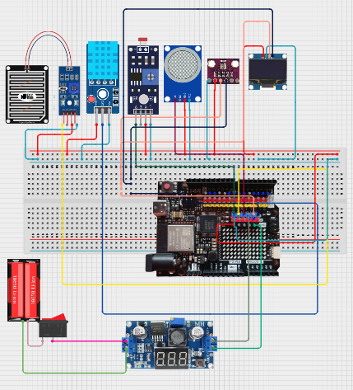
Figure7.1:- System Architecture for Arduino UNO R4 WiFi

Chapter 8:- Working Principle

Sensor Data Acquisition:

Arduino Uno R4 WiFi: This microcontroller acts as the interface for acquiring data from all the sensors connected to it. It has a WiFi module, which is imperative for the transmission of data to the ThingSpeak IoT server and your Flask web application.
DHT11 Sensor: It's used to measure two important environmental parameters:
Temperature: It senses the ambient air temperature in degrees Celsius.
Humidity is the measurement of the relative humidity, meaning the level of moisture in the air.
Rain Sensor: This sensor will sense the amount and intensity of rain. It usually gives a digital output (high/low) as to whether it is raining or an analog output that varies proportionally with the volume of rain.
BMP280 Sensor: This sensor will give precise readings of:
Atmospheric Pressure: This is measured in Pascals (Pa), or hectopascals (hPa).
Temperature: Gives another temperature measurement, which can be cross-checked with the DHT11 for accuracy.
Altitude: Can be approximated from the atmospheric pressure.

MQ135 Sensor: Sensitive to a variety of air contaminants, including:

Ammonia (NH3)
Nitrogen oxides (NOx)
Benzene (C6H6)
Alcohol (C2H5OH) It provides an analog voltage that changes with concentration of these gases. This reading will be used to estimate Air Quality.
LDR (Light Dependent Resistor) Sensor: This sensor detects the light intensity. As the light intensity increases, its resistance decreases. This can be utilized to find out the ambient light level.
Working Principle of Data Collection:

Each sensor will be directly connected to the digital or analog input/output pins on the Arduino Uno R4 WiFi.

You will need to generate Arduino code to:-Initialize each sensor and set its working mode. Read raw data from every sensor at an interval. Process raw data to transform it to useful units (e.g., temperature in °C, humidity in %, pressure in hPa, etc.). For MQ135, you would probably have to use a calibration curve to calculate an estimate of gas concentration or Air Quality Index (AQI) from its readings. LDR will give a resistance reading that can be related to levels of light intensity.

Data Transmission to ThingSpeak IoT Server:

The Arduino Uno R4 WiFi will employ its onboard WiFi functionality to join your local network and subsequently the internet.
Your Arduino program will utilize the ThingSpeak API (Application Programming Interface) to post the processed sensor data to your specified ThingSpeak channel. ThingSpeak will save this data in its cloud platform, producing a time-series database of your sensor readings.

Working Principle of Data Transmission:

Your Arduino code will have libraries and software to connect to WiFi. It will then process the sensor data in accordance with the ThingSpeak API specifications (usually as HTTP POST requests with API keys and field names).The Arduino will then send this processed data to the ThingSpeak server at the specified intervals.

Data Analysis and Machine Learning (CSV File & Algorithm):

You will occasionally pull the accumulated data from your ThingSpeak channel. ThingSpeak provides facilities to download data in different formats, such as CSV.
The CSV file will hold historical sensor readings with timestamps.
You will then apply a machine learning algorithm using an appropriate programming language (such as Python with libraries Pandas, NumPy, and scikit-learn).
Working Principle of Machine Learning Implementation

Data Preprocessing: The CSV data will be cleaned and missing values will be processed. Features may be scaled or transformed as necessary for the chosen algorithm.
Feature Engineering: You could generate new features from the available sensor data (e.g., taking temperature and humidity and combining to estimate heat index).
Model Selection: You will select a machine learning algorithm appropriate to your objective. Because you didn't indicate the prediction task, the following are some options:
Weather Forecasting (temperature, humidity): Time series forecasting models such as ARIMA, Prophet, or even more advanced deep learning models like LSTMs could be employed.
Air Quality Forecasting: The regression algorithms (linear regression, support vector regression, random forest) or time series algorithms may be used to forecast future AQI readings.
Anomaly Detection: The algorithm such as Isolation Forest or One-Class SVM may detect out-of-pattern sensor readings.
Training of Model: The selected algorithm will be trained on your CSV data.
Model Evaluation: The trained model will be tested with the correct metrics (i.e., Mean Squared Error for a regression, accuracy for classification).

Power BI Dashboard:

You will link Power BI to your ThingSpeak data source or the processed CSV file (or possibly your machine learning model output).Power BI will enable you to produce interactive visualizations and dashboards to track the real-time and historical sensor data.

Workings of Power BI Dashboard:

Data Connection: Power BI will make a connection to your data source (ThingSpeak through its API or the CSV file).
Data Transformation (if necessary): You may do additional data cleaning or transformation in Power BI.
Visualization: You will choose suitable charts (line charts for time series, bar charts, gauges, maps, etc.) to display the sensor reading and any information from your machine learning model.
Dashboard Construction: You will place these visualizations on a dashboard to give you a complete view of the environmental state.

Flask Web Page for Real-Time Weather and AQI Prediction, 5-Day Forecast:

You will implement the Flask microframework (in Python) to construct a web application.
Such a web application must:
Retrieve Live Data: Fetch the recent sensor data from ThingSpeak.
AQI Calculation: Add in the logic to compute the Air Quality Index from the readings of the MQ135 sensor (and additional pollutants if you add additional sensors in the future). This will entail converting raw sensor readings into pollutant concentrations and then applying typical AQI calculation formulas.
Machine Learning Integration: Upload your trained machine learning model and supply the most recent sensor data as input to obtain predictions for current weather (if your model is trained for it) and future weather/AQI (for 5-day forecasting). You may have to integrate with an external weather API for 5-day forecasting if you haven't trained a smart enough model from your own data.

Working Principle of Flask Web Application:

Routing: Flask will define URLs (routes) for different pages of your web application (e.g., a page for live data, a page for the forecast).
Data Retrieval: When a user visits a specific page, the Flask application will execute Python code to:
Connect to ThingSpeak and retrieve the latest data.
Process the MQ135 data to calculate the AQI.
Load your trained machine learning model.
Feed the current sensor data into the model to get predictions.
(Optionally) Make an external weather API call for 5-day forecast.
Rendering: HTML templates are used by Flask to render the web pages and insert the fetched and processed data (live readings, AQI, predictions, forecast) dynamically into these templates prior to them being sent to the browser of the user.
In Summary:

Your system operates by:

Sensing: The Arduino Uno R4 WiFi, which is connected to all the sensors (DHT11, rain, BMP280, MQ135, LDR), reads environmental data continuously.
Transmission: The Arduino sends this data wirelessly to the ThingSpeak IoT server.
Storage: ThingSpeak stores sensor data in the cloud.
Analysis & ML: Historic data are fetched from ThingSpeak, saved in a CSV file, preprocessed, and utilized to train a machine learning model for predictive tasks (weather, AQI, etc.).
Visualization: Power BI accesses the data source to generate interactive dashboards to monitor the current as well as historic conditions.
Web Interface: A Flask web app fetches real-time data from ThingSpeak, computes the AQI, employs the trained machine learning model to make live predictions, and if necessary, bridges external APIs to give a 5-day weather forecast, displaying all this data on easy-to-use web pages.
This is a cross-disciplinary project that involves hardware, software, IoT platforms, data analysis, machine learning, and web development. Every element must be thoroughly implemented and combined for the whole system to work properly. Good luck with your project!

Chapter 9:-Flow Chart & Implementation Steps
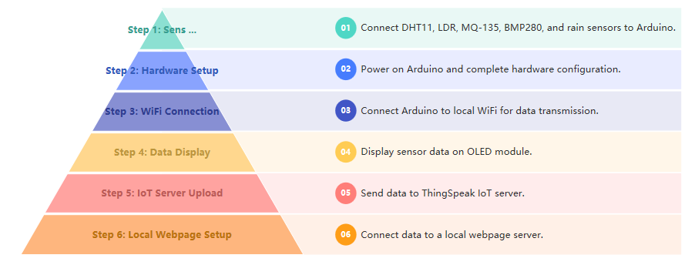

Figure 9.1:- Flow Chart in Arduino Uno R4 WiFi

Chapter 10:- Sensor Integration and Data Acquisition

DHT Sensor: It measures temperature and humidity. Connect its data pin to one of the digital pins on the Arduino Uno R4 WiFi. Needs power and ground connections.

LDR Sensor: Monitors ambient light intensity. Provides analog data. Connect in a voltage divider setup (with a resistor such as 10k Ohm), and connect the center point to the Arduino Uno R4 WiFi's analog input (A1).

Rain Drop Sensor: Detects raindrops. May provide digital or analog signals. Connect its output to a corresponding digital or analog pin on the Arduino Uno R4 WiFi. Needs power and ground.

MQ135 Sensor: Measures air quality (CO2, NH3, etc.). Outputs analog signals. Connect its analog output (most probably labeled OUT) to the Arduino Uno R4 WiFi's analog input (A0). Connect VCC and GND.

BMP Sensor: Reads atmospheric pressure information. Outputs accurate pressure information. (The connection mode wasn't specifically mentioned, but it probably uses I2C or SPI depending on common BMP sensor modules.)

OLED (0.91-inch) Module: Displays real-time sensor readings. Implements I2C communication with Arduino Uno R4 WiFi.

Arduino Uno R4 WiFi Capabilities and Limitations:

Serves as the main data collection device.
Boasts analog pins for analog sensors (LDR, MQ135) and can accommodate digital sensors (Rain Sensor, DHT Sensor).
Fitted with one 10-bit ADC (usually A0) to read analog sensor outputs.
Supports communication protocols such as SPI, I2C, and UART for interfacing with different peripherals and sensors.

Chapter 11:-Hardware Setup
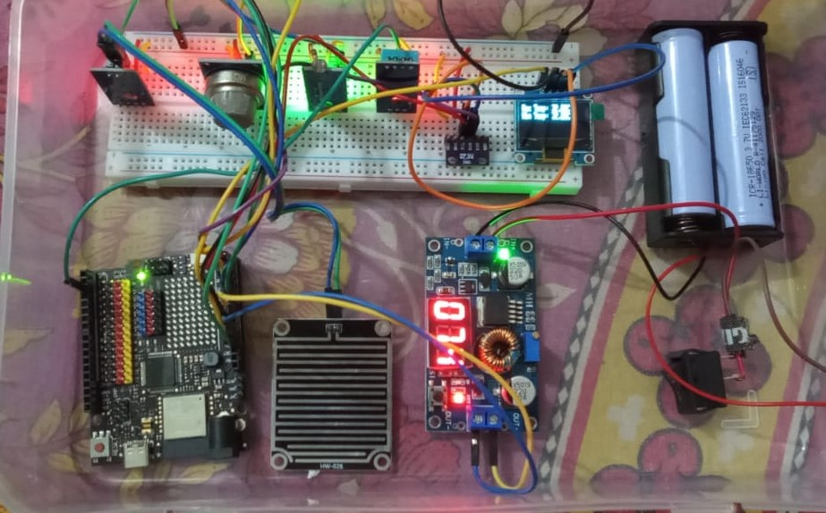
Figure 11.2:-Arduino UNO R4 WiFi Hardware Setup

Chapter12:- Coding & Implementation for Arduino IDE

#include <WiFiS3.h> // Include the library for WiFi connectivity on ESP32-S3 boards.
#include <ThingSpeak.h> // Include the library for interacting with the ThingSpeak IoT platform.
#include <Wire.h> // Include the library for I2C communication.
#include <Adafruit_Sensor.h> // Include the base class for Adafruit sensors.
#include <Adafruit_BMP280.h> // Include the library for the BMP280 barometric pressure and temperature sensor.
#include <Adafruit_SSD1306.h> // Include the library for the Adafruit SSD1306 OLED display.
#include <DHT.h> // Include the library for DHT series temperature and humidity sensors.
#include <WiFiServer.h> // Include the library for creating a WiFi server (though not explicitly used in this code).

// WiFi credentials
const char* ssid = "Nayan Saha"; // Define the SSID (network name) of your WiFi network.
const char* password = "Na667ugf"; // Define the password of your WiFi network.

// ThingSpeak channels
unsigned long channel1ID = 2701253; // Define the ID of your first ThingSpeak channel.
const char* writeAPIKey1 = "5N75HGINZR7O1F9N"; // Define the write API key for your first ThingSpeak channel.
unsigned long channel2ID = 2868457; // Define the ID of your second ThingSpeak channel.
const char* writeAPIKey2 = "4VP6ITQRBF6PHMTD"; // Define the write API key for your second ThingSpeak channel.

WiFiClient client; // Create a WiFiClient object to handle network connections.
WiFiServer server(80); // Create a WiFiServer object listening on port 80 (standard HTTP port).

// BMP280 object
Adafruit_BMP280 bmp; // I2C // Create an object named 'bmp' for the BMP280 sensor, assuming it's connected via I2C.

// OLED Display - 0.91" (128x32)
#define SCREEN_WIDTH 128 // Define the width of the OLED display in pixels.
#define SCREEN_HEIGHT 32 // Define the height of the OLED display in pixels.
#define OLED_RESET -1 // Define the reset pin for the OLED display (using -1 means no reset pin is connected).
#define SCREEN_ADDRESS 0x3C // Define the I2C address of the OLED display (common address).
Adafruit_SSD1306 display(SCREEN_WIDTH, SCREEN_HEIGHT, &Wire, OLED_RESET); // Create an object named 'display' for the SSD1306 display, using the defined parameters and the Wire (I2C) library.

// DHT Sensor
#define DHTPIN 2 // Define the digital pin connected to the DHT sensor's data pin.
#define DHTTYPE DHT11 // Define the type of DHT sensor being used (DHT11).
DHT dht(DHTPIN, DHTTYPE); // Create an object named 'dht' for the DHT sensor, using the defined pin and type.

// Sensor Pins
const int rainSensorPin = A0; // Define the analog pin connected to the rain sensor.
const int ldrPin = A1; // Define the analog pin connected to the Light Dependent Resistor (LDR).
const int mq135Pin = A2; // Define the analog pin connected to the MQ135 air quality sensor.

// Variables
int rainValue = 0, rainStatus = 0; // Declare integer variables to store the raw rain sensor value and its digital status (rain/no rain).
int ldrValue = 0, airQuality = 0; // Declare integer variables to store the raw LDR value and the raw air quality sensor value.
float bmpTemp = 0, pressure = 0, altitude = 0; // Declare float variables to store the temperature, pressure, and altitude readings from the BMP280 sensor.
float dhtTemp = 0, humidity = 0; // Declare float variables to store the temperature and humidity readings from the DHT sensor.
float maxTemp = -100.0; // Initialize a float variable to store the maximum recorded temperature (initialized to a very low value).
float minTemp = 100.0; // Initialize a float variable to store the minimum recorded temperature (initialized to a very high value).

void setup() {
Serial.begin(115200); // Initialize serial communication at a baud rate of 115200 for debugging output.
dht.begin(); // Initialize the DHT sensor.

if (!bmp.begin(0x76)) { // Initialize the BMP280 sensor with its I2C address (0x76 is a common address). The '!' negates the result, so the condition is true if initialization fails.
Serial.println("BMP280 not found!"); // Print an error message to the serial monitor if the BMP280 is not found.
while (1); // Enter an infinite loop to halt further execution if the BMP280 is not detected.
}

if (!display.begin(SSD1306_SWITCHCAPVCC, SCREEN_ADDRESS)) { // Initialize the OLED display. SSD1306_SWITCHCAPVCC sets the display to use its internal voltage booster.
Serial.println(F("OLED not found!")); // Print an error message to the serial monitor if the OLED is not found (using F() to store the string in flash memory).
while (1); // Enter an infinite loop to halt further execution if the OLED is not detected.
}

display.clearDisplay(); // Clear the OLED display buffer.
display.setTextSize(1); // Set the text size for the OLED display to 1.
display.setTextColor(SSD1306_WHITE); // Set the text color for the OLED display to white.

while (WiFi.begin(ssid, password) != WL_CONNECTED) { // Attempt to connect to the WiFi network using the provided SSID and password. The loop continues until a connection is established.
Serial.println("Connecting to WiFi..."); // Print a message to the serial monitor indicating that the ESP32 is trying to connect to WiFi.
delay(1000); // Wait for 1 second before attempting to connect again.
}

Serial.println("Connected to WiFi"); // Print a message to the serial monitor once the WiFi connection is successful.
ThingSpeak.begin(client); // Initialize the ThingSpeak library with the WiFi client.
server.begin(); // Start the WiFi server (though it's not actively used for handling requests in this code).
}

void showOnOLED(String line1, String line2) { // Define a function to display two lines of text on the OLED screen.
display.clearDisplay(); // Clear the OLED display buffer before writing new content.
display.setCursor(0, 0); // Set the cursor position to the top-left corner (column 0, row 0).
display.println(line1); // Print the first string to the OLED display.
display.println(line2); // Print the second string below the first one.
display.display(); // Update the physical OLED screen with the content in the buffer.
delay(3000); // Pause for 3 seconds, allowing the user to read the displayed information.
}

void loop() {
// Read sensors
rainValue = analogRead(rainSensorPin); // Read the analog value from the rain sensor pin.
rainStatus = (rainValue < 500) ? 1 : 0; // Determine the rain status: if the analog value is less than 500 (indicating moisture), set rainStatus to 1 (rain), otherwise 0 (no rain).
ldrValue = analogRead(ldrPin); // Read the analog value from the LDR pin.
airQuality = analogRead(mq135Pin); // Read the analog value from the MQ135 air quality sensor pin.
dhtTemp = dht.readTemperature(); // Read the temperature in Celsius from the DHT sensor.
humidity = dht.readHumidity(); // Read the relative humidity from the DHT sensor.

if (!isnan(dhtTemp)) { // Check if the temperature reading from the DHT sensor is a valid number (not NaN - Not a Number).
if (dhtTemp > maxTemp) maxTemp = dhtTemp; // If the current temperature is greater than the current maximum temperature, update maxTemp.
if (dhtTemp < minTemp) minTemp = dhtTemp; // If the current temperature is less than the current minimum temperature, update minTemp.
}

bmpTemp = bmp.readTemperature(); // Read the temperature in Celsius from the BMP280 sensor.
pressure = bmp.readPressure() / 100.0; // Read the atmospheric pressure in Pascals from the BMP280 and convert it to hectopascals (hPa).
altitude = bmp.readAltitude(1013.25); // Calculate the approximate altitude in meters based on the current pressure and a standard sea-level pressure of 1013.25 hPa.

// Serial Output for Monitoring
Serial.print("Temp: "); Serial.print(dhtTemp); // Print the DHT temperature to the serial monitor.
Serial.print(" C, Humidity: "); Serial.print(humidity); // Print the humidity to the serial monitor.
Serial.print(" %, LDR: "); Serial.print(ldrValue); // Print the LDR value to the serial monitor.
Serial.print(", Rain: "); Serial.print(rainStatus ? "Yes" : "No"); // Print the rain status (Yes or No) to the serial monitor.
Serial.print(", Air Quality: "); Serial.print(airQuality); // Print the air quality sensor value to the serial monitor.
Serial.print(", BMP Temp: "); Serial.print(bmpTemp); // Print the BMP280 temperature to the serial monitor.
Serial.print(" C, Pressure: "); Serial.print(pressure); // Print the pressure to the serial monitor.
Serial.print(" hPa, Altitude: "); Serial.println(altitude); // Print the altitude to the serial monitor and move to the next line.

// Display values one by one on OLED
showOnOLED("DHT Temp: " + String(dhtTemp) + "C", "Humidity: " + String(humidity) + "%"); // Display DHT temperature and humidity on the OLED.
showOnOLED("LDR: " + String(ldrValue), "Rain: " + String(rainStatus ? "Yes" : "No")); // Display LDR value and rain status on the OLED.
showOnOLED("Air Quality:", String(airQuality)); // Display air quality value on the OLED.
showOnOLED("BMP Temp: " + String(bmpTemp) + "C", "Pressure: " + String(pressure) + "hPa"); // Display BMP280 temperature and pressure on the OLED.
showOnOLED("Altitude:", String(altitude) + " m"); // Display altitude on the OLED.
showOnOLED("Max Temp: " + String(maxTemp) + "C", "Min Temp: " + String(minTemp) + "C"); // Display maximum and minimum recorded temperatures on the OLED.

// ThingSpeak Channel 1
ThingSpeak.setField(1, dhtTemp); // Set the value for field 1 of ThingSpeak channel 1 to the DHT temperature.
ThingSpeak.setField(2, humidity); // Set the value for field 2 of ThingSpeak channel 1 to the humidity.
ThingSpeak.setField(3, ldrValue); // Set the value for field 3 of ThingSpeak channel 1 to the LDR value.
ThingSpeak.setField(4, rainValue); // Set the value for field 4 of ThingSpeak channel 1 to the raw rain sensor value.
ThingSpeak.setField(5, airQuality); // Set the value for field 5 of ThingSpeak channel 1 to the air quality sensor value.
ThingSpeak.setField(6, maxTemp); // Set the value for field 6 of ThingSpeak channel 1 to the maximum recorded temperature.
ThingSpeak.setField(7, minTemp); // Set the value for field 7 of ThingSpeak channel 1 to the minimum recorded temperature.
ThingSpeak.setField(8, rainStatus); // Set the value for field 8 of ThingSpeak channel 1 to the rain status.

int x = ThingSpeak.writeFields(channel1ID, writeAPIKey1); // Write all the set fields to ThingSpeak channel 1 using its ID and write API key, and store the HTTP response code in 'x'.
if (x == 200) Serial.println("Channel 1 update successful."); // If the HTTP response code is 200 (OK), print a success message to the serial monitor.
else Serial.print("Channel 1 update failed, HTTP error code: "), Serial.println(x); // If the update fails, print an error message along with the HTTP error code.

delay(20000); // Wait for 20 seconds before proceeding to update the second ThingSpeak channel.

// ThingSpeak Channel 2
ThingSpeak.setField(1, bmpTemp); // Set the value for field 1 of ThingSpeak channel 2 to the BMP280 temperature.
ThingSpeak.setField(2, pressure); // Set the value for field 2 of ThingSpeak channel 2 to the pressure.
ThingSpeak.setField(3, altitude); // Set the value for field 3 of ThingSpeak channel 2 to the altitude.

int y = ThingSpeak.writeFields(channel2ID, writeAPIKey2); // Write all the set fields to ThingSpeak channel 2 using its ID and write API key, and store the HTTP response code in 'y'.
if (y == 200) Serial.println("Channel 2 update successful."); // If the HTTP response code is 200 (OK), print a success message to the serial monitor.
else Serial.print("Channel 2 update failed, HTTP error code: "), Serial.println(y); // If the update fails, print an error message along with the HTTP error code.

delay(40000); // Wait for 40 seconds before the next iteration of the loop, resulting in a total delay of 60 seconds between updates to channel 1.
}

Serial Monitor of Output:-
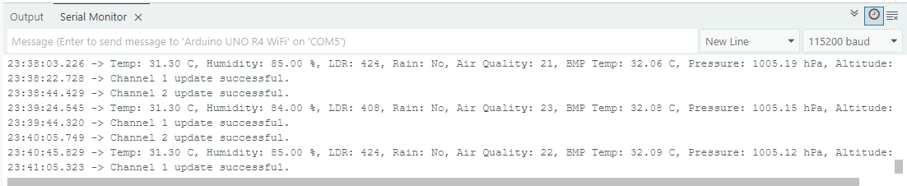
Fig 12:- Serial Monitor of Output
Chapter 13:- IoT Platform: ThingSpeak

Fig 13.1: Temperature in Month Jun Fig 13.2: Humidity in Month Jun

Fig 13.3: Rain Value in Month Jun Fig 13.4:- LED in Month Jun

Fig 13.5: Air Quality in Month Jun Fig 13.6: Max Temperature in Month Jun

Fig 13.8:Temperatue in Month May 2025
Fig 13.7: Min Temperature in Month Jun

\

Fig 13.9-:DHT Humidity in Month May 2025 Fig 13.10:- Max Temperature in Month May 2025

Fig 13.11:-Air Quality in Month May 2025 Fig 13.12:-LED in Month May 2025

Fig 13.13:-Rain Status in Month May 2025 Fig 13.14:-Rain Value in Month May 2025

Fig 13.15:- Min Temperature in Month May 2025 Fig 13.16:- BMP Temperature in Month May 2025

Fig 13.17:- BMP Pressure in Month May 2025 Fig 13.18:- BMP Altitude in Month May 2025

Fig 13.19:- BMP Only Value Show for Pressure & Altitude

Fig 13.20:- BMP Only Value Show for Temperature

13.1 MATLAB Visualizations

Visualize correlation between temperature and humidity 1

Fig 13.1.1:- MATLAB Code Visualize correlation between temperature and humidity

Fig 13.1.1:- MATLAB Code Visualize correlation between temperature and humidity 1

Fig 13.1.2:- MATLAB Plot Output Visualize correlation between temperature and humidity 1

Compare temperature data from three different days 3

Fig 13.1.3:- MATLAB Code Compare temperature data from three different days

Fig 13.1.4 :- MATLAB Plot Output for 1 day temperature Compassion

Visualize directional data with compass plot 6

Fig 13.1.5:- MATLAB Code Visualize directional data with compass plot 6

Fig 13.1.6:- MATLAB Plot Output Visualize directional data with compass plot 6

Chapter 14:- Machine Learning for Weather Prediction
from google.colab import files
import pandas as pd
# Upload the Excel file
uploaded = files.upload()
# Read the Excel file into a pandas DataFrame
for filename in uploaded.keys():
# Assuming the first sheet is named 'Sheet1'
sdf = pd.read_csv(filename, sep='\t')
# Display the DataFrame (optional)
print(sdf.head())
print(sdf['Date'].dtype)
# Ensure the 'Date' column is in datetime format
sdf['Date'] = pd.to_datetime(sdf['Date'])
# Verify the data type change
print(sdf['Date'].dtype)
from google.colab import files
import pandas as pd
# Upload the Excel file
uploaded = files.upload()
# Read the Excel file into a pandas DataFrame
for filename in uploaded.keys():
# Assuming the first sheet is named 'Sheet1'
df = pd.read_csv(filename)
arima_df=df.copy()
# Display the DataFrame
print(df.head())
print(df.size)
print(arima_df.shape)
import pandas as pd
# Define start and end dates
start_date = '2017-01-01'
end_date = '2022-12-31'
# Generate date range
date_range = pd.date_range(start=start_date, end=end_date)
# Assuming your DataFrame is named 'df'
df['Date'] = date_range
#arima_df['Date']=date_range
# Verify the data type
print(df['Date'].dtype)
import matplotlib.pyplot as plt
import pandas as pd
# Assuming your DataFrame is named 'df' and has 'Date' and 'Temperature' columns
# --- Ensure 'Date' column is in datetime format and set as index ---
#df['Date'] = pd.to_datetime(df['Date']) # Convert to datetime if not already
df.set_index('Date', inplace=True) # Set 'Date' as the index

# --- Generate the line chart of the 'Temperature' column ---
df[['Temperature','Maximum Temperature','Minimum Temperature']].plot(kind='line')
# Customize the chart (optional)
plt.title('Temperature Over Time')
plt.xlabel('Date')
plt.ylabel('Temperature (°C)')
plt.legend(loc='best') # Legend will show 'Temperature' by default
# Display the chart
plt.show()

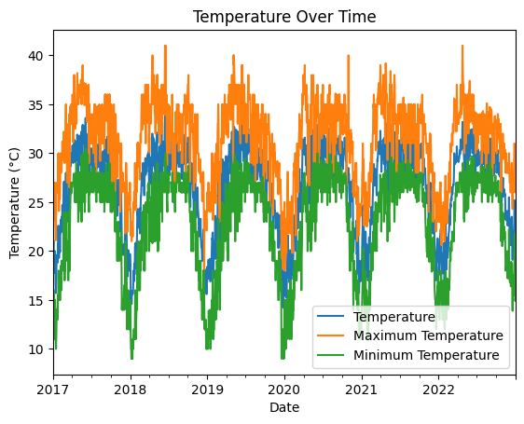
Fig 14.1:- Temperature Over Time

#df['Date'] = pd.to_datetime(df['Date']) # Convert to datetime if not already
#df.set_index('Date', inplace=True) # Set 'Date' as the index

df['Relative Humidity'].plot(kind='line')

# Customize the chart (optional)
plt.title('Line Chart of Humidity')
plt.xlabel('Date')
plt.ylabel('Humidity')
plt.legend(loc='best')

# Set y-axis range
#plt.ylim(0, 100)

# Set x-axis range (up to the index)
#plt.xlim(0, len(df.index) -1)

# Display the chart
plt.show()

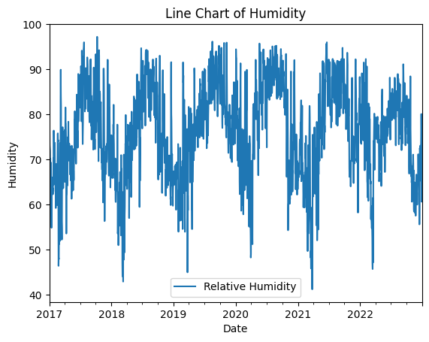

Fig 14.2:-Line Chart Of Humiditiy
df['Sea Level Pressure'].plot(kind='line')

# Customize the chart (optional)
plt.title('Line Chart of Pressure in millibars')
plt.xlabel('Date')
plt.ylabel('Pressure')
plt.legend(loc='best')

# Set y-axis range
#plt.ylim(800, 1100)

# Set x-axis range (up to the index)
#plt.xlim(0, len(df.index) -1)

# Display the chart
plt.show()
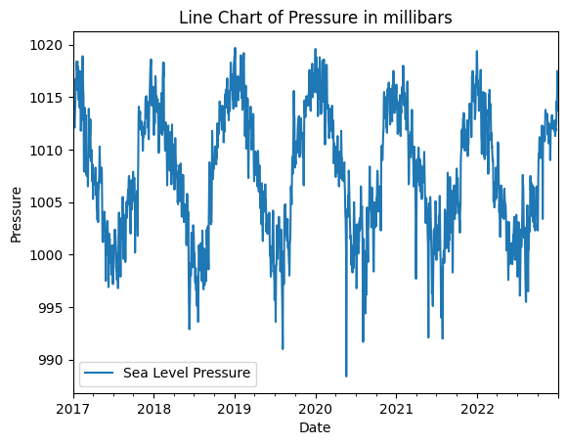
Fig 14.3:-Line Chart of Pressure in millibars

from sklearn.model_selection import train_test_split
# Step 1: Prepare the data with lagged features
def create_lagged_features(dataframe, column_name, n_lags):
df_lagged = pd.DataFrame(dataframe[column_name])
for i in range(1, n_lags + 1):
df_lagged[f'{column_name}_lag_{i}'] = df_lagged[column_name].shift(i)
# Shift the original column to be the target variable (predicting the next day's value)
df_lagged['target'] = df_lagged[column_name].shift(-1)
df_lagged.dropna(inplace=True) # Drop rows with NaN values introduced by shifting
return df_lagged
# Define the column to forecast and the number of lags
target_column = 'Maximum Temperature'
n_lags = 7 # You can adjust the number of lags
# Create the lagged dataset
lagged_df = create_lagged_features(new_df, target_column, n_lags)
# Define features (X) and target (y)
X = lagged_df.drop(target_column, axis=1)
X = X.drop('target', axis=1) # Drop the target column itself
y = lagged_df['target']
# Ensure the columns in X are in a consistent order
#feature_columns = X.columns.tolist()
X_train, X_test, y_train, y_test = train_test_split(X, y, test_size=0.2, shuffle=False) # Use shuffle=False for time series
print("Shape of training features:", X_train.shape)
print("Shape of testing features:", X_test.shape)
print("Shape of training target:", y_train.shape)
print("Shape of testing target:", y_test.shape)
# Step 3: Train the Random Forest model
# Initialize the Random Forest Regressor model
model_rf = RandomForestRegressor(n_estimators=100, random_state=42)
# Fit the model to the training data
model_rf.fit(X_train, y_train)
# Step 4: Make predictions
# Make predictions on the test data
predictions_rf = model_rf.predict(X_test)
# Step 5: Evaluate the model
# Calculate Mean Squared Error (MSE)
mse_rf = mean_squared_error(y_test, predictions_rf)
print(f'Mean Squared Error (MSE) for Random Forest: {mse_rf}')
# Calculate Root Mean Squared Error (RMSE)
rmse_rf = np.sqrt(mse_rf)
print(f'Root Mean Squared Error (RMSE) for Random Forest: {rmse_rf}')
# Optional: Plot actual vs. predicted
plt.figure(figsize=(12, 6))
plt.plot(y_test.index, y_test, label='Actual')
plt.plot(y_test.index, predictions_rf, label='Random Forest Predictions', color='red')
plt.title('Random Forest Time Series Forecasting')
plt.xlabel('Index (Time Step)') # Note: The index here is not date if you didn't set it as index
plt.ylabel(target_column)
plt.legend()
plt.show()

Shape of training features: (1746, 7)
Shape of testing features: (437, 7)
Shape of training target: (1746,)
Shape of testing target: (437,)
Mean Squared Error (MSE) for Random Forest: 3.2702498421052666
Root Mean Squared Error (RMSE) for Random Forest: 1.808383212182989
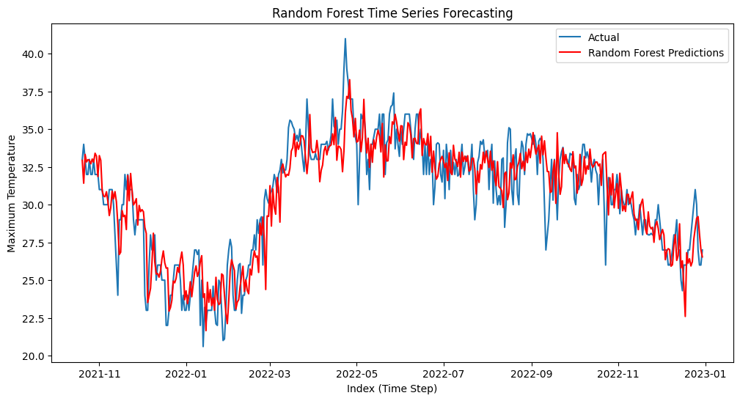
Fig 14.4:-Random Forest Time Series Forecasting

from sklearn.ensemble import RandomForestRegressor
import numpy as np
import matplotlib.pyplot as plt
# Assuming your DataFrame is named 'df' and contains 'Maximum Temperature'
# And you have already trained your RandomForestRegressor model (model_rf)
# and defined target_column and n_lags
# Step 1: Prepare the data for forecasting
# Start with the last 'n_lags' observations from your original data
# These will be the initial lags for the first forecast step
last_n_lags = new_df[target_column].tail(n_lags).tolist()
# Create a list to store the future forecasts
future_forecasts = []
# Step 2: Implement recursive forecasting
# We will forecast for 882 days
n_forecast_steps = 882
for _ in range(n_forecast_steps):
# Create the input features for the current forecasting step
# This will be a single row with the last 'n_lags' values
input_features = np.array(last_n_lags).reshape(1, -1)
# Make the prediction for the next time step
next_prediction = model_rf.predict(input_features)[0]
# Append the prediction to the list of future forecasts
future_forecasts.append(next_prediction)
# Update the 'last_n_lags' list for the next forecasting step
# Remove the oldest lag and add the new prediction
last_n_lags.pop(0)
last_n_lags.append(next_prediction)
# Step 3: Create a DataFrame for the future forecasts
# Generate future dates
# Assuming your original df has a DatetimeIndex or you can create dates based on the end of your data
# If your df has a DatetimeIndex:
if isinstance(new_df.index, pd.DatetimeIndex):
last_date = new_df.index[-1]
future_dates = pd.date_range(start=last_date + pd.Timedelta(days=1), periods=n_forecast_steps, freq='D')
else:
# If your index is not datetime, you might need to create dates differently
# For simplicity, let's just use a range starting from the end of the current index
last_index = new_df.index[-1]
future_indices = range(last_index + 1, last_index + 1 + n_forecast_steps)
future_dates = future_indices # Or create datetime objects if possible
future_forecast_df = pd.DataFrame({'Date': future_dates, target_column: future_forecasts})
# Optional: Set 'Date' as the index if you created datetime objects
if isinstance(future_dates, pd.DatetimeIndex):
future_forecast_df.set_index('Date', inplace=True)
# Print the future forecasts
#print(future_forecast_df.head())
#print(future_forecast_df.tail())
# Optional: Plot the historical data and the future forecasts
plt.figure(figsize=(14, 7))
plt.plot(df.index, df[target_column], label='Historical Data')
plt.plot(future_forecast_df.index, future_forecast_df[target_column], label='Random Forest Forecast', color='red')
plt.title(f'{target_column} Forecast (Random Forest)')
plt.xlabel('Date')
plt.ylabel(target_column)
plt.legend()
plt.show()
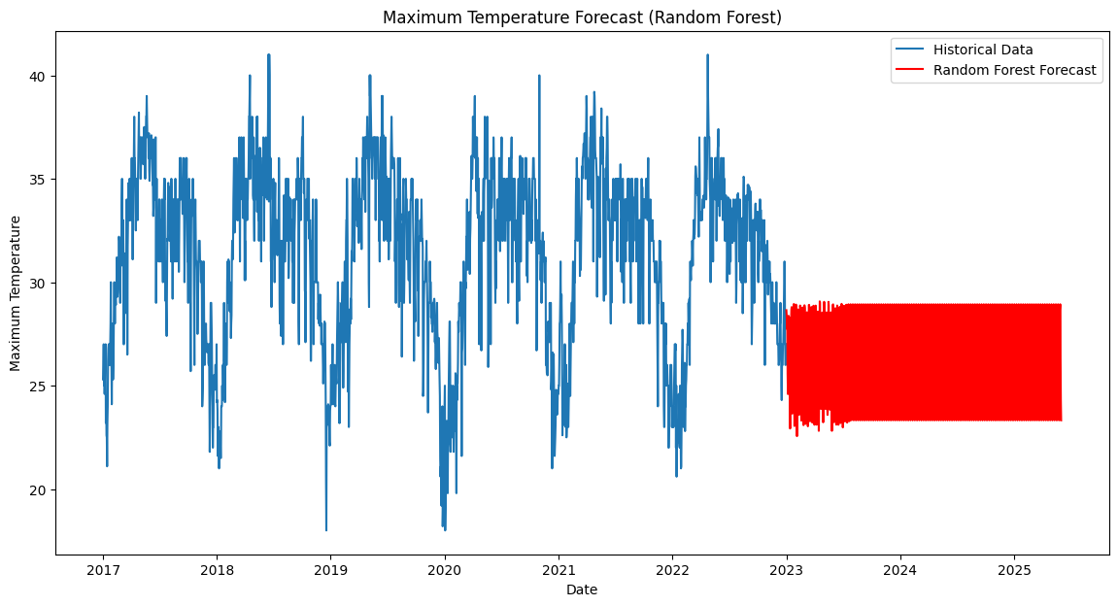

Fig 14.5:- Maximum Temperature Forecast(Random Forcast)

# Prepare data for Prophet
# Create a copy of the DataFrame to avoid modifying the original df in place
prophet_df = df.copy()
# Reset the index to make 'Date' a regular column again
prophet_df = prophet_df.reset_index()
# Rename columns for Prophet
prophet_df = prophet_df.rename(columns={'Date': 'ds', 'Maximum Temperature': 'y'}) # Prophet expects 'ds' and 'y' columns
# Add other features as regressors to the Prophet DataFrame
prophet_df['MinTemp'] = prophet_df['Minimum Temperature']
prophet_df['Humidity'] = prophet_df['Relative Humidity']
prophet_df['Pressure'] = prophet_df['Sea Level Pressure']
# Select only the required columns for Prophet
prophet_df = prophet_df[['ds', 'y', 'MinTemp', 'Humidity', 'Pressure']]
# Create and train the model
model = Prophet()
model.add_regressor('MinTemp')
model.add_regressor('Humidity')
model.add_regressor('Pressure')
model.fit(prophet_df) # Fit the model using the prepared DataFrame
# Create future dates for forecasting
future = model.make_future_dataframe(periods=882) # Forecast for the next 2.5 year
# Add the regressors to the future DataFrame by merging with the prophet_df
future = pd.merge(future, prophet_df[['ds', 'MinTemp', 'Humidity', 'Pressure']], on='ds', ho
# Fill NaN values in the future DataFrame with the mean of the respective columns from prophet_df
future = future.fillna(prophet_df[['MinTemp', 'Humidity', 'Pressure']].mean())
# Make predictions
forecast = model.predict(future)
# Access forecast values
print(forecast[['ds', 'yhat', 'yhat_lower', 'yhat_upper']].tail(30)) # View the last 30 days
import matplotlib.pyplot as plt
# Assuming you have the forecast DataFrame from the model
# Plot the forecast
fig = model.plot(forecast)
plt.title('Weather Forecast')
plt.xlabel('Date')
plt.ylabel('Max Temperature')
# Get the line representing the forecast (usually the second line in the plot)
forecast_line = fig.axes[0].lines[1]
# Change the color of the forecast line
forecast_line.set_color('green')
plt.show()
# Plot components (trend, seasonality)
fig2 = model.plot_components(forecast)
plt.show()
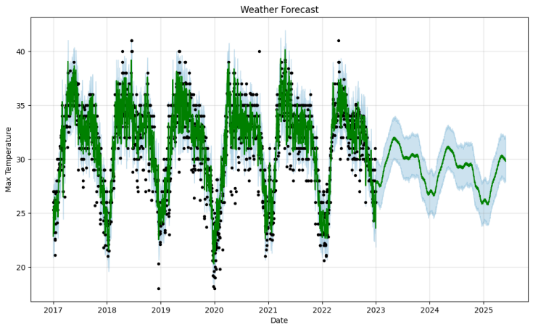
Fig 14.6:- Weather Forecast for Max Temperature
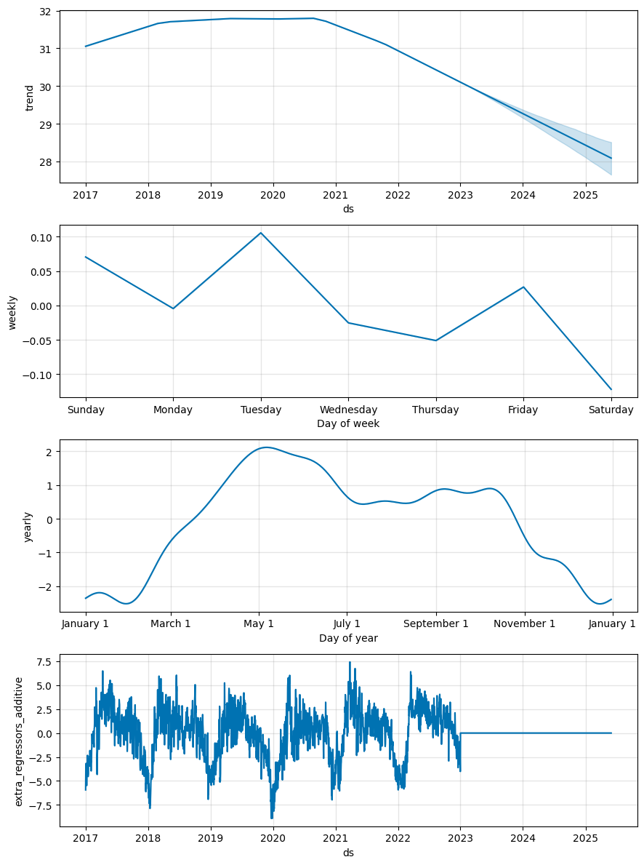
Fig 14.7:- Weather Forecast, Trend, Weekly, Yearly, Extra Regressors additive for Max Temperature
from prophet import Prophet
# Prepare data for Prophet
# Create a copy of the DataFrame to avoid modifying the original df in place
prophet_min_df = df.copy()
# Reset the index to make 'Date' a regular column again
prophet_min_df = prophet_min_df.reset_index()
# Rename columns for Prophet
prophet_min_df = prophet_min_df.rename(columns={'Date': 'ds', 'Minimum Temperature': 'y'}) # Prophet expects 'ds' and 'y' columns
# Add other features as regressors to the Prophet DataFrame
prophet_min_df['MaxTemp'] = prophet_min_df['Maximum Temperature']
prophet_min_df['Humidity'] = prophet_min_df['Relative Humidity']
prophet_min_df['Pressure'] = prophet_min_df['Sea Level Pressure']
# Select only the required columns for Prophet
prophet_min_df = prophet_min_df[['ds', 'y', 'MaxTemp', 'Humidity', 'Pressure']]
# Create and train the model
model = Prophet()
model.add_regressor('MaxTemp')
model.add_regressor('Humidity')
model.add_regressor('Pressure')
model.fit(prophet_min_df) # Fit the model using the prepared DataFrame
# Create future dates for forecasting
future_min = model.make_future_dataframe(periods=882) # Forecast for the next 2.5 year
# Add the regressors to the future DataFrame by merging with the prophet_df
future_min = pd.merge(future_min, prophet_min_df[['ds', 'MaxTemp', 'Humidity', 'Pressure']], on='ds', how='left')
# Fill NaN values in the future DataFrame with the mean of the respective columns from prophet_df
future_min = future_min.fillna(prophet_min_df[['MaxTemp', 'Humidity', 'Pressure']].mean())
# Make predictions
forecast_min = model.predict(future_min)
# Access forecast values
print(forecast_min[['ds', 'yhat', 'yhat_lower', 'yhat_upper']].tail(30)
# Plot the forecast
fig = model.plot(forecast_min)
plt.title('Weather Forecast')
plt.xlabel('Date')
plt.ylabel('Minimum Temperature')
# Get the line representing the forecast (usually the second line in the plot)
forecast_line = fig.axes[0].lines[1]
# Change the color of the forecast line
forecast_line.set_color('green')
plt.show()
# Plot components (trend, seasonality)
fig2 = model.plot_components(forecast)
plt.show()
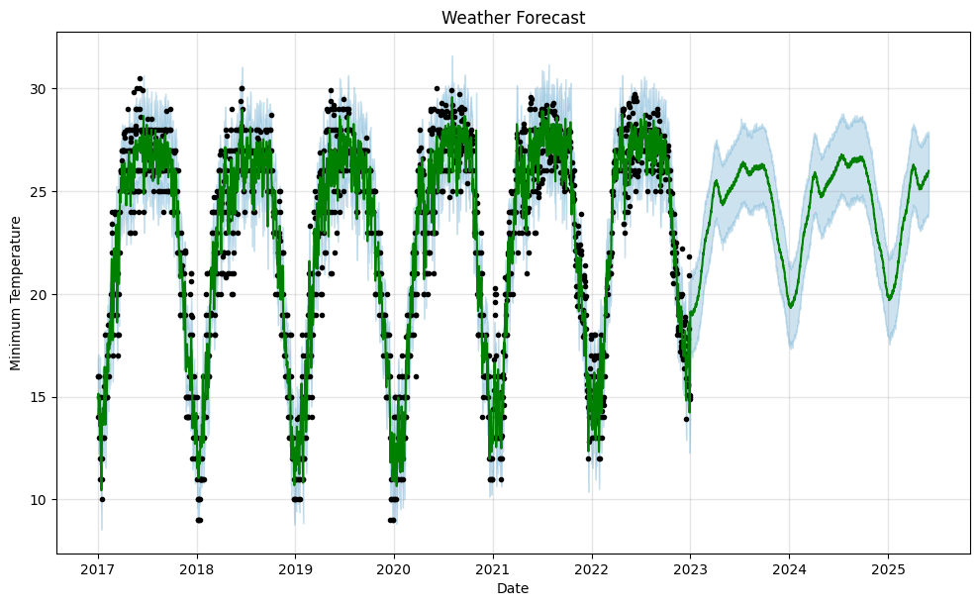
Fig 14.8:- Weather Forecast for Min Temperature
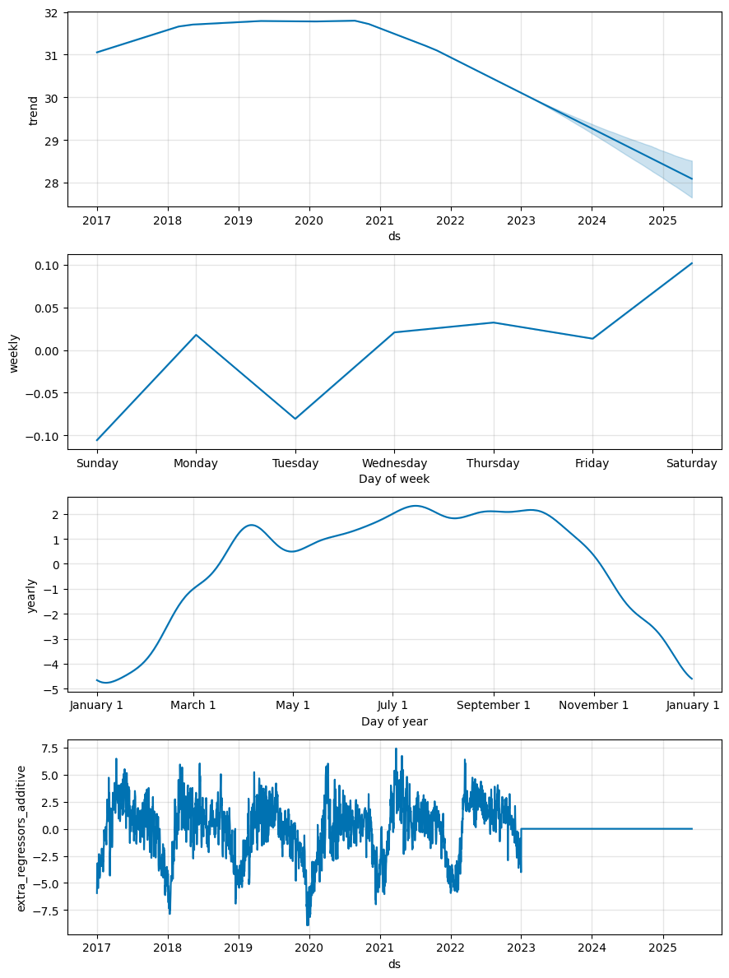

Fig 14.9:- Weather Forecast, Trend, Weekly, Yearly, Extra Regressors additive For Min Temperature

from prophet import Prophet
# Prepare data for Prophet
# Create a copy of the DataFrame to avoid modifying the original df in place
prophet_hum_df = df.copy()
# Reset the index to make 'Date' a regular column again
prophet_hum_df = prophet_hum_df.reset_index()
# Rename columns for Prophet
prophet_hum_df = prophet_hum_df.rename(columns={'Date': 'ds', 'Relative Humidity': 'y'}) # Prophet expects 'ds' and 'y' columns
# Add other features as regressors to the Prophet DataFrame
prophet_hum_df['MaxTemp'] = prophet_hum_df['Maximum Temperature']
prophet_hum_df['MinTemp'] = prophet_hum_df['Minimum Temperature']
prophet_hum_df['Pressure'] = prophet_hum_df['Sea Level Pressure']
# Select only the required columns for Prophet
prophet_hum_df = prophet_hum_df[['ds', 'y', 'MaxTemp', 'MinTemp', 'Pressure']
# Create and train the model
model = Prophet()
model.add_regressor('MaxTemp')
model.add_regressor('MinTemp')
model.add_regressor('Pressure')
model.fit(prophet_hum_df) # Fit the model using the prepared DataFrame
# Create future dates for forecasting
future_hum = model.make_future_dataframe(periods=882) # Forecast for the next 2.5 year
# Add the regressors to the future DataFrame by merging with the prophet_df
future_hum = pd.merge(future_hum, prophet_hum_df[['ds', 'MaxTemp', 'MinTemp', 'Pressure']], on='ds', how='left')
# Fill NaN values in the future DataFrame with the mean of the respective columns from prophet_df
future_hum = future_hum.fillna(prophet_hum_df[['MaxTemp', 'MinTemp', 'Pressure']].mean())
# Make predictions
forecast_hum = model.predict(future_hum)
# Access forecast values
print(forecast_hum[['ds', 'yhat', 'yhat_lower', 'yhat_upper']].tail(30)) # View the last 30 days
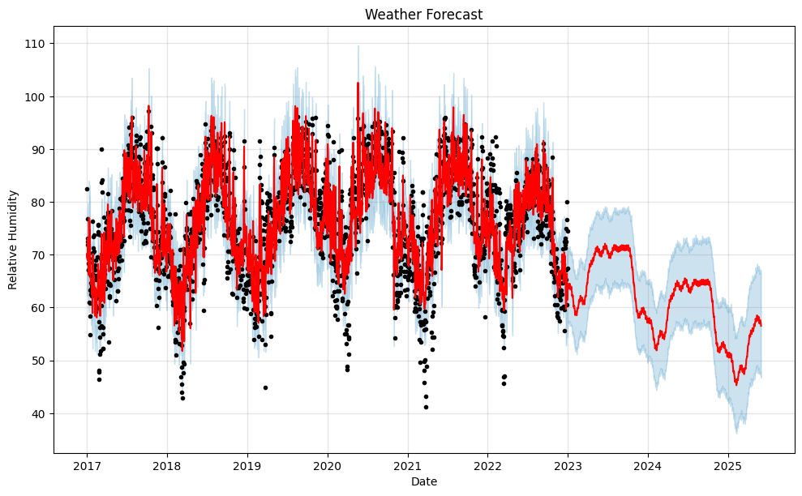
# Plot the forecast
fig = model.plot(forecast_hum)
plt.title('Weather Forecast')
plt.xlabel('Date')
plt.ylabel('Relative Humidity')
# Get the line representing the forecast (usually the second line in the plot)
forecast_line = fig.axes[0].lines[1]
# Change the color of the forecast line
forecast_line.set_color('red')
plt.show()
# Plot components (trend, seasonality)
fig2 = model.plot_components(forecast_hum)
plt.show()
Fig 14.10:- Weather Forecast for Relative Humidity

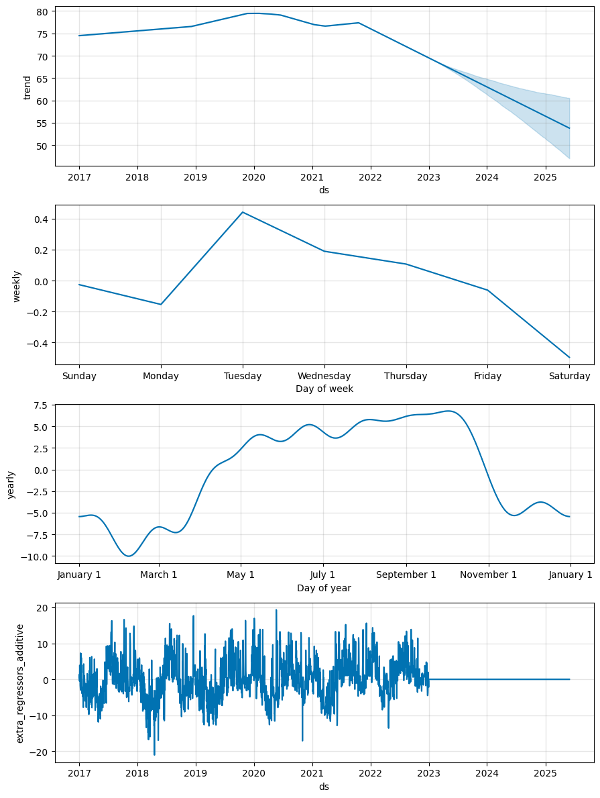
Fig 14.11:- Weather Forecast, Trend, Weekly, Yearly, Extra Regressors additive For Relative Humidity

from prophet import Prophet
# Prepare data for Prophet
# Create a copy of the DataFrame to avoid modifying the original df in place
prophet_prs_df = df.copy()
# Reset the index to make 'Date' a regular column again
prophet_prs_df = prophet_prs_df.reset_index()
# Rename columns for Prophet
prophet_prs_df = prophet_prs_df.rename(columns={'Date': 'ds', 'Sea Level Pressure': 'y'}) # Prophet expects 'ds' and 'y' columns
# Add other features as regressors to the Prophet DataFrame
prophet_prs_df['MaxTemp'] = prophet_prs_df['Maximum Temperature']
prophet_prs_df['MinTemp'] = prophet_prs_df['Minimum Temperature']
prophet_prs_df['Humidity'] = prophet_prs_df['Relative Humidity']
# Select only the required columns for Prophet
prophet_prs_df = prophet_prs_df[['ds', 'y', 'MaxTemp', 'MinTemp', 'Humidity']]
# Create and train the model
model = Prophet()
model.add_regressor('MaxTemp')
model.add_regressor('MinTemp')
model.add_regressor('Humidity')
model.fit(prophet_prs_df) # Fit the model using the prepared DataFrame
# Create future dates for forecasting
future_prs = model.make_future_dataframe(periods=882) # Forecast for the next 2.5 year
# Add the regressors to the future DataFrame by merging with the prophet_df
future_prs = pd.merge(future_prs, prophet_prs_df[['ds', 'MaxTemp', 'MinTemp', 'Humidity']], on='ds', how='left')
# Fill NaN values in the future DataFrame with the mean of the respective columns from prophet_df
future_prs = future_prs.fillna(prophet_prs_df[['MaxTemp', 'MinTemp', 'Humidity']].mean())
# Make predictions
forecast_prs = model.predict(future_prs)
# Access forecast values
print(forecast_prs[['ds', 'yhat', 'yhat_lower', 'yhat_upper']].tail(30)) # View the last 30 days
# Plot the forecast
fig = model.plot(forecast_prs)
plt.title('Weather Forecast')
plt.xlabel('Date')
plt.ylabel('Sea Level Pressure')
# Get the line representing the forecast (usually the second line in the plot)
forecast_line = fig.axes[0].lines[1]
# Change the color of the forecast line
forecast_line.set_color('green')
plt.show()
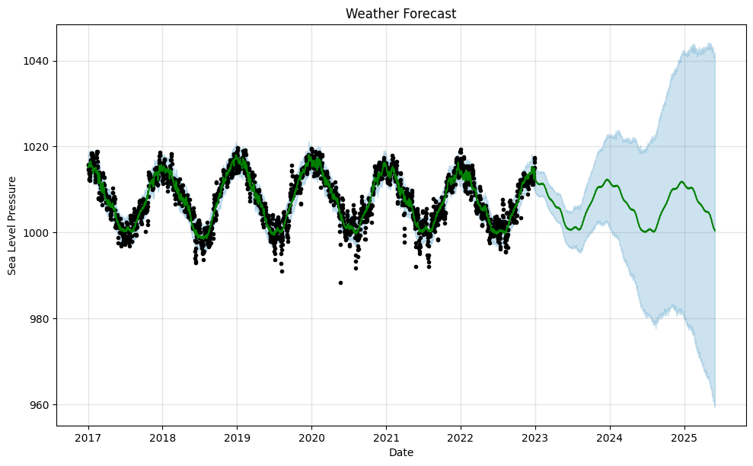
Fig 14.12:- Weather Forecast for Sea Level Pressure

# Assuming 'actual_data' is the DataFrame with actual values for the forecast period
# It should have a 'Date' column (datetime objects) and the actual value columns
# Rename the date column in actual_data to 'ds' to match forecast dataframes
sdf = sdf.rename(columns={'Date': 'ds'})
# Merge forecast dataframes with actual_data
# Maximum Temperature comparison
max_temp_comparison = pd.merge(forecast[['ds', 'yhat']], sdf[['ds', 'maxtemp']], on='ds', how='inner')
max_temp_comparison = max_temp_comparison.rename(columns={'yhat': 'Predicted Max Temp', 'maxtemp': 'Actual Max Temp'})
print("Maximum Temperature Comparison:")
print(max_temp_comparison.tail())
# Minimum Temperature comparison
min_temp_comparison = pd.merge(forecast_min[['ds', 'yhat']], sdf[['ds', 'mintemp']], on='ds', how='inner')
min_temp_comparison = min_temp_comparison.rename(columns={'yhat': 'Predicted Min Temp', 'mintemp': 'Actual Min Temp'})
print("\nMinimum Temperature Comparison:")
print(min_temp_comparison.tail())
# Relative Humidity comparison
hum_comparison = pd.merge(forecast_hum[['ds', 'yhat']], sdf[['ds', 'Hum']], on='ds', how='inner')
hum_comparison = hum_comparison.rename(columns={'yhat': 'Predicted Humidity', 'Hum': 'Actual Humidity'})
print("\nRelative Humidity Comparison:")
print(hum_comparison.tail())
# Sea Level Pressure comparison
prs_comparison = pd.merge(forecast_prs[['ds', 'yhat']], sdf[['ds', 'pressure']], on='ds', how='inner')
prs_comparison = prs_comparison.rename(columns={'yhat': 'Predicted Pressure', 'pressure': 'Actual Pressure'})
print("\nSea Level Pressure Comparison:")
print(prs_comparison.tail())
# Plot Maximum Temperature comparison
plt.figure(figsize=(12, 6))
plt.plot(max_temp_comparison['ds'], max_temp_comparison['Actual Max Temp'], label='Actual Max Temp')
plt.plot(max_temp_comparison['ds'], max_temp_comparison['Predicted Max Temp'], label='Predicted Max Temp', color='red')
plt.title('Maximum Temperature: Actual vs. Predicted')
plt.xlabel('Date')
plt.ylabel('Temperature (°C)')
plt.legend()
plt.show()
# Plot Minimum Temperature comparison
plt.figure(figsize=(12, 6))
plt.plot(min_temp_comparison['ds'], min_temp_comparison['Actual Min Temp'], label='Actual Min Temp')
plt.plot(min_temp_comparison['ds'], min_temp_comparison['Predicted Min Temp'], label='Predicted Min Temp', color='red')
plt.title('Minimum Temperature: Actual vs. Predicted')
plt.xlabel('Date')
plt.ylabel('Temperature (°C)')
plt.legend()
plt.show()
# Plot Relative Humidity comparison
plt.figure(figsize=(12, 6))
plt.plot(hum_comparison['ds'], hum_comparison['Actual Humidity'], label='Actual Humidity')
plt.plot(hum_comparison['ds'], hum_comparison['Predicted Humidity'], label='Predicted Humidity', color='red')
plt.title('Relative Humidity: Actual vs. Predicted')
plt.xlabel('Date')
plt.ylabel('Humidity')
plt.legend()
plt.show()
# Plot Sea Level Pressure comparison
plt.figure(figsize=(12, 6))
plt.plot(prs_comparison['ds'], prs_comparison['Actual Pressure'], label='Actual Pressure')
plt.plot(prs_comparison['ds'], prs_comparison['Predicted Pressure'], label='Predicted Pressure', color='red')
plt.title('Sea Level Pressure: Actual vs. Predicted')
plt.xlabel('Date')
plt.ylabel('Pressure')
plt.legend()
plt.show()

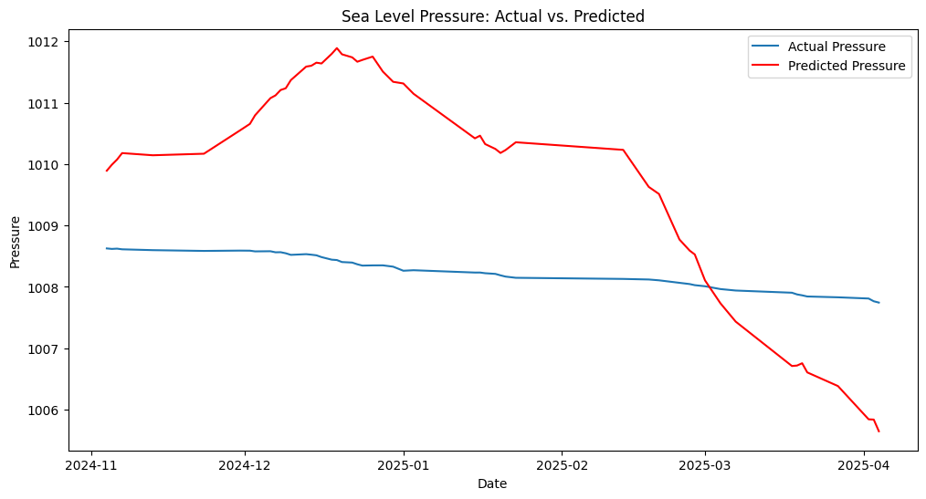
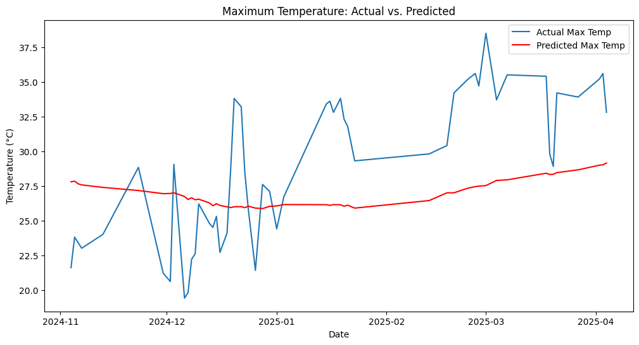
Fig 14.16:-'Sea Level Pressure: Actual vs. Predicted

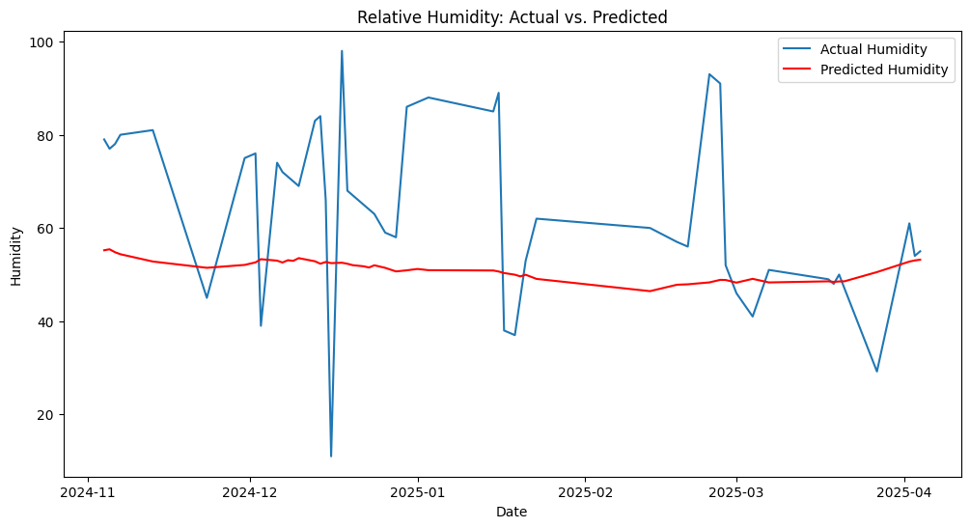
Fig 14.13:-Maximum Temperature: Actual vs. Predicted
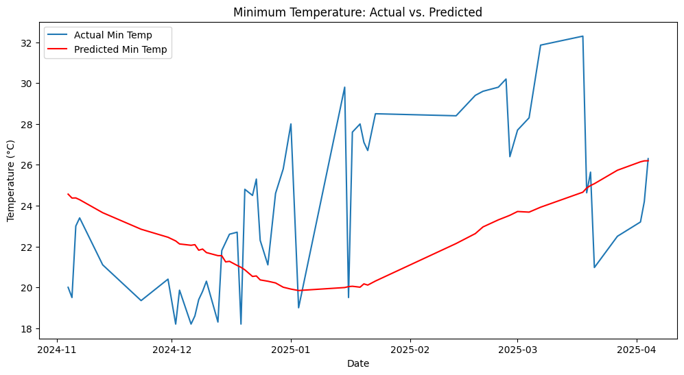
Fig 14.15:-Relative Humidity: Actual vs. Predicted Fig 14.14:-Minimum Temperature: Actual vs. Predicted

AQI Prediction (Regression)

AQI Prediction using Linear Regression

# Import libraries
import pandas as pd
import numpy as np
from sklearn.model_selection import train_test_split
from sklearn.linear_model import LinearRegression
from sklearn.metrics import mean_squared_error, r2_score
import matplotlib.pyplot as plt

# Load your CSV file
df = pd.read_csv("aqi 2.3.csv") # Replace with your actual CSV file
print("Data Sample:\n", df.head())

Data Sample:
dhtTemp dhthum LDR value rainValue pressure altitude aqi value
0 30.2 79.0 687.0 999.0 1008.62531 28.16959 396.0
1 29.8 77.0 688.0 404.0 1008.61737 28.23564 397.0
2 29.9 78.0 715.0 506.0 1008.62201 28.19682 413.0
3 30.8 80.0 708.0 585.0 1008.61108 28.28807 345.0
4 31.3 81.0 753.0 584.0 1008.59741 28.40253 366.0

# Check for missing values
print("\nMissing values:\n", df.isnull().sum())
# Drop rows with missing values (or use fillna if you prefer)
df.dropna(inplace=True)
# Define features and target
X = df[['dhtTemp', 'dhthum', 'LDR value', 'rainValue', 'pressure', 'altitude']]
y = df['aqi value']

# Split into training and testing sets
X_train, X_test, y_train, y_test = train_test_split(X, y, test_size=0.2, random_state=42)
# Create and train the model
model = LinearRegression()
model.fit(X_train, y_train)
# Predict on test data
y_pred = model.predict(X_test)

# Evaluate model
print("\nModel Coefficients:", model.coef_)
print("Intercept:", model.intercept_)
print("Mean Squared Error:", mean_squared_error(y_test, y_pred))
print("R² Score:", r2_score(y_test, y_pred))

Model Coefficients: [-0.89898361 -4.86666218 0.17247998 -0.05191577 -7.95275106 0.3249091 ]
Intercept: 8589.066718034073
Mean Squared Error: 10601.686967755431
R² Score: 0.35622318985304036

# Plot actual vs predicted AQI
plt.figure(figsize=(10,6))
plt.scatter(y_test, y_pred, color='blue', edgecolors='k')
plt.plot([y.min(), y.max()], [y.min(), y.max()], color='red', linestyle='--')
plt.xlabel("Actual AQI")
plt.ylabel("Predicted AQI")
plt.title("Actual vs Predicted AQI using Linear Regression")
plt.grid(True)
plt.show()

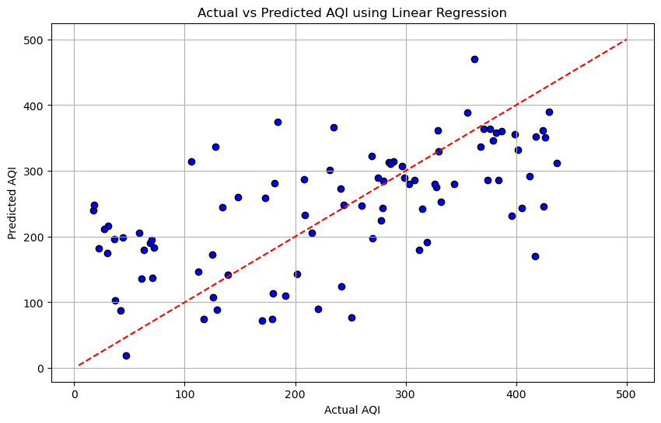
Fig 14.17:-Actual vs Predicted AQI using Linear Regression

AQI Prediction using Decision Tree Regression
# Import necessary libraries
import pandas as pd
from sklearn.model_selection import train_test_split
from sklearn.tree import DecisionTreeRegressor
from sklearn.metrics import mean_squared_error, r2_score
import matplotlib.pyplot as plt
# Load your CSV file
df = pd.read_csv("aqi 2.3.csv") # Replace with your actual file name
# Check and drop missing values
df.dropna(inplace=True)
# Define features and target variable
X = df[['dhtTemp', 'dhthum', 'LDR value', 'rainValue', 'pressure', 'altitude']]
y = df['aqi value']
# Split into training and test sets
X_train, X_test, y_train, y_test = train_test_split(X, y, test_size=0.2, random_state=42)
# Initialize and train the Decision Tree Regressor
model = DecisionTreeRegressor(random_state=42)
model.fit(X_train, y_train)
# Predict AQI values
y_pred = model.predict(X_test)
# Evaluation metrics
mse = mean_squared_error(y_test, y_pred)
r2 = r2_score(y_test, y_pred)
print("Mean Squared Error:", mse)
print("R² Score:", r2)

Mean Squared Error: 4359.450867052024
R² Score: 0.7024895653248079
# Plot actual vs predicted AQI
plt.figure(figsize=(10,6))
plt.scatter(y_test, y_pred, color='green', edgecolor='k')
plt.plot([y.min(), y.max()], [y.min(), y.max()], 'r--')
plt.xlabel("Actual AQI")
plt.ylabel("Predicted AQI")
plt.title("Decision Tree Regressor - Actual vs Predicted AQI")
plt.grid(True)
plt.show()

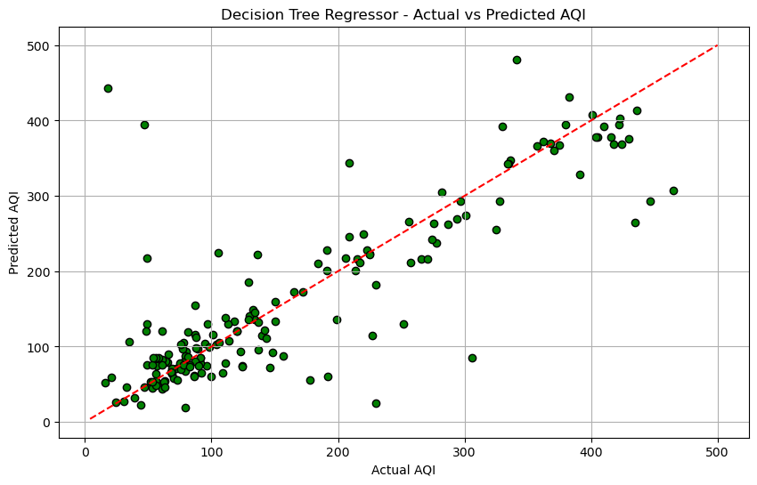
Fig 14.18:- Decision Tree Regressor - Actual vs Predicted AQI
AQI Prediction using Random Forest Regression
# Import libraries
import pandas as pd
from sklearn.model_selection import train_test_split
from sklearn.ensemble import RandomForestRegressor
from sklearn.metrics import mean_squared_error, r2_score
import matplotlib.pyplot as plt
# Load CSV data
df = pd.read_csv("aqi 2.3.csv") # Replace with your actual CSV filename
# Drop missing values
df.dropna(inplace=True)
# Define features and target
features = ['dhtTemp', 'dhthum', 'LDR value', 'rainValue', 'pressure', 'altitude']
X = df[features]
y = df['aqi value']
# Split into training and testing sets
X_train, X_test, y_train, y_test = train_test_split(X, y, test_size=0.2, random_state=42)
# Initialize and train the Random Forest Regressor
model = RandomForestRegressor(n_estimators=100, random_state=42)
model.fit(X_train, y_train)
# Predict on the test data
y_pred = model.predict(X_test)
# Evaluate the model
mse = mean_squared_error(y_test, y_pred)
r2 = r2_score(y_test, y_pred)

Mean Squared Error: 1564.0764479768786
R² Score: 0.8932597067626777

# Plot actual vs predicted AQI
plt.figure(figsize=(10, 6))
plt.scatter(y_test, y_pred, color='orange', edgecolor='k')
plt.plot([y.min(), y.max()], [y.min(), y.max()], 'r--')
plt.xlabel("Actual AQI")
plt.ylabel("Predicted AQI")
plt.title("Random Forest Regressor - Actual vs Predicted AQI")
plt.grid(True)
plt.show()

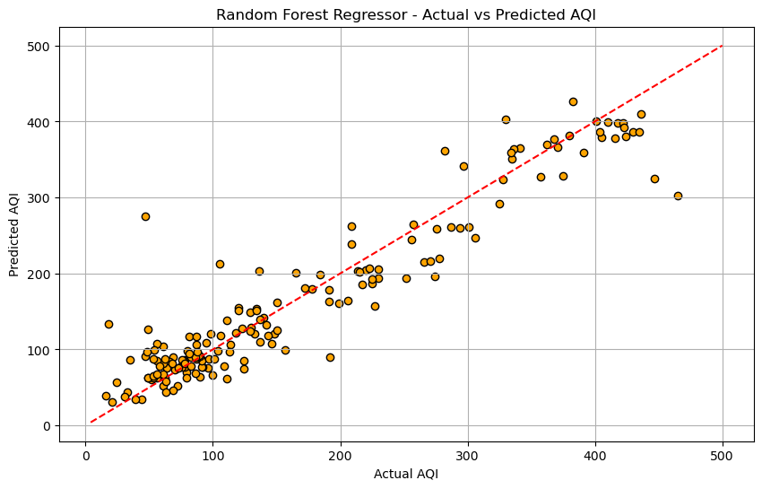
Fig 14.19:-Random Forest Regressor - Actual vs Predicted AQI

# Optional: Feature Importance
importances = model.feature_importances_
feature_importance = pd.Series(importances, index=features).sort_values(ascending=False)

# Plot feature importance
plt.figure(figsize=(8, 5))
feature_importance.plot(kind='bar', color='skyblue')
plt.title("Feature Importance (Random Forest)")
plt.ylabel("Importance Score")
plt.grid(True)
plt.show()

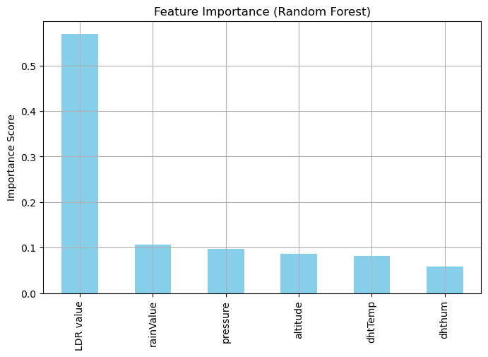
Fig 14.20:- Feature Importance (Random Forest)

AQI Prediction using XGBoost Regressor,
# Import required libraries
import pandas as pd
from sklearn.model_selection import train_test_split
from sklearn.metrics import mean_squared_error, r2_score
import matplotlib.pyplot as plt
import xgboost as xgb

# Load the dataset
df = pd.read_csv("aqi 2.3.csv") # Replace with your actual CSV file

# Drop rows with missing values
df.dropna(inplace=True)

# Define input features and target variable
features = ['dhtTemp', 'dhthum', 'LDR value', 'rainValue', 'pressure', 'altitude']
X = df[features]
y = df['aqi value']

# Split into train and test sets
X_train, X_test, y_train, y_test = train_test_split(X, y, test_size=0.2, random_state=42)

# Create and train the XGBoost Regressor
model = xgb.XGBRegressor(objective='reg:squarederror', n_estimators=100, random_state=42)
model.fit(X_train, y_train)

# Predict on the test set
y_pred = model.predict(X_test)

# Evaluation
mse = mean_squared_error(y_test, y_pred)
r2 = r2_score(y_test, y_pred)

print("Mean Squared Error:", mse)
print("R² Score:", r2)

Mean Squared Error: 3174.6065438634787
R² Score: 0.8072252009990453

# Plot actual vs predicted AQI
plt.figure(figsize=(10, 6))
plt.scatter(y_test, y_pred, color='purple', edgecolor='k')
plt.plot([y.min(), y.max()], [y.min(), y.max()], 'r--')
plt.xlabel("Actual AQI")
plt.ylabel("Predicted AQI")
plt.title("XGBoost Regressor - Actual vs Predicted AQI")
plt.grid(True)
plt.show()

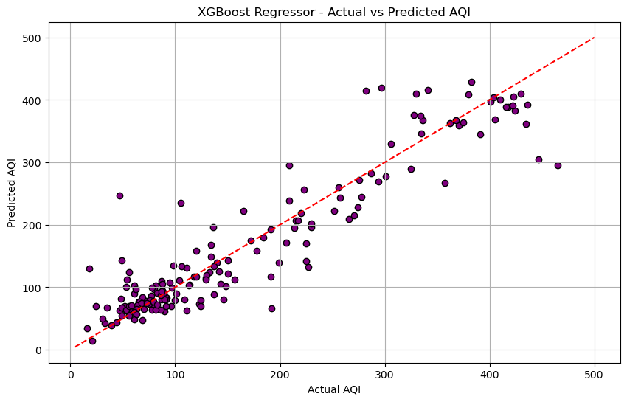
Fig 14.21:- XGBoost Regressor - Actual vs Predicted AQI

xgb.plot_importance(model, height=0.5, importance_type='gain', title='Feature Importance')
plt.show()

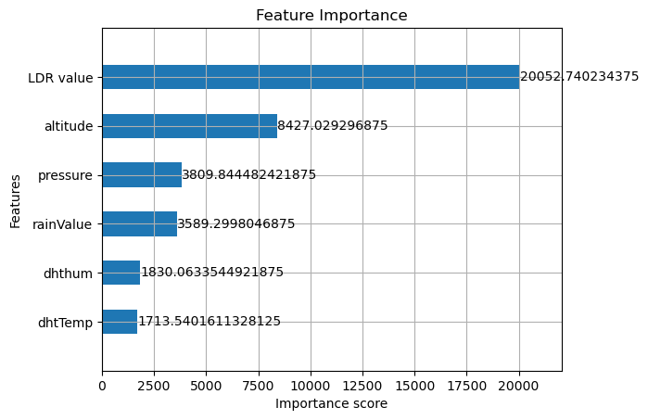
Fig 14.22:- Feature Importance(XGBoost Regression)
AQI Prediction with SVR
# Import necessary libraries
import pandas as pd
import numpy as np
from sklearn.model_selection import train_test_split
from sklearn.svm import SVR
from sklearn.preprocessing import StandardScaler
from sklearn.metrics import mean_squared_error, r2_score
import matplotlib.pyplot as plt
# Load the CSV file
df = pd.read_csv("aqi 2.3.csv") # Replace with your actual file name

# Drop missing values
df.dropna(inplace=True)

# Define input features and target
features = ['dhtTemp', 'dhthum', 'LDR value', 'rainValue', 'pressure', 'altitude']
X = df[features]
y = df['aqi value']

# Standardize the features
scaler_X = StandardScaler()
scaler_y = StandardScaler()

X_scaled = scaler_X.fit_transform(X)
y_scaled = scaler_y.fit_transform(y.values.reshape(-1, 1)).ravel()

# Train-test split
X_train, X_test, y_train, y_test = train_test_split(X_scaled, y_scaled, test_size=0.2, random_state=42)

# Initialize and train SVR model
model = SVR(kernel='rbf', C=100, gamma='scale', epsilon=0.1)
model.fit(X_train, y_train)

# Predict and inverse scale
y_pred_scaled = model.predict(X_test)
y_pred = scaler_y.inverse_transform(y_pred_scaled.reshape(-1, 1)).ravel()
y_test_actual = scaler_y.inverse_transform(y_test.reshape(-1, 1)).ravel()

# Evaluate the model
mse = mean_squared_error(y_test_actual, y_pred)
r2 = r2_score(y_test_actual, y_pred)

Mean Squared Error: 3673.5206447515416
R² Score: 0.7493008277560016

# Plot actual vs predicted AQI
plt.figure(figsize=(10, 6))
plt.scatter(y_test_actual, y_pred, color='cyan', edgecolor='k')
plt.plot([y.min(), y.max()], [y.min(), y.max()], 'r--')
plt.xlabel("Actual AQI")
plt.ylabel("Predicted AQI")
plt.title("SVR - Actual vs Predicted AQI")
plt.grid(True)
plt.show()

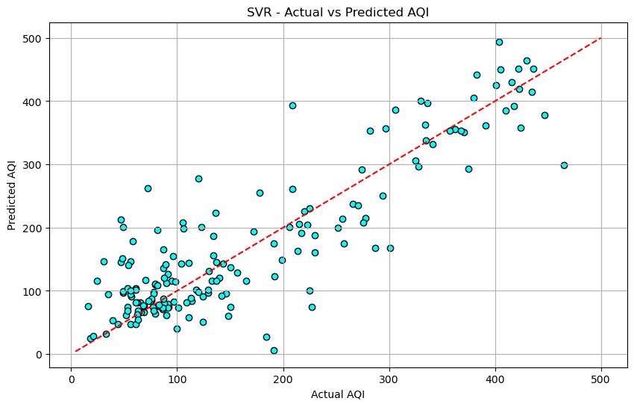
Fig 14.23:-SVR - Actual vs Predicted AQ
import pandas as pd
import numpy as np
from sklearn.model_selection import train_test_split
from sklearn.preprocessing import StandardScaler
from sklearn.metrics import mean_squared_error, r2_score
from sklearn.linear_model import LinearRegression
from sklearn.tree import DecisionTreeRegressor
from sklearn.ensemble import RandomForestRegressor
from sklearn.svm import SVR
import xgboost as xgb
import matplotlib.pyplot as plt

# Load dataset
df = pd.read_csv("aqi .csv") # <-- Replace with your file if needed
df.dropna(inplace=True)

# Features and Target
features = ['dhtTemp', 'dhthum', 'LDR value', 'rainValue', 'pressure', 'altitude']
target = 'aqi value'
X = df[features]
y = df[target]

# Standard scaling for SVR
scaler_X = StandardScaler()
scaler_y = StandardScaler()
X_scaled = scaler_X.fit_transform(X)
y_scaled = scaler_y.fit_transform(y.values.reshape(-1, 1)).ravel()

# Train-test split
X_train, X_test, y_train, y_test = train_test_split(X, y, test_size=0.2, random_state=42)
X_train_scaled, X_test_scaled, y_train_scaled, y_test_scaled = train_test_split(X_scaled, y_scaled, test_size=0.2, random_state=42)

# Models to compare
models = {
"Linear Regression": LinearRegression(),
"Decision Tree": DecisionTreeRegressor(random_state=42),
"Random Forest": RandomForestRegressor(n_estimators=100, random_state=42),
"XGBoost": xgb.XGBRegressor(objective='reg:squarederror', n_estimators=100, random_state=42),
"SVR": SVR(kernel='rbf', C=100, epsilon=0.1)
}

results = []

for name, model in models.items():
if name == "SVR":
model.fit(X_train_scaled, y_train_scaled)
y_pred_scaled = model.predict(X_test_scaled)
y_pred = scaler_y.inverse_transform(y_pred_scaled.reshape(-1, 1)).ravel()
y_true = scaler_y.inverse_transform(y_test_scaled.reshape(-1, 1)).ravel()
else:
model.fit(X_train, y_train)
y_pred = model.predict(X_test)
y_true = y_test
mse = mean_squared_error(y_true, y_pred)
r2 = r2_score(y_true, y_pred)
results.append({"Model": name, "MSE": mse, "R2 Score": r2})

# Save to CSV
results_df = pd.DataFrame(results)
results_df.to_csv("model_comparison_results.csv", index=False)
print("Results saved to model_comparison_results.csv")
print(results_df)
# Plot comparison
plt.figure(figsize=(10, 5))
plt.bar(results_df['Model'], results_df['R2 Score'], color='skyblue')
plt.title("Model R² Score Comparison")
plt.ylabel("R² Score")
plt.xticks(rotation=45)
plt.tight_layout()
plt.show()
Model | MSE | R2 Score
Linear Regression | 10464.45522217116 | 0.28585394887303517
Decision Tree | 4359.450867052024 | 0.7024895653248079
Random Forest | 1564.0764479768786 | 0.8932597067626777
XGBoost | 1970.528900836263 | 0.8655213861317664
SVR | 3673.5206447515416 | 0.7493008277560016

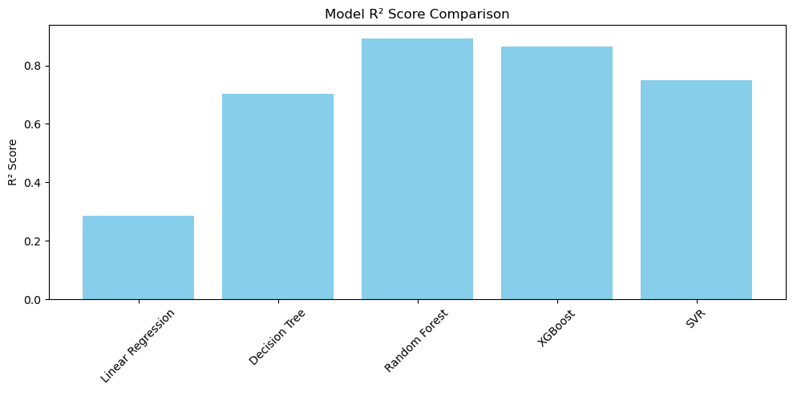

Fig 14.24:-Model R² Score Comparison & R² Score

Rain Status Prediction (Classification)

Logistic Regression for Rain Prediction
import pandas as pd
from sklearn.model_selection import train_test_split
from sklearn.linear_model import LogisticRegression
from sklearn.preprocessing import StandardScaler
from sklearn.metrics import accuracy_score, confusion_matrix, classification_report

# Load the dataset
df = pd.read_csv("rain.csv") # Make sure this CSV contains 'rainStatusNum' and all input fields
df.dropna(inplace=True)

# Features and Target
features = ['dhtTemp', 'dhthum', 'LDR value', 'pressure', 'altitude', 'rainValue']
target = 'rainStatusNum'

X = df[features]
y = df[target]

# Train-test split
X_train, X_test, y_train, y_test = train_test_split(X, y, test_size=0.2, random_state=42)

# Feature Scaling
scaler = StandardScaler()
X_train_scaled = scaler.fit_transform(X_train)
X_test_scaled = scaler.transform(X_test)

# Model: Logistic Regression
model = LogisticRegression()
model.fit(X_train_scaled, y_train)

# Prediction
y_pred = model.predict(X_test_scaled)

# Evaluation
accuracy = accuracy_score(y_test, y_pred)
conf_matrix = confusion_matrix(y_test, y_pred)
class_report = classification_report(y_test, y_pred)

# Output
print("✅ Logistic Regression - Rain Prediction")
print(f"Accuracy: {accuracy:.4f}")
print("Confusion Matrix:")
print(conf_matrix)
print("\nClassification Report:")
print(class_report)

Output:-
Logistic Regression - Rain Prediction
Accuracy: 0.9769
Confusion Matrix:
[[ 36 1]
[ 3 133]]

Classification Report:
precision recall f1-score support

0 0.92 0.97 0.95 37
1 0.99 0.98 0.99 136

accuracy 0.98 173
macro avg 0.96 0.98 0.97 173
weighted avg 0.98 0.98 0.98 173

Rain Status Prediction model using Decision Tree Classifier
import pandas as pd
from sklearn.model_selection import train_test_split
from sklearn.tree import DecisionTreeClassifier
from sklearn.preprocessing import StandardScaler
from sklearn.metrics import accuracy_score, confusion_matrix, classification_report

# Load the dataset
df = pd.read_csv("rain.csv") # Ensure the CSV has all required fields
df.dropna(inplace=True)

# Define features and target
features = ['dhtTemp', 'dhthum', 'LDR value', 'pressure', 'altitude', 'rainValue']
target = 'rainStatusNum'

X = df[features]
y = df[target]

# Train-test split
X_train, X_test, y_train, y_test = train_test_split(X, y, test_size=0.2, random_state=42)

# Feature scaling (optional for Decision Tree, but useful if comparing with others)
scaler = StandardScaler()
X_train_scaled = scaler.fit_transform(X_train)
X_test_scaled = scaler.transform(X_test)

# Initialize and train Decision Tree Classifier
model = DecisionTreeClassifier(random_state=42)
model.fit(X_train_scaled, y_train)

# Predict
y_pred = model.predict(X_test_scaled)

# Evaluation
accuracy = accuracy_score(y_test, y_pred)
conf_matrix = confusion_matrix(y_test, y_pred)
class_report = classification_report(y_test, y_pred, target_names=["No Rain", "Rain"])

# Output
print("🌳 Decision Tree Classifier - Rain Status Prediction")
print(f"Accuracy: {accuracy:.4f}")
print("Confusion Matrix:")
print(conf_matrix)
print("\nClassification Report:")
print(class_report)

🌳 Decision Tree Classifier - Rain Status Prediction
Accuracy: 1.0000
Confusion Matrix:
[[ 37 0]
[ 0 136]]

Classification Report:
precision recall f1-score support

No Rain 1.00 1.00 1.00 37
Rain 1.00 1.00 1.00 136

accuracy 1.00 173
macro avg 1.00 1.00 1.00 173
weighted avg 1.00 1.00 1.00 173

Rain Status Prediction using a Random Forest Classifier
import pandas as pd
from sklearn.model_selection import train_test_split
from sklearn.ensemble import RandomForestClassifier
from sklearn.preprocessing import StandardScaler
from sklearn.metrics import accuracy_score, confusion_matrix, classification_report

# Load the dataset
df = pd.read_csv("rain.csv") # Make sure this file includes all required fields
df.dropna(inplace=True)

# Features and Target
features = ['dhtTemp', 'dhthum', 'LDR value', 'pressure', 'altitude', 'rainValue']
target = 'rainStatusNum'

X = df[features]
y = df[target]

# Train-test split
X_train, X_test, y_train, y_test = train_test_split(X, y, test_size=0.2, random_state=42)

# Feature Scaling (not strictly necessary for Random Forest, but consistent if comparing)
scaler = StandardScaler()
X_train_scaled = scaler.fit_transform(X_train)
X_test_scaled = scaler.transform(X_test)

# Model: Random Forest Classifier
model = RandomForestClassifier(n_estimators=100, random_state=42)
model.fit(X_train_scaled, y_train)

# Prediction
y_pred = model.predict(X_test_scaled)

# Evaluation
accuracy = accuracy_score(y_test, y_pred)
conf_matrix = confusion_matrix(y_test, y_pred)
class_report = classification_report(y_test, y_pred, target_names=["No Rain", "Rain"])

# Output
print("🌲 Random Forest Classifier - Rain Status Prediction")
print(f"Accuracy: {accuracy:.4f}")
print("Confusion Matrix:")
print(conf_matrix)
print("\nClassification Report:")
print(class_report)

Random Forest Classifier - Rain Status Prediction
Accuracy: 1.0000
Confusion Matrix:
[[ 37 0]
[ 0 136]]

Classification Report:
precision recall f1-score support

No Rain 1.00 1.00 1.00 37
Rain 1.00 1.00 1.00 136

accuracy 1.00 173
macro avg 1.00 1.00 1.00 173
weighted avg 1.00 1.00 1.00 173

import pandas as pd
from sklearn.model_selection import train_test_split
from sklearn.preprocessing import StandardScaler
from sklearn.metrics import accuracy_score, classification_report, confusion_matrix
from sklearn.linear_model import LogisticRegression
from sklearn.tree import DecisionTreeClassifier
from sklearn.ensemble import RandomForestClassifier
from sklearn.neighbors import KNeighborsClassifier
from sklearn.svm import SVC

# Load and clean data
df = pd.read_csv("rain.csv")
df.dropna(inplace=True)

# Define features and target
features = ['dhtTemp', 'dhthum', 'LDR value', 'pressure', 'altitude', 'rainValue']
target = 'rainStatusNum'

X = df[features]
y = df[target]

# Train/test split
X_train, X_test, y_train, y_test = train_test_split(X, y, test_size=0.2, random_state=42)

# Standardize features
scaler = StandardScaler()
X_train_scaled = scaler.fit_transform(X_train)
X_test_scaled = scaler.transform(X_test)

# Models
models = {
"Logistic Regression": LogisticRegression(),
"Decision Tree": DecisionTreeClassifier(random_state=42),
"Random Forest": RandomForestClassifier(n_estimators=100, random_state=42),
"KNN": KNeighborsClassifier(n_neighbors=5),
"SVM": SVC()
}

# Evaluation storage
results = []

for name, model in models.items():
model.fit(X_train_scaled, y_train)
y_pred = model.predict(X_test_scaled)
accuracy = accuracy_score(y_test, y_pred)
conf_matrix = confusion_matrix(y_test, y_pred)
report = classification_report(y_test, y_pred, target_names=["No Rain", "Rain"], output_dict=True)

print(f"\n🔍 {name}")
print(f"Accuracy: {accuracy:.4f}")
print("Confusion Matrix:\n", conf_matrix)
print("Classification Report:\n", classification_report(y_test, y_pred, target_names=["No Rain", "Rain"]))

results.append({
"Model": name,
"Accuracy": accuracy,
"Precision (Rain)": report["Rain"]["precision"],
"Recall (Rain)": report["Rain"]["recall"],
"F1-Score (Rain)": report["Rain"]["f1-score"]
})

# Save model comparison
results_df = pd.DataFrame(results)
results_df.to_csv("rain_classification_comparison.csv", index=False)
print("\n✅ Comparison saved to 'rain_classification_comparison.csv'")

Model | Accuracy | Precision (Rain) | Recall (Rain) | F1-Score (Rain)
Logistic Regression | 0.976878612716763 | 0.9925373134328358 | 0.9779411764705882 | 0.9851851851851852
Decision Tree | 1 | 1 | 1 | 1
Random Forest | 1 | 1 | 1 | 1
KNN | 0.976878612716763 | 0.9852941176470589 | 0.9852941176470589 | 0.9852941176470589
SVM | 0.9653179190751445 | 0.9710144927536232 | 0.9852941176470589 | 0.9781021897810219

Temperature Forecasting (Regression)

Linear Regression for Temperature Forecasting
import pandas as pd
from sklearn.model_selection import train_test_split
from sklearn.linear_model import LinearRegression
from sklearn.preprocessing import StandardScaler
from sklearn.metrics import mean_squared_error, r2_score

# Load dataset
df = pd.read_csv("weather.csv")
df.dropna(inplace=True)

# Select target variable (uncomment the one you want to predict)
target = 'dhtTemp'
#arget = 'maxTemp'
#target = 'minTemp'

# Define input features
features = ['pressure', 'altitude', 'dhthum', 'LDR value', 'rainValue']
X = df[features]
y = df[target]

# Train/test split
X_train, X_test, y_train, y_test = train_test_split(X, y, test_size=0.2, random_state=42)

# Feature scaling
scaler = StandardScaler()
X_train_scaled = scaler.fit_transform(X_train)
X_test_scaled = scaler.transform(X_test)

# Linear Regression model
model = LinearRegression()
model.fit(X_train_scaled, y_train)

# Predict
y_pred = model.predict(X_test_scaled)

# Evaluate
mse = mean_squared_error(y_test, y_pred)
r2 = r2_score(y_test, y_pred)

# Output results
print(f"\n🌡️ Temperature Forecasting - Linear Regression (Target: {target})")
print(f"Mean Squared Error (MSE): {mse:.4f}")
print(f"R² Score: {r2:.4f}")

Temperature Forecasting - Linear Regression (Target: dhtTemp)
Mean Squared Error (MSE): 29.9445
R² Score: 0.6811

Random Forest Regression for Temperature Forecasting
import pandas as pd
from sklearn.model_selection import train_test_split
from sklearn.ensemble import RandomForestRegressor
from sklearn.preprocessing import StandardScaler
from sklearn.metrics import mean_squared_error, r2_score

# Load and clean data
df = pd.read_csv("weather.csv")
df.dropna(inplace=True)

# Choose target variable (uncomment the one you want to predict)
target = 'dhtTemp'
#target = 'maxTemp'
#target = 'minTemp'

# Input features
features = ['pressure', 'altitude', 'dhthum', 'LDR value', 'rainValue']
X = df[features]
y = df[target]

# Train/test split
X_train, X_test, y_train, y_test = train_test_split(X, y, test_size=0.2, random_state=42)
# Standardize features
scaler = StandardScaler()
X_train_scaled = scaler.fit_transform(X_train)
X_test_scaled = scaler.transform(X_test)
# Random Forest Regressor
model = RandomForestRegressor(n_estimators=100, random_state=42)
model.fit(X_train_scaled, y_train)
# Predict
y_pred = model.predict(X_test_scaled)
# Evaluate
mse = mean_squared_error(y_test, y_pred)
r2 = r2_score(y_test, y_pred)
# Output
print(f"\n🌡️ Temperature Forecasting - Random Forest Regressor (Target: {target})")
print(f"Mean Squared Error (MSE): {mse:.4f}")
print(f"R² Score: {r2:.4f}")

🌡️ Temperature Forecasting - Random Forest Regressor (Target: dhtTemp)
Mean Squared Error (MSE): 5.4177
R² Score: 0.9423

XGBoost Regressor for Temperature Forecasting
import pandas as pd
from sklearn.model_selection import train_test_split
from sklearn.preprocessing import StandardScaler
from sklearn.metrics import mean_squared_error, r2_score
from xgboost import XGBRegressor

# Load and clean data
df = pd.read_csv("weather.csv")
df.dropna(inplace=True)

# Choose target variable (uncomment one)
target = 'dhtTemp'
# target = 'maximum temperature'
# target = 'min temperature'

# Define features
features = ['pressure', 'altitude', 'dhthum', 'LDR value', 'rainValue']
X = df[features]
y = df[target]

# Split into training/testing
X_train, X_test, y_train, y_test = train_test_split(X, y, test_size=0.2, random_state=42)

# Standardize input features
scaler = StandardScaler()
X_train_scaled = scaler.fit_transform(X_train)
X_test_scaled = scaler.transform(X_test)

# XGBoost Regressor
model = XGBRegressor(n_estimators=100, learning_rate=0.1, max_depth=4, random_state=42)
model.fit(X_train_scaled, y_train)

# Prediction
y_pred = model.predict(X_test_scaled)

# Evaluation
mse = mean_squared_error(y_test, y_pred)
r2 = r2_score(y_test, y_pred)

# Output
print(f"\n🌡️ Temperature Forecasting - XGBoost Regressor (Target: {target})")
print(f"Mean Squared Error (MSE): {mse:.4f}")
print(f"R² Score: {r2:.4f}")

Temperature Forecasting - XGBoost Regressor (Target: dhtTemp)
Mean Squared Error (MSE): 9.1613
R² Score: 0.9024

Compare Linear, RF, XGBoost for Temperature Forecasting
import pandas as pd
from sklearn.model_selection import train_test_split
from sklearn.linear_model import LinearRegression
from sklearn.ensemble import RandomForestRegressor
from xgboost import XGBRegressor
from sklearn.preprocessing import StandardScaler
from sklearn.metrics import mean_squared_error, r2_score

# Load and clean data
df = pd.read_csv("weather.csv")
df.dropna(inplace=True)

# Choose one target variable (uncomment the one you want)
target = 'dhtTemp'
# target = 'maximum temperature'
# target = 'min temperature'

# Input features
features = ['pressure', 'altitude', 'dhthum', 'LDR value', 'rainValue']
X = df[features]
y = df[target]

# Train-test split
X_train, X_test, y_train, y_test = train_test_split(X, y, test_size=0.2, random_state=42)

# Standardize features
scaler = StandardScaler()
X_train_scaled = scaler.fit_transform(X_train)
X_test_scaled = scaler.transform(X_test)

# Models to compare
models = {
'Linear Regression': LinearRegression(),
'Random Forest': RandomForestRegressor(n_estimators=100, random_state=42),
'XGBoost': XGBRegressor(n_estimators=100, learning_rate=0.1, max_depth=4, random_state=42)
}

results = []

# Train and evaluate each model
for name, model in models.items():
model.fit(X_train_scaled, y_train)
y_pred = model.predict(X_test_scaled)
mse = mean_squared_error(y_test, y_pred)
r2 = r2_score(y_test, y_pred)
results.append({'Model': name, 'MSE': mse, 'R2 Score': r2})
print(f"\n{name} (Target: {target})")
print(f"MSE: {mse:.4f}")
print(f"R² Score: {r2:.4f}")

# Save comparison results
results_df = pd.DataFrame(results)
results_df.to_csv("temperature_model_comparison.csv", index=False)
print("\n✅ Results saved to 'temperature_model_comparison.csv'")

Model | MSE | R2 Score
Linear Regression | 29.944495688184375 | 0.6811424035886136
Random Forest | 5.417698684698235 | 0.9423107873088795
XGBoost | 9.16129938564439 | 0.9024478510999161

Weather Conditions Classification (Sunny, Cloudy, Rainy, etc.)

Weather Condition Classification with Random Forest
import pandas as pd
from sklearn.model_selection import train_test_split
from sklearn.ensemble import RandomForestClassifier
from sklearn.preprocessing import StandardScaler
from sklearn.metrics import accuracy_score, confusion_matrix, classification_report

# Load data
df = pd.read_csv("weather condition.csv")
df.dropna(inplace=True)

# Create target categorical label
def get_weather_condition(row):
if row['rainStatusNum'] == 1:
return 'Rainy'
elif row['LDR value'] < 300:
return 'Cloudy'
elif row['aqi value'] > 100:
return 'Hazy'
else:
return 'Clear'

df['weather_condition'] = df.apply(get_weather_condition, axis=1)

# Input features (all sensors, adjust as per your dataset columns)
features = ['dhtTemp', 'dhthum', 'LDR value', 'rainValue', 'pressure', 'altitude', 'aqi value', 'rainStatusNum']
X = df[features]
y = df['weather_condition']

# Train/test split
X_train, X_test, y_train, y_test = train_test_split(X, y, test_size=0.2, random_state=42, stratify=y)

# Feature scaling
scaler = StandardScaler()
X_train_scaled = scaler.fit_transform(X_train)
X_test_scaled = scaler.transform(X_test)

# Model: Random Forest Classifier
model = RandomForestClassifier(n_estimators=100, random_state=42)
model.fit(X_train_scaled, y_train)

# Prediction
y_pred = model.predict(X_test_scaled)

# Evaluation
accuracy = accuracy_score(y_test, y_pred)
conf_matrix = confusion_matrix(y_test, y_pred)
class_report = classification_report(y_test, y_pred)

# Output
print("🌤️ Weather Condition Classification - Random Forest")
print(f"Accuracy: {accuracy:.4f}")
print("Confusion Matrix:")
print(conf_matrix)
print("\nClassification Report:")
print(class_report)
🌤️ Weather Condition Classification - Random Forest
Accuracy: 1.0000
Confusion Matrix:
[[ 5 0 0 0]
[ 0 10 0 0]
[ 0 0 18 0]
[ 0 0 0 140]]

Classification Report:
precision recall f1-score support

Clear 1.00 1.00 1.00 5
Cloudy 1.00 1.00 1.00 10
Hazy 1.00 1.00 1.00 18
Rainy 1.00 1.00 1.00 140

accuracy 1.00 173
macro avg 1.00 1.00 1.00 173
weighted avg 1.00 1.00 1.00 173

Weather Condition Classification using Support Vector Machine (SVM).
import pandas as pd
from sklearn.model_selection import train_test_split
from sklearn.svm import SVC
from sklearn.preprocessing import StandardScaler
from sklearn.metrics import accuracy_score, confusion_matrix, classification_report

# Step 1: Load data
df = pd.read_csv("weather condition.csv")
df.dropna(inplace=True)

# Step 2: Create target label based on conditions
def get_weather_condition(row):
if row['rainStatusNum'] == 1:
return 'Rainy'
elif row['LDR value'] < 300:
return 'Cloudy'
elif row['aqi value'] > 100:
return 'Hazy'
else:
return 'Clear'

df['weather_condition'] = df.apply(get_weather_condition, axis=1)

# Step 3: Feature and target selection
features = ['dhtTemp', 'dhthum', 'LDR value', 'rainValue', 'pressure', 'altitude', 'aqi value', 'rainStatusNum']
X = df[features]
y = df['weather_condition']

# Step 4: Train-test split
X_train, X_test, y_train, y_test = train_test_split(X, y, test_size=0.2, random_state=42, stratify=y)

# Step 5: Feature scaling
scaler = StandardScaler()
X_train_scaled = scaler.fit_transform(X_train)
X_test_scaled = scaler.transform(X_test)

# Step 6: Train SVM Classifier
model = SVC(kernel='rbf', C=1.0, gamma='scale') # You can experiment with 'linear' or 'poly'
model.fit(X_train_scaled, y_train)

# Step 7: Prediction
y_pred = model.predict(X_test_scaled)

# Step 8: Evaluation
accuracy = accuracy_score(y_test, y_pred)
conf_matrix = confusion_matrix(y_test, y_pred)
class_report = classification_report(y_test, y_pred)

# Step 9: Output
print("🌤️ Weather Condition Classification - SVM")
print(f"Accuracy: {accuracy:.4f}")
print("Confusion Matrix:")
print(conf_matrix)
print("\nClassification Report:")
print(class_report)
🌤️ Weather Condition Classification - SVM
Accuracy: 0.9769
Confusion Matrix:
[[ 2 1 2 0]
[ 0 10 0 0]
[ 1 0 17 0]
[ 0 0 0 140]]

Classification Report:
precision recall f1-score support

Clear 0.67 0.40 0.50 5
Cloudy 0.91 1.00 0.95 10
Hazy 0.89 0.94 0.92 18
Rainy 1.00 1.00 1.00 140

accuracy 0.98 173
macro avg 0.87 0.84 0.84 173
weighted avg 0.97 0.98 0.97 173

Weather Condition Classification using Naive Bayes
import pandas as pd
from sklearn.model_selection import train_test_split
from sklearn.naive_bayes import GaussianNB
from sklearn.preprocessing import StandardScaler
from sklearn.metrics import accuracy_score, confusion_matrix, classification_report

# Step 1: Load the dataset
df = pd.read_csv("weather condition.csv")
df.dropna(inplace=True)

# Step 2: Create target label
def get_weather_condition(row):
if row['rainStatusNum'] == 1:
return 'Rainy'
elif row['LDR value'] < 300:
return 'Cloudy'
elif row['aqi value'] > 100:
return 'Hazy'
else:
return 'Clear'

df['weather_condition'] = df.apply(get_weather_condition, axis=1)

# Step 3: Select input features and target
features = ['dhtTemp', 'dhthum', 'LDR value', 'rainValue', 'pressure', 'altitude', 'aqi value', 'rainStatusNum']
X = df[features]
y = df['weather_condition']

# Step 4: Train-test split
X_train, X_test, y_train, y_test = train_test_split(X, y, test_size=0.2, random_state=42, stratify=y)

# Step 5: Feature scaling
scaler = StandardScaler()
X_train_scaled = scaler.fit_transform(X_train)
X_test_scaled = scaler.transform(X_test)

# Step 6: Train Naive Bayes classifier
model = GaussianNB()
model.fit(X_train_scaled, y_train)

# Step 7: Make predictions
y_pred = model.predict(X_test_scaled)

# Step 8: Evaluate model
accuracy = accuracy_score(y_test, y_pred)
conf_matrix = confusion_matrix(y_test, y_pred)
class_report = classification_report(y_test, y_pred)

# Step 9: Display results
print("☁️ Weather Condition Classification - Naive Bayes")
print(f"Accuracy: {accuracy:.4f}")
print("Confusion Matrix:")
print(conf_matrix)
print("\nClassification Report:")
print(class_report)

☁️ Weather Condition Classification - Naive Bayes
Accuracy: 0.9711
Confusion Matrix:
[[ 4 1 0 0]
[ 0 10 0 0]
[ 2 2 14 0]
[ 0 0 0 140]]

Classification Report:
precision recall f1-score support

Clear 0.67 0.80 0.73 5
Cloudy 0.77 1.00 0.87 10
Hazy 1.00 0.78 0.88 18
Rainy 1.00 1.00 1.00 140

accuracy 0.97 173
macro avg 0.86 0.89 0.87 173
weighted avg 0.98 0.97 0.97 173

AQI Category Classification (Good, Moderate, Unhealthy, etc.)

Decision Tree - AQI Category Classification
import pandas as pd
from sklearn.model_selection import train_test_split
from sklearn.preprocessing import StandardScaler
from sklearn.tree import DecisionTreeClassifier
from sklearn.metrics import classification_report, accuracy_score, confusion_matrix

# Load dataset
df = pd.read_csv("aqi cat.csv")
df.dropna(inplace=True)

# Define AQI category
def get_aqi_category(aqi):
if aqi <= 50:
return "Good"
elif aqi <= 100:
return "Moderate"
elif aqi <= 150:
return "Unhealthy for Sensitive Groups"
elif aqi <= 200:
return "Unhealthy"
elif aqi <= 300:
return "Very Unhealthy"
else:
return "Hazardous"
df['AQI_Category'] = df['aqi value'].apply(get_aqi_category)
# Features and target
features = ['dhtTemp', 'dhthum', 'LDR value', 'rainValue', 'pressure', 'altitude', 'rainStatusNum']
X = df[features]
y = df['AQI_Category']
# Train-test split
X_train, X_test, y_train, y_test = train_test_split(X, y, test_size=0.2, random_state=42, stratify=y)
# Feature scaling
scaler = StandardScaler()
X_train_scaled = scaler.fit_transform(X_train)
X_test_scaled = scaler.transform(X_test)
# Model training
clf = DecisionTreeClassifier(random_state=42)
clf.fit(X_train_scaled, y_train)
# Predictions and evaluation
y_pred = clf.predict(X_test_scaled)
print("✅ Decision Tree - AQI Category Classification")
print(f"Accuracy: {accuracy_score(y_test, y_pred):.4f}")
print("Confusion Matrix:")
print(confusion_matrix(y_test, y_pred))
print("\nClassification Report:")
print(classification_report(y_test, y_pred))

✅ Decision Tree - AQI Category Classification
Accuracy: 0.6071
Confusion Matrix:
[[ 5 0 2 0 1 0]
[ 0 28 0 1 0 3]
[ 1 0 7 1 1 0]
[ 1 2 0 1 3 3]
[ 0 1 3 2 3 1]
[ 0 3 1 1 2 7]]

Classification Report:
precision recall f1-score support
Good 0.71 0.62 0.67 8
Hazardous 0.82 0.88 0.85 32
Moderate 0.54 0.70 0.61 10
Unhealthy 0.17 0.10 0.12 10
Unhealthy for Sensitive Groups 0.30 0.30 0.30 10
Very Unhealthy 0.50 0.50 0.50 14

accuracy 0.61 84
macro avg 0.51 0.52 0.51 84
weighted avg 0.58 0.61 0.59 84

XGBoost-based AQI Category Classification pipeline using Python
import pandas as pd
from sklearn.model_selection import train_test_split
from sklearn.preprocessing import StandardScaler, LabelEncoder
from sklearn.metrics import accuracy_score, classification_report, confusion_matrix
import xgboost as xgb
# Load dataset
df = pd.read_csv("aqi cat.csv")
df.dropna(inplace=True)

# AQI Category conversion
def get_aqi_category(aqi):
if aqi <= 50:
return "Good"
elif aqi <= 100:
return "Moderate"
elif aqi <= 150:
return "Unhealthy for Sensitive Groups"
elif aqi <= 200:
return "Unhealthy"
elif aqi <= 300:
return "Very Unhealthy"
else:
return "Hazardous"

df['AQI_Category'] = df['aqi value'].apply(get_aqi_category)

# Encode labels
label_encoder = LabelEncoder()
df['AQI_Label'] = label_encoder.fit_transform(df['AQI_Category'])

# Input features (all sensors)
features = ['dhtTemp', 'dhthum', 'LDR value', 'pressure', 'altitude', 'rainValue']
X = df[features]
y = df['AQI_Label']

# Train-test split
X_train, X_test, y_train, y_test = train_test_split(X, y, test_size=0.2, random_state=42)

# Scaling
scaler = StandardScaler()
X_train_scaled = scaler.fit_transform(X_train)
X_test_scaled = scaler.transform(X_test)

# XGBoost Classifier
xgb_model = xgb.XGBClassifier(use_label_encoder=False, eval_metric='mlogloss')
xgb_model.fit(X_train_scaled, y_train)

# Predictions
y_pred = xgb_model.predict(X_test_scaled)

# Evaluation
accuracy = accuracy_score(y_test, y_pred)
conf_matrix = confusion_matrix(y_test, y_pred)
class_report = classification_report(y_test, y_pred, target_names=label_encoder.classes_)
# Output
print("✅ XGBoost - AQI Category Classification")
print(f"Accuracy: {accuracy:.4f}")
print("Confusion Matrix:")
print(conf_matrix)
print("\nClassification Report:")
print(class_report)

XGBoost - AQI Category Classification
Accuracy: 0.7143
Confusion Matrix:
[[ 6 0 1 0 0 0]
[ 0 31 0 0 0 2]
[ 2 0 3 0 1 1]
[ 0 1 0 6 1 2]
[ 0 1 1 1 6 2]
[ 0 3 1 1 3 8]]

Classification Report:
precision recall f1-score support

Good 0.75 0.86 0.80 7
Hazardous 0.86 0.94 0.90 33
Moderate 0.50 0.43 0.46 7
Unhealthy 0.75 0.60 0.67 10
Unhealthy for Sensitive Groups 0.55 0.55 0.55 11
Very Unhealthy 0.53 0.50 0.52 16

accuracy 0.71 84
macro avg 0.66 0.65 0.65 84
weighted avg 0.70 0.71 0.71 84

import matplotlib.pyplot as plt
import xgboost as xgb

# ... (previous code: training XGBoost and predicting)
# Plot feature importance
plt.figure(figsize=(10,6))
xgb.plot_importance(xgb_model, max_num_features=10, importance_type='gain')
plt.title('Feature Importance - XGBoost (by Gain)')
plt.show()

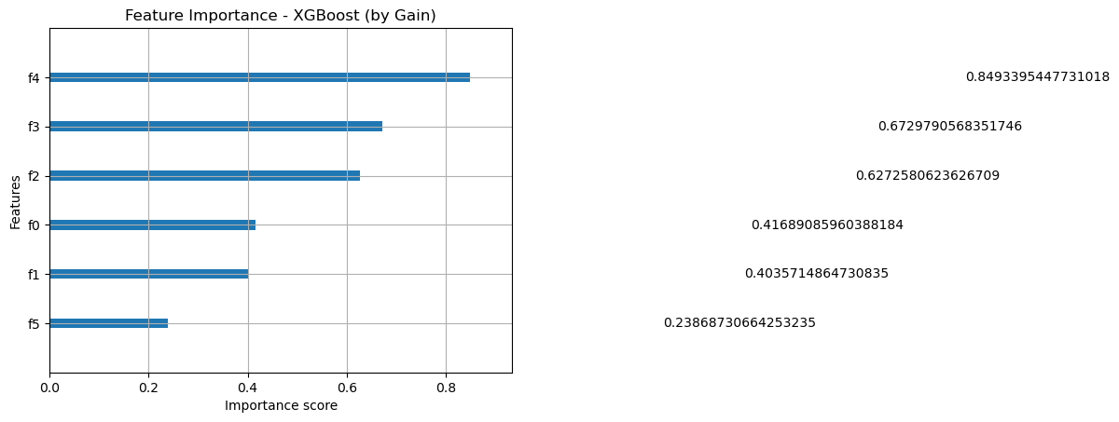
Fig 14.25:-('Feature Importance - XGBoost (by Gain)

Logistic Regression - AQI Category Classification
import pandas as pd
from sklearn.model_selection import train_test_split
from sklearn.preprocessing import StandardScaler, LabelEncoder
from sklearn.linear_model import LogisticRegression
from sklearn.metrics import accuracy_score, classification_report, confusion_matrix
# Load dataset
df = pd.read_csv("aqi cat.csv")
# Drop rows with missing values
df.dropna(inplace=True)
# Convert AQI value to AQI category
def get_aqi_category(aqi):
if aqi <= 50:
return "Good"
elif aqi <= 100:
return "Moderate"
elif aqi <= 150:
return "Unhealthy for Sensitive Groups"
elif aqi <= 200:
return "Unhealthy"
elif aqi <= 300:
return "Very Unhealthy"
else:
return "Hazardous"

df['AQI_Category'] = df['aqi value'].apply(get_aqi_category)
# Encode target labels
label_encoder = LabelEncoder()
df['AQI_Label'] = label_encoder.fit_transform(df['AQI_Category'])
# Input features
features = ['dhtTemp', 'dhthum', 'LDR value', 'pressure', 'altitude', 'rainValue']
X = df[features]
y = df['AQI_Label']
# Train-test split
X_train, X_test, y_train, y_test = train_test_split(X, y, test_size=0.2, random_state=42)
# Feature scaling
scaler = StandardScaler()
X_train_scaled = scaler.fit_transform(X_train)
X_test_scaled = scaler.transform(X_test)
# Train logistic regression model
model = LogisticRegression(max_iter=1000)
model.fit(X_train_scaled, y_train)
# Prediction
y_pred = model.predict(X_test_scaled)
# Evaluation
accuracy = accuracy_score(y_test, y_pred)
conf_matrix = confusion_matrix(y_test, y_pred)
class_report = classification_report(y_test, y_pred, target_names=label_encoder.classes_)
# Logistic variables (coefficients)
coefficients = model.coef_
intercepts = model.intercept_
coef_df = pd.DataFrame(coefficients.T, index=features, columns=[f'Class {cls}' for cls in label_encoder.classes_])
# Results
print("✅ Logistic Regression - AQI Category Classification")
print(f"Accuracy: {accuracy:.4f}")
print("Confusion Matrix:")
print(conf_matrix)
print("\nClassification Report:")
print(class_report)
print("\nLogistic Coefficients (Impact of each feature per class):")
print(coef_df)
print("\nIntercepts:")
print(intercepts)

✅ Logistic Regression - AQI Category Classification
Accuracy: 0.5119
Confusion Matrix:
[[ 2 0 1 3 0 1]
[ 0 31 1 0 0 1]
[ 1 0 2 1 4 1]
[ 1 6 0 0 1 1]
[ 1 5 0 3 4 0]
[ 0 6 1 1 1 4]]

Classification Report:
precision recall f1-score support

Good 0.40 0.29 0.33 7
Hazardous 0.65 0.94 0.77 33
Moderate 0.40 0.22 0.29 9
Unhealthy 0.00 0.00 0.00 9
Unhealthy for Sensitive Groups 0.40 0.31 0.35 13
Very Unhealthy 0.50 0.31 0.38 13

accuracy 0.51 84
macro avg 0.39 0.34 0.35 84
weighted avg 0.47 0.51 0.47 84

Logistic Coefficients (Impact of each feature per class):
Class Good Class Hazardous Class Moderate Class Unhealthy \
dhtTemp 0.166786 -0.104705 -0.251221 0.655080
dhthum 0.736374 -1.177472 1.011705 0.068583
LDR value 0.079745 0.920021 -0.088854 -0.448301
pressure 0.404347 -0.045655 -0.757371 -0.347897
altitude -0.114939 1.377499 -0.902797 -0.119252
rainValue -0.070116 -0.151784 0.007874 0.073266

Class Unhealthy for Sensitive Groups Class Very Unhealthy
dhtTemp -0.495487 0.029548
dhthum -0.039137 -0.600053
LDR value -0.371260 -0.091351
pressure 0.369853 0.376723
altitude -0.322369 0.081858
rainValue 0.113660 0.027101

Intercepts:
[-0.5185569 0.49717898 -0.31352046 -0.00807088 -0.28609134 0.6290606 ]

Weather Intelligence Dashboard
import pandas as pd
import numpy as np
from sklearn.model_selection import train_test_split
from sklearn.preprocessing import StandardScaler, LabelEncoder
from sklearn.metrics import accuracy_score, classification_report, confusion_matrix
import xgboost as xgb
import plotly.graph_objs as go
from dash import Dash, dcc, html, Input, Output
import dash_bootstrap_components as dbc

# ---------- Load Rain Status Model Results ----------
rain_results_df = pd.read_csv("rain_classification_comparison.csv")

# ---------- Load AQI Dataset and Train XGBoost ----------
df = pd.read_csv("aqi cat.csv")
df.dropna(inplace=True)

def get_aqi_category(aqi):
if aqi <= 50: return "Good"
elif aqi <= 100: return "Moderate"
elif aqi <= 150: return "Unhealthy for Sensitive Groups"
elif aqi <= 200: return "Unhealthy"
elif aqi <= 300: return "Very Unhealthy"
else: return "Hazardous"

df['AQI_Category'] = df['aqi value'].apply(get_aqi_category)
label_encoder = LabelEncoder()
df['AQI_Label'] = label_encoder.fit_transform(df['AQI_Category'])

features = ['dhtTemp', 'dhthum', 'LDR value', 'pressure', 'altitude', 'rainValue']
X = df[features]
y = df['AQI_Label']

X_train, X_test, y_train, y_test = train_test_split(X, y, test_size=0.2, random_state=42)
scaler = StandardScaler()
X_train_scaled = scaler.fit_transform(X_train)
X_test_scaled = scaler.transform(X_test)

xgb_model = xgb.XGBClassifier(eval_metric='mlogloss')
xgb_model.fit(X_train_scaled, y_train)
y_pred = xgb_model.predict(X_test_scaled)

accuracy = accuracy_score(y_test, y_pred)
conf_matrix = confusion_matrix(y_test, y_pred)
class_report = classification_report(y_test, y_pred, target_names=label_encoder.classes_, output_dict=True)

importance = xgb_model.get_booster().get_score(importance_type='gain')
feat_imp = pd.DataFrame({
'Feature': list(importance.keys()),
'Importance': list(importance.values())
}).sort_values(by='Importance', ascending=False)

# ---------- Start Dash App ----------
app = Dash(__name__, external_stylesheets=[dbc.themes.BOOTSTRAP], suppress_callback_exceptions=True)
app.title = "Weather Intelligence Dashboard"

app.layout = dbc.Container([
html.H1("Weather Intelligence Dashboard", className="my-4 text-center"),

dbc.Tabs([
dbc.Tab(label="Rain Model Comparison", tab_id="tab-1"),
dbc.Tab(label="AQI Category Prediction", tab_id="tab-2"),
dbc.Tab(label="Rain Model Table View", tab_id="tab-3")
], id="tabs", active_tab="tab-1"),

html.Div(id="tab-content", className="p-4")
], fluid=True)

@app.callback(
Output("tab-content", "children"),
Input("tabs", "active_tab")
)
def render_tab_content(active_tab):
if active_tab == "tab-1":
return html.Div([
html.H4("Compare Rain Prediction Models"),
html.Label("Select Evaluation Metric:"),
dcc.Dropdown(
id='rain-metric-dropdown',
options=[{'label': m, 'value': m} for m in ['Accuracy', 'Precision', 'Recall', 'F1 Score']],
value='Accuracy',
style={'width': '300px'}
),
dcc.Graph(id='rain-bar-chart')
])

elif active_tab == "tab-2":
return dbc.Container([
dbc.Row([
dbc.Col([
html.H4("Model Accuracy"),
html.P(f"{accuracy:.4f}")
], width=3),
dbc.Col([
html.H4("Classification Summary"),
html.Pre('\n'.join([
f"{cls}: Precision {v['precision']:.2f}, Recall {v['recall']:.2f}, F1 {v['f1-score']:.2f}"
for cls, v in class_report.items() if cls in label_encoder.classes_
]), style={"whiteSpace": "pre-wrap", "fontFamily": "monospace"})
])
]),
dbc.Row([
dbc.Col([
dcc.Graph(
figure=go.Figure(
data=[go.Heatmap(
z=conf_matrix,
x=label_encoder.classes_,
y=label_encoder.classes_,
colorscale='Viridis'
)],
layout=go.Layout(
title="Confusion Matrix",
xaxis_title="Predicted",
yaxis_title="Actual"
)
)
)
], width=6),
dbc.Col([
dcc.Graph(
figure=go.Figure(
data=[go.Bar(
x=feat_imp['Feature'],
y=feat_imp['Importance'],
marker_color='indianred'
)],
layout=go.Layout(
title="Feature Importance (Gain)",
yaxis_title="Importance"
)
)
)
], width=6),
])
])

elif active_tab == "tab-3":
return html.Div([
html.H3("Rain Model Performance Table", className="text-center"),
dcc.Graph(
figure=go.Figure(
data=[go.Table(
header=dict(values=list(rain_results_df.columns), fill_color='lightblue', align='center'),
cells=dict(values=[rain_results_df[col] for col in rain_results_df.columns], fill_color='white', align='center')
)]
)
)
])
return "No tab selected"

@app.callback(
Output('rain-bar-chart', 'figure'),
Input('rain-metric-dropdown', 'value')
)
def update_rain_chart(metric):
return {
'data': [go.Bar(
x=rain_results_df['Model'],
y=rain_results_df[metric],
marker_color='skyblue'
)],
'layout': go.Layout(
title=f'{metric} Comparison (Rain Prediction)',
xaxis_title='Model',
yaxis_title=metric,
plot_bgcolor='whitesmoke'
)
}

if __name__ == '__main__':
app.run(debug=True)

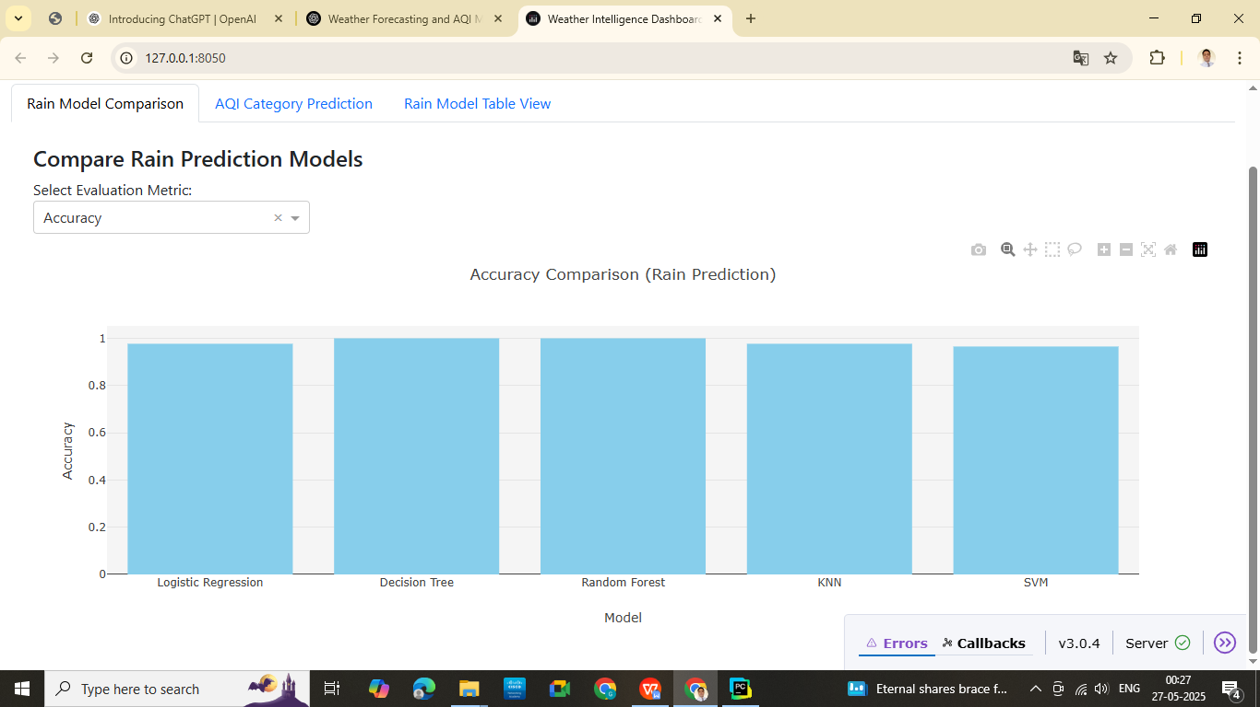

Fig 14.26:- Compare Rain Prediction Model for Using Weather Intelligence Dashboard
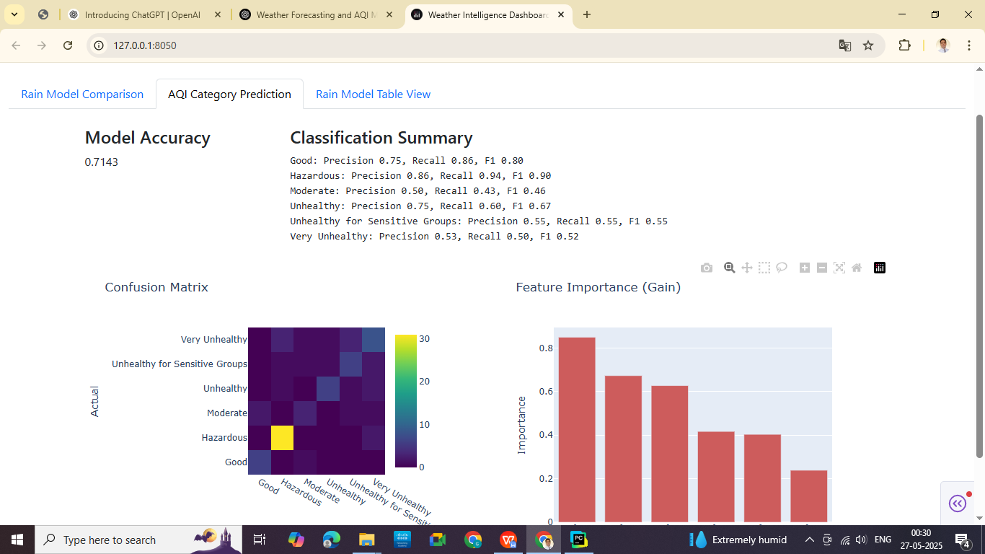
Fig 14.27:- AQI Category Prediction Model for Using Weather Intelligence Dashboard

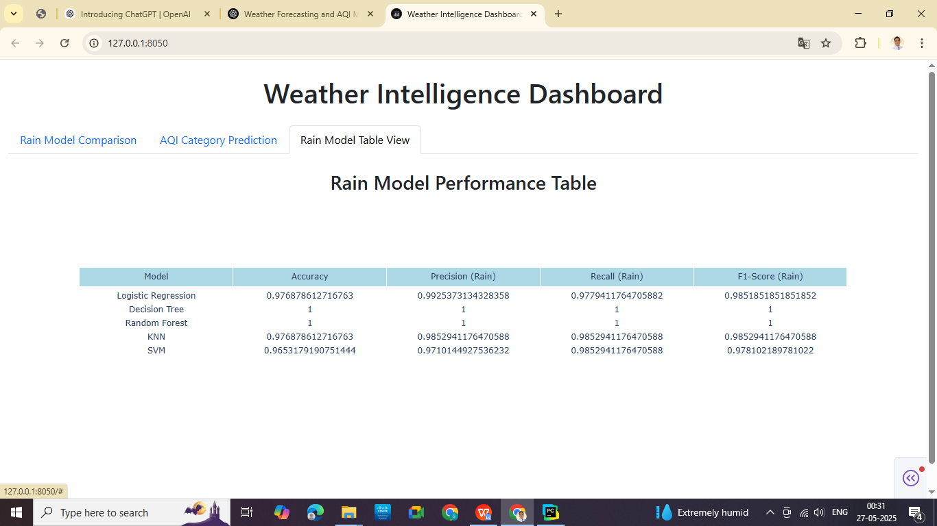
Fig 14.28:- Rain Model Performance Table for Using Weather Intelligence Dashboard

Chapter 15:- Power BI Visualization Implementation

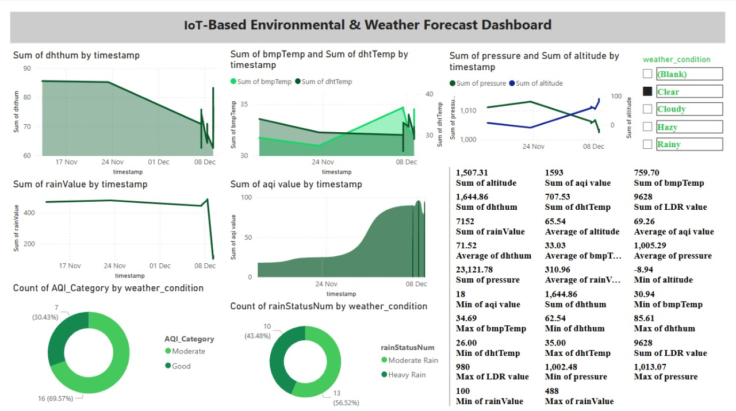
Fig 15.1:- Power BI Visualization Photo-1

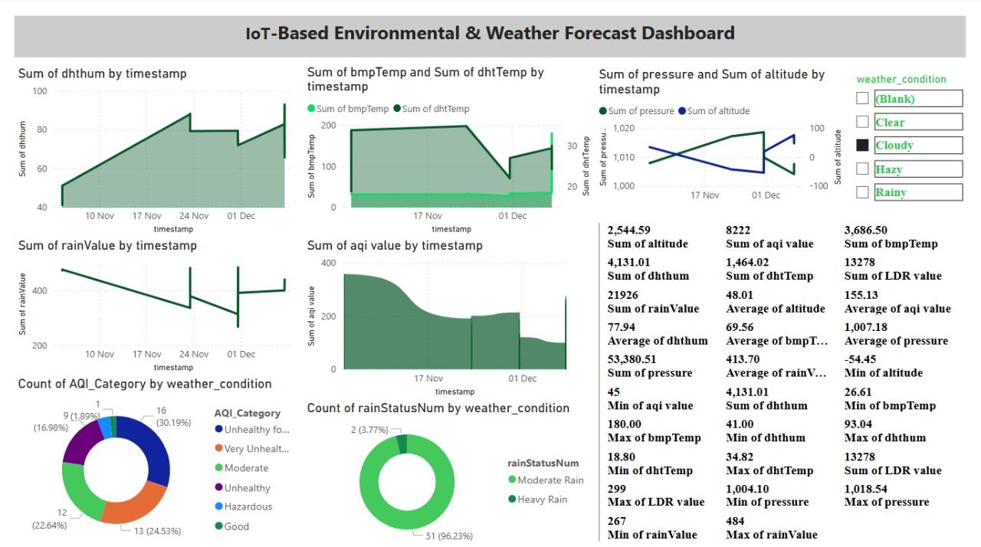

Fig 15.2:- Power BI Visualization Photo-2

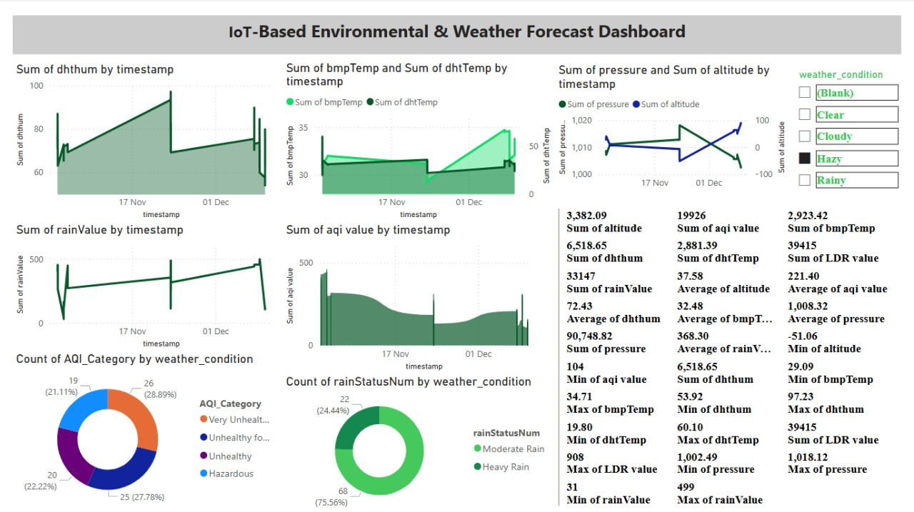

Fig 15.3:- Power BI Visualization Photo-3

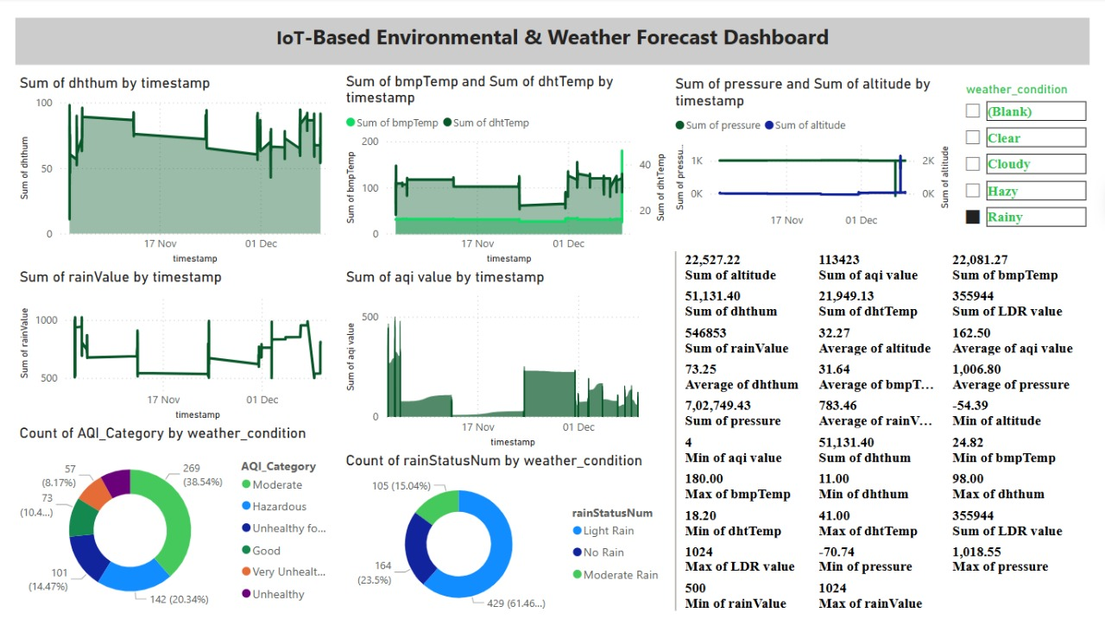
Fig 15.4:- Power BI Visualization Photo-4

Chapter 16:-Web Server & Coding Implementation
<!DOCTYPE html>
<html lang="en">
<head>
<meta charset="UTF-8">
<meta name="viewport" content="width=device-width, initial-scale=1.0">
<title>Welcome to Weather Forecast</title>
<style>
body {
font-family: Arial, sans-serif;
text-align: center;
background: linear-gradient(135deg, #2a2a72, #009ffd);
background-image: url('image4.jpg');
background-size: cover;
background-position: center;
background-attachment: fixed;
color: white;
margin: 0;
padding: 0;
}
.container {
max-width: 600px;
margin: 100px auto;
background: rgba(255, 255, 255, 0.1);
padding: 30px;
border-radius: 10px;
box-shadow: 0 4px 8px rgba(0, 0, 0, 0.2);
}
h1 {
font-size: 30px;
margin-bottom: 20px;
}
.btn {
display: inline-block;
background: #007bff;
color: white;
padding: 12px 20px;
border-radius: 5px;
margin-top: 20px;
text-decoration: none;
font-size: 18px;
}
.btn:hover {
background: #0056b3;
}
</style>
</head>
<body>
<div class="container">
<h1>Welcome Smart Weather Forecast System</h1>
<a href="channel1.html" class="btn">View Channel 1 Data</a>
<a href="channel2.html" class="btn">View Channel 2 Data</a>
</div>
</body>
</html>

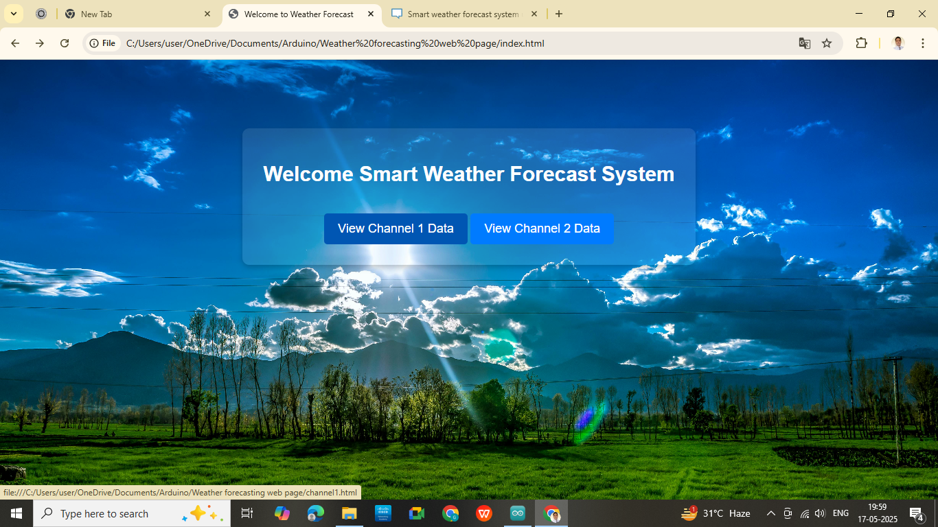
Fig 16.1:- Web server Welcome Page
<!DOCTYPE html>
<html lang="en">
<head>
<meta charset="UTF-8">
<meta name="viewport" content="width=device-width, initial-scale=1.0">
<title>Channel 1 - BMP280 Data</title>
<style>
body {
font-family: Arial, sans-serif;
text-align: center;
background: linear-gradient(135deg, #2a2a72, #009ffd);
background-image: url('image5.jpg');
background-size: cover;
background-position: center;
background-attachment: fixed;
color: white;
margin: 0;
padding: 0;
}
.container {
max-width: 600px;
margin: 50px auto;
background: rgba(255, 255, 255, 0.1);
padding: 20px;
border-radius: 10px;
box-shadow: 0 4px 8px rgba(0, 0, 0, 0.2);
}
h1 {
font-size: 28px;
margin-bottom: 20px;
}
.data-box {
font-size: 20px;
background: rgba(0, 0, 0, 0.3);
padding: 12px;
border-radius: 8px;
margin: 10px 0;
}
.btn {
background: #ff5722;
color: white;
padding: 12px 24px;
border-radius: 5px;
text-decoration: none;
display: inline-block;
margin-top: 20px;
transition: background 0.3s ease;
}
.btn:hover {
background: #e64a19;
}
.last-update {
margin-top: 10px;
font-size: 14px;
color: #ffddc1;
}
</style>
<script>
const channelId1 = '2868456';
const apiKey1 = '78W6DJ0XFSMRB9Y5';

async function fetchDataChannel1() {
const url1 = `https://api.thingspeak.com/channels/${channelId1}/feeds.json?api_key=${apiKey1}&results=1`;
try {
const response = await fetch(url1);
const data = await response.json();

if (data.feeds.length > 0) {
const feed = data.feeds[0];
document.getElementById('temperature').textContent = feed.field1 + " °C";
document.getElementById('pressure').textContent = feed.field2 + " hPa";
document.getElementById('approxAltitude').textContent = feed.field3 + " m";
document.getElementById('lastUpdate1').textContent = "Last Update: " + new Date(feed.created_at).toLocaleString();
}
} catch (error) {
console.error('Error fetching Channel 1 data:', error);
document.getElementById('lastUpdate1').textContent = "Error fetching data.";
}
}

// Fetch data initially and then every 15 seconds
setInterval(fetchDataChannel1, 15000);
window.onload = fetchDataChannel1;
</script>
</head>
<body>
<div class="container">
<h1>Real-Time BMP280 Data</h1>
<p class="data-box">Temperature: <span id="temperature">Loading...</span></p>
<p class="data-box">Pressure: <span id="pressure">Loading...</span></p>
<p class="data-box">Approx Altitude: <span id="approxAltitude">Loading...</span></p>
<p class="last-update" id="lastUpdate1">Waiting for update...</p>
<a href="index.html" class="btn">Back to Home</a>
</div>
</body>
</html>

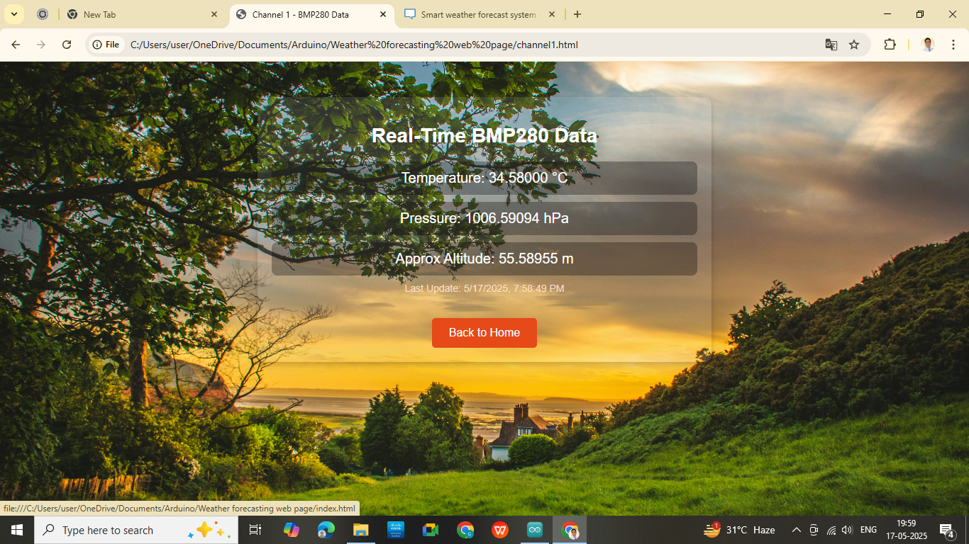
Fig 16.2:- Web Page Real Time BMP 280 Data
<!DOCTYPE html>
<html lang="en">
<head>
<meta charset="UTF-8">
<meta name="viewport" content="width=device-width, initial-scale=1.0">
<title>Channel 2 - Smart Weather Forecast System</title>
<style>
body {
font-family: 'Segoe UI', Tahoma, Geneva, Verdana, sans-serif;
text-align: center;
background: linear-gradient(135deg, #2a2a72, #009ffd);
background-image: url('image5.jpg');
background-size: cover;
background-position: center;
background-attachment: fixed;
color: white;
margin: 0;
padding: 0;
}
.container {
max-width: 700px;
margin: 60px auto;
background: rgba(0, 0, 0, 0.5);
padding: 30px;
border-radius: 15px;
box-shadow: 0 8px 16px rgba(0, 0, 0, 0.3);
}
h1 {
font-size: 28px;
margin-bottom: 25px;
}
.data-box {
font-size: 20px;
background: rgba(255, 255, 255, 0.15);
padding: 12px;
border-radius: 8px;
margin: 12px 0;
box-shadow: 0 2px 4px rgba(0, 0, 0, 0.2);
}
.btn {
background: #4caf50;
color: white;
padding: 12px 25px;
border-radius: 8px;
text-decoration: none;
font-size: 16px;
display: inline-block;
margin-top: 20px;
transition: background 0.3s ease;
}
.btn:hover {
background: #45a049;
}
.last-update {
margin-top: 15px;
font-size: 14px;
color: #e0e0e0;
}
</style>
<script>
const channelId2 = '2701253';
const apiKey2 = '5N75HGINZR7O1F9N';

async function fetchDataChannel2() {
const url2 = `https://api.thingspeak.com/channels/${channelId2}/feeds.json?api_key=${apiKey2}&results=1`;
try {
const response = await fetch(url2);
const data = await response.json();

if (data.feeds.length > 0) {
const feed = data.feeds[0];
document.getElementById('dhtTemp').textContent = feed.field1 + " °C";
document.getElementById('dhtHum').textContent = feed.field2 + " %";
document.getElementById('rainValue').textContent = feed.field4 + " ";
document.getElementById('ldrValue').textContent = feed.field3;
document.getElementById('airQuality').textContent = feed.field5;
document.getElementById('maxTemp').textContent = feed.field6 + " °C";
document.getElementById('minTemp').textContent = feed.field7 + " °C";
document.getElementById('rainStatusNum').textContent = feed.field8 + " ";
document.getElementById('lastUpdate2').textContent = "Last Update: " + new Date(feed.created_at).toLocaleTimeString();
}
} catch (error) {
console.error('Error fetching Channel 2 data:', error);
}
}

setInterval(fetchDataChannel2, 15000);
fetchDataChannel2(); // Initial fetch
</script>
</head>
<body>
<div class="container">
<h1>Channel 2: Smart Weather Forecast System using IoT & ML</h1>
<p class="data-box">Temperature: <span id="dhtTemp">Loading...</span></p>
<p class="data-box">Humidity: <span id="dhtHum">Loading...</span></p>
<p class="data-box">LDR Value: <span id="ldrValue">Loading...</span></p>
<p class="data-box">Air Quality: <span id="airQuality">Loading...</span></p>
<p class="data-box">Max Temperature: <span id="maxTemp">Loading...</span></p>
<p class="data-box">Min Temperature: <span id="minTemp">Loading...</span></p>
<p class="data-box">RainValue:<span id="rainValue">Loading...</span></p>
<p class="data-box">RainStatus:<span id="rainStatusNum">Loading...</span></p>
<p class="last-update" id="lastUpdate2">Waiting for update...</p>
<a href="index.html" class="btn">Back to Home</a>
</div>
</body>
</html>

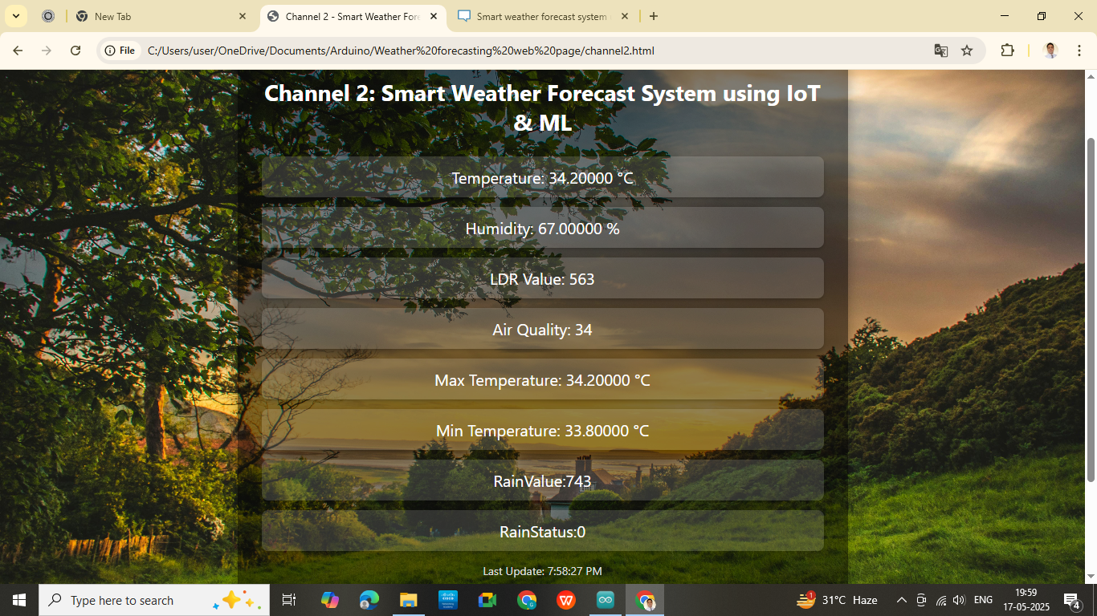

Fig 16.3:-Web Server Page Smart Weather Forecast System using IoT & ML

Chapter 17:- Additional Features

Enhanced Data Acquisition & Management:-

Multi-Sensor Data Integration: Beyond basic temperature and humidity, you're incorporating BMP280 (pressure & altitude), MQ135 (air quality), LDR (light intensity), and rain sensors. This provides a much richer dataset for comprehensive environmental monitoring. The GPS module for geo-tagging is crucial for location-based predictions and mapping.

Real-Time Data Collection and Streaming: Utilizing ThingSpeak or AWS IoT for continuous data streaming and MQTT protocol ensures lightweight and fast communication, vital for real-time applications.
Cloud-Based Data Storage: Storing historical data on platforms like InfluxDB, Firebase, or Google Sheets is essential for long-term analysis, model training, and historical trend comparisons.

Data Preprocessing and Cleaning: Crucial for model accuracy, you're addressing missing values, outliers, inconsistencies, smoothing time-series data, and normalization/feature engineering. This ensures your ML models work with high-quality data.

Advanced Machine Learning Capabilities:-

Diverse ML Algorithms: Implementing Random Forest, SVM, Naive Bayes, and XGBoost for forecasting temperature, humidity, rain probability, AQI, and general weather conditions provides a robust set of tools.

Automatic Model Retraining: This is a key feature for continuous improvement, ensuring your ML models adapt to new data and evolving weather patterns, maintaining high accuracy over time.7-Day Weather Forecast: Extending predictions to a 7-day horizon for key metrics like temperature, humidity, and AQI significantly enhances the system's utility for planning.

Historical Forecast Comparison: This crucial feature for model evaluation allows you to compare predicted vs. actual weather, displaying metrics like confusion matrix, accuracy score, and prediction error directly on the dashboard. This provides transparency and a feedback loop for ML model improvement.

Dynamic ML Model Evaluation Interface: An interface to view model performance and even switch between models for comparison offers powerful insights for optimizing your forecasting.

Sophisticated Power BI Dashboard Feature:-

Interactive and Comprehensive Visualizations: Power BI is leveraged for real-time charts (temp, humidity, AQI), geospatial maps, and advanced features like filters, slicers, drill-through capabilities, and forecasting line charts. This ensures a highly engaging and informative user experience.

Weather Classification and Alert System: Classifying weather into categories like "Clear," "Rainy," "Stormy" provides easily digestible information. The alert system for rainfall warnings, poor air quality, and temperature extremes is critical for user safety and awareness, with SMS or email alerts via IFTTT or Twilio. AQI Category Classification and Health Tags: Breaking down AQI into "Good," "Unhealthy," "Hazardous" and providing corresponding health tags like "Use Mask" or "Avoid Outdoor Activities" adds immense value for public health guidance.

Environmental Index and Health Recommendations: Calculating and displaying Discomfort Index and UV Index with actionable recommendations (e.g., "Use sunscreen," "Stay indoors," "Carry an umbrella") empowers users to make informed decisions.

User Experience & Accessibility:-

Mobile and Web Accessibility: Ensuring responsive web and mobile interfaces using modern technologies like HTML, CSS, JavaScript, Typescript, and Tailwind CSS, along with PWA for offline access, makes the system widely accessible.

Voice and Chat bot Integration: Integrating with Google Assistant or Alexa for voice queries and developing a chat bot using Dialog flow or Python NLP offers intuitive, hands-free interaction.Localization and Multi-Language Support: Crucial for a broader user base, supporting multiple languages and localized units (°C/°F, h Pa/in-Hg) makes the system globally friendly.

Export and Report Generation: Providing export options (PDF, Excel, CSV) from Power BI and automatic daily/weekly email reports caters to different user needs for data sharing and archival.

System Management & Scalability:-

Predictive Maintenance for Sensors: Monitoring sensor health, tracking anomalies, and sending alerts for calibration or replacement is a proactive approach to maintaining data integrity and system uptime.

Security and Authentication: Implementing user authentication, HTTPS/SSL encryption, and role-based access (Admin, Analyst, Viewer) ensures data security and controlled access.

Backup and Disaster Recovery: Regular data backup and auto-restart scripts for IoT devices are essential for system reliability and resilience.

System Scalability and Modularity: Designing the system to easily add new sensors or locations and support various environments (home, industrial, agricultural) ensures future growth and adaptability.

External Integrations & Future Potential:-

Integration with External Weather APIs: Using OpenWeatherMap or WeatherAPI for comparison and as a fallback during device downtime adds a layer of redundancy and validation.

Smart City Integration: The vision to integrate with smart traffic lights and pollution control systems and offer data sharing APIs for government agencies highlights a significant societal impact and future potential.

Custom Widget and IoT Device Control: The ability to create widgets for smart home devices and send control signals based on weather predictions transforms the system from mere monitoring to active automation.

Enhanced Data Acquisition & Management (Further Integrations): Your expanded list already included Satellite Imagery, Radar Data, External API, and Social Media data integration, which are advanced inputs for highly accurate forecasting. You also mentioned Anomaly Detection and Missing Data Imputation for robust data validation.

Advanced Machine Learning Capabilities (Further Refinements): Features like Ensemble Forecasting, Spatiotemporal Forecasting, Probabilistic Forecasting, Event-Based Prediction (severe weather, specific phenomena), Personalized Forecasting, and Reinforcement Learning for model adaptation demonstrate a deep understanding of state-of-the-art ML in meteorology.

Sophisticated Power BI Dashboard Features (More Visuals): Your previous suggestions for Heatmaps, Wind Roses, Multi-Variate Anomaly Charts, Comparison Dashboards, and "What If" Scenarios add tremendous depth to the visual analytics.

Advanced Alerting & Notifications (More Control): Configurable Threshold Alerts, Predictive Alerts, Multi-Channel Notifications, and Severity Levels offer highly flexible and impactful alerting mechanisms.

Historical Trend Analysis & Reporting (Deeper Insights): Long-Term Trend Analysis, Customizable Reports, and Correlation Analysis go beyond simple averages to reveal deeper insights.

User Feedback & Model Improvement Loop: Crucial for continuous improvement, this direct feedback loop will help you refine your ML models based on real-world accuracy.

Edge Computing, Containerization (Docker), Orchestration (Kubernetes), and Cloud-Native Services (AWS, Azure, GCP): These are fundamental for building a scalable, robust, and production-ready system. Application:

Chapter 18:- Applications

The Real-Time IoT Weather Forecast System using Machine Learning and Power BI Dashboard is a comprehensive solution that integrates environmental sensors, IoT connectivity, predictive analytics, and visual business intelligence tools to monitor and forecast weather conditions accurately. The key applications include:

Smart Agriculture:-Helps farmers plan irrigation, sowing, and harvesting based on real-time and predicted weather data such as temperature, humidity, rainfall, and air quality.
Disaster Management:-Enables early detection of extreme weather events like heavy rainfall or poor air quality, aiding in disaster preparedness and response planning.

Urban Planning and Smart Cities:-Assists city administrators in monitoring environmental parameters for sustainable development, pollution control, and energy-efficient infrastructure.

Environmental Monitoring:-Provides continuous tracking of air quality and weather conditions, supporting government agencies and NGOs in environmental protection efforts.

Transportation and Logistics:-Aids in route optimization and operational planning by forecasting weather conditions that could impact transport systems.

Educational and Research Use:-Useful in academic institutions for real-world demonstration of IoT, machine learning, and data visualization in weather forecasting.

Chapter 19:- Future Scope

Integration with Satellite and GIS Data: Combining ground-level sensor data with satellite imagery and GIS mapping can enhance the accuracy and scale of weather predictions.

Advanced AI and Deep Learning Models:-Employing more complex models like LSTM, CNNs, or hybrid models for time-series forecasting to improve predictive performance.

Mobile App and Notification System:-Developing a mobile application to deliver real-time alerts and forecast summaries to users.

Edge Computing Implementation:-Processing data locally at the sensor or gateway level to reduce latency and ensure faster decision-making.

Global Data Integration:-Incorporating data from global weather APIs (e.g., OpenWeatherMap, NOAA) for comparison and calibration of local predictions.

Public Dashboard and Open Data Access:-Creating public-facing dashboards for citizen engagement and encouraging open access to environmental data
.
Energy Efficiency and Solar Forecasting:-Adding solar radiation and wind speed sensors to support energy forecasting for solar panel optimization.

Scalability for Large-Scale Deployment:-Adapting the system for nationwide implementation in collaboration with meteorological departments and smart city initiatives.

Chapter 20:- Conclusion

The Real-Time IoT Weather Forecast System using Machine Learning and Power BI Dashboard successfully integrates sensor-based data acquisition, real-time monitoring, intelligent forecasting, and interactive visualization to deliver a comprehensive weather prediction platform.

By utilizing IoT devices such as DHT sensors, BMP280, LDR, and rain sensors, the system captures key environmental parameters with high accuracy. The application of machine learning algorithms enables predictive insights such as future temperature trends, rainfall likelihood, and air quality classification.

The system's real-time visualization using Power BI ensures that users—from individuals to decision-makers—can easily interpret complex weather data and make informed choices.

This project not only demonstrates the potential of combining IoT and machine learning but also showcases how data analytics and business intelligence tools can transform raw data into actionable information.

In conclusion, the project addresses the growing need for accurate, accessible, and real-time weather forecasting. It offers scalable potential for smart agriculture, urban planning, disaster management, and environmental sustainability, making it a valuable contribution to the advancement of smart technologies in climate monitoring and prediction.

References

Mark Holmstrom, Dylan Liu, Christopher Vo, “Machine Learning Applied to Weather Forecasting Stanford University, 2016.

Piyush Kapoor and Sarabjeet Singh Bedi “ Weather Forecasting Using Sliding Window Algorithm”, Kvantum Inc., Gurgaon 122001, India MJP Rohilkhand University, Bareilly 243006, India, 2013

DivyaChauhan, Jawahar Thakur “ Techniques for Weather Prediction: A Review 5, India: ISSN, 2013.

Qing Yi Feng1 , RuggeroVasile,Marc Segond4 , AviGozolchiani, Yang Wang , Markus Abel , ShilomoHavlin, Armin Bunde, and Henk A. Dijkstra1 “ ClimateLearn: A machine-learning approach for climate prediction using network measures,”, Germany,
2016.

Siddharth S. Bhatkande1 ,Roopa G. Hubballi2 “Weather Prediction Based on Decision Tree Algorithm Using Data Mining Techniques”, Belgaum India: International Journal of Advanced Research in Computer and Communication Engineering, 2016.

Sanyam Gupta, Indumathy , GovindSinghal “ Weather Prediction Using Normal Equation Method and Linear regression Techniques” , Vellore, Tamil Nadu, India: International Journal of Computer Science and Information Technologies, 2016.

Muthulakshmi A, ME (SE), Dr.S.BaghavathiPriya “ A survey on weather forecasting to predict rainfall using big data analytics”, Chennai.: IJISET , 2015.

Aditya Grover, AshishKapoor, Eric Horvitz (n.d.) “A Deep Hybrid Model for Weather Forecasting”, : Microsoft Research, Redmond.

John K. Williams and D. A. Ahijevych, C. J. Kessinger, T. R. Saxen, M. Steiner and S. Dettling National Center for Atmospheric Research, Boulder, Colorado (n.d.) “ A MACHINE LEARNING APPROACH TO FINDING WEATHER REGIMES AND SKILLFUL PREDICTOR COMBINATIONS FOR SHORT-TERM STORM FORECASTING”, Colorado.

S.V.Manikanthan and T.Padmapriya “Recent Trends In M2m Communications In 4g Networks And Evolution Towards 5g”, International Journal of Pure and Applied Mathematics, ISSN NO:1314-3395, Vol-115, Issue -8, Sep 2017.

S.V. Manikanthan, T.Padmapriya “An enhanced distributed evolved node-b architecture in 5G telecommunications network” International Journal of Engineering & Technology (UAE), Vol 7 Issues No (2.8) (2018) 248-254.March2018.

- V. Manikanthan, T. Padmapriya, Relay Based Architecture For Energy Perceptive For Mobile Adhoc Networks, Advances and Applications in Mathematical Sciences, Volume 17, Issue 1, November 2017, Pages 165-179

- Satra, R. Satra, and A. Rachman, “Pengembangan Sistem Monitoring Pencemaran Udara Berbasis Protokol ZIGBEE dengan Sensor CO,” Ilk. J. Ilm., vol. 8, no. 1, pp. 17–22, Apr. 2016.

- K. Faroqi, Adam Hadisantoso, Eko Prabowo Halim and M. S. WS, “Perancangan Alat Pendeteksi Kadar Polusi Udara Menggunakan Sensor Gas MQ-7 Dengan Teknologi Wirelles HC-05,” J. ISTEK, vol. X, no. 2, pp. 33–47, 2016.

- F. Arya, M. Faiqurahman, and Y. Azhar, “Aplikasi Wireless Sensor Network untuk Sistem Monitoring dan Klasifikasi Kualitas Udara,” J. Sist. Inf., vol. 14, no. 2, pp. 74–82, Oct. 2018.

F. M. Rizon, “Alat Pendeteksi Udara Di Dalam Mobil Menggunakan Arduino Uno,”Jumantaka, vol. 02, no. 01, pp. 31–40, 2018.
I. Journal, D. Srivastava, A. Kesarwani, and S. Dubey, “IRJET-Measurement of Temperature and Humidity by using Arduino Tool and DHT11 Measurement of Temperature and Humidity by using Arduino Tool and DHT11,” Int. Res. J. Eng. Technol., vol. 876, 2008.

“Hands-On Internet of Things with Blynk: Build on the power of Blynk to ... -Pradeeka Seneviratne Google Buku.” [Online]. Available:https://books.google.co.id/books?hl=id&lr=&id=ZHteDwAAQBAJ&oi=fnd&pg=PP1&dq=blynk+application&ots=K0_6c9QtiO&sig=46c3ZhLFuy36t01nI2oYXo63fN4&redir_esc=y#v=on page&q=blynk application&f=false. [Accessed: 30-Apr-2022].

- H. Hareva and C. D. P. Marsyaf, “Air quality monitoring at Pelita Harapan University using the MQ135 sensor,” ACM Int. Conf. Proceeding Ser., pp. 6–10, Nov. 2019.

H. Ouldzira, A. Mouhsen, H. Lagraini, M. Chhiba, A. Tabyaoui, and S. Amrane, “Remote monitoring of an object using a wireless sensor network based on NODEMCU ESP8266,” Indones. J. Electr. Eng. Comput. Sci., vol. 16, no. 3, pp. 1154–1162, 2019.
F. N. Abbas, I. M. Saadoon, Z. K. Abdalrdha, and E. N. Abud, “Capable of gas sensor MQ135 to monitor the air quality with arduino uno,” Int. J. Eng. Res. Technol., vol. 13, no. 10,pp. 2955–2959, 2020.

A. D. Hendra Saptadi Sekolah Tinggi Teknologi Telematika Telkom Purwokerto Jl I Panjaitan No, “Perbandingan Akurasi Pengukuran Suhu dan Kelembaban Antara Sensor DHT11 dan DHT22,” J. INFOTEL, vol. 6, no. 2, pp. 49–56, Nov. 2014.
R. A. Gustavia and E. Nurraharjo, “Rancang Bangun Sistem Multiple Warning Deteksi Asap Rokok,” Pros. SINTAK 2018, pp. 278–282, 2018.

- A. Rosa, B. A. Simon, and K. S. Lieanto, “Sistem Pendeteksi Pencemaran Udara Portabel Menggunakan Sensor MQ-7 dan MQ135,” Ultim. Comput. J. Sist. Komput., vol. 12, no. 1, pp. 23–28, Jul. 2020.

Albaladejo-Perez, C., Soto Valles, F., Torres Sanchez, R., Jimenez Buendia, M., Lopez-Castejon, F. &Gilabert Cervera, J. 2017. Design and Deployment of a Wireless Sensor Network for the Mar Menor Coastal Observation System. IEEE J. Oceanic Eng., 42(4): 966 976https://doi.org/10.1109/JOE.2016.2639118Asaad, I., Lundquist, C.J., Erdmann, M.V & Costello,

- J. 2018. Delineating priority areas for marine biodiversity conservation in the Coral Triangle. Biolog. Conserv., 222: 198–211. https://doi.org/10.1016/j.biocon.2018.03.037

Bello, O. & Zeadally, S. 2022. Internet of underwater thingscommunication: Architecture, technologies, research challenges and future opportunities. Ad Hoc Networks, 135: p.102933 https://doi.org/10.1016/j.adhoc.2022.102933

Bolanakis, D.E. 2017. Evaluating performance of MEMS barometric sensors in differential altimetry systems. IEEE Aerosp. Electron. Syst. Mag., 32(9): 34–39. https://doi.org/10.1109/MAES.2017.160248

Bolanakis, D.E., Kotsis, K.T. & Laopoulos, T. 2015. A prototype wireless sensor network system for a comparative evaluation of differential and absolute barometric altimetry. IEEE Aerosp. Electron. Syst. Mag.,30(11):20–https://doi.org/10.1109/MAES.2015.150013

Bosch Sensortec. 2015. BMP280: Datasheet. Retrieved from https://cdn-shop.adafruit.com/datasheets/BST-BMP280-DS001-11.pdfBudihartono, E., Afriliana, I. & Rakhman, A. 2020. Analisa Penggunaan Alat Pengukur Ketinggian Menggunakan. Smart Comp., 9(1): 31–34. https://doi.org/10.30591/smartcomp.v9i1.18 16

Dickow, A. & Feiertag, G. 2014. A framework for calibration of barometric MEMS pressure sensors. Procedia Eng., 87: 1350–1353. https://doi.org/10.1016/j.proeng.2014.11.716

Dina, A., Atmodjo, W. & Setiyo Pranowo, W. 2019. Karakteristik Pasang Surut di Teluk Jakarta Berdasarkan Data 253 Bulan. J. Riset Jakarta, 12(1):25–36. https://doi.org/10.37439/jurnaldrd.v12i1.7

Fadholi, A. 2013. Study Pengaruh Suhu Dan Tekanan Udara Terhadap Operasi Penerbangan Di Bandara H.A.S. Hananjoeddin Buluh Tumbang Belitung Periode 1980-2010. J. Penelitian Fisika Dan Aplikasinya, 3(1): 110. https://doi.org/1026740/jpfa.v3n1.p1-10

Fadly, R. & Dewi, Ci. 2019. Pengembangan Sensor Ultrasoic Guna Pengukuran Pasang Surut Laut Secara Otomatis dan Real Time. J. Rekayasa, 23(1): 1–16.

Ganev, B., Nikolov, D. & Marinov, M.B. 2020. Performance evaluation of MEMS pressuresensors. 11th National Conf. Int. Participation, Electronica 2020 - Proceedings, p.23–26 . https://doi.org/10.1109/ELECTRONICA50406.2020.9305140
Giancoli, D.C. 2001.

Fisika 1 (fifth). Jakarta: Erlangga.Guo, Y., Han, Q. & Kang, X. 2020. Underwater sensor networks localization based on mobilityconstrained beacon. Wirel. Netw., 26(4): 2585–2594. https://doi.org/10.1007/s11276-019-02023-5Haq, M. R. & Ni, Z. 2019.

A new hybrid model for short-term electricity load forecasting. IEEE Access, 7: p.125413–125423. https://doi.org/10.1109/ACCESS.2019.2937222

Haq, N.A., Khomsin & Pratomo, D.G. 2021. The Design of an Arduino Based Low-Cost Ultrasonic Tide Gauge with the Internet of Things (IoT) System. IOP Conf. Ser. Earth Environ. Sci., 698(1): p.012004 https://doi.org/10.1088/1755-1315/698/1/012004

Hossain, D., Imtiaz, M.H. & Sazonov, E. 2020. Comparison of Wearable Sensors for Estimation of Chewing Strength. IEEE Sens. J., 20(10): 5379–5388. https://doi.org/10.1109/JSEN.2020.2968009

Indrabayu, Pallu, S., Achmad, A., Areni, I. S. &Bustamin, A. 2020. A prototype of low cost weather station for data spatial and temporal analysis. ICIC Express Letters, 14(11): 1121–1127. https://doi.org/10.24507/icicel.14.11.1121

Intergovernmental Oceanographic Commission. 2006. Manual on Sea Level Measurement and Interpretation, Volume IV: An Update to 2006. IOC Manuals and Guides No.14, Vol. IV ; JCOMM Technical Report No. 31.

Wang, R.Q., Stacey, M.T., Herdman, L.M.M., Barnard, P.L. & Erikson, L. 2018. The Influence of Sea Level Rise on the Regional Interdependence of Coastal Infrastructure. Earth’s Future, 6(5):677–688. https://doi.org/10.1002/2017EF000742

Xia, H., Wang, X., Qiao, Y., Jian, J. & Chang, Y. 2015. Using Multiple Barometers to Detect the Floor Location of Smart Phones with Built-in
Barometric Sensors for Indoor Positioning. Sensors, 15(4): 7857–7877. https://doi.org/10.3390/s150407857

Yulkifli, Asrizal & Ardi, R. 2014. Pengukuran Tekanan Udara Menggunakan Dt-Sense Barometric Presure Berbasis Sensor Hp03. J. Sainstek IAIN
Batusangkar, 6(2): 110–115. https://doi.org/10.31958/js.v6i2.110
Amin, M. (2020) ‘InfoTekJar : Jurnal Nasional Informatika dan Teknologi Jaringan Sistem Cerdas Kontrol Kran Air Menggunakan Mikrokontroler Arduino dan Sensor Ultrasonic’, 2, pp. 0–4.

Doni, R. and Rahman, M. (2020) ‘Sistem Monitoring Tanaman Hidroponik Berbasis Iot ( Internet of Thing ) Menggunakan Nodemcu ESP8266’, 4(September), pp. 516–522.

Esp, N. (2020) ‘MIKROKONTROLER NODEMCU DAN APLIKASI TELEGRAM’, 1(1), pp. 8–14.

Informatika, T. et al. (no date) ‘Sistem Monitoring Suhu Dan Kelembaban Ruang Produksi Berbasis Wireless Sensor Network Pada Pt . Xxx Manufacturing Services Indonesia’, pp. 136–143.

Najmurrokhman, A, Kusnandar, A. (2018) ‘Prototipe Pengendali Suhu Dan Kelembaban Untuk Cold Storage Menggunakan Mikrokontroler Atmega328 Dan Sensor

Shivang, S. S. Sridhar, “Weather prediction for indian location using Machine learning,” International Journal of Pure and Applied Mathematics, vol. 118, no. 22 pp. 1945-1949, 2018.

Z. U. Khan and M. Hayat, “Hourly based climate prediction using data mining techniques by comprising entity demean algorithm” Middle-East Journal of Scientific Research 21, vol. 8, pp. 1295-1300, 2014.

S. S. Bhatkande1, R. G. Hubballi2, “Weather Prediction Based on Decision Tree Algorithm Using Data Mining Techniques.” Belgaum India: International Journal of Advanced Research in Computer and Communication Engineering, vol. 5, no.5, pp. 483-48, 2016.

Y. Radhika, and M. Shashi, “Atmospheric temperature prediction using support vector machines.” International Journal of Computer Theory and Engineering 1.1, vol. 1, no. 1, pp.1793-8201, 2009.

D. Chauhan, J. Thakur, “Data mining techniques for Weather Prediction:” International Journal of Computer Science Trends and Technology (IJCST), vol. 6, issue 3, pp.249-254, 2018.

S.S. Badhiye, B. V. Wakode, P. N. Chatur, “Analysis Of Temperature And Humidity Data For Future Value Prediction” International Journal Of Computer Science And Information Technologies , vol. 3, no.1 pp.3012- 3014, 2012.

F. Olaiya, Adesesan Barnabas Adeyemo, “Application of Data Mining Techniques in Weather Prediction and Climate Change Studies”, IJCSNS International Journal of Computer Science and Network Security, vol.17, no.6, pp 22-25, 2017 .
G. J. Sawale, S. R. Gupta, “Use of Artificial Neural Network in Data Mining For Weather Forecasting”, International Journal Of Computer Science And Applications vol. 6, no.2, pp.383-387, 2013.

- Gautam, G. Verma, S. Qamar, S. Shekhar, “Vehicle Pollution Monitoring, Control and Challan SystemUsing MQ2 Sensor Based on Internet of Things”, Wireless Personal Communications (An International Journal of Springer with impact factor of 1.2), November 2019. https://doi.org/10.1007/s11277-019-06936-4

Arduino UNO R4 — Arduino Official Store, accessed on May 17, 2025, https://store.arduino.cc/pages/uno-r4

An overview of different UNO boards - Arduino Help Center, accessed on May 17, 2025, https://support.arduino.cc/hc/en-us/articles/7901453165724-An-overview-of-different-UNO-boards

Arduino UNO R4 WiFi User Manual, accessed on May 17, 2025, https://docs.arduino.cc/tutorials/uno-r4-wifi/cheat-sheet

Arduino® UNO R4 WiFi, accessed on May 17, 2025, https://store.arduino.cc/products/uno-r4-wifi

