VITyarthi---Build your own project
STUDENT MONEY TRACKER
Course : Introduction to problem solving and programming
Submitted by : BANI MISHRA
Reg. no. : 26BCE10165

- PROJECT OBJECTIVE
The objective of the student money tracker project is to develop a simple and practical Python based application that helps users record , manage and review their personal income and expenses. The project applies programming concepts such as variables, conditional statements, loops , functions, modules, classes, file handling, JSON storage, exception handling and testing in a real world context.
. Identify the common problem of manually tracking income and daily expenses.
.Design a simple menu- driven solution for students and working professionals.
. Allows users to record income and expenses with appropriate categories.
. Calculate the available balance automatically.
. Validate user input and handle invalid entries safely.
. Store transaction information locally so that it can be loaded again.
. Demonstrate modular programming ,documentation and testing.
2.SCOPE AND REQUIREMENTS
The Money tracker is a console based personal finance management application . It is designed for users who want a simple method of recording basic financial transactions without using a complex banking applications.
2.1 SCOPE
. student mode provides categories relevant to students such as food, travel, rent and shopping.
.Professional mode provides categorized such as food , rent, travel , and shopping .
. users can add income and expenses .
.Users can view their current balance and transaction history.
. Users can generate a category-wise expense report .
. Transaction data can be stored locally.
. The project does not perform online banking , payments or real bank transactions.

2.2 functional requirements
Functional requirements describe4s the features and capablities provided by the system .
. user type selection: The user can select student or professional mode.
. Add income : The user can enter an income amount and description.
. Add expenses : The user can enter an amount , category and description.
. Balance calculations : The system calculates total income minus total expenses .
. Transaction history: The system calculates and displays expenses according to category.
. Category report : The system calculates and display expenses according to category.
. Data storage : Transactions can be saved to and loaded from a file.
. Input validation : The system rejects invalid amounts and invalid menu choices.
. Save and exit : The system saves the current data before exiting.

2.3 . Non functional requirements :
. Performance: The application should respond quickly to normal user operations.
. Usability: The menu and messages should be simple and understandable or beginners.
. Reliability: The system should calculate balance consistently and handle invalid input.
Maintainability: The code is divided into separate modules so that individual components can be modified easily .
. Scalability : Additional categories , reports and features can be added in future versions.
. Error handling: Invalid numeric input , invalid choices and file error are handled without unexpectedly terminating the program.
.Resource efficiency: the application uses lightweight python operations .
. Security : The application does not connect to banking systems or expose financial information online .
2.4 Reliability:
Reliability is achieved through input validation , controlled menu choices , exception handling and testing of important transaction operations . The application avoids accepting negative and numeric transaction amounts and provides meaningful error messages.
2.5 Scalability:
The modular structure allows the project to be extended with features such as monthly budgets , data filtering , charts , csv export, pdf exports , SQLites storage and graphical user interface without rewriting the complete application .
2.6 Maintainability :
The application separates the user interface transaction logic, data model , validation , reporting and storage into different files. This makes the code easier to understand, debug and update .
2.7 Error handling strategy:
The application uses validation and exception handling to manage invalid user input. For example, non-numeric amounts area rejected , zero or negative amounts are not accepted invalid menu choices diplay and error message is handled when loading stored transactions .
2.8 Logging or monitoring :
The current version provides user-facing status messages such as successful transaction entry , invalid input notifications and successful data saving . In a future version , a python logging system can be added to record application events and errors in a log file.
2.9 Resource efficiency:
The application uses simple in memory data structures and a local file . it does not requires a database server and continous internet connection , making it lightweight for a small personal finance application .
- Technical expectations
  - architectural design :
the project follows a modular architecture . main.py controls the user interaction, model.py defines the Transaction object, transaction. Py manages transaction operations ,generates financial summaries and storage . py handles data storage .
  - application of subject concepts :
. Variable and data types are used for storing amounts , categories and descriptions.
. Conditional statements control menu choice and transaction types .
. Loops repeatedly display menu until the user selects Save and Exit.
. Functions divide the program into reusable operations .
. Classes and objects represents individual transactions .
. Lists and dictionaries organize transaction data .
. Exceptions handling manages invalid input and file error.
. Testing verifies important application behaviour .
  - Modular and clean implementation
The implementation is divided into meaningful python modules instead of placing all functionality in a file. This improves readability, testing and maintainability .
  - documentation and comments
the project contains README.md , statement.md and a detailed project report. Function and module purposes are explained through meaningful names and documentation.
  - validation and error handling
the application validated amounts , menu selections and text inputs.
  - project modules / files
.main.py : controls menus and overall program flow .
. modal.py : defines the transaction class .
. transaction.py : manage income, expenses , balance and transactions.
. tests.py: validates important functions.
.README.md : explains the project and how to run it.
. statement . py : contains problems , scope , target users and features.
- Design and documentation requirements :
  - Problem statement
Student frequently record their income and dailky expenses manually. This can make it difficult to calculate the remaining balance and understand where the money is being spent. A simple digital system is therefore required to record transactions , calculate the balance and provide basic spending information.
  - Objectives
. Create a simple personal money management system.
. Record income and expenses accurately .
. Calculate the current balance automatically.
. Organize expenses into categories .
. Provide useful transaction and spending reports .
. Apply python programming and software design concepts.
  - Functional requirements
The system supports user-type selection , income entry , expenses entry , balance calculation, transaction history, category reporting , data storage and input validation.
  - Non – functional requirements
The system should be usable , reliable, maintainable , scalable , efficient and capable of handling invalid input safely .
4.5 project flow design

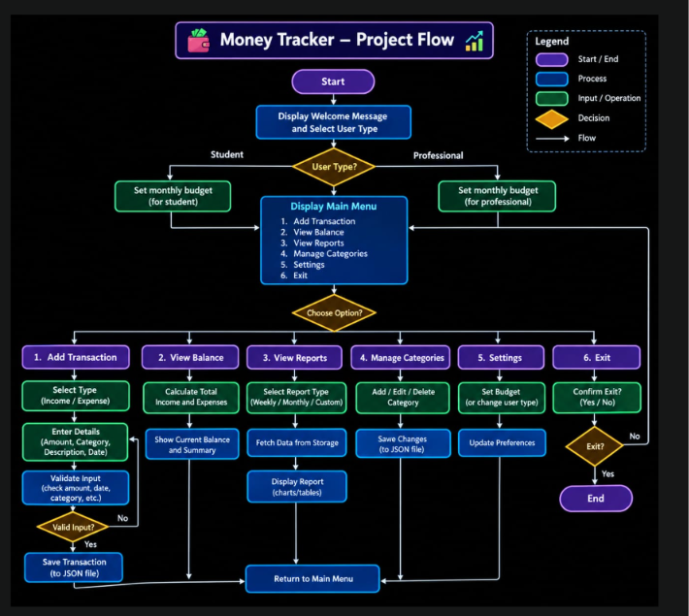
4.6 Use case diagram 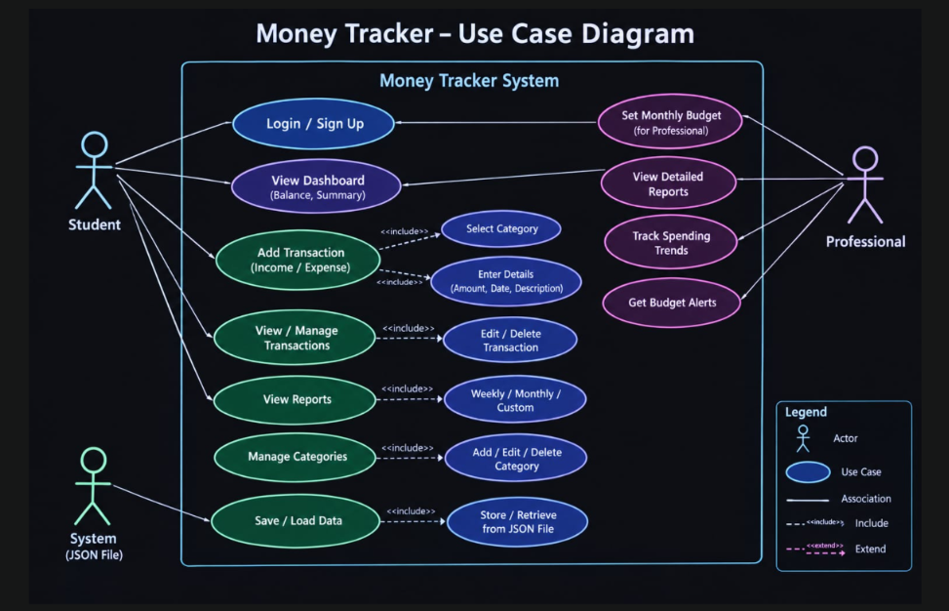

4.7 User component diagram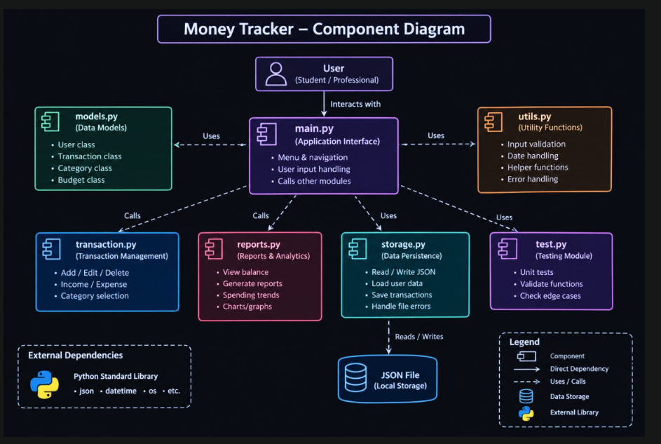

4.8 Sequence diagram 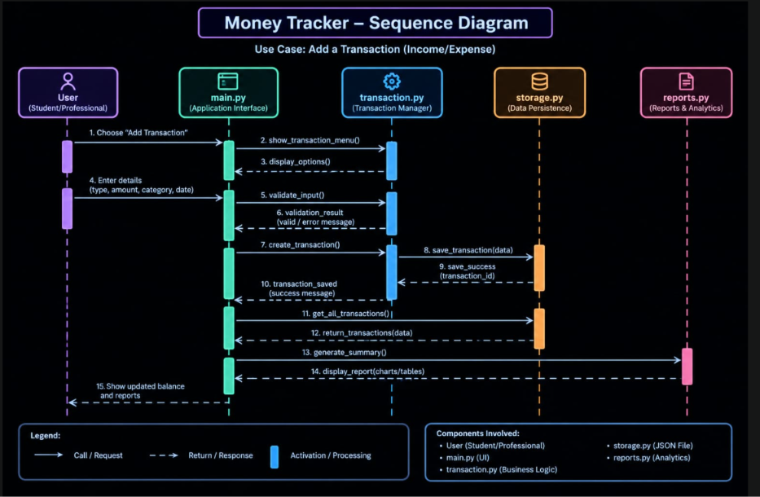

Design decision & rationale:
. Python was selected because it is suitable for rapid development and learning programming concepts.
. A Transaction class was selected to represent transaction data in a organized way.
. Separate modules were selected to represent transaction data in an organized way.
. A console interface was selected to keep the first version simple and focused on core programming concepts.
Implementation details:
The implementation uses python functions classes list dictionaries loops conditions exception handling and file operations.

Screenshots/ Results :
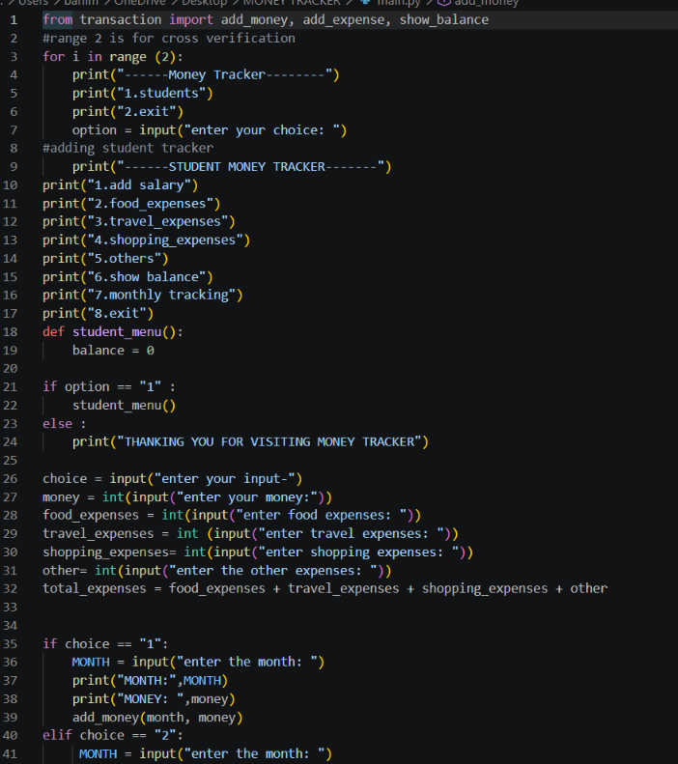

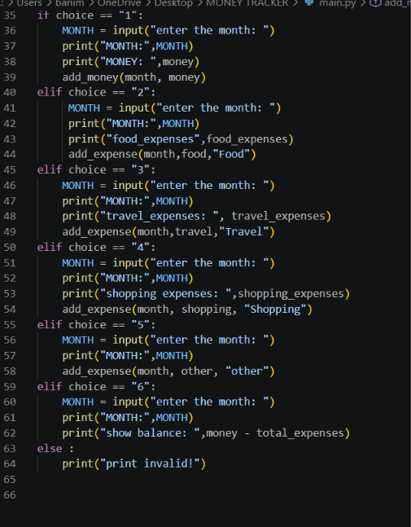
Testing approach:
The project uses test.py to validate income addition, expense calculation, multiple expenses and transaction count. Manual tests are also performed for invalid amounts, invalid menu selections and empty transaction history.
Challenges Faced :
. Designing a simple but complete menu driven workflow.
. Connecting multiple python functions and modules .
. Maintaining the balance when income and expenses are added.
. Handling invalid user input .
. Testing different transaction scenarios.
Learning & key takeaways:
. Improved understanding of python functions and modules.
. learned how classes and objects can model real- world entities.
. Practiced lists, dictionaries, loops and conditional statements.
. Learned input validation and exception handling .
. learned basic file handling.
. Learned how to organize a multi-file python project.
. Learned the importance of testing and documentation.
Future enhancements:
. Graphical user interface (GUI )
. SOLite database
. Monthly and yearly budget tracking
. Date-wise transaction filtering
. CSV and PDF report export
. User authentication and password protection.
. Automatic monthly summaries.
References
. Python documentation – Python programming language documentation.
. Git documentation .
. Course notes and classroom material..

