**Assignment 6 – Python Registration Script**

**Introduction**

This week, I learned how to create a program that utilizes classes and functions to register students, display the information, and save the data to a JSON file. The information below breaks down the steps of how I was able to create this program.

**Creating the Program**

Creating classes

This assignment was taking my existing program and restructuring it into two main classes the IO class and the FileProcessor class.

IO Class

The first goal was to create the IO class that was responsible for the outputting and inputting of all data. These includes the following functions: output_error_messages, output_menu, input_menu_choice, output_student_courses, input_student_data **(Figure 1.1, 1.2, 1.3, 1.4, 1.5)**.

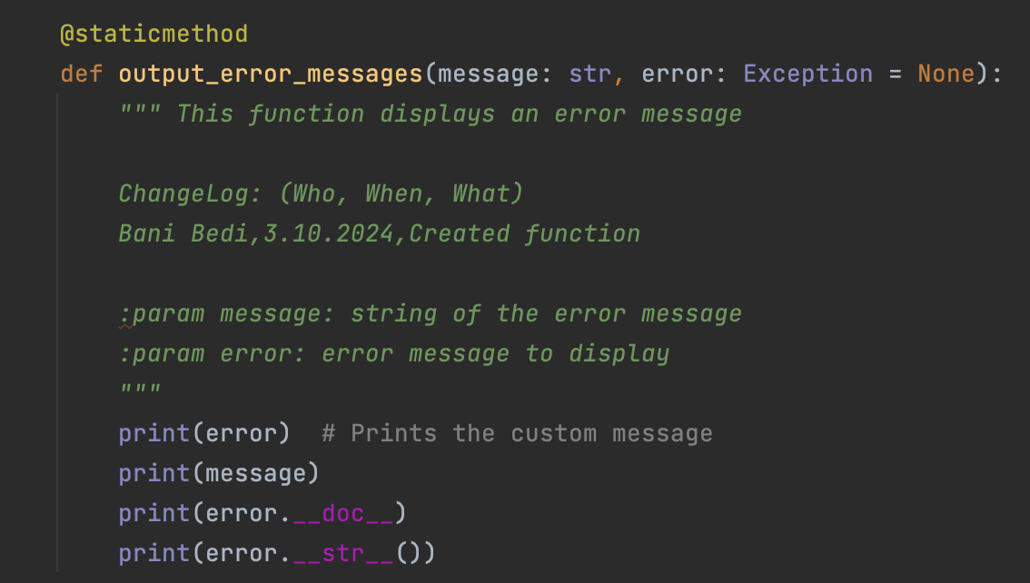

**Figure 1.1**: Added output_error_messages function to IO Class.

.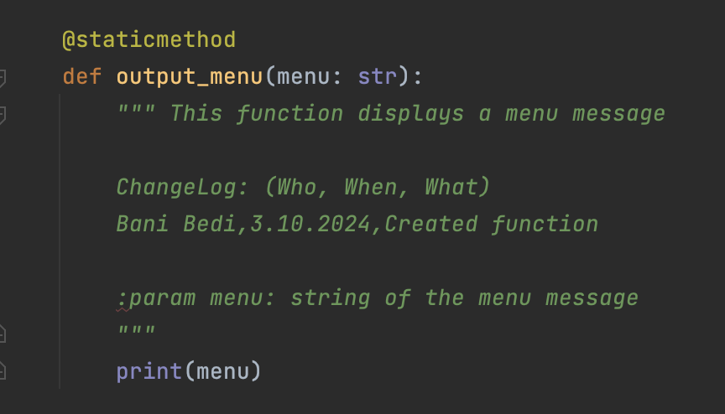

**Figure 1.2**: Added output_menu function to IO Class.

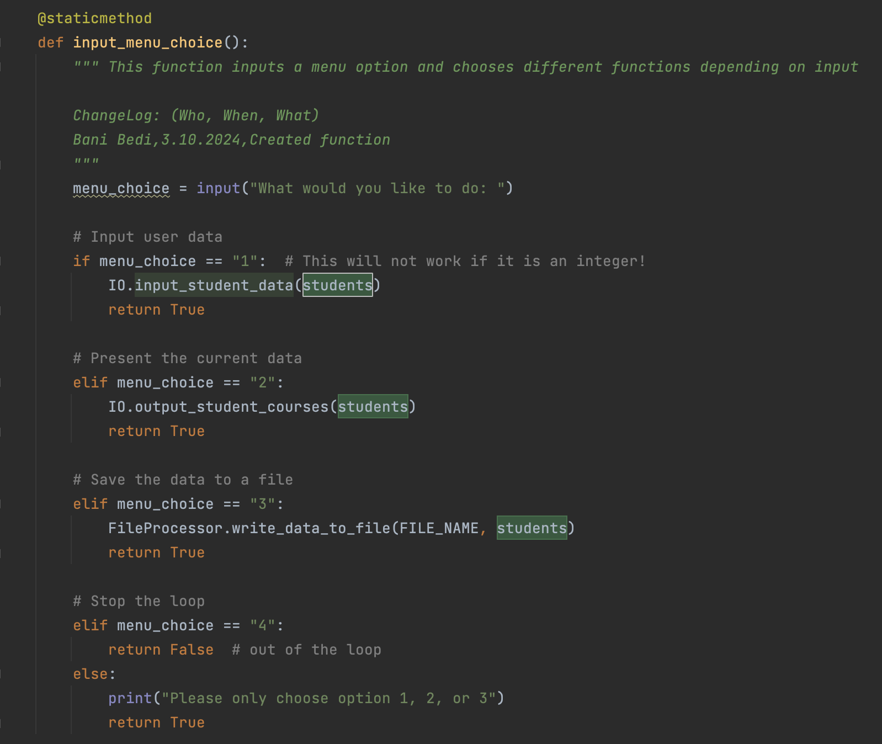

**Figure 1.3**: Added input_menu_choice function to IO Class.

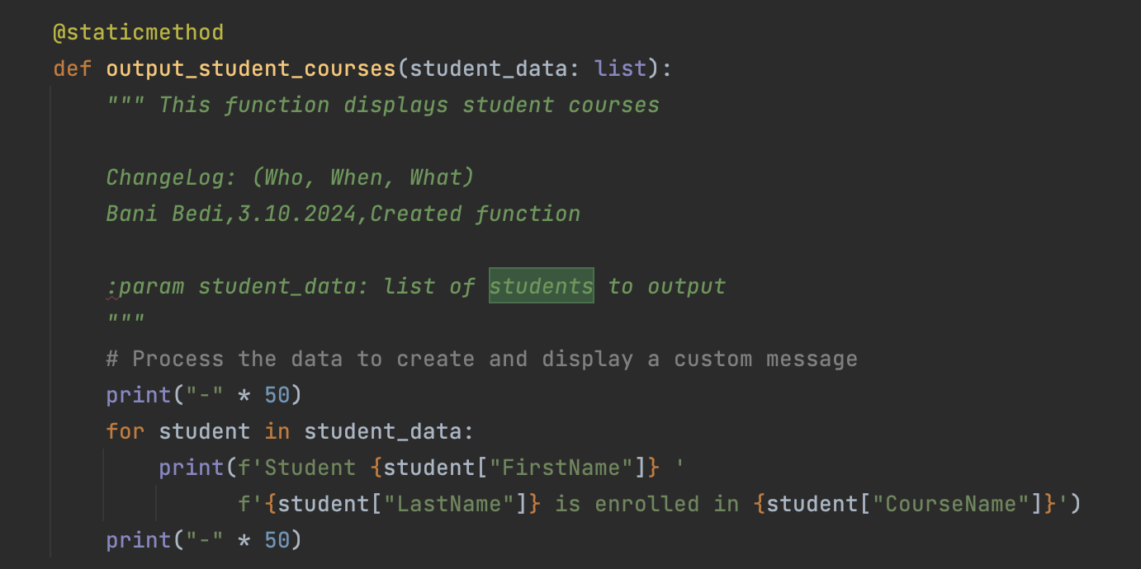

**Figure 1.4**: Added output_error_messages function to IO Class.

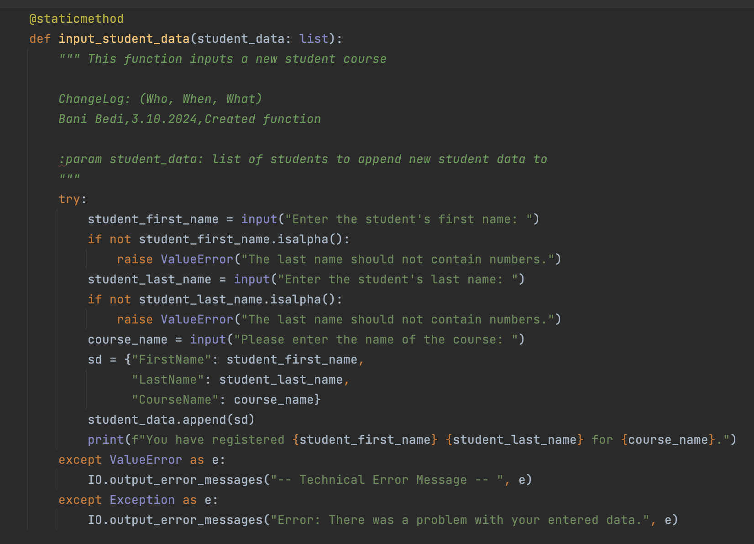

**Figure 1.5**: Added input_student_data function to IO Class.

FileProcessor Class

The second goal was to create the FileProcessor class that was responsible all file data saving and retrieving. These includes the following functions read_data_from_file and write_data_to_file **(Figures 1.6, 1.7)**.

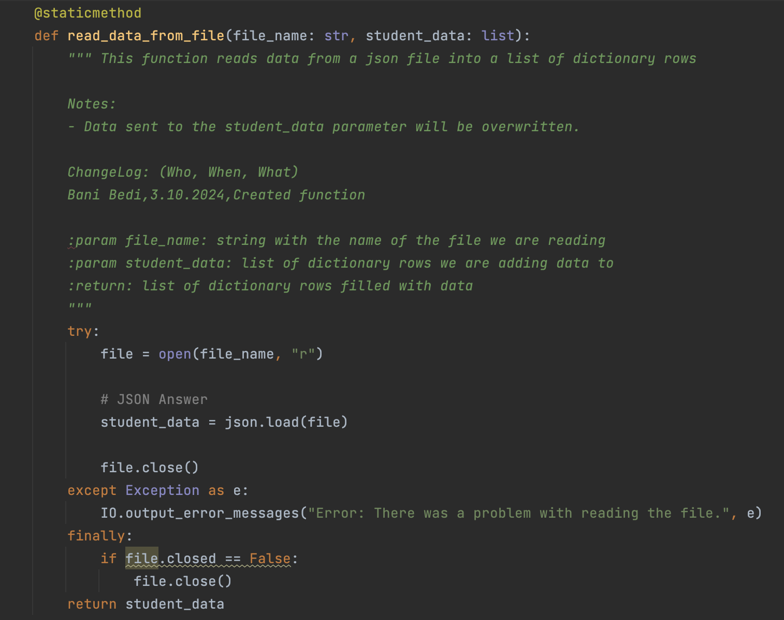

**Figure 1.6**: Added read_data_from_file function to FileProcessor Class

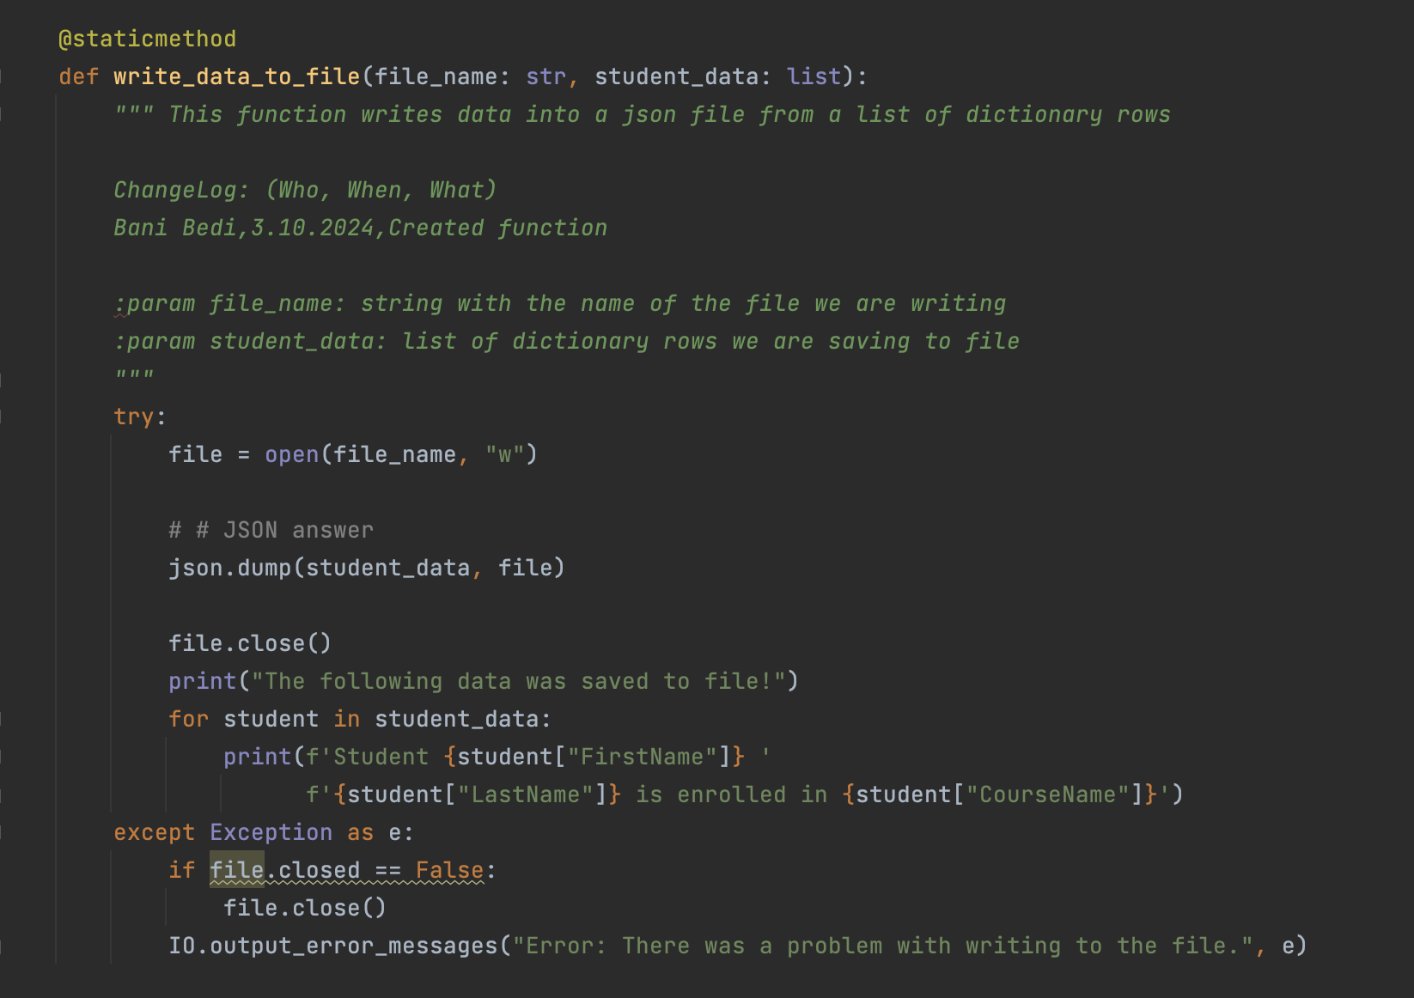

**Figure 1.7**: Added write_data_to_file function to FileProcessor Class

**Summary**

In this project, I successfully created a Python registration script that allowed a user to enter an unlimited amount of students’ first, last, and course names; display them in the program; and save them in a JSON file. I employed key programming elements such as classes and functions to achieve this outcome. I, then, tested my program in both the terminal and PyCharm to ensure that it works **(Figure 1.8, Figure 1.9).**

**Figure 1.8:** An image of the Python Registration Script in PyCharm.

**Figure 1.9:** The code successfully working in Terminal.