**Assignment 7 – Python Registration Script**

**Introduction**

This week, I learned how to create a program that utilizes classes and functions to register students, display the information, and save the data to a JSON file. The information below breaks down the steps of how I was able to create this program.

**Creating the Program**

Creating classes

This assignment was taking my existing program and adding two new classes the Person class and the Student class.

Person Class

The first goal was to create the Person class that is responsible for representing a person who has a first_name and a last_name. These includes the following functions: constructor, first_name getter and setter, last_name getter and setter, and a __str__ override function **(Figure 1.1, 1.2, 1.3, 1.4)**.

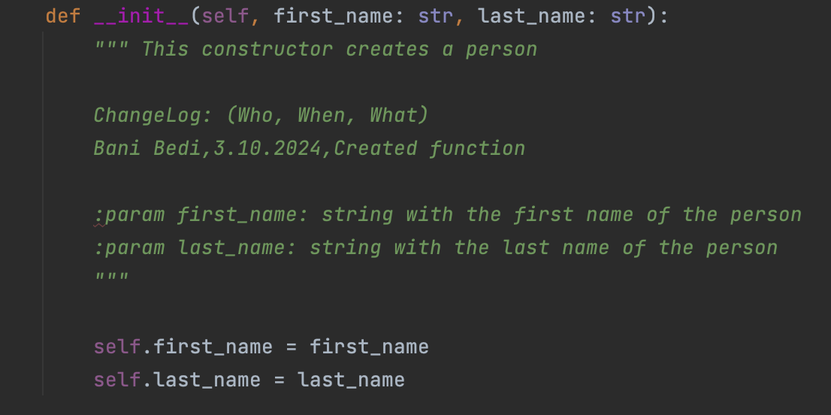

**Figure 1.1**: Added Person constructor.

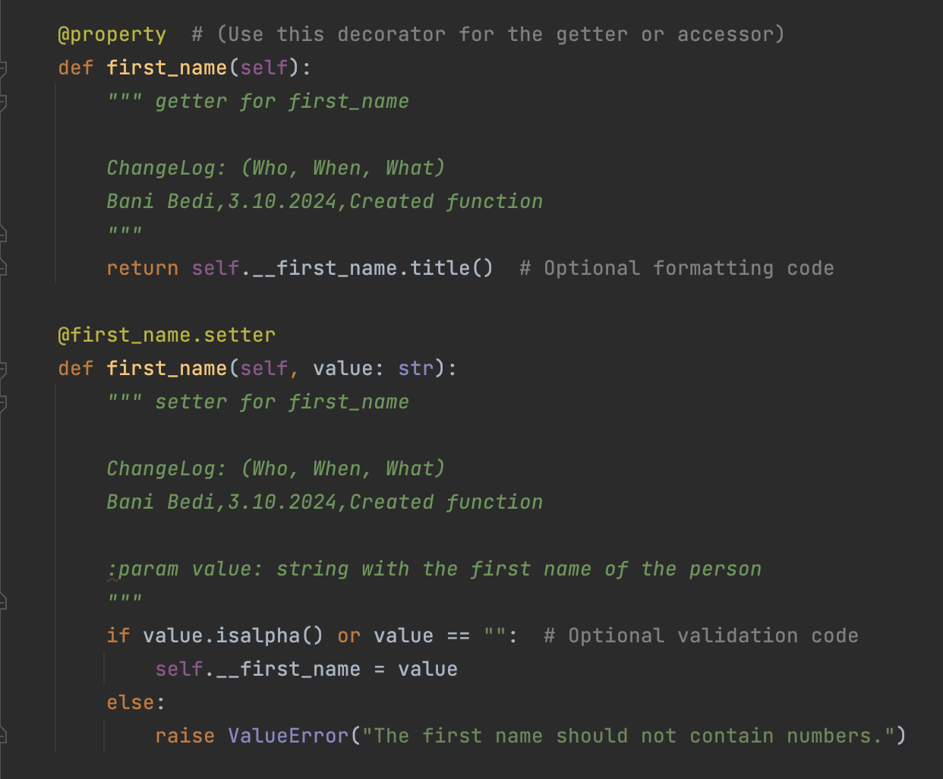

**Figure 1.2**: Added first_name getter / setter.

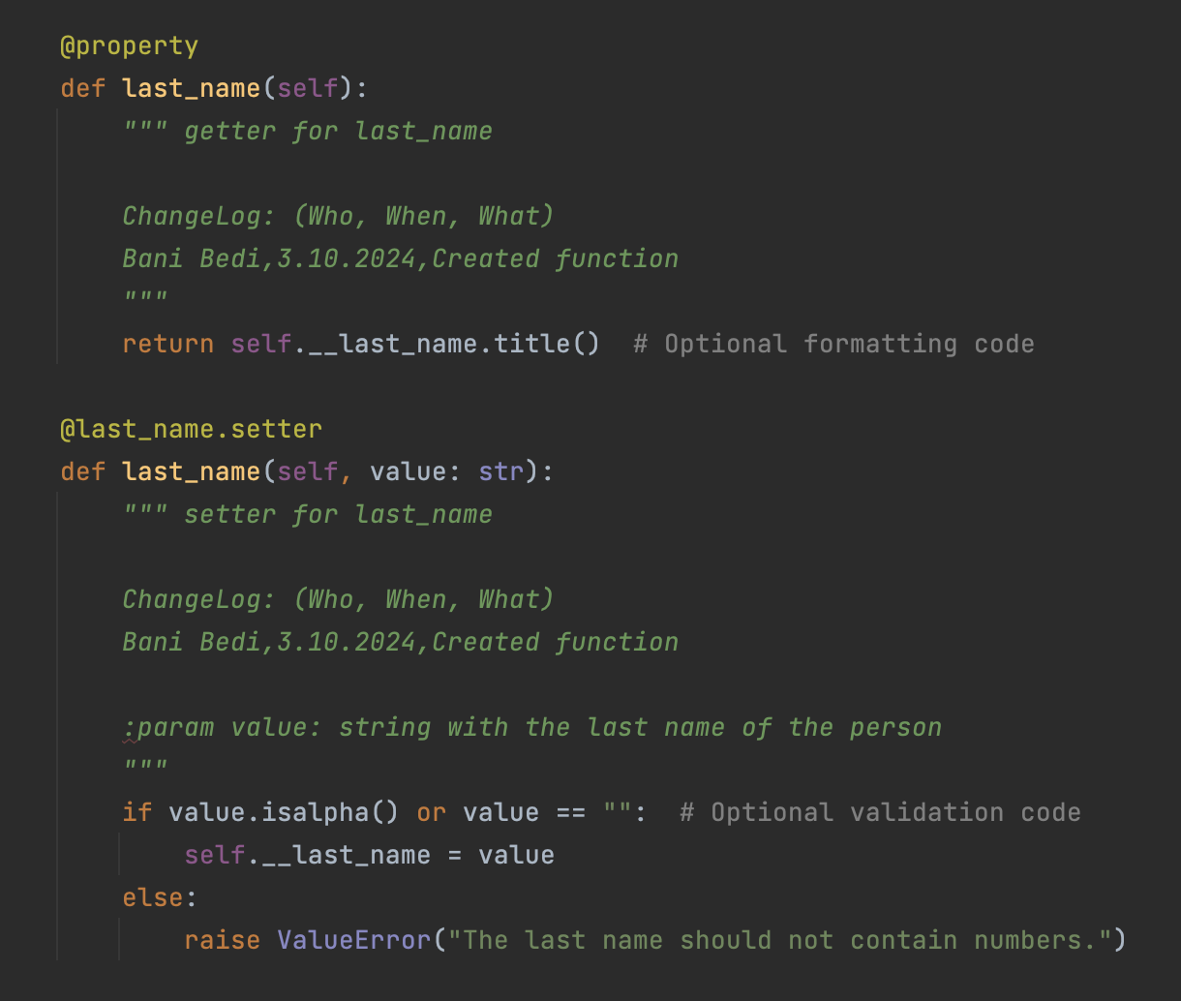

**Figure 1.3**: Added last_name getter / setter.

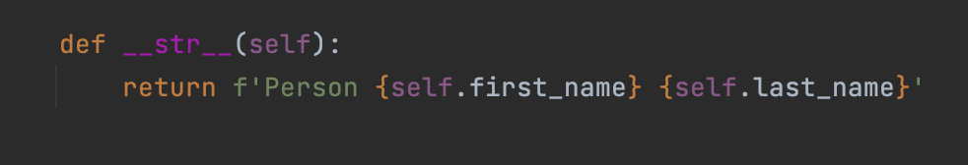

**Figure 1.4**: Added __str__ override.

Student Class

The second goal was to create the Student class that inherited from Person was for representing a student including course_name. These includes the following functions constructor, course_name getter / setter and __str__ override **(Figures 1.5, 1.6, 1.7)**. I also had to update the read_data_from_file, write_data_to_file and input_student_data functions to deal with Student objects (**Figures 1.8, 1.9, 1.10**).

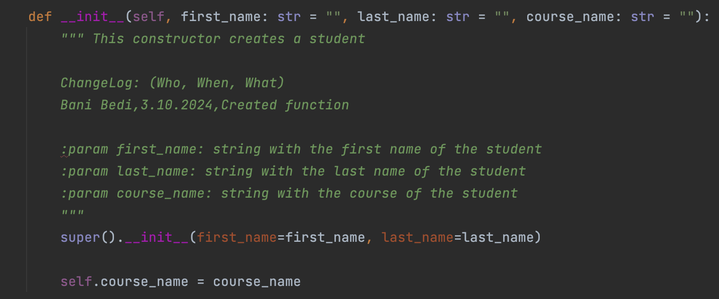

**Figure 1.5**: Added Student constructor.

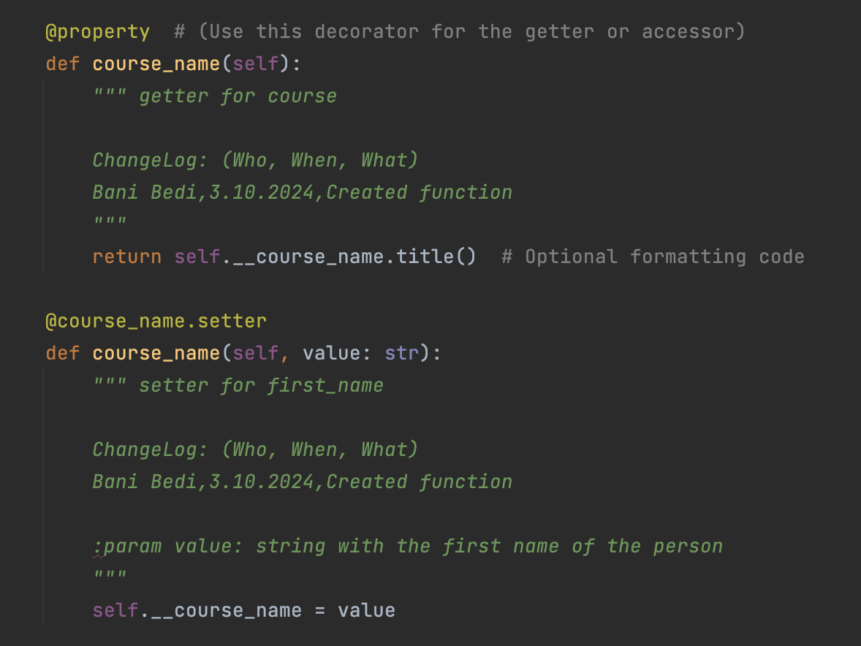

**Figure 1.6**: Added Student course_name getter / setter.

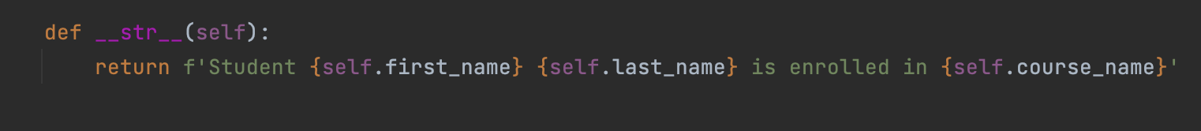

**Figure 1.7**: Added __str__ override function to Student Class

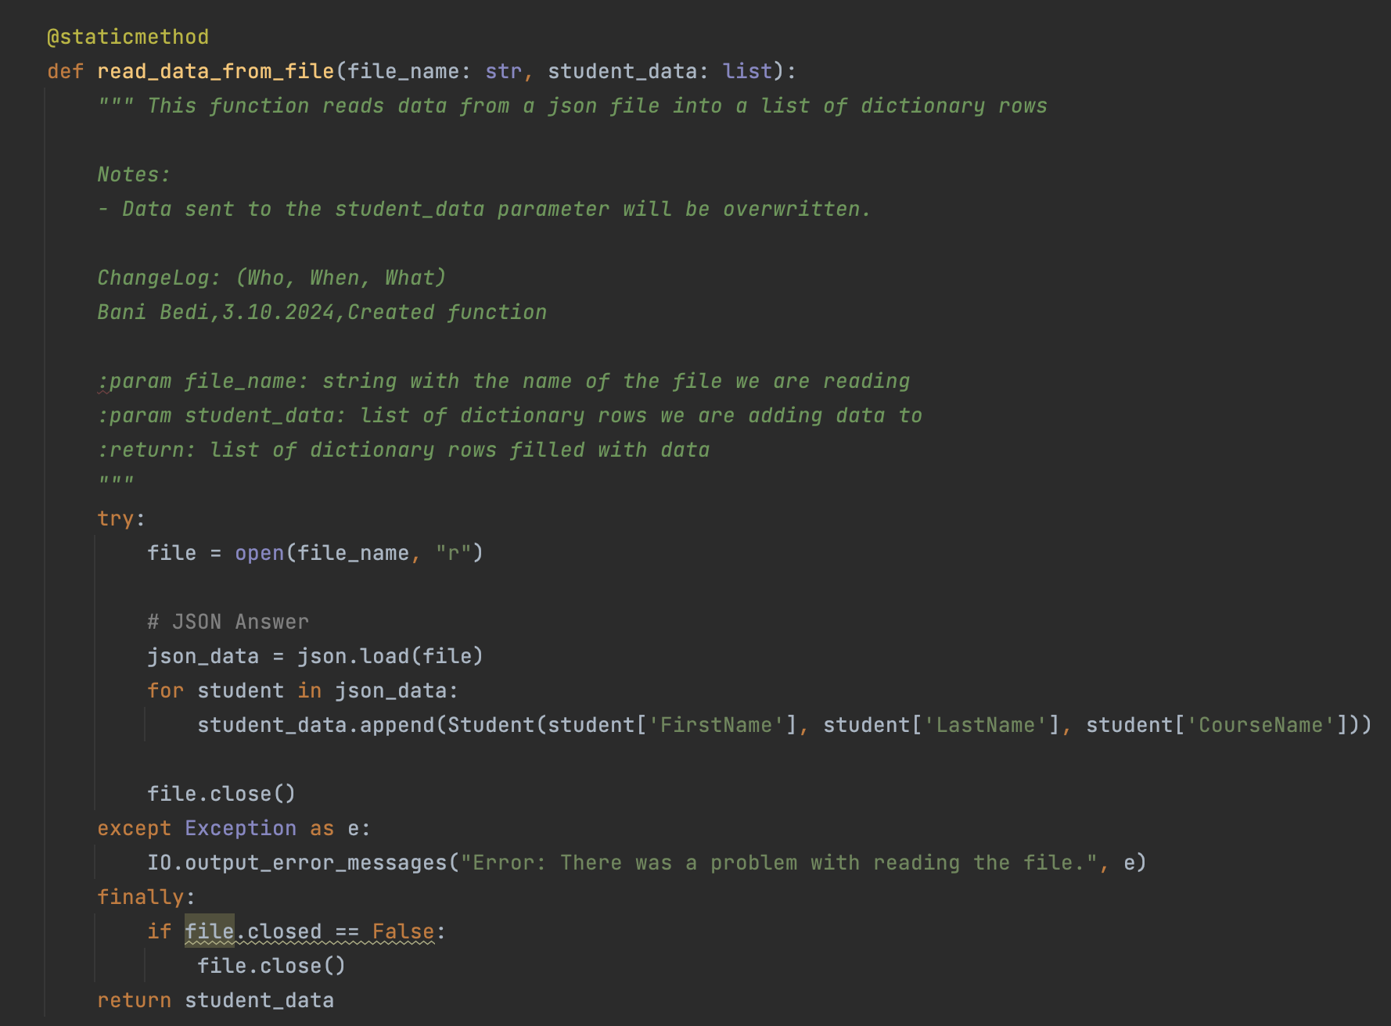

**Figure 1.8**: Updated read_data_from_file function to use Student Class

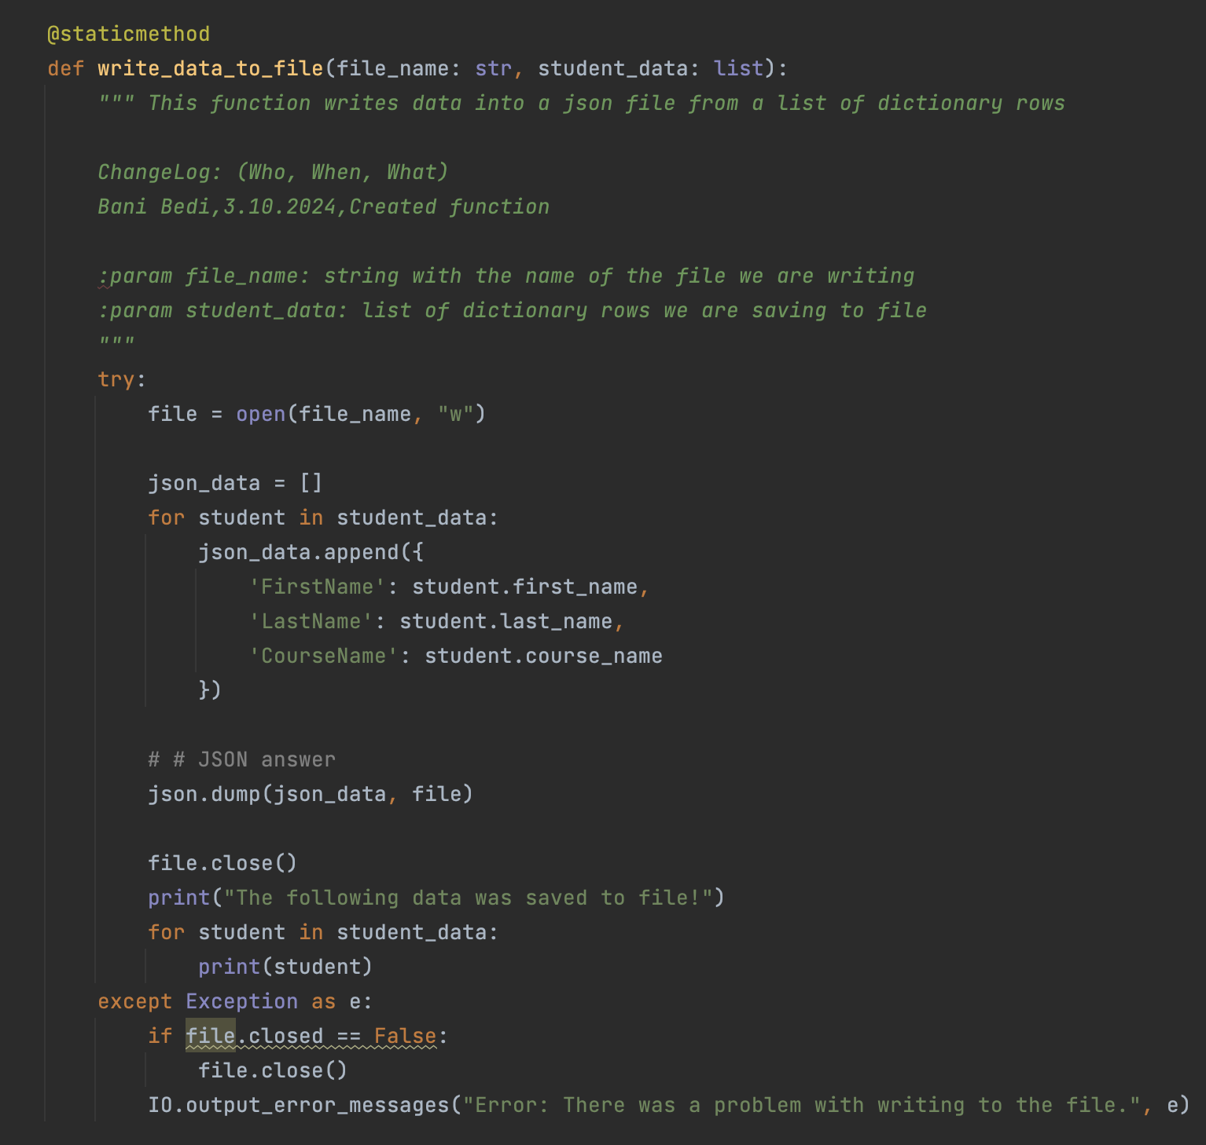

**Figure 1.9**: Updated write_data_to_file function to use Student Class

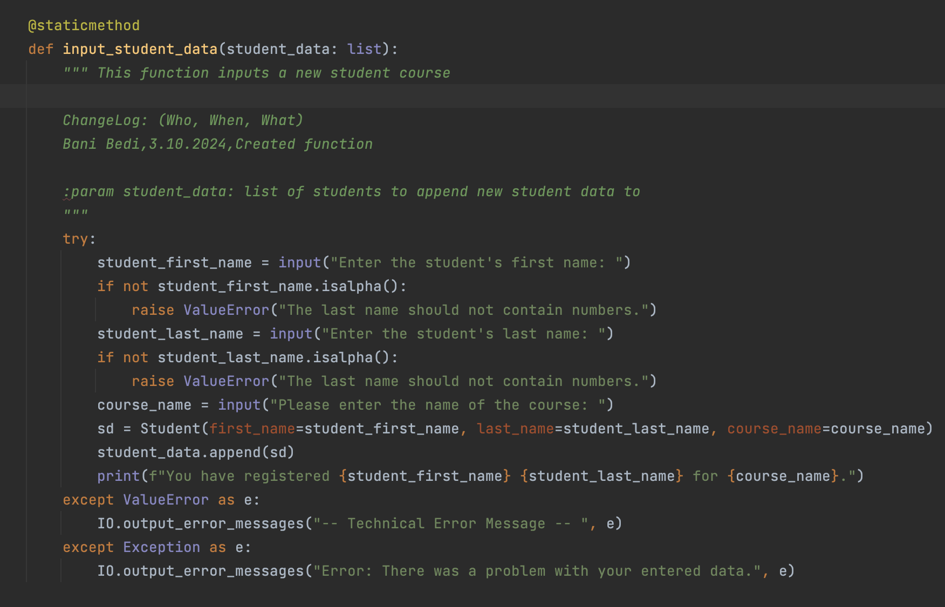

**Figure 1.10**: Updated input_student_data function to use Student Class

**Summary**

In this project, I successfully created a Python registration script that allowed a user to enter an unlimited amount of students’ first, last, and course names; display them in the program; and save them in a JSON file. I employed key programming elements such as classes and functions to achieve this outcome. I, then, tested my program in both the terminal and PyCharm to ensure that it works **(Figure 1.11, Figure 1.12).**

**Figure 1.11:** An image of the Python Registration Script in PyCharm.

**Figure 1.12:** The code successfully working in Terminal.