1. Creare index global

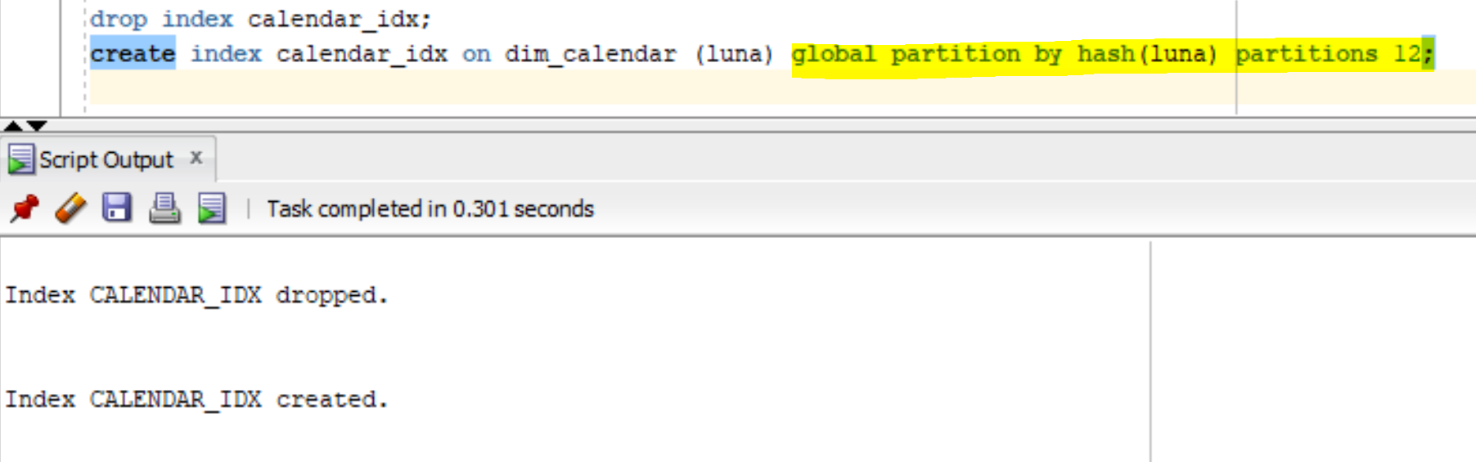

Consulatare dictionarul datelor pentru verificarea crearii partitiilor pe index

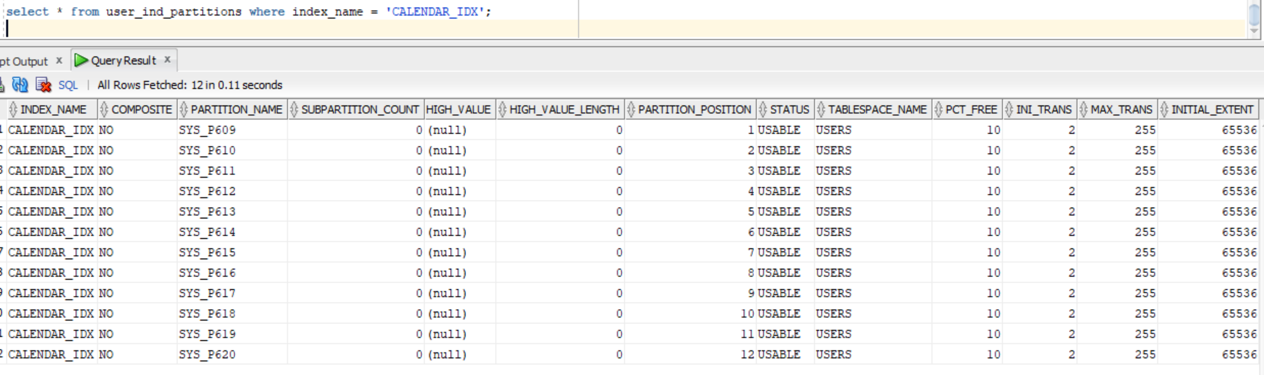Folosire index

EXPLAIN PLAN

SET STATEMENT_ID = 's1_index_global' FOR

select /*+ index(dim_calendar calendar_idx) */ * from dim_calendar where luna= 'June';

SELECT plan_table_output

FROM

table(dbms_xplan.display('plan_table', 's1_index_global','serial'));

Plan hash value: 2382551087

---------------------------------------------------------------------------------------------------------------------

| Id | Operation | Name | Rows | Bytes | Cost (%CPU)| Time | Pstart| Pstop |

---------------------------------------------------------------------------------------------------------------------

| 0 | SELECT STATEMENT | | 167 | 5344 | 8 (0)| 00:00:01 | | |

| 1 | PARTITION HASH SINGLE | | 167 | 5344 | 8 (0)| 00:00:01 | 7 | 7 |

| 2 | TABLE ACCESS BY INDEX ROWID BATCHED| DIM_CALENDAR | 167 | 5344 | 8 (0)| 00:00:01 | | |

|* 3 | INDEX RANGE SCAN | CALENDAR_IDX | 167 | | 1 (0)| 00:00:01 | 7 | 7 |

---------------------------------------------------------------------------------------------------------------------

2. Creare index local

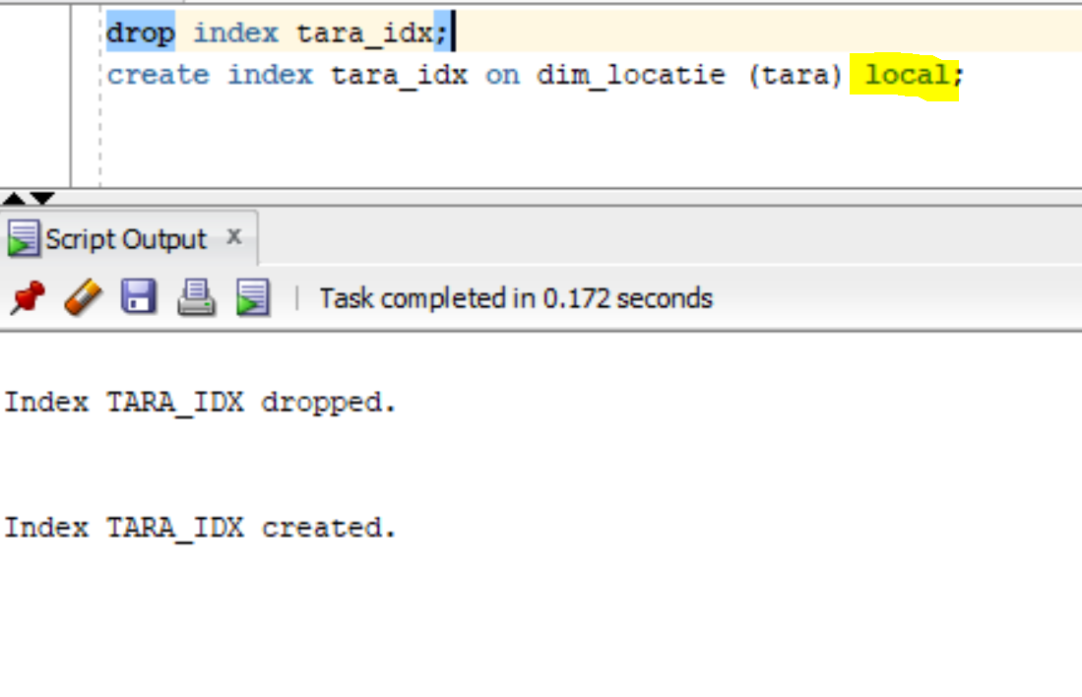

Folosire index

EXPLAIN PLAN

SET STATEMENT_ID = 's1_index_local' FOR

select * from dim_locatie where tara = 'Romania';

SELECT plan_table_output

FROM

table(dbms_xplan.display('plan_table', 's1_index_local','serial'));

Plan hash value: 1361974882

--------------------------------------------------------------------------------------------------------------------------

| Id | Operation | Name | Rows | Bytes | Cost (%CPU)| Time | Pstart| Pstop |

--------------------------------------------------------------------------------------------------------------------------

| 0 | SELECT STATEMENT | | 4 | 124 | 8 (0)| 00:00:01 | | |

| 1 | PARTITION LIST ALL | | 4 | 124 | 8 (0)| 00:00:01 | 1 | 5 |

| 2 | TABLE ACCESS BY LOCAL INDEX ROWID BATCHED| DIM_LOCATIE | 4 | 124 | 8 (0)| 00:00:01 | 1 | 5 |

|* 3 | INDEX RANGE SCAN | TARA_IDX | 4 | | 4 (0)| 00:00:01 | 1 | 5 |

--------------------------------------------------------------------------------------------------------------------------

3. Bitmap index

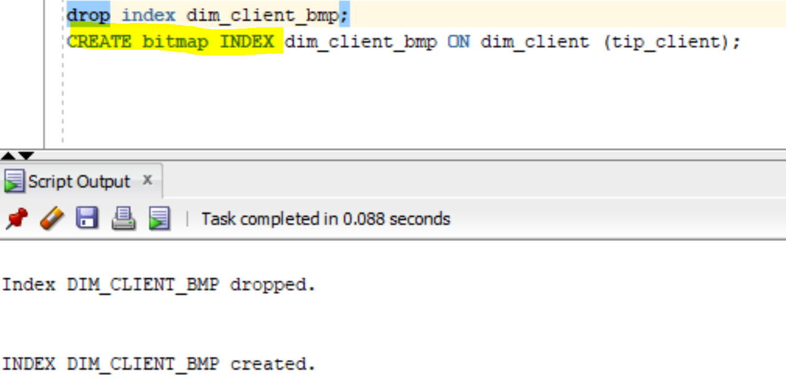

Folosire index

analyze index dim_client_bmp compute statistics;

EXPLAIN PLAN

SET STATEMENT_ID = 's1_index_bmp' FOR

select /*+ index(dim_client dim_client_bmp) */ * from dim_client where tip_client = 'PF';

SELECT plan_table_output

FROM

table(dbms_xplan.display('plan_table', 's1_index_bmp','serial'));

Plan hash value: 2457481617

------------------------------------------------------------------------------------------------------

| Id | Operation | Name | Rows | Bytes | Cost (%CPU)| Time |

------------------------------------------------------------------------------------------------------

| 0 | SELECT STATEMENT | | 6 | 156 | 7 (0)| 00:00:01 |

| 1 | TABLE ACCESS BY INDEX ROWID BATCHED| DIM_CLIENT | 6 | 156 | 7 (0)| 00:00:01 |

| 2 | BITMAP CONVERSION TO ROWIDS | | | | | |

|* 3 | BITMAP INDEX SINGLE VALUE | DIM_CLIENT_BMP | | | | |

4. Bitmap join index

create bitmap index bmp_join_idx on fact_tranzactii (suma) from fact_tranzactii f, dim_comerciant d

where f.id_comerciant = d.id_comerciant local;

analyze index bmp_join_idx compute statistics;

alter session set star_transformation_enabled = true;

Folosire bitmap join index

EXPLAIN PLAN

SET STATEMENT_ID = 's1_index_join_bmp' FOR

select /*+ STAR_TRANSFORMATION */

/*+ FACT(fact_tranzactii) */

f.suma, d.nume

from fact_tranzactii f, dim_comerciant d

where f.id_comerciant = d.id_comerciant

and suma = 50;

SELECT plan_table_output

FROM

table(dbms_xplan.display('plan_table', 's1_index_join_bmp','serial'));

Plan hash value: 3558226070

--------------------------------------------------------------------------------------------------------------------------------

| Id | Operation | Name | Rows | Bytes | Cost (%CPU)| Time | Pstart| Pstop |

--------------------------------------------------------------------------------------------------------------------------------

| 0 | SELECT STATEMENT | | 1 | 37 | 1 (0)| 00:00:01 | | |

| 1 | NESTED LOOPS | | 1 | 37 | 1 (0)| 00:00:01 | | |

| 2 | NESTED LOOPS | | 1 | 37 | 1 (0)| 00:00:01 | | |

| 3 | PARTITION RANGE ALL | | 1 | 26 | 1 (0)| 00:00:01 | 1 |1048575|

|* 4 | TABLE ACCESS BY LOCAL INDEX ROWID BATCHED| FACT_TRANZACTII | 1 | 26 | 1 (0)| 00:00:01 | 1 |1048575|

| 5 | BITMAP CONVERSION TO ROWIDS | | | | | | | |

|* 6 | BITMAP INDEX SINGLE VALUE | BMP_JOIN_IDX | | | | | 1 |1048575|

|* 7 | INDEX UNIQUE SCAN | SYS_C008471 | 1 | | 0 (0)| 00:00:01 | | |

| 8 | TABLE ACCESS BY INDEX ROWID | DIM_COMERCIANT | 1 | 11 | 0 (0)| 00:00:01 | | |

--------------------------------------------------------------------------------------------------------------------------------