1. Definire partitie pe tabela de fapte.

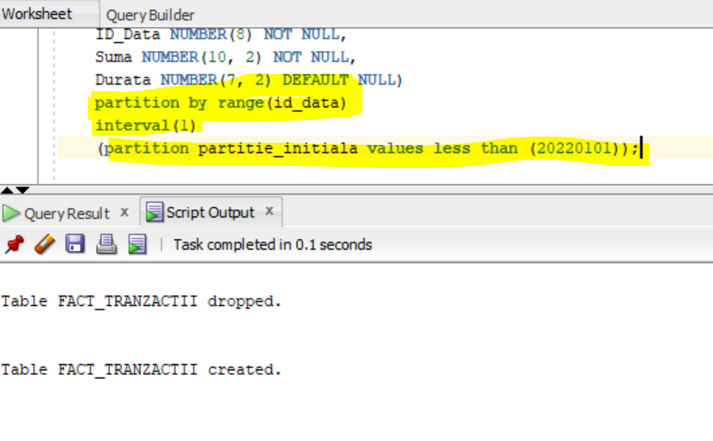

Partitionarea te tip interval este o extensie a partitionarii de tip range. Partitiile noi sunt create autmomat de catre SGBD. atunci cand coloana pe care s-a definit regula de partitionare “depaseste” toate valorile. Cel putin o partitie initiala trebuie creata. Valoarea cheii de partitie interval determină valoarea superioara a partitiilor interval, care se numește punct de tranziție, iar serverul de baze de date creează partiții de interval noi pentru datele care au o valoare mai mare decat punctul de tranziție.

Se pot defini pana la 1,048,757 partitii la nivel de tabel. Avand in vedere ca partitionarea este la nivel de zi se pot stoca intr-un tabel 2, 873 de ani.

Verific crearea partitiilor prin consultarea dictionarului datelor.

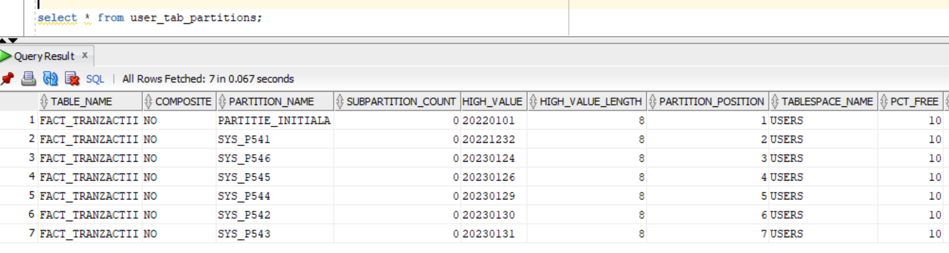

analyze table fact_tranzactii compute statistics;

Table FACT_TRANZACTII analyzed.

EXPLAIN PLAN

SET STATEMENT_ID = 'st_fact_partition'

FOR

select * from fact_tranzactii where id_data = 20221231;

SELECT plan_table_output

FROM

table(dbms_xplan.display('plan_table','st_fact_partition','serial'));

Plan hash value: 3811362893

----------------------------------------------------------------------------------------------------------

| Id | Operation | Name | Rows | Bytes | Cost (%CPU)| Time | Pstart| Pstop |

----------------------------------------------------------------------------------------------------------

| 0 | SELECT STATEMENT | | 24 | 648 | 274 (0)| 00:00:01 | | |

| 1 | PARTITION RANGE SINGLE| | 24 | 648 | 274 (0)| 00:00:01 | 1132 | 1132 |

|* 2 | TABLE ACCESS FULL | FACT_TRANZACTII | 24 | 648 | 274 (0)| 00:00:01 | 1132 | 1132 |

----------------------------------------------------------------------------------------------------------

Predicate Information (identified by operation id):

---------------------------------------------------

2 – filter("ID_DATA"=20221231)

EXPLAIN PLAN

SET STATEMENT_ID = 'st_fact_partition_pruning'

FOR

select * from fact_tranzactii where id_data between 20230123 and 20230128;

SELECT plan_table_output

FROM

table(dbms_xplan.display('plan_table','st_fact_partition_pruning','serial'));

Plan hash value: 370717546

------------------------------------------------------------------------------------------------------------

| Id | Operation | Name | Rows | Bytes | Cost (%CPU)| Time | Pstart| Pstop |

------------------------------------------------------------------------------------------------------------

| 0 | SELECT STATEMENT | | 6 | 168 | 820 (1)| 00:00:01 | | |

| 1 | PARTITION RANGE ITERATOR| | 6 | 168 | 820 (1)| 00:00:01 | 10024 | 10029 |

|* 2 | TABLE ACCESS FULL | FACT_TRANZACTII | 6 | 168 | 820 (1)| 00:00:01 | 10024 | 10029 |

------------------------------------------------------------------------------------------------------------

Predicate Information (identified by operation id):

---------------------------------------------------

2 - filter("ID_DATA">=20230123 AND "ID_DATA"<=20230128)

2. Definire partitie pe tabela de dimensiune locatie

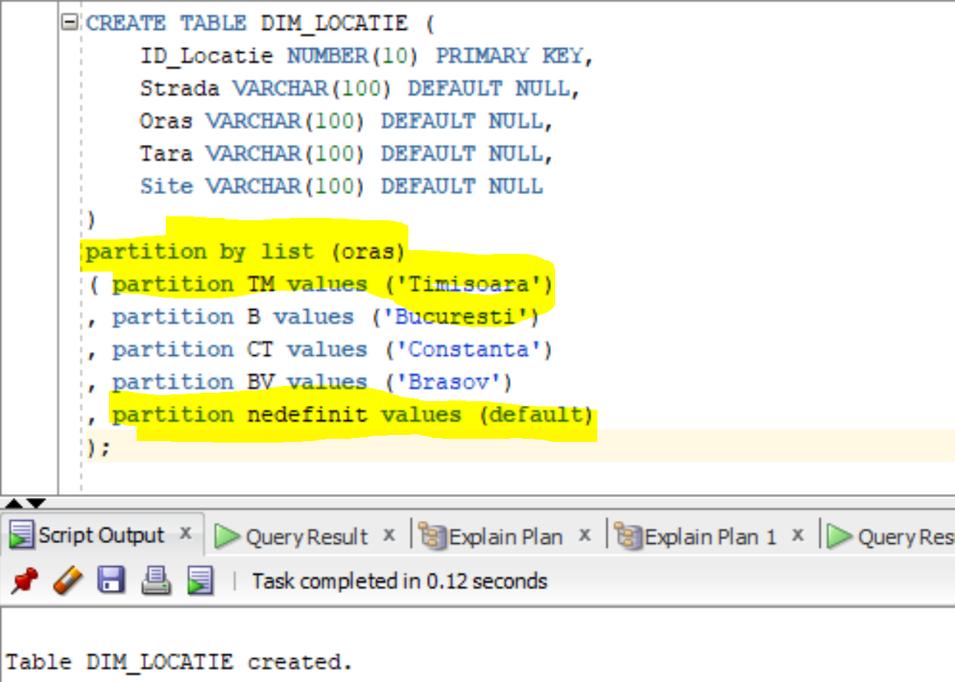

Verific crearea partitiilor prin consultarea dictionarului datelor.

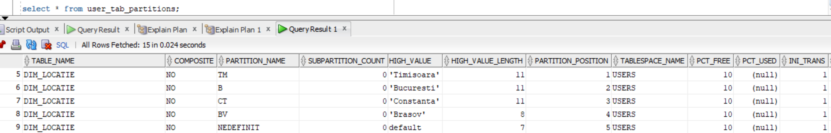

analyze table dim_locatie compute statistics;

Table DIM_LOCATIE analyzed.

EXPLAIN PLAN

SET STATEMENT_ID = 'st_dim_partition'

FOR

select * from dim_locatie where oras = 'Timisoara'

SELECT plan_table_output

FROM

table(dbms_xplan.display('plan_table','st_dim_partition','serial'));

Plan hash value: 3299633729

| Id | Operation | Name | Rows | Bytes | Cost (%CPU)| Time | Pstart| Pstop |

| 0 | SELECT STATEMENT | | 1 | 36 | 274 (0)| 00:00:01 | | |

| 1 | PARTITION LIST SINGLE| | 1 | 36 | 274 (0)| 00:00:01 | KEY | KEY |

| 2 | TABLE ACCESS FULL | DIM_LOCATIE | 1 | 36 | 274 (0)| 00:00:01 | 1 | 1 |

EXPLAIN PLAN

SET STATEMENT_ID = 'st_dim_partition_pruning'

FOR

select * from dim_locatie where oras in ('Timisoara', 'Constanta')

SELECT plan_table_output

FROM

table(dbms_xplan.display('plan_table','st_dim_partition_pruning','serial'));

Plan hash value: 1889622376

-----------------------------------------------------------------------------------------------------

| Id | Operation | Name | Rows | Bytes | Cost (%CPU)| Time | Pstart| Pstop |

-----------------------------------------------------------------------------------------------------

| 0 | SELECT STATEMENT | | 2 | 54 | 547 (0)| 00:00:01 | | |

| 1 | PARTITION LIST INLIST| | 2 | 54 | 547 (0)| 00:00:01 |KEY(I) |KEY(I) |

| 2 | TABLE ACCESS FULL | DIM_LOCATIE | 2 | 54 | 547 (0)| 00:00:01 |KEY(I) |KEY(I) |

-----------------------------------------------------------------------------------------------------