**Response to all reviewers**

**Both reviewers have noted that the lack of experimental support for the MDP account of default mode function is a weak point of our manuscript.**

To strengthen the usefulness of the proposed functional account, besides explicitly linking previous experimental findings to properties of the Markov decision process (MDP) model, we provide several supplementary items in the revised version of the manuscript: First, we have realized the suggestion of reviewer 1 to concretize how the MDP account of DMN function can be tested in neuroscience experiments. We now derive three explicit hypotheses and detail how they can be tested in future empirical investigations to confirm or reject our framework. Second, we used the UK Biobank 10,000 subject release to provide empirical evidence for a linkage between the DMN and the reward circuitry (Figure 2) that is currently a blind spot in the neuroscience literature. A linear classifier can use volumetric information from the DMN regions alone to successfully predict the volume of the nucleus accumbens in new individual unseen by the predictive model. Third, we further detail how our functional account has commonalities and idiosyncrasies with current functional theories discussed in the literature in a new Venn diagram (Figure 5). This reflection now more clearly emphasizes that the MDP account jointly acknowledges time horizon, behavioral goals, neural plasticity and hierarchical information processing, only subsets of which are incorporated into existing functional accounts.

Together, these supplementary items in the current manuscript should facilitate reception and experimental testing of our viewpoint in the neuroscience community.

**Box 1: Hypotheses for testing the MDP account of DMN function**

1) Experiment 1 (Humans): We hypothesize a functional relationship between the DMN closely associated with the occurrence of stimulus-independent thoughts and the reward circuitry. During an iterative neuroeconomic two-player game, fMRI signals in the DMN should be able to predict reward-related signals in the nucleus accumbens across trials in a continuous learning paradigms. We expect that the more DMN activity is measured to be increased, supposedly the higher the tendency for stimulus-independent thoughts, the more the fMRI signals in the reward circuits should be independent of current reward context, and vice versa.

2) Experiment 2 (Humans): We hypothesize a functional dissociation between computations for policy versus value matrix adaptation as these are probably implemented in different subsystems of the DMN. We first expect that fMRI signals in the RTPJ can predict behavioral changes in later trials caused by adaptation in the policy matrix, related to *non-value-related* prediction error. Second, fMRI signals in the vmPFC should predict behavioral changes in later trials caused by adaptation in the value matrix, due to reward-related stimulus-value association. We finally predict that fMRI signals in the the PMC, as a potential global information integrator, should be able to predict later differences in overt behavior as a result of previous adaptation in the policy or value matrix.

3) Experiment 3 (Animals): We hypothesize that experience replay for browsing problem solutions subserved by the DMN is necessary for choice behavior in mice. Hippocampal single-cell recordings have shown that neural patterns during experimental choice behavior are reiterated during sleep and before make analogous choices in the future. Necessity of the DMN, in addition to the hippocampus, for “mind-searching” actions during choice behavior can be demonstrated by causal disruption of DMN nodes, including the inferior parietal and prefrontal cortices by circumscribed brain lesion or optogenetic intervention.

Moreover, we integrated a totally new figure summarizing the different accounts describe in the paper and how MDP is situated in this theoretical landscape:

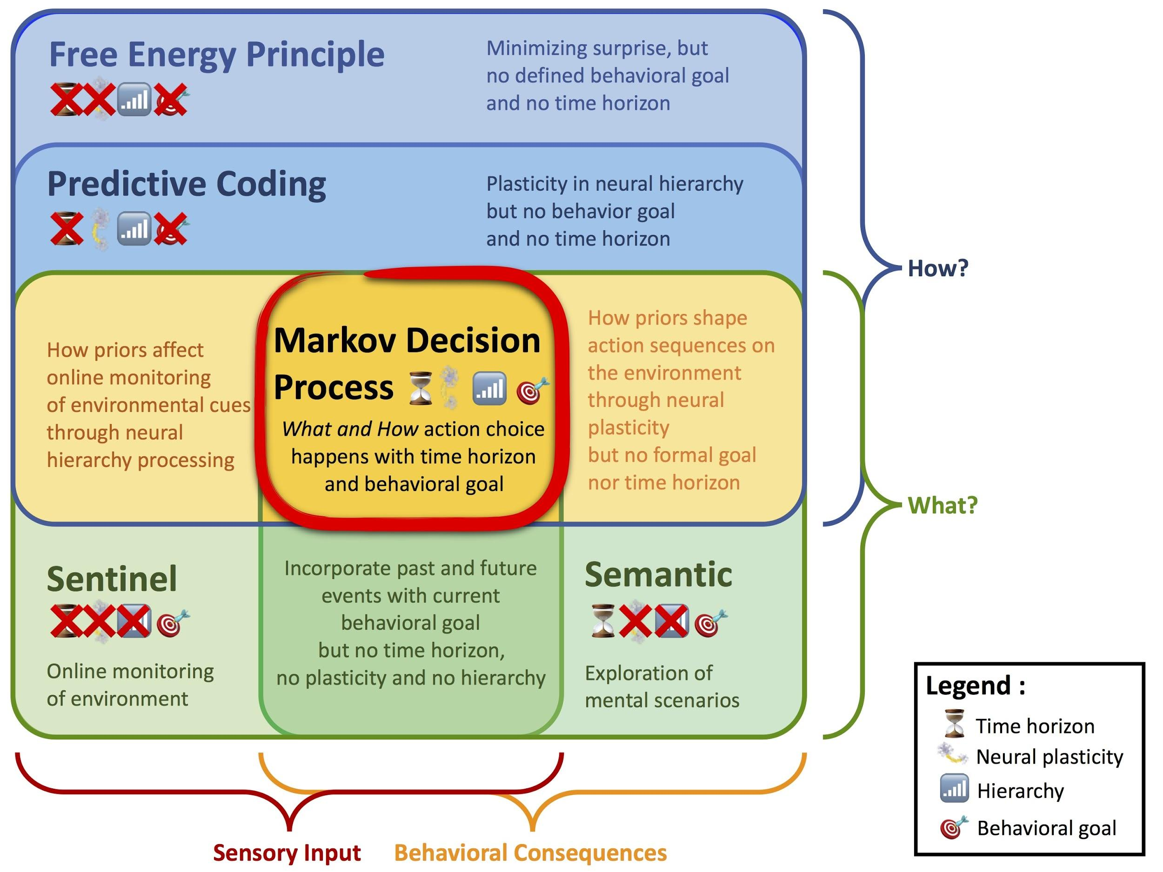

*Fig 5. Where does Markov Decision Process fit in the theoretical landscape? This Venn diagram summarizes the relationship between four existing accounts of DMN: in blue colors, the Free Energy Principle & Predictive Coding, more related to the How DMN works, and in yellow, the Sentinel & the Semantic hypotheses, more related to ”What” DMN does. Our account of DMN by Markov Decision Process is at the intersection of those accounts and thus corresponds to a ”Process model” meaning a model of both ”How” and ”What” a process occur.*

# 

# 

# Reviewer #1

**The submission is incredibly ambitious in that it attempts to unite approximately two decades worth of research into default mode network (DMN) function under a common modeling framework, namely that of Markov decision processes (MDPs). If successful, this type of model fills an important gap in the existing literature. Namely, that we have many disparate accounts of what the DMN ``does' (activation or co-activation of DMN nodes under different contexts) but we lack straightforward and testable theories for explaining why those areas are active in the first place.**

We are grateful for the very positive feedback on our work.

## Main Comments:

**1. Another issue is the tacit assumption that the DMN functions autonomously. The DMN does not function in isolation of the rest of the brain; the areas that make up the DMN are interlinked to other brain systems via structural connections and transiently co-activate/couple with those systems. Even if it is speculative, can the authors comment on how the details of the MDP model accounts for the interaction of the DMN with the rest of the brain? This seems particularly important as there is a rich body of work on reinforcement learning in human and other animals that implicates brain regions/networks outside of the DMN, including the Saliency network. For example, the anterior cingulate is involved in error likelihood prediction based on reinforcement learning, of which conflict and error detection are special cases (Brown and Braver 2005). These observations seem to undercut the authors’ hypothesized function of DMN. It seems fairer to assume that the DMN and its subregions contribute to the hypothesized process via interaction with other distributed networks.**

We completely agree that the DMN realizes its functional roles by close interaction with other distributed brain networks. A misunderstanding appears to account for this comment. We did not mean to state that the DMN acts in functional isolation from other parts of the brain. Our focus on the DMN for overall control of the organism is justified by the DMN being at the likely top of the neural processing hierarchy, far away from sensory input processing and motor processing regions. In analogy, a partially observed MDP controls value estimation of and action choice without explicitly modeling structure in the (sensory) environment and without modeling details of action execution (motor) on the environment. To this extend, the DMN may relate to perception and action from a similarly remote position as the MDP formalizes value matrix and policy matrix updates.

Further, our focus on the DMN for higher-order control the organism is supported by a number of observations. First, the DMN has repeatedly been proposed to be functionally situated at the top of the hierarchy of brain networks with likely influence on various other lower-order functional networks (e.g., Margulies et al., 2016 PNAS). Second, parts of the DMN account for considerable parts of the brain’s baseline energy consumption (Raichle et al., 2001 Nat Rev Neurosci). Third, we have reviewed and discussed extensive empirical evidence from animal studies showing each node of the DMN to bear functional features of time-discounting, strategic planning, action choice considerations, and integration of error signaling from the reward systems.

These views are expressed in several parts of the current manuscript:

Page 2: “A hierarchy of brain systems with the DMN at the top and the salience and dorsal attention systems at intermediate levels, above thalamic and unimodal sensory cortex (Carhart-Harris and Friston, 2010).”

Page 2: “Today, many psychologists and neuroscientists believe that the DMN implements some form of probabilistic estimation of past, hypothetical, and future events.”

Page 20: “MDPs motivate an attractive formal account of how the human association cortex might implement multi-sensory representation and control of the environment to optimize the organism's interaction with the world.”

**2. The title, abstract, and introduction all promise that the account of the DMN will be some roughly equivalent blend of reinforcement learning and control theory. However, the exposition is really most focused on reinforcement learning, and there is very little discussion of how this relates to control theory, what exactly is meant by the term control theory, how this notion of control relates to other notions of control, and what other control theoretic accounts exist of default mode network function. Of course, a cognitive neuroscientist with a deep understanding of RL will know how they relate, but many readers of this paper will not. To broaden the audience who will appreciate this review, I think it would be important to more explicitly treat the question of how these ideas are or relate to control theory as a broader discipline.**

We fully agree with this comment. We considered that MDPs are intimately related to both reinforcement learning and control theory (<https://en.wikipedia.org/wiki/Markov_decision_process>). We now see that this may not have been well reflected by the previous title and beginning of the manuscript. In response to this reviewer we have changed the paper title to include “A Unified Account of Default Mode Function by Markov Decision Processes”. Furthermore, we make the immanent relationships of the MDP formalism to both control theory and reinforcement learning now explicit in the abstract of the revised manuscript.

Abstract: “DMN function is recast in terms of control theory and reinforcement learning by basing it on Markov decision processes.”

**3. Finally, while the MDP represents a concise approach for uniting disparate DMN functions, it is unclear how such processes might be instantiated neurophysiologically. The authors on occasion present some hypotheses that are reasonable (e.g. dopamine is a reward signal) but provide other hypotheses that are a bit speculative and lack clear, empirical grounding (e.g., the policy matrix can be supported by synaptic epigenesis). I think that the paper would benefit from some discussion of the underlying neurophysiological mechanisms (not just psychological mechanisms) that might support the authors’ theory.**

We have performed a thorough search of the literature on studies of animal and human brain physiology to provide a maximum of arguments for the plausibility of MDP-like processes in the default mode network. These pieces of neurophysiological evidence are summarized in section 2 “Known neurobiological properties of the default mode network” that actually de-emphasizes arguments from cognitive neuroscience or psychological processes alone. Here are a few quintessential findings:

Posteromedial cortex: “Direct stimulation of PMC neurons promoted exploratory actions, which would otherwise be shunned. Graded changes in firing rates of PMC neurons indicated changes in upcoming choice trials, while their neural patterns were distinct from neuronal spike firings that indicated choosing either option. Similarly in humans, the DMN has been shown to gather and integrate information over different parts of auditory narratives in an fMRI study.”

Prefrontal cortex: “Quantitative lesion findings across 344 human individuals confirmed a substantial impairment in value-based action choice. Indeed, this DMN node is preferentially connected with reward-related and limbic regions. The vmPFC is well known to have direct connections with the NAc in axonal tracing studies in monkeys. ”

Hippocampus: “Based on spike recordings of hippocampal neuronal populations, complex spiking patterns can be followed across extended periods including their modification of input-free self-generated patterns after environmental events. Specific spiking sequences, which were elicited by experimental task design, have been shown to be re-enacted spontaneously during quiet wakefulness and sleep. Moreover, neuronal spike sequences measured in hippocampal place cells of rats featured re-occurrence directly after experimental trials as well as directly before upcoming experimental trials. Similar spiking patterns in hippocampal neurons during rest and sleep have been proposed to be critical in communicating local information to the neocortex for long-term storage, potentially also in the nodes of the DMN.”

Right temporoparietal junction: “Direct electrical stimulation of the human RTPJ during neurosurgery was associated with altered perception and stimulus awareness.”

Left temporoparietal junction: “The TPJ in the left-hemispheric DMN (LTPJ), in turn, has a close relationship to Wernicke’s area involved in semantic processes, such as in spoken and written language. Neurological patients with damage in Wernicke’s area have a major impairment of language comprehension when listening to others or reading a book. …Isolated building blocks of world structure probably get rebuilt in internally constructed mental scenarios that guide present action choice, weigh hypothetical possibilities, and forecast future events.”

In response to this helpful comment, we have removed the admittedly speculative statement on synaptic epigenesis. Across the entire manuscript we have either clearly marked speculations, toned the down or entirely removed them in the enhanced manuscript.

## Minor Comments:

**1. While I recognize that because most DMN research involves fMRI the authors must draw disproportionately on that literature, it would be good to show examples of DMN activation as measured with other methods, e.g. MEG. This is especially true given the complex (and indirect) relationship between the fMRI BOLD signal and population-level neural activity. Similarly, the authors’ model is housed within a system of brain regions with well-studied structural pathways. It would be useful to provide a schematic of the hypothesized interactions between these DMN nodes based on the RL model.**

We added references to MEG works related to large-scale resting state networks and their potential link with DMN, such as by stating:

"Despite observation in MEG of similar large-scale networks of co-varying spontaneous activity (De Pasquale et al., 2010; Brookes et al., 2011; Baker et al., 2014), the link between the fMRI BOLD signal and population-level neural activity is still unclear. If those frequency-specific electrophysiological correlations are proposed as complementary to those observed with BOLD (Hipp and Siegel, 2015), their link to DMN remains challenging (Maldjian et al., 2014)."

Regarding the second part of reviewer's comment, 1) we provided a comprehensive review of neurobiological relationships between the DMN nodes in the first part of the paper; 2) we link the MDP to these node-wise properties by linkage to the machine learning literature (cf. the parallel structure between Fig. 1 & 4); and 3) we thus propose that the MDP is neurobiologically possible and all its key aspects appear to have correlates in what we already know about DMN.

**2. The title seems to be more sensationalist than veritable. Scientifically, there really is nothing about the DMN that is dark, the focus of the paper is more on reinforcement learning than on control, and there is nothing about control theory that is dark. I suggest the authors revise their title to enhance accuracy.**

The title is actually an explicit reference to Raichle’s Science paper (http://science.sciencemag.org/content/314/5803/1249) which consider the DMN as the “dark matter of brain physiology”. We have cite this reference in the referred paragraph of the introduction. Since Raichle discovered the DMN, our title was intended to be a historical reference to how previous contribution and pioneering work.

**3. Figure 2: the brain overlay colors (red , blue) are not explained.**

The colors are indicative of the sign (red = positive, blue = negative) and size of the regression coefficients. This information has now been added to the figure caption thanks to this reviewer comment.

**4. Figure 4: legend needs more explanation. It is not clear how these nodes interact based on the model. Why some regions don’t have equations and some do? For example wouldn’t Ncl. Accumbens’ function have a formal mathematical equation?**

The interaction of the nodes is thoroughly explained in detail in section 2 of the manuscript.

**5. I think the abstract would work better as a single paragraph than as 2 separate paragraphs.**

Yes, indeed. The paragraphs have been collapsed into a single concise paragraph as proposed.

**6. The word “probably” is used 12 times in the paper. These usages should be replaced either by a more exact word, or by evidence to support that probability (and ideally estimates of the probability).**

This was a grammar issue. Reduced from 17 to 5 occurrences of the word “probably”.

**7. The word “node” was never defined, and in most cases could be replaced by “region” to be more accurate. The word node should only be used when discussed the element of a graph, and where that graph is explicitly defined, and its graph architecture relevant for the discussion.**

In response to this remark, we now make our biological use of the word “node” explicit in an early part of the manuscript.

Beginning of section 1.1.: “The network nodes that compose the human DMN are responsible for extended parts of the baseline neural activity, which typically decreases when engaged in psychological experiments.”

Additionally, we have replaced the word “node” by “region” were appropriate in the entire manuscript.

**8. On page 7, it is unclear what “control and maintenance brain networks” are.**

The referred sentence was rephrased as follows.

Page 7: “Additionally, neural activity in the RTPJ has been proposed to reflect stimulus-driven attentional reallocation to self-relevant and unexpected sources of information as a ‘‘circuit breaker’’ that recalibrates functional control of brain networks.”

**9. On page 8, I suggest making Figure 3 more polished, more formal.**

We polished the figure 3 to better integrate the message of the paper, especially integrating the Bellman equation:

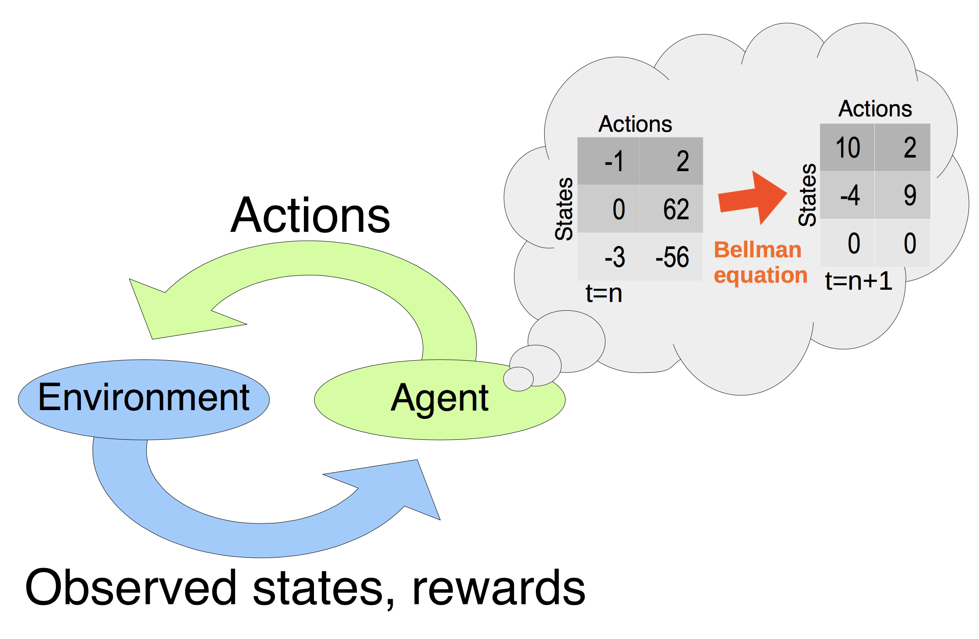

*Fig 3. Reinforcement learning in a nutshell. Given the current state of the environment, the agent takes an action by following the policy matrix as updated by the Bellman equation. The agent receives a consequential reward and observes the next state. The process goes on until interrupted or a goal state is reached.*

**10. On page 12, I do not understand what is meant by “which likely are state-of-the-art in RL.” They either are or they aren’t state-of-the-art. Which is it? There is no “likely” in this context.**

This was mostly grammar issues. Thanks. Fixed.

**11. Throughout, I think it is important to state where each of the equations comes from. Which was the first paper to state that equation? Whatever it was, make sure to cite it when first writing down the equation.**

These equations are adapted from RL theory (Barto & Sutton, Silver et al.) to give a formal treatment of the DMN as a (hypothesized) RL agent.

**12. On page 13, I think it would be important to be more explicit about exactly what is meant by “brain network hierarchy”.**

We are happy to integrate the proposed addition to the manuscript.

Page 13: “Additionally, this network was proposed to be situated at the top of the brain network hierarchy, with the subordinate salience and dorsal attention network in the middle and the unimodal sensory cortices at the bottom.”

## Typos:

**1. On page 5, “an individuals subjective” -> “an individual’s subjective”**

**2. On page 8, it is unclear what is meant by “upon recently on the game of Go”. I think there might be an extra word or two in here?**

**3. On page 12, “examples samples” -> “samples”**

**4. On page 14, “move to new” -> “moves to a new”**

**5. On page 14, “world aspects” -> “aspects of the world”**

**6. On page 14, In the phrase “A prediction error at one of the processing levels incurs plasticity”, it does not seem that “incur” is the correct word here. The error does not incur plasticity.**

We replaced "incur" with "induce".

**7. On page 14, I do not think “plausibilized” is an accepted word in English.**

We replaced "plausibilized" by "supported".

**8. On page 15, “in form of nested” -> “in the form of nested”**

**9. On page 15, “controversal” -> “controversial”**

**10. On page 15, “imaging the future” -> “imagining the future”**

**11. On page 15, “estimating other others’” -> “estimating others’”**

**12. On page 16, “explanation why” -> “explanations for why”**

**13. On page 16, “is a likely to be” -> “is likely to be”**

**14. On page 17, “which outlined” -> “which is outlined”**

**15. On page 18, “trick” is informal. Suggest choosing a more formal word.**

We replaced "trick" by "maneuver".

**16. On page 18, “account how” -> “account of how”**

**17. On page 19, “may be well” -> “may well be”**

All typos were fixed thanks to the reviewer.

# Reviewer #2:

## Remarks to the Author:

**This paper presents an ambitious attempt to synthesize empirical work on the default mode network within a reinforcement learning framework. Although I think understanding the default mode network is a laudable goal, in my view, the paper is too ambitious: by trying to explain everything, it succeeds at explaining very little. It reads as a combination of vacuously general statements (see below for some examples), unnecessarily technical exposition, some technically incorrect statements, and some unsubstantiated claims. The technical exposition in of itself would be useful if it were made to do some explanatory work, but essentially the authors show a lot of equations and attach brain labels to some of the variables. Much of this is a rehash of well-known computational neurobiology (basic reinforcement learning theory).**

We are thankful to this reviewer for the remark that helped us to better stress the core of our contribution. We would like to emphasize that some of the most widespread existing cognitive theories of what the default mode might be doing are i) the DMN monitors importance in the environment (sentinel hypothesis), ii) the DMN makes the environment intelligible by semantic knowledge and logical analogies (semantic hypothesis), and iii) minimization of prediction error signaling (predictive coding). We argue that all three functional accounts can be explained as special cases by our Markov Decision Process account of DMN function. Additionally, all 3 accounts are largely restricted to the computational level of David Marr’s, that is, describing *what* representations this major brain network might maintain and manipulate. The MDP account of DMN function goes beyond the computational level by providing an explicit process model, thus extend to Marr’s algorithmic level of neural processes - *how* such neural processes come about. Moreover, our account leads to a variety of specific empirical predictions that can be verified or falsified in targeted experimental studies in future research, that we translated into a set of experimental predictions in Box 1. For these reasons, we see our alternative functional account as a reintegration and extension of the previous literature on DMN function.

## More specific comments:

**p. 2: what does it mean to "entertain probabilistic contemplations"?**

We have rephrased the sentence in "Gaining insight into DMN function is particularly challenging because this network appears to simultaneously modulate perception-action cycles in the present and to support mental travel across time, space, and content domains (Boyer, 2008)."

**p. 2: I'm not sure what this means. "The more the world is easy to predict, the more human mental activity becomes detached from the actual sensory environment"**

This sentence states that when the external world become predictive, the brain has less to rely on external sensory information since it can use its internal model, thus becoming detached from the environment.

Weissman, D.H., Roberts, K.C., Visscher, K.M., Woldorff, M.G., 2006. The neural bases of momentary lapses in attention. Nat Neurosci 9, 971-978.

Mason, M.F., Norton, M.I., Van Horn, J.D., Wegner, D.M., Grafton, S.T., Macrae, C.N., 2007. Wandering minds: the default network and stimulus-independent thought. Science 315, 393-395.

Both these paper references have been added to the sentence in question.

**p. 2: I don't know why Tenenbaum et al. (2011) is used as a reference fo MCMC sampling in the brain. There are other more relevant papers, such as Buesing et al. (2011) PLOS CB, Moreno-Bote et al. (2011) PNAS, Gershman et al. (2012) Neural Computation, Sanborn & Chater (2016) TICS, Aitchison & Lengyel (2016) PLOS CB.**

These interesting references have been added to the manuscript.

**p. 3: I don't see how the Kording & Wolpert or Fiser et al. studies provide any evidence for the claim that "the human brain's energy budget is largely dedicated to the development and maintance of a probabilistic model of anticipated events." I don't know of any direct evidence for such a claim about the brain's energy budget, since no one has quantified how much energy probabilistic models use, and I don't see how anyone can even begin to answer this question until there is more agreement about the nature of probabilistic representation.**

We are sorry for the lack of precision and have now made the statement much more explicit, which will hopefully avoid confusion in future readers. The fragment reads now as: "Evidence from computational modeling in human behavior (Kö̈rding and Wolpert, 2004) and cell recording experiments in ferrets (Fiser et al., 2004) suggest that the human brain is largely dedicated to “the development and maintenance of [a] probabilistic model of anticipated events” (Raichle and Gusnard, 2005)."

**p. 4: "PMC could support representation of action possibilities and evaluation of reward outcomes by integrating information from memory recall and different perspective frames." I don't see how such a vague statement represents a falsifiable hypothesis.**

The referred sentence is the summary of a detailed passage reintegrating experimental findings on the posteromedial cortex. It does not attempt to make new statements or prediction to be tested experimentally. The experimentally testable prediction result from the MDP formalizes that is presented in the section after that quoted sentence.

**p. 5: "Such highly abstract neural computations necessarily rely on the construction of probabilistic internal information drawing from memory recall, mental scene elaboration processes, and stored knowledge of world regularities." Again, this is extremely vague. I'm not sure what the value of such a statement.**

We have removed the sentence in response to this comment. The quoted sentence on the functional role of the dmPFC in the DMN actually represented commonly stated opinion that are for instance present in these previous publications:

Randy L Buckner and Daniel C Carroll. Self-projection and the brain. Trends in cognitive sciences, 11(2):49{57, 2007.

Daniel L Schacter, Donna Rose Addis, and Randy L Buckner. Remembering the past to imagine the future: the prospective brain. Nature Reviews Neuroscience, 8(9):657{661, 2007.

Moshe Bar. The proactive brain: using analogies and associations to generate predictions. Trends in cognitive sciences, 11(7):280{289, 2007.

Jeffrey R Binder and Rutvik H Desai. The neurobiology of semantic memory. Trends in cognitive sciences, 15(11):527{536, 2011.

It is these types of intuitive cognitive accounts of DMN function that we hope to formalize and thus concretize with our MDP re-interpretation, which does not negate but re-itegrate previous cognitive theories on mental scene elaboration and predicting regularities in the external environment.

**p. 7: "RL is a problem-solving technique in which, through repeated interactions with an environment, an agent learns to reach goals and optimize reward signals in an iterative trial-and-error fashion." This is not a technically correct definition of RL. First of all, RL is a problem, not a problem technique. Second of all, RL does not in fact require any of the things listed (repeated interaction, learning to reach goals, iterative trial-and-error). Please see the Sutton & Barto (1998) book for a proper definition.**

Fixed.

**p. 19: "Ultimately, DMN activity may instantiate a holistic integration ranging from real experience over purposeful dreams to anticipated futures for continued refinement of the organism’s fate." What does this mean??**

What this final statement tries to emphasize is the following: a major hurdle in explaining DMN activity from brain-imaging studies has been its very similar engaged across time scales: thinking about the past (e.g., autobiographical memory), thinking about hypothetical presents (e.g., dreams during sleep or daytime mind-wandering), and thinking about future scenarios (e.g., prospection or delay discounting). The MDP account of DMN function naturally integrates this a-priori diverging mental processes into a common framework. It is this feature of our functional view that we underline in the referred sentence.