SZCZECIN UNIVERSITY OF TECHNOLOGY



Project: FILM-FREE

Work Scope Package’ E’

An automated defect recognition algorithms for radiographic weld inspection - Features definition and extraction

Szczecin, September 2007

1. Area.
A

2. Perimeter.
p

3. Center of gravity.

4. Diagonals of a ellipse.
a, b

5. Position:
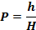

6. Radius mean, standard deviation, and circularity. This set of features measures the circularity of defects. Circularity is defined as the standard deviation, σ_{r} ; divided by the mean radius, μ_{r}.
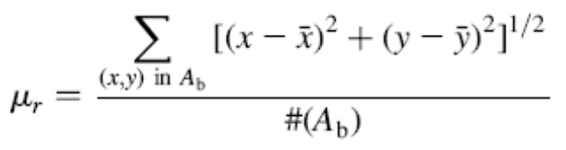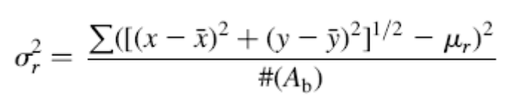
7. Moments:
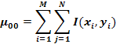
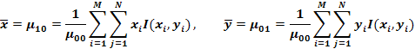
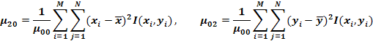
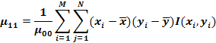
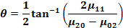
In gray images every analyzed point must be add to the wage, which is the normalized brightness (between 0,1).

8. Compactness. This is ratio that measures the resemblance degree between the defect shape and a circumference. Its value is included in [0,1]. It has little values for sharp defects (crack, lack of fusion) and it has values near to 1 for spherical defects (porosity, tungsten inclusion, etc.).
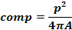

9. Major axis. The orientation of the defect object stretching in the weld. It is calculated as the angle between the orientation of defect and the horizontal line.

10. Width and length. Length is the projection of defect along the major axis whereas width is the projection along the minor axis, which is perpendicular to the major axis.

11. Elongation. This computes the ratio between the length and width of the defect object, which takes a value between 0 and 1.. Big values of this attribute characterize longitudinal defects (crack, lack of fusion, lack of penetration, elongated porosity, undercut, etc.).
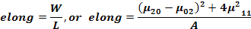

12. Heywood diameter. The diameter of a circle having an equivalent area to that of the defect.

13. Average intensity and standard deviation of intensity. It gives the information about the brightness of the defect.

14. Rectangularity. Its value is included in [0,1]. It is equal to 1 for a rectangle. It characterizes rectangular defects (lack of penetration).
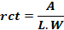

15. Anisometr. It depends on the direction of principal axis of defect. Its value is proportional to defect lengthening.
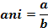

16. Symmetry. Its value is included in [0,1]. The value 1 describes a perfectly symmetrical shape. Asymmetrical aspects of defects (slag inclusion, warm holes, etc.) are related by little values of this attribute.
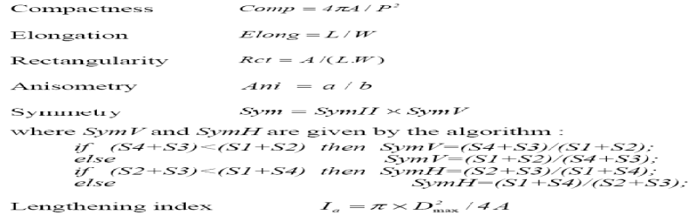

17. Lengthening index. Big values of this indicia put in obviousness fine and rectilinear cracks.

18. Deviation index to inscribed circle. The indicia value is maximal (near to 1) for lengthened defects and minimal (near to 0) for round defects.
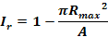

19. Aspect Ratio:
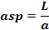

20. Ratio:
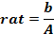

21. Difference between the average gray level of the defect and the defect’s surrounding.

Area (A), perimeter (P), centre of gravity G(x, y) , angle of orientation (α), principal axes of inertia, width (W) and length (L) of the minimal surrounding rectangle, maximal diameter (D_{max}), radius of maximal inscribed circle (R_{max}), semi major and semi-minor axes (a,b) of the image ellipse are computed, distance from the centroid of the defect to the weld joint center (h), the joint thickness at the defect occurrence point (H), mesure of image (M, N), object function (I(x_{i},y_{i})), coordinates of the center of mass of defect object ( and ), the set of boundary points of defect (A_{b} ), the number of boundary points (#(A_{b}))

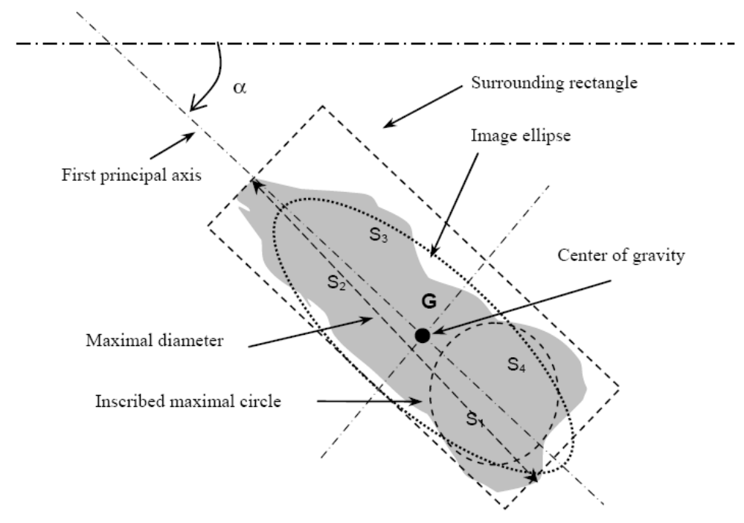

Feature number | Done in C++ | Implemented in ADDIP
1 | + | +
2 | + | +
3 | + | +
4 | + | +
5 | - | -
6 | - | -
7 | + | +
8 | + | +
9 | + | +
10 | + | +
11 | + | +
12 | + | +
13 | + | +
14 | + | +
15 | + | +
16 | - | -
17 | + | +
18 | + | +
19 | - | -
20 | + | +
21 | + | +

