1. Grade Checker

Take a score as input and print the grade based on the following:

90+ : "A"

80-89 : "B"

70-79 : "C"

60-69 : "D"

Below 60 : "F"

here we used a basic if else statement to carry out marks and all.

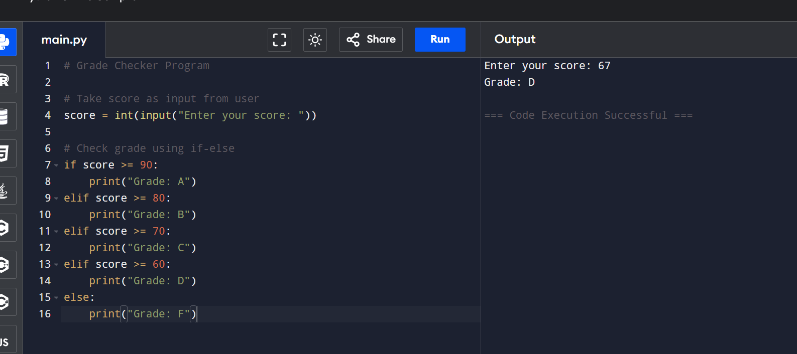

2 Student Grades

Create a dictionary where the keys are student names and the values are their grades. Allow the user to:

Add a new student and grade.

Update an existing student’s grade.

Print all student grades.

Used dictionary and basic operations. Using if else:

Code :

# Student Grades Manager

grades = {}

while True:

    print("\nChoose an option:")

    print("1. Add a new student")

    print("2. Update existing student's grade")

    print("3. Print all student grades")

    print("4. Exit")

    choice = input("Enter your choice (1-4): ")

    if choice == "1":

        name = input("Enter student name: ")

        if name in grades:

            print("Student already exists.")

        else:

            grade = input("Enter grade: ")

            grades[name] = grade

            print(f"Added {name} with grade {grade}.")

    elif choice == "2":

        name = input("Enter student name to update: ")

        if name in grades:

            grade = input(f"Enter new grade for {name}: ")

            grades[name] = grade

            print(f"Updated {name}'s grade to {grade}.")

        else:

            print("Student not found.")

    elif choice == "3":

        if grades:

            print("\nStudent Grades:")

            for name, grade in grades.items():

                print(f"{name}: {grade}")

        else:

            print("No student records found.")

    elif choice == "4":

        print("Exiting program.")

        break

    else:

        print("Invalid choice. Please select between 1 and 4.")

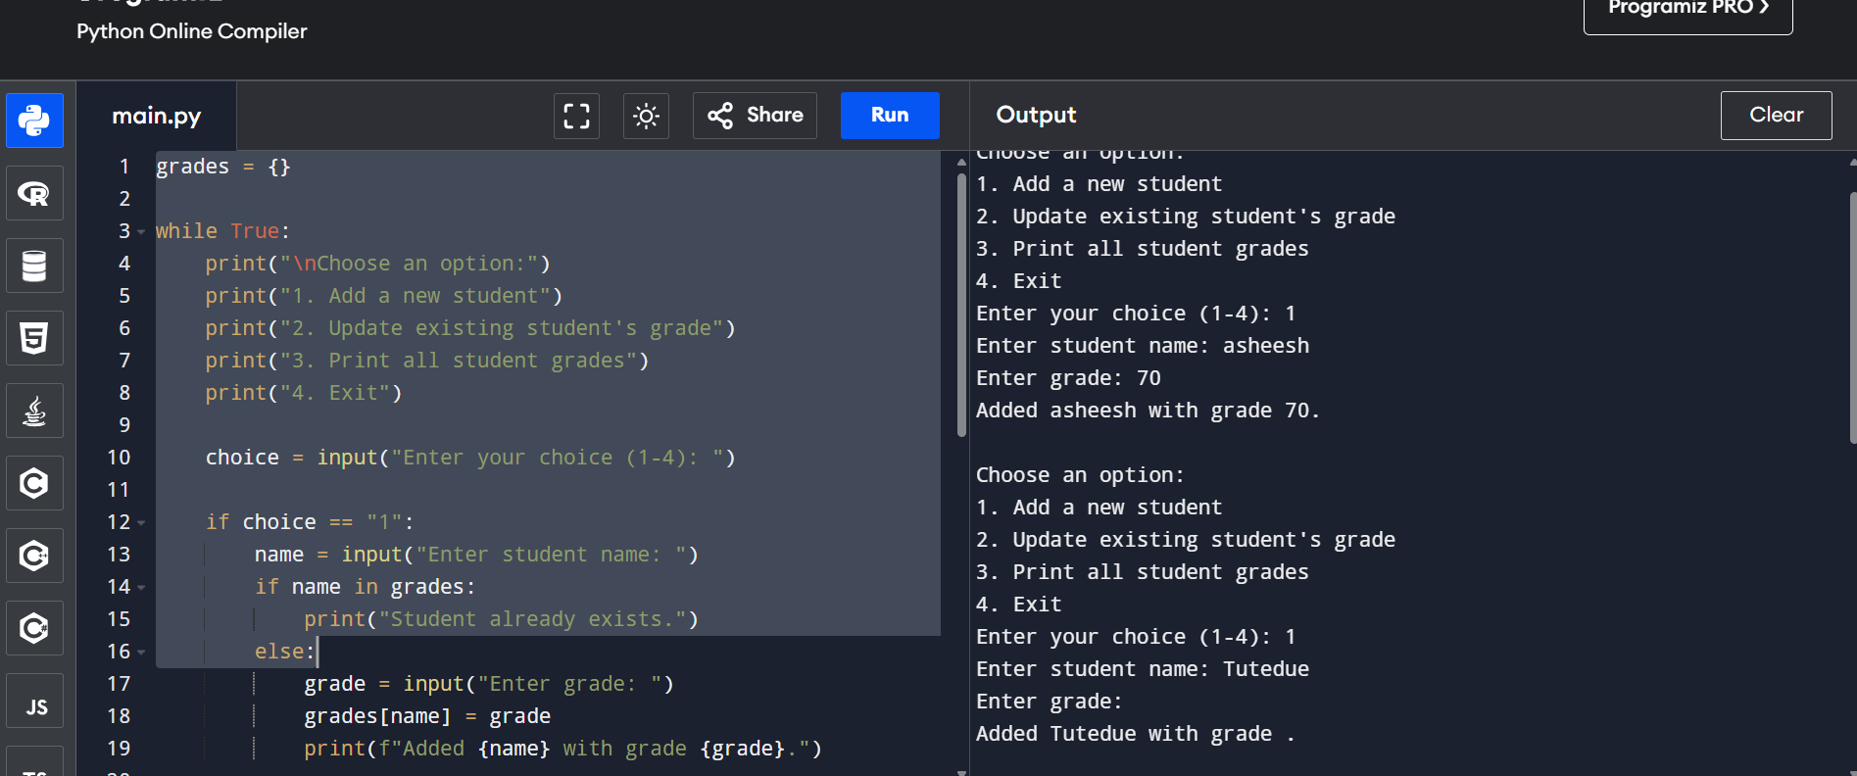

3.Write to a File

Write a program to create a text file and write some content to it.

Using file functions like write and open.

with open("output.txt", "w") as file:

    # Write some content to the file

    file.write("This is a sample text written to the file.\n")

    file.write("You can add more lines as needed.\n")

print("Content written to output.txt successfully.")

code :

with open("output.txt", "w") as file:

    # Write some content to the file

    file.write("This is a sample text written to the file.\n")

    file.write("You can add more lines as needed.\n")

print("Content written to output.txt successfully.")

4. Read from a File

We used open in read mode and file.read to read and print to display.

Code :

with open("output.txt", "r") as file:

    # Read the entire content of the file

    content = file.read()

    # Print the content to the console

    print(content)