# Task1: Requirement Analysis and Documentation

**Create a Basic SRS Document**

**Scope of the Project**

This project is to build a simple and reliable Food Delivery Mobile App where users can register, browse restaurants by cuisine, add items to their cart, and pay online or via cash on delivery. Users can track their order status in real-time and leave ratings and reviews for restaurants and dishes. The app will help customers order food easily while enabling restaurants to reach more customers.

**2. Functional Requirements**

**2.1 User Authentication**

* Users can create accounts using email or phone number.
* OTP-based verification for phone login.
* Forgot password/reset option.

**2.2 Browse Restaurants**

* Users can view a list of restaurants.
* Restaurants can be filtered by cuisine, ratings, and delivery time.

**2.3 View Menu by Category**

* Menu items will be grouped into categories like "Starters", "Main Course", "Drinks", etc.

**2.4 Place Order**

* Users can add items to a cart and place an order.
* Payment via cash on delivery (initial version).
* Order status: Pending, Confirmed, Preparing, Out for Delivery, Delivered.

**2.5 Track Order**

Real-time tracking of order status through the app.

**3. Non-Functional Requirements**

**3.1 Performance**

* The app should load restaurant and menu data within 3 seconds.
* Order confirmation and updates should be reflected in real time.

**3.2 Security**

* All sensitive user data should be encrypted.
* OTP verification must be secure and reliable.

**3.3 Usability**

* App should have an intuitive, mobile-first UI.
* Support for both Android and iOS platforms.

**3.4 Scalability**

* The backend should support scaling to handle a growing number of users and restaurants.

**4. Use Case Descriptions**

**4.1 Use Case 1: User Registration and Login**

Actor: End User

Description: A user signs up using email or phone number and logs into the app.

Precondition: The app is installed on the user's device.

**Main Flow**:

* User opens the app and selects “Sign” Up” or “Login.”
* Enters email or phone number.
* Receives and enters OTP or password and gains access to the app dashboard.

**4.2 Use Case 2: Browse Restaurants and Menus**

Actor: End User

Description: cuisine.

Precondition: User is logged in. User explores restaurants and their food menus categorized by

**Main Flow:**

* User navigates to the Browse Restaurants section.
* Selects a category (e.g., Nepali).
* Views available restaurants and their menus.

**4.3 Use Case 3: Add to Cart and Checkout**

Actor: End User

Description: User selects items, adds them to the cart, and places an order.

Precondition: User has selected at least one menu item.

**Main Flow:**

* User adds desired items to the cart.
* Proceeds to checkout.
* Selects payment method (online or cash on delivery).
* Confirms and places the order.

**4.4 Use Case 4: Track Order Status**

Actor: End User

Description: User monitors their order in real time.

Precondition: An order has been placed.

**Main Flow:**

* User goes to the ‘My Orders’ section.
* Selects the active order.
* Sees current status: Pending, Preparing, Out for Delivery, or Delivered.

**4.5 Use Case 5: Rate and Review Restaurants and Dishes**

Actor: End User

Description: After delivery, user leaves feedback.

Precondition: The order has been delivered.

**Main Flow:**

* User receives a prompt or opens order history and selects the delivered order.
* Rates the restaurant, adds a review and submits feedback.

**2. UML Diagrams:**

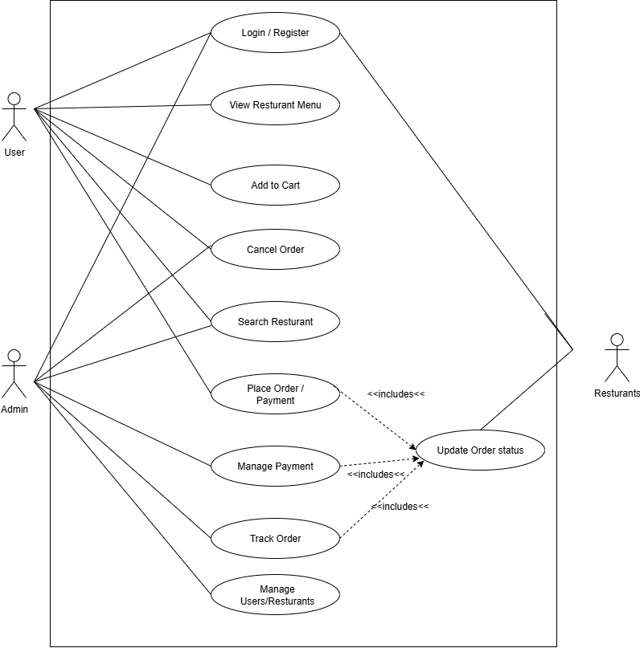 **2.1.1 Use Case Diagram:**

**Activity Diagram**

Login / Register

View Restaurants Menu

Select Items & Add to Cart

Place Order

Choose Payment Method

Is Payment Successful

Cancel Order

Update Order Status

Restaurants Prepares Order

Delivery Picks up & Delivered

Order Delivered

Leave Rating and Feedback

YES

NO

**3. 3-4 wireframes**

**Login Screen Wireframe**

* **Fields**: Email or Phone Number, Password
* **Buttons**: Login, Register, Forgot Password
* **Option**: Switch between email and phone login
* Simple design with app logo at the top

Example:

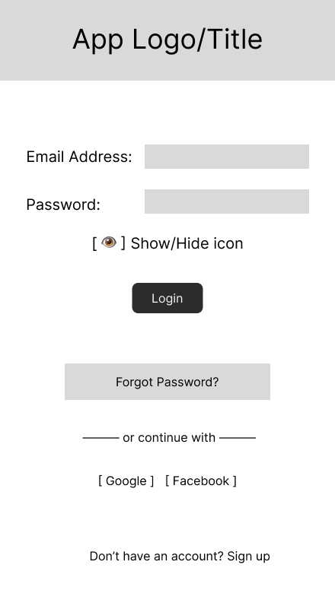

Figure 1 Login Page

**2. Restaurant Listing Screen Wireframe**

* Search bar at the top
* Filter buttons/categories (Nepali, Indian, Chinese) below search bar
* List of restaurants with:
* Restaurant name
* Cuisine type
* Rating (stars)
* Delivery time estimate
* Each restaurant clickable to open menu

Search

Chinese

Indian

Nepali

Cuisine

Restaurant Name

25-35 min



Nepali

25-35 min



25-35 min

Indian

Fig2: Restaurant Listing Screen Wireframe

**3. Cart Screen Wireframe**

* Shows list of food items added to the cart
* Each item shows: name, quantity, price
* Option to remove an item
* Total price displayed at the bottom
* Payment options: Online or Cash on Delivery
* Checkout button to place the order

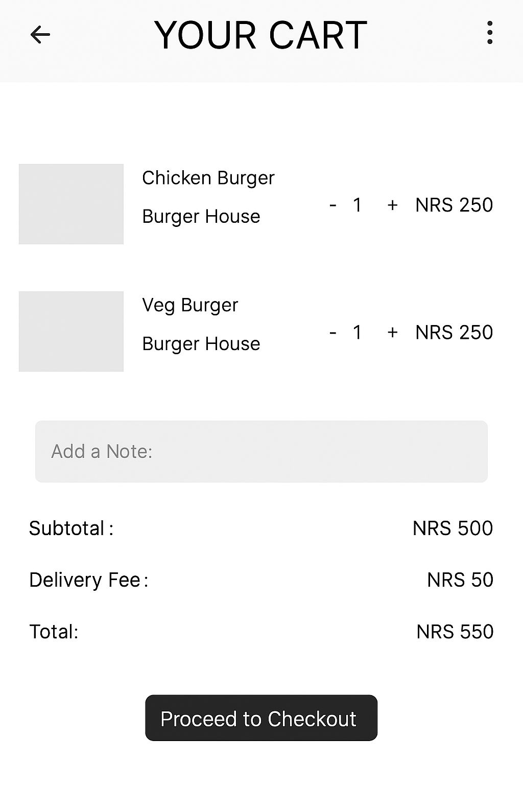

Fig 3: Cart Screen Wireframe

**4. Order Tracking Screen Wireframe**

* Shows order ID and basic details at the top
* Progress bar with steps: Pending → Preparing → Out for Delivery → Delivered
* Shows estimated delivery time
* Optional: Small map to show delivery location/status, example Daraz App

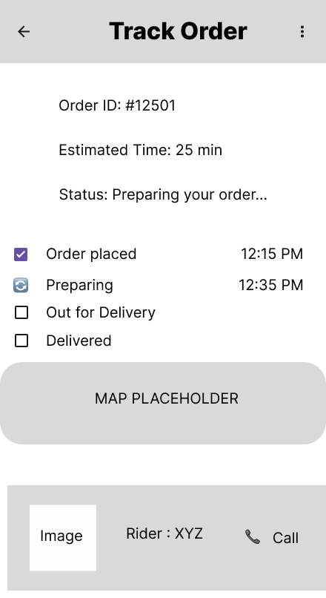

Fig 3: Order Tracking Screen Wireframe

**Task 2: User Story and Acceptance Criteria**

**User Story 1: Browsing Restaurants**

**User Story:**

As a user, I want to browse restaurants by cuisine so that I can easily find food that matches my preference.

**User Story 2: Placing an Order**

**User Story:**

As a user, I want to add food items to my cart and place an order so that I can get the food delivered to my location.

**User Story 3: Tracking Orders**

User Story:

As a user, I want to track the status of my order in real-time so that I know when to expect delivery

**Acceptance Criteria for each User Story**

**User Story 1:**

Acceptance Criteria

* The user can filter restaurants by selecting a specific cuisine type like Indian, Chinese and Italian.
* The system displays a list of restaurants that match the selected cuisine with name, rating, and delivery time.
* If no restaurants match the selected cuisine, it shows “No restaurants found”.

**User Story 2:**

Acceptance Criteria

* Users can choose food items, set the quantity, and pick options like spice level or toppings, then add them to the cart.
* The cart shows the total price and lets users change or delete items.
* When users place the order, the system checks their address, shows delivery time, and gives them an order number

**User Story 3:**

Acceptance Criteria

* Users can see the status of their order, like "Preparing" or "Delivered".
* A map shows where the delivery person is and when the food will arrive.
* The order status updates automatically without refreshing the page.

**Task 3: Change Request Simulation**

**Change Request:** Add “Favorite Restaurants” Feature

**Requested By:** Client

**Purpose:** Improve user experience by providing fast access to preferred restaurants.

**User Story**

As a user, I want to mark restaurants as favorites so that I can easily find and order from them later.

**Acceptance Criteria:**

* Users can tap a heart icon to mark or unmark a restaurant as a favorite.
* Each user has their own list of favorite restaurants, which they can view in a "Favorites" section.
* When a restaurant is added or removed from favorites, the app shows a quick confirmation message.
  + **Update to SRS / Wireframe for “Favorite Restaurants”:**
* New Feature: Users can tap a heart icon to mark restaurants as favorites.
* Favorites Section: Users can see all their favorite restaurants in a new “Favorites” page.
* Data Storage: The system will save favorite restaurants linked to each user.

**Impact on current scope:**

* The icons (heart icon, favorite page) can be updated or customized through UI/UX changes.
* API to save/remove/get favorite restaurants using Backend.
* A table with columns named user_id and restaurant_id is used to store the data in the database.
* Functional and UI testing are performed to verify the newly added features.
* Improves user experience by making it easier to find preferred restaurants.

**Steps Taken for the Report**

**1.Defined the Project Scope**

I started by clearly outlining the scope of my project, which is a Food Delivery System. This helped me to set the direction and boundaries of the system which I’m building.

**2.Documented Requirements**

I explained both:

* Functional Requirements: What the system should do (e.g., ordering food, tracking delivery, add to cart, login)
* Non-Functional Requirements: How the system should perform (e.g., speed, reliability, usability, scalability)

**3.Created UML Diagrams**

I visualized the system behavior using UML diagrams:

* Use Case Diagram – to show how users interact with the system
* Activity Diagram – to describe the flow of key processes

**4.Designed Wireframes**

I created 3–4 screen wireframes using Figma and Microsoft Word. These helps me to represent the layout and user interface of screens like login, cart, order tracking, and restaurant listing.

**5.Defined User Stories and Acceptance Criteria**

I wrote simple, clear user stories to describe what users need to do (e.g., "As a user, I can add a restaurant to favorites").

For each story, I included acceptance criteria that define when the feature is considered complete.

**6.Handled Change Requests**

I simulated a change request based on a new client requirement (e.g., adding a “Favorite Restaurants” feature) and updated the documentation and wireframes accordingly.