Well Posed Learning Problem:

A computer program is said to learn from **experience** **E** with respect to some **class of tasks T** and **performance measure P**, if its performance at tasks in T, as measured by P, improves with experience E.

Any problem can be segregated as well-posed learning problem if it has three traits –

* Task
* Performance Measure
* Experience

examples,

 1. **Checkers game**: A computer program that learns to play checkers might improve its performance as measured by its ability to win at the class of tasks involving playing checkers games, through experience obtained by playing games against itself. A checkers learning problem:

* Task T: playing checkers
* Performance measure P: percent of games won against opponents
* Training experience E: playing practice games against itself

2. **A handwriting recognition learning problem:**

* Task T: recognizing and classifying handwritten words within images
* Performance measure P: percent of words correctly classified
* Training experience E: a database of handwritten words with given classifications

3. A**robot driving learning problem:**

* Task T: driving on public four-lane highways using vision sensors
* Performance measure P: average distance travelled before an error (as judged by human overseer)
* Training experience E: a sequence of images and steering commands recorded while observing a human driver
* **A spam filtering for emails learning problem:**

A spam filter is software that detects unsolicited and undesired email and prevents it from reaching the inbox of a user.

T -> Identifying whether or not an email is spam.

P -> The percentage of emails correctly categorized as spam or nonspam.

E -> Observing how you categorize emails as spam or nonspam.

* **Face Recognition Problem:**

A facial recognition system device is capable of matching a human face from a digital image or a video frame against a database of faces.

It works by locating and measuring facial characteristics from a given image and is often used to verify users through ID verification services.

T -> Predicting distinct sorts of faces.

P -> Ability to anticipate the largest number of different sorts of faces.

E -> train the system with as many datasets of varied facial photos as possible.

**Designing a Learning System in Machine Learning :**

According to Tom Mitchell, “A computer program is said to be learning from experience (E), with respect to some task (T). Thus, the performance measure (P) is the performance at task T, which is measured by P, and it improves with experience E.”

**Example:**In Spam E-Mail detection,

* **Task, T:** To classify mails into Spam or Not Spam.
* **Performance measure, P:** Total percent of mails being correctly classified as being “Spam” or “Not Spam”.
* **Experience, E:** Set of Mails with label “Spam”

**Steps for Designing Learning System are:**

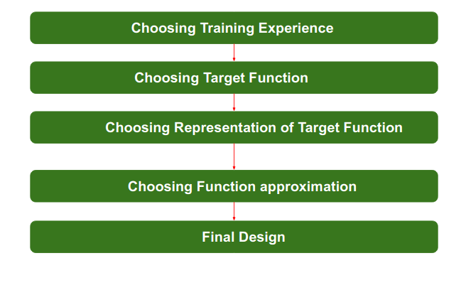

**Step 1) Choosing the Training Experience:**The very important and first task is to choose the training data or training experience which will be fed to the Machine Learning Algorithm. It is important to note that the data or experience that we fed to the algorithm must have a significant impact on the Success or Failure of the Model. So Training data or experience should be chosen wisely.

Below are the attributes which will impact on Success and Failure of Data:

* The training experience will be able to provide direct or indirect feedback regarding choices. For example: While Playing chess the training data will provide feedback to itself like instead of this move if this is chosen the chances of success increases.
* Second important attribute is the degree to which the learner will control the sequences of training examples. For example: when training data is fed to the machine then at that time accuracy is very less but when it gains experience while playing again and again with itself or opponent the machine algorithm will get feedback and control the chess game accordingly.
* Third important attribute is how it will represent the distribution of examples over which performance will be measured. For example, a Machine learning algorithm will get experience while going through a number of different cases and different examples. Thus, Machine Learning Algorithm will get more and more experience by passing through more and more examples and hence its performance will increase.

**Step 2- Choosing target function:**The next important step is choosing the target function. It means according to the knowledge fed to the algorithm the machine learning will choose NextMove function which will describe what type of legal moves should be taken.  For example : While playing chess with the opponent, when opponent will play then the machine learning algorithm will decide what be the number of possible legal moves taken in order to get success.

**Step 3- Choosing Representation for Target function:**When the machine algorithm will know all the possible legal moves the next step is to choose the optimized move using any representation i.e. using linear Equations, Hierarchical Graph Representation, Tabular form etc. The NextMove function will move the Target move like out of these move which will provide more success rate. For Example : while playing chess machine have 4 possible moves, so the machine will choose that optimized move which will provide success to it.

**Step 4- Choosing Function Approximation Algorithm:**An optimized move cannot be chosen just with the training data. The training data had to go through with set of example and through these examples the training data will approximates which steps are chosen and after that machine will provide feedback on it. For Example : When a training data of Playing chess is fed  to algorithm so at that time it is not machine algorithm will fail or get success and again from that failure or success it will measure while next move what step should be chosen and what is its success rate.

**Step 5- Final Design:**The final design is created at last when system goes from number of examples  , failures and success , correct and incorrect decision and what will be the next step etc. Example: DeepBlue is an intelligent  computer which is ML-based won chess game against the chess expert Garry Kasparov, and it became the first computer which had beaten a human chess expert.

**Design of a learning system**

Just now we looked into the learning process and also understood the goal of the learning. When we want to design a learning system that follows the learning process, we need to consider a few design choices. The design choices will be to decide the following key components:

**1. Type of training experience  
2. The exact type of knowledge to be learned (Choosing the Target Function). Initially, the target function will be unknown.  
3. A representation for this target knowledge (Choosing a representation for the Target Function)  
4. A learning mechanism (Choosing an approximation algorithm for the Target Function)**

We will look into the checkers learning problem and apply the above design choices. For a checkers learning problem, the three elements will be,

*1. Task T: To play checkers  
2. Performance measure P: Total percent of the game won in the tournament.  
3. Training experience E: A set of games played against itself*

**Training experience**

During the design of the checker's learning system, the type of training experience available for a learning system will have a significant effect on the success or failure of the learning.

1. **Direct or Indirect training experience —**In the case of direct training experience, an individual board states and correct move for each board state are given.  
   In case of indirect training experience, the move sequences for a game and the final result (win, loss or draw) are given for a number of games. How to assign credit or blame to individual moves is the credit assignment problem.
2. **Teacher or Not —**Supervised — The training experience will be labeled, which means, all the board states will be labeled with the correct move. So the learning takes place in the presence of a supervisor or a teacher.  
   Unsupervised — The training experience will be unlabeled, which means, all the board states will not have the moves. So the learner generates random games and plays against itself with no supervision or teacher involvement.  
   Semi-supervised — Learner generates game states and asks the teacher for help in finding the correct move if the board state is confusing.
3. **Is the training experience good —**Do the training examples represent the distribution of examples over which the final system performance will be measured?  
   Performance is best when training examples and test examples are from the same/a similar distribution.

The checker player learns by playing against oneself. Its experience is indirect. It may not encounter moves that are common in human expert play. Once the proper training experience is available, the next design step will be choosing the Target Function.

**Choosing the Target Function**

In this design step, we need to determine exactly what type of knowledge has to be learned and it's used by the performance program.

*When you are playing the checkers game, at any moment of time, you make a decision on choosing the best move from different possibilities. You think and apply the learning that you have gained from the experience. Here the learning is, for a specific board, you move a checker such that your board state tends towards the winning situation. Now the same learning has to be defined in terms of the target function.*

Here there are 2 considerations — direct and indirect experience.

**During the direct experience**, the checkers learning system, it needs only to learn how to choose the best move among some large search space. We need to find a target function that will help us choose the best move among alternatives. Let us call this function ChooseMove and use the notation **ChooseMove : B →M** to indicate that this function accepts as input any board from the set of legal board states B and produces as output some move from the set of legal moves M.

**When there is an indirect experience**, it becomes difficult to learn such function. How about assigning a real score to the board state. So the function be **V : B →R** indicating that this accepts as input any board from the set of legal board states B and produces an output a real score. This function assigns the higher scores to better board states.

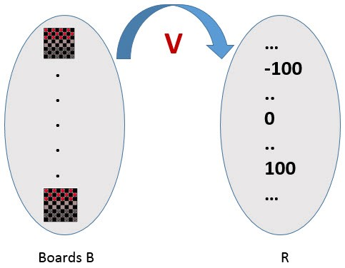

If the system can successfully learn such a target function V, then it can easily use it to select the best move from any board position.

Let us therefore define the target value V(b) for an arbitrary board state b in B, as follows:  
1. if b is a final board state that is won, then V(b) = 100  
2. if b is a final board state that is lost, then V(b) = -100  
3. if b is a final board state that is drawn, then V(b) = 0  
**4. if b is a not a final state in the game, then V (b) = V (b’), where b’ is the best final board state that can be achieved starting from b and playing optimally until the end of the game.**

The (4) is a recursive definition and to determine the value of V(b) for a particular board state, it performs the search ahead for the optimal line of play, all the way to the end of the game. So this definition is not efficiently computable by our checkers playing program, we say that it is a nonoperational definition.  
**The goal of learning, in this case, is to discover an operational description of V ; that is, a description that can be used by the checkers-playing program to evaluate states and select moves within realistic time bounds.**

It may be very difficult in general to learn such an operational form of V perfectly. We expect learning algorithms to acquire only some approximation to the target function ^V.

**Choosing a representation for the Target Function**

Now its time to choose a representation that the learning program will use to describe the function ^V that it will learn. The representation of ^V can be as follows.

1. A table specifying values for each possible board state?
2. collection of rules?
3. neural network?
4. a polynomial function of board features?
5. …

To keep the discussion simple, let us choose a simple representation for any given board state, the function ^V will be calculated as a linear combination of the following board features:

* x1(b) — number of black pieces on board b
* x2(b) — number of red pieces on b
* x3(b) — number of black kings on b
* x4(b) — number of red kings on b
* x5(b) — number of red pieces threatened by black (i.e., which can be taken on black’s next turn)
* x6(b) — number of black pieces threatened by red

^V = w0 + w1 · x1(b) + w2 · x2(b) + w3 · x3(b) + w4 · x4(b) +w5 · x5(b) + w6 · x6(b)

Where w0 through w6 are numerical coefficients or weights to be obtained by a learning algorithm. Weights w1 to w6 will determine the relative importance of different board features.

**Specification of the Machine Learning Problem at this time —**Till now we worked on choosing the type of training experience, choosing the target function and its representation. The checkers learning task can be summarized as below.

* **Task T : Play Checkers**
* **Performance Measure : % of games won in world tournament**
* **Training Experience E : opportunity to play against itself**
* **Target Function : V : Board → R**
* **Target Function Representation : ^V = w0 + w1 · x1(b) + w2 · x2(b) + w3 · x3(b) + w4 · x4(b) +w5 · x5(b) + w6 · x6(b)**

The first three items above correspond to the specification of the learning task,whereas the final two items constitute design choices for the implementation of the learning program.

**Choosing an approximation algorithm for the Target Function**

**Generating training data —**

To train our learning program, we need a set of training data, each describing a specific board state b and the training value V_train (b) for b. Each training example is an ordered pair <b,V_train(b)>

For example, a training example may be <(x1 = 3, x2 = 0, x3 = 1, x4 = 0, x5 = 0, x6 = 0), +100">. This is an example where black has won the game since x2 = 0 or red has no remaining pieces. However, such clean values of V_train (b) can be obtained only for board value b that are clear win, loss or draw.

In above case, assigning a training value V_train(b) for the specific boards b that are clean win, loss or draw is direct as they are direct training experience. But in the case of indirect training experience, assigning a training value V_train(b) for the intermediate boards is difficult. In such case, the training values are updated using temporal difference learning. **Temporal difference (TD) learning is a concept central to reinforcement learning, in which learning happens through the iterative correction of your estimated returns towards a more accurate target return.**

Let Successor(b) denotes the next board state following b for which it is again the program’s turn to move. ^V is the learner’s current approximation to V. Using these information, assign the training value of V_train(b) for any intermediate board state b as below :  
**V_train(b) ← ^V(Successor(b))**

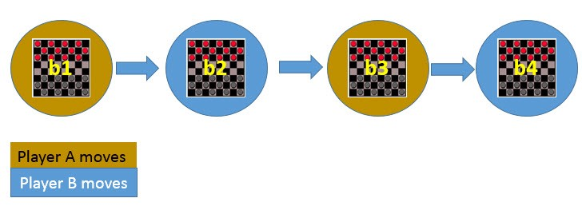

In the above figure, V_train(b1) ← ^V(b3), where b3 is the successor of b1. Once the game is played, the training data is generated. For each training example, the V_train(b) is computed.

**Adjusting the weights**

Now its time to define the learning algorithm for choosing the weights and best fit the set of training examples. One common approach is to define the best hypothesis as that which minimizes the squared error E between the training values and the values predicted by the hypothesis ^V.

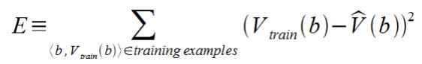

The learning algorithm should incrementally refine weights as more training examples become available and it needs to be robust to errors in training data  
Least Mean Square (LMS) training rule is the one training algorithm that will adjust weights a small amount in the direction that reduces the error.

The LMS algorithm is defined as follows:

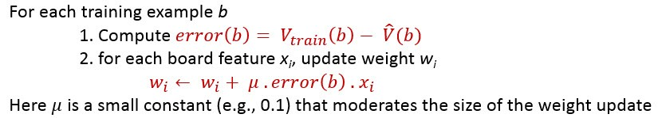

**Final Design for Checkers Learning system**

1. The performance System — Takes a new board as input and outputs a trace of the game it played against itself.
2. The Critic — Takes the trace of a game as an input and outputs a set of training examples of the target function.
3. The Generalizer — Takes training examples as input and outputs a hypothesis that estimates the target function. Good generalization to new cases is crucial.
4. The Experiment Generator — Takes the current hypothesis (currently learned function) as input and outputs a new problem (an initial board state) for the performance system to explore.