Pang-Fa Chou

934378517

choupa@oregonstate.edu

The result after running the program is shown as proj01.xlsx and the following as well:



proj01.xlsx is transformed into 2 graphs as following:  
1. Graph of performance vs. number of trials

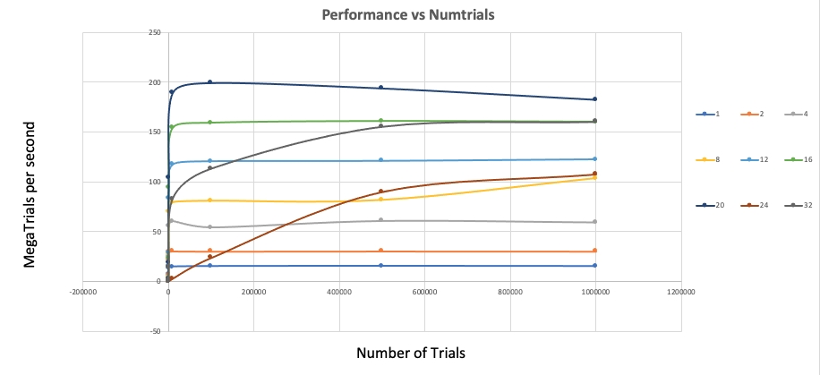

2. Graph of performance vs. number of threads

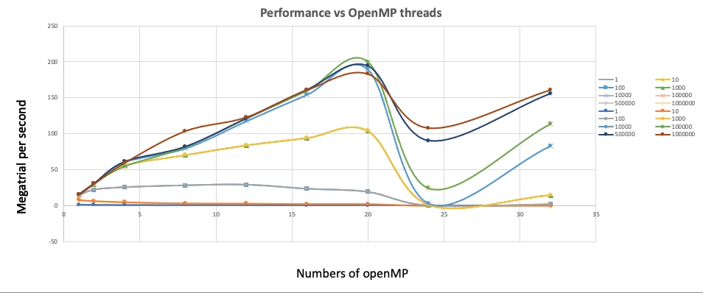

For the probability and Fp, I choose the data from 1,000,000 trials. Based on the test result, I believe the actual probability is approximate 29.13%

For Speedup:

S2 = 30.33 / 15.1 = 2.01

S4 = 59.29 / 15.1 = 3.94

S8 = 103.5 / 15.1 = 6.85

S12 = 122.57 / 15.1 = 8.11

S16 = 160.28 / 15.1 = 10.61

S20 = 182.55 / 15.1 = 12.08

S24 = 107.71 / 15.1 = 7.13

S32 = 160.44 / 15.1 = 10.62

For Fp:

Fp2 = 2/1 \* (1 – 1/S2) = 0.502

Fp4 = 4/3 \* (1 – 1/S4) = 0.994

Fp8 = 8/7 \* (1 – 1/S8) = 0.975

Fp12 = 12/11 \* (1 – 1/S12) = 0.956

Fp16 = 16/15 \* (1 – 1/S16) = 0.996

Fp20 = 20/19 \* (1 – 1/S20) = 0.965

Fp24 = 24/23 \* (1 – 1/S24) = 0.897

Fp32 = 32/31 \* (1 – 1/S32) = 0.935