<https://www.cherrihartigan.com/>

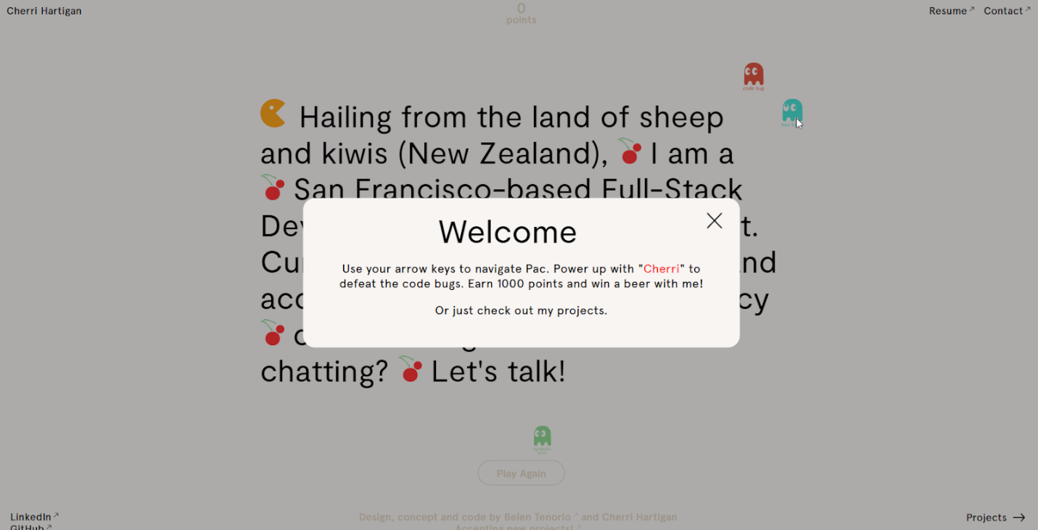

This has one of the coolest landing pages/introductions I have seen. You want to read her introduction because it’s part of the game, so you have to focus on the words. I did find the popup annoying, but it’s to tell you the rules for the game. I don’t know if my JavaScript skills are up to programming something like this or not. The color scheme is just black and off-white, so the Pacman content also adds some interesting color. I like the two column layout with a short description of the project and an overview of the languages and technologies used to create it. The navigation is minimal but it works.

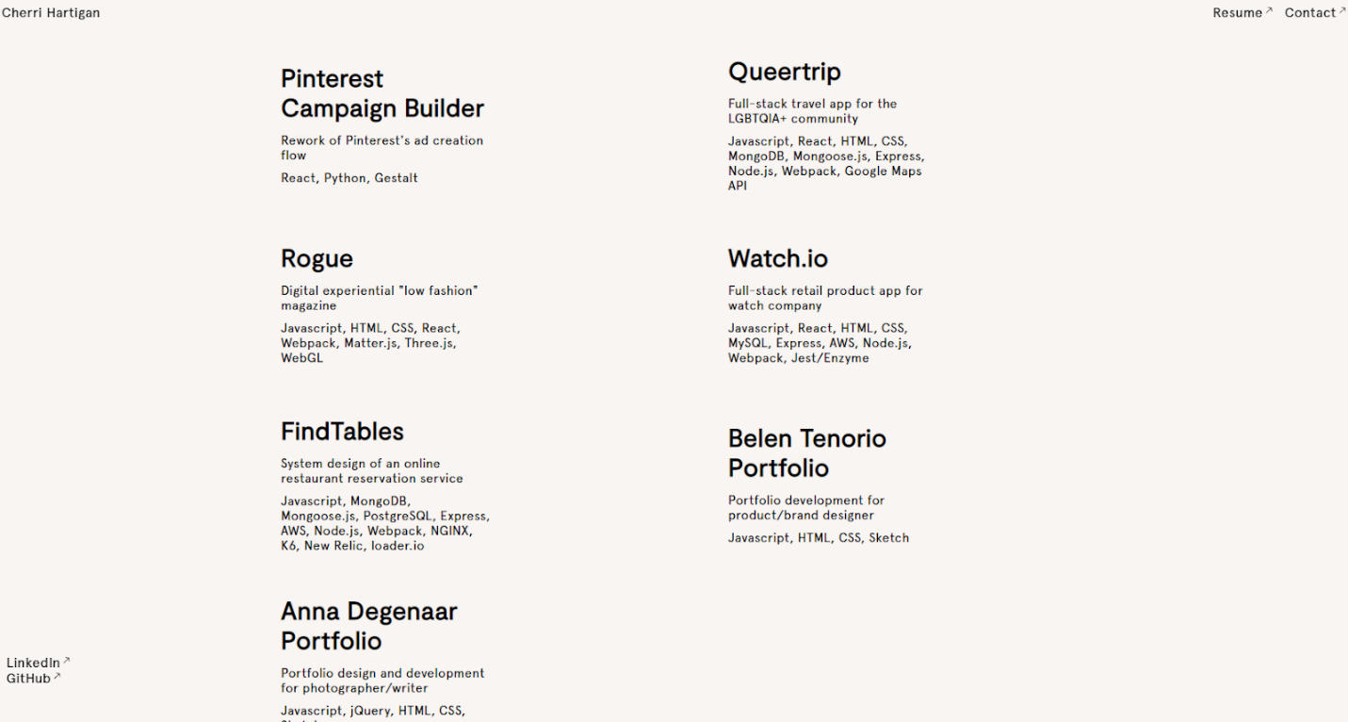

<http://rumz.org/>



This had a lot of hover effects, highlighting the text and displaying new content (animations, images, and links). All of this happens as you passively scroll through the page, you don’t have to click on the red dots or otherwise seek the information out. I think the effect is striking, but it also got distracting. It’s difficult to just read through his projects with all of the added content and effects. Like Cherri Hartigan’s site, the color scheme is basically just black and white. The red dots and yellowish highlighting are how emphasis is added. It’s easy to read. The main content is in a single column, and additional information is displayed to the right, partially covering up the main text. This site doesn’t have any navigation at all, and the contact information/links only come up at the end. I think the interactivity is a good idea, but I might tone it down.



<https://simonrahm.pro/>

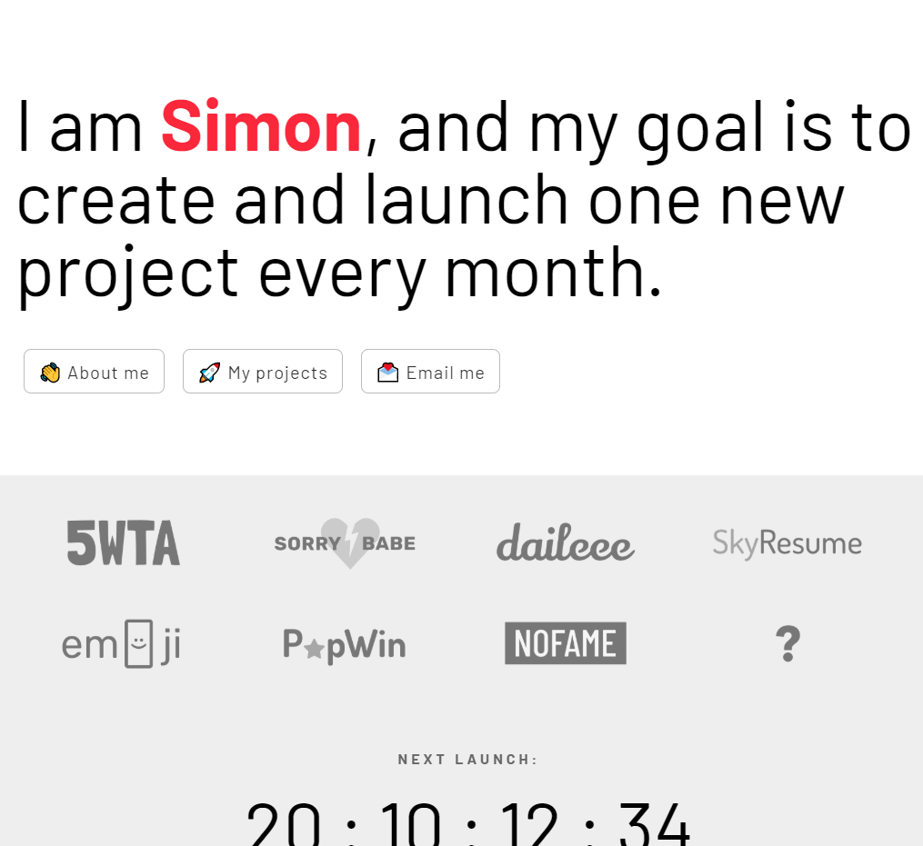

I think highlighting his name was a good idea. Again, the color scheme is basically black, white, and some shades of grey. Adding color for emphasis with the name on the icons really makes them stand out without being obnoxious. As you scroll down there’s more color. The background changes for each project, which helps make each project feel distinct. The layout is a single column. There isn’t any navigation except for what was at the beginning. I like the simplicity and the countdown clock, but there’s almost no interactivity, especially compared to the other two sites.

