Sarah Kovar

May 17, 2020

Web 335, Assignment 3.2

**Business Rules, ORD:**

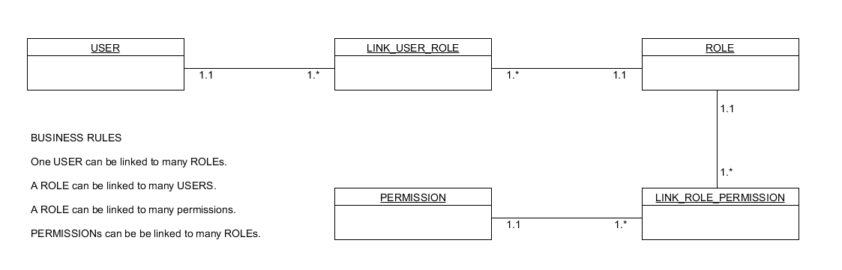

**Document Diagram:**

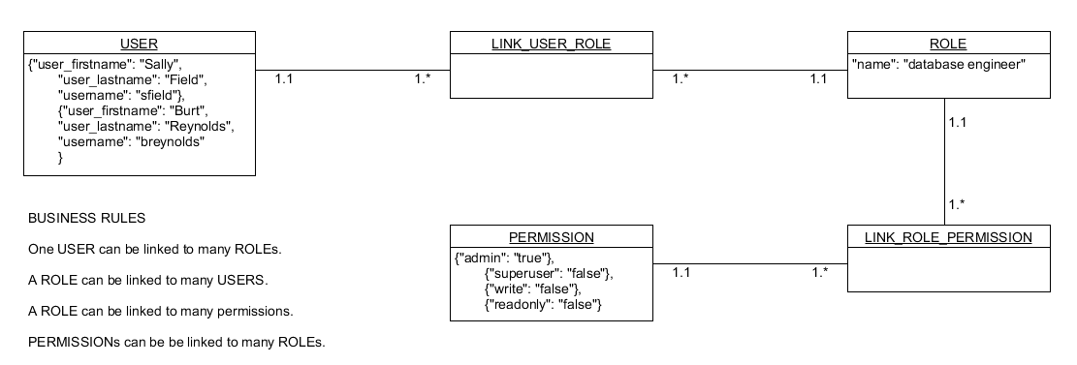

**Data Structure:**

