Sarah Kovar

May 17, 2020

Web 335, Assignment 3.3

**ORD**

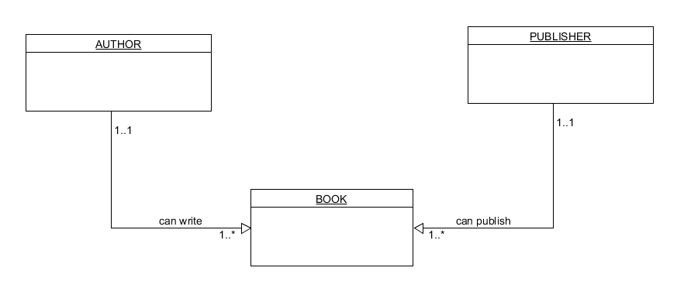

**Document Diagram**

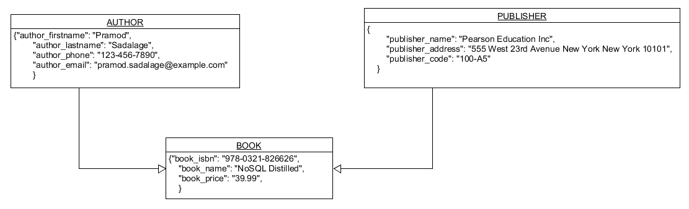

**Data Structure**

