Sarah Kovar

May 29, 2020

Web 335, Assignment 5.3

findOne() operation:

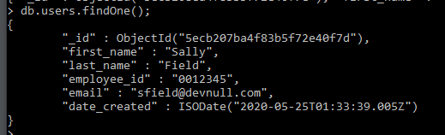

update() operation:



second findOne() operation:

