Sarah Kovar

June 6, 2020

Web 335, Assignment 6.2

**Add a Unique Index to the “employee_id” field**

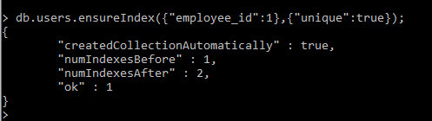

**Execute the insert() operation to validate the Unique Index was added correctly**



**Execute the insert() operation to validate the Unique Index was added correctly**

