Sarah Kovar / James Brown / Nicole Forke  
June 15, 2020  
Assignment 8.4 / Milestone 3

**User 1 Story:**

As a user, I need to be able to stream content, so that I can keep myself entertained.

**User 1 Wireframe:**

**User 1 Business Rules:**

A USER can stream one VIDEO at a time

A USER can save many Videos in their Watch Later Queue

A USER can only have one Watch Queue

**User 1 ORD:**

**User 1 Document Model:**

**User 1 JSON:**

**User 2 Story:** As a user, I need to be able to manage my account, so that I can change my password, update notification preferences, or adjust billing details.

**User 2 Wireframe:**

**User 2 Business Rules:**

A USER can have one password

A User can have many notification preferences

A User can have many funding sources

**User 2 ORD:**

**User 2 Document Model:**

**User 2 JSON:**

**User 3 Story:** As a user, I need to be able to navigate the content easily, so that I don’t spend a lot of time searching.

**User 3 Wireframes:**  
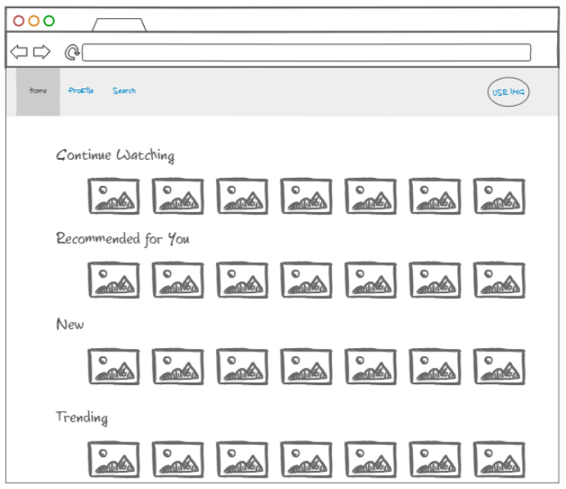

**User 3 Business Rules:**  
  
A USER can see many CATEGORIES

A CATEGORY can contain many VIDEOS

**User 3 ORD:**

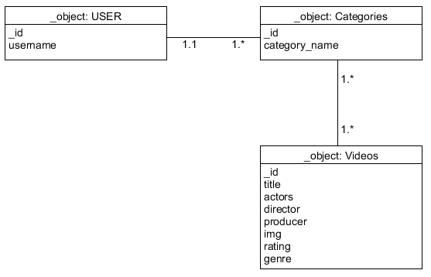

**User 3 Document Model:**

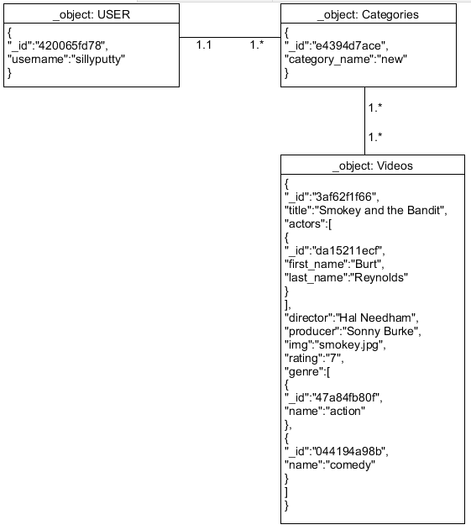

**User 3 JSON:**

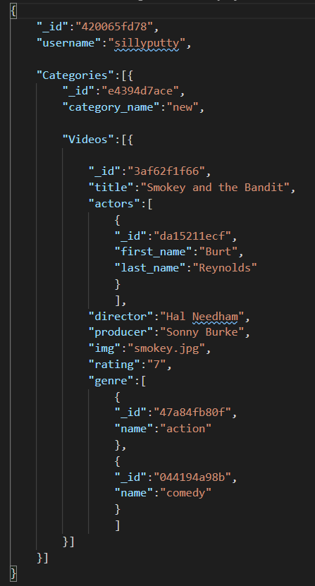

**User 4 Story:** As a user, I need to be able to monitor my children, so I can block certain content and know they are only watching approved shows, movies, etc.

**User 4 Wireframe:**

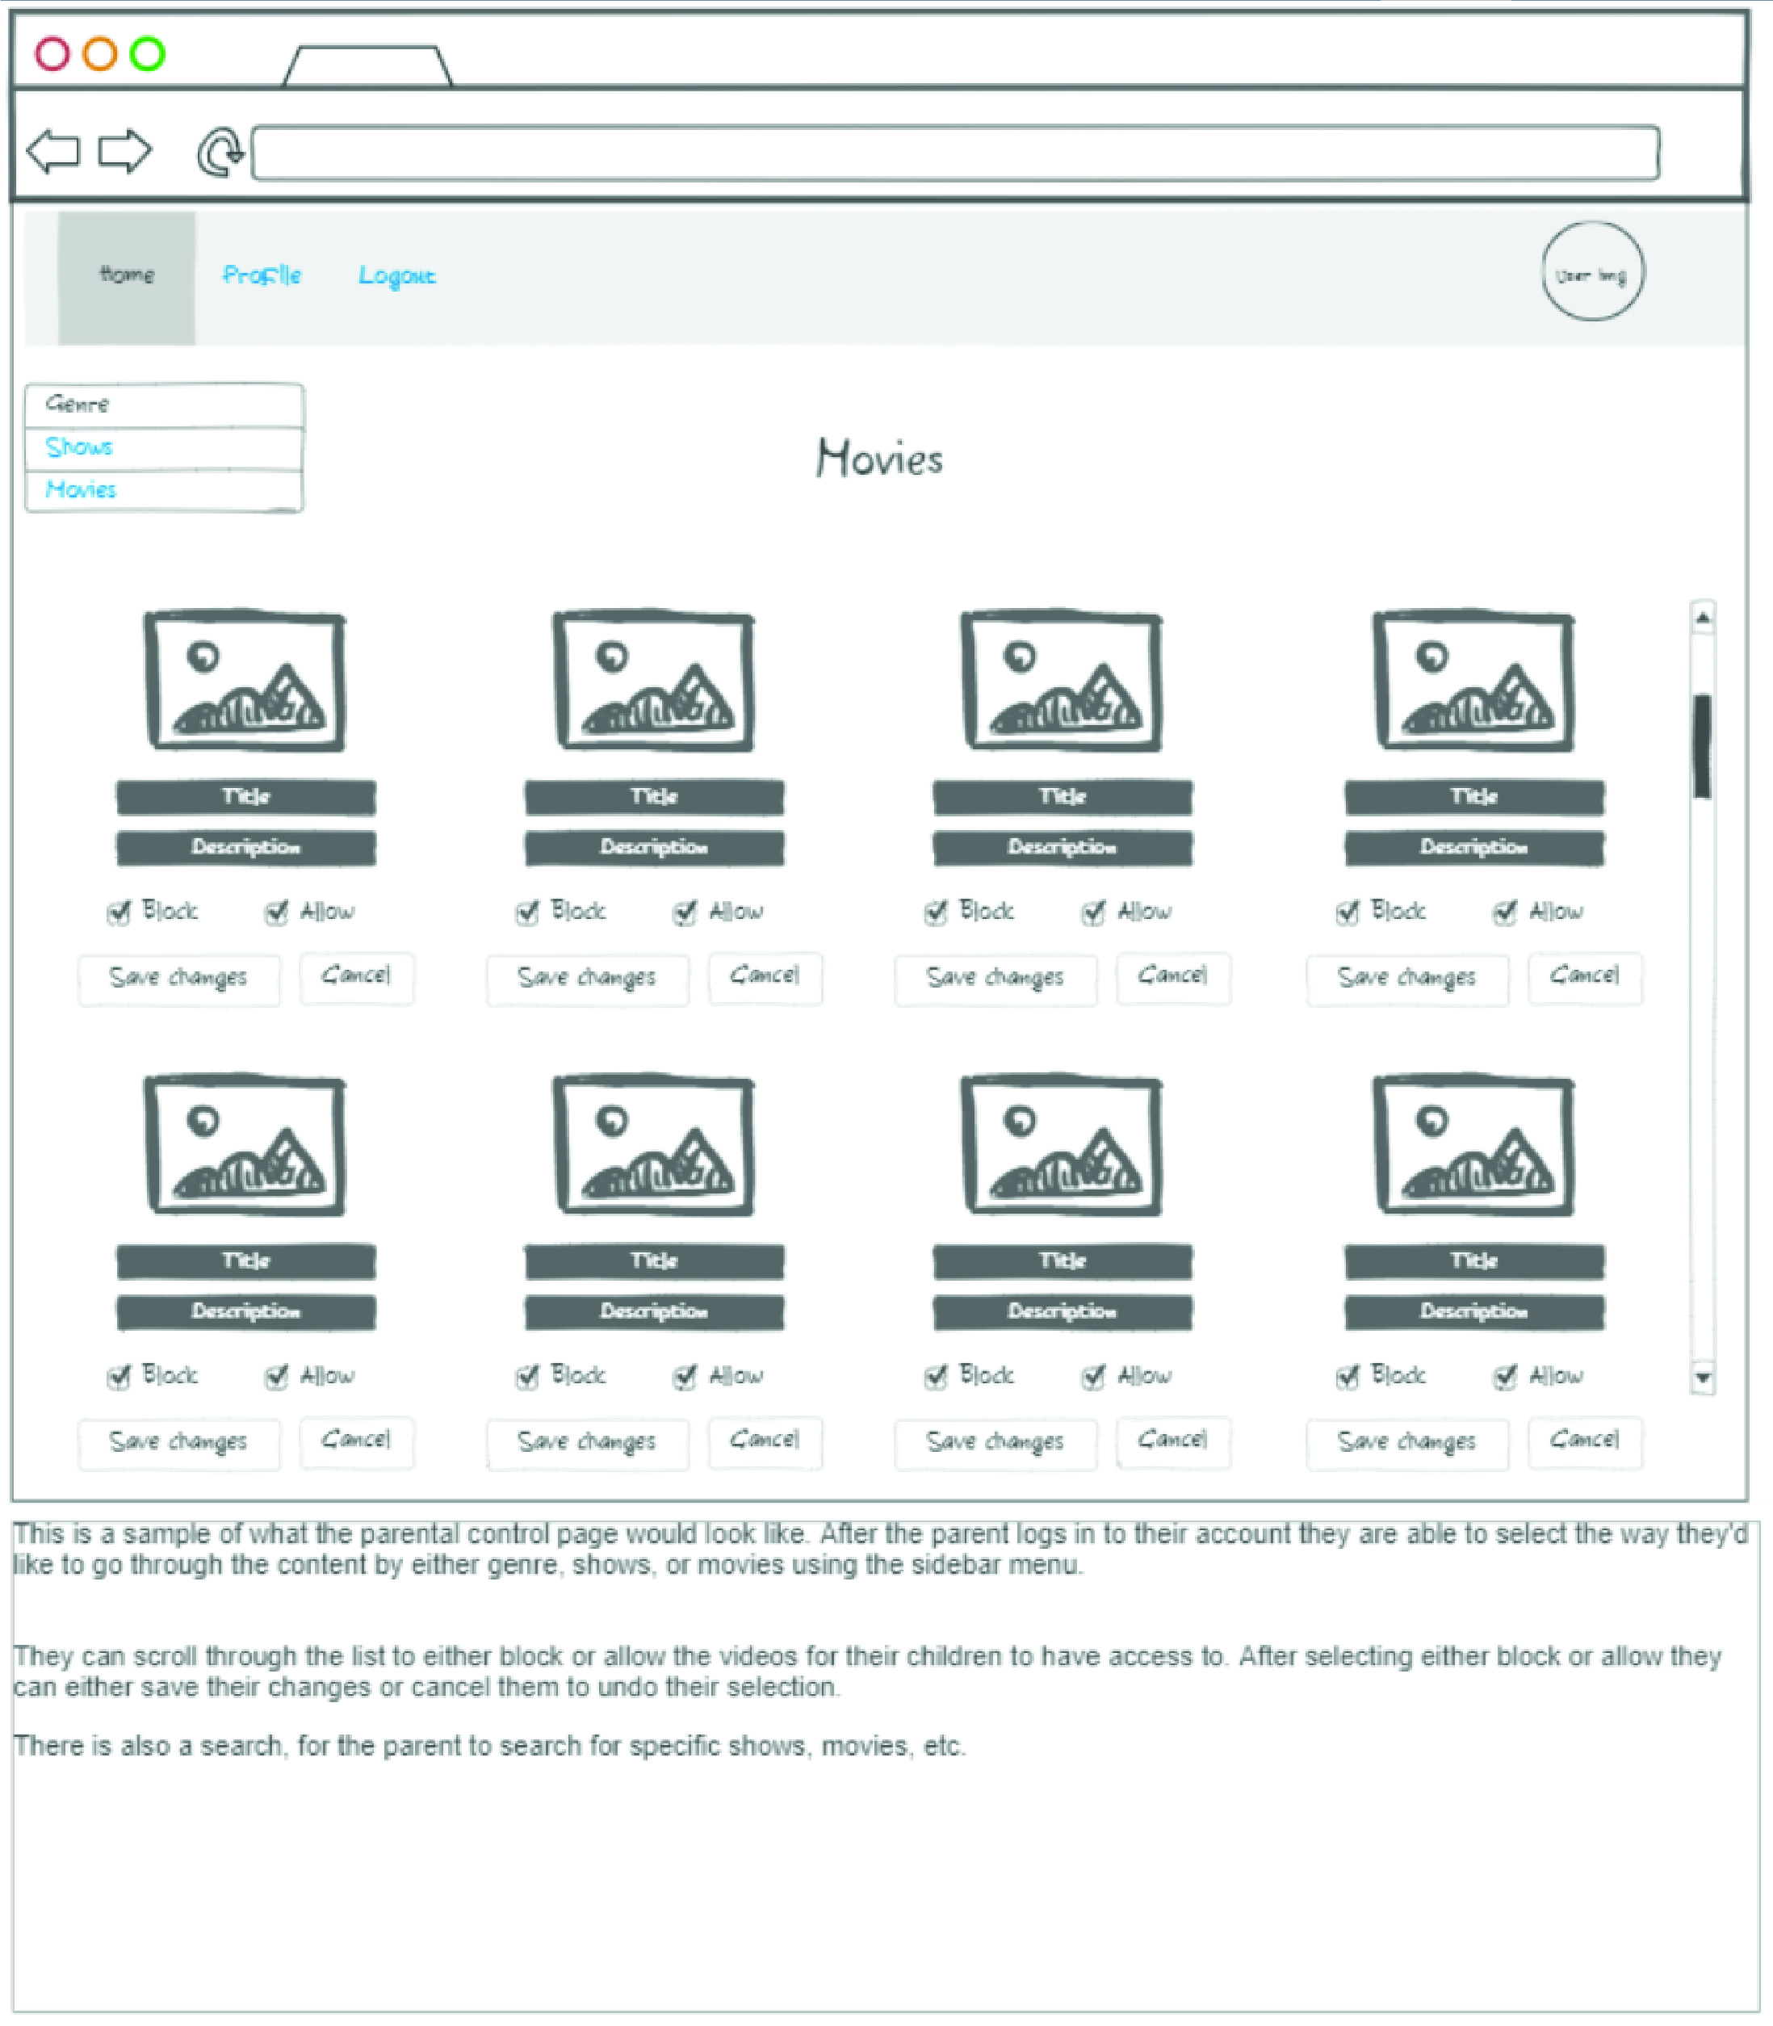

**User 4 Business Rules:**

A USER can login to parental controls.

A USER can block content from children.

A USER can allow content for children.

**User 4 ORD:**

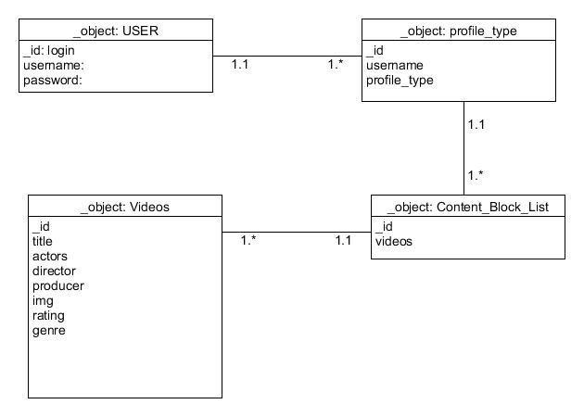

**User 4 Document Model:**

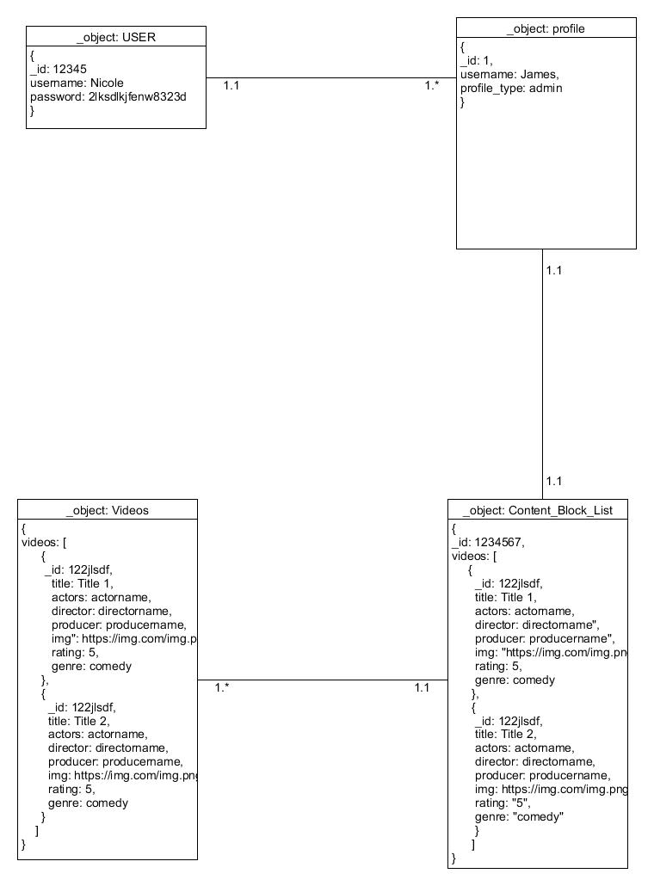

**User 4 JSON:**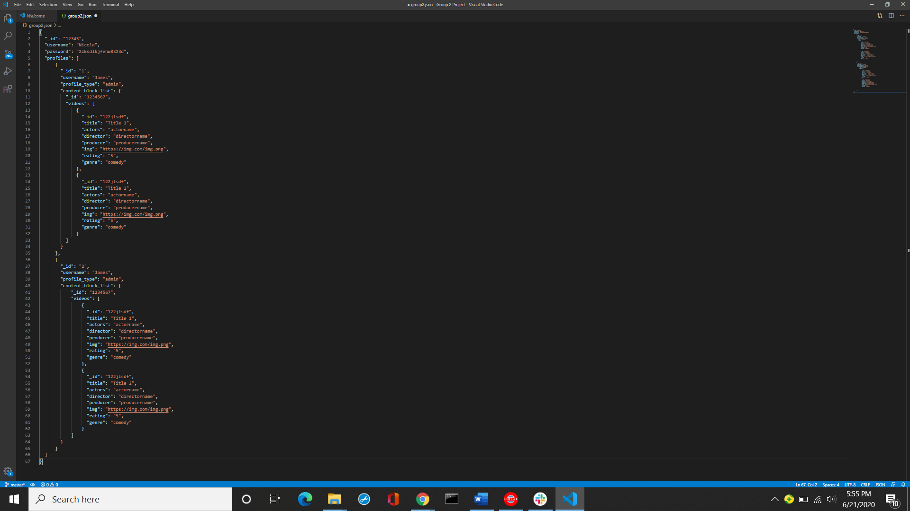

**User 5 Story:** As a user, I would like to be able to sort and search content by various filters (ex: genre, title, actor).

**User 5 Wireframe:**  
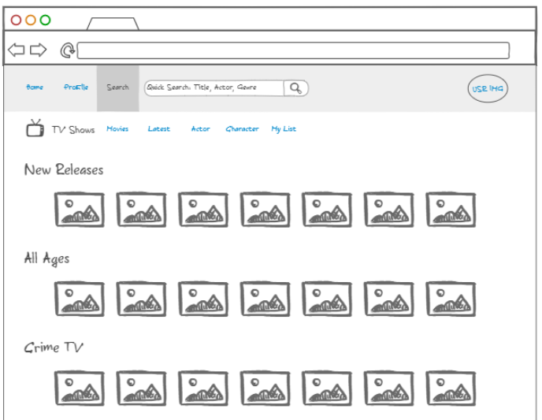

**User 5 Business Rules:**

A VIDEO can have multiple TAGS (title, actor, genre)

A TAG can be present in multiple VIDEOS

A FILTER can contain multiple TAGS

**User 5 ORD:**  
  
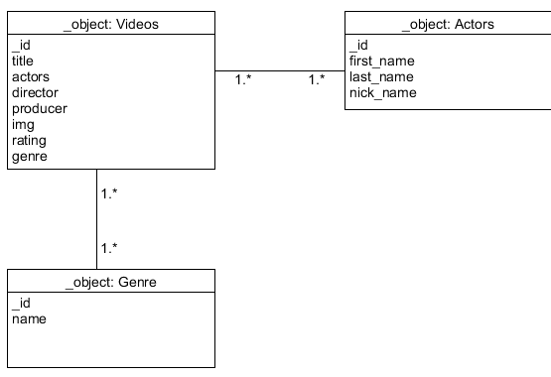

**User 5 Document Model:**

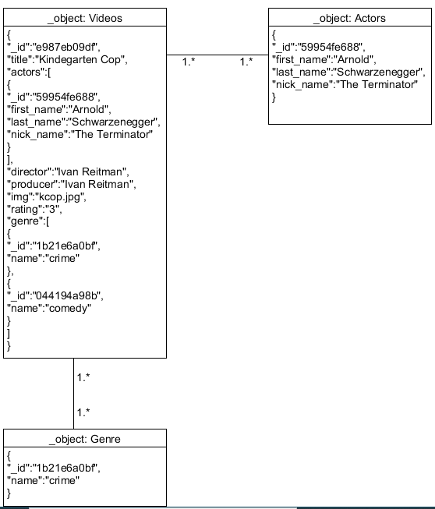

**User 5 JSON:**

