Sarah Kovar

June 6, 2020

Web 420, Assignment 6.3

**login [/api/auth/login] – Request & Response**

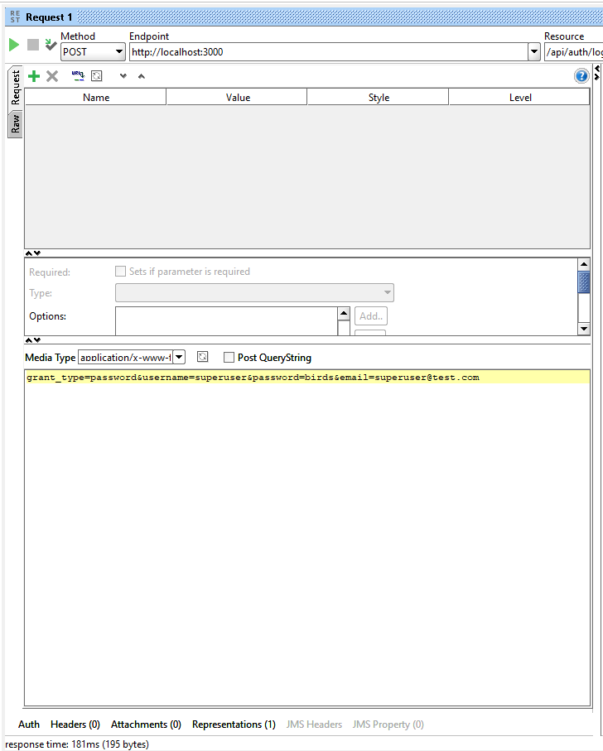

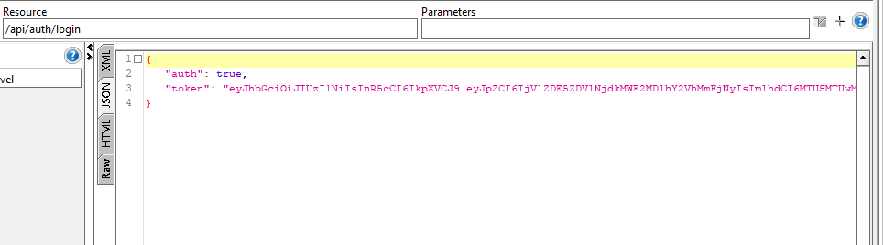

**logout [/api/auth/logout] – Request & Response**

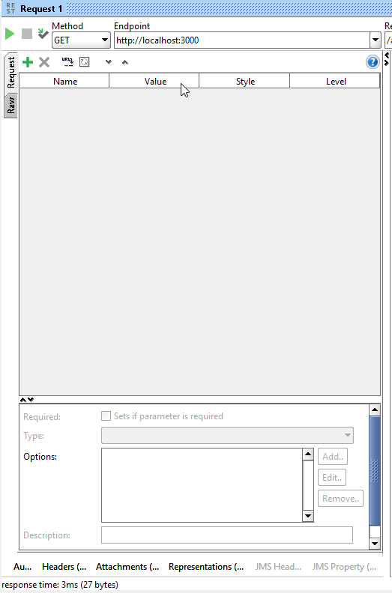

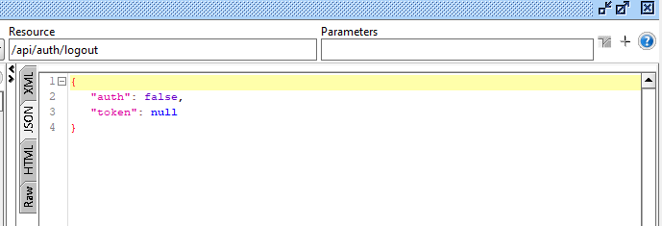

**solution running in a browser**

