**Introduction**

As part of our software development studies, we were given an assignment to develop a virtual ATM machine. The machine should include all the same functions as a physical ATM would. At the same time the project team would learn how to combine different aspects of software building like MySQL, RestAPI and QT-programming.

**Objectives**

The main objective for the project was to develop a functioning ATM machine software combining multiple different components that work together as one.

The actual Visa-card was simulated with an RFID-reader capable of recognizing different badges. The badge information was then passed on to the software.

The team was also required to build a database that contains the personal details, balances etc. that can be accessed by the software through RestAPI also built by the team.

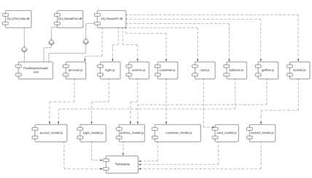

*Figure 1. The Component Diagram*

**Methods**

The main application was built using C++ language in the QT-programming environment. The application used three different external libraries, one to import pin code submitted by user, other one to import the ID of the card used and last one to transfer data between database and the main program via RestAPI.

Olimex MOD-RFID125 was used as the external RFID-reader.

MySQL database was used to store all the customer data and was built with MySQL Workbench.

RestAPI was programmed using Visual Studio Code.

**Results**

The team managed to make the system as requested and it worked just as it should. When the device detects a card approaching, it asks for the card PIN code. Id the card’s ID matches the PIN code the user can access to the main menu. If the PIN is wrong, it can be tried two times until it locks. In the main menu, the user can select the functions they want to do, such as withdrawing or depositing money.

*Figure 2. Main Menu*

**Conclusions**

The team is happy with the results and made all the features work just as they should. Team members also learn new things as well as solve various problems through the project.

**References**

* [MOD-RFID125-BOX User’s Manual Source](https://www.olimex.com/Products/Modules/RFID/MOD-RFID125-BOX/resources/MOD-RFID125-BOX.pdf)
* [Qt Documentation Source](https://doc.qt.io/qt-5/index.html)