CSE 3025 – LARGE SCALE DATA PROCESSING
FACULTY : DR. SYED IBRAHIM
LAB : L-23,24 , DATE : 17.9.19
DHRUBANKA DUTTA
SIDE CONFIGURATION

- Create a text file for students details(student id,student name, marks-5 courses) in HDFS. Get a particular student details using side data configuration.

CODE :

import java.io.IOException;

import org.apache.hadoop.fs.Path;
import org.apache.hadoop.conf.*;
import org.apache.hadoop.io.*;
import org.apache.hadoop.mapreduce.*;
import org.apache.hadoop.mapreduce.Mapper.Context;
import org.apache.hadoop.mapreduce.lib.input.*;
import org.apache.hadoop.mapreduce.lib.output.*;

public class sidec{
public static class Map extends Mapper<LongWritable, Text, Text, Text> {
public void map(LongWritable key, Text value, Context context) throws IOException, InterruptedException {
String name1;
name1 = context.getConfiguration().get("name");
String line1 = value.toString();
String[] line = line1.split(",");
if(line[1].equals(name1)){
context.write(new Text(line1),new Text("found") );
}
}
}
public static void main(String[] args) throws Exception {
Configuration conf = new Configuration();
conf.set("name",args[2]);
Job job = new Job(conf, "sidec");
job.setJarByClass(sidec.class);
job.setOutputKeyClass(Text.class);
job.setOutputValueClass(Text.class);
job.setMapperClass(Map.class);

job.setInputFormatClass(TextInputFormat.class);
job.setOutputFormatClass(TextOutputFormat.class);
FileInputFormat.addInputPath(job, new Path(args[0]));
FileOutputFormat.setOutputPath(job, new Path(args[1]));

// job.setNumReduceTasks(0);

job.waitForCompletion(true);
}
}

OUTPUT :

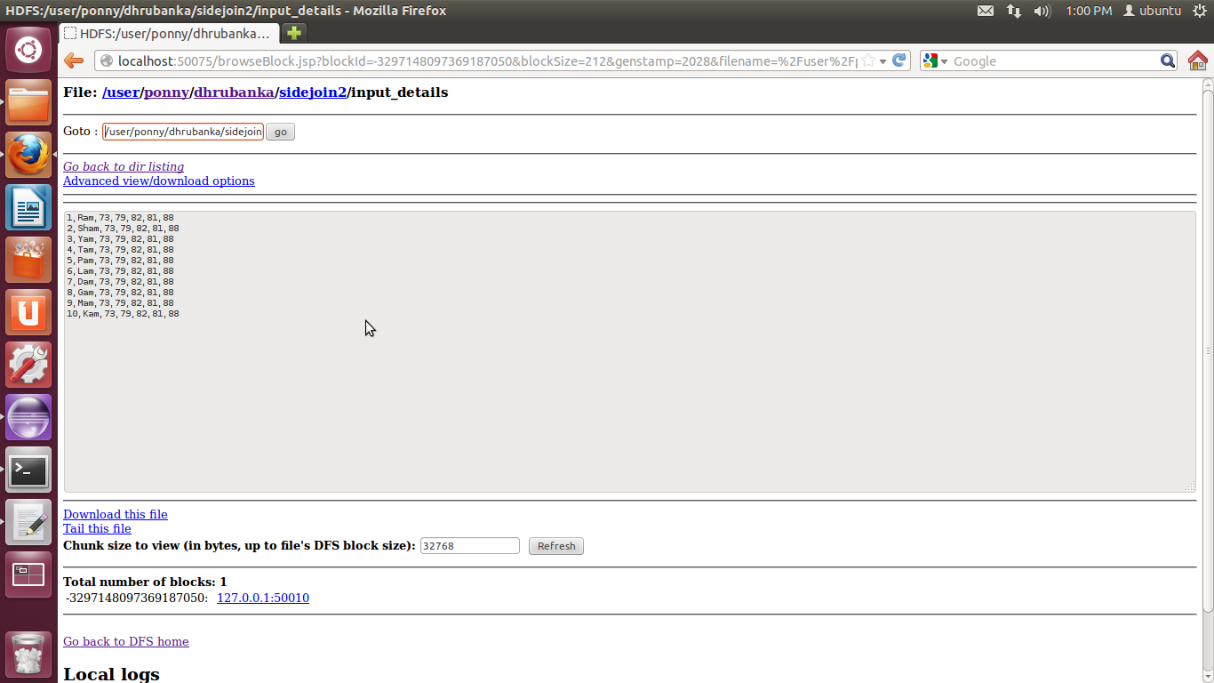

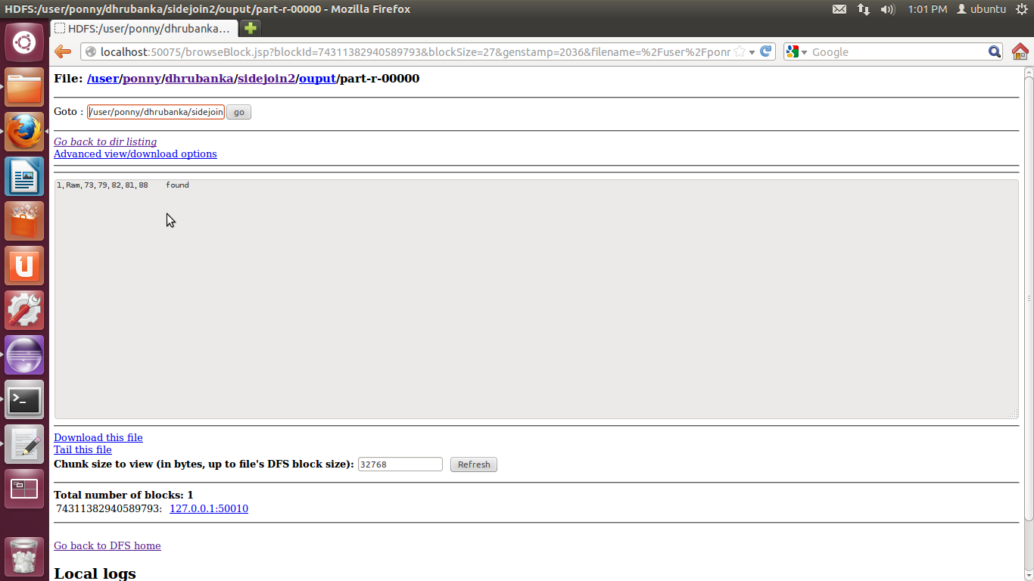

- Create the student details(student id,student name,CGPA) file and the department details(student id,department) file in HDFS. Let the department details can be stored using distributed cache. Write the student id, name,department and CGPA in the HDFS. Use map side join.

CODE :

import java.io.*;
import java.util.*;

import org.apache.hadoop.filecache.DistributedCache;
import org.apache.hadoop.fs.Path;
import org.apache.hadoop.conf.*;
import org.apache.hadoop.io.*;
import org.apache.hadoop.mapreduce.*;
import org.apache.hadoop.mapreduce.Mapper.Context;
import org.apache.hadoop.mapreduce.lib.input.*;
import org.apache.hadoop.mapreduce.lib.output.*;

public class dist {
public static class Map extends Mapper<LongWritable,Text,Text,Text> {
Path[] cfile=new Path[0];
ArrayList<Text> dep=new ArrayList<Text>();
public void setup(Context context)
{
Configuration conf=context.getConfiguration();
try
{
cfile = DistributedCache.getLocalCacheFiles(conf);
BufferedReader reader=new BufferedReader(new FileReader(cfile[0].toString()));
String line;
while ((line=reader.readLine())!=null)
{
Text tt=new Text(line);
dep.add(tt);
}
}
catch(IOException e)
{
e.printStackTrace();
}
}

public void map(LongWritable key, Text value, Context context) throws IOException, InterruptedException {
String line2 = value.toString();
String[] elements=line2.split(",");
for(Text e:dep)
{
String[] line1 = e.toString().split(",");
if(elements[0].equals(line1[0]))
{
context.write(new Text(elements[0]),new Text(elements[1]+","+elements[2]+","+line1[1]));
}
}
}
}
public static void main(String[] args) throws Exception {
Configuration conf = new Configuration();
Job job = new Job(conf, "dist");
job.setJarByClass(dist.class);
job.setOutputKeyClass(Text.class);
job.setOutputValueClass(Text.class);
job.setMapperClass(Map.class);

job.setInputFormatClass(TextInputFormat.class);
job.setOutputFormatClass(TextOutputFormat.class);
DistributedCache.addCacheFile(new Path(args[0]).toUri(),job.getConfiguration());
FileInputFormat.addInputPath(job, new Path(args[1]));
FileOutputFormat.setOutputPath(job, new Path(args[2]));

// job.setNumReduceTasks(0);

job.waitForCompletion(true);
}
}
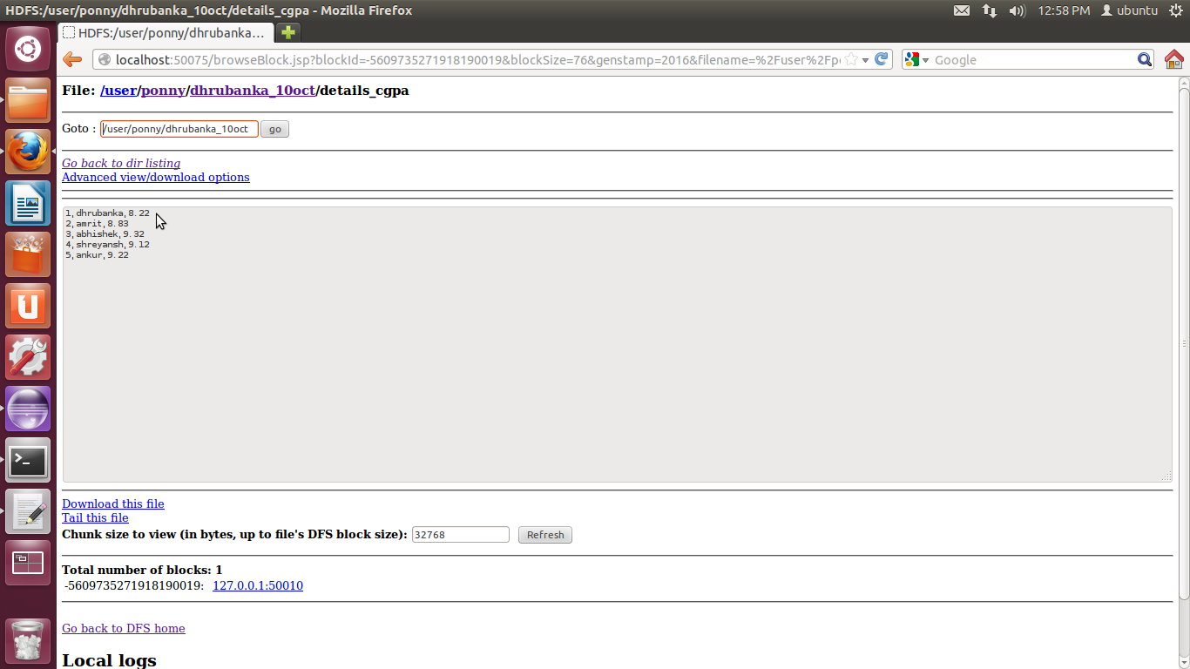
OUTPUT :

