CSE 3025 – LARGE SCALE DATA PROCESSING
FACULTY : DR. SYED IBRAHIM
LAB : L-23,24 , DATE : 25.7.19
DHRUBANKA DUTTA
HADOOP COMMANDS

Original Directory :
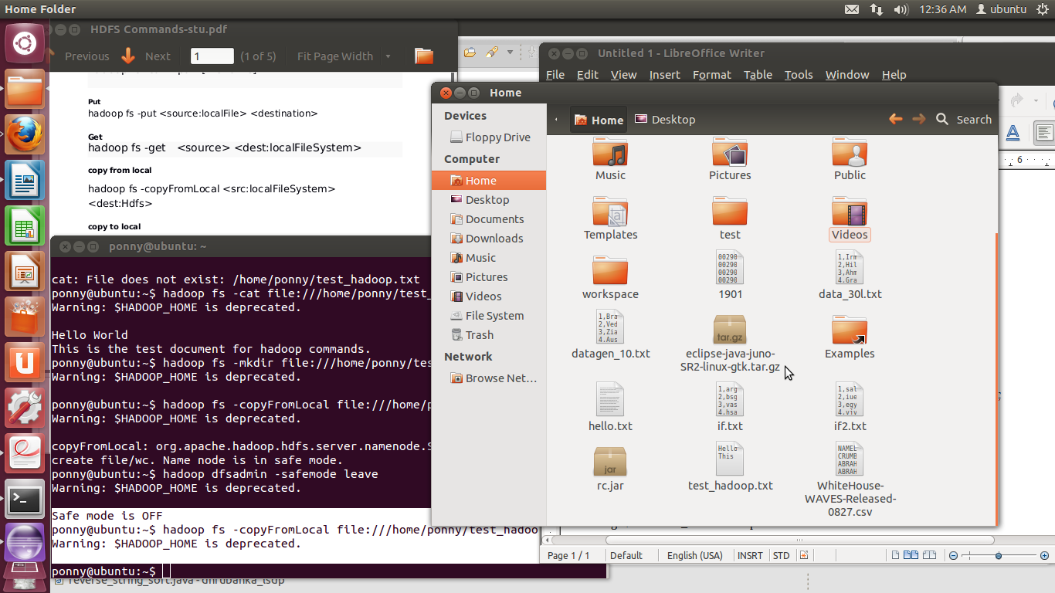

- List the file

$ hadoop fs -ls
Warning: $HADOOP_HOME is deprecated.

Found 3 items
-rw-r--r-- 1 ponny supergroup 44 2018-10-24 16:40 /user/ponny/rin1
-rw-r--r-- 1 ponny supergroup 78 2018-10-24 16:40 /user/ponny/rin2
drwxr-xr-x - ponny supergroup 0 2018-10-24 16:42 /user/ponny/rout

- View the contents

ponny@ubuntu:~$ hadoop fs -cat file:///home/ponny/test_hadoop.txt
Warning: $HADOOP_HOME is deprecated.

Hello World
This is the test document for hadoop commands.

- Copy from Local (put)

Safe mode is OFF
ponny@ubuntu:~$ hadoop fs -copyFromLocal file:///home/ponny/test_hadoop.txt /wc
Warning: $HADOOP_HOME is deprecated.

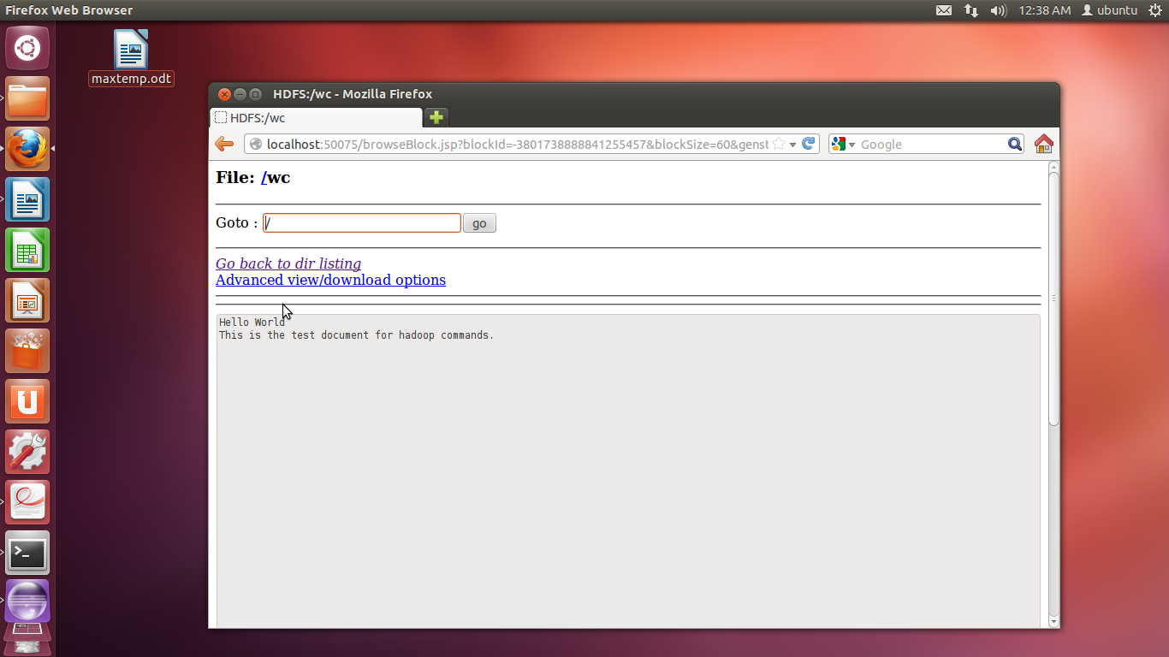

- Copy to Local (get)

ponny@ubuntu:~$ hadoop fs -copyToLocal /user/ponny/rout file:///home/ponny/
Warning: $HADOOP_HOME is deprecated.

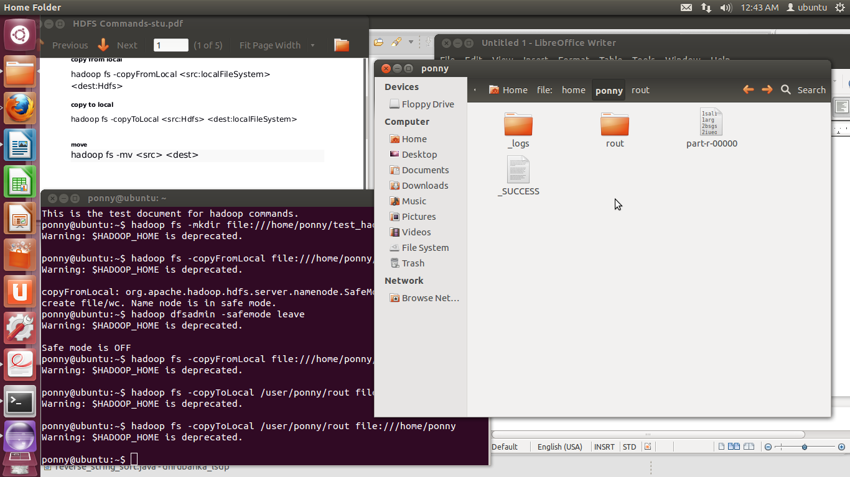

- Move

ponny@ubuntu:~$ hadoop fs -mv /wc/ /new_folder
Warning: $HADOOP_HOME is deprecated.

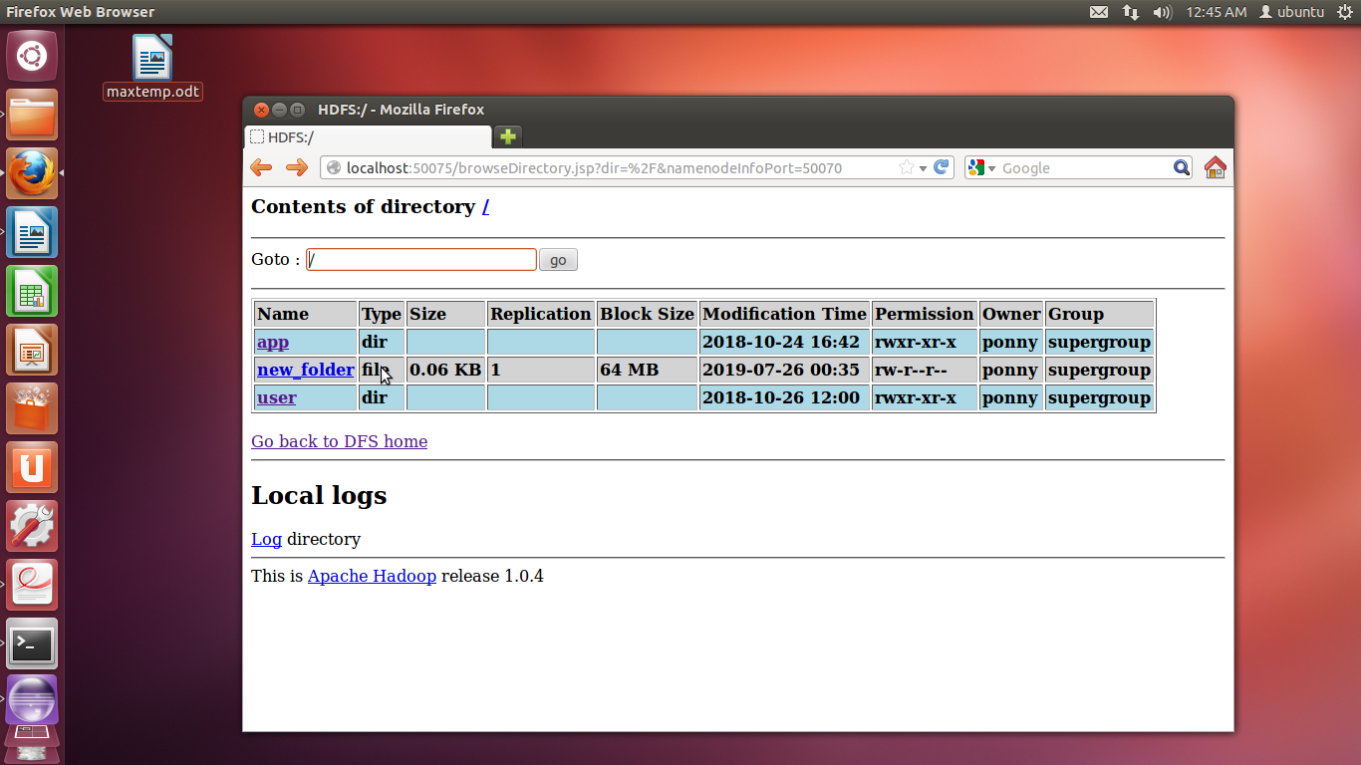

- Remove

ponny@ubuntu:~$ hadoop fs -rm /new_folder
Warning: $HADOOP_HOME is deprecated.

Deleted hdfs://localhost:54310/new_folder

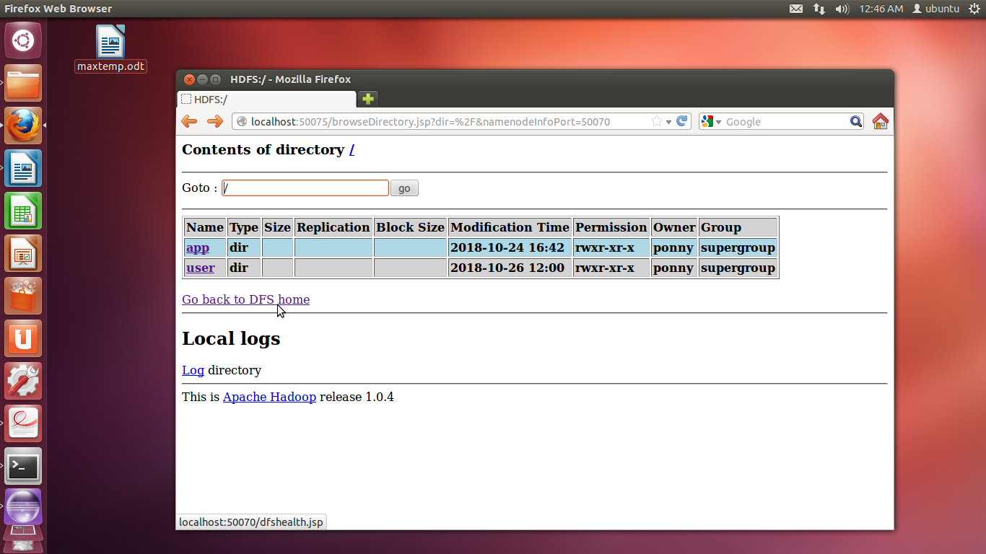

- Mkdir

ponny@ubuntu:~$ hadoop fs -mkdir file:///home/ponny/test_hadoop1.txt
Warning: $HADOOP_HOME is deprecated.

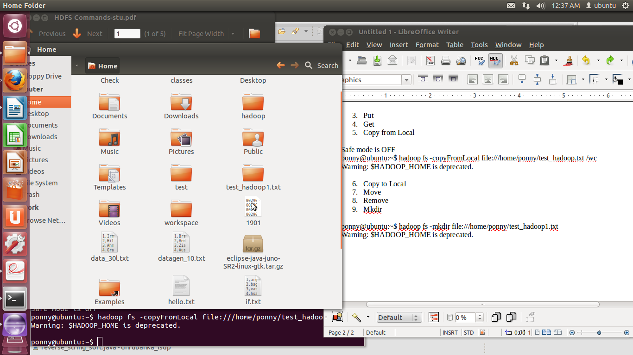

Question : From input file , find all the occurrences of the words

Input : cat, rat
mat, pat
cat, pot
mat, pat

Command: hadoop jar /home/ponny/wcount.jar WordCount /wc /ac

CODE :

import java.io.IOException;
import java.util.*;
import org.apache.hadoop.fs.Path;
import org.apache.hadoop.conf.*;
import org.apache.hadoop.io.*;
import org.apache.hadoop.mapreduce.*;
import org.apache.hadoop.mapreduce.lib.input*;

public class 17BCE1019_lab3 {
public static class Map extends Mapper<LongWritable, Text, Text, IntWritable> {
private final static IntWritable one = new IntWritable(1);
IntWritable one = new IntWritable(1);
private Text word = new Text();
public void map(LongWritable key, Text value, Conetxt context) throws IOException, InterruptedException {
String[] line = value.toString().split(",");
for (String lines:line) {
context.write(new Text(lines), one);
}
}
public static class Reduce extends Reducer<Text, IntWritable, Text, IntWritable> {
public void reduce(Text key, Iterable<IntWritable> values, Context context) throws IOException, InterruptedException {
int sum = 0;
for (IntWritable val:values) {
sum+=val.get()
}
context.write(key,new IntWritable(sum));
}
}
}
}

