CSE 3025 – LARGE SCALE DATA PROCESSING
FACULTY : DR. SYED IBRAHIM
LAB : L-23,24 DATE : 1.8.19
DHRUBANKA DUTTA – 17BCE1019

QUESTION :

Find the total number of words in the input and the word with the maximum frequency.

CODE :

import java.io.IOException;
import java.util.*;
import org.apache.hadoop.fs.Path;
import org.apache.hadoop.conf.*;
import org.apache.hadoop.io.*;
import org.apache.hadoop.mapreduce.*;
import org.apache.hadoop.mapreduce.lib.input.*;
import org.apache.hadoop.mapreduce.lib.output.FileOutputFormat;
import org.apache.hadoop.mapreduce.lib.output.TextOutputFormat;

public class maxOccurences{
public static class Map extends Mapper<LongWritable, Text, Text, IntWritable> {
// private final static IntWritable one = new IntWritable(1);
IntWritable one = new IntWritable(1);
private Text word = new Text();
public void map(LongWritable key, Text value, Context context) throws IOException, InterruptedException {
String[] line = value.toString().split(",");
for (String lines:line) {
context.write(new Text(lines), one);
}
}
}
public static class Reduce extends Reducer<Text, IntWritable, Text, IntWritable> {
public static int max = 0;
public static int sum2 = 0;
public static Text key1;

public void reduce(Text key, Iterable<IntWritable> values, Context context) throws IOException, InterruptedException {
int sum = 0;
for (IntWritable val:values) {
sum+=val.get();
if(max<sum){
max=sum;
key1=key;
}

}
sum2 = sum2+sum;
}
public void cleanup(Context context) throws IOException, InterruptedException{
String a = "Total";
context.write(new Text(a),new IntWritable(sum2));
context.write(key1,new IntWritable(max));
}
}
public static void main (String[] args) throws Exception {
Configuration conf = new Configuration();
Job job = new Job(conf, "maxOccurences");
job.setJarByClass(maxOccurences.class);
job.setOutputKeyClass(Text.class);
job.setOutputValueClass(IntWritable.class);
job.setMapperClass(Map.class);
job.setReducerClass(Reduce.class);
job.setInputFormatClass(TextInputFormat.class);
job.setOutputFormatClass(TextOutputFormat.class);
FileInputFormat.addInputPath(job, new Path(args[0]));
FileOutputFormat.setOutputPath(job, new Path(args[1]));
job.waitForCompletion(true);
}
}

INPUT :

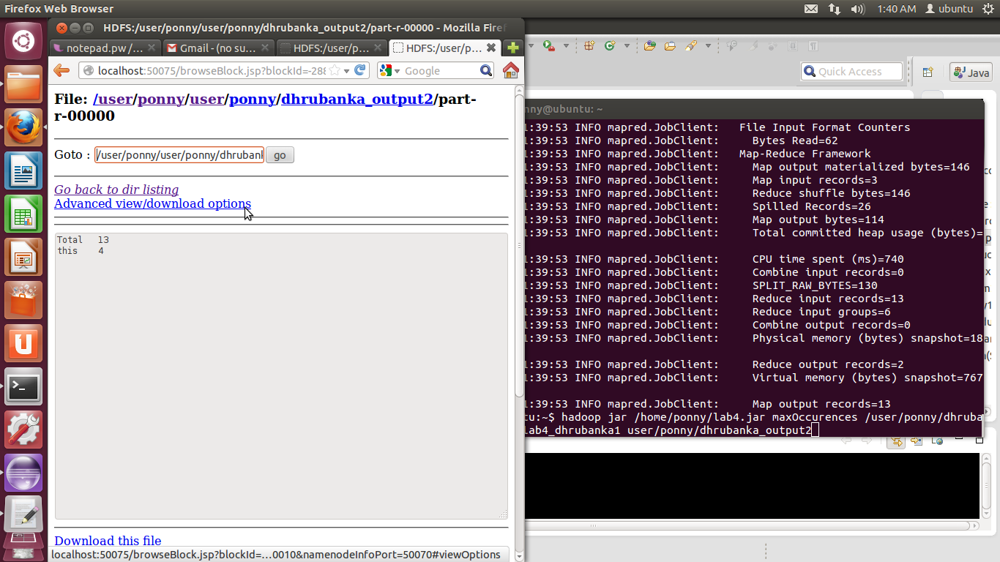

OUTPUT :

