CSE 3025 – LARGE SCALE DATA PROCESSING
FACULTY : DR. SYED IBRAHIM
LAB : L-23,24 , DATE : 12.9.19
DHRUBANKA DUTTA
INPUT FORMATS

Customers details(customer name, address,mobile) are maintained in a file in hdfs. Create the customer details file with 10 records and do the following:

QUESTION 1:

- Use keyvalueinput format as the input format. Consider customer name as key. Separate the customer name and address,mobile using “,” separator in the text file. (Ex: sam,233 first street, chennai,9999967891 (or) sam,233 first street chennai 9999967891 ). Customer name is the key and Address, Mobile are the value. Search a particular customer detail.

import java.io.IOException;
import java.util.*;
import org.apache.hadoop.fs.Path;
import org.apache.hadoop.conf.*;
import org.apache.hadoop.io.*;
import org.apache.hadoop.mapreduce.*;
import org.apache.hadoop.mapreduce.lib.input.*;
import org.apache.hadoop.mapreduce.lib.output.FileOutputFormat;
import org.apache.hadoop.mapreduce.lib.output.TextOutputFormat;

public class inputFormat{
public static class Map extends Mapper<Text, Text, Text, Text> {
String c="sam";
public void map(Text key, Text value, Context context) throws IOException, InterruptedException
{
String line=key.toString();
if(c.equalsIgnoreCase(line))
context.write(key,value);
}
}
/*
public static class Reduce extends Reducer<Text, IntWritable, Text, IntWritable> {
public static int max = 0;
public static int min = 50;
public static int sum2 = 0;
Text word= new Text();
Text word2 = new Text();
public void reduce(Text key, Iterable<IntWritable> values, Context context) throws IOException, InterruptedException {
int sum=0;
for (IntWritable val:values) {
sum+=val.get();
if(sum>max){
max= sum;
word.set(key);
}

}
sum2 = sum2+sum;
if(sum<min ){
min= sum;
word2.set(key);
}

context.write(key,new IntWritable(sum));
}
public void cleanup(Context context) throws IOException, InterruptedException{
String a = "Total";
context.write(new Text(a),new IntWritable(sum2));
context.write(word,new IntWritable(max));
context.write(word2,new IntWritable(min));
}
}
*/
public static void main (String[] args) throws Exception {
Configuration conf = new Configuration();
conf.set("mapreduce.input.keyvaluelinerecordreader.key.value.separator",",");
Job job = new Job(conf, "inputFormat");
job.setJarByClass(inputFormat.class);
job.setOutputKeyClass(Text.class);
job.setOutputValueClass(Text.class);
job.setMapperClass(Map.class);
//job.setReducerClass(Reduce.class);
//job.setInputFormatClass(TextInputFormat.class);
job.setInputFormatClass(KeyValueTextInputFormat.class);
job.setOutputFormatClass(TextOutputFormat.class);
FileInputFormat.addInputPath(job, new Path(args[0]));
FileOutputFormat.setOutputPath(job, new Path(args[1]));
job.waitForCompletion(true);
}
}

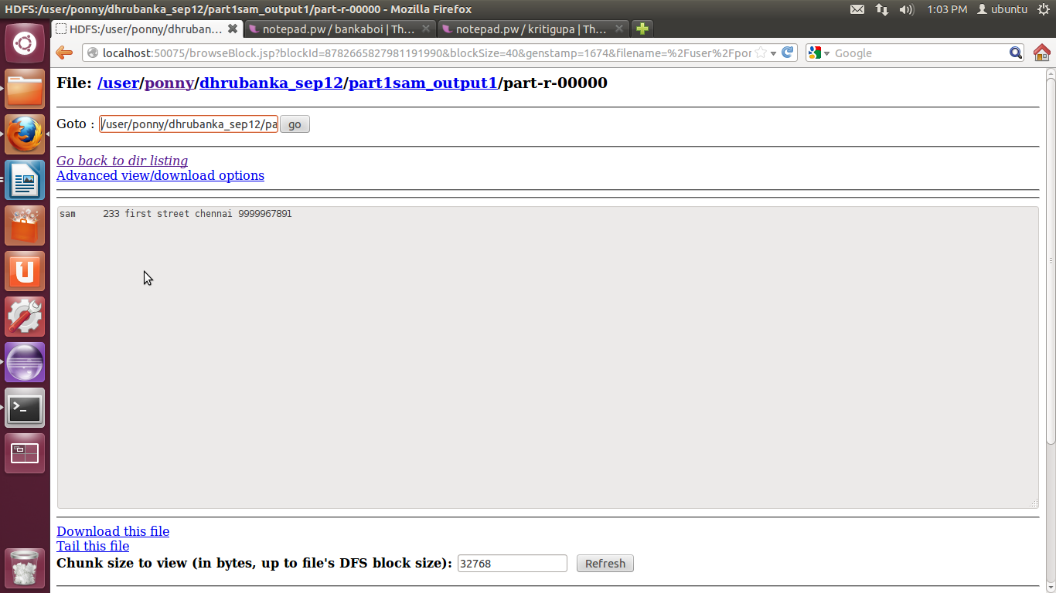
- Write the customer details in mapper with 3 lines in each mapper.Use NLineinput format.

import java.io.IOException;
import java.util.*;
import org.apache.hadoop.fs.Path;
import org.apache.hadoop.conf.*;
import org.apache.hadoop.io.*;
import org.apache.hadoop.mapreduce.*;
import org.apache.hadoop.mapreduce.lib.input.*;
import org.apache.hadoop.mapreduce.lib.output.FileOutputFormat;
import org.apache.hadoop.mapreduce.lib.output.TextOutputFormat;

public class inputFormat2{
public static class Map extends Mapper<LongWritable, Text, LongWritable, Text> {
String c="sam";
public void map(LongWritable key, Text value, Context context) throws IOException, InterruptedException
{
context.write(key,value);
}
}
/*
public static class Reduce extends Reducer<Text, IntWritable, Text, IntWritable> {
public static int max = 0;
public static int min = 50;
public static int sum2 = 0;
Text word= new Text();
Text word2 = new Text();
public void reduce(Text key, Iterable<IntWritable> values, Context context) throws IOException, InterruptedException {
int sum=0;
for (IntWritable val:values) {
sum+=val.get();
if(sum>max){
max= sum;
word.set(key);
}

}
sum2 = sum2+sum;
if(sum<min ){
min= sum;
word2.set(key);
}

context.write(key,new IntWritable(sum));
}
public void cleanup(Context context) throws IOException, InterruptedException{
String a = "Total";
context.write(new Text(a),new IntWritable(sum2));
context.write(word,new IntWritable(max));
context.write(word2,new IntWritable(min));
}
}
*/
public static void main (String[] args) throws Exception {
Configuration conf = new Configuration();
conf.setInt(NLineInputFormat.LINES_PER_MAP, 3);
//conf.set("mapreduce.input.keyvaluelinerecordreader.key.value.separator",",");
Job job = new Job(conf, "inputFormat2");
job.setInputFormatClass(NLineInputFormat.class);
job.setNumReduceTasks(0);

job.setJarByClass(inputFormat.class);

job.setOutputKeyClass(LongWritable.class);
job.setOutputValueClass(Text.class);
job.setMapperClass(Map.class);
//job.setReducerClass(Reduce.class);
//job.setInputFormatClass(TextInputFormat.class);
//job.setInputFormatClass(KeyValueTextInputFormat.class);

job.setOutputFormatClass(TextOutputFormat.class);
FileInputFormat.addInputPath(job, new Path(args[0]));
FileOutputFormat.setOutputPath(job, new Path(args[1]));
job.waitForCompletion(true);
}
}

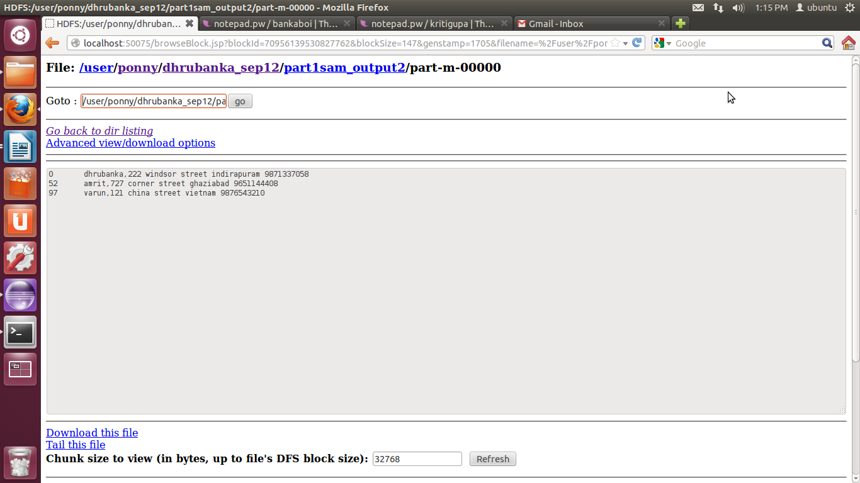
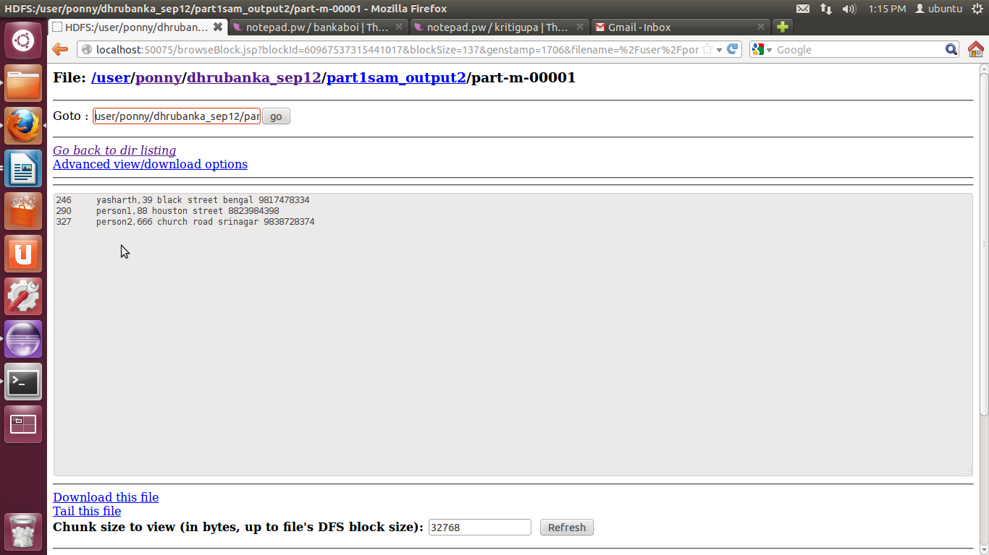

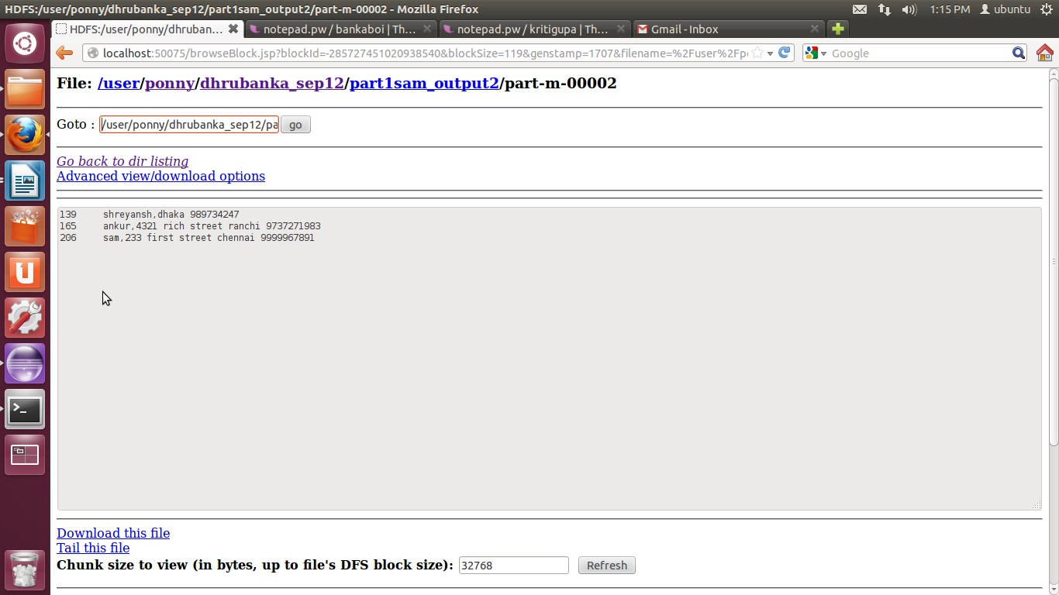

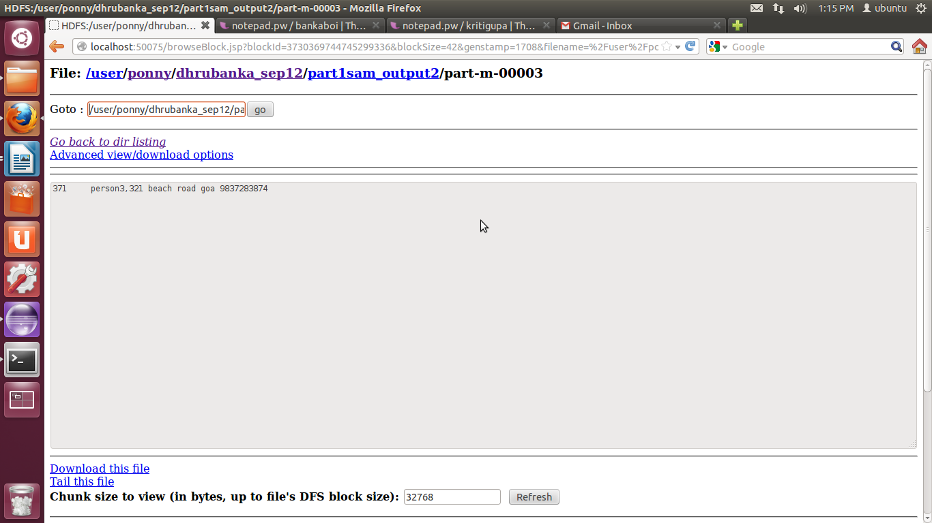

3. Write the customer details using sequential file output and read using sequential file input format.

import java.io.IOException;
import java.util.*;

import org.apache.hadoop.fs.Path;
import org.apache.hadoop.conf.*;
import org.apache.hadoop.io.*;
import org.apache.hadoop.mapreduce.*;
import org.apache.hadoop.mapreduce.lib.input.*;
import org.apache.hadoop.mapreduce.lib.output.*;
//import org.apache.hadoop.mapreduce.lib.output.TextOutputFormat;

public class writeFile {
public static class Map extends Mapper<LongWritable,Text,LongWritable,Text>{
String c="sam";
public void map(LongWritable key, Text value, Context context) throws IOException, InterruptedException
{
context.write(key,value);
}
}

public static void main(String[] args) throws Exception{
Configuration conf = new Configuration();
Job job = new Job(conf, "writeFile");
job.setJarByClass(writeFile.class);
job.setOutputKeyClass(LongWritable.class);
job.setOutputValueClass(Text.class);
job.setMapperClass(Map.class);
job.setNumReduceTasks(0);
// job.setReducerClass(Reduce.class);
job.setOutputFormatClass(SequenceFileOutputFormat.class);
job.setInputFormatClass(TextInputFormat.class);
// job.setOutputFormatClass(TextOutputFormat.class);
FileInputFormat.addInputPath(job, new Path(args[0]));
FileOutputFormat.setOutputPath(job, new Path(args[1]));
job.waitForCompletion(true);

}

}

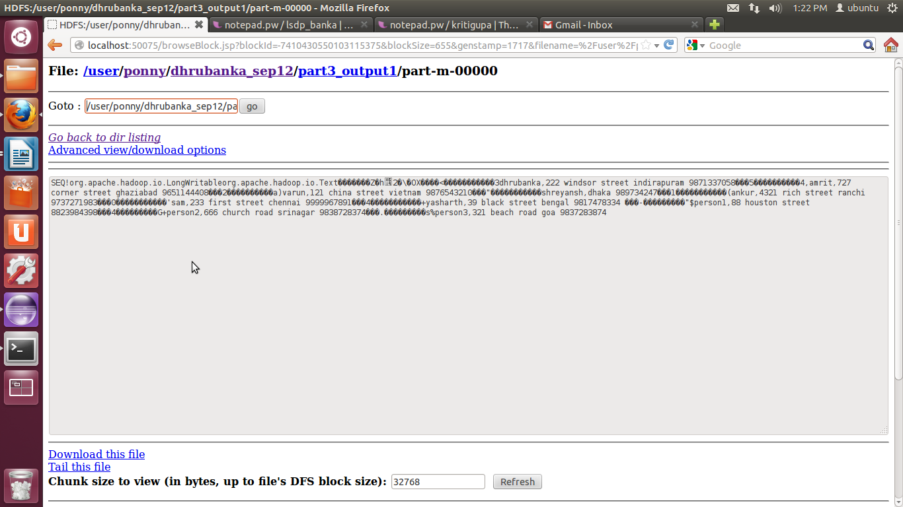
import java.io.IOException;
import java.util.*;

import org.apache.hadoop.fs.Path;
import org.apache.hadoop.conf.*;
import org.apache.hadoop.io.*;
import org.apache.hadoop.mapreduce.*;
import org.apache.hadoop.mapreduce.lib.input.*;
import org.apache.hadoop.mapreduce.lib.output.*;
//import org.apache.hadoop.mapreduce.lib.output.TextOutputFormat;

public class readFile {
public static class Map extends Mapper<LongWritable,Text,LongWritable,Text>{
String c="sam";
public void map(LongWritable key, Text value, Context context) throws IOException, InterruptedException
{
context.write(key,value);
}
}

public static void main(String[] args) throws Exception{
Configuration conf = new Configuration();
Job job = new Job(conf, "input3rd");
job.setJarByClass(readFile.class);
job.setOutputKeyClass(LongWritable.class);
job.setOutputValueClass(Text.class);
job.setMapperClass(Map.class);
job.setNumReduceTasks(0);
// job.setReducerClass(Reduce.class);
job.setInputFormatClass(SequenceFileInputFormat.class);
// job.setInputFormatClass(TextInputFormat.class);
job.setOutputFormatClass(TextOutputFormat.class);
FileInputFormat.addInputPath(job, new Path(args[0]));
FileOutputFormat.setOutputPath(job, new Path(args[1]));
job.waitForCompletion(true);

}

}

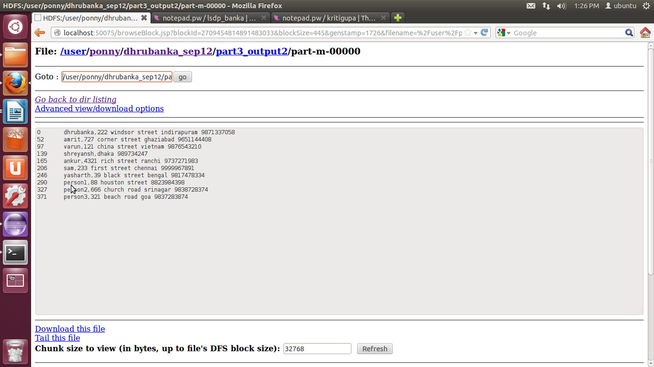

- Multiple Outputs

import java.io.IOException;

import org.apache.hadoop.fs.Path;
import org.apache.hadoop.conf.*;
import org.apache.hadoop.io.*;
import org.apache.hadoop.mapreduce.*;
import org.apache.hadoop.mapreduce.lib.input.*;
import org.apache.hadoop.mapreduce.lib.output.*;

public class MultipleOutput {
public static class Map extends Mapper<LongWritable, Text, Text, IntWritable> {

IntWritable one = new IntWritable(1);

public void map(LongWritable key, Text value, Context context) throws IOException, InterruptedException {
String[] lines = value.toString().split(",");
for (String line : lines)
context.write(new Text(line), one);
}
}

public static class Reduce extends Reducer<Text, IntWritable, Text, IntWritable> {
public MultipleOutputs multipleOutputs;

public void setup(Context context) throws IOException, InterruptedException {

multipleOutputs = new MultipleOutputs(context);
}

public void reduce(Text key, Iterable<IntWritable> values, Context context)
throws IOException, InterruptedException {
int sum = 0;
for (IntWritable val : values) {
sum += val.get();
}
multipleOutputs.write(key, new IntWritable(sum), key.toString());

}

public void cleanup(Context context) throws IOException, InterruptedException {
multipleOutputs.close();
}

}

public static void main(String[] args) throws Exception {
Configuration conf = new Configuration();
Job job = new Job(conf, "wordcount");
job.setJarByClass(MultipleOutput.class);
job.setOutputKeyClass(Text.class);
job.setOutputValueClass(IntWritable.class);
job.setMapperClass(Map.class);
job.setReducerClass(Reduce.class);

job.setInputFormatClass(TextInputFormat.class);

LazyOutputFormat.setOutputFormatClass(job, TextOutputFormat.class);
FileInputFormat.addInputPath(job, new Path(args[0]));
FileOutputFormat.setOutputPath(job, new Path(args[1]));
// MultipleOutputs.addNamedOutput(job, "wordcount", TextOutputFormat.class,
// Text.class, IntWritable.class);
job.waitForCompletion(true);

}
}

