CSE 3025 – LARGE SCACLE DATA PROCESSING
FACULTY: DR. SYED IBRAHIM
LAB : L-23,24
DATE : 11.7.19
DHRUBANKA DUTTA – 17BCE1019
COUNTER

CODE :

import java.io.IOException;
import org.apache.hadoop.fs.Path;
import org.apache.hadoop.conf.*;
import org.apache.hadoop.io.*;
import org.apache.hadoop.mapreduce.*;
import org.apache.hadoop.mapreduce.lib.input.*;
import org.apache.hadoop.mapreduce.lib.output.*;

public class counter {
public enum ct {
cnt, nt
};

public static class Map extends Mapper<LongWritable, Text, Text, IntWritable> {
public void map(LongWritable key, Text value, Context context) throws IOException, InterruptedException {
String line = value.toString();
String[] str = line.split(",");
int g1 = Integer.parseInt(str[7]);
float avg = 0;
for (int i = 7; i < 10; i++)
avg += Integer.parseInt(str[i]);
avg /= 4;
if (g1 < 10) {
context.getCounter(ct.cnt).increment(1);
context.write(new Text(str[0] + " " + g1), null);
}
if (avg > 13) {
context.getCounter(ct.nt).increment(1);
}
}

}

public static void main(String[] args) throws Exception {
Configuration conf = new Configuration();
Job job = new Job(conf, "counter");
job.setJarByClass(counter.class);
job.setOutputKeyClass(Text.class);
job.setOutputValueClass(IntWritable.class);
job.setMapperClass(Map.class);

job.setInputFormatClass(TextInputFormat.class);
job.setOutputFormatClass(TextOutputFormat.class);
FileInputFormat.addInputPath(job, new Path(args[0]));
FileOutputFormat.setOutputPath(job, new Path(args[1]));

job.setNumReduceTasks(0);

job.waitForCompletion(true);
Counters cn = job.getCounters();
cn.findCounter(ct.cnt).getValue();
cn.findCounter(ct.nt).getValue();
}

}

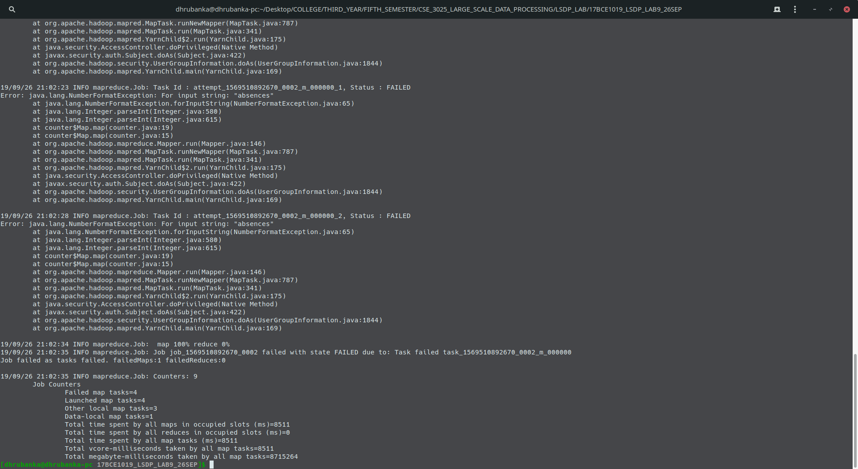
OUTPUT:

