PARALLEL AND DISTRIBUTED COMPUTING
L – 19,20
DATE: 27.7.19
FACULTY : PROF. GAYATHRI R.
DHRUBANKA DUTTA, 17BCE1019

Example 1 :

#include<stdlib.h>
#include<stdio.h>
#include "omp.h"

int main() {
# pragma omp parallel
{
int ID = omp_get_thread_num();
printf("Hello (%d)\n", ID);
printf(" world (%d)\n", ID);
}
}

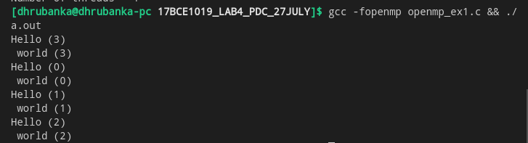

Example 2 :

#include<stdlib.h>
#include<stdio.h>
#include "omp.h"

int main () {
int nthreads, tid;
#pragma omp paralle num_threads(4) private(tid)
{
tid = omp_get_thread_num();
printf("Hello world from (%d) \n", tid);
if (tid==0)
{
nthreads = omp_get_num_threads();
printf("Number of threads = %d\n", nthreads);
}
}
}

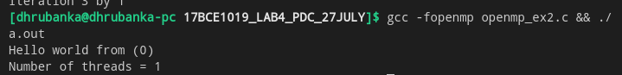

Example 3 :

#include<stdlib.h>
#include<stdio.h>
#include "omp.h"

int main() {
int nthreads, tid;
omp_set_num_threads(3);
# pragma omp parallel private (tid)
{
int i;
tid = omp_get_thread_num();
printf("Hello world from (%d)\n", tid);
# pragma omp for
for (i=0;i<=4;i++)
printf("Iteration %d by %d \n",i,tid);
}
}

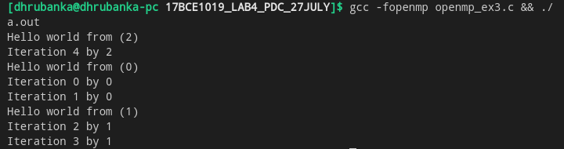

Example 4 :

#include<stdio.h>
#include<stdlib.h>
#include "omp.h"

int main (int argc, char *argv[]) {
int i , count; // points inside the unit quarter circle
unsigned short xi[3]; // random number seed
int samples; // Samples number of points to generate
double x,y; // coordinates of points
double pi; // Estimate of pi

samples = atoi(argv[1]);

#pragma omp parallel
{
xi[0] = 1;
xi[1] = 1;
xi[2] = omp_get_thread_num();
count = 0;
printf("I am thread %d\n",xi[2]);
#pragma omp for firstprivate(xi) private(x,y) reduction(+:count)
for (i=0;i<samples;i++) {
x = erand48(xi);
y = erand48(xi);
if(x*x+y*y <= 1.0)
count++;
}
}
pi = 4.0*(double)count / (double)samples;
printf("Count = %d, Samples = %d, Estimate of pi: %7.5f\n", count, samples, pi);
}

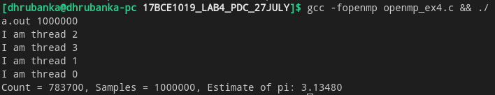
Example 5 :

#include<stdio.h>
#include<stdlib.h>
#include "omp.h"

# define N 10

int main () {
int i;
double a[N], b[N], c[N], d[N];
for (i=0;i<N;i++) {
a[i] = i*2.0;
b[i] = i + a[i]*22.5;
}
#pragma omp parallel shared(a,b,c,d) private(i)
{
#pragma omp sections nowait
{
#pragma omp section
for (i=0;i<N;i++)
c[i] = a[i]+b[i];
#pragma omp section
for (i=0;i<N;i++)
d[i] = a[i]*b[i];
}
}
printf("The value of array c: \n");
for (i=0;i<N;i++)
printf("%d\n", c[i]);
printf("The value of array d: \n");
for (i=0;i<N;i++)
printf("%d\n", d[i]);
}
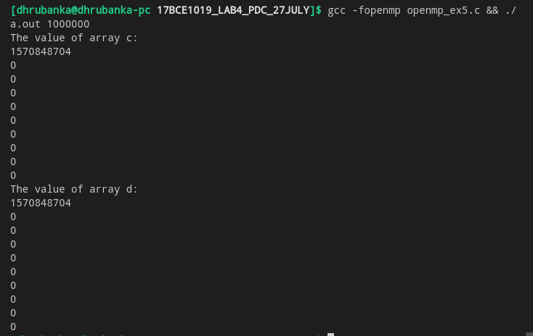

Example 6 :

#include<stdio.h>
#include<stdlib.h>
#include "omp.h"

static int fib(int);

int main() {
int nthreads, tid, n=8;
#pragma omp parallel num_threads(4) private(tid)
{
#pragma omp single
{
tid = omp_get_thread_num();
printf("hello world from (%d)\n", tid);
printf("Fib(%d) = %d by %d\n",n,fib(n),tid);
}
}
}

static int fib(int n) {
int i,j,id;
if (n<2)
return n;
#pragma omp task shared(i) private(id)
{
i = fib(n-1);
}
#pragma omp task shared(j) private(id)
{
j = fib(n-2);
}
return (i+j);
}

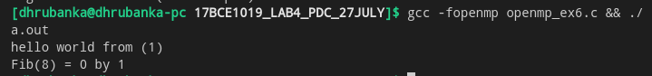
Example 7 :

#include<stdio.h>
#include<stdlib.h>
#include<omp.h>
#include <mpi.h>

#define _NUM_THREADS 4

/* Each MPI process spawns a distinct OpenMP master thread;
so limit the number of MPI processes to one per node
*/

int main (int argc, char *argv[]) {
int p, my_rank;

/* set the number of threads to spawn */
omp_set_num_threads(_NUM_THREADS);

/* Initalize the MPI stuff */
MPI_Init(&argc, &argv);
MPI_Comm_size(MPI_COMM_WORLD, &p);
MPI_Comm_rank(MPI_COMM_WORLD, &my_rank);

int c;
/* the following is a parallel OpenMP executed by each MPI process */
#pragma omp parallel reduction(+:c)
{
c = omp_get_num_threads();
}

/* expect a number to get printed for each MPI process */
printf("%d\n", c);
/* finalize MPI */
MPI_Finalize();
return 0;
}

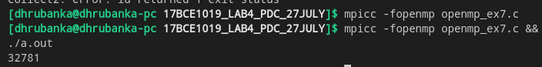

Example 8 :

#include<stdio.h>
#include<stdlib.h>
#include "mpi.h"
#include "omp.h"

int main(int argc, char*argv[]) {
int rank, omp_rank, mpi_support;

MPI_Init_thread(&argc, &argv, MPI_THREAD_MULTIPLE, &mpi_support);
MPI_Comm_rank(MPI_COMM_WORLD, &rank);

#pragma omp parallel private(omp_rank)
{
omp_rank = omp_get_thread_num();
printf("Hello. This is process %d, thread %d\n", rank, omp_rank);
}
MPI_Finalize();
}

