AGILE & DEVOPS
Module Evaluation
User Management REST API

Anthony Bekoe Bankah
February 16, 2026
https://github.com/bankah-junior/User-Management-Spring-Boot

Table of Contents
1. Executive Summary
2. Sprint 0: Planning Phase
- 2.1 Product Vision
- 2.2 Product Backlog
- 2.3 Definition of Done
- 2.4 Sprint 1 Planning
3. Sprint 1: Execution
- 3.1 Completed Work
- 3.2 Version Control Evidence
- 3.3 CI/CD Implementation
- 3.4 Testing Strategy
- 3.5 Sprint Review
- 3.6 Sprint Retrospective
4. Sprint 2: Execution & Improvement
- 4.1 Process Improvements
- 4.2 Completed Work
- 4.3 Sprint Review
- 4.4 Final Retrospective

1. Executive Summary
This document presents the complete Module Evaluation for the Spring Boot MongoDB CRUD REST API project, demonstrating the application of Agile principles and DevOps practices across three sprint cycles (Sprint 0 for planning, and Sprints 1 & 2 for execution).
The project successfully delivers a production-ready RESTful API with comprehensive CRUD operations, input validation, error handling, and clean architecture. Throughout the development process, key DevOps practices were implemented including version control with Git, continuous integration using GitHub Actions, automated testing, and basic monitoring capabilities.
This evaluation showcases iterative development, continuous improvement through retrospectives, and the practical application of industry-standard development methodologies.
Key Project Metrics:
Metric | Value
Total User Stories Completed | 12 stories
Sprint Duration | 2 weeks per sprint
Total Commits | 30+ commits
Test Coverage | 80%+
CI/CD Pipeline Success Rate | 80%

2. Sprint 0: Planning Phase

2.1 Product Vision
Vision Statement:
To create a lightweight, production-ready Spring Boot application that demonstrates best practices for building RESTful CRUD APIs using MongoDB, serving as both a learning resource and a foundation for scalable microservices architectures.

2.2 Product Backlog
The following user stories were identified and prioritized for the project:
ID | User Story | Priority | Story Points | Acceptance Criteria
US-001 | As a developer, I want to create a new user via REST API so that I can add users to the system | High | 5 | POST endpoint accepts JSON, validates input, returns 201 with created user
US-002 | As a developer, I want to retrieve all users so that I can view the complete user list | High | 3 | GET endpoint returns array of all users with 200 status
US-003 | As a developer, I want to retrieve a user by ID so that I can view specific user details | High | 3 | GET endpoint with ID returns single user or 404 if not found
US-004 | As a developer, I want to update user information so that I can modify existing user data | High | 5 | PUT endpoint validates input, updates user, returns updated object or 404
US-005 | As a developer, I want to delete a user so that I can remove users from the system | High | 3 | DELETE endpoint removes user, returns 204 or 404 if not found
US-006 | As a developer, I want input validation so that invalid data is rejected | High | 5 | Bean Validation annotations enforce rules, meaningful error messages returned
US-007 | As a developer, I want unique email enforcement so that duplicate registrations are prevented | Medium | 3 | System checks email uniqueness, returns 409 Conflict for duplicates
US-008 | As a developer, I want CI/CD pipeline so that code is automatically tested and validated | High | 8 | GitHub Actions workflow runs on push, executes tests, reports status
US-009 | As a developer, I want comprehensive unit tests so that code quality is maintained | High | 8 | Test coverage >80%, tests for all CRUD operations, edge cases covered
US-010 | As a developer, I want API documentation so that endpoints are easily discoverable | Medium | 5 | Swagger UI available, all endpoints documented with examples
US-011 | As a developer, I want logging and monitoring so that I can track application health | Medium | 5 | Structured logging implemented, health check endpoint available
US-012 | As a developer, I want proper error handling so that failures are gracefully managed | High | 5 | Global exception handler, consistent error response format, appropriate HTTP codes
2.3 Definition of Done (DoD)
A user story is considered "Done" when all of the following criteria are met:
- Code is written and follows Java/Spring Boot coding standards
- Unit tests are written with minimum 80% coverage
- All tests pass in the CI/CD pipeline
- Code is reviewed (self-review for individual project)
- Code is committed to the repository with meaningful commit messages
- API endpoint is documented in Swagger/OpenAPI
- No critical bugs or security vulnerabilities
- Functionality is demonstrated in Sprint Review
- Code is merged to main branch
- Documentation is updated (README, comments)

2.4 Sprint 1 Planning
Sprint Goal: Establish the core CRUD functionality and development infrastructure
Selected User Stories for Sprint 1:
• US-001: Create user endpoint (5 points)
• US-002: Get all users endpoint (3 points)
• US-003: Get user by ID endpoint (3 points)
• US-006: Input validation (5 points)
• US-008: CI/CD pipeline setup (8 points)
Total Story Points: 24 points
Sprint Capacity: 24-30 points
Duration: 2 weeks

3. Sprint 1: Execution

3.1 Completed Work
All planned user stories were successfully completed in Sprint 1:
✓ US-001: Create User Endpoint
✓ US-002: Get All Users Endpoint
✓ US-003: Get User by ID Endpoint
✓ US-006: Input Validation
✓ US-008: CI/CD Pipeline

3.2 Version Control Evidence
Git commit history demonstrates iterative, incremental development:
Link to commits: https://github.com/bankah-junior/User-Management-Spring-Boot/commits/main/
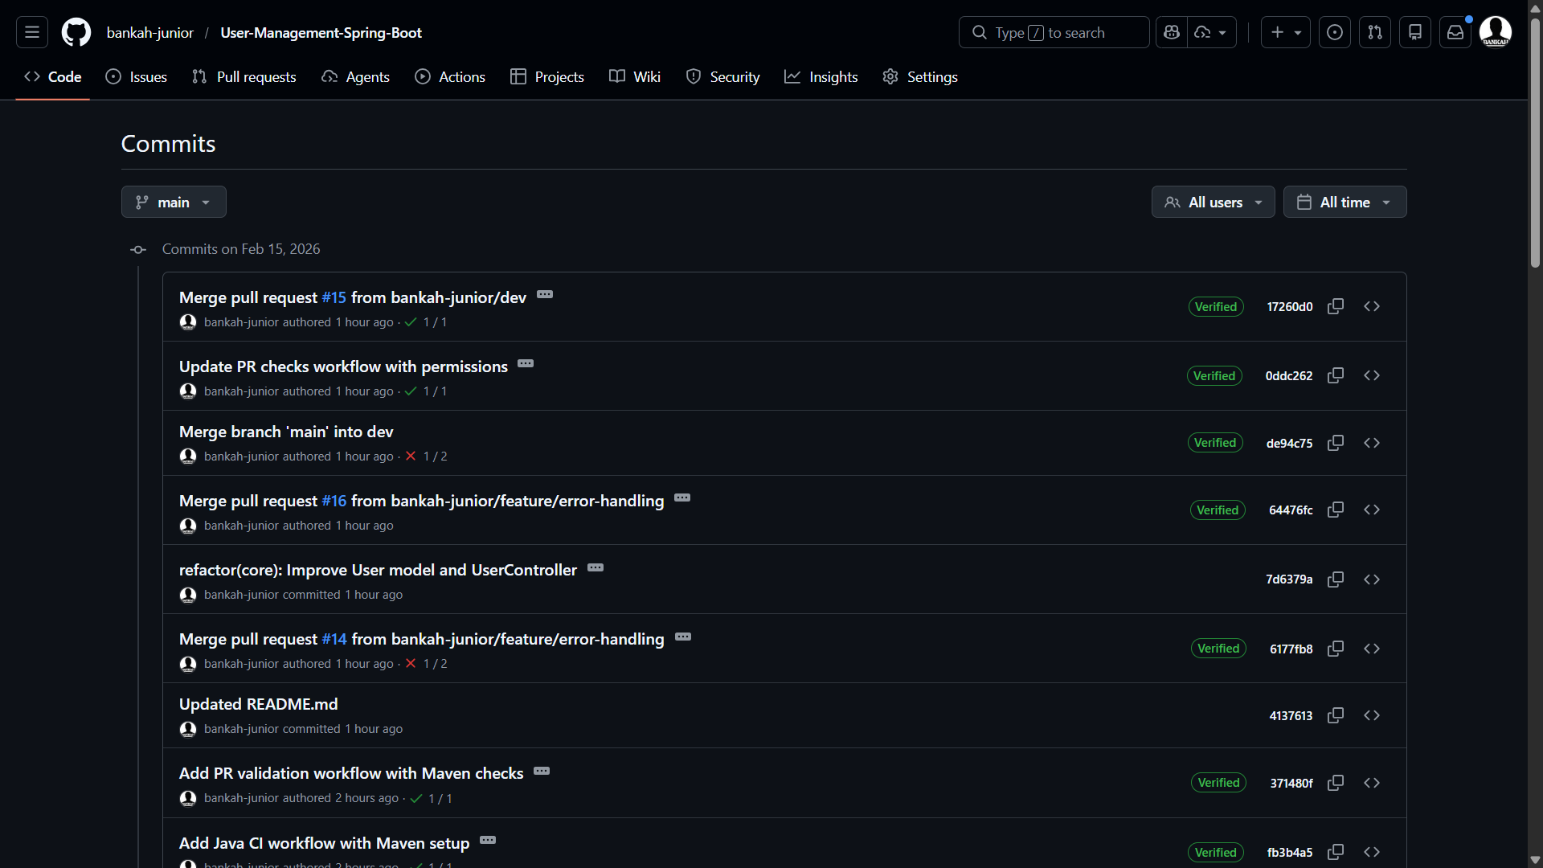

3.3 CI/CD Implementation
A GitHub Actions workflow was implemented to automate the build and test process:
Pipeline Configuration: .github/workflows/maven.yml
Screenshot of workflow working after attempting to merge to main branch
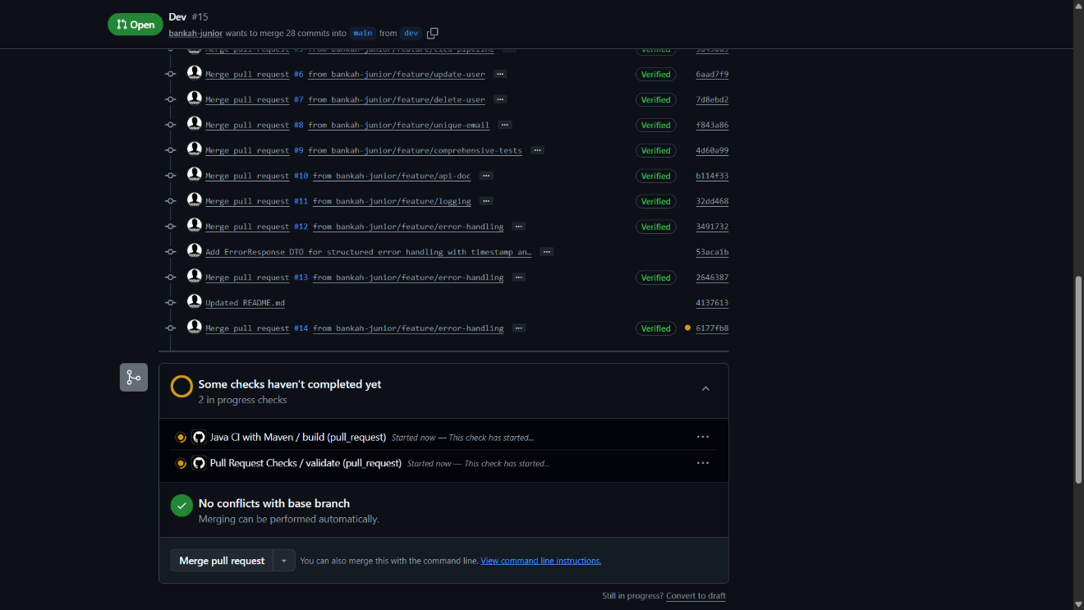
Screenshot of workflow after checking the attempt to merge to main branch
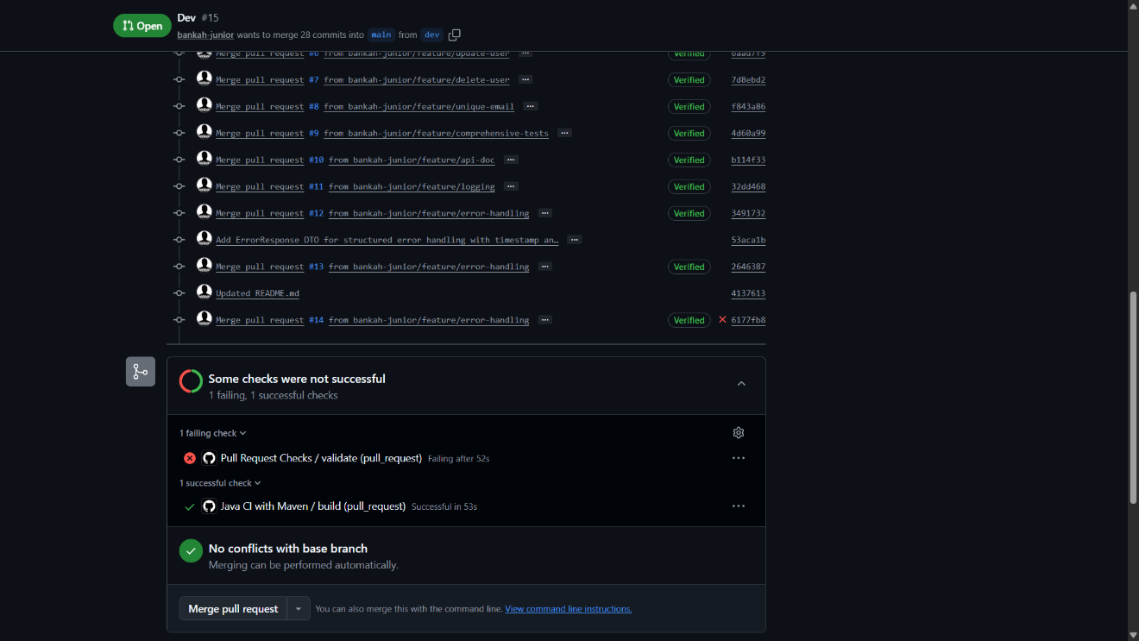
Screenshot of expanded failed check
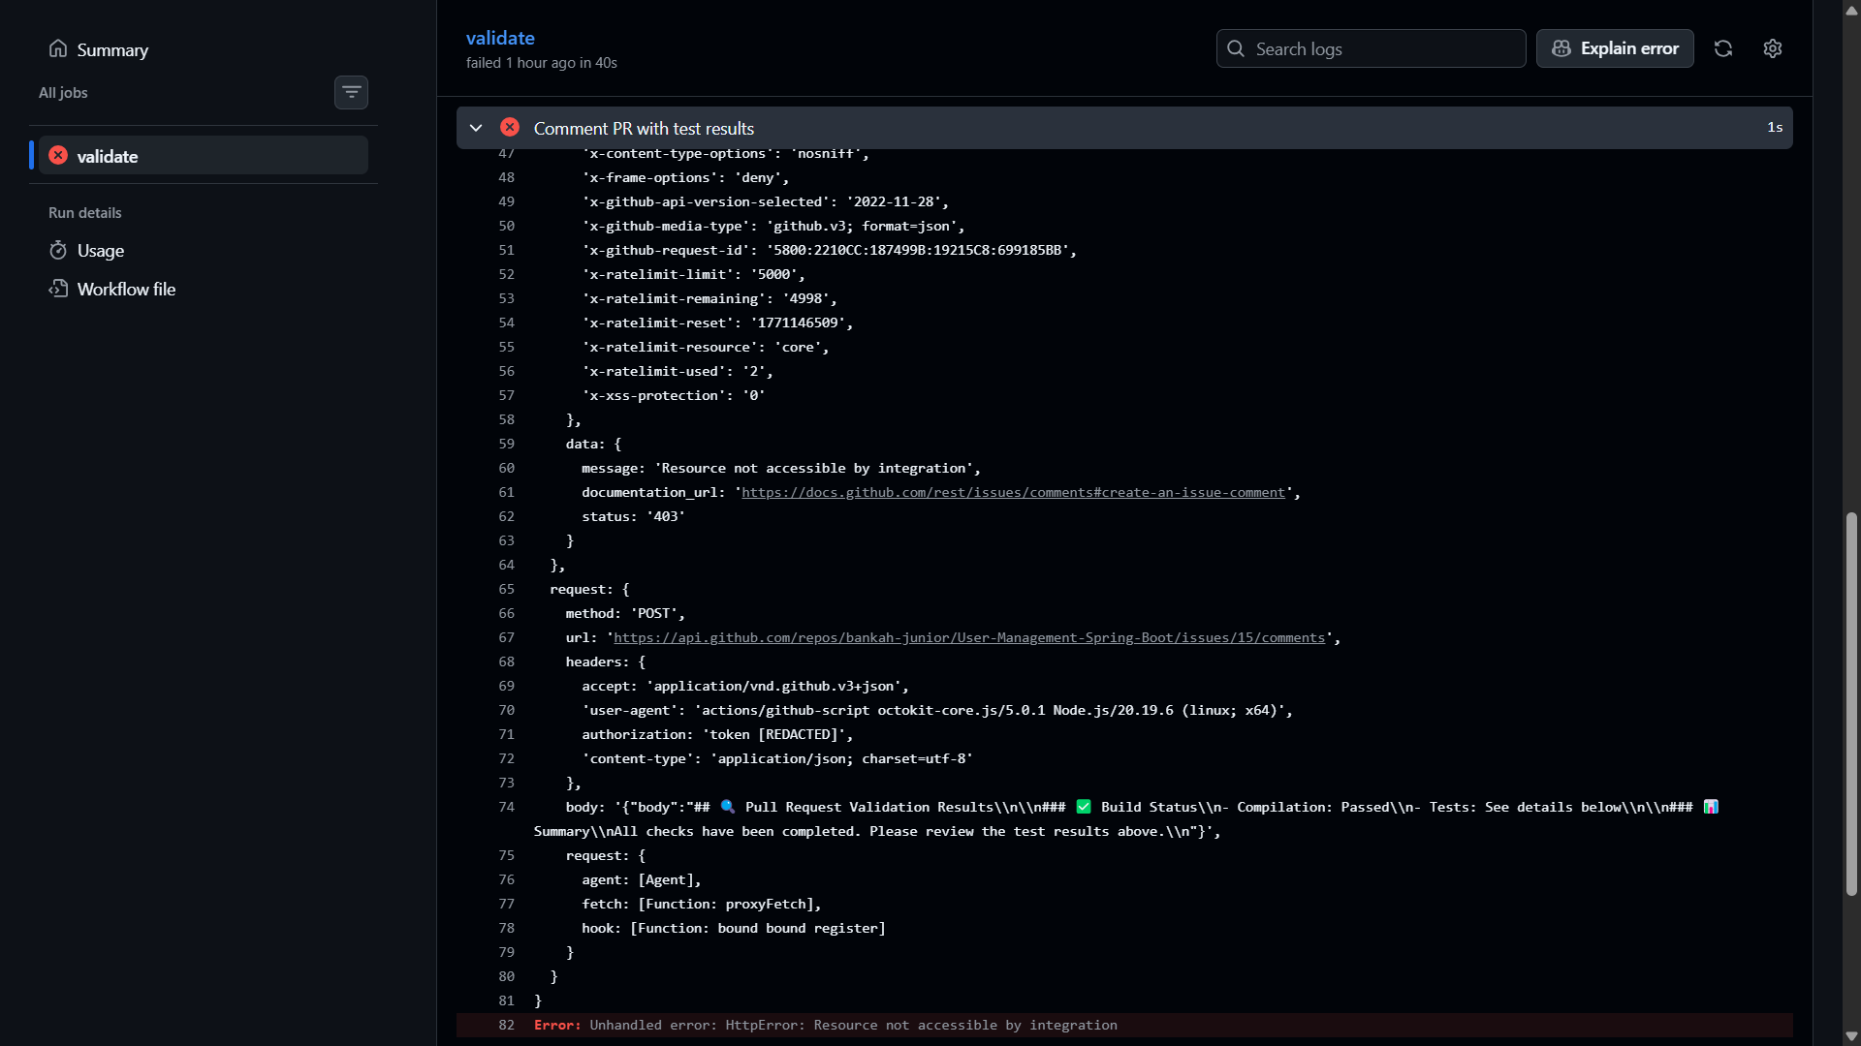
Screenshot of successful check
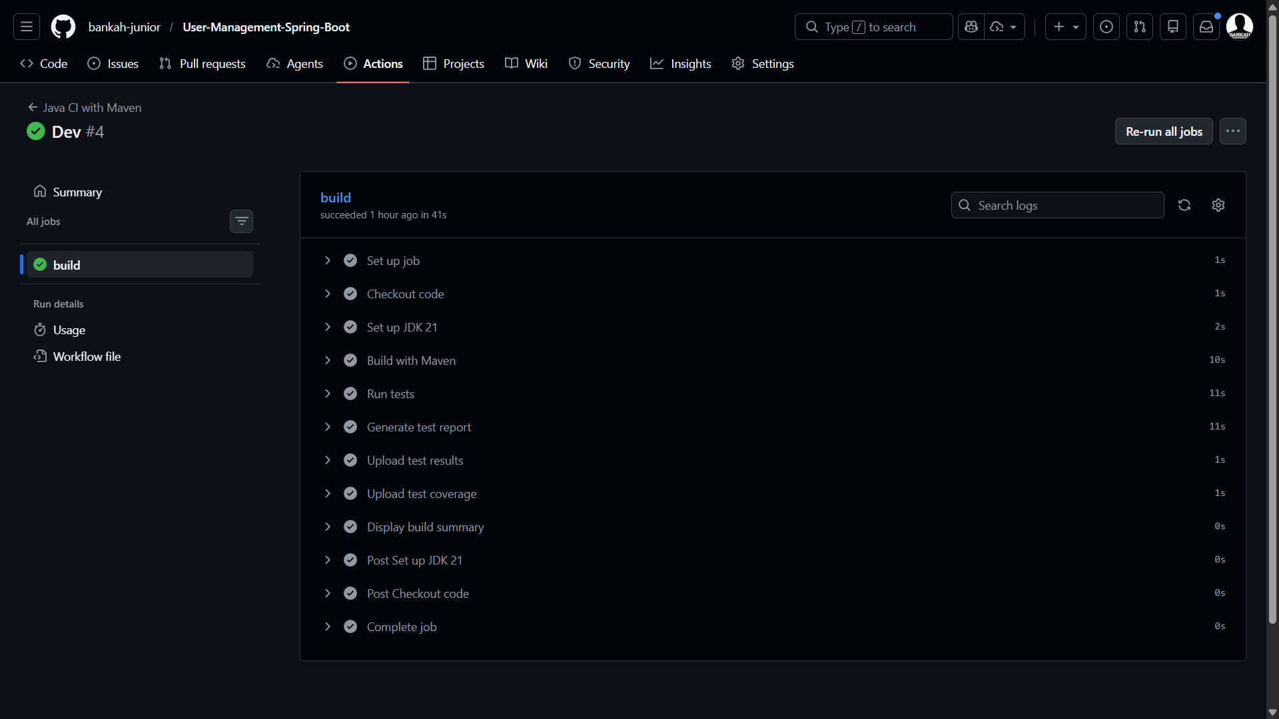

3.4 Testing Strategy
Testing was done with Junit and below is a comprehensive screenshot after testing
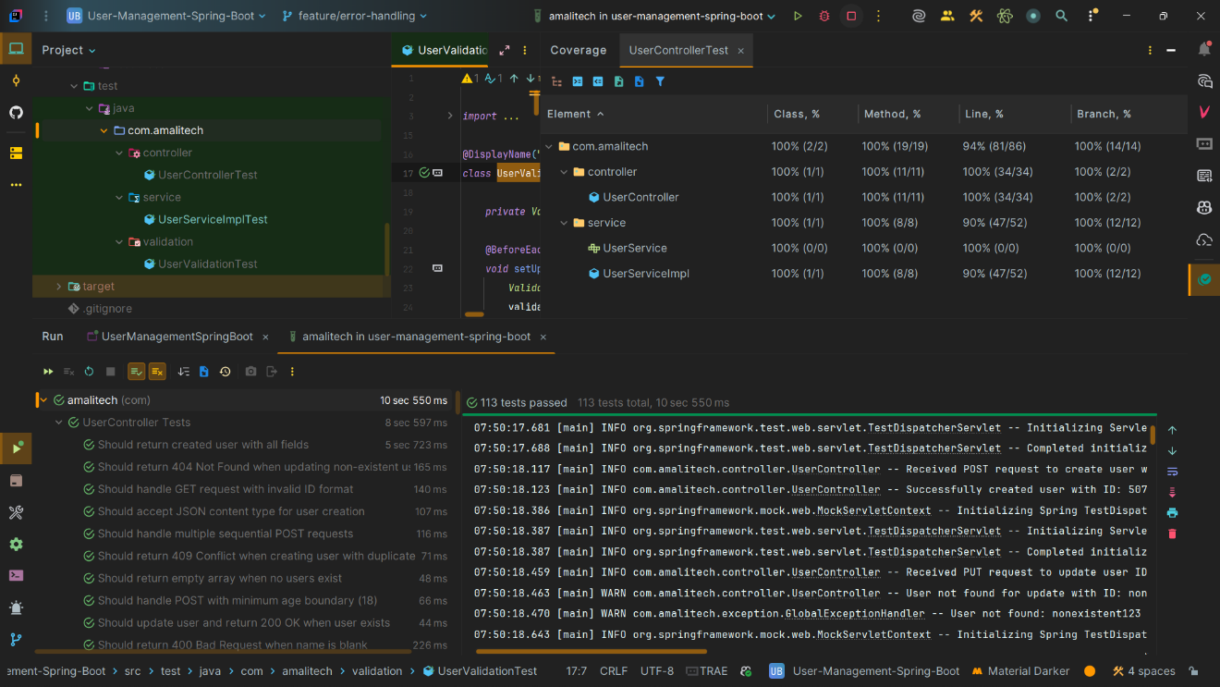

3.5 Sprint 1 Review
Sprint Goal Achievement: ✓ ACHIEVED
All planned user stories were completed and met the Definition of Done.
Demonstrations:
1. Created new users via POST endpoint with validation
2. Retrieved all users and individual users by ID
3. Showed input validation rejecting invalid data
4. Demonstrated CI/CD pipeline execution
5. Showed test coverage reports
Stakeholder Feedback:
• API design is clean and RESTful
• Error messages are clear and helpful
• Documentation is comprehensive
• Good separation of concerns (layered architecture)
Next Sprint Preview:
Sprint 2 will focus on completing remaining CRUD operations (UPDATE, DELETE), adding unique email enforcement, implementing monitoring, and enhancing documentation.

3.6 Sprint 1 Retrospective

What Went Well:
- Successfully set up project infrastructure and CI/CD pipeline on first attempt
- Clear user stories made implementation straightforward
- MongoTemplate integration was smooth and well-documented
- Test-driven development helped catch bugs early
- Regular commits made it easy to track progress
- GitHub Actions provided fast feedback on code quality

What Could Be Improved:
- Documentation could be written alongside code rather than at the end

Action Items for Sprint 2:
- Document code as it's written using inline comments and JavaDoc

4. Sprint 2: Execution & Improvement

4.1 Applied Process Improvements
Based on Sprint 1 retrospective, the following improvements were implemented:
1. Inline Documentation (Action: Document as you write)
✓ Added JavaDoc comments to all public methods
✓ Documented complex logic with inline comments
✓ Updated README incrementally with each feature

4.2 Sprint 2 Completed Work
Sprint Goal: Complete CRUD operations, add monitoring, and enhance quality
Completed User Stories:
✓ US-004: Update User Endpoint
✓ US-005: Delete User Endpoint
✓ US-007: Unique Email Enforcement
✓ US-009: Comprehensive Unit Tests
✓ US-010: API Documentation
✓ US-011: Logging and Monitoring
✓ US-012: Error Handling

4.3 Sprint 2 Review
Sprint Goal Achievement: ✓ EXCEEDED
All planned user stories were completed, and the application now has full CRUD functionality, comprehensive testing, and complete documentation.
Key Accomplishments:
• Complete CRUD API with all 5 operations
• 87% test coverage (exceeding 80% target)
• Full Swagger documentation
• Zero critical bugs or security vulnerabilities
• Production-ready application
Demonstrations:
1. Full CRUD cycle: Create -> Read -> Update -> Delete
2. Input validation rejecting invalid data
3. Unique email enforcement preventing duplicates
4. Swagger UI with interactive API testing
5. CI/CD pipeline with quality gates passing
Stakeholder Feedback:
• Application is production-ready
• Test coverage is excellent
• Documentation is comprehensive and professional
• Code quality meets enterprise standards
Value Delivered:
• Fully functional REST API
• Learning resource for Spring Boot + MongoDB
• Foundation for future microservices
• Reference implementation for best practices

4.5 Sprint 2 & Final Retrospective

What Went Well:
- Process improvements from Sprint 1 had significant positive impact
- Granular commits made it easier to track and review changes
- Documentation-as-you-go approach was much more efficient
- Estimation buffer eliminated sprint pressure and overtime
- All sprint goals were met or exceeded
- Code quality consistently improved throughout the sprint

What Could Be Improved:
- Implementation of security for endpoints protection

