**FFmpeg Basics**

多媒体处理与快速音视频编码器

Frantisek Korbel

半棵树（译）

**FFmpeg Basics**

Copyright © 2012 Frantisek Korbel

All rights reserved.

Please if trademarked names are used in this book without a trademark symbol,

it is for easier reading with no intention of infringement of the trademark.

Book index, user forum and other resources

are available on the website ffmpeg.tv.

ISBN: 1479327832

ISBN-13: 978-1479327836

**致谢**

The greatest thanks belongs to the developers of excellent FFmpeg tools and libraries and to the whole

FFmpeg community that drives this project forward. The project documentation was the main source for

the book.

Another great source was the Wikipedia, especially articles about color spaces, quantization, sampling, etc.

Thank you very much and best wishes.

**内容简介**

1. ffmpeg基础 15

2. 显示帮助和功能 29

3. 比特率，帧速率和文件大小 60

4. 调整大小和缩放视频 64

5. 裁剪视频 69

6. 填充视频 73

7. 翻转和旋转视频 77

8. 模糊、锐化和其他 81

9. 图片叠加 87

10. 在视频上添加文本 93

11. 格式转换 99

12. 时间的操作 108

13. 数学函数 113

14. 元数据和字幕 117

15. 图像处理 122

16. 数字音频 128

17. 预置编解码器 138

18. 交错视频 142

19. FFmpeg组件和项目 147

20. 麦克风和摄像头 154

21. 批处理文件 159

22. 色彩校正 164

23. 先进技术 179

24. 网络视频 193

25. 调试与测试 200

Glossary 207

About the author 216

**表的内容**

介绍 ..............................................................................................................................................12

欢迎................................................................................................................................................12

第一步............................................................................................................................................12

专业网站........................................................................................................................................12

公约................................................................................................................................................13

你的反馈是很重要........................................................................................................................14

1. ffmpeg基础 ..............................................................................................................................15

ffmpeg介绍............................................................................................................................15

ffmpeg开发............................................................................................................................16

参与ffmpeg开发 ..................................................................................................................16

FFmpeg下载 .........................................................................................................................17

命令行语法 .......................................................................................................................... 17

Windows命令提示符.............................................................................................................18

路径设置 .............................................................................................................................. 19

重命名的简写形式................................................................................................................ 20

显示输出预览........................................................................................................................ 21

ffplay媒体播放器 ................................................................................................................ 21

SDL的输出设备 ....................................................................................................................21

SI 标签的应用 ......................................................................................................................21

转码 ......................................................................................................................................22

过滤器,过滤链和过滤图 ......................................................................................................23

媒体流的选择 ...................................................................................................................... 25

虚拟设备 .............................................................................................................................. 27

颜色名称................................................................................................................................ 27

2. 帮助和功能 ............................................................................................................................ 29

文本工具................................................................................................................................29

可用的比特流过滤器............................................................................................................29

可用的编解码........................................................................................................................30

可用的解码器........................................................................................................................36

可用的编码器........................................................................................................................43

可用的过滤器........................................................................................................................46

可用的格式............................................................................................................................48

音频通道的布局....................................................................................................................52

FFmpeg许可..........................................................................................................................54

可用的像素格式....................................................................................................................54

可用的协议............................................................................................................................57

可用的音频样本格式............................................................................................................58

FFmpeg 版本.........................................................................................................................58

使用更多的命令输出格式 ..................................................................................................59

重定向输出到文件................................................................................................................59

3. 比特率、帧速率和文件大小.....................................................................................................60

框架（频率）介绍.....................................................................................................................60

帧速率设置............................................................................................................................ 61

使用-r选项 ...........................................................................................................................61

使用过滤器............................................................................................................................61

FPS帧速率..............................................................................................................................61

比特（数据）介绍...................................................................................................................62

设置比特率............................................................................................................................ 62

恒定比特率（CBR）设置......................................................................................................62

设置输出文件大小.................................................................................................................63

文件大小的计算....................................................................................................................63

4. 调整大小和缩放视频..............................................................................................................64

调整视频.............................................................................................................................64

预定义的视频帧大小...........................................................................................................64

重置大小、奈奎斯特定律 注意事项.................................................................................66

特殊的放大滤波.....................................................................................................................67

高级缩放..............................................................................................................................67

缩放视频输入...................................................................................................................68

缩放到预定义的宽度或高度............................................................................................68

5. 裁剪视频 ................................................................................................................................69

裁剪基础................................................................................................................................69

裁剪帧中心.........................................................................................................................70

裁剪面积自动检测..............................................................................................................71

裁剪定时器............................................................................................................................71

6. 填充视频...................................................................................................................................73

填充基础............................................................................................................................73

从4:3 到16:9填充视频.....................................................................................................75

从16:9到4:3填充视频.....................................................................................................75

纵横比填充........................................................................................................................76

Pillarboxing - 添加水平盒子..................................................................................................76

Letterboxing - 添加垂直盒子................................................................................................76

7. 翻转和旋转视频.......................................................................................................................77

水平翻转............................................................................................................................77

垂直翻转...........................................................................................................................77

旋转介绍...............................................................................................................................78

旋转90度逆时针垂直翻转.................................................................................................79

旋转90度顺时针 ...............................................................................................................79

旋转90度逆时针..............................................................................................................80

旋转90度顺时针旋转和垂直翻转......................................................................................80

8. 模糊、锐化和去噪.................................................................................................................81

模糊的视频效果...................................................................................................................81

锐化视频.............................................................................................................................83

denoise3d 降低噪音............................................................................................................84

hqdn3d 降噪......................................................................................................................85

NR降噪选项 .........................................................................................................................86

9. 覆盖-画中画.........................................................................................................................87

覆盖介绍...............................................................................................................................87

覆盖命令结构........................................................................................................................87

角落里的标识........................................................................................................................88

左上角落里的标识 ...............................................................................................................89

右上角落里的标识.................................................................................................................89

右下角落里的标识.................................................................................................................89

左下角落里的标识.................................................................................................................90

标识显示在指定时刻.............................................................................................................90

视频定时器 ..........................................................................................................................91

其他覆盖的例子....................................................................................................................92

10. 视频中添加文本 ...................................................................................................................93

视频中添加文本 介绍..........................................................................................................93

文本定位................................................................................................................................95

水平位置设置........................................................................................................................95

垂直位置设置........................................................................................................................95

字体大小和颜色设置.............................................................................................................96

动态文本................................................................................................................................97

水平文本运动........................................................................................................................97

垂直文本运动........................................................................................................................98

11. 转换格式.................................................................................................................................99

媒体格式介绍 ......................................................................................................................99

文件格式 ..............................................................................................................................99

媒体容器................................................................................................................................99

转码和转换............................................................................................................................99

解码器介绍..........................................................................................................................100

覆盖同名文件输出..............................................................................................................101

通用转换选项......................................................................................................................102

专用转换选项......................................................................................................................105

MPEG-1 视频编码器...........................................................................................................105

MPEG-2 视频编码器...........................................................................................................106

MPEG-4 视频编码器...........................................................................................................106

libvpx 视频编码器...............................................................................................................106

AC-3 音频编码器 ...............................................................................................................107

简化编码 VCD, SVCD, DVD, DV and DV50............................................................................107

12. 时间操作...............................................................................................................................108

音视频持续时间 ................................................................................................................108

-t 选项设置..........................................................................................................................108

帧数设定..............................................................................................................................108

从开始设置延迟..................................................................................................................108

从媒体文件中提取特定部分..............................................................................................108

输入流之间的延迟..............................................................................................................109

一个输入文件......................................................................................................................109

两个或多个输入件............................................................................................................109

处理时限............................................................................................................................109

短流确定编码时间............................................................................................................109

时间戳和时基....................................................................................................................110

编码器的时基设置 ...........................................................................................................110

音频和视频速度修改.........................................................................................................111

视频速度变化.....................................................................................................................111

音频速度变化 ...................................................................................................................112

同步音频数据的时间戳 ...................................................................................................112

13. 数学函数 ............................................................................................................................113

使用数学函数的表达式.....................................................................................................113

内置算术运算符.................................................................................................................114

内置常数 ...........................................................................................................................114

内建数学函数表..................................................................................................................114

使用函数的例子..................................................................................................................116

14. 元数据和字幕.......................................................................................................................117

元数据介绍 ........................................................................................................................117

创建元数据 ........................................................................................................................117

保存和加载元数据到/从文件.............................................................................................119

删除元数据..........................................................................................................................119

字幕介绍..............................................................................................................................119

字幕编码到视频..................................................................................................................121

15. 图像处理..............................................................................................................................122

支持的图像格式..................................................................................................................122

创建图像..............................................................................................................................123

视频截图..............................................................................................................................123

视频中截取GIF动画...........................................................................................................123

从FFmpeg视频源取图像....................................................................................................123

视频图像转换......................................................................................................................124

调整大小，裁剪和填充图像..............................................................................................125

翻转，旋转和叠加图像......................................................................................................126

图像类型转换......................................................................................................................127

从图像创建视频..................................................................................................................127

一个图像的视频..................................................................................................................127

多个图像的视频..................................................................................................................127

16. 数字音频...............................................................................................................................128

数字音频介绍......................................................................................................................128

音频量化与采样..................................................................................................................128

音频文件格式 ....................................................................................................................130

声音合成 ............................................................................................................................130

立体声和更复杂的声音......................................................................................................132

双耳减重音..........................................................................................................................132

音量设置..............................................................................................................................133

多个声音混合到一个输出...................................................................................................133

混音立体声、环绕立体声..................................................................................................134

简单的音频分析仪..............................................................................................................135

调整音频收听耳机...............................................................................................................136

-map_channel 选项音频修改 ...........................................................................................136

立体声输入切换音频通道...................................................................................................137

分割立体声到2个独立的流...............................................................................................137

从立体声输入静音通道 .....................................................................................................137

将2个音频流合并到1个多信道流 ...................................................................................137

缓存音频流转发控制...........................................................................................................137

17. 预置的编解码器 .................................................................................................................138

预置文件介绍......................................................................................................................138

预置文件实例......................................................................................................................139

libvpx-1080p.ffpreset 预置文件..........................................................................................139

libvpx-1080p50_60.ffpreset 预置文件................................................................................139

libvpx-360p.ffpreset 预置文件............................................................................................140

libvpx-720p.ffpreset 预置文件............................................................................................140

libvpx-720p50_60.ffpreset 预置文件..................................................................................141

18. 视频交错...............................................................................................................................142

NTSC, PAL and SECAM TV 标准............................................................................................142

交错帧类型设置...................................................................................................................143

交错帧顺序变化 .................................................................................................................143

去交错..................................................................................................................................144

yadif 过滤器.........................................................................................................................144

-deinterlace 选项.................................................................................................................144

从MPlayer项目去交错过滤器...........................................................................................144

Pullup 过滤器......................................................................................................................145

交错视频和数字电视...........................................................................................................145

19. FFmpeg组件和项目...............................................................................................................147

FFplay 介绍..........................................................................................................................147

播放中的键和鼠标控制.......................................................................................................148

FFplay 显示模式..................................................................................................................148

FFprobe 介绍.......................................................................................................................149

FFserver 介绍 .....................................................................................................................150

FFmpeg 软码库....................................................................................................................150

libavcodec ............................................................................................................................150

libavdevice............................................................................................................................150

libavfilter...............................................................................................................................151

libavformat............................................................................................................................151

libavutil .................................................................................................................................151

libpostproc............................................................................................................................151

libswresample.......................................................................................................................151

libswscale..............................................................................................................................151

使用ffmpeg组件项目.........................................................................................................152

HTML5支持谷歌浏览器......................................................................................................152

YouTube 和Facebook 视频处理.........................................................................................152

使用FFmpeg多媒体框架 ...................................................................................................152

视频编辑器..........................................................................................................................152

音频编辑器..........................................................................................................................152

使用FFmpeg媒体播放.......................................................................................................153

20. 麦克风和摄像头...................................................................................................................154

输入设备绍..........................................................................................................................154

可用相机和麦克风列表......................................................................................................154

摄像头的可用选项 ............................................................................................................155

显示和记录摄像头输入......................................................................................................156

使用两个摄像头..................................................................................................................156

录制声音并发送给扬声器...................................................................................................158

21. 批处理文件...........................................................................................................................159

批处理文件的优点...............................................................................................................159

批处理文件命令...................................................................................................................159

批文件的经典用法...............................................................................................................161

音调生成器..........................................................................................................................161

创建铃儿响叮当..................................................................................................................162

简化转换 ............................................................................................................................163

22. 色彩校正...............................................................................................................................164

通过查找表的视频修改.......................................................................................................164

转换成黑白（黑白）图像...................................................................................................164

颜色空间介绍......................................................................................................................165

YUV颜色空间及其衍生物..................................................................................................166

Luma (亮度) and chroma (彩色)..........................................................................................166

像素格式..............................................................................................................................166

RGB像素格式修改...............................................................................................................167

色彩平衡..............................................................................................................................168

修改YUV格式的像素.........................................................................................................169

亮度校正..............................................................................................................................170

色相和饱和度设置..............................................................................................................171

2个窗体比较........................................................................................................................172

2个窗体水平比较................................................................................................................172

2个窗体垂直比较................................................................................................................173

多个窗体之间......................................................................................................................173

修改后的版本......................................................................................................................174

2 个无输入的修改版本.......................................................................................................174

3个窗体比较........................................................................................................................175

3个窗体水平比较................................................................................................................175

3个窗体垂直比较................................................................................................................175

中间窗体输入......................................................................................................................176

2和3个窗体亮度校正.......................................................................................................176

4个窗体比较.......................................................................................................................178

23. 高级技术...............................................................................................................................179

加入音频和视频文件...........................................................................................................179

关联shell命令 ...................................................................................................................179

关联连接协议......................................................................................................................180

关联滤波器 ........................................................................................................................180

加入其他类型......................................................................................................................180

删除标志..............................................................................................................................181

delogo滤波器.......................................................................................................................181

抖动视频的固定件..............................................................................................................182

添加彩色框到视频..............................................................................................................183

帧数检测..............................................................................................................................183

检测转换或损坏的编码......................................................................................................184

blackframe滤波器 检测 ...................................................................................................185

选择指定帧输出 ................................................................................................................186

通过纵横比改变输入缩放...................................................................................................187

屏幕抓取 ............................................................................................................................188

详细视频帧信息 ................................................................................................................188

音频频谱..............................................................................................................................189

声波可视化..........................................................................................................................190

语音合成 ............................................................................................................................190

保存输出为多种格式 ........................................................................................................191

滤图添加额外的信息...........................................................................................................192

24. 网站视频...............................................................................................................................193

HTML5支持主要的浏览器 .................................................................................................193

HTML5 添加音频.................................................................................................................194

HTML5 添加视频.................................................................................................................195

Flash Player 添加视频.........................................................................................................196

视频分享网站......................................................................................................................196

Web服务器的视频处理......................................................................................................198

上传视频..............................................................................................................................199

25. 调试和测试 .........................................................................................................................200

debug, debug_ts and fdebug 选项......................................................................................200

检测错误标识 ....................................................................................................................202

日志记录级别设置...............................................................................................................202

时基配置测试......................................................................................................................203

测试编码特征......................................................................................................................203

测试模式..............................................................................................................................205

RGB 测试模式.....................................................................................................................205

滚动梯度和时间戳的彩色图案..........................................................................................205

SMPTE 条纹.........................................................................................................................205

数据包的释放或载荷..........................................................................................................205

CPU时间和内存使用消费..................................................................................................206

词汇表..........................................................................................................................................207

关于作者......................................................................................................................................216

**介绍**

欢迎

亲爱的读者,

欢迎使用本书，本书讲述FFMPEG项目很多有趣的功能，功能如下:

* Facebook 最大的社交网络，使用ffmpeg工具处理视频

* 谷歌浏览器，流行的Web浏览器，使用FFmpeg库支持HTML5音频和视频

* YouTube，最大的视频分享网站，使用ffmpeg转换上传视频

此书的重点是解释基本的视频编辑，如大小调整，裁剪，填充，去噪，覆盖等，本章介绍了如何将数字音频和创建音频，高级的声音处理的几批处理文件和高级技术。

**第一步**

第一步是下载FFmpeg二进制文件，文件可在专门的网站获得。许多Linux发行版已经安装ffmpeg工具或用户可以自己编译更高版本的二进制文件。

第一章关于ffmpeg项目基本信息和如何简化工作的工具。如果你已经掌握了这些技术，你可以移动到第二章开始进入各种FFMPEG命令。

请注意，本书中的许多命令被简化，主要是说明当前的功能和一些参数。

专门的网站

在专业网站ffmpeg.tv 可以找到本书。

* 本书目录，表格和介绍

* 从书中可以看视频操作的例子

* 用户可以在论坛相关的主题中发表自己的想法

* 错误列表

* 联系方式

* 邮件列表

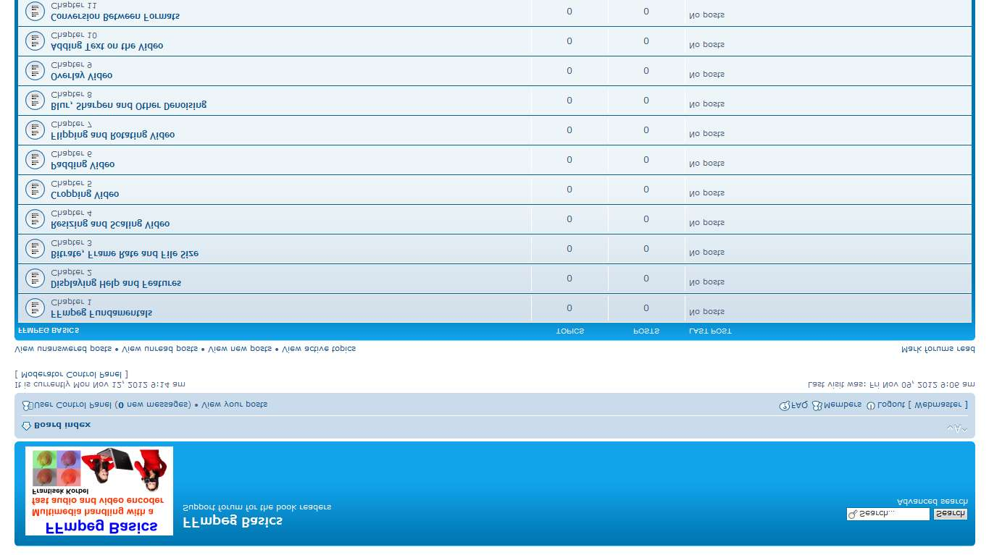

**约定**

命令行中输入的文本应以斜体字体打印，例如:

ffmpeg -i input.mpg -q 1 output.avi

一个特定的文本替换命令的部分应该用斜体字印刷的，例如:

ffmpeg -i input -vf mp=denoise3d -s vga output

控制台输出以斜体字体打印:

Muxer avi [AVI (Audio Video Interleaved)]:

Common extensions: avi.

Mime type: video/x-msvideo.

Default video codec: mpeg4.

Default audio codec: mp3.

符号 ^ 表示命令太长无法在一行印刷的书继续另一个，但它仍然是一个1计算机命令，例如:

ffplay -f lavfi -i color=c=white ^

-vf drawtext=fontfile=/Windows/Fonts/arial.ttf:text=Welcome

请注意，在前面的例子中，在命令行上也需要有空白表示空格。这种形式的符号主要是批处理文件所需的部分解释。

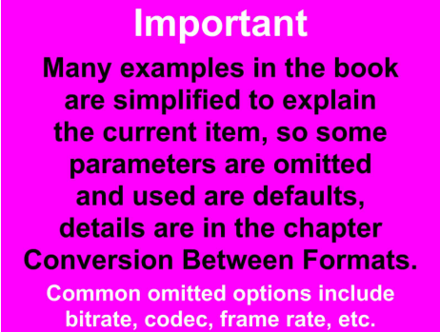

本书让我们更好的使用色分化、素像过滤器、设备、数据源...等功能

|  |  |
| --- | --- |
| 彩色、设备、过滤器 例如：音频和视频相关的设备 | |
| 只有音频 |  |
| 只有视频 |  |
| 视频和音频 |  |

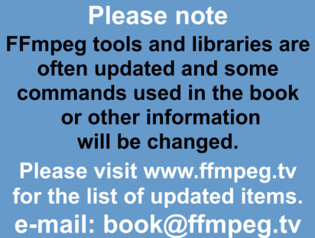

你的反馈是非常重要的，在200页左右的书中不能完全解释许多选项和ffmpeg工具参数。你有什么意见或改进可以反馈给我们，我们争取在下一个版本中概述。

你可以通过邮箱、论坛、www.ffmpeg.tv常见问题、其它搜索等提出。

非常感谢

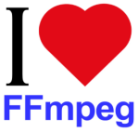

**1. FFmpeg 基础**

正确使用和优化ffmpeg，如果你想直接使用，可跳过本章进入下一章。

FFmpeg 介绍

FFmpeg是基于GNU公共许可证下的多媒体处理软件项目，最受欢迎的部分是视频和音频编码/解码 以及操作速度快、输出文件大小较小等。FF在ffmpeg中意味着快速前进按钮，“MPEG”是一个运动图像专家组的缩写，FFmpeg处理LOGO包含锯齿形图案，熵编码方案与图片中的8x8块特征。



|  |  |
| --- | --- |
| FFmpeg 命令行工具 | |
| ffmpeg | 快速音/视频编解码 |
| ffplay | 多媒体播放器 |
| ffprobe | 显示媒体文件特性 |
| ffserver | HTTP和RTSP协议的流媒体服务器 |
| FFmpeg 软码库 | |
| libavcodec | 各种多媒体编解码器的软码库 |
| libavdevice | 设备软码库 |
| libavfilter | 过滤器的软码库 |
| libavformat | 媒体格式软码库 |
| libavutil | 各种辅助程序的软码库 |
| libpostproc | 后台处理软件库 |
| libswresample | 音频重采样软件库 |
| libswscale | 媒体缩放软件库 |

所有项目的代码都是C语言，可以在Linux / UNIX，Windows，Mac OS X等编译。

本书是参考微软Windows使用官方二进制文件的，所有的指令和例子都可以跨平台使用，请参阅有关选项和FFmpeg配置项。

**Developers of FFmpeg**

The project was started in 2000 by Fabrice Bellard, excellent programmer known also as a creator of QEMU and Tiny C Compiler. Now the project is maintained by the FFmpeg team and developers are from many countries, main developers available for contracting work are in the table:

|  |  |  |
| --- | --- | --- |
| Name | Location | Specialization |
| Baptiste Coudurier | Los Angeles USA | He has special expertise in broadcast codecs (ProRes, DNxHD,  IMX/D-10, AVC-Intra), formats (MXF, GXF, MOV) and  usages (Avid, FCP, Interlacing, Time Code, Metadata). |
| Benjamin Larsson | Stockholm,  Sweden | Main area of his expertise is audio codecs. |
| Diego Biurrun | Aachen,  Germany | He has special expertise in license compliance engineering and  build systems. |
| Jason Garrett-Glaser | Los Angeles,  USA | He is the lead x264 developer and has special expertise in  H.264 and other modern lossy video formats, as well as x86  SIMD assembly optimization. |
| Luca Barbato | Torino, Italy | He has special expertise in streaming protocols. |
| Michael Niedermayer | Vienna, Austria | He is an expert in all areas of video coding as well as x86  assembly. |
| Stefano Sabatini | Cagliari, Italy | He has special expertise in libavfilter, ff* tools usage and  usability issues. |

**Participation in FFmpeg development**

Anyone can participate by joining particular mailing list on the webpage

http://www.ffmpeg.org/contact.html

Available mailing lists are in the table:

|  |  |
| --- | --- |
| FFmpeg mailing lists | |
| ffmpeg-user | for regular user questions like compilation troubles, command-line issues and similar |
| ffserver-user | for ffserver user questions like configuration and streaming issues |
| libav-user | for application developer questions about development using the FFmpeg libraries |
| ffmpeg-devel | for development of FFmpeg itself, it is not for development of software that use the  FFmpeg libraries and not for bug reports |
| ffmpeg-cvslog | for all changes to the FFmpeg sources / main git repository |
| ffmpeg-trac | for all changes to the FFmpeg Trac issuetracker |

**FFmpeg download**

The primary download source is located on the webpage:

http://ffmpeg.org/download.html

The users of Windows can download the binaries (static builds are recommended) from the webpage

http://ffmpeg.zeranoe.com/builds

Many Linux distributions have FFmpeg tools already installed, otherwise they can be compiled, this is

possible also on the OS X, or the OS X binaries can be downloaded from the webpages

http://www.evermeet.cx/ffmpeg or http://ffmpegmac.net

**Command line syntax**

The syntax of ffmpeg command line tool is relatively simple, important is to type required parameters in

the correct position and not to mix options between various inputs and outputs. The general structure of

ffmpeg command follows, global options affect all inputs and outputs:

ffmpeg [global options] [input file options] -i input_file [output file

options] output_file

