Abstract — This report introduces a sophisticated DDoS (Distributed Denial of Service) attack simulation tool, designed to analyze and mitigate TCP SYN flood attacks. The tool leverages technologies such as Scapy for packet manipulation, Tkinter for its user interface, and Matplotlib for real-time traffic visualization, offering a comprehensive and user-friendly platform for network security analysis. Its primary features include control over attack duration and intensity, real-time monitoring of network traffic, detailed packet logging, and graphical representation of network traffic dynamics during simulated attacks. Essential for cybersecurity professionals and network administrators, this tool not only facilitates a deeper understanding of DDoS threats but also aids in the development of more robust defense strategies. The report delineates the tool's architecture, implementation, and functionality, highlighting its effectiveness in simulating realistic DDoS scenarios and its potential impact in advancing cybersecurity practices.

Keywords — DDoS (Distributed Denial of Service), TCP SYN flood, Cybersecurity, Attack Simulation Tool, Network Traffic Visualization, Real-time Monitoring, Packet Logging, Scapy, Tkinter, Matplotlib, Intensity Control, Duration Control, Network Security, Network Analysis.

I. Introduction

In today's interconnected digital landscape, cybersecurity faces an ever-evolving array of threats, with Distributed Denial of Service (DDoS) attacks standing as one of the most formidable. These attacks aim to disrupt the availability of online services by flooding target systems with an overwhelming volume of malicious traffic, rendering them inaccessible to legitimate users. The consequences of such attacks extend far beyond temporary service unavailability, often resulting in significant financial losses, reputational damage, and eroding trust in online infrastructure.

Among the various types of DDoS attacks, the TCP SYN flood attack represents a particularly insidious threat. It exploits the TCP handshake process, overwhelming a target server with a deluge of TCP SYN requests. This method effectively exhausts the server's capacity to establish legitimate connections, leading to service disruption and denial of access for genuine users.

In response to this critical cybersecurity challenge, this report introduces a specialized tool designed to simulate and analyze TCP SYN flood attacks. The tool provides a controlled environment for cybersecurity professionals, network administrators, and researchers, enabling them to comprehensively analyze, understand, and develop effective countermeasures against such attacks. It emphasizes not only the simulation of these threats but also the analysis and understanding necessary for developing robust defensive strategies.

This tool is meticulously engineered to offer a simulated environment where TCP SYN flood attacks can be accurately replicated. Users can manipulate critical attack parameters such as duration and intensity, facilitating a deeper understanding of the attack's behavior and its implications on network security. By providing real-time insights into these attack dynamics, the tool aims to empower users with actionable intelligence to bolster network defenses against potential DDoS threats.

Key functionalities of the tool include the ability to initiate and cease attack simulations at will, display real-time logs of transmitted packets, monitor network traffic in bits per second (bps), and present a detailed graphical representation of network traffic during an attack. The tool's interface is designed to be intuitive, allowing users to observe and analyze attack patterns effectively, identify anomalies indicative of ongoing attacks, and implement proactive defense strategies. By equipping users with this comprehensive simulation platform, the tool plays a crucial role in enhancing the preparedness and responsiveness of cybersecurity systems against DDoS attacks.

III. Proposed System

The proposed DDoS attack simulation tool is engineered to provide organizations with a controlled and secure environment to effectively prepare for, assess, and respond to Distributed Denial of Service attacks. Its primary objectives are to test and validate defense mechanisms against DDoS attacks through controlled simulations.

3.1 System Design and Architecture

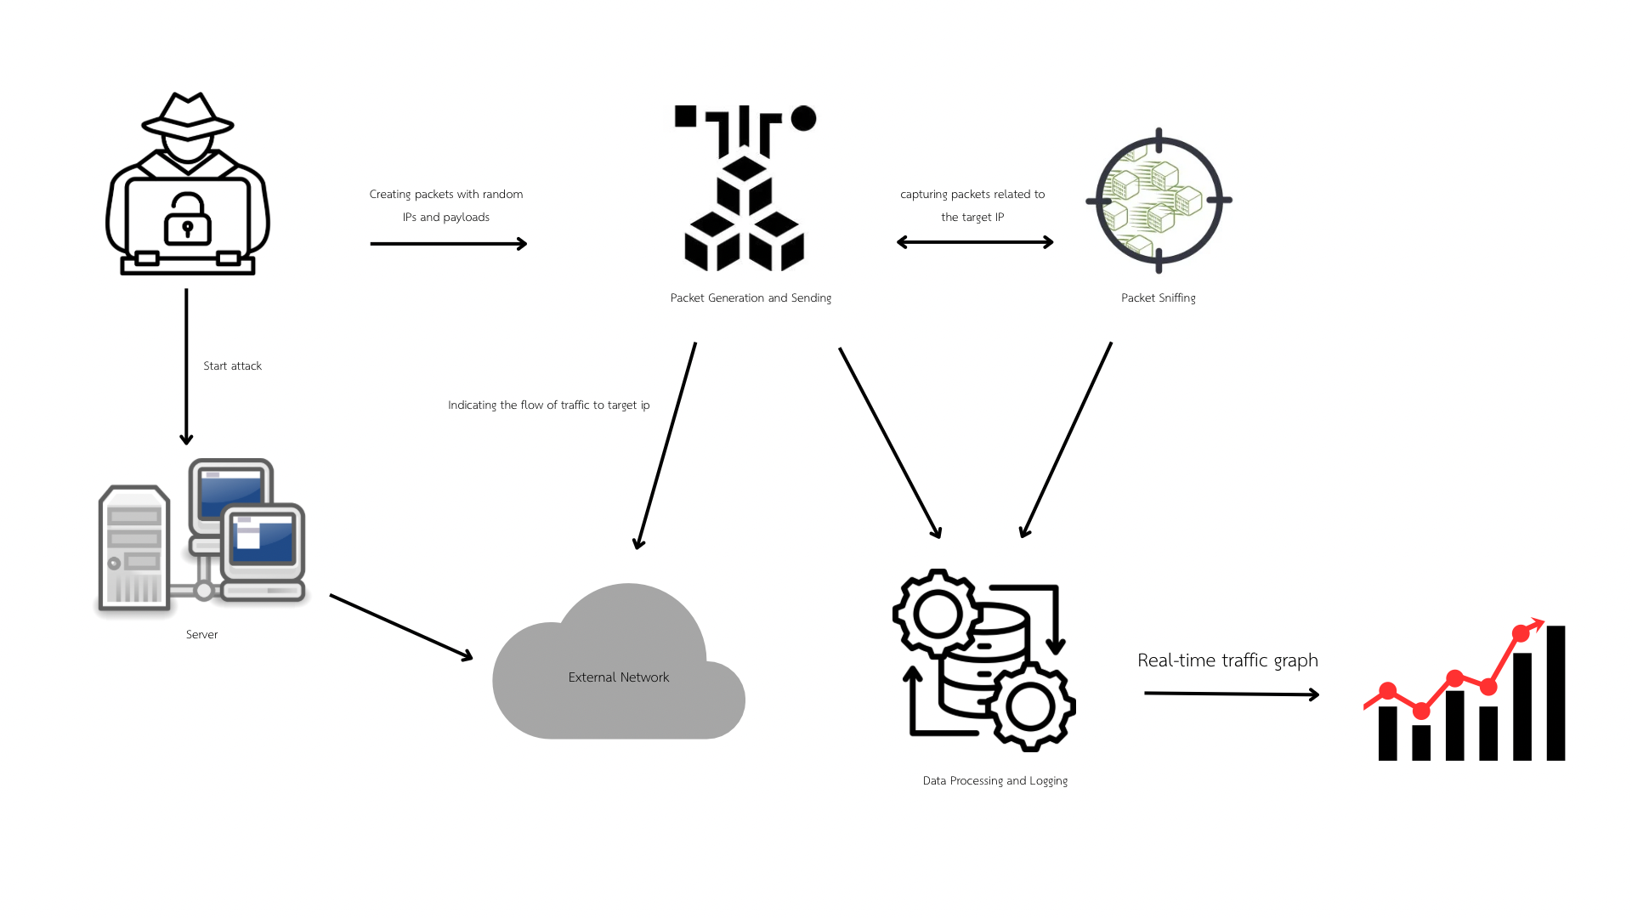

*Figure 1. System Architecture*

The system's architecture integrates several key components to effectively simulate and analyze TCP SYN flood attacks:

* Simulation Environment Setup: Deployed on an Ubuntu-based virtual machine (VM), the setup includes Apache2 as the target service for attack simulations. Our proposed SynFlood Tool, housed on a separate VM, is responsible for executing attack simulations.
* Attack Execution: Utilizes Visual Studio Code and Python libraries like Scapy for generating SYN Flood attacks aimed at the target service. Comprehensive documentation is provided to guide users through the attack generation process.

เดียวมึงวาด Attack Flow Diagram ให้กุด้วยนะ

*Figure 2.Attack Flow Diagram*

* Packet Detection and Visualization: The tool doubles as a packet analyzer post-attack, presenting findings within the user interface for detailed examination.
* Dashboard Interface: Features include a Configuration Display for setting attack parameters, Progress Monitoring with real-time updates, Packet Logs for in-depth traffic analysis, and Statistics for summarizing attack data.

3.2 Functionalities and Features

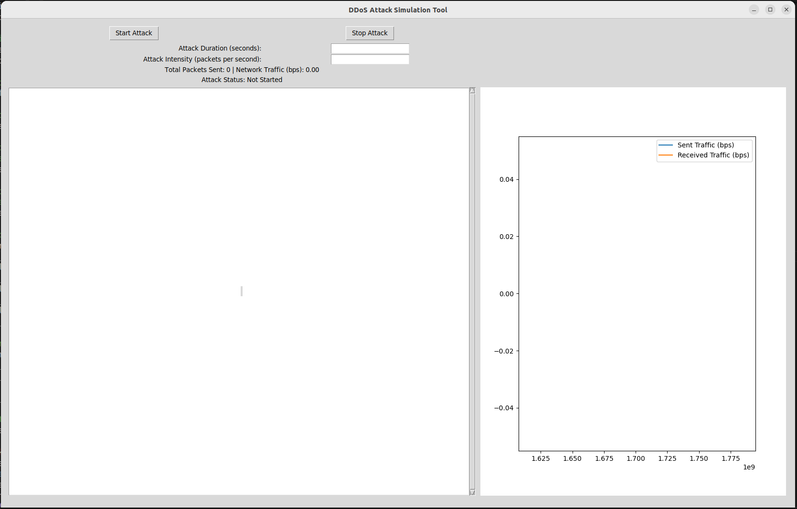

*Figure 3. UI Screenshots*

The tool is endowed with various functionalities, each designed to offer a holistic understanding and control over simulated DDoS attacks:

* Configuration Display: Enables users to adjust and tailor attack parameters.
* Progress Monitoring: Provides real-time information on the attack progress, including the rate and details of sent packets.
* Logging Mechanism: Logs every attack packet sent, detailing source and destination IP addresses, timestamps, and packet sizes.
* Statistical Analysis: Offers comprehensive statistics during and post-attack, including total packets sent and target responses.
* Traffic Analysis Dashboard: Captures and visualizes real-time traffic to and from the target system, using advanced network analysis tools for detailed data representation.

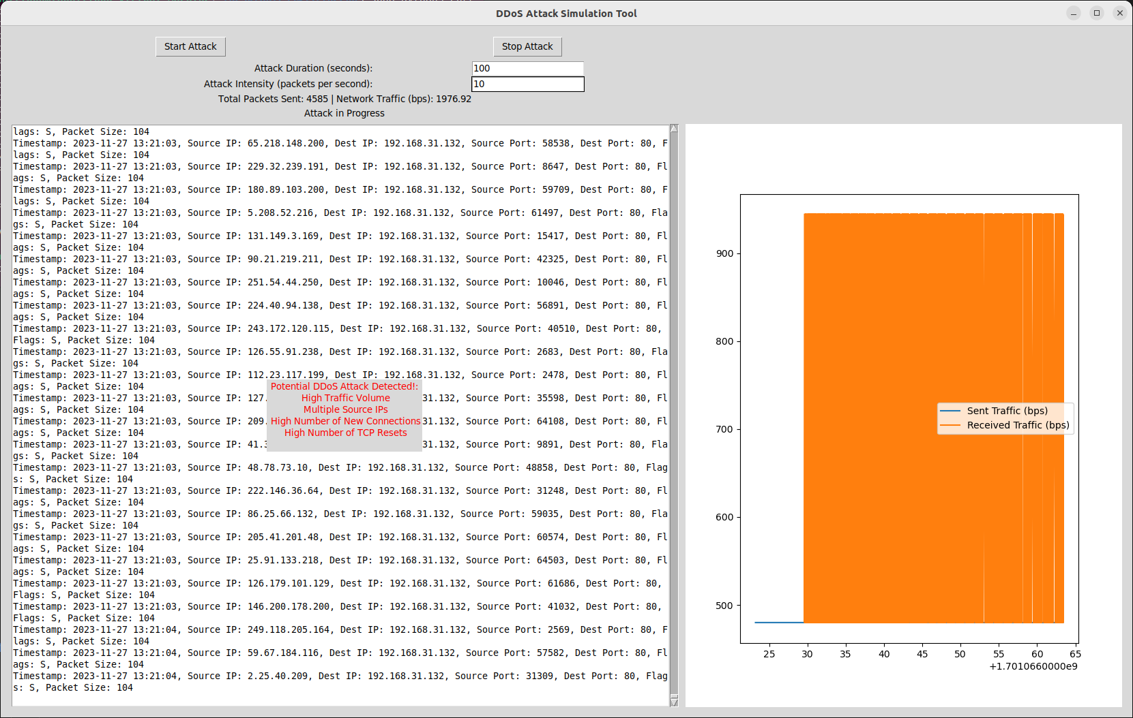

*Figure 4.Statical Graph*

* Control over Attack Parameters: Allows users to vary attack duration and intensity for different simulation scenarios.
* Start/Stop Functionality: Grants users the ability to initiate or cease attack simulations as required.
* Real-time Monitoring: Showcases live packet logs, total packets sent, network traffic in bps, and graphical traffic patterns during the simulation.

This tool, with its user-centric design, caters to a wide range of users, from novices to expert cybersecurity professionals. It incorporates robust security measures to ensure that the simulated environment is both safe and effective, thereby offering a powerful platform for organizations to simulate, analyze, and enhance their defenses against DDoS threats.

IV. Experiment

The experiment to evaluate the DDoS attack simulation tool was conducted on a Linux Ubuntu 22.0.4 64-bit system. The setup utilized Apache 2 for service hosting and Python for generating SYN packets, providing a realistic environment for the simulation.

เดียวมึงวาด Network Setup Diagram ให้กุด้วยนะ

*Figure 5. Network Setup Diagram*

Service Setup using Apache 2

The setup process involved several key steps:

* Installation of Apache 2: The command sudo apt-get install apache2 was executed to install Apache 2.
* Service Configuration: Apache 2 was configured to host a mock service, with relevant files placed in the /var/www/html/ directory.
* Start Apache 2: The service was initiated using sudo systemctl start apache2.
* Verify Service: The hosted service's functionality was verified by accessing it through a web browser at IP address 192.168.31.132.

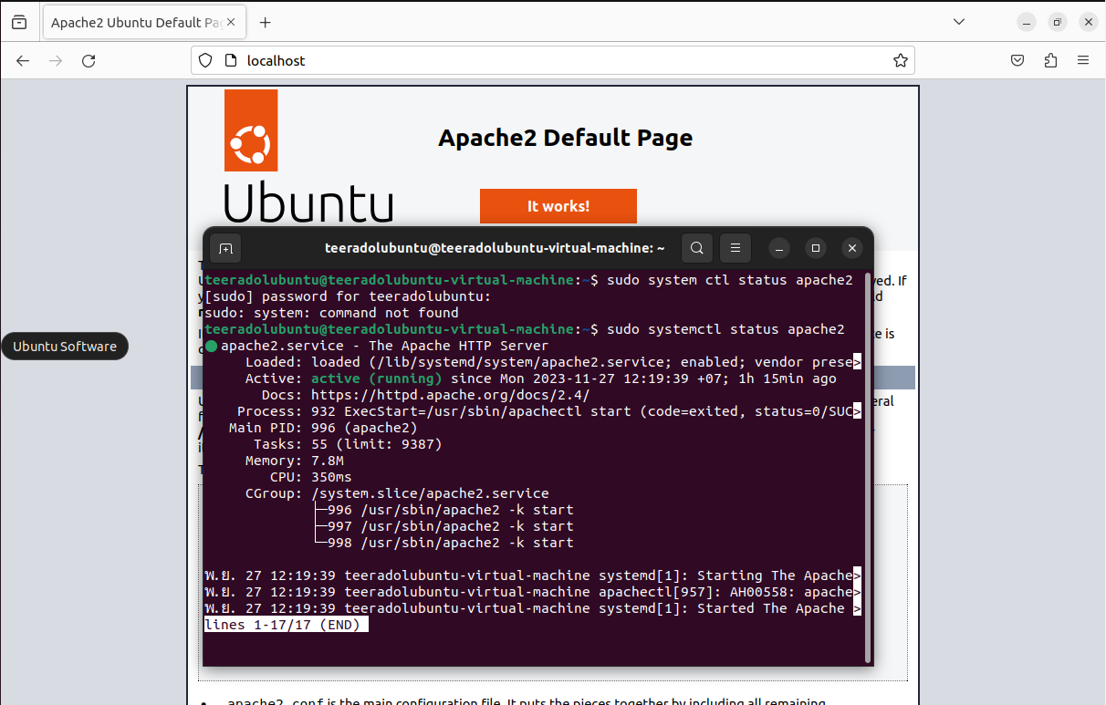

*Figure 6. Service Verification Screenshot*

Using the Tool

The operation of the DDoS attack simulation tool involved the following steps:

* Launching the Tool: The tool was launched via the command line using sudo python3 [tool name].
* Input Attack Parameters: The user inputs the attack duration in seconds and sets the attack intensity by specifying the number of packets per second.

**

*Figure 7. Tool Configuration Interface*

Initiating and Stopping the Attack: The attack was initiated by pressing the 'Start Attack' button and stopped using the 'Stop Attack' button.

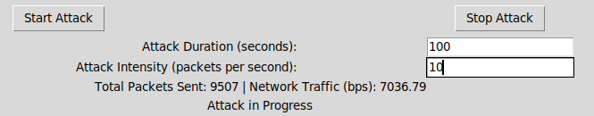

*Figure 8. Attack Simulation in Progress*

Live Statistics Display: The tool provided live statistics on the target system, including:

* + Live logging of attack details (source/destination IP addresses, timestamps, and packet sizes).
  + Progression status of the attack (packets sent and network traffic in bps).
  + Real-time graphical representation of network traffic variations.

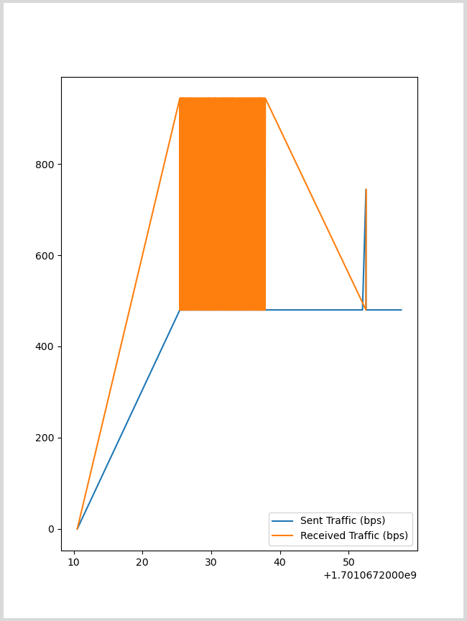

*Figure 9. Live Statistics and Traffic Analysis*

The experiment conducted using the Ubuntu environment with Apache 2 for service hosting and Python for SYN packet generation successfully showcased the DDoS attack simulation tool's capabilities. Notable was the tool's user-friendly interface and its ability to provide live, detailed insights into attack dynamics and traffic patterns. This demonstrates its efficacy in analyzing and understanding DDoS attack behaviors, emphasizing its potential as an invaluable resource in cybersecurity analysis.

V. Discussion

5.1 Implementation Details

The DDoS attack simulation tool was implemented using the Python programming language, utilizing key libraries such as time, threading, tkinter, scapy, logging, psutil, matplotlib, and random. The core of the tool's attack simulation algorithm is designed to replicate TCP SYN flood attacks within the Python environment. Data visualization algorithms were crafted to provide real-time, graphical analyses during simulations, enhancing the tool's analytical capabilities.

5.2 Analysis of Comparative Results

Our comparative analysis underscores the tool's proficiency in simulating TCP SYN flood attacks, with accurate real-time displays of attack progression, packet logs, and network traffic trends. The live statistics and graphical outputs provided critical insights, aiding effective decision-making during simulations. However, challenges were observed, including system lag during concurrent virtual machine operations and occasional tool freezing under high-intensity attacks, indicating areas for improvement.

5.3 Proposed Ideas for Improvement

* Enhanced Resource Management: Implementing efficient resource management could mitigate the observed system lag. Optimizing resource allocation is essential to enhance performance.
* Improved Attack Handling: Upgrading the tool to handle high-intensity attacks more smoothly is vital. Enhancements in the attack simulation algorithm or adoption of parallel processing could enhance stability.
* Adaptive Scaling: Introducing dynamic scaling mechanisms would allow the tool to adjust its performance based on varying system loads and attack intensities, promoting resilience and stability.

5.4 Proposed Techniques

To further improve the tool, integrating machine learning algorithms for anomaly detection could be pivotal. An adaptive algorithm that adjusts attack parameters based on system load and attack impact could significantly enhance efficiency. Additionally, employing parallel processing methodologies could distribute computational loads more effectively, maintaining tool operation even under strenuous conditions.

In conclusion, this analysis recognizes the tool's strengths in accurately simulating DDoS attacks, while also pinpointing critical areas for enhancement. The proposed improvements aim to elevate the tool's performance, making it a more robust solution in the evolving landscape of DDoS threats."

### VI. Conclusion:

In conclusion, the development and thorough evaluation of the DDoS attack simulation tool, as detailed in this report, underscore its vital role in understanding and simulating TCP SYN flood attacks. This specialized tool, with its user-friendly interface, provides cybersecurity professionals, network administrators, and researchers with a dynamic platform to simulate and analyze DDoS threats effectively. Its capabilities, from configurable attack parameters to real-time traffic visualization, offer comprehensive insights essential for developing proactive defense strategies against DDoS attacks.

The comparative analysis and subsequent identification of potential areas for improvement underscore the necessity for ongoing development. Proposed enhancements, such as improved resource management, attack handling mechanisms, and adaptive scaling techniques, are geared towards enhancing the tool’s efficacy, stability, and adaptability. Furthermore, the integration of advanced techniques like machine learning for anomaly detection and parallel processing methodologies promises to further augment the tool’s performance, particularly in high-intensity attack scenarios.

This tool not only serves as a crucial asset for immediate DDoS threat analysis and mitigation but also represents a significant contribution to the broader cybersecurity landscape. It empowers users to stay ahead of evolving DDoS tactics and strengthens the overall network defense posture. We advocate for continued research and collaboration in this field, aiming to foster further advancements and ensure that tools like ours evolve in tandem with the dynamic nature of cybersecurity threats.

Therefore, the DDoS attack simulation tool stands as a pivotal instrument in the arsenal of cybersecurity defenses, offering an interactive and evolving platform for robust defense strategy formulation against TCP SYN flood attacks. The path laid out for future enhancements ensures that the tool remains a relevant and effective resource in the ongoing battle against DDoS threats.