

CSE370 : Database Systems
Project Report
Project Title : UniTask

Group No : 12, CSE370 Lab Section : 05, Spring 2026
ID | Name | Contribution
24341236 | Mesbah Uddin Ahmed | Led the project ideation and brainstorming phase, defining the core concept, target audience, and overall vision of UniTask. Designed the ER/EER Diagram, Schema and was responsible for the full frontend development including Authentication & OTP flow, User Roles & Permissions, Profile System, Feed & Navigation, Job Posting & Management, Job Application & Hiring workflow, Messaging System, Payment & Wallet System, and Notification System. Also handled backend integration with Supabase, database triggers, RLS policies, and overall system architecture.
Table of Contents

Section  No | Content | Page No
1 | Introduction | 3
2 | Project Features | 4
3 | ER/EER Diagram | 5
4 | Schema Diagram | 6
5 | Normalization | 7
6 | Frontend Development | 9
7 | Backend Development | 14
8 | Source Code Repository | 16
9 | Conclusion | 16
10 | References | 17

Introduction
UniTask is a comprehensive web platform built specifically to connect students with freelance work and job opportunities. The application serves as a secure, verified marketplace where clients and students can post jobs, apply for tasks, and manage the entire workflow from initial contact to final payment.

Target Audience
University Students: Individuals looking to apply for jobs, showcase their portfolios, and earn money. They must verify their academic status by signing up with a valid .edu or .ac.bd email domain.
Clients: Individuals or businesses who want to post jobs and hire talented student freelancers.
Administrators: Platform moderators who manage disputes, handle reports, and maintain the integrity of user activity.

Why This Project?
University students often struggle to find flexible, legitimate freelance work that accommodates their academic schedules. This project creates a high-trust, localized ecosystem by restricting student registration to verified academic emails. Furthermore, it addresses common gig-economy issues like payment fraud by implementing a built-in wallet system that automatically charges the job poster upfront and secures the funds until the work is completed.

Goals and Visions
Secure Networking: Build a safe, scam-free environment where communication is centralized through an integrated messenger chatbox.
Skill Showcasing: Allow students to build a professional identity by displaying their ratings, portfolios, and top skills on their profiles.
Fair Resolution: Ensure fair treatment for both clients and freelancers through a structured rating system and a dedicated dispute resolution center.

Project Features

ID,  Name | Features [3 per member]
24341236,  Mesbah Uddin Ahmed | Ft 1 | Authentication
 | Ft 2 | User Roles & Permissions
 | Ft 3 | Profile System
 | Ft 4 | Feed & Navigation
 | Ft 5 | Job Posting & Management
 | Ft 6 | Job Application & Hiring
 | Ft 7 | Messaging System
 | Ft 8 | Payment & Wallet System
 | Ft 9 | Notification System
20101998,  BCD | Ft 1 | Rating
 | Ft 2 | Dispute

ER/EER Diagram
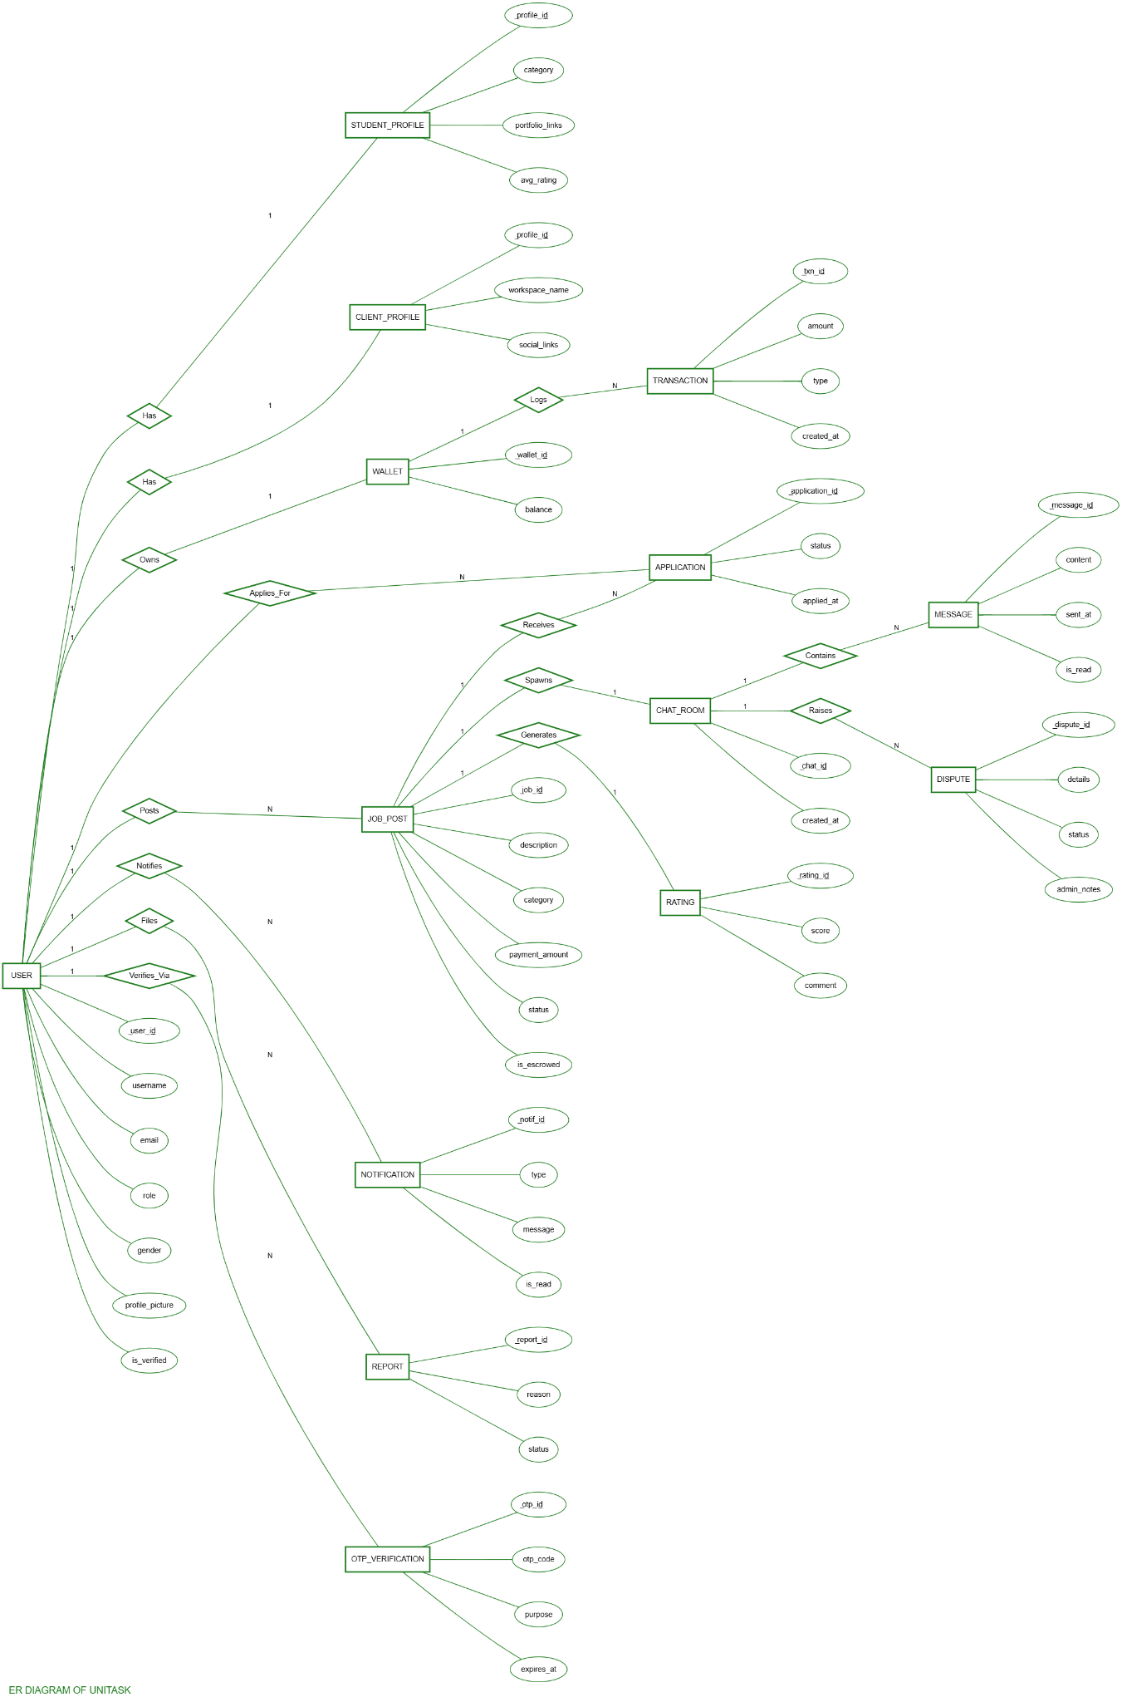
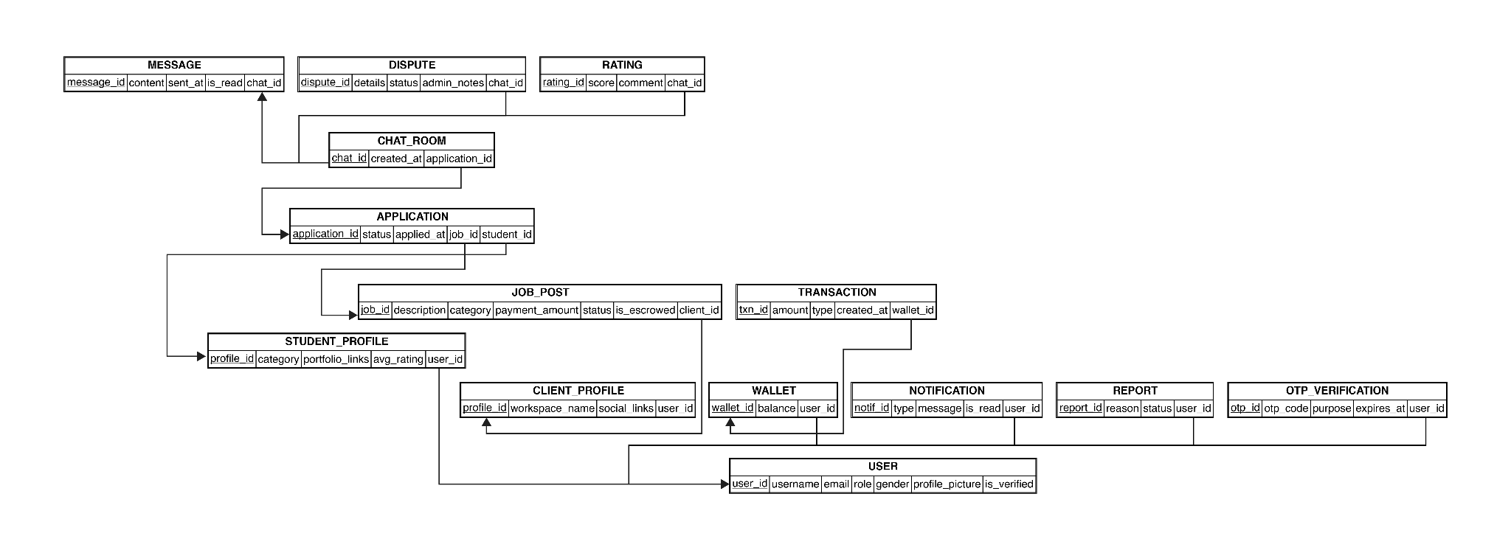
Schema Diagram

Normalization

a. Explain if your converted Schema is in 1NF or not. If not, decompose it to 1NF.

Ans. A relation is in 1NF if all attributes contain only atomic (indivisible) values and each column holds values of a single type with no repeating groups.
Analysis: The UniTask schema satisfies 1NF. Each table cell holds a single atomic value. For example:
The users table stores one email per user — no comma-separated emails in a single cell.
portfolio_links in the original design could have been a multi-valued attribute. To satisfy 1NF, it was decomposed into a separate portfolio_links(user_id FK, url) table so that each row holds exactly one link.
The categories relation stores one category name per row; job categories reference this table via a foreign key rather than embedding category names directly in the jobs table.
Conclusion: The schema is in 1NF.

b. Explain if your converted Schema is in 2NF or not. If not, decompose it to 2NF. Can there be any partial functional dependencies in your relational schema?

Ans. A relation is in 2NF if it is in 1NF and every non-key attribute is fully functionally dependent on the entire primary key (no partial dependencies). Partial dependencies can only occur in tables with composite primary keys.
Analysis: Tables with composite keys in this schema are examined below:
applications(application_id, job_id, applicant_id, status, applied_at) — the primary key is application_id (surrogate). All attributes depend fully on application_id. No partial dependency.
ratings(rating_id, job_id, rater_id, ratee_id, score, created_at) — surrogate PK ensures full dependency of all attributes on rating_id. No partial dependency.
messages(message_id, room_id, sender_id, content, sent_at) — all attributes fully depend on message_id.
There are no composite natural primary keys in the schema that would introduce partial dependencies. All non-key attributes are fully dependent on their respective primary keys.
Conclusion: The schema is in 2NF. No partial functional dependencies exist.
c. Explain if your converted Schema is in 3NF or not. If not, decompose it to 3NF. Can there be any transitive dependencies in your relational schema?

Ans. A relation is in 3NF if it is in 2NF and no non-key attribute is transitively dependent on the primary key through another non-key attribute.
Analysis: The UniTask schema was designed to avoid transitive dependencies:
Originally, a denormalized design might store category_name directly in the jobs table. This would create a transitive dependency: job_id → category_name (via category). This was resolved by introducing the categories table and using category_id as a foreign key in jobs.
User role-specific attributes (category, avg_rating for students; workspace for clients) were separated into student_profiles and client_profiles rather than stored in the users table — preventing transitive dependency through the role attribute.
avg_rating in student_profiles is a derived/cached value computed from the ratings table. While technically derivable, caching it is a deliberate performance optimization; the canonical data resides in the ratings table.
The wallets table holds balance separate from user identity, preventing transitive dependency between user_id and wallet balance.

Conclusion: The schema is in 3NF. No transitive dependencies exist in any relation.

Frontend Development

The UniTask frontend is a Single-Page Application (SPA) built with React 18 and Vite as the build tool. Routing is handled by React Router DOM v6 and the UI is styled with custom CSS. Lucide React provides icon components, and React Hot Toast is used for user feedback notifications. The application communicates with the Supabase backend through the official @supabase/supabase-js client library.

Technology Stack
- Framework: React 18.3 with Vite 5
- Routing: React Router DOM v6
- Backend Client: @supabase/supabase-js v2
- UI Components: Custom CSS + Lucide React icons
- Notifications: React Hot Toast
- Date Formatting: date-fns

Contribution of ID: 24341236, Name: Mesbah Uddin Ahmed

Authentication Pages (Sign Up / Login / OTP / Password Recovery)
Developed the complete authentication flow including the registration form with role selection and .edu/.ac.bd email validation, the OTP entry screen, the login page, and the forgot-password workflow. Integrated all forms with Supabase Auth.

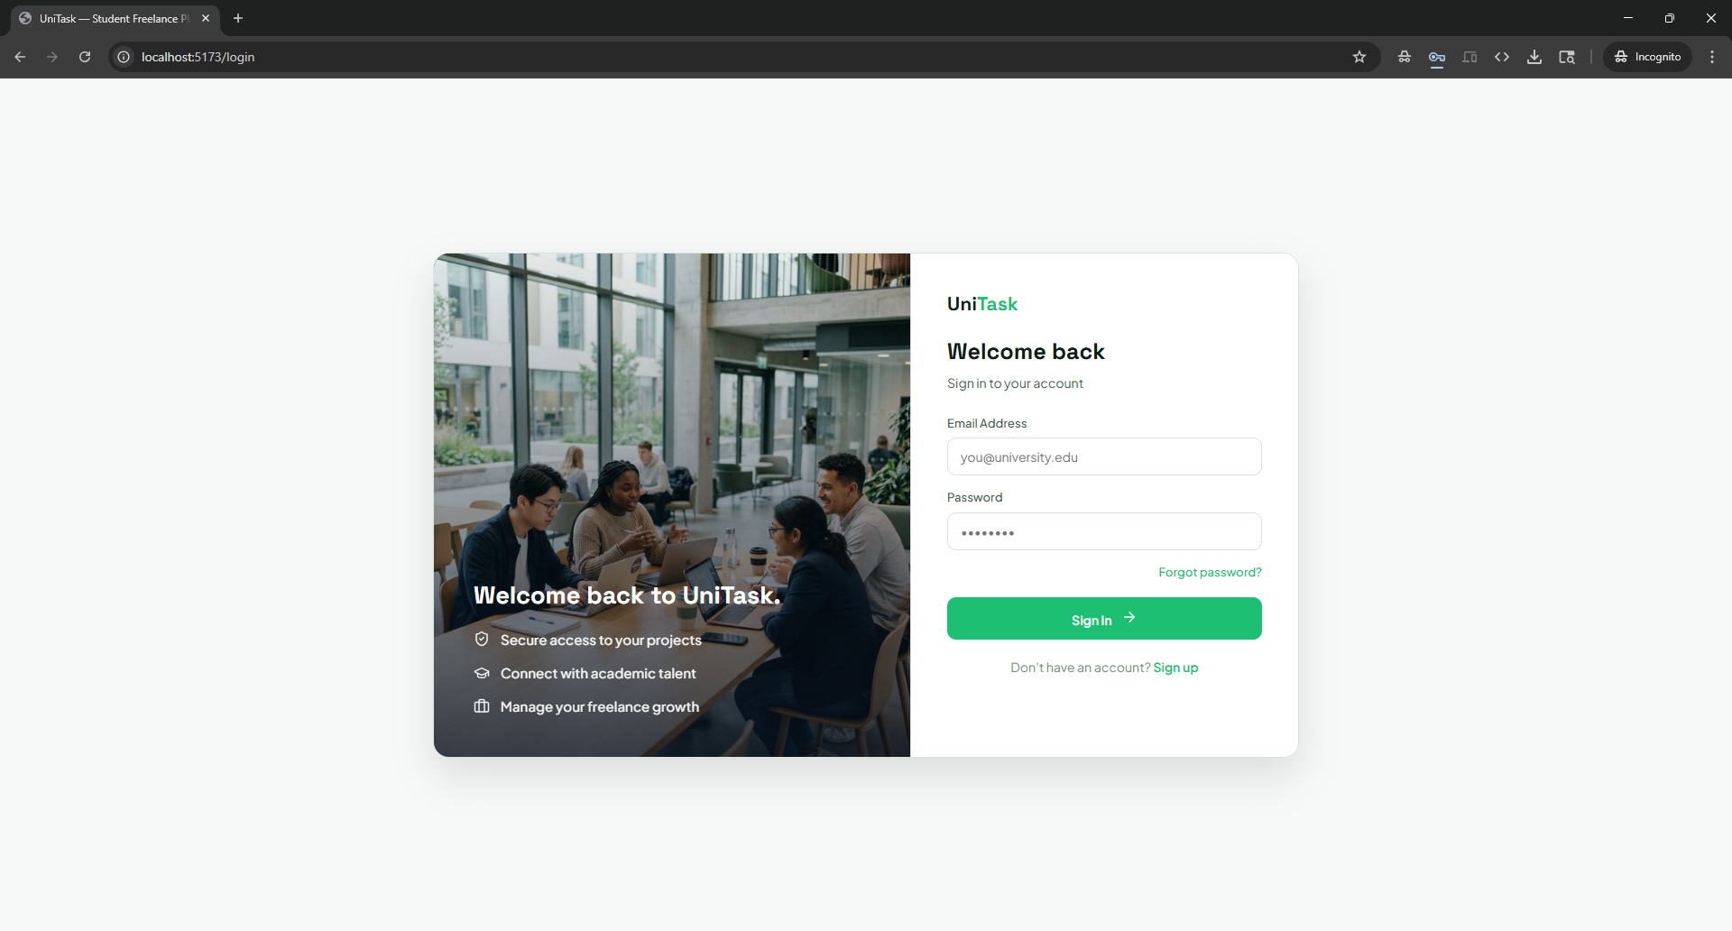

Main Feed & Job Discovery
Built the main job feed component that fetches and displays active job listings from Supabase in real time. Implemented the search bar with live filtering and the category dropdown filter. Designed responsive job cards displaying job title, category badge, payment, and poster information.

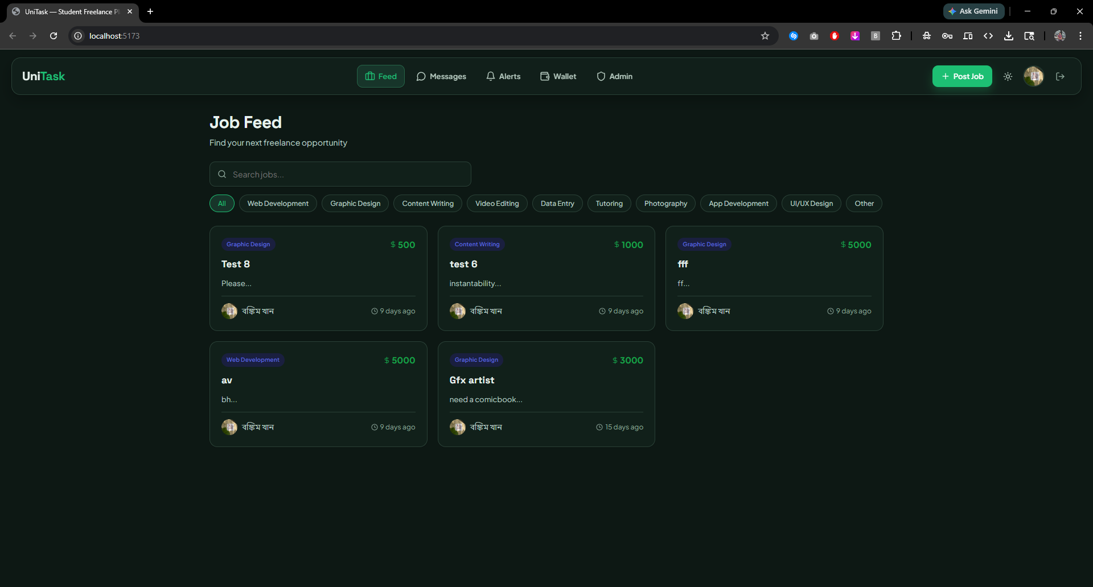

Job Post Detail & Application
Created the job detail view that renders full job information and poster profile. Implemented the Apply, Report, and View Applicants buttons with appropriate role-based visibility. Wired the apply action to insert a record in the applications table and trigger a notification.

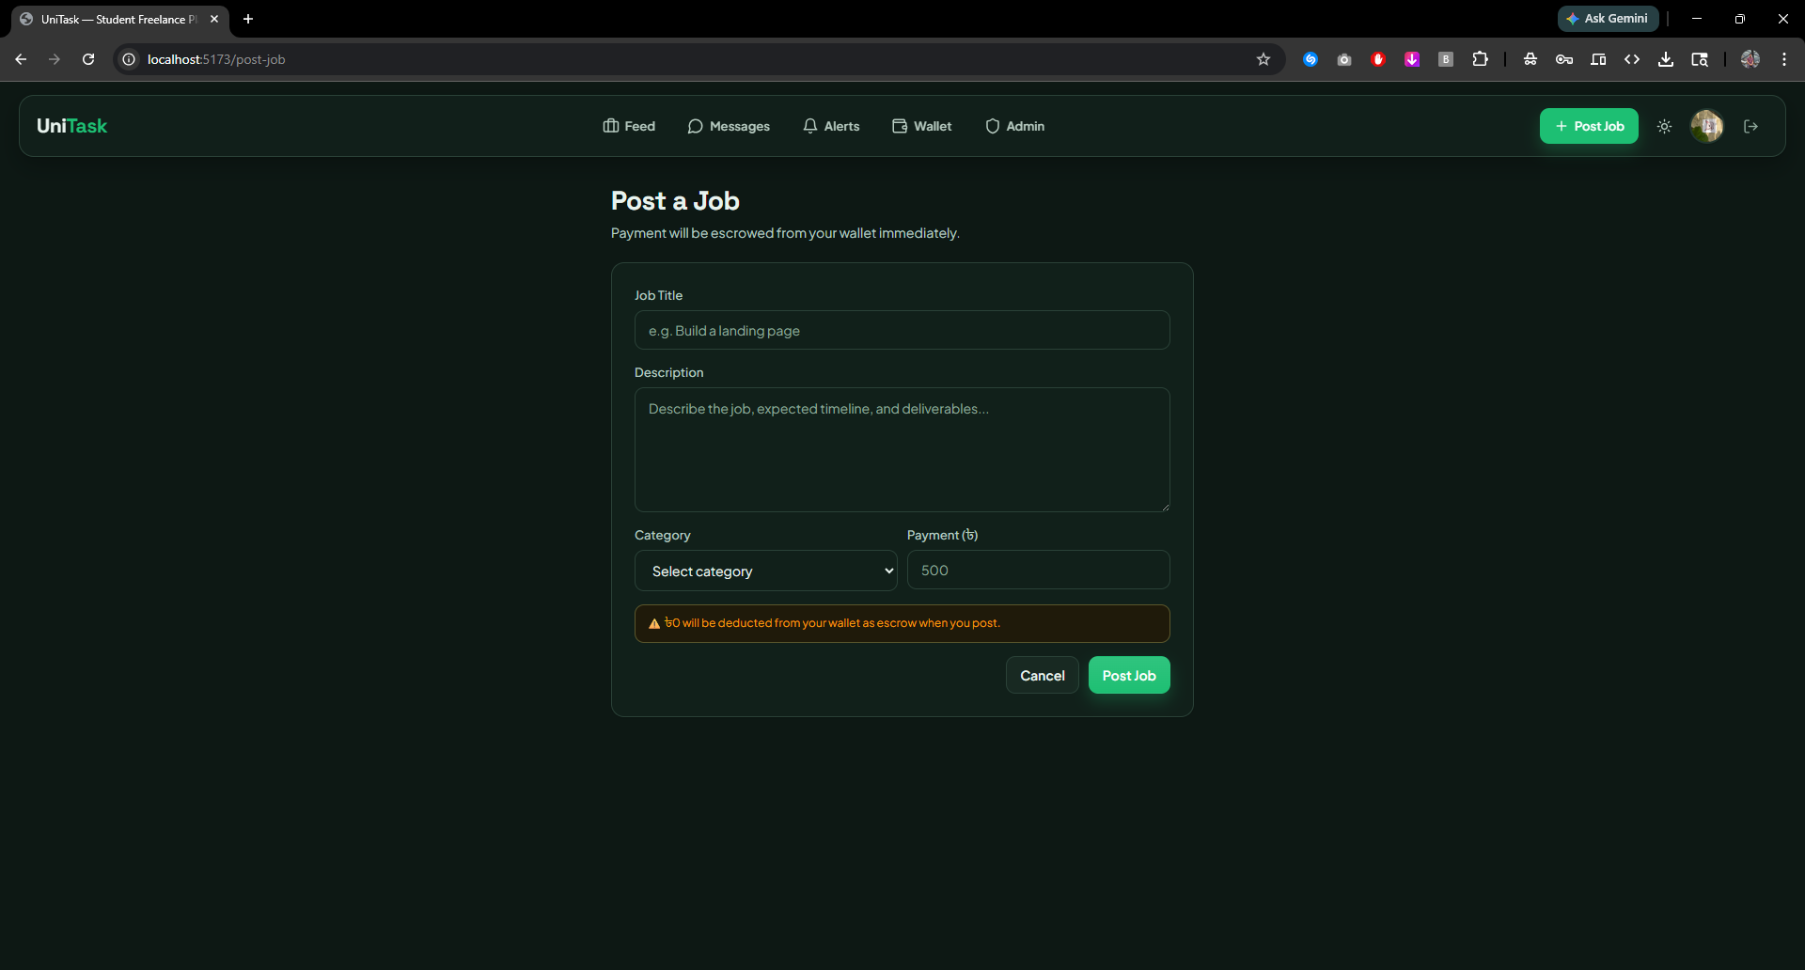

Profile Pages (Student & Client)
Designed separate profile views for students (displaying category, portfolio links, star rating, and edit controls) and clients (displaying workspace and social links). Implemented profile editing modals that update the respective Supabase tables.
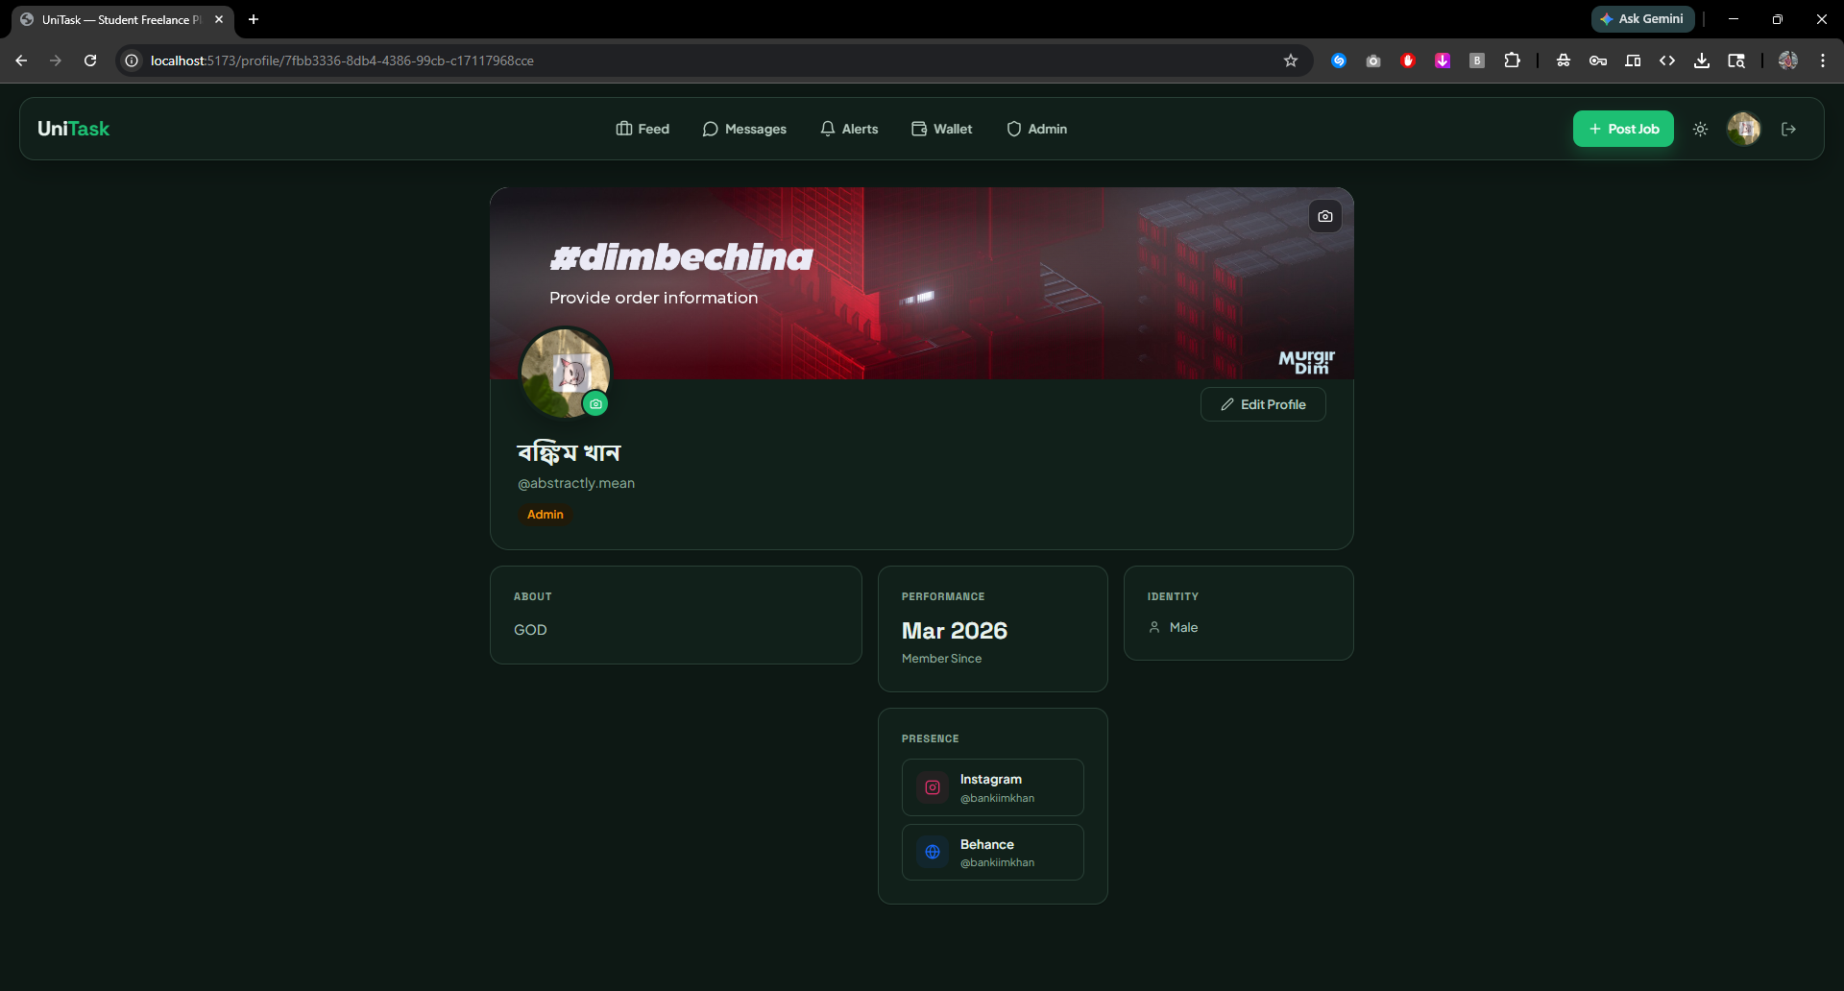

Messaging / Chat Interface
Developed the Messenger-style chat interface using Supabase Realtime subscriptions for live message updates. The chat component is rendered once a job is assigned and the chat room record is created. Implemented the Raise Dispute button within the chat view.

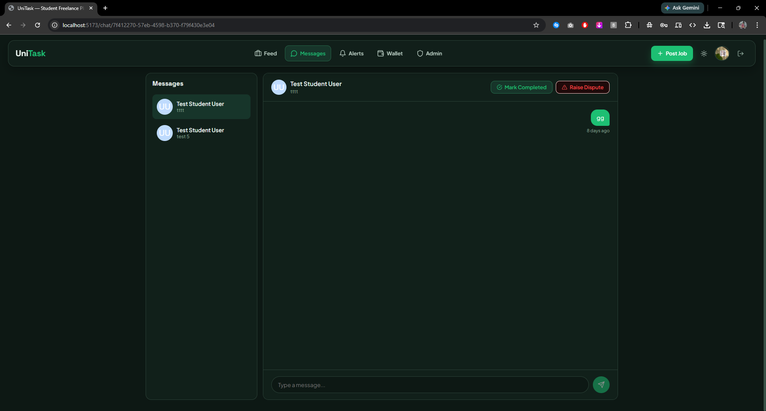

Wallet & Notification Pages
Built the digital wallet page showing current balance and transaction history. Implemented the notification hub with read/unread separation and red-dot indicators on the navigation bar. Wallet top-up and cash-out flows are displayed with appropriate status messaging.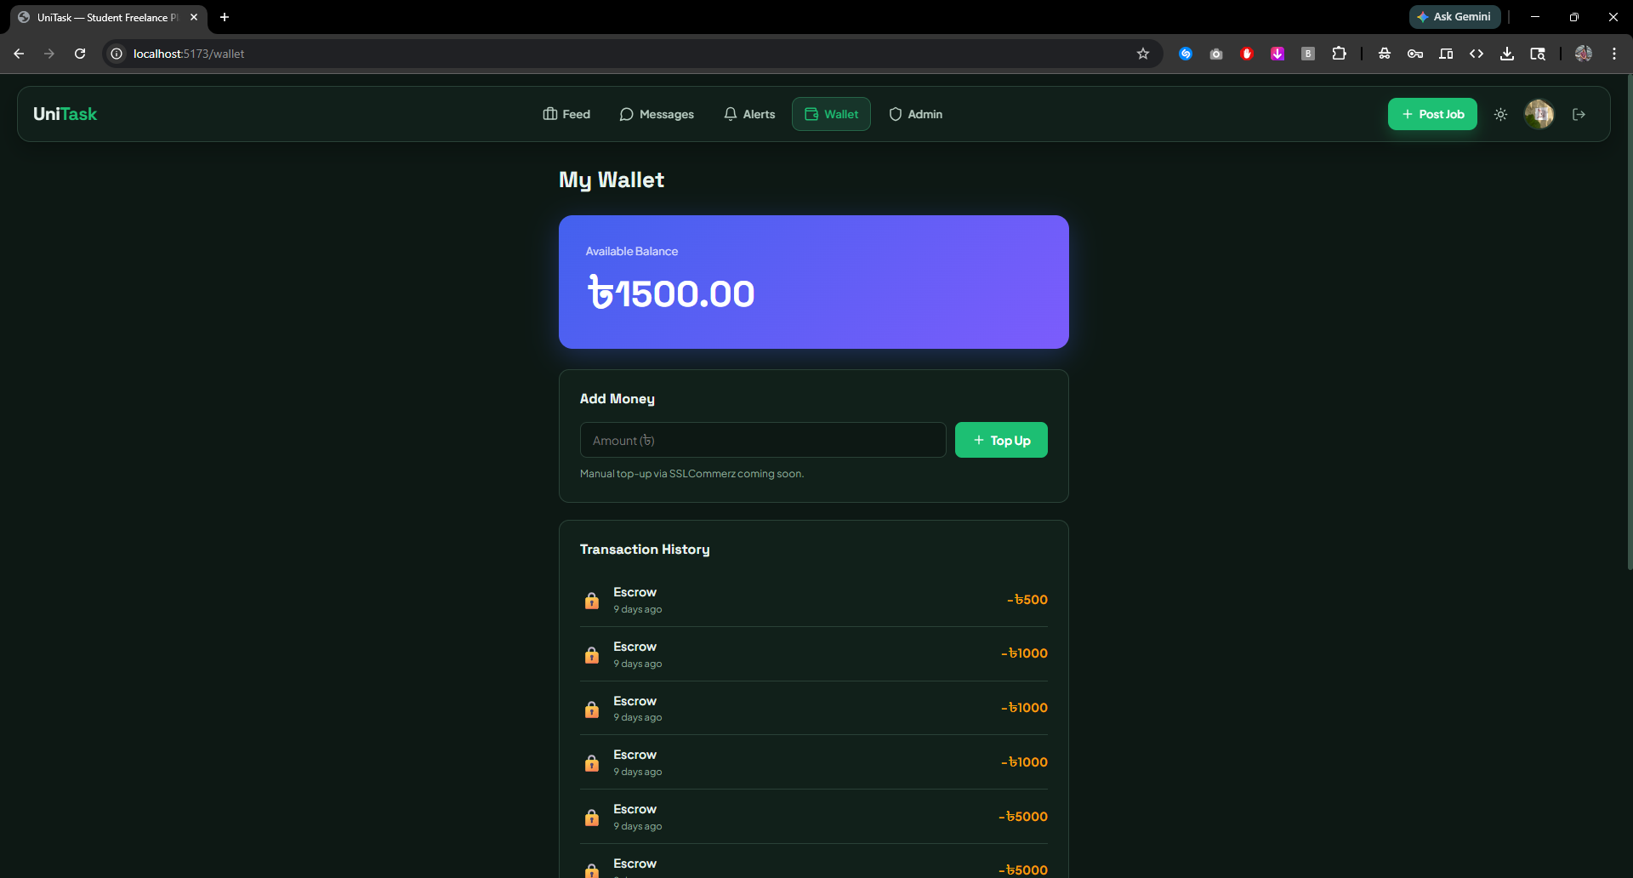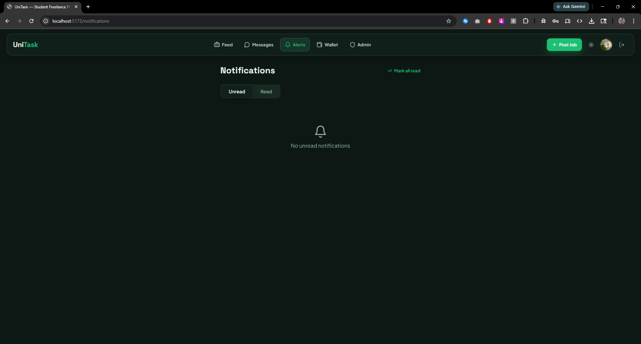

Backend Development

UniTask uses Supabase as its Backend-as-a-Service (BaaS) provider, which provides a hosted PostgreSQL database, built-in authentication, Row Level Security (RLS) policies, Realtime subscriptions, and serverless Edge Functions. There is no separate custom backend server — all business logic is handled either through Supabase's API, database triggers, or client-side logic secured by RLS.

Technology Stack
- Database: PostgreSQL 17 (via Supabase)
- Authentication: Supabase Auth (email + OTP, JWT-based sessions)
- Realtime: Supabase Realtime for live chat message delivery
- Security: Row Level Security (RLS) policies per table per role
- Hosting: Supabase cloud (ap-south-1 region)

Contribution of ID: 24341236, Name: Mesbah Uddin Ahmed

Database Schema Design & Migrations
Designed all 14 relational tables from the ER model, applying proper primary keys, foreign key constraints, and NOT NULL constraints. Created and applied migrations using the Supabase CLI to maintain a version-controlled schema history.

Authentication & OTP Configuration
Configured Supabase Auth with email OTP verification. Implemented domain restriction logic by validating email domains on the client against an allowed list (.edu, .ac.bd). Roles are stored as a custom field in the users table and enforced through RLS.

Row Level Security (RLS) Policies
Defined RLS policies for every table to enforce access control at the database level. Key policies include: students can only read their own applications; only the job poster can view the applicant list; messages are only accessible to the two parties of a chat room; admin users bypass standard restrictions for moderation purposes.

Escrow Payment Logic
Implemented the escrow workflow using PostgreSQL functions and triggers. When a job is inserted, a database trigger deducts the payment from the poster's wallet and records a HOLD transaction. When the job status is updated to 'completed', a second trigger releases the funds to the worker and records a RELEASE transaction. This ensures atomic, consistent payment handling.

Realtime Chat
Configured Supabase Realtime publication on the messages table so that new messages are pushed to subscribed clients instantly without polling. Chat rooms are scoped by room_id and access is secured by RLS.

Notification System
Application events (new application, selection, job completion, wallet credit/debit) write notification records to the notifications table. The frontend subscribes to this table via Realtime to update the notification count badge in real time.

Source Code Repository
The complete source code for the UniTask project is publicly available on GitHub at the following link:

bankiimkhan/CSE370-Project

The repository contains the full React + Vite frontend source (src/ directory), Vite configuration, package.json with all dependencies, the ER diagram image, and the Schema Diagram image. The Supabase backend configuration and migration files are managed separately through the Supabase dashboard.

Conclusion
UniTask successfully demonstrates the application of relational database design principles in a real-world, full-stack web project. Starting from an identified problem, the lack of a trusted, student-specific freelance marketplace in Bangladesh, the project was developed through systematic stages: entity modeling, ER diagram construction, schema normalization, and full-stack implementation.

The normalized schema (verified to satisfy 1NF, 2NF, and 3NF) ensures data integrity, eliminates redundancy, and supports efficient querying. The use of Supabase allowed leveraging PostgreSQL's full relational capabilities including foreign key constraints, triggers, and Row Level Security, providing both database robustness and application-layer security.

Key functional modules like authentication, job lifecycle management, escrow payments, real-time messaging, and notifications, were all implemented end-to-end, demonstrating how a well-designed relational schema supports complex application workflows. Future enhancements include integrating SSLCommerz for real payment processing, adding a review/endorsement system for skill categories, and building a mobile-responsive version of the application.

References
Supabase Documentation. (2024). Supabase Docs. https://supabase.com/docs
React Documentation. (2024). React — The Library for Web and Native User Interfaces. https://react.dev
Vite Documentation. (2024). Vite Next Generation Frontend Tooling. https://vitejs.dev
Elmasri, R., & Navathe, S. B. (2015). Fundamentals of Database Systems (7th ed.). Pearson.
Codd, E. F. (1970). A Relational Model of Data for Large Shared Data Banks. Communications of the ACM, 13(6), 377–387.
MDN Web Docs. (2024). JavaScript Reference. https://developer.mozilla.org
React Router Documentation. (2024). React Router v6. https://reactrouter.com

