## Problem 2 – Lorem Ipsum Site

Create a Web site (HTML5 + CSS3 + images) that looks and behaves like the screenshots below:

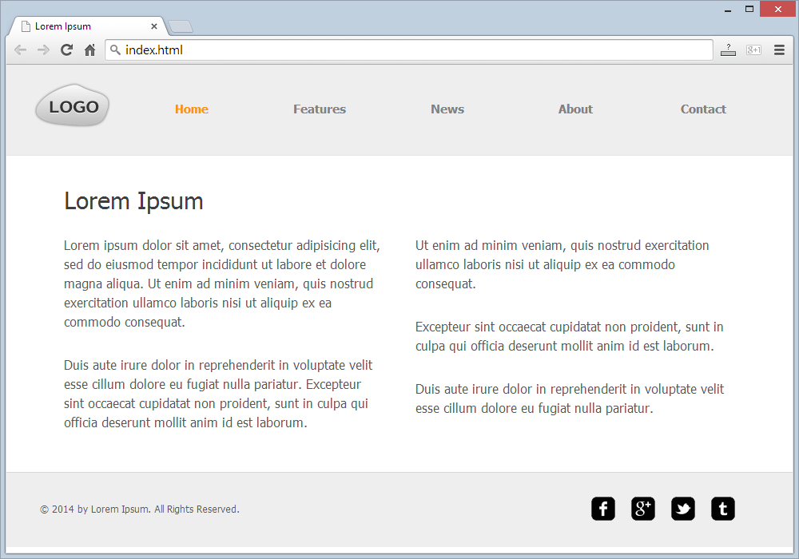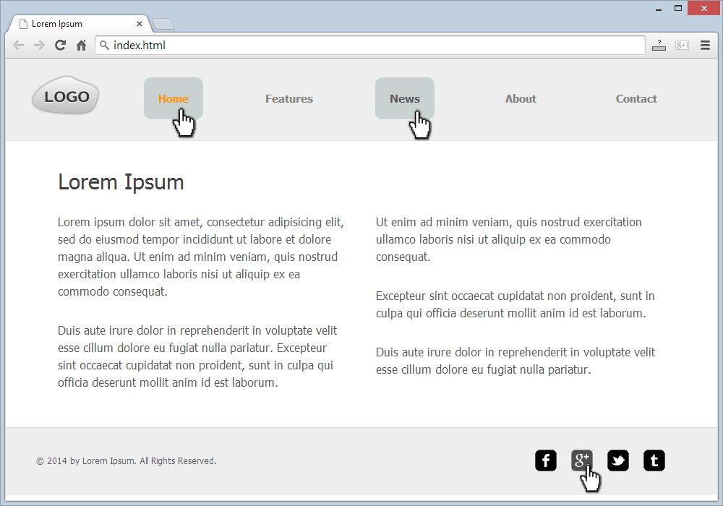

* The hand cursors in the screenshots shows what happens when the mouse moves over certain elements.

### Input

You are given the above screenshots + the texts on the site + the site logo + the contact icons (as sprite).

### Output

The output should be valid HTML5 + CSS3 + images that implement the above Web site.

### Constraints

* Font: Tahoma / sans-serif.
* Site content: fixed width 840px.
* Header and footer: fixed width 920px.
* Header and footer background: fluid width;
* The site should open correctly in Chrome 35.
* Responsive design is not required.
* Pixel-perfect implementation is not required.