## Problem 3 – Login / Search Form

Create a Web form (HTML5 + CSS3 + images) that looks and behaves like the screenshots below:

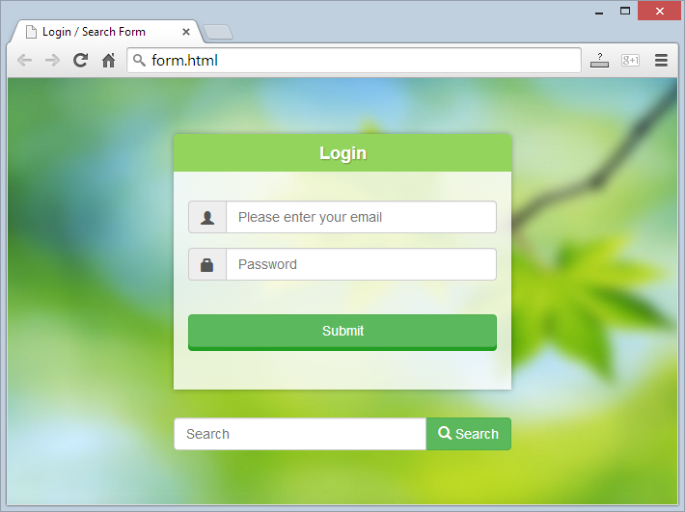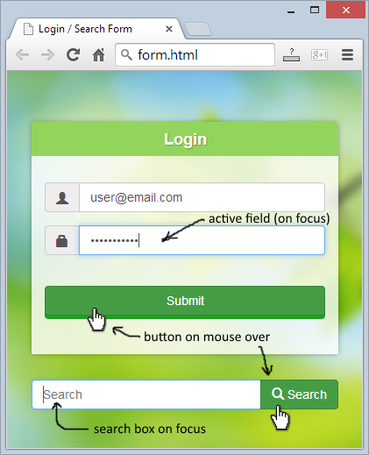

* The mouse hand-pointers and the hand-written captions are not part of your form, so please skip them.

### Input

You are given the above screenshots + the background image + the form field icons (as glyph font).

* The "username" glyph icon is the character "\e008" in the "Glyphicons Halflings" font.
* The "password" glyph icon is the character "\e033" in the "Glyphicons Halflings" font.
* The "search" glyph icon is the character "\e003" in the "Glyphicons Halflings" font.

### Output

The output should be valid HTML5 + CSS3 + images that implement the above Web form.

### Constraints

* Fonts: Arial / Helvetica / sans-serif.
* Login form size: 350px x 265px (fixed size).
* Search form size: 350px x 34px (fixed size).
* Form background: stretched to fill the entire page.
* Form validation: no validation is required
* The site should open correctly in Chrome 35.
* Responsive design is not required.
* Pixel-perfect implementation is not required.
* You are allowed to use external frameworks like Bootstrap, Gumby and ZURB.