## Problem 2 – My Blog

Create a Web site (HTML5 + CSS3 + images) that looks and behaves like the screenshots below:

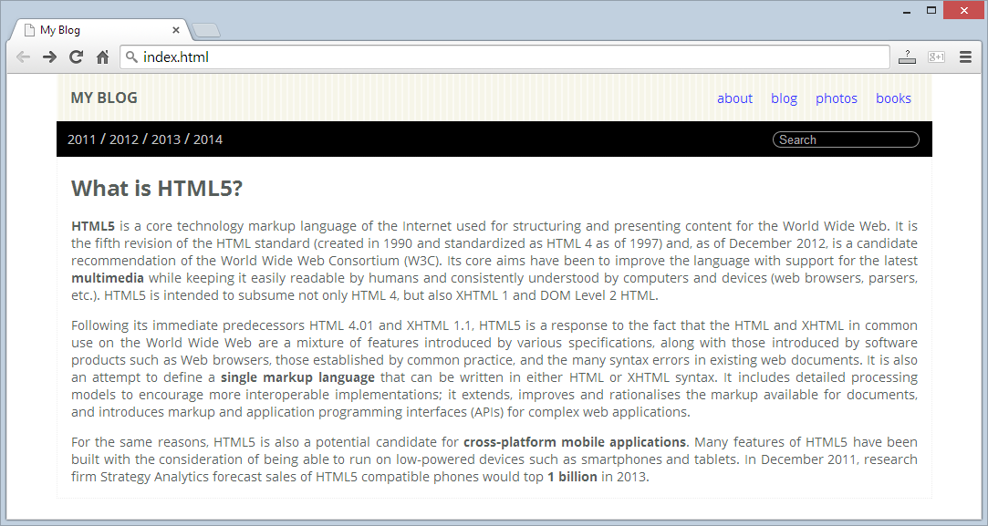

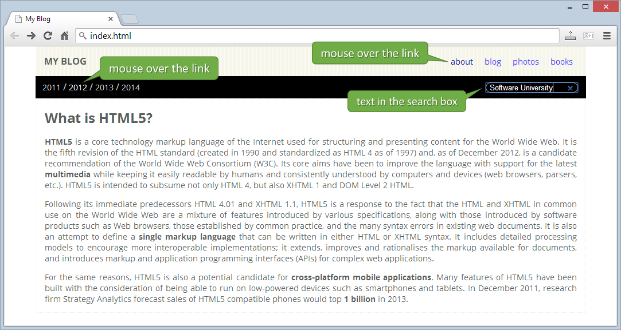

* The green bullets in the screenshots are not part of your site, so please skip them.

### Input

You are given the above screenshots + the texts on the site, nothing else.

### Output

The output should be valid HTML5 + CSS3 + images that implement the above Web site.

### Constraints

* Font: Open Sans / Helvetica Neue / Helvetica / Arial / sans-serif.
* Fixed width: 960px.
* The site should open correctly in Chrome 35.
* Responsive design is not required.
* Pixel-perfect implementation is not required.