## Problem 3 – Contact Form

Create a Web form (HTML5 + CSS3 + images) that looks and behaves like the screenshots below:

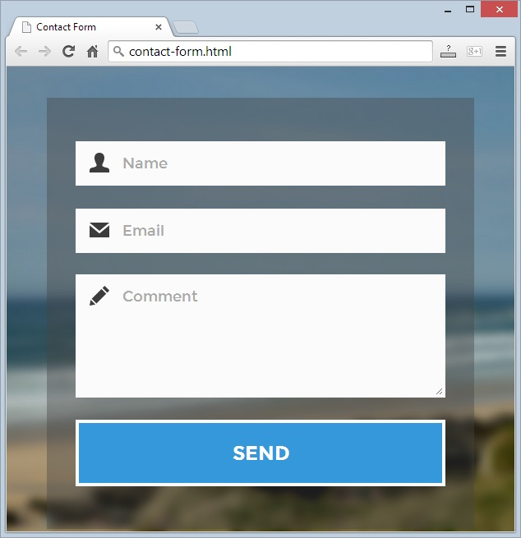 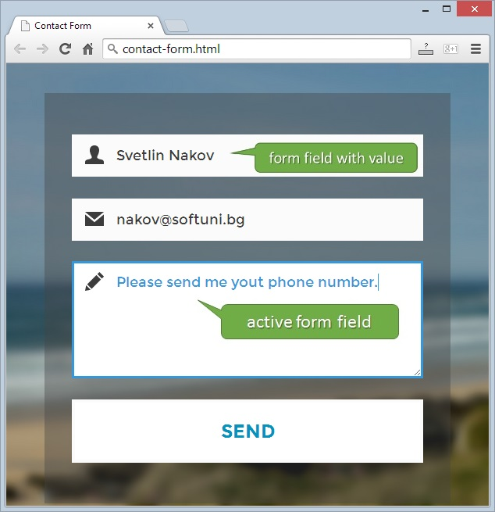

* The green bullets and the mouse hand-pointer are not part of your form, so please skip them.

### Input

You are given the above screenshots + the background image + the form field icons.

### Output

The output should be valid HTML5 + CSS3 + images that implement the above Web form.

### Constraints

* Fonts: <http://fonts.googleapis.com/css?family=Montserrat:400,700>.
* Form width: 520px x 525px (fixed size).
* Form background: stretched to fill the entire page.
* Form validation:
  + The name should hold at least one word (cannot be empty).
  + The email should be valid email address (cannot be empty).
  + The comment should be non-empty text (cannot be empty).
* The site should open correctly in Chrome 35.
* Responsive design is not required.
* Pixel-perfect implementation is not required.