SKILL – 5
INPUT

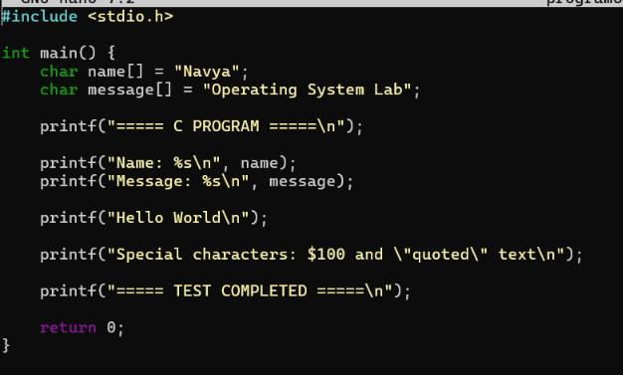

OUTPUT
